**CIS INTERNATIONAL HOLDINGS (N.A) CORP- 5358**

**CIS INTERNATIONAL DISTRIBUTERS Inc- 8917**

**Automated Systems International Inc- 2362**

**Lion Rock Investment LLC- 3533**

|  |  |
| --- | --- |
| Subject | Daily Bank Reconciliation |
| Object | To ensure the bank balance, checks and All bank transactions recorded in QB. |
| Department | Finance |
| Recorder | Nisansala Dilhani -(Accounts Executive) |
| Approved By | Deepika Thilakarathne (Accountant) |
| Created Date |  |
| Last Updated | 07.20.2019 |
| Path on Network Folder | Teknowledge Shared Services\Finance Dept. - Documents\OPR's\Nisansala Dilhani |
| No Of pages including this OPR | 02 |

1. **Get the bank transactions daily from bank.**
2. 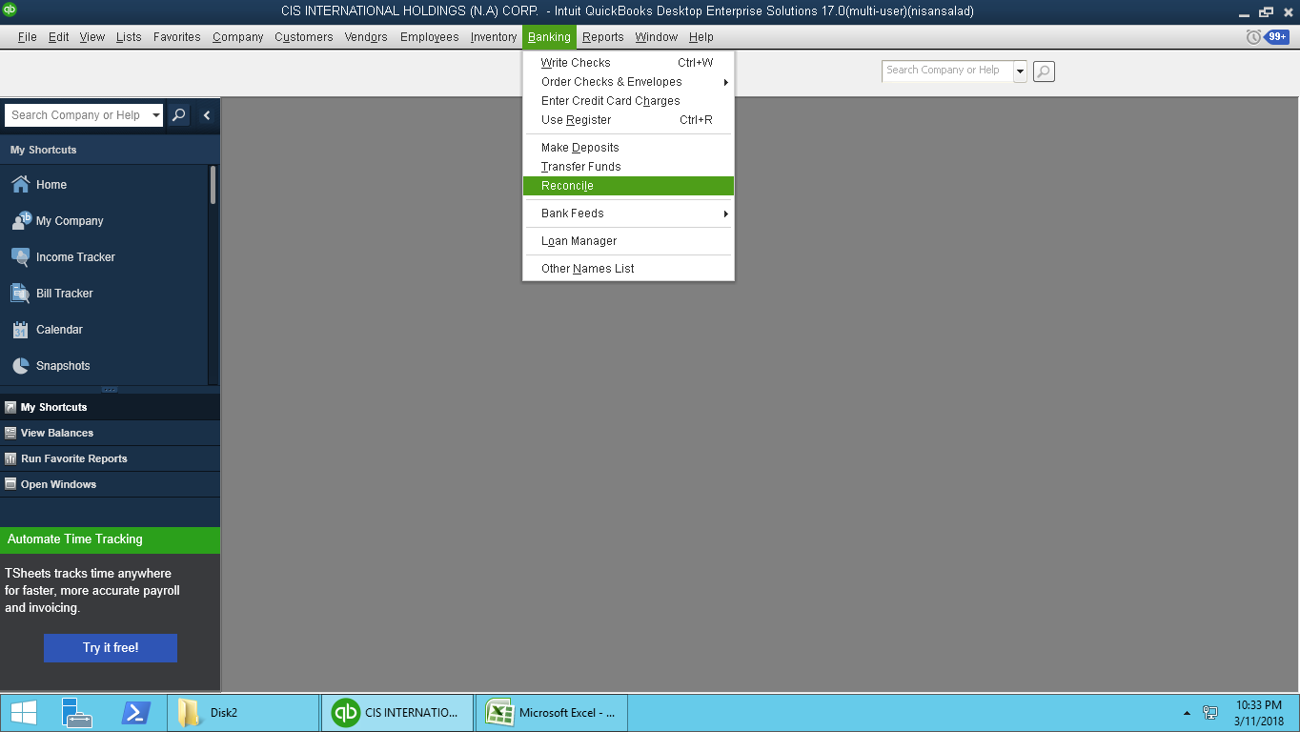**Reconcile the bank transactions daily with bank accounts.**
3. **Recognize the differences, unrecorded deductions and realized checks**

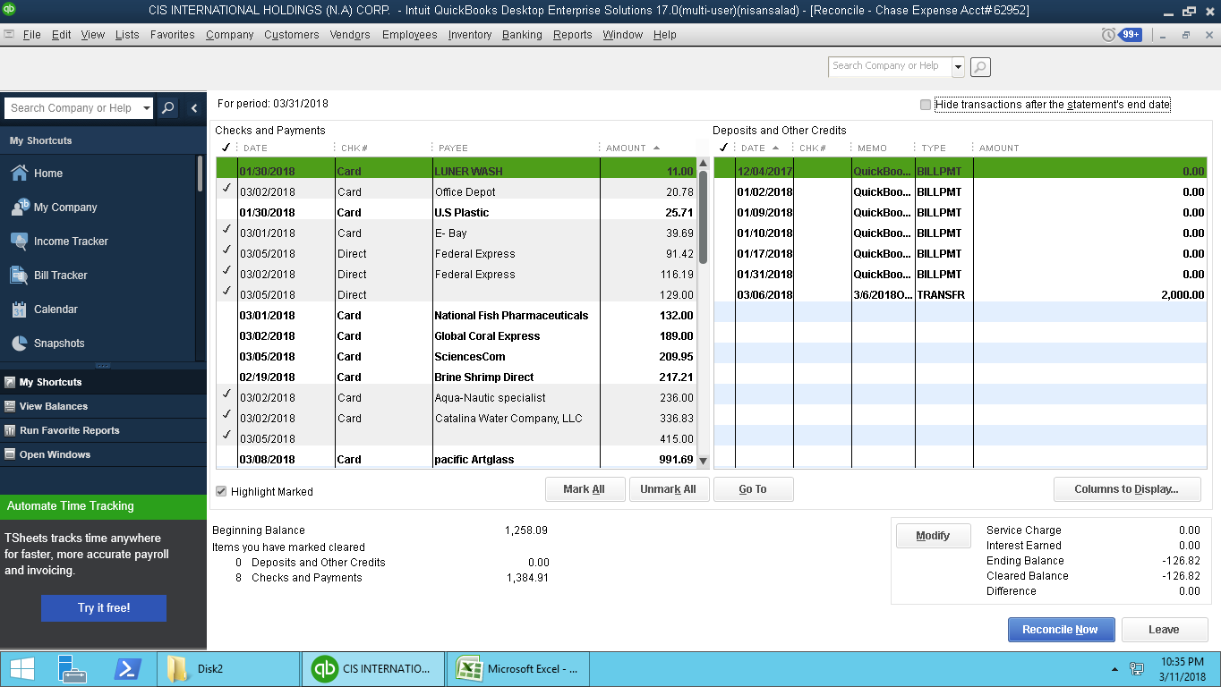

1. **Doing the need corrections if necessary.**