**CIS INTERNATIONAL HOLDINGS (N.A) CORP**

|  |  |
| --- | --- |
| Subject | Entering Dry/Live goods Bills |
| Object | To ensure all the Expenses and Dry/live goods Bills are Update in timely Manner |
| Department | Finance |
| Recorder | Nisansala Dilhani -(Accounts Executive) |
| Approved By | Deepika Thilakarathne (Accountant) |
| Created Date |  |
| Last Updated | 07.20.2019 |
| Path on Network Folder | Teknowledge Shared Services\Finance Dept. - Documents\OPR's\Nisansala Dilhani |
| No Of pages including this OPR | 02 |

1. **Check the Dry inventory tracker for live and dry goods send by US Admin every day**

Teknowledge Shared Services\Finance Dept. - Documents\Operational\CIS INTERNATIONAL HOLDINGS (N.A) CORP\2019\Daily Inventory Tracker Reports

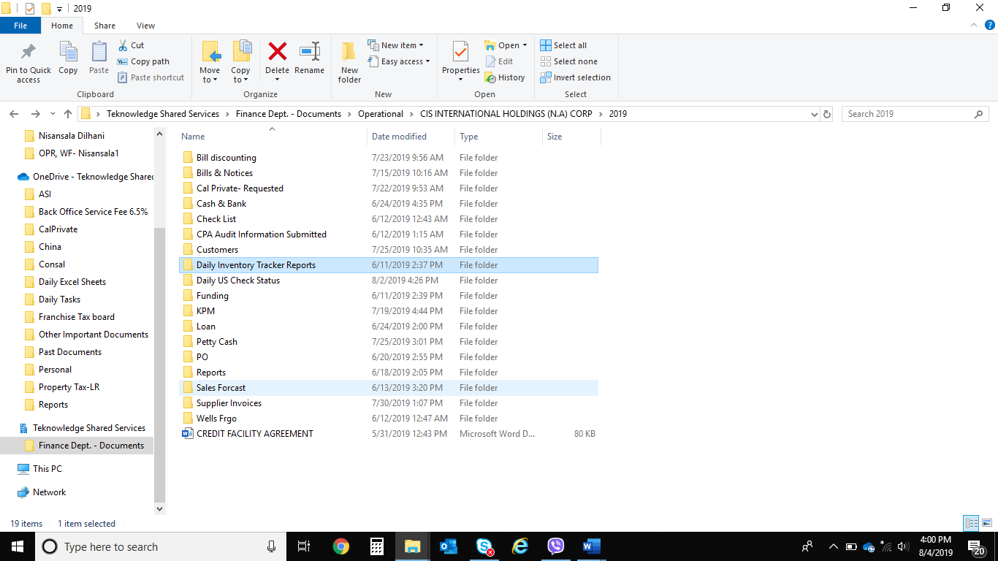

**2. Record bills in QB**

Vendor Enter Bill Select Vendor Select Date Fill Relevant Details

Attached the bill Save

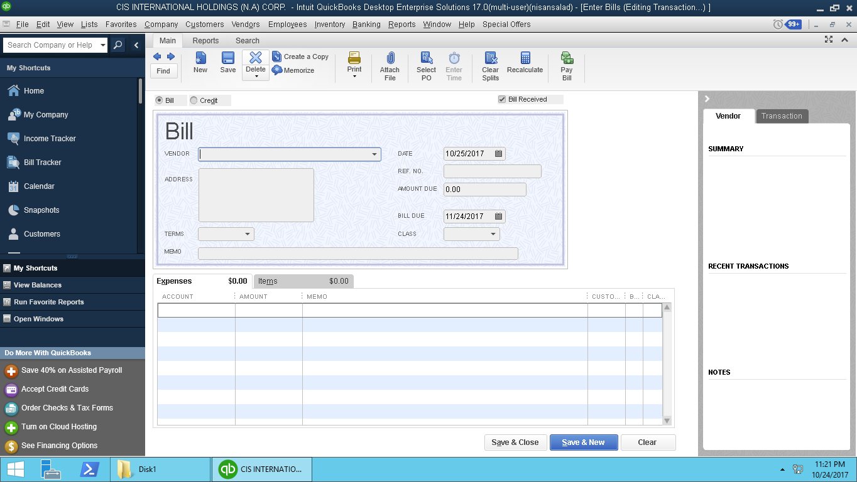

Vendor

Invoice Date Date

Due Date

Expenses $ Item

1. Make sure all the bills and payments are recorded properly in QB
2. Check whether the vendor Payable amounts are correct or not

**3.     Make sure all the bills and payments are recorded properly in QB**

**4.     Check whether the vendor Payable amounts are correct or not**