**Automated Systems International Inc-**

|  |  |
| --- | --- |
| Subject | Updating All transactions |
| Object | To ensure all the truncations updated in QB in timely Manner. |
| Department | Finance |
| Recorder | Nisansala Dilhani - (Accounts Executive) |
| Approved By | Deepika Thilakarathne (Accountant) |
| Created Date |  |
| Last Updated | 07.20.2019 |
| Path on Network Folder | Teknowledge Shared Services\Finance Dept. - Documents\OPR's\Nisansala Dilhani |
| No Of pages including this OPR | 02 |

1. **Entering Customers and Invoices (Track the emails and Get the instructions and details from john)**

* Estimated
* T&M

1. **Record all bills relevant to project.**

* Tacking the e-mails send by John and Justin
* Select the bills among the mails and saved in SharePoint.
* Record Bills (It is needed to record relevant to CUSTOMER JOB and line item which is come under invoice)
* Attached the bill (PDF or Scanned Copy)

1. **Imputing the Payroll every Thursday.**

* Getting payroll file from ADP website

1. 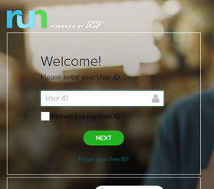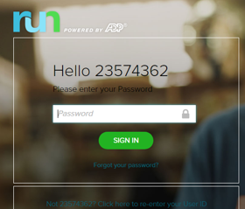Enter Username 2) Enter Password

) In General Ledger select the transaction history

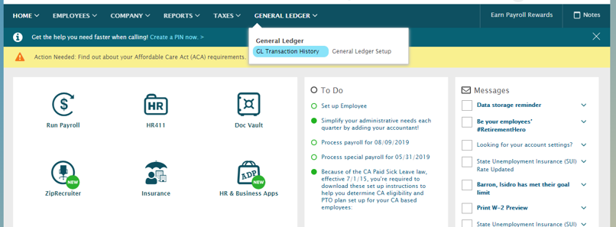

4) Download the correct File save in QB Desktop.

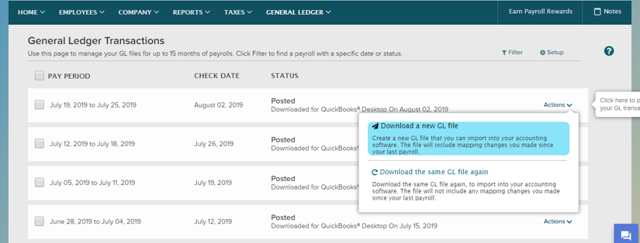

* Importing payroll by getting help of IT Support.

1. **Issuing the checks if needed (AP Summary)**
2. **Doing the daily bank reconciliation- 2362**
3. **Doing the intercompany reconciliation (monthly)**