**CIS INTERNATIONAL DISTRIBUTERS Inc**

|  |  |
| --- | --- |
| Subject | Updating All transactions |
| Object | To ensure all the truncations updated in QB in timely Manner. |
| Department | Finance |
| Recorder | Nisansala Dilhani -(Accounts Executive) |
| Approved By | Deepika Thilakarathne (Accountant) |
| Created Date |  |
| Last Updated | 07.20.2019 |
| Path on Network Folder | Teknowledge Shared Services\Finance Dept. - Documents\OPR's\Nisansala Dilhani |
| No Of pages including this OPR | 02 |

1. **Importing weekly Payroll every Thursday.**

* Getting payroll file from ADP website

1. Enter Username 2) Enter Password

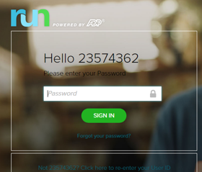

3) In General Ledger select the transaction history

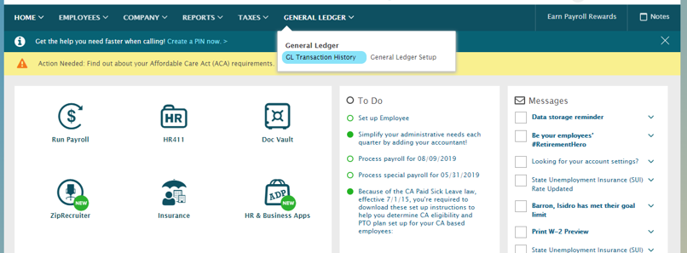

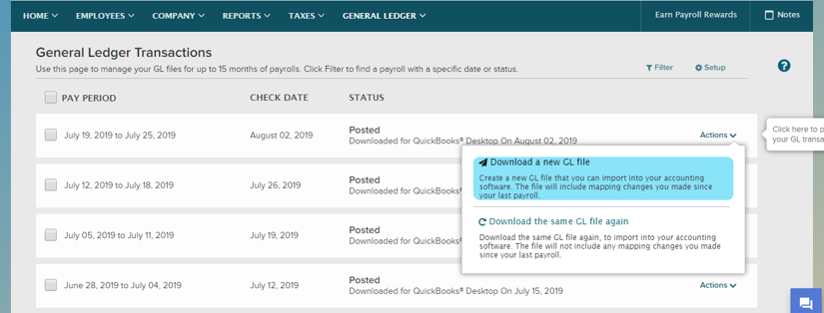4) Download the correct File save in QB Desktop.

* Importing payroll by getting help of IT Support.

1. Recording and transferring the invoice to CIS International Holdings (Revenue)

* Run the P&L in relevant week and export to excel
* Add the Management fee $2,000 into Payroll total payment
* Get the total and transfer to CIS as a bill

1. Enter all bills in QB when received.
2. Issuing the checks, when needed.
3. Doing the daily bank reconciliation- 8917
4. Doing the intercompany reconciliation (monthly**)**