**Teknowledge Shared Services Pvt. Ltd**

**How to Create new user and mac binding on Firewall**

|  |  |
| --- | --- |
| **SUBJECT** | How to Create new user and mac binding on Firewall |
| **DEPARTMENT** | IT Support |
| **RECORDER (Name & Designation)** | Amila Kaushalya |
| **APPROVEDBY (Name & Designation)** |  |
| **CREATED DATE** | 31-May-2018 |
| **LAST UPDATED** | 31-May-2018 |
| **PATH ON NETWORK FOLDER** | https://cisintlcom.sharepoint.com/Shared%20Documents/IT_Sup/OPR |
| **NO. OF PAGES INCLUDING THIS PAGE** |  |

1. Log in to Cyberoam firewall 192.168.3.1

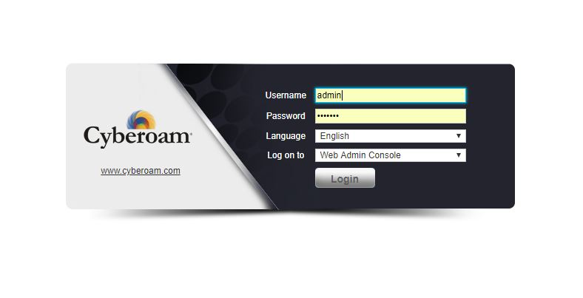

1. Go to Network > DHCP > DHCP Server

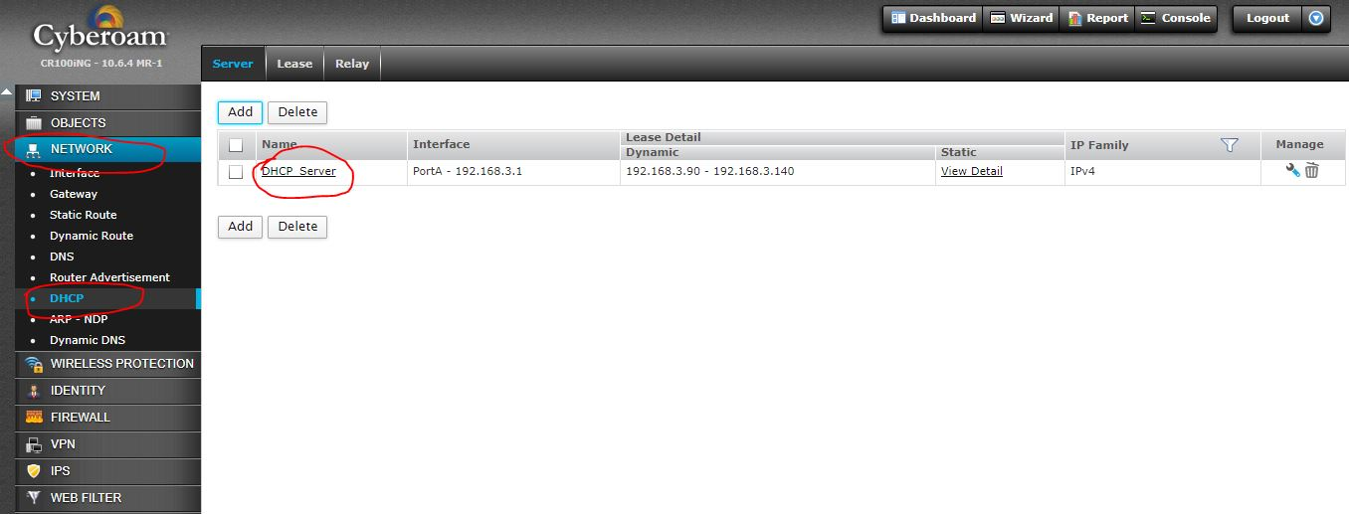

1. Click + button and add new

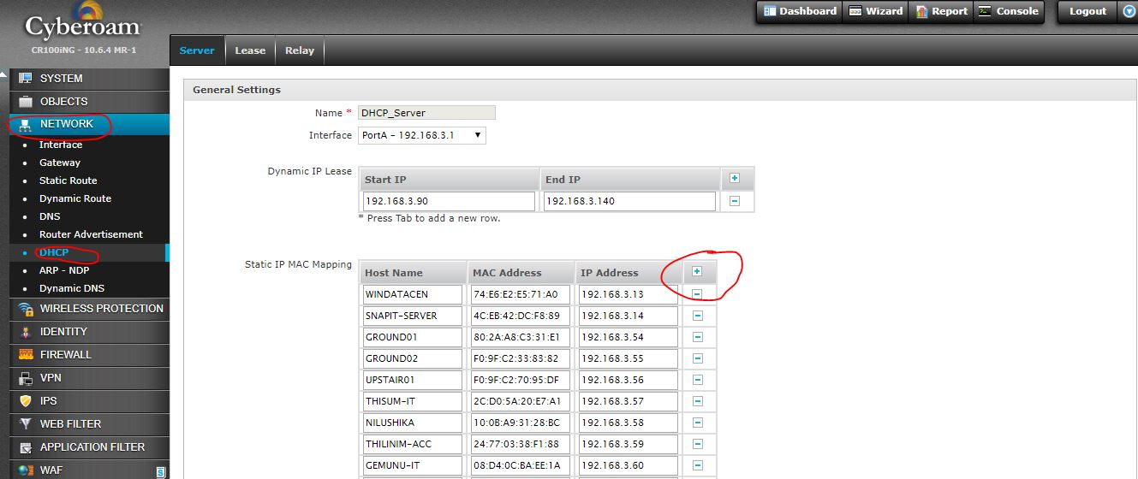

1. 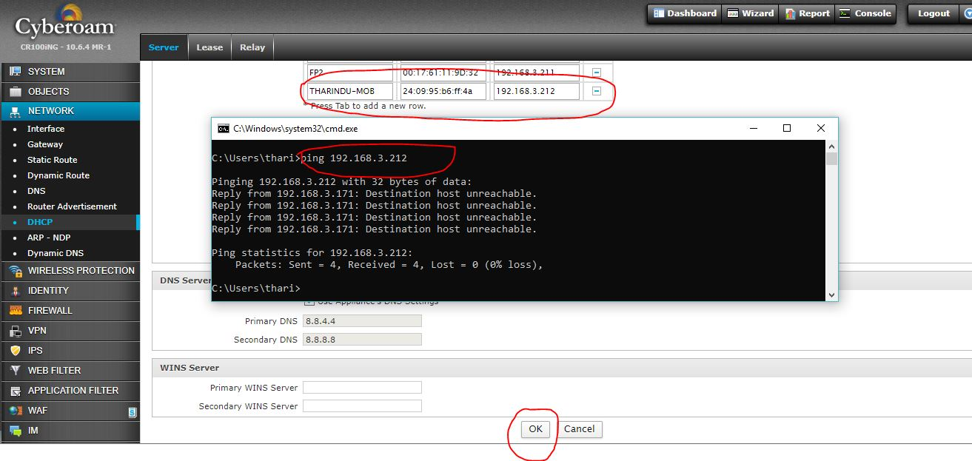Add Name, Mac address and IP address. please make sure IP address not in use. Then click OK
2. Then go to Identity > Users and click Add user

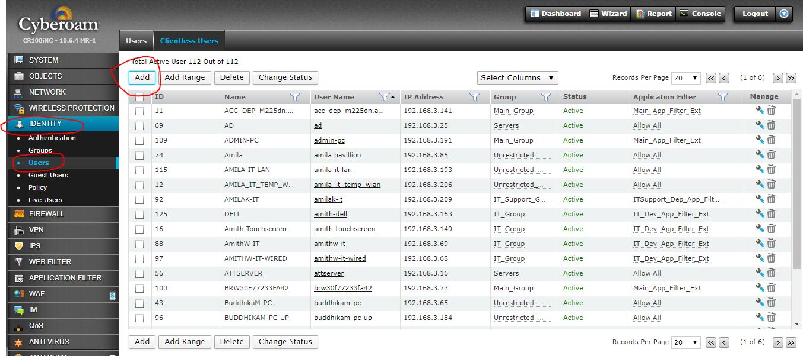

1. Add Previous Name and IP address (same as previously added) Then click OK

