OPR For How to Revise Event Viewer and Patch Update Rackspace servers

|  |  |
| --- | --- |
| **Subject** | OPR For How to Revise Event Viewer and Patch Update Rackspace servers |
| **Department** | **IT Support** |
| **Recorder** | **Amila Kaushalya** |
| **Approved by** |  |
| **Create Date** | **24/04/2020** |
| **Last Update** |  |
| **Path on Network Location** | [**Click Here**](https://cisintlcom.sharepoint.com/:f:/g/itsupport/Eg5WSG-9UWRDqy0Rmffyq0oBYmcMbnksGufnxsNHE1-mnQ?e=C3daLi) |
| **No. of Pages Including this page** | **01** |

# Use the checklist located at below location for server administration tasks.

IT-Support - Documents\Operational Data\Management\Workflow\OPRs\Amila\Server Administration

# Event Viewer

1. Log in to the server
2. Run------- > eventvwr

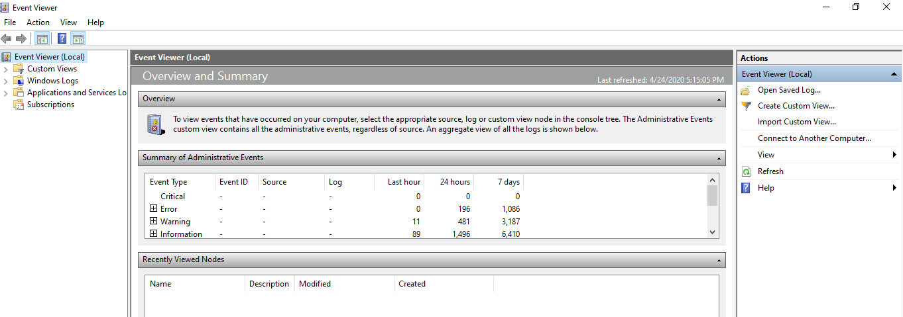

1. Review Critical events
2. Update the excel sheet exist here.

# Patch Update

1. Log in to the server
2. Run ------ > wuapp (or) control update
3. Update the excel sheet exist here

# HDD & RAM Usage

# Malware/Spyware scan