

本科毕业设计

外文文献及译文

文献、资料题目：Fault Localization for Automat

ed Program Repair: Effectiveness,Perfoance, Repair

Correctness
文献、资料来源：期刊（著作、网络等）
文献、资料发表（出版）日期：2015
院 （部）：计算机科学与技术学院
专 业： 软件工程（软件测试）
班 级： 软测141
姓 名： 李怀鹏
学 号： 20141113022
指导教师： 田甜
翻译日期： 2018.02.25
外文文献：
Fault localization for automated program repair: effectiveness, performance, repair correctness
Abstract Automated program repair (APR) tools apply fault localization (FL) techniques to identify the locations of likely faults to be repaired. The effectiveness, performance, and repair correctness of APR depends in part on the FL method used. If FL does not identify the location of a fault, the application of an APR tool will not be effective– it will fail to repair the fault. If FL assigns the actual faulty statement a low priority for repair, APR performance will be reduced by increasing the time required to find a potential repair. In addition, the correctness of a generated repair will be decreased since APR will modify fault-free statements that are assigned a higher priority for repair than an actual faulty statement. We conducted a controlled experiment to evaluate the impact of ten FL techniques on APR effectiveness, performance, and repair correctness using a brute force APR tool applied to faulty versions of the Siemens Suite and two other large programs: space and sed.
All FL techniques were effective in identifying all faults; however, Wong3 and Ample1 were the least effective FL techniques since they assigned the low- est priority for repair in more than 26% of the trials. We obtained the worst APR performance significantly when Ample1 was used since it generated a large number of variants in 29.11% of the trials, and took the longest time to produce potential repairs. Jaccard FL improved repair correctness by generating more validated repairs potential repairs that pass a set of regression tests, and generating potential repairs that failed fewer regression tests. Also Jaccard’s performance is noteworthy in that it never generated a large number of variants during the repair process compared to the alternatives.
Introduction
Debugging is an expensive process [22] that includes locating software faults and fixing them. Automated program repair (APR) refers to techniques that locate and fix software faults automatically, and thus promise to dramatically reduce debugging costs. APR techniques apply fault localization (FL) to guide a repair tool towards code segments that are more likely to contain faults. Then an APR tool can modify the code most likely to contain faults. FL techniques compute a suspiciousness score to indicate the likelihood that each statement contains a fault. A list of potentially faulty statements (LPFS), ordered by their suspiciousness, is created for use by the repair tool.
The effectiveness, performance, and repair correctness of APR can be impacted by the selected FL technique. APR effectiveness is the ability to fix faults, while performance is the time or number of steps required to find a potential repair, and repair correctness indicates how well a potentially repaired program retains the required functionality. An ineffective fault localization technique might mislead the repair process by missing the statements where a fault hides, assigning a low score to the actual faulty statement, or identifying too many statements that might contain the faults. Missing faulty statements will lower APR effectiveness by failing to find a potential repair. Assigning a low score to a faulty statement will not decrease APR effectiveness, but it will reduce APR performance and generate an incorrect repairs since the APR will unproductively modify many fault-free statements before reaching an actually faulty statement. On the other hand, identifying too many statements might improve APR effectiveness by increasing the chance of finding a potential repair, but with potentially poor performance and incorrect repair. In the worst case, a fault localization technique can mark all statements in a program as potentially faulty, which can decrease the performance of APR dramatically especially with large programs. LeGouesetal. [27] found that for APR “time is governed” by the number of potentially faulty statements rather than program size. Thus, a fault localization technique that marks fewer statements, and/or places an actually faulty statement at the head of the LPFS will decrease the number of variants generated by an APR technique to find a potential repair, thus improving APR performance. It also will improve repair correctness by guiding the APR to actually faulty statements and reduce the chances of modifying non-faulty statements.
Different FL techniques have been used with APR to locate potential faults. Weimeretal. [21, 39] apply a simple Weighting Scheme that assigns weight values to statements based on their execution by passing and failing tests. Higher weights are assigned to statements that are executed only by failing tests, and lower weights are assigned to statements that are executed by both passing and failing tests. They excluded statements that are only executed by passing.
tests to prevent changing correct statements. Our previous paper [11], which evaluated the correctness of generated repairs, uses the Weighting Scheme fol- lowing the Weimer et al. approach. Nguyen etal. [33] use the Tarantula fault localization technique [25, 24, 23]. Debroy and Wong [18, 19] use Tarantula and Ochiai fault localization techniques to rank program statements based on their likelihood of containing faults. Using better fault localization techniques can identify actual faulty statements more quickly, thus improving APR effective- ness, performance, and repair correctness.
The effectiveness of different fault localization techniques on automated program repairs has been evaluated by Qi et al. [35]. Their evaluation used GenProg, an APR that implements a genetic algorithm to find the optimal solution from the solution space. Genetic algorithms employ randomness through the selection of program modification operators (PMOs) and a crossover operator; the randomness of the search algorithm might affect the accuracy of the reported results since there is dependency between the accuracy of the fault localization technique and the randomness of the search algorithm. The FL technique might accurately locate the actual faulty statement, but the search algorithm can select a PMO that does not fix the fault. A brute-force algorithm is guaranteed to fix a fault if a repair is feasible. Therefore, a failure to find a potential repair can be related to the selected FL technique. On the other hand, Debroy and Wong evaluated the impact of Tarantula and Ochiai with an APR technique that applies a brute-force search method. The effectiveness of different FL techniques is measured in terms of the number of PMOs applied until a fault is fixed, and they found that Ochiai fixed more faults with fewer PMOs compared to Tarantula.
In this paper we do not propose a novel approach; rather, we designed and conducted a controlled experiment to accurately evaluate the effect of FL on APR effectiveness, performance, and repair correctness. There was a study by Qi et. al. [35] to evaluate the impact of different FL techniques when used for APR effectiveness and performance. However, to the best of our knowledge, we are the first to study the impact of different fault localization techniques within APR on the correctness of generated repairs. We evaluate FL techniques with an APR that applies a brute-force search algorithm to eliminate the randomness of a genetic algorithm that might affect the accuracy of the results reported by Qi et al. [35].Even though Debroy and Wong applied a brute-force search method to evaluate FL techniques when used for APR, the differences between their eval- uation and our evaluation are as follows: 1) Debory and Wong compared the effectiveness of two FL techniques (Tarantula and Ochiai) while we compared the effectiveness of ten of the most recent FL techniques in the literature,Debroy and Wong use a brute-force search method that applies PMOs in a random order; however, we order PMOs so that PMOs with the greater chance of fixing faults are applied earlier, 3) Our study measures APR effectiveness, performance, and the correctness of generated repairs when using different FL techniques, while their approach only measured the effectiveness of FL techniques, and 4) We measured APR effectiveness when different FL.techniques are used as the ability of an FL technique to identify actual faulty statements, while they measured effectiveness as the number of PMOs applied until a repair is produced.
We studied the impact of ten well known fault localization techniques: Jaccard, Optimal, OptimalP, Ochiai, Ochiai2, Tarantula, Ample1, Ample2, Wong3, and Zoltar. Our evaluation was conducted on six subject programs that include large programs (more than 12K LOC). Our results show that all ten fault localization techniques successfully identified actually faulty statements. Ample1 decreased APR performance significantly since it assigned faulty statements low priority for repair, which caused the APR process to generate a large number of variants, and took a greater amount of time to produce potential repairs. Jaccard produced more validated repairs–potential repairs that pass a set of regression tests. In addition, Jaccard always assigned faulty statements a high priority for repair. It took an average of 43.28 seconds to produce potential repairs, which was the best performance of the tested FL techniques.
The main contributions of this paper are the following:
A framework for comparing FL techniques in terms of their impact on the effectiveness, performance, and repair correctness when used for automated program repair. The MUT-APR evaluation framework is built by adapting GenProg to (1) fix operator faults, (2) use a brute-force search, and
(3) apply ten FL techniques.
A determination of the impact of FL techniques on an APR tool’s ability to repair a faulty statement. We found that all studied FL techniques identified actually faults statements.Our results show that Ample1 decreased APR performance significantly compared to the alternative FL techniques, while differences between the alternatives are not always statistically significant at the 0.95 confidence level.Jaccard produced more repairs (%70.88) that were validated by passing all regression tests compared to all alternative FL techniques. Also, Jaccard generated potential repairs that rarely failed regression tests (an average of 2.57%).
Background
Fault Localization Techniques (FL)
Fault localization techniques were introduced in order to guide developers to- wards the most suspicious statements to check during debugging. Lately, FL techniques are employed by APR to guide search algorithms towards statements that are more likely to hide faults than other statements (step 1 in Figure 1). Thus, applying FL helps to fix faults faster without breaking other required functionality.
FL techniques locate potentially faulty statements in the source code by computing a suspiciousness score for each statement that indicates its like li hood of containing a fault. Then, statements are ordered based on their suspiciousness. Developers can use the suspiciousness score to order their search for a fault to debug. Spectrum-based fault localization (SBFL) [7, 12, 16, 24, 36, 5, 15] is a common FL approach; it compares the program behavior of a passing execution to that of a failing execution. SBFL collects information on the dynamic behavior of program statements when they are executed against each test in a test suite. SBFL methods record the number of passing and failing tests executed for each statement, and compute a suspiciousness score for each statement. Statements that are executed more often during a failing run are considered to be more likely to contain faults, thus are assigned a higher suspiciousness score than other statements in the program. Many heuristics have been proposed to compute statement suspiciousness scores [7, 25, 24, 36, 5, 5, 32].
To illustrate how FL techniques rank program statements using the com- puted suspiciousness scores, we used the C program adapted from an example used by Weimer et al. [39] (Table 1), which computes Eculid’s greatest common divisor. FL techniques count the number of passing and failing tests for each statement. Each FL technique uses a formula to compute suspiciousness scores. This example uses five test inputs T S = T1, T2, T3, T4, T5 in which T1, T2, T3, and T4 are passing tests, and T5 is a failing test, and Tarantula computes suspiciousness score for each statement using equation from Table 2. A list of potentially faulty statement (LPFS), which consists of statement IDs and their suspiciousness scores is created and sorted (Table 3). The LPFS contains all statements with a suspiciousness score greater than zero, and will be used by the APR tool to locate the fault.
Automated program repair (APR) techniques locate and fix faults. APR techniques take a faulty program and a set of repair tests, and produce a repaired program. APR techniques consist of three main steps: fault localization (Step 1), variant creation (Step 2), and variant validation (Step 3). Figure 1 describes the overall organization and activities of APR techniques.
First, an APR technique locates faults (Step 1 in Figure 1) by applying a fault localization technique creating the LPFS as explained in the previous section. Then, an APR technique fixes faults (Step 2 in Figure 1) by modifying a faulty program using a set of program modification operators (PMOs).
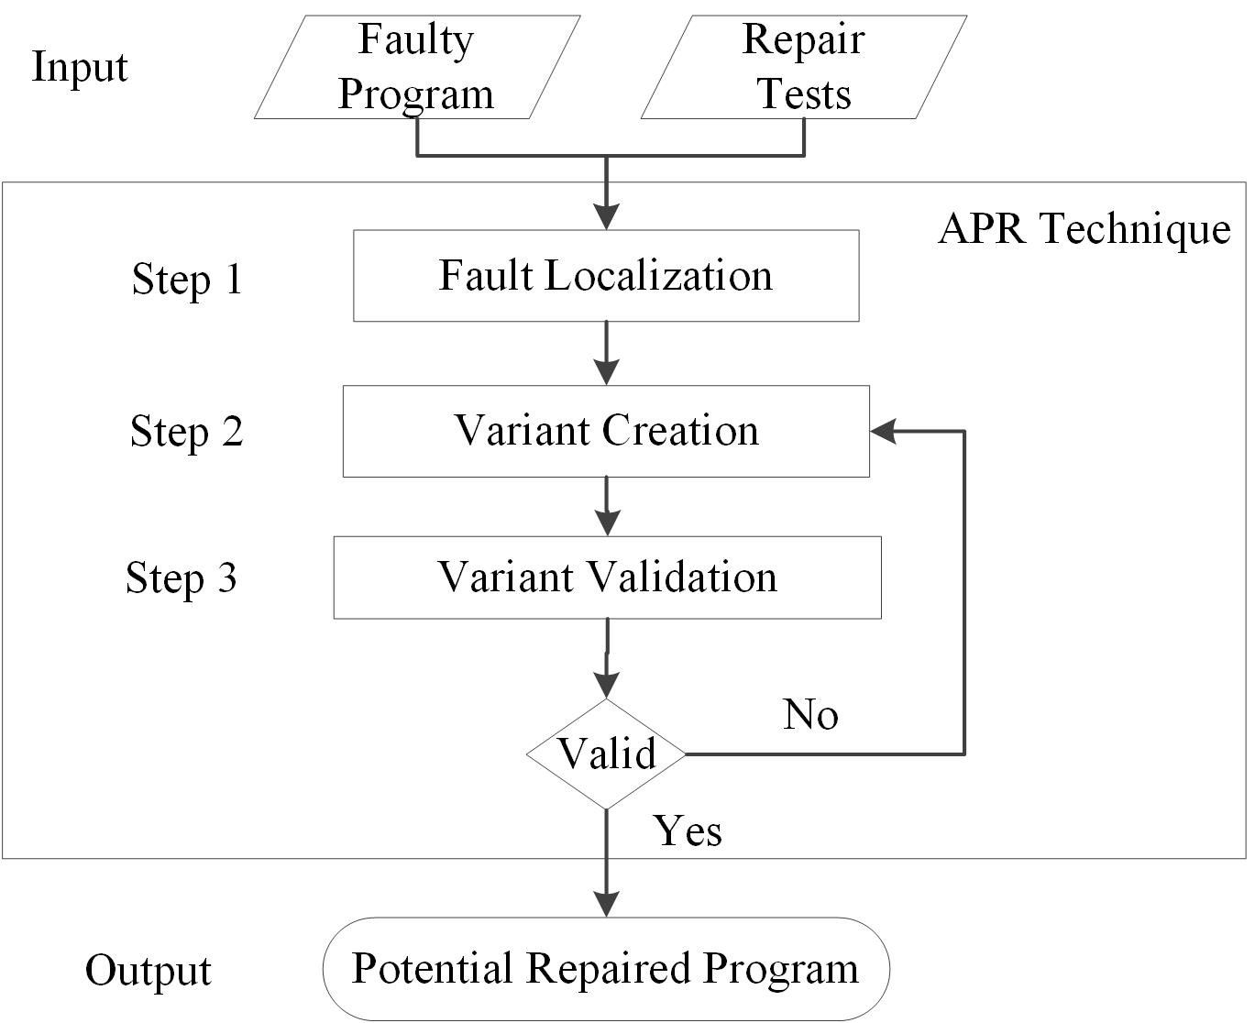
Fig. 1: Overall Automated Program Repair (APR) Process
that change the code in the faulty statement to generate a new version of the faulty program, which is called a variant. An APR technique applies a search algorithm to create variants by selecting and applying a PMO; some search algorithms run for multiple iterations and in some cases APR techniques generate a variant from a variant produced in prior iterations. The variant is validated (Step 3 in Figure 1) by executing it against a set of repair tests. The variant is called a potential repair or potential repaired program if it passes all of the repair tests. The repair process stops when it finds a potentially repaired program, or when the number of iterations have reached a limit. A potential repair is considered a validated repair when it passes a set of tests (often regression tests) that were not included in repair tests.
Automated Program repair (APR) Framework
To fix faults, we used our MUT-APR repair tool [11]. MUT-APR was built by adapting the GenProg version 1 framework [21, 39, 38, 27]. Unlike GenProg which makes use of existing code in the subject program to repair faults, MUT- APR applies a set of PMOs that construct new operators to replace faulty ones creating new variants within a genetic algorithm. For this paper, we replaced the genetic algorithm in MUT-APR with a brute-force search algorithm, and added support for the use of different FL techniques applying the changes developed by Qi et al. [35].MUT-APR makes use of a mutation-based technique adapted from Debroy and Wong [18, 19] to fix simple faults. Simple operator faults are common mistakes made by developers. For example, relational operator faults, such as the use of > instead of >=, can produce off-by-one errors, and many operator faults are security vulnerabilities [1]. Many faults can be fixed by one-line modifications [34, 17]. In addition, our previous study shows that the use of simple PMOs improves the correctness of generated repairs by generating more vali- dated repairs and generated repairs are similar to repairs done by humans [11].
Faults are fixed in source code by constructing new operators. PMOs are applied to change a faulty operator into a set of alternatives until finding the correct operator. For example, MUT-APR can generate five different variants when changing a mutable statement (a mutable statement is a program construct that can be changed by one of the supported PMOs) that contains the > operator. We apply PMOs to fix faults in all statements that contain relational operators, arithmetic operators, bitwise operators, and shift operators (Table 4). The PMOs are as follows: (1) change relational operators in if statements, return statements, assignments, and loops, (2) change arithmetic operators, bit wise operators and shift operators in return statements, assignments, if bodies, and loop bodies.
Although MUT-APR supports PMOs to fix faults in binary operators, MUT-APR does not apply PMOs to fix faults in Logical Operators due to MUT-APR’s use of CIL [32]. CIL is an intermediate language for C programs to manipulate source code and generate a simplified version of source code. It transforms logical operators into if -then and if -else blocks. Therefore, in order to fix faults in logical operators w.r.t. CIL would require making changes to the generated if blocks rather than the operators. We left this for future work.
PMO Algorithm
Algorithm 1 is used in the implementation of our PMOs. MUT-APR selects the first potentially faulty statement from the LPFS. If the statement contains an operator (Line 4), the operator is checked (line 5). Then, a PMO, that is one of the alternatives of the potential faulty operator, is selected (line 6 )(e.g., stmti contains >, and PMO that is change > operator into an alternative is selected), the statement type is checked (line 7), and a new statement stmtj is created (line 8). Then stmti is substituted by stmtj (line 9) creating a new variant.
Algorithm 1 PMOs Pseudocode to Modify Simple Operators
1: Inputs: Program P and List of Potentially Faulty Statements LPFS
2: Output: mutated program
3: for all statements stmti in the LPFS do
4: if stmti contains an operator then
5: let stmtOp = checkOperator (stmti )
6: let pmo = choose(ChangestmtOpToOp), 7: let stmtType = checkStmtType(stmti)
8: let stmtj = apply (stmti,pmo)
9: substitute stmti with stmtj in program P 10: end if
11: end for
12: return P with stmti substituted by stmtj
Illustrated Example
A faulty Euclid’s greatest common divisor adapted from an example used by Weimeretal. [39] illustrates our approach. The original fault was a missing statement (line 3), which cannot be fixed by MUT-APR’s PMOs. In order to demonstrate how MUT-APR fixes binary operator faults, we inserted the missing statement and seeded a fault in the if statement in line 1 as shown in Table 1.
The gcd program in Table 1 has three relational operators and two arithmetic operators: line 1: if(a <0), line 4: while(b !=0), line 5: if(a>b), line 6: a= a - b, and line 8: b = b - a. The faulty operator is in the first if statement (line 1). In order to fix the fault, the operator in line 1 must be switched to.
We assume that all three relational operator statements and the two arithmetic operators are identified as potentially faulty statements plus two other statements, and the statement in line 1 is the first statement in the LPFS, thus it is selected first for modification. MUTAPR checks the operator in the statement and selects one of its alternatives (based on the predefined order). The faulty operator in statement 1 is <. If the tool selects the PMO that changes < to > , a new variant is created by constructing a new operator for line 1. The variants are compiled and executed against repair tests. This variant fails two test inputs: (0,55) and (55,0). Since the variant did not pass all repair tests, it is not a potential repair and the process continues. Another statement and PMO are selected. MUTAPR will successfully repair the fault in line 1 when it selects the correct PMO.
3.2 Search Algorithm
APR applies a search algorithm to select a program modification operator (PMO) from a pool of PMOs to modify a suspicious statement (step 2 in Figure 1). PMOs can be selected in a predefined order as done in a brute-force search method, or randomly as done in stochastic search. Brute-force requires an exhaustive search that applies all possible changes to the program until a potential repair is found, which is inefficient and can be infeasible with large programs. In contrast, a genetic algorithm applies mutation and crossover operators to modify a faulty program. A genetic algorithm randomly selects PMOs from a pool of operators, and a crossover operator combines changes from two parent variants to generate a new child variant. A genetic algorithm does not guarantee a potential repair due to its randomness. In this study, we apply a brute-force APR process to eliminate the randomness of a genetic algorithm, and to guarantee a potential repair when the FL technique identifies the faulty statements and the repair is supported by the set of PMOs.
A brute-force algorithm applies all possible PMOs for each mutable state- ment from the LPFS. PMOs are applied in a predefined order; we order relational PMOs to apply operators with a greater chance to fix the faults before other operators; thus, decreasing the number of PMOs applied in the exhaustive search to find potential repairs (the ordering mechanism is beyond the scope of this paper, for more details look at the dissertation manuscript [10]).
3.2.1 Brute-force Algorithm
Algorithm 2 describes how the brute-force algorithm fixes faults within MUT- APR. The algorithm modifies statements sequentially. It takes the first statement in the LPFS, and checks if it contains an operator (line 4). If the operator is mutable, it applies all possible alternatives (line 5-10). Each change creates a variant (line 7). The fitness value is computed for each generated variant (line 8) by executing it against the repair tests (one of the inputs to the repair process in Figure 1). If a variant that passes all repair tests is found (in other words, the variant has a fitness value equal to the maximum fitness value), a potential repair is found. If not, the process continues with the next statement in the LPFS until a potential repair is found (line 9) or the algorithm reaches the last statement in the LPFS without a potential repair.
3.3 Fitness Function
Fitness values are computed for each generated variant to determine its goodness. The fitness function, adapted from GenProg [39], is given in Equation 1. Tests pass and Test sf ail are the number of passing and failing tests respectively, and W pass and W fail are positive constants that represent the weights of passing and failing tests respectively. Failing tests are assigned a weight of 10 and passing tests are assigned a weight of 1 following the approach by Weimeretal. [39]. A variant (v1) that passes failing tests will have a higher fitness value than another variant (v2) that passes all passing tests but not failing tests. Thus, v1 will be more likely to be used for the next generation than v2. If avariant that maximizes the fitness function (equal to max, which is one input to the algorithm) is found, a potential repair is identified and the process stops. Different weights can be assigned to repair tests. Weimeretal. [28] studied the impact of assigning different weights to passing and failing tests on APR effectiveness; however, this is beyond the scope of this paper.

中文译文：
自动程序修复的故障定位：有效性、性能、修复正确性
摘要
自动化程序修复（APR）工具应用故障定位（FL）技术来识别可能故障的位置。APR的有效性、性能和修复正确性在一定程度上取决于使用的FL方法。如果FL不确定故障的位置，APR工具的应用程序将无法有效——修复故障。如果FL将实际故障语句分配为一个低优先级的修复，那么就会通过增加查找潜在修复所需的时间来降低APR性能。此外，因为APR将修改无故障语句，这些语句相对于实际的错误语句分配了更高的修复优先级，生成的修复的正确性将会降低，我们进行了一个受控实验，用十西门子和其他两个大型程序：空间和SED，用一个蛮力APR工具评估了4个FL技术对APR有效性、性能和修复正确性的影响,得出所有的F1技术在识别所有故障上有效，然而，因为他们分配的低科技优先wong3和ample1的最有效外语技术在超过26%的试验修复上无效。我们得到的最坏性能显著ample1 APR是自时生成大量的试验29.11%的变种，它将产生潜在的维修时间最长的现象。Jaccard FL改进修复了正确的根管修复–验证了潜在维修，通过一系列的回归测试，产生了潜在的修理失败而减少的回归测试。同时Jaccard的表现值得注意的是，在修复过程中选择比较通用，它不会产生大量的变种。
1介绍
调试是一个昂贵的过程（22），其中包括定位软件故障并修复它们。自动程序修复（APR）是指自动定位和修复软件故障的技术，从而大大降低了调试成本。APR技术应用故障定位（FL）来引导一个修复工具，用于更可能包含故障的代码段。然后，APR工具可以修改最有可能包含故障的代码。FL技术计算多疑分数表明每个语句包含一个故障的可能性。一系列潜在错误陈述（LPF），是他们通过猜疑的，有序的修复工具创建的。
APR修复的有效性，正确性和性能可以由选定的FL技术改善。APR的有效性是解决故障的能力，而表现为时间或要求找坡位维修的次数，维修的正确性，表明如何潜在的修复程序保留所需的功能。一个无效的故障定位技术可能会由于缺少一个错误隐藏的语句、将一个低分值分配给实际的错误语句或识别可能包含错误的语句而误导修复过程。因为找不到潜在的修复条件，缺少错误的语句会降低APR的有效性。一个错误的语句分配一个低的分数不会减少APR的有效性，但会降低APR性能和生成不正确的维修，由于APR将会因为真正的错误声明而修改很多无故障报表。另一方面，识别太多的状态可能通过增加潜在的修复的机会来提高APR的有效性，但是会潜在性能不佳和不正确的修复现象。在最坏的情况下，故障定位技术可以将程序中的所有语句标记为潜在的故障，尤其是在大型程序中，这将大大降低APR的性能。乐佳等人[ 27 ]发现4月“时间”是由潜在的错误语句数量而不是程序大小决定的。因此，故障定位技术，标志着在更少的状态下，实际的错误声明的LPF的头会降低。由APR技术生成找到一个潜在的修复变异的数量，从而提高电性能。它还将通过指导APR实际故障语句和减少修改非故障语句的机会来提高修复的正确性。
不同的FL技术已用在APR定位潜在的故障上。魏玛等人,[ 21, 39 ]应用一个简单的加权方案，通过传递和失败测试，将权重分配给语句。更高的权重被分配给仅通过失败测试执行的语句，而较低的权重分配给通过和失败测试执行的语句。它们排除了仅通过传递执行的语句，防止更改正确语句的测试，并生成维修的正确性报表，采用加权方案均降低魏玛等人测试方法的风险。阮等人，[ 33 ]使用狼蛛的故障定位技术[ 25, 24, 23 ]。德布鲁瓦和Wong [ 18, 19 ]在蜘蛛落合故障定位技术的基础上对程序语句含有故障的可能性等级。使用更好的故障定位技术可以更快地识别实际故障语句，从而提高APR的有效性、性能和修复正确性。
不同的故障定位技术对自动化程序修复的有效性进行了评估。[ 35 ]他们的评价用例，用APR实现遗传算法来寻找最优解。遗传算法采用程序修改的运营商随机性选择（PMOS）和交叉操作算子实现；由于存在的故障定位技术的精度和搜索算法的随机性之间的关系，搜索算法的随机性可能会影响报告的结果的准确性。FL技术可以精确定位实际的错误声明，但是搜索算法可以选择一个项目，不排除故障。如果修复是可行的，则强力算法可以保证修复错误。因此，找不到潜在的修复可能与选定的FL技术有关。另一方面，Debroy和Wong对Ochiai的影响与蜘蛛和APR技术，采用穷举搜索法。不同液体技术的有效性在PMOS应用到故障是固定的数量来衡量的，他们发现更多的故障较少的PMOS相比蜘蛛落合。
在本文中，我们没有提出一种新的方法，相反，我们设计并进行了一个控制实验，以准确地评估FL对APR有效性、性能和修复正确性的影响。有一项研究，齐等人。[ 35 ]评估不同的FL技术对APR效能和性能的影响。然而，据我们所知，我们是第一个研究不同故障定位技术在APR中对生成修复的正确性的影响的人。我们对APR技术进行了评估，采用了一种穷举搜索算法来消除遗传算法的随机性，这可能会影响齐先生报告的结果的准确性。[ 35 ]。尽管德布鲁瓦和Wong应用穷举搜索法对FL技术使用了APR，他们的评估和评价的区别如下：1）debory和Wong比较两种FL技术的有效性（蜘蛛和Ochiai），我们比较了十份文献中最新的FL技术的有效性，2）德布鲁瓦和Wong用蛮力搜索方法，采用PMOS随机执行的顺序；3）我们的研究措施的有效性4，性能，和使用不同的FL技术产生维修的正确性，虽然他们的方法只有FL技术的有效性问题4），在测定不同月效力时，FL.techniques作为一个FL技术来识别实际故障报表的能力，而他们测量有效性作为PMOS应用，直到产生一个修复数。
我们研究了十个已知的故障定位技术的影响：Jaccard最优，OptimalP，落合，ochiai2，狼蛛，ample1，ample2，wong3，和Zoltar。我们的评估是在六种主题项目，包括大型的程序（超过12k LOC）。我们的结果表明，所有十个故障定位技术成功地识别出实际故障状态。ample1降低月表现明显因为它分配错误陈述低优先级进行维修，造成APR过程产生大量的变异，并把大量时间用在潜在的修理上。Jaccard产生了更多的验证–潜在维修修理，通过一系列的回归测试。此外，Jaccard总是分配语句错误修复一个高优先级。平均43.28秒的时间来执行潜在的维修，这是测试佛罗里达州技术的最佳性能表现。
本文的主要贡献如下：
-一个框架，用于比较FL技术在自动化程序修复时对有效性、性能和修复正确性的影响。（1）修复算子的缺点，（2）使用蛮力搜索，和（3）应用十种FL技术。
–确定APR工具的能力，外语技术影响修复的错误声明。我们发现所有研究的FL技术实际上都确定了故障语句。
我们的结果表明，–ample1降低APR表现上比其他外语的技术明显，而在选择之间的差异并不总是统计学在0.95的置信水平。
–通过与所有替代FL技术验证的回归测试相比，Jaccard产生更多的维修（占70.88）占比，另外，Jaccard产生了很少的失败回归测试（平均2.57%）的潜在的修理。
1.1 fault定位技术（FL）
介绍了故障定位技术，以指导开发人员在调试过程中对最可疑的语句进行检查。最近，在APR上采用了FL技术来引导搜索算法，使之更容易隐藏故障，因此，应用FL有助于更快地修复故障而不破坏其他所需的功能。
FL技术定位源代码中的潜在错误陈述通过计算一个多疑得分为每个声明表明其包含故障。开发人员可以使用他们的多疑得分点故障调试搜索。基于频谱的故障本地化（SBFL）[ 7, 12, 16，24, 36, 5，15 ]是一种常见的比较了一个失败的通过执行程序的执行的FL方法。SBFL收集程序语句执行时，动态行为信息对每个测试在线测试套件。方法记录SBFL传球次数和失败-测试每个语句执行，并计算每个语句的多疑得分。往往一个失败的运行期间的执行更可能包含错误，因此被分配到程序中的其他语句多疑得分较高。现在已经提出了很多方法来计算语句的多疑分数[ 7, 25, 24，36, 5, 5，32 ]。
为了说明FL技术等级的程序语句如何使用COM计算多疑分数，我们用C程序改编魏玛等人使用过的例子。[ 39 ]计算最大的COM周一除数Euclid。FL技术计算每个语句的通过和失败测试的数量。每个FL技术使用一个公式来计算多疑分数。本例使用五个测试输入T = T1，T2，T3，T4，T5通过测试。
自动程序修复（APR）技术定位和修复故障。APR技术主要采取错误的程序和一套修复的试验，并产生一个修复程序。APR技术包括三个主要步骤：故障定位（步骤1）、变量创建（步骤2）和变体验证（步骤3）。图1描述了APR技术的总体组织和活动。
首先，APR技术故障（图1 1步）运用故障定位技术创造的LPF在先前的部分解释。然后，APR技术通过修改一组程序修改操作符（PMOS）来修复错误程序，从而修复错误（图1中的步骤2）。
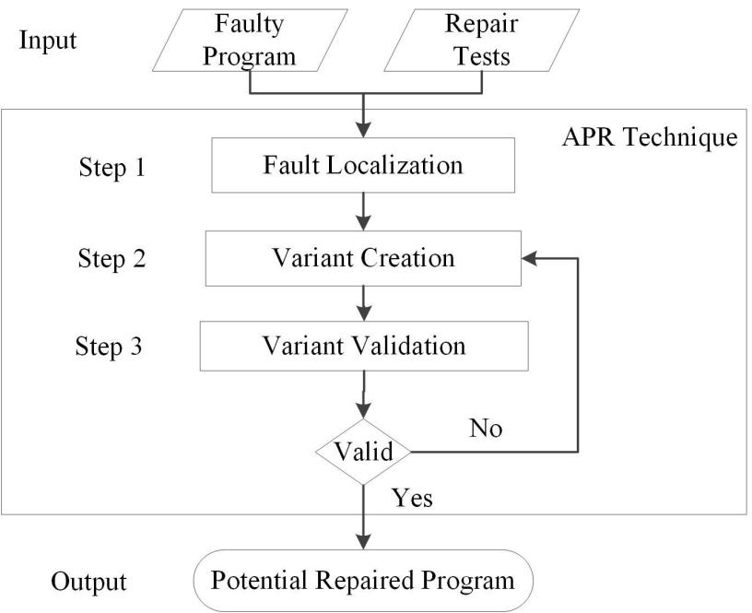
图1：全自动程序修复（APR）过程
这样就改变了错误语句中的代码以生成错误程序的新版本，这称为变体。APR技术应用搜索算法的选择和应用项目管理办公室创建变体；一些搜索算法运行多次迭代，APR技术中心提供全方位在之前的迭代产生的的变体，并在某些情况下通过执行一组修复测试，验证该变体（图1中的步骤3）。该变体被称为潜在修复或潜在修复程序，如果它通过所有的修复测试，修复过程在找到一个可能修复的程序或迭代次数达到极限时停止。当一组测试（通常是回归测试）不包含在修复测试中时，一个潜在的修复则被认为是一个有效的修复。
1.automated程序修复（APR）框架
修复故障，我们用我们的mutapr修复工具[ 11 ]。mutapr是采用genprog 1版框架[21, 39, 38建成，27 ]。不像genprog使得修复故障的主体程序变成现有代码的使用，它构建新的运营商来替换有缺陷的人来创造新的变种遗传算法。对于本文，我们更换了遗传算法在mutapr中用蛮力搜索算法，增加了对不同液体技术应用齐等人开发的支持使用的变化。[ 35 ]。
1.1 program修改操作员（PMOS）
mut-apr利用突变技术改编自Debroy和Wong [18,19]解决简单的故障。简单的运算符错误是开发人员所犯的常见错误。例如，关系操作符错误，例如使用> >而不是>，可以产生一个错误。并且许多操作员故障都是安全漏洞[1]，许多故障可以通过一系改性阳离子[34,17]固定。此外，我们以前的研究表明，简单的PMOS的使用通过提高生成维修测试成本，产生更多的验证和修理，产生了类似人类的正确性[11]。
PMOS被应用于通过构造新的操作符来修复源代码中的错误，将错误的操作符转换成一组替代方案，直到找到正确的操作符为止。例如，mut-apr可以产生五种不同的变种，改变mutable声明时（易变的声明是一种程序控制结构，可以通过一个支持的PMOS改变）包含>操作符。我们采用PMOS管固定在包含关系运算符，算术运算符，运算符的所有语句错误，和移位操作的原因。PMOs如下：（1）变化关系运算符应用在if语句，返回语句，作业，和循环中，（2）改变算术化运营，按位运算符和移位运算符返回语句，赋值。
虽然mut-apr支持PMOS修元算子的缺点，但mut-apr不适用PMOS的修复，由于mut-apr使用CIL[32]逻辑算子的缺点。CIL是C程序操纵的源代码和生成源代码的简化版本的中间语言。它将逻辑运算符转换为if和if块。因此，为了解决逻辑运算符关于CIL问题，需要变更的是程序而不是运营商。我们把这个留作将来的工作。
1.1.1pmo算法
算法1用于我们的PMOs的实现。mut-apr选择低通滤波器的第一个可能的错误声明。如果语句包含操作符（第4行），则检查操作符（第5行）。然后，一个项目，这是一个潜在的错误操作方案，选择（6行）（例如，stmti包含>，和PMO，改变为另一种是>操作符选中）语句类型被检查（第7行），并创建一个新语句（第8行）。然后stmti代替stmtj（9行）创建一个新的变种。
Algorithm 1 PMOs Pseudocode to Modify Simple Operators
1: Inputs: Program P and List of Potentially Faulty Statements LPFS
2: Output: mutated program
3: for all statements stmti in the LPFS do
4: if stmti contains an operator then
5: let stmtOp = checkOperator (stmti )
6: let pmo = choose(ChangestmtOpToOp), 7: let stmtType = checkStmtType(stmti)
8: let stmtj = apply (stmti,pmo)
9: substitute stmti with stmtj in program P 10: end if
11: end for
12: return P with stmti substituted by stmtj
1.1 1illustrated例子
从一个由魏玛等人用例子改编的一个错误的Euclid的最大公约数[ 39 ]来说明我们的方法。原来的故障是一不能被mut-apr的PMOS固定失踪的语句（3行）。为了演示mut-apr如何修复元算子的缺点，我们在1行插入缺失的声明和种子中的故障，如表1所示的声明。
表1中的最大公约数程序有三个关系运算符和算术运算符：算术两线1：如果（< 0），而4线：（B！= 0），5行：如果（a > b），6行：一= A和B，第8行：B = B A。错误的操作符在第一if语句（第1行）中。为了修复故障，第1行的操作员必须切换到= =。
我们假设所有的三关系运算符的语句和两个算术化运营商识别为潜在的故障报表，加上其他两个报表，并把1行的语句加在低通滤波器的第一个语句上，因此首先选择修改。mut-apr检查操作者在声明中，选择一个它的替代品（基于预定义的顺序）。语句1中有错误的操作符是<。如果工具选择变化＜＞PMO，一个新的变种是通过构建一个新的算子创建线1产生的。这些变体是编译和执行的。这种变异失败两测试输入：（0.55）和（55,0）。由于这个变体没有通过所有的修复测试，所以它不是一个潜在的修复过程。另一个说法，PMO的选择mut-apr成功修复故障1号线时应选择正确的项目。
3.2搜索算法
应用搜索算法选择一个程序修改操作（PMO）从池中的PMOS管的可疑语句进行修改（图1 2步）。PMOS可以按一种预定义的顺序选择，如在穷举搜索法中进行，或者随机地在随机搜索中进行。蛮力需要穷举搜索，将所有可能的更改应用到程序中，直到找到潜在的修复，这是低效的，并且对于大型程序是不可行的。与此相反，遗传算法应用变异和交叉算子修改错误程序。遗传算法从操作员池中随机选择PMOS，而交叉算子结合了两个父变量的变化来生成一个新的子变量。遗传算法由于其随机性不能保证潜在的修复。在这项研究中，我们应用一个蛮力APR过程，以消除随机性的遗传算法，并保证在潜在的维修时，佛罗里达州的技术识别错误的语句和修复支持的一套PMOS。
蛮力算法适用于所有可能的PMOs，是为每个可变状态从低通到滤波器的方法。PMOS应用预定义的顺序关系；我们为了国家的PMOS应用，以至于运营商在其他运营商解决故障的机会更大；因此，降低PMOS应用在力竭性搜索找到潜在的维修数量（订货机制超出了本文的范围，更多细节看本文稿[ 10 ]）。
3.2.1蛮力算法
算法描述的蛮力算法，修复故障在MUT - 4算法修改语句顺序。它的第一状态的低通滤波器，并检查它是否包含一个算子（4行）。如果运算符是可变的，则应用所有可能的替代方案（第5-10行）。每个更改创建一个变量（第7行）。通过对修复测试执行它（对图1中的修复过程之一的输入），为每个生成的变量（第8行）计算适应度值。如果找到一个经过所有修复测试的变体（换句话说，这个变体的适应值等于最大适应值），就会发现一个潜在的修复。如果没有，程序继续执行下一条语句的LPF直到发现潜在的修复（9行）或算法达到的最后一个语句在LPF没有潜在的修复。
3.3.健身功能
为每个生成的变量计算适应度值，以确定其良好性。健身功能，改编自gen prog [ 39 ]，在方程1有表示。Tests pass和Tests f AIL是传球次数和失败测试次数，分别地，W pass和WF都是正的常数，代表通过权重和失败的试验次数。失败的测试被分配了10的权重，通过测试后，分配测试的权重为1。魏玛等人[ 39 ]传递失败测试的变体（V1）是通过所有测试而不是失败测试的另一个变体（V2）具有更高的适应度值。因此，V1比下一代更可能被用于下一代。如果找到一个最大化适应度函数（等于max，它是算法的一个输入）的变体，就会发现一个潜在的修复，进程停止。可以分配不同的重量来修理试验。魏玛等人[ 28 ]研究了不同权重对传递和失效检验对APR有效性的影响；然而，这超出了本文的范围。

