Qualitative, subjective interpretation of MIBG scans is subject to poor inter-reader reliability

We propose that a fully quantitative, computerized method of scoring mIBG scans will further improve reliability and provide a more accurate measure of response to treatment. The software is written in Lua based on Abras platform.

A computer algorithm was designed that also divided the scan into 9 segments and assigned extension scores by relative mIBG signal intensity when compared to physiologic mIBG uptake in the liver. Current algorithm is semi automated, a fully automated human body segmentation algorithm need to be developed if possible.

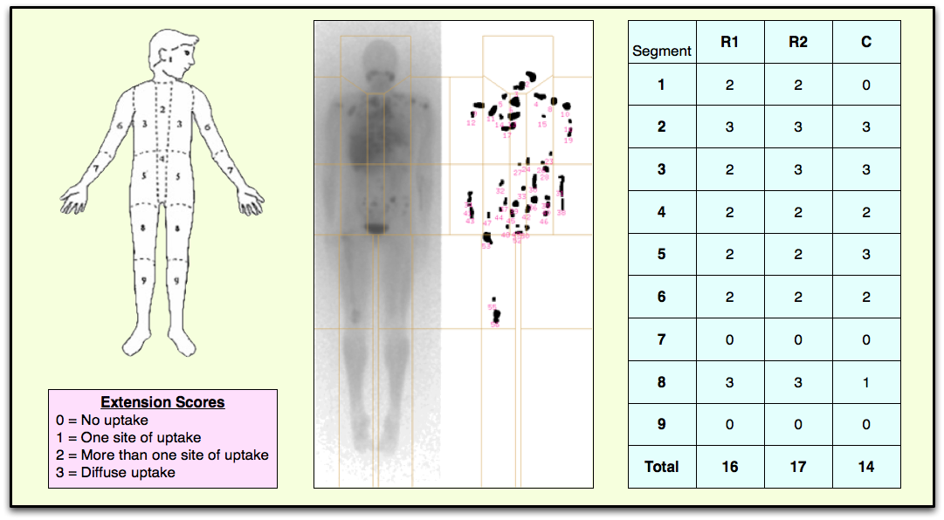

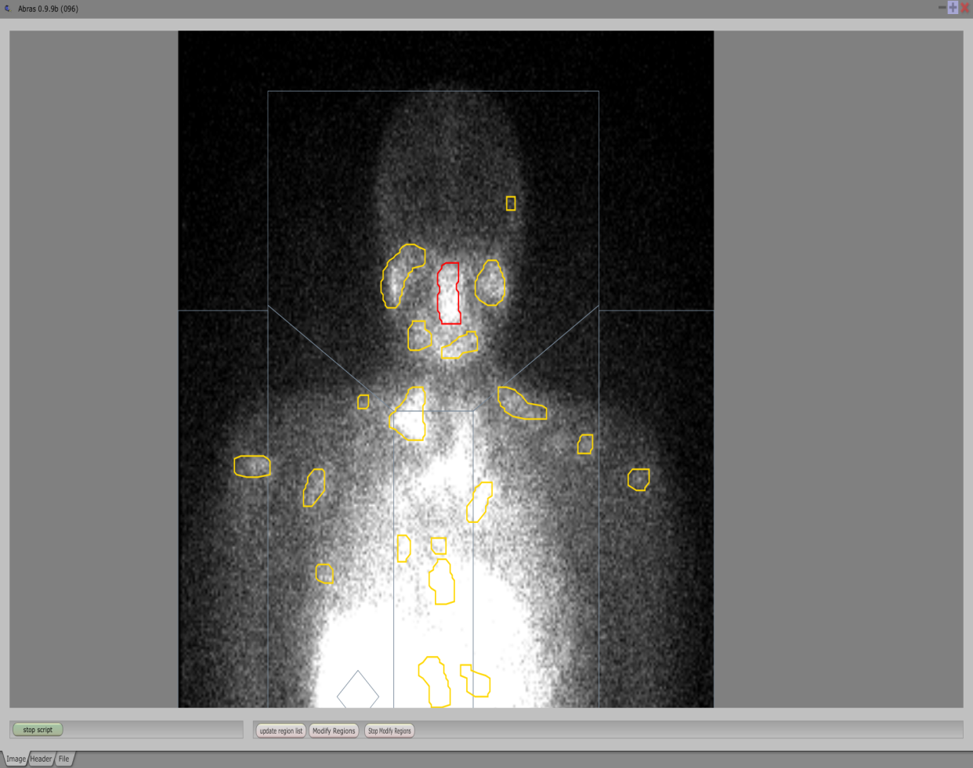

Snapshot of MIBG Automated Scoring Interface