Louisiana Highway crash analysis interface
The main goal of the project is to develop an accident-analysis program on a GIS platform that is comprehensive in the functionality but also user friendly. This program can be used to assist engineers at LaDOTD and other highway safety professionals in the state to conduct a variety of highway safety analysis in order to come with the most effective safety improvement projects that target the core of the problems. The programming language is VB.NET.
There are 10 modules in the program:

- User register and management
- By time& By crash characteristics
- Blackspot Identification
- Overview of a Particular Highway
- Overview of a Particular Highway by Compound Query
- By Individual Crash Report
- By Sliding Window Method (User-defined lengths)
- By Flexible Inquiry
- Historical Data vs the Predicted by SPF
- Map Control

The followings are the snapshots of the platform.

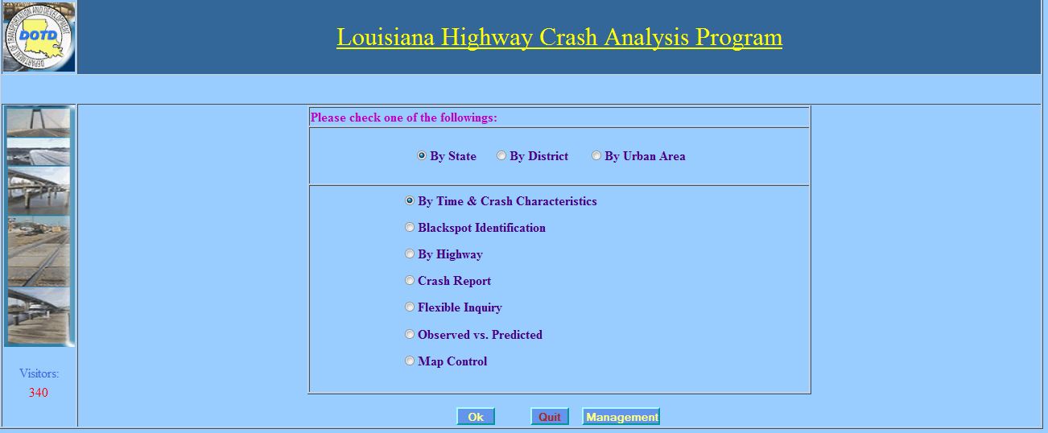
The Basics

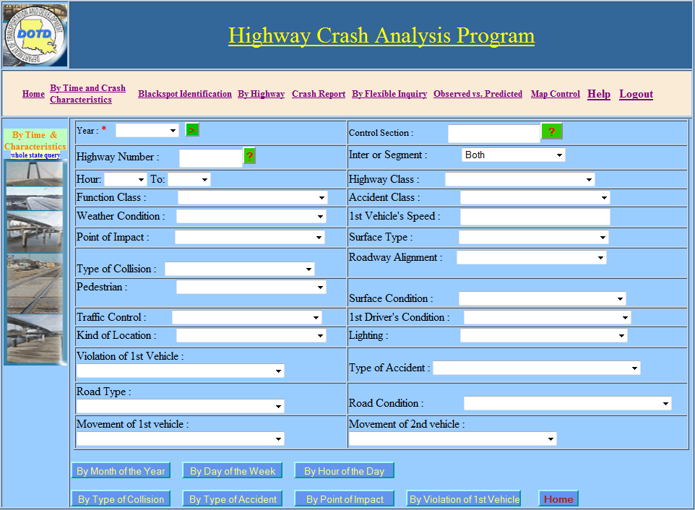

Query Output
After the search criteria have been set, the user must then determine the output type. The output type is either by time or by accident. The options available and the output type are listed below. Once the query is run, all parameters selected will be listed in red on the top of the screen in the green box.
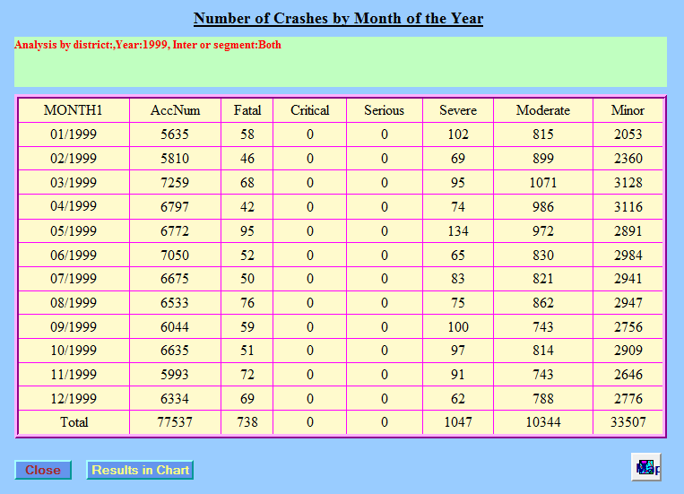
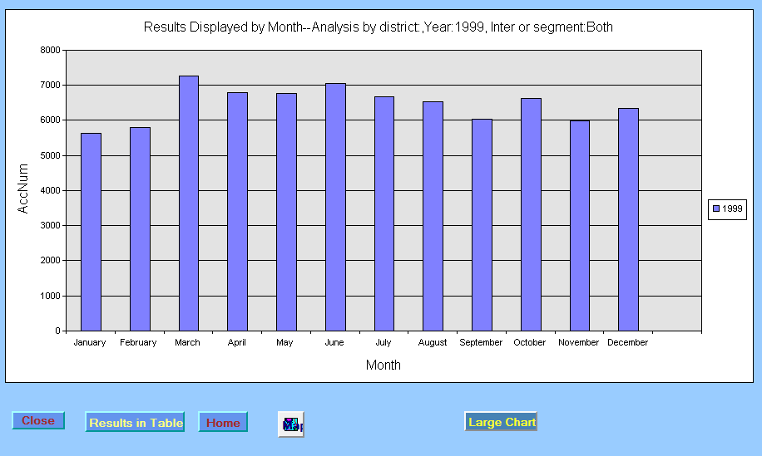

After selecting Crash Report the query parameters will be set. The user is allowed to enter different selections by using the drop down selections available. Only fields notated with are required to be entered.
REQUIRED FIELD(S) – Year
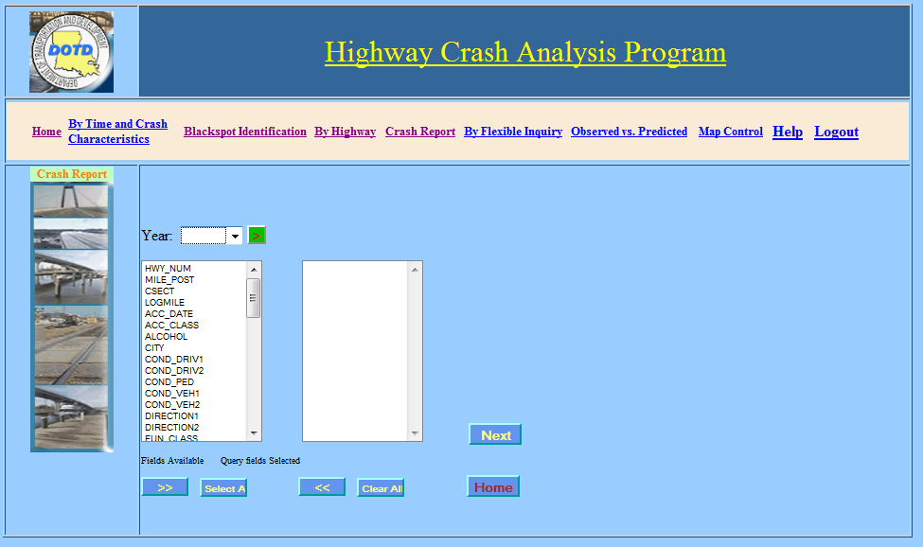
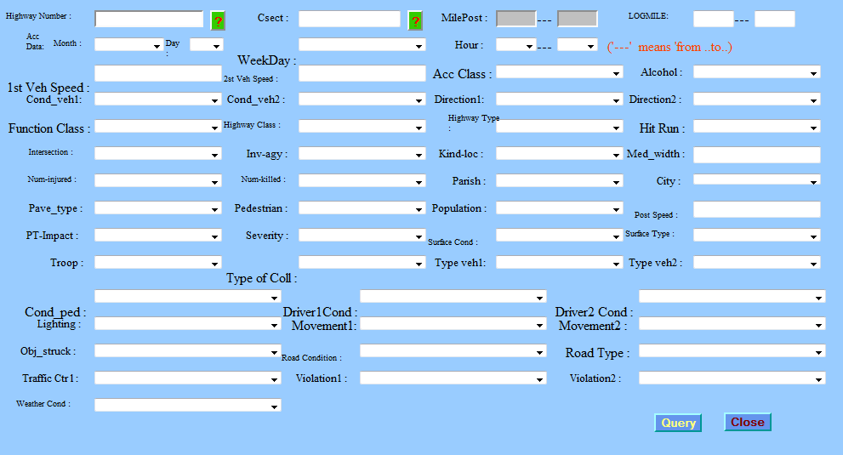

Query Output
After the search criteria have been set the query is run. Once the query run is complete, all parameters selected will be listed in black on the top of the screen in the green box.
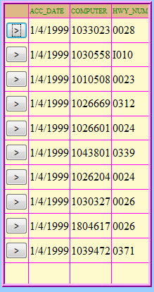
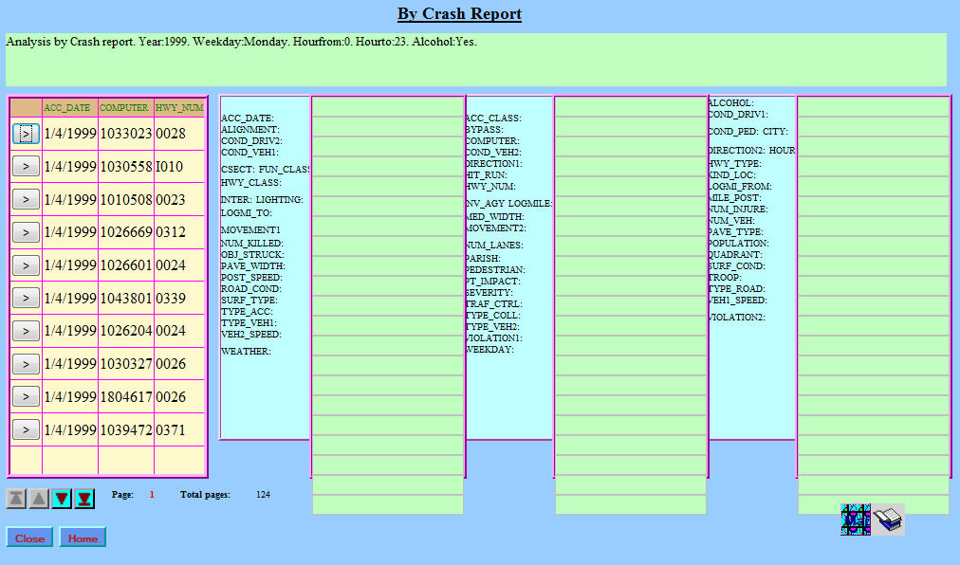
At this point the query results are listed on the left side of the screen. Each accident is listed and can be selected for further review.

Once an individual accident has been selected for review, there is an additional option available to the user. The user can then click on the  icon and view the actual crash report. Also, the user will be able to view all fields in which that accident satisfied for the query.
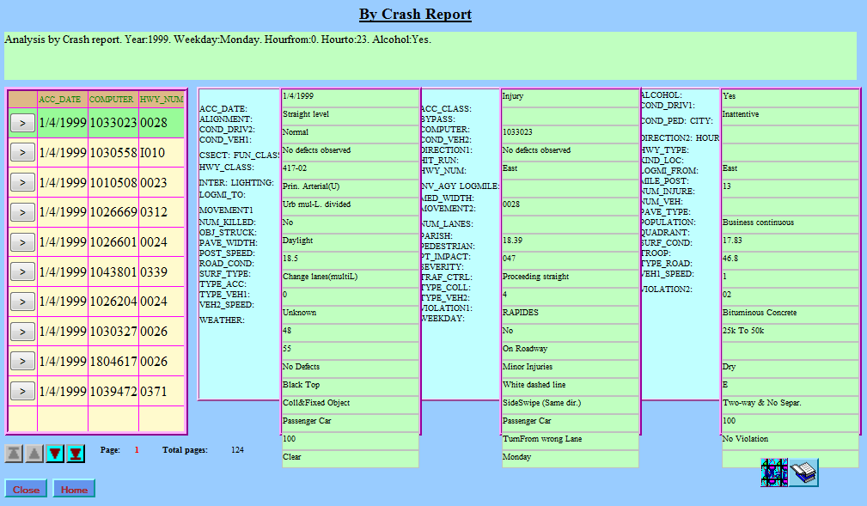
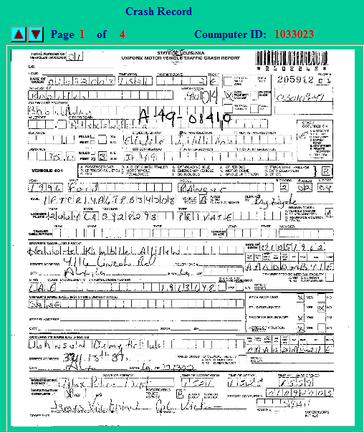

Query Output
After the search criteria have been set, the user then runs the query. Once the query is run, all parameters

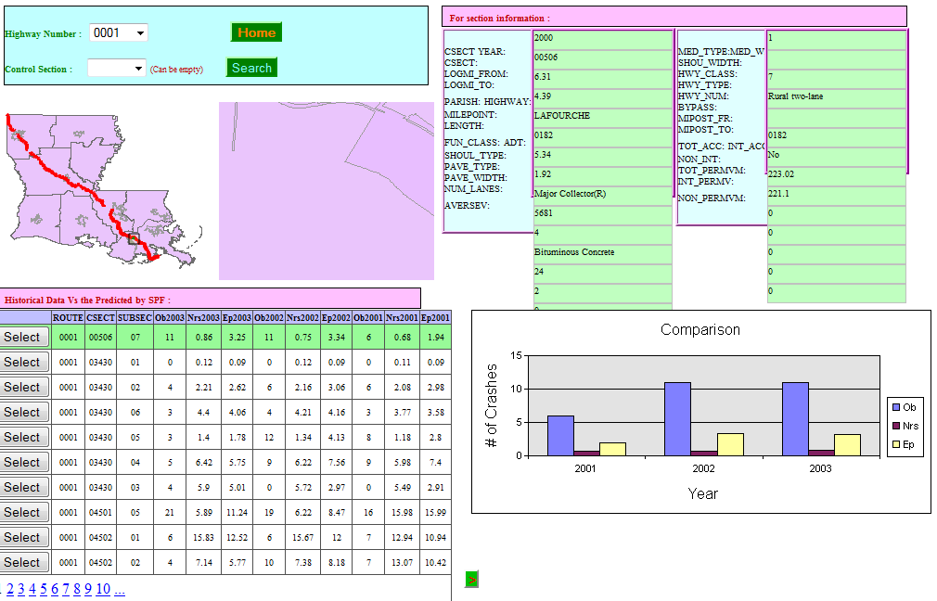

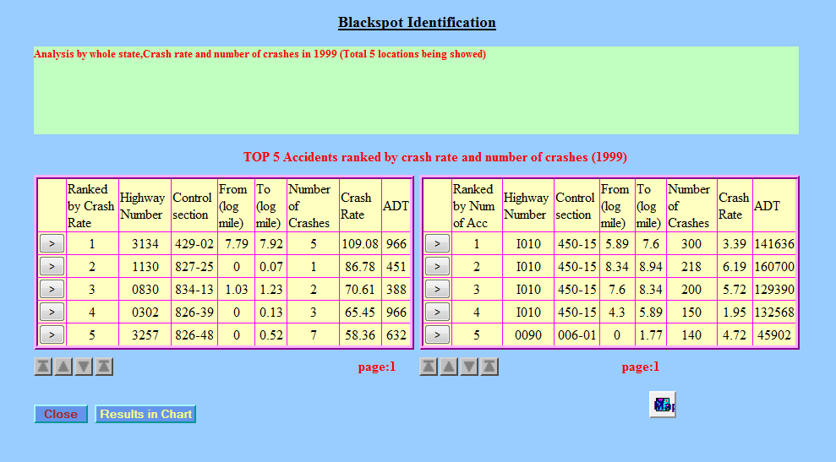
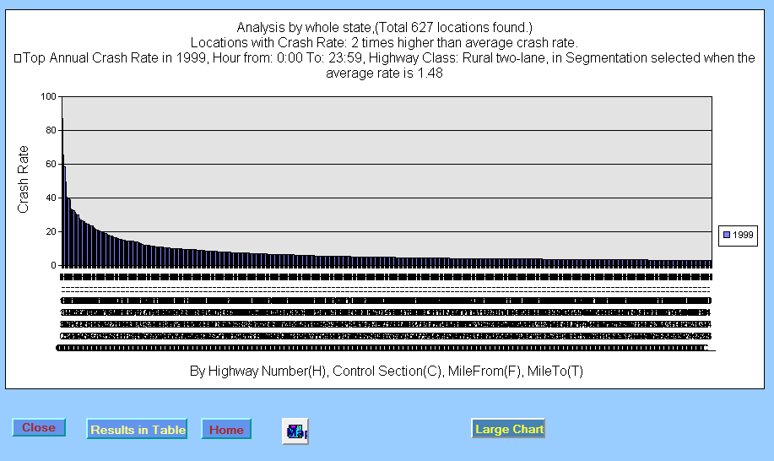

REQUIRED FIELD(S) – Highway Class
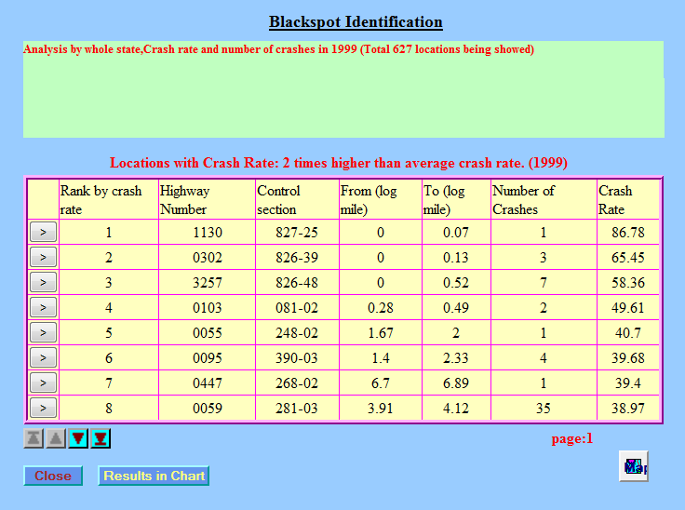

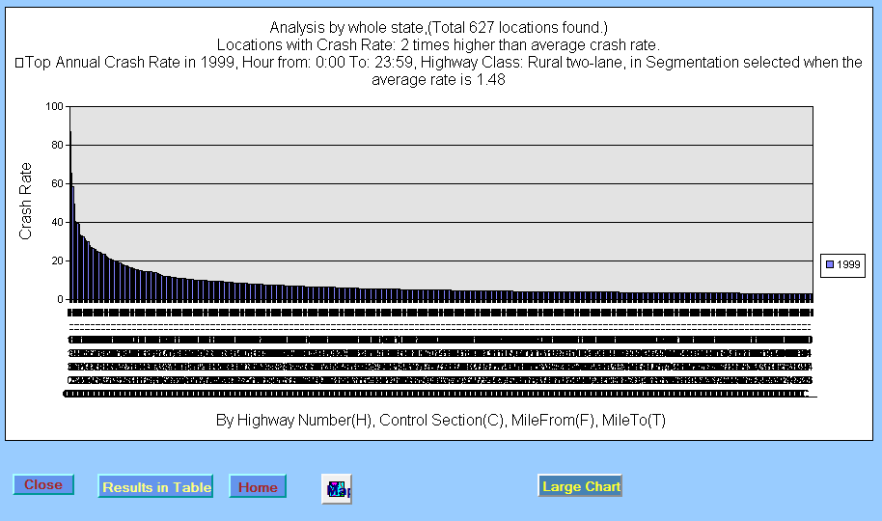

REQUIRED FIELD(S) – Year and Highway Number
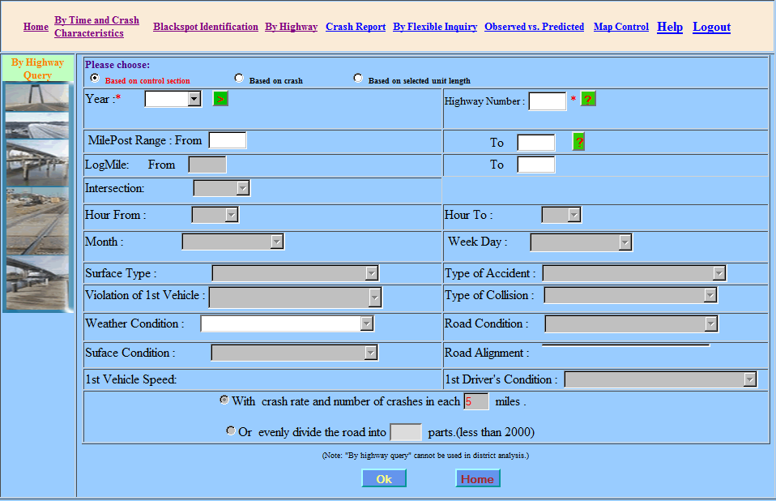

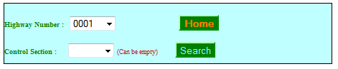
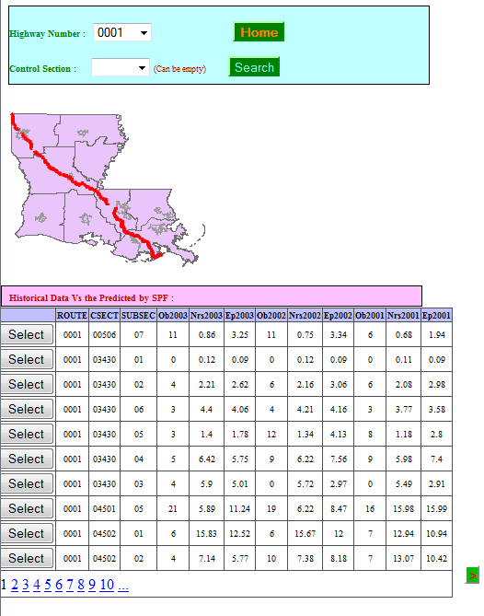

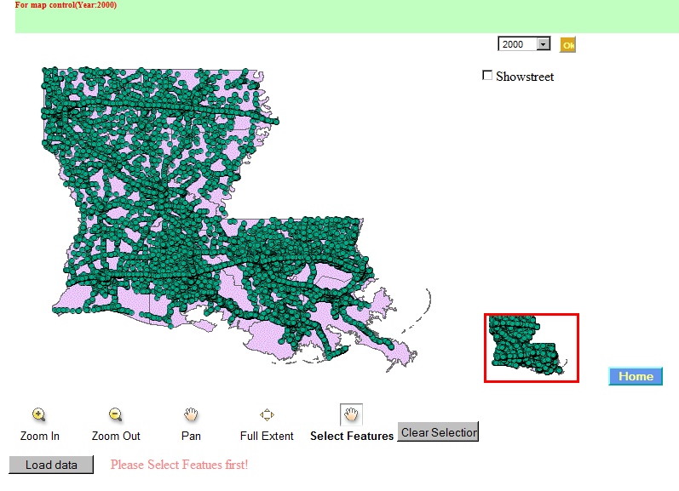
The user is capable of selecting the following in addition to the features:
The year in which to view -

Show streets on map –

Change views by zooming in or out, panning the view and also viewing to the full extent –

view on Map Control option

