**90DaysOfDevOps Challenge (Learn, Upskill, Grow with the DevOps with Shubham Community)**

<https://github.com/LondheShubham153/90DaysOfDevOps>

<https://www.youtube.com/watch?v=d81GTPkSrBQ>

<https://www.youtube.com/live/cIn_V9nUt_A>

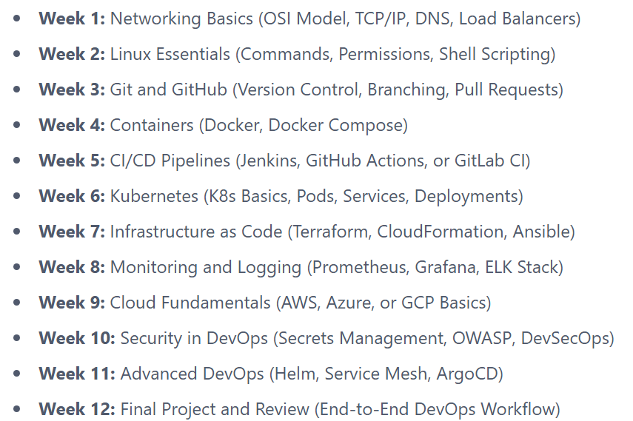

25 Jan 2025: Introduction to DevOps and Cloud

26 Jan 2025: Network Fundamentals

1 Feb 2025: Introduction of Linux for DevOps

