**Objectives:**

Based on the codes provided here, the objectives or functionalities of each file:

**index.php:**

Objective: Provide a simple login form using PHP PDO for authentication.

Functionality:

* Validates user input for username and password.
* Checks the input against the database for authentication.
* Redirects to home.php upon successful login.

**home.php:**

Objective: Display a welcome message and provide links to other functionalities.

Functionality:

* Displays a welcome message with the logged-in username.
* Provides links to additional features like adding users and using a sample drop-down menu.
* Includes a logout link to end the session.

**dropdown.php:**

Objective: Display a drop-down menu populated with usernames from the

database.

Functionality:

* Retrieves usernames from the database and populates a drop-down menu.
* Displays a message indicating successful login.
* Provides navigation links.

**add.php:**

Objective: Insert user data into the database.

Functionality:

* Inserts user data (username, password, and full name) into the tbuser table.
* Displays the existing user data in a tabular format.

**read.php:**

Objective: Display and manage user data from the database.

Functionality:

* Displays existing user data in a table.
* Provides a form to add new users.
* Allows searching for users based on their ID.
* Provides options to edit or delete user data.

**update.php:**

Objective: Modify user data in the database.

Functionality:

* Displays a form pre-filled with existing user data.
* Allows the modification of username, password, and full name.
* Updates the database with the modified data upon submission.

**delete.php:**

Objective: Delete a user record from the database.

Functionality:

* Deletes a user record based on the provided ID.
* Redirects to the sampleadd.php page after deletion.

**search.php:**

Objective: Search for a user based on their ID.

Functionality:

* Provides a form to input an ID for searching.
* Displays user data in a table if the ID exists.
* Displays a message if no data is found or if an invalid ID is provided.

These objectives summarize the main functionalities of each file within the context of

a user management system.

**Folder Structure of the Project**

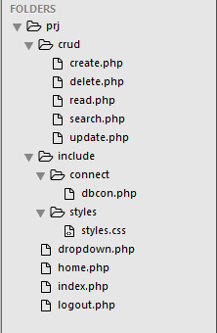

**For the database:**

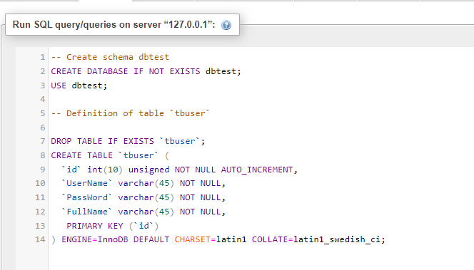

This code defines a MySQL database named **dbtest** and a table within it called **tbuser**. Let's break it down:

**CREATE DATABASE IF NOT EXISTS dbtest;:** This line creates a database named dbtest if it doesn't already exist.

USE **dbtest;**: This line selects the dbtest database for use. It's essentially saying, "I want to work within the dbtest database."

**DROP TABLE IF EXISTS tbuser;:** This line drops the table tbuser if it already exists. It's a safety measure to ensure that if the table exists, it's deleted before creating a new one.

**CREATE TABLE tbuser (...)::** This block of code creates the tbuser table with the following columns:

* id: An auto-incremented integer used as the primary key.
* UserName: A varchar (variable character) column for storing usernames.
* PassWord: Another varchar column for storing passwords.
* FullName: A varchar column for storing full names.

The table uses the InnoDB storage engine, and the character set is set to Latin1 with a specific collation.

**PRIMARY KEY (id):** This line designates the id column as the primary key for the tbuser table.

So, in summary, this script sets up a MySQL database named dbtest with a table tbuser to store user information. The user table has columns for username, password, full name, and profile picture. The id column is the primary key for uniquely identifying each user.

**Index.php**

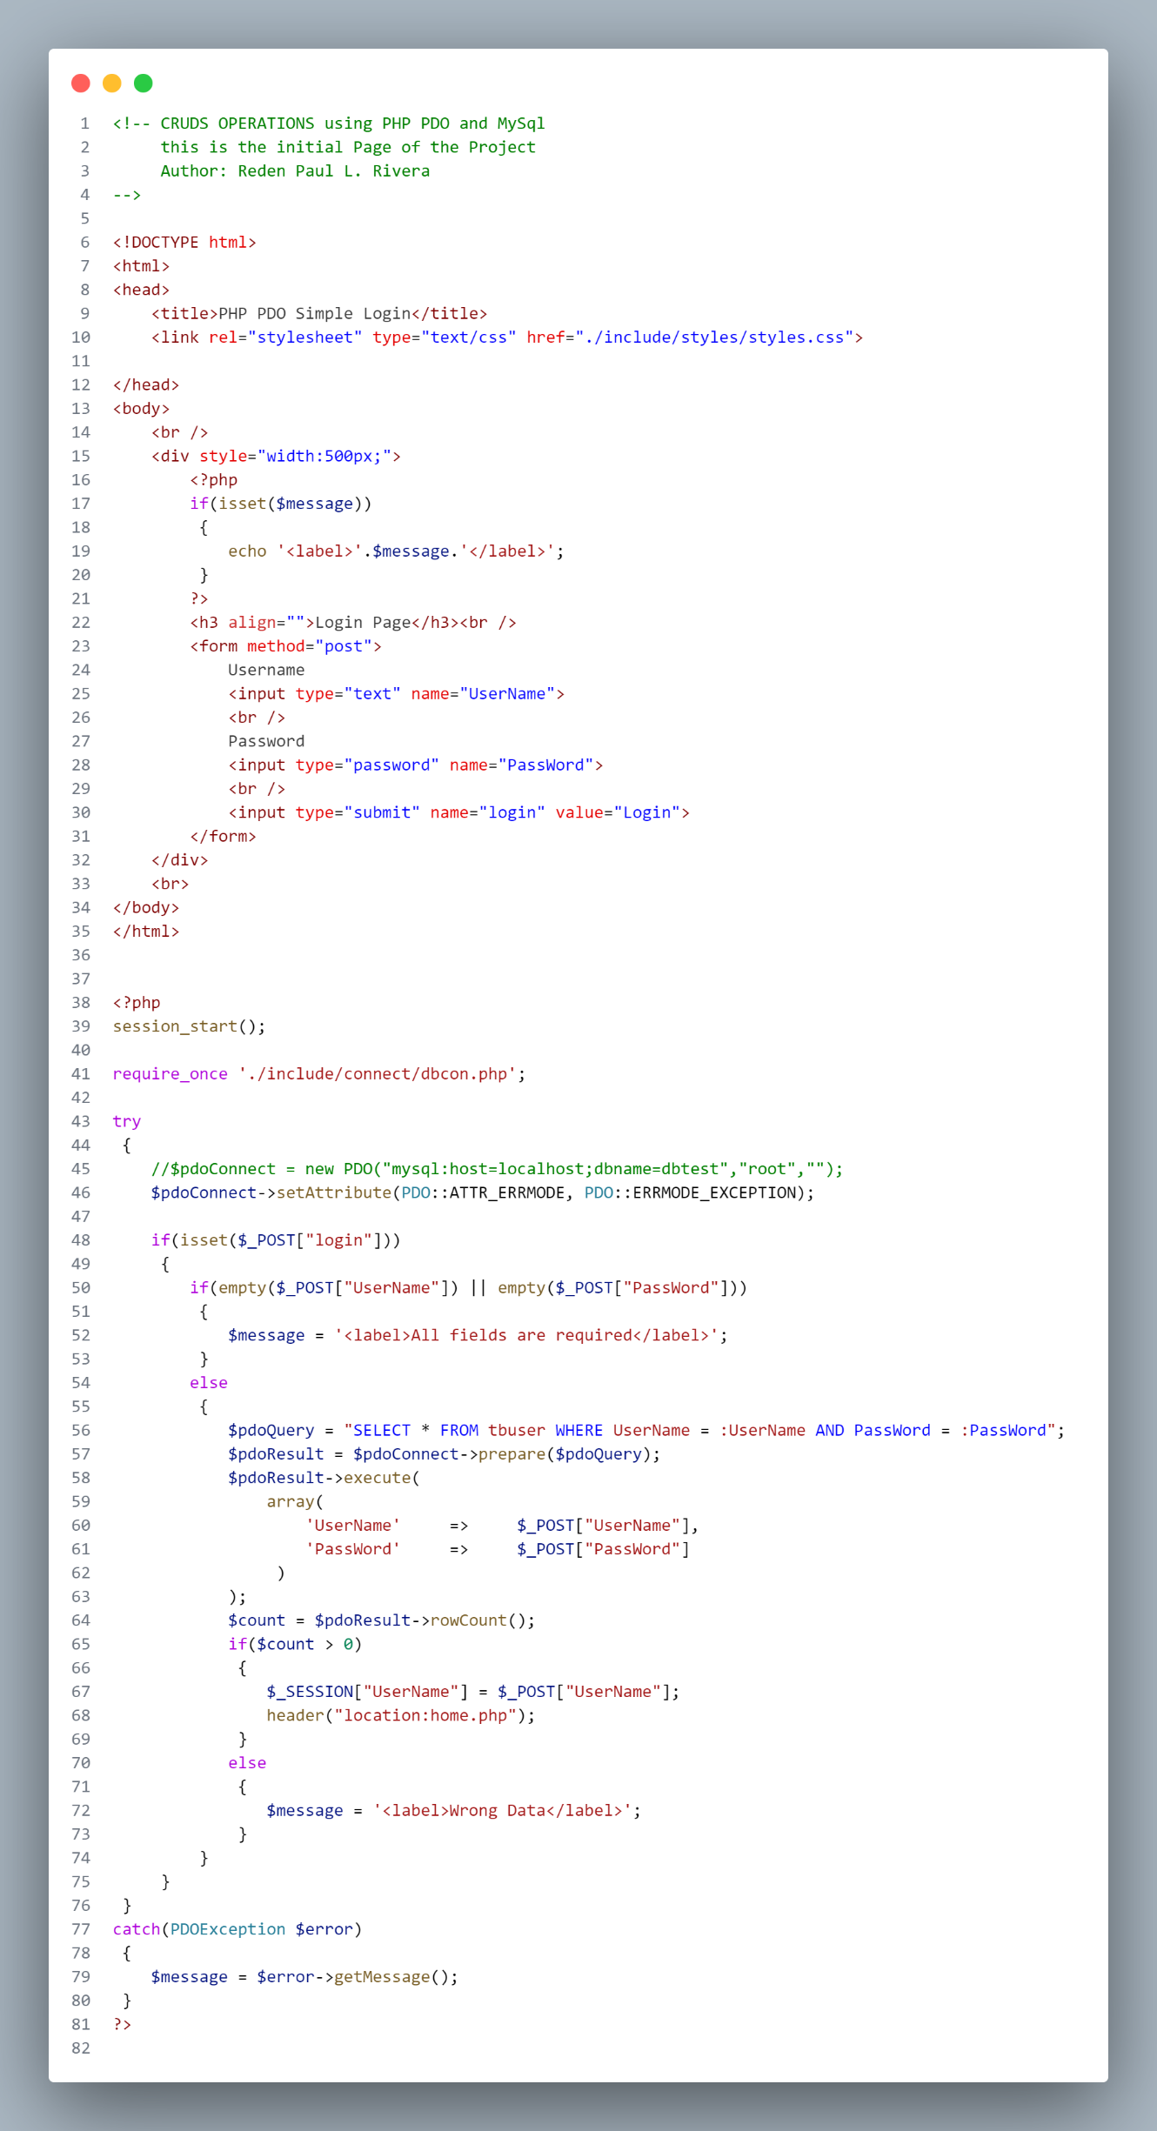

**Home.php**

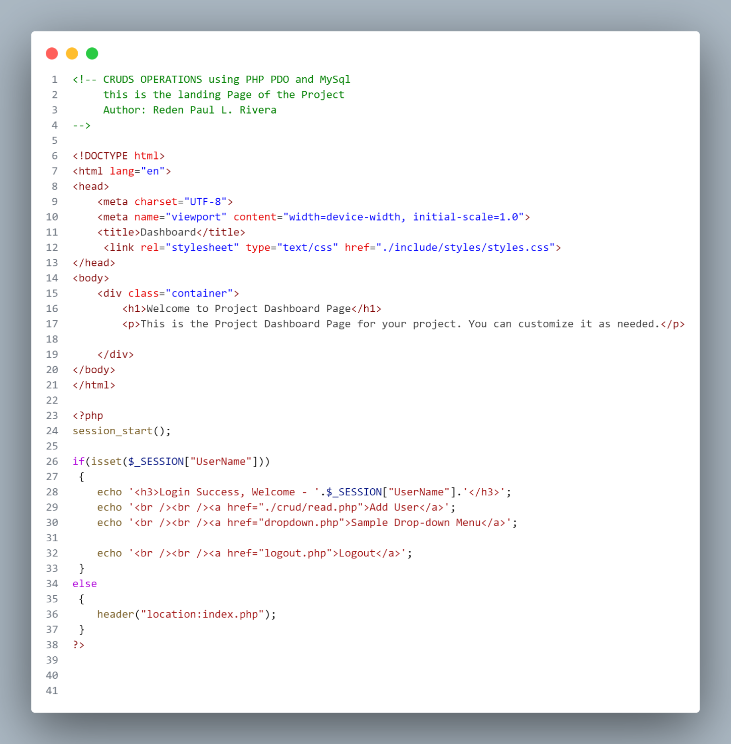

**Logout.php**

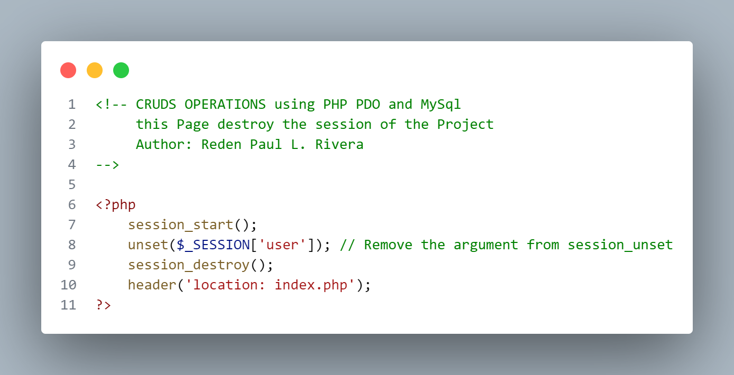

**dropdown.php**

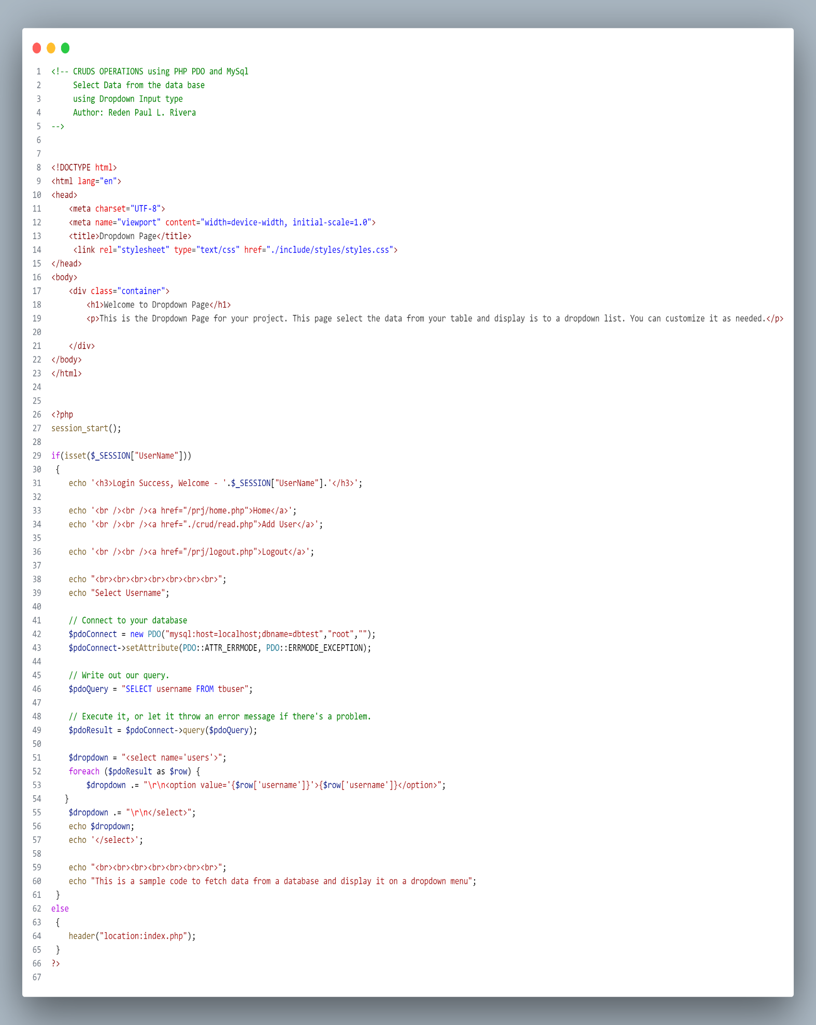

**Style.css**

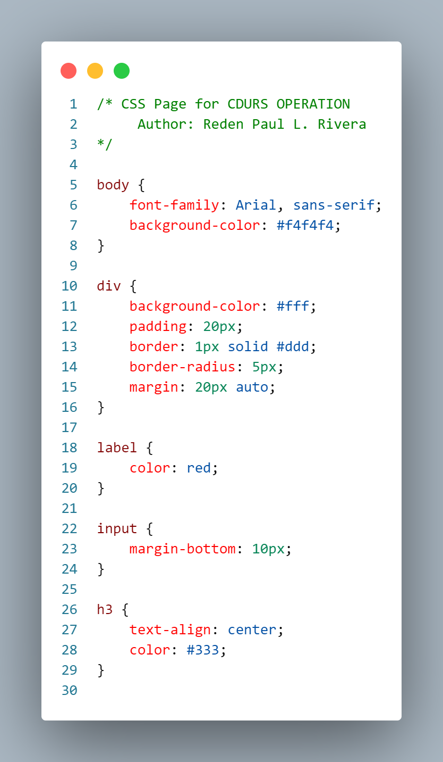

**dbcon.php**

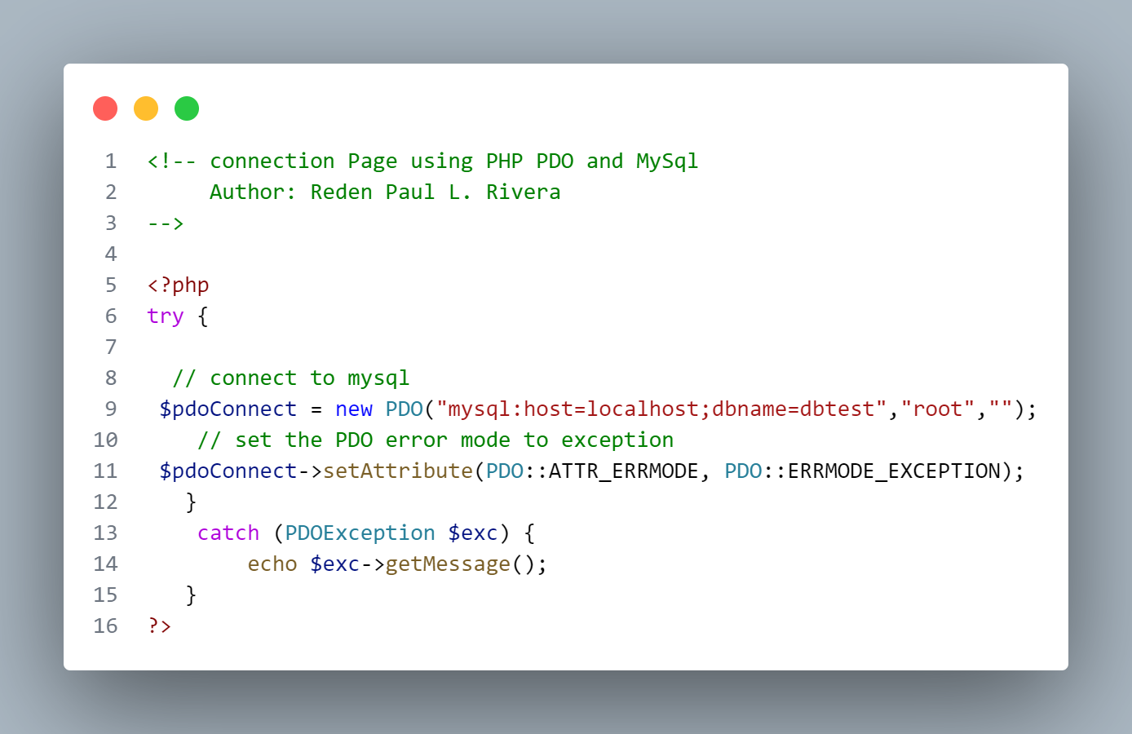

**Create.php**

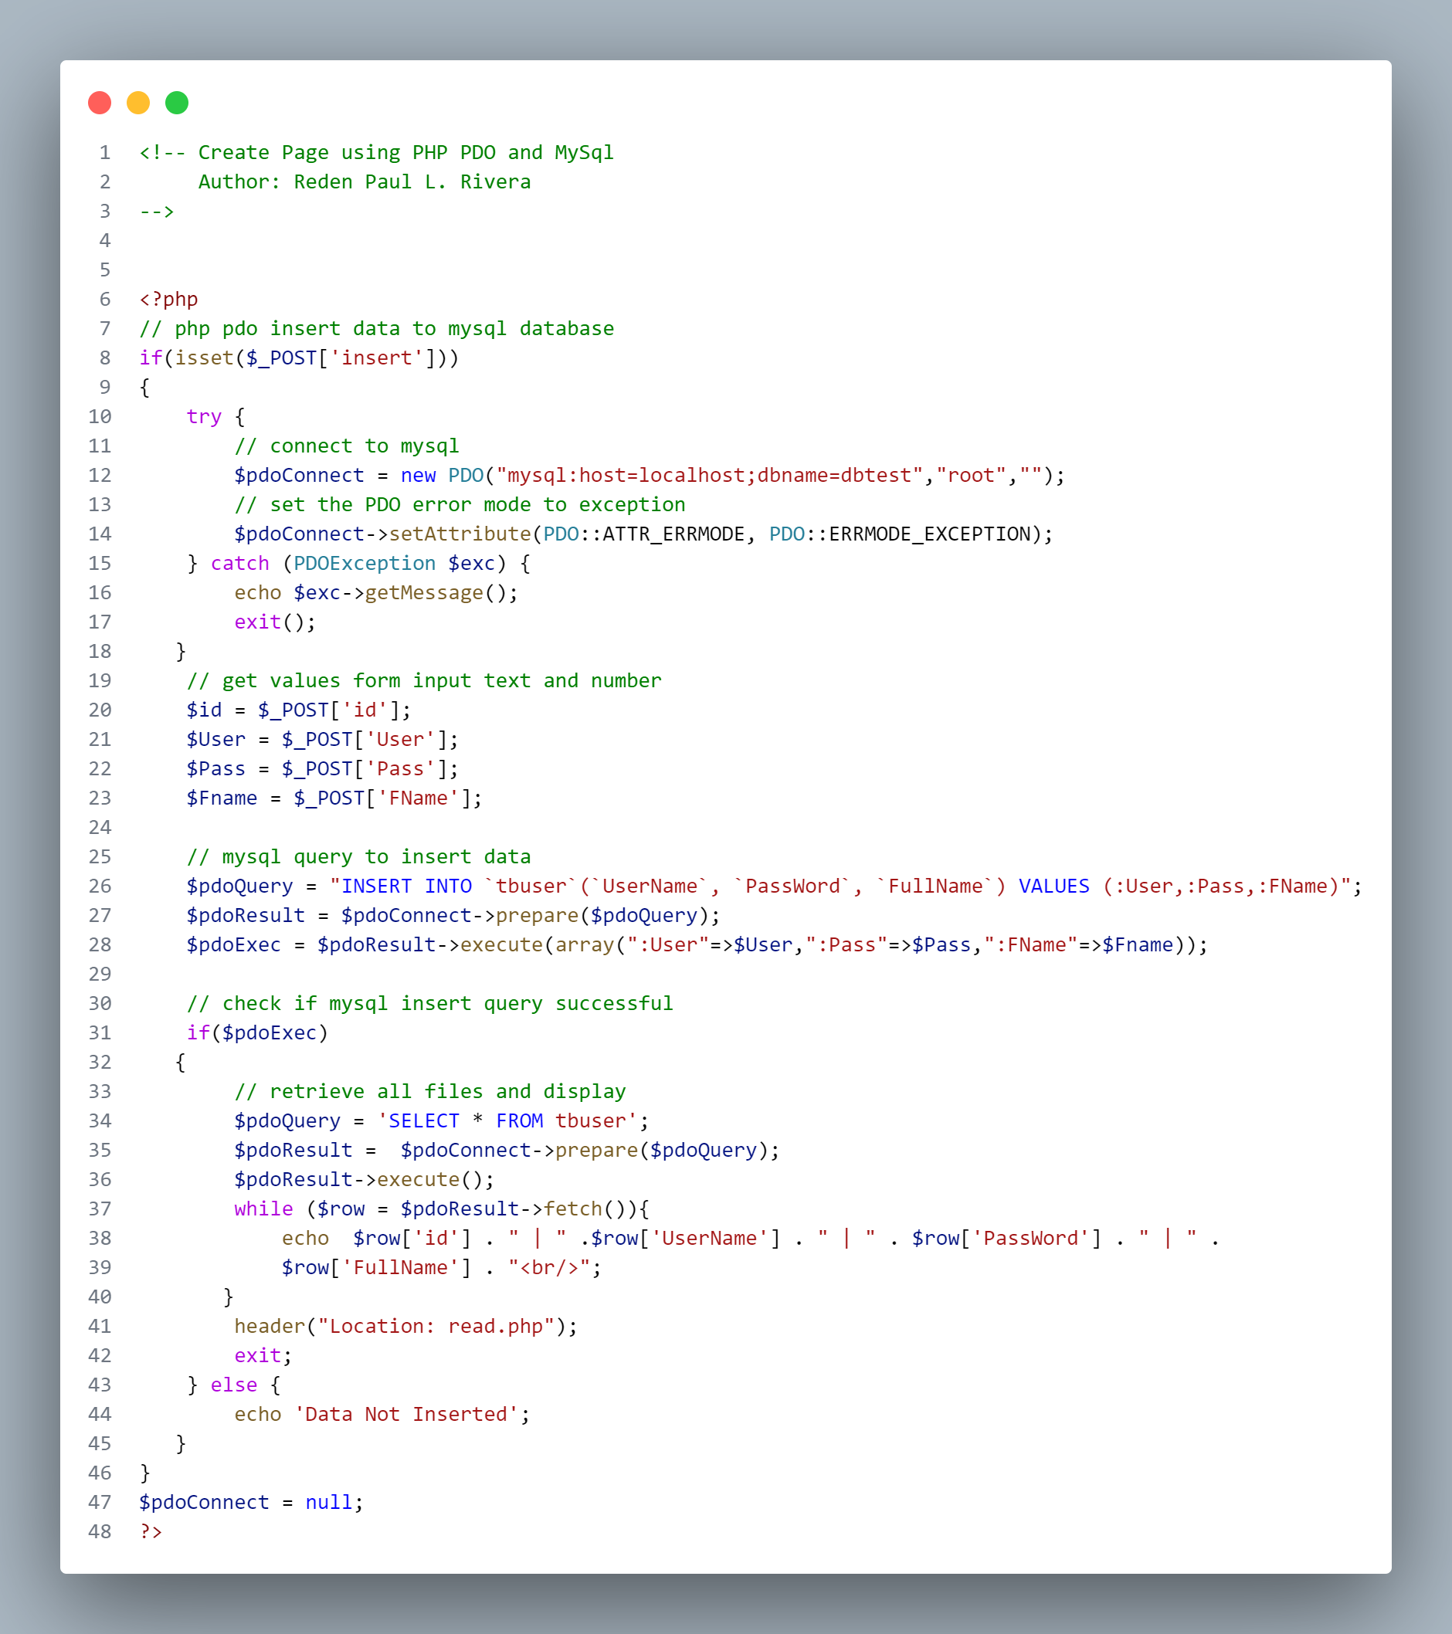

**Read.php**

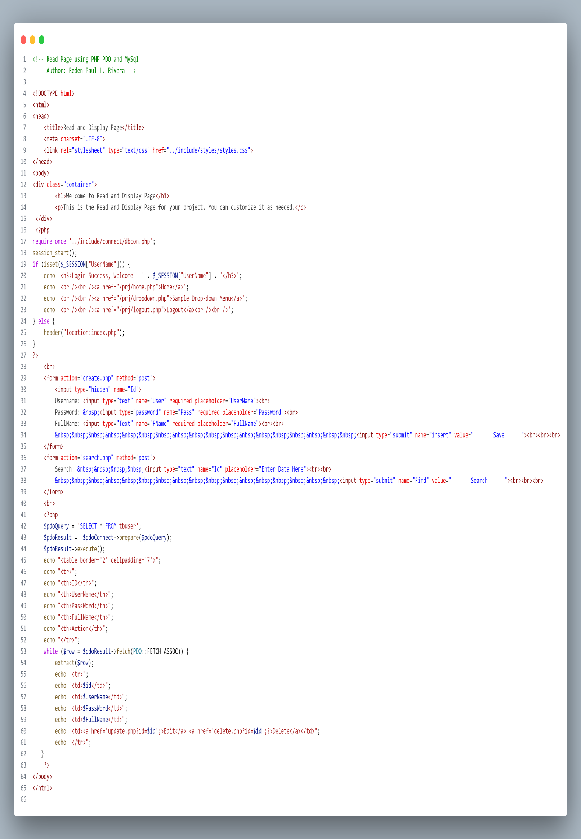

**Update.php**

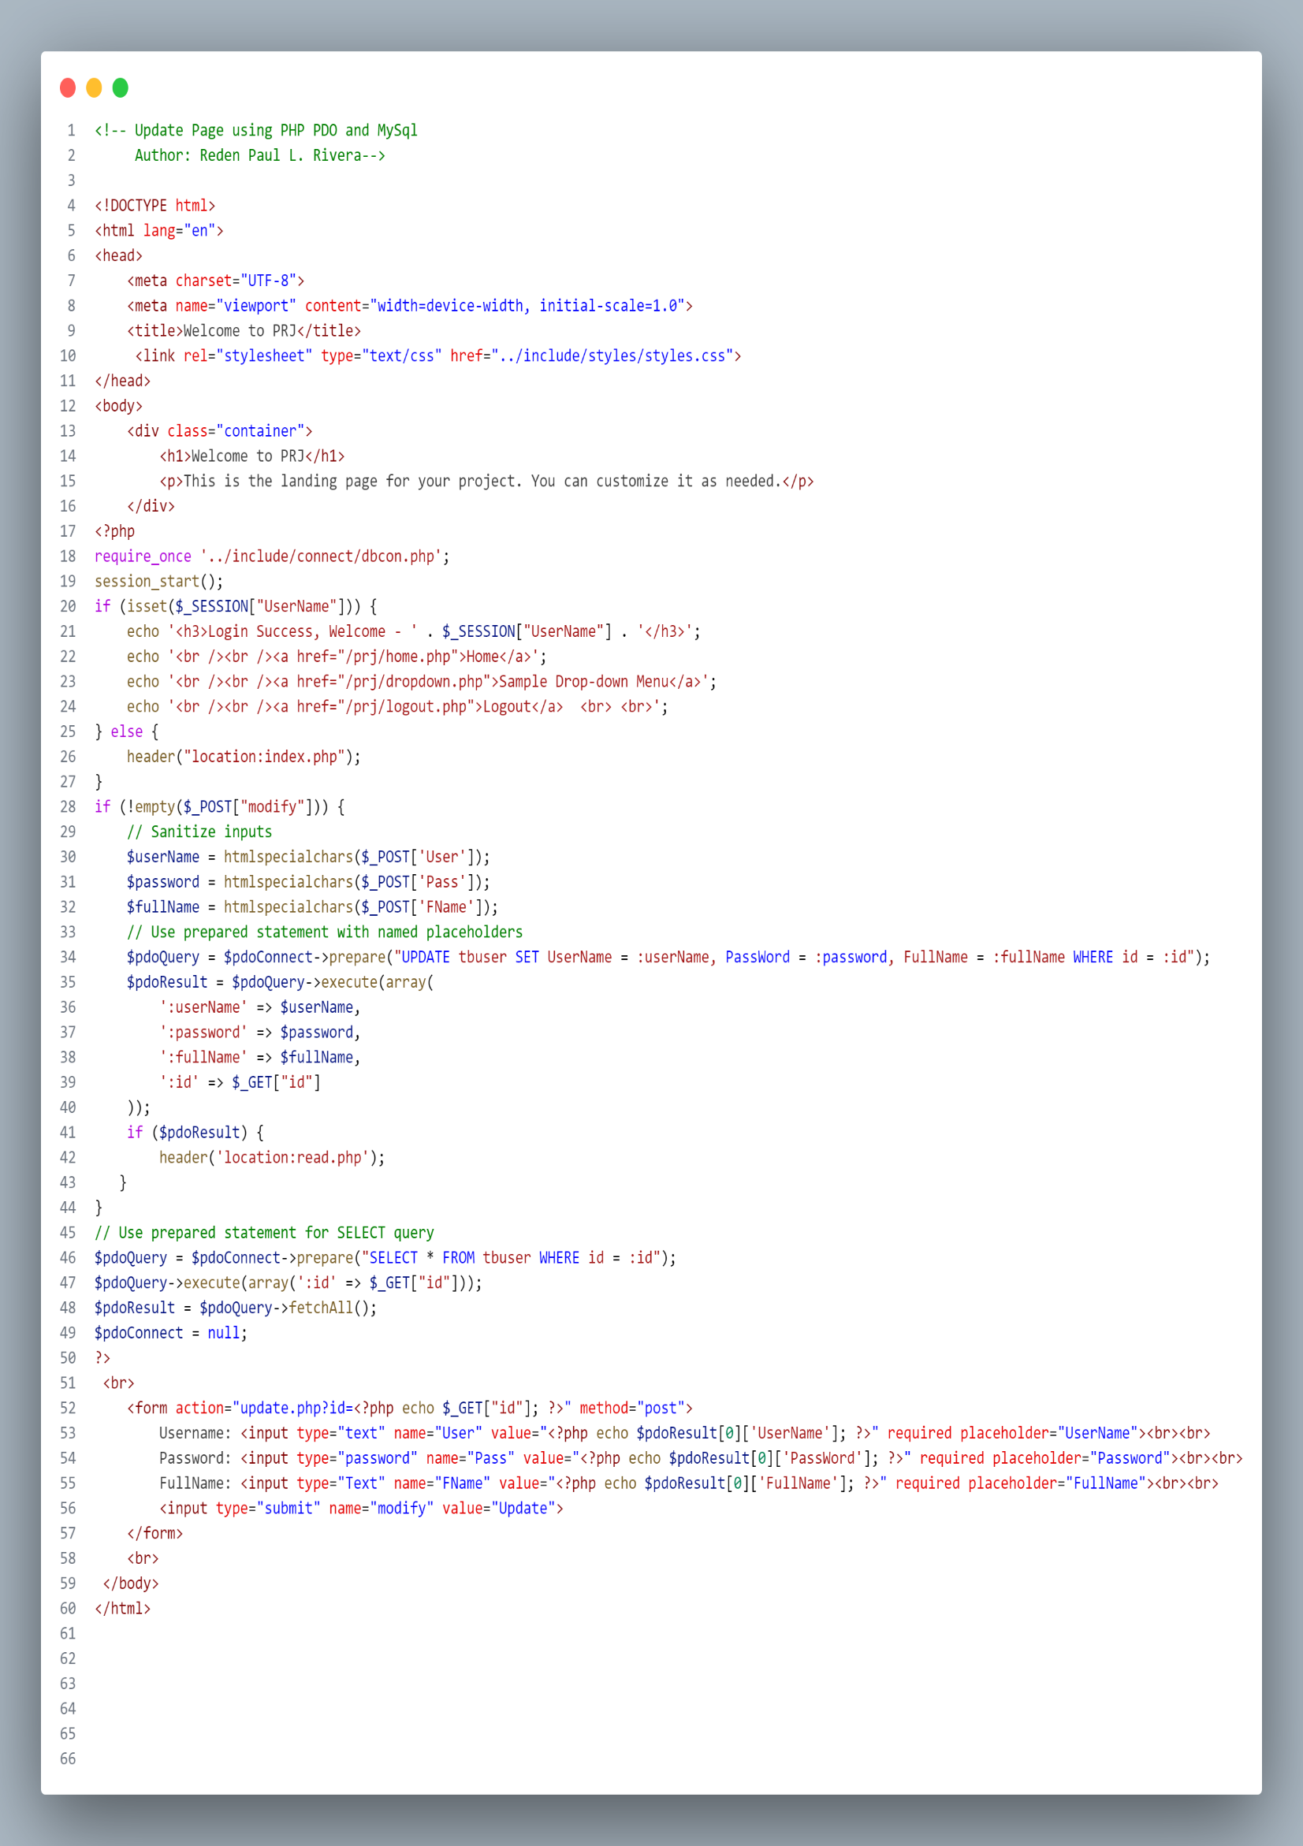

**Delete.php**

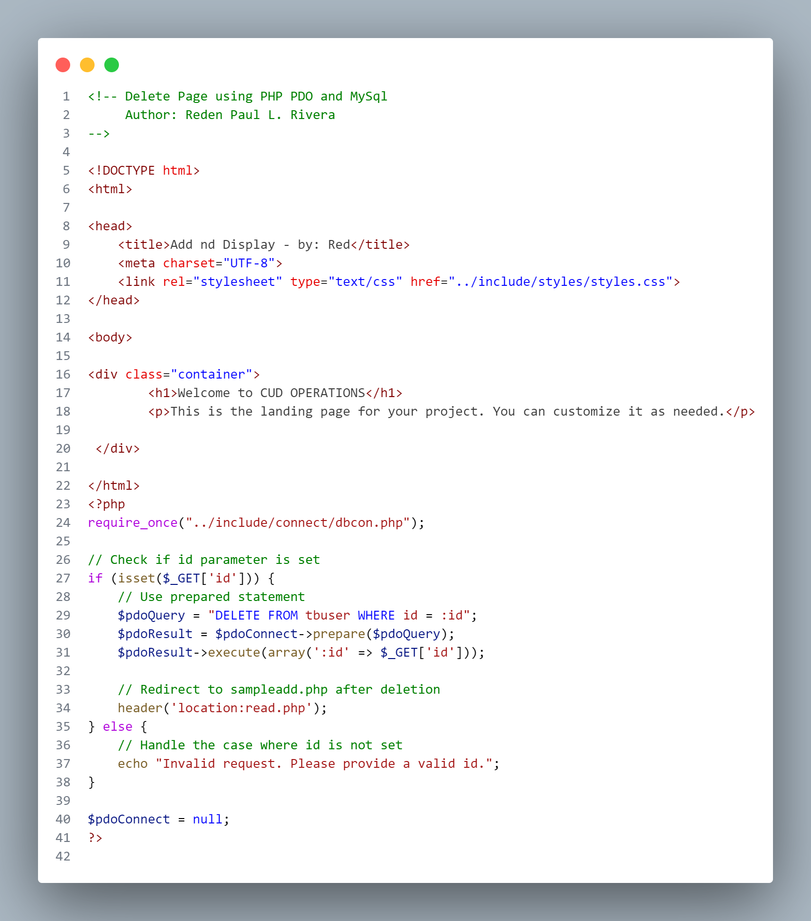

**Search.php**

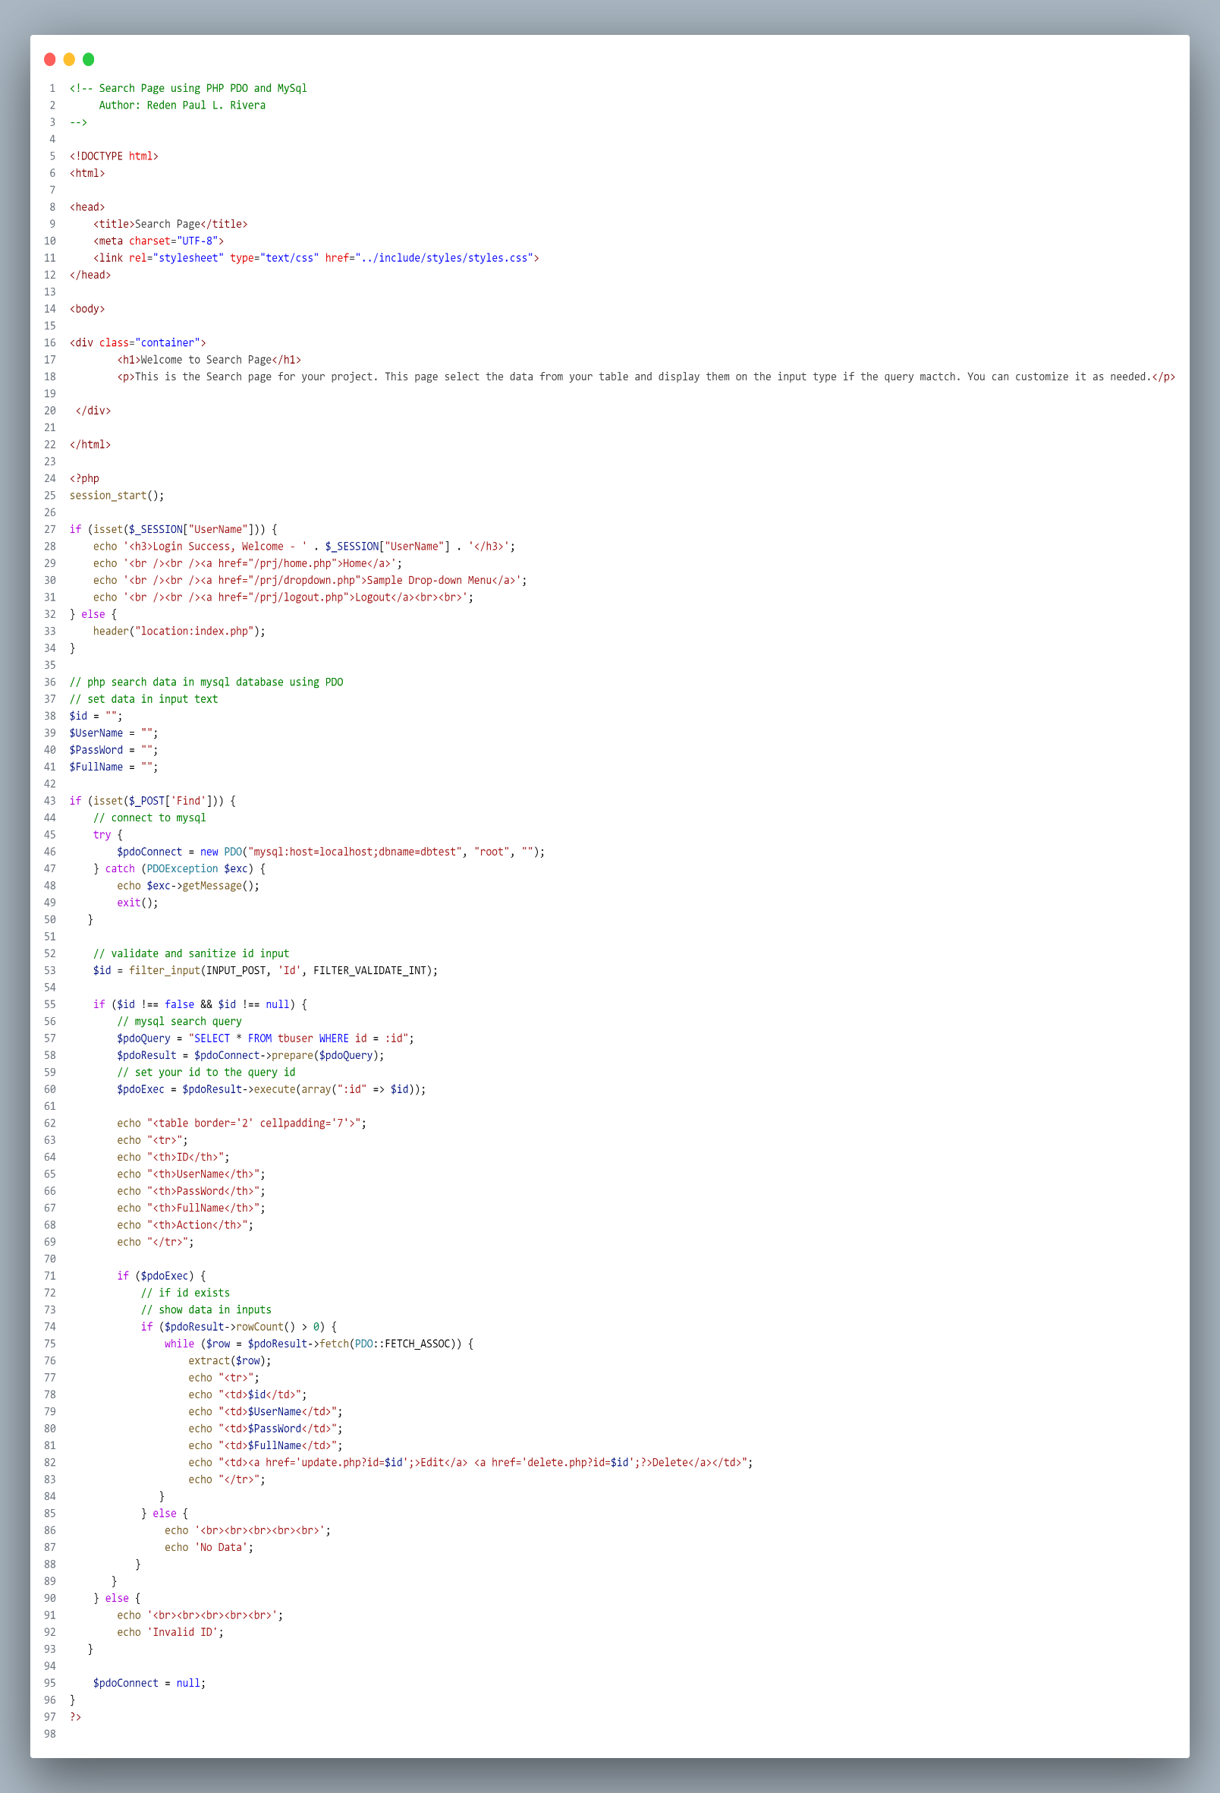

Call the page once done and run it:

http://localhost/prj/index.php

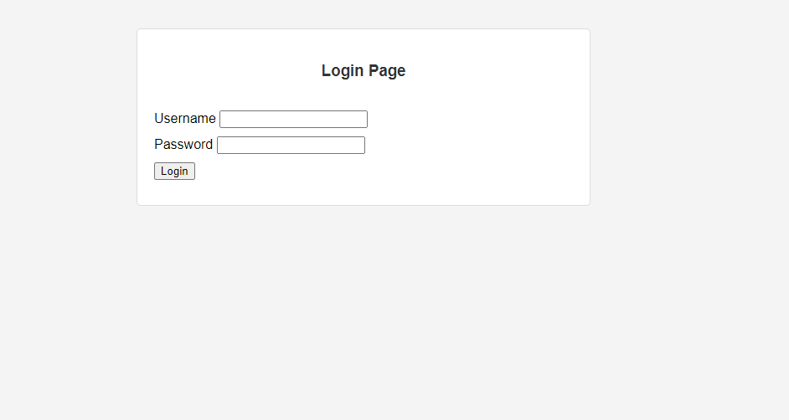

Add credentials on your database.

Once done and had a successful login it will redirect you on your page dashboard.

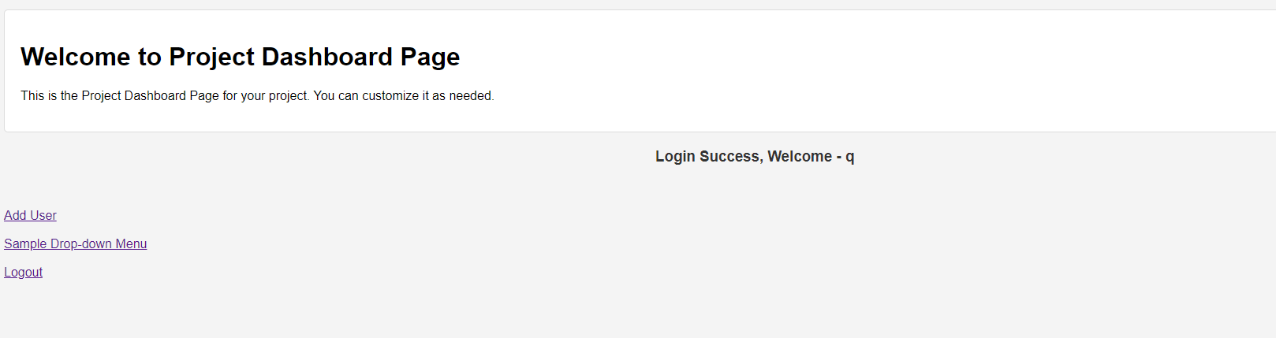

Click add user and it will show you this page. Explore the sample project.

