**HY564 Phase 1**

**Intermediate Deliverable**

**Team 7**

**Dagalakis Stauros**

**Kalaitzakis Giannis**

**Kalogiannis kostas**

**Smart Office Overview**

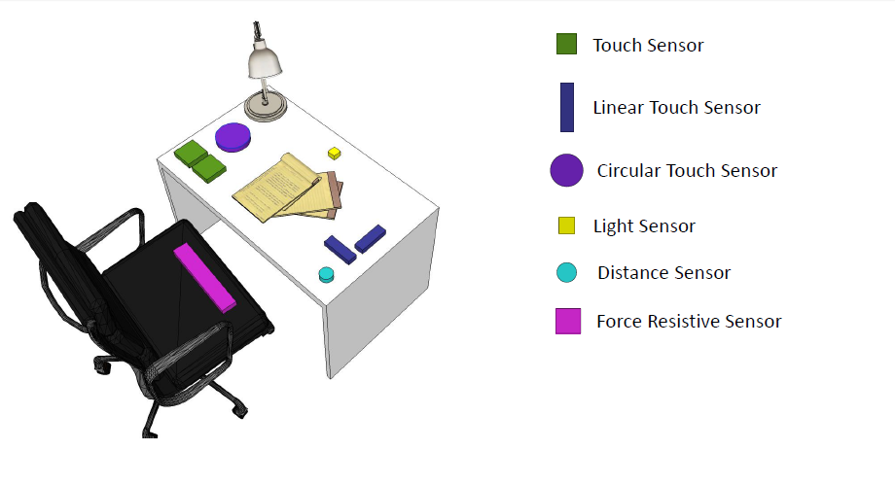

**Regarding the Sensors**

The system makes use of all the available sensors in order to provide to the user a more comfortable approach to fulfill his needs.

**How many users?**

Our system consists of 5 users,but can support many users simultaneously as the number only depends on the available devices,who don’t necessarily have to be in the same room or interact explicitly with the smart environment.The inter-user privacy is of great importance in our office because of the pleasure of use of our system.

**Devices in use**

Our system supports 4 devices (pc,tablet,huge screen and phone/tablet)

Every user can perform a plethora of actions before and during a meeting.

**Conference Description**

Every attendant comes to the conference room. By switching the lights on, the sleeping mode is revoked and the huge screen opens up. Those who select to attend remotely can use the device they have at the time being (smartphone,tablet,pc). The ones who join by physically being there “attend” the meeting when they sit on their chair which activates the force resistive sensor while the ones using their devices “attend” by tapping/clicking the “I am here” button on their screen. After the conference session has started the presentation begins with the admin having control/being on the “top left” side of the screen.

Huge screen: sleep mode



**Kinect**

* The admin can use the kinect to choose the menu(raise and hold hand along with saying “settings”) and adjust with his hand the option.

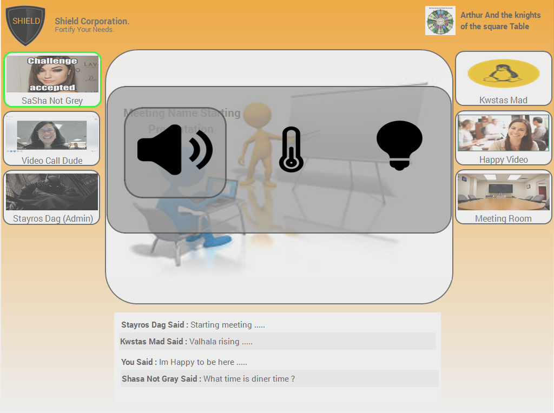

* He has the ability to use the kinect in order to drag and drop a session file to his tablet, in order to inspect if privately.(bottom center of the huge screen.
* He can choose a colleague using kinect and dragging him to the central area in order to make him the “speaker”
* The admin has the ability to do the same as above by using the verbal command “speak” accompanied by his colleague name.
* By using his hand,captured by kinect, and saying mute at the central area,mutes the person currently speaking
* Saying “mute” accompanied by the user name,the admin can also mute a person
* Saying “start” the meeting starts

**Sensors**

* The admin can change the “options” of the conference by using the sensors (button,linear,circular) to open, select and change the values.

1. Using either touch sensor he can open the menu(one button on each side for left/right hand users
2. Using the horizontal linear sensor he can change between the available settings (sound,lights,temperature)
3. Using the vertical linear sensor he can change the value of the selected setting.
4. The circular sensor does the same thing as the vertical linear sensor.

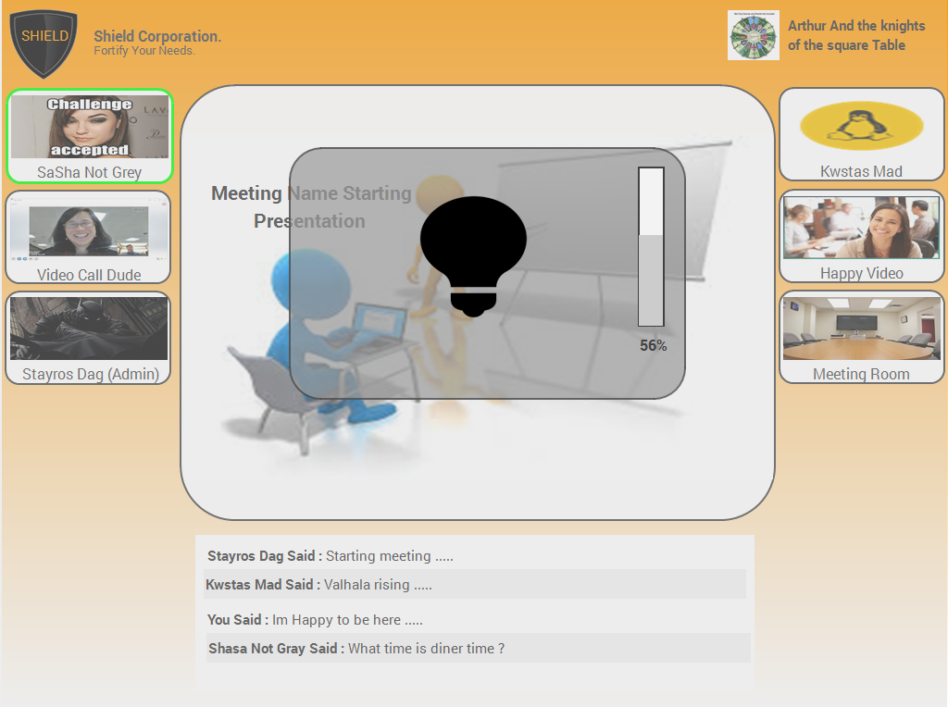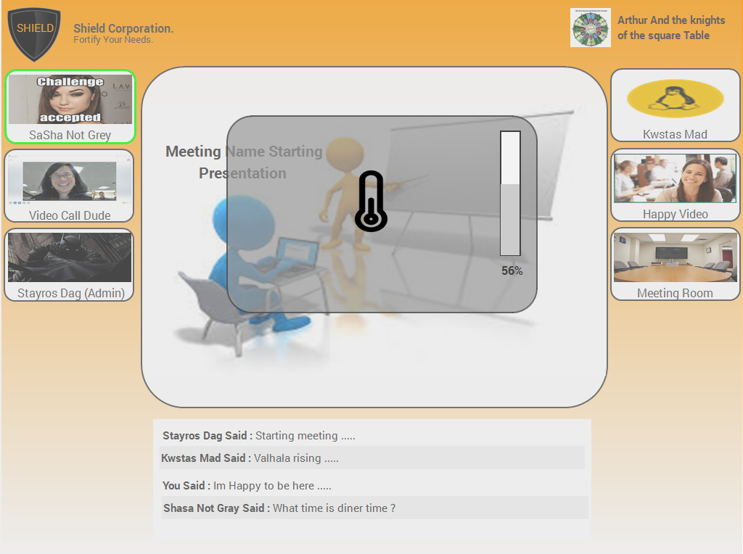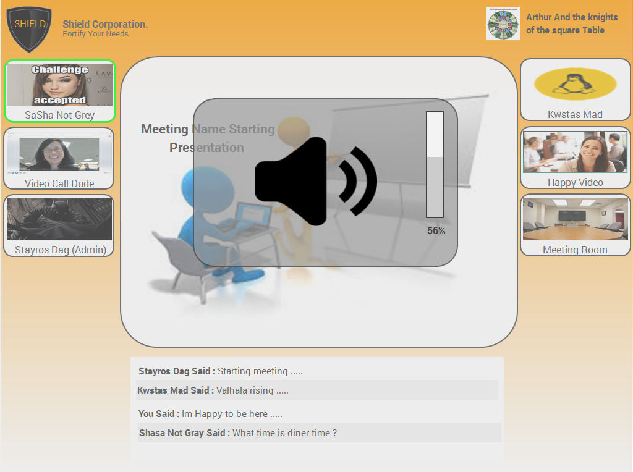

* By using the the proximity sensor, the person currently speaking becomes muted.
* The light sensor is responsible for starting the tablet and the huge screen. When someone enters the meeting room and opens the lights the sleep mode of the devices is lifted.

Huge screen during meeting

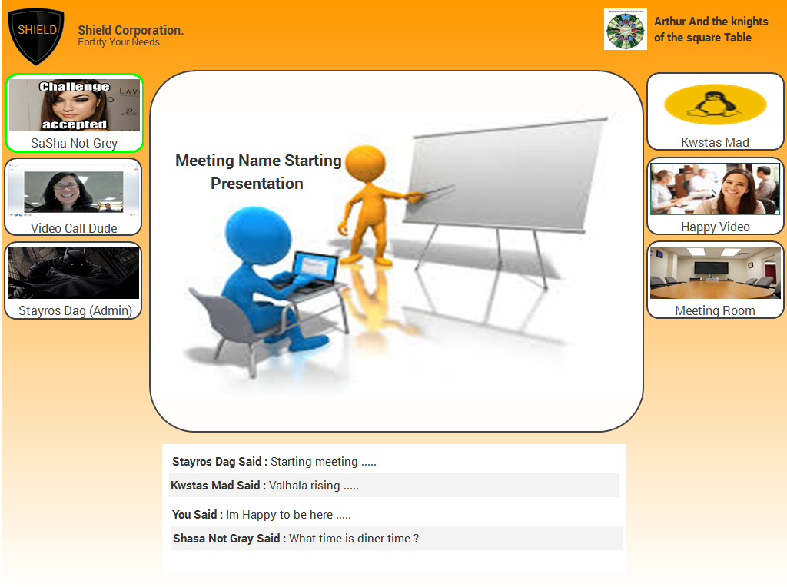

Huge screen during waiting time, meeting not yet started

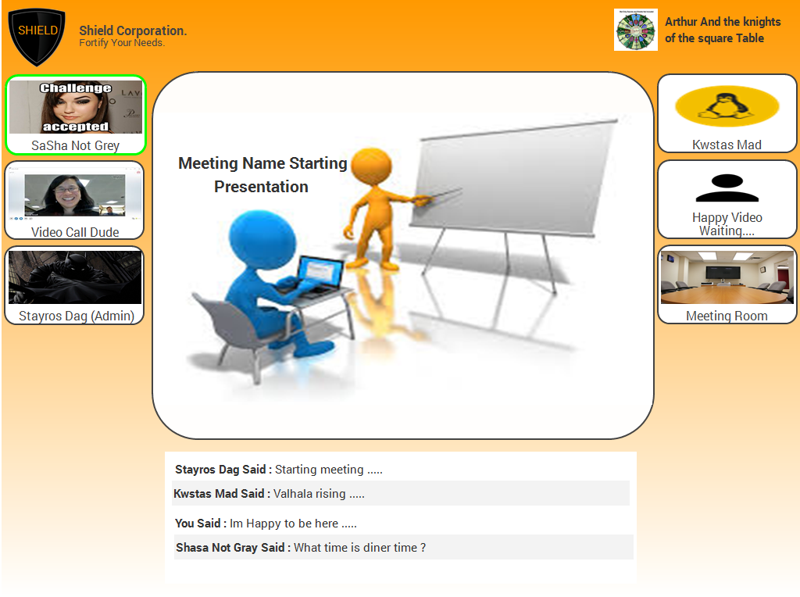

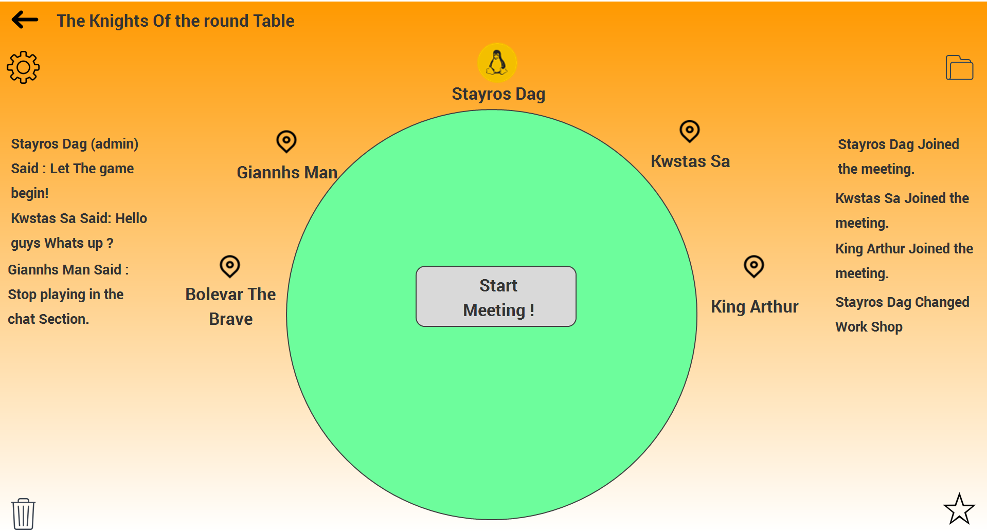**Tablet-Huge Screen**

**Function 1(changing settings):**

The admin can change the brightness of the screen,the sound of the conference call(if there are people remotely attending),the temperature of the room and the lights inside the conference room

* He can do that by tapping the settings on his tablet screen and change each setting accordingly

**Function 2(access meeting files):**

The session files are public to everyone participating in the conference.

* Clicking on the workshop(central area) on the tablet brings up the session files.

**Function 3(give user the control):**

The admin of the session has the power to place someone on the “speaking chair”

The admin can see,when someone has requested control in his tablet and at the huge screen from a green frame around the user who asked to speak

* He can do this by rotating the table with his hand,using the tablet
* He can choose him through his tablet and specifying him as the “speaker”

**Function 4(mute user):**

* Clicking the user and selecting mute, mutes the user

**Function 5(Add to favorites):**

The admin has the ability to put files on favorites list, in order to access them later and bring them on for discussion

* He can do this, using his tablet by dragging a file from the central workshop to the bottom right corner. Doing this the file gets copied to the favorite list.

**Function 6(Delete files):**

In the same manner, the admin can delete files.

This time the delete icon/space is located on the bottom left corner of his screen.

Deleted files are not permanently deleted at first. The admin has the ability to restore a file if he wishes to.

The option to permanently delete a file is given.

**Function 7(Drawing):**

The admin has the ability to start drawing things on the file/document/page currently displayed on the central workshop. The drawing mode doesn’t change the file itself but a copy of the current document so that the original can be viewed again/stored in the history of the session.

* Inside the menu, the first option corresponds to the drawing function. In drawing mode, the admin can choose color and pen size in order to draw on the document.

**Function 8(Start meeting)**

* The admin can start the meeting by tapping the “Start meeting” button on his tablet

**Function 9(End meeting)**

* By going back in his app and after confirming his action the admin ends the meeting.

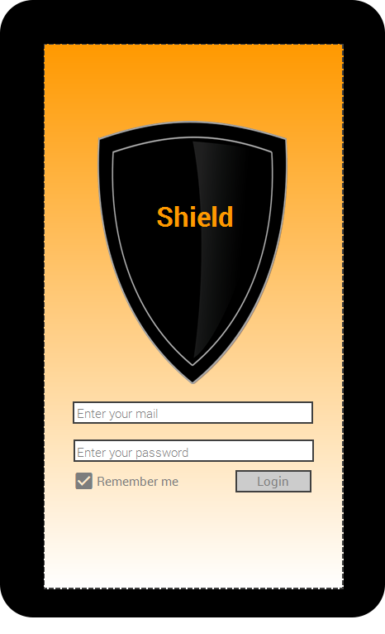**Smartphone/tablet**

**Function 1(Access Meetings)**

After the login page, the user is presented with the meeting screen.

Clicking on a meeting the user is transferred to the meeting’s description.

* He can, through the new screen, inspect the files included
* 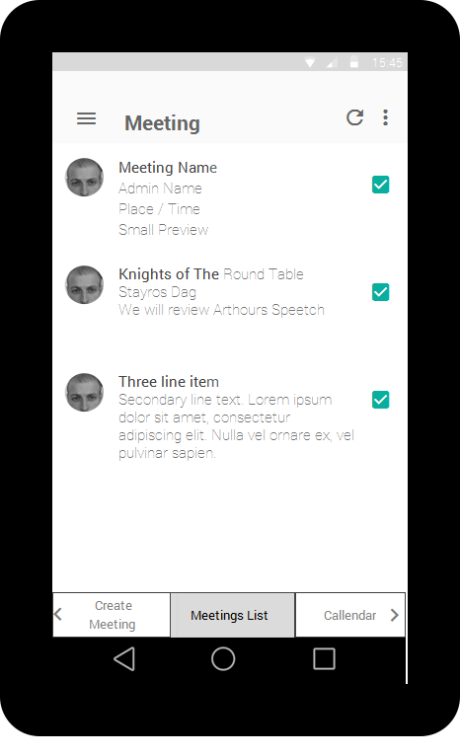Accept the meeting by selecting either “Attending” or “Remote Attendance”

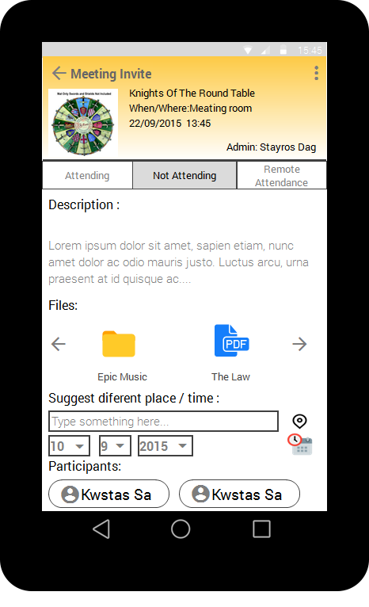

**Function 2(Suggestions and messages)**

* If the user isn’t satisfied with the meeting hours he can choose to suggest a time that fits his needs.
* 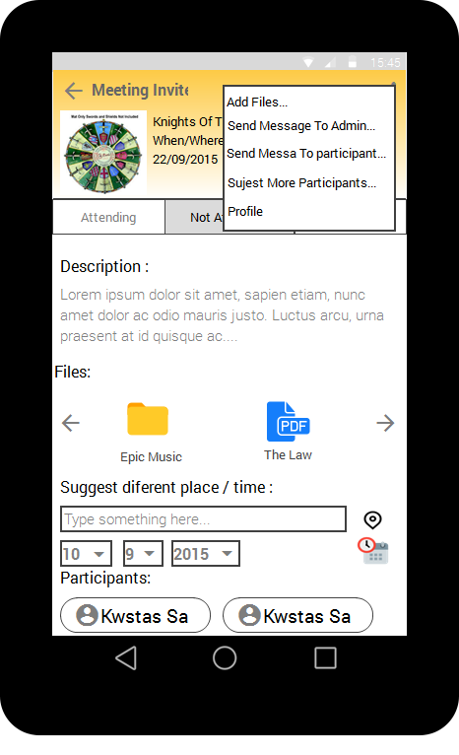He can also send messages to other participants regarding the meeting or the creator of the meeting itself(admin)

**Function 3(Create Meeting)**

Swiping left takes you to the “create meeting” screen, in order to start a new meeting.

* The user can specify the meeting’s name
* The user can specify place if he wishes to, if left unchecked the place is by default the meeting room
* The user can also specify time and date of the meeting
* 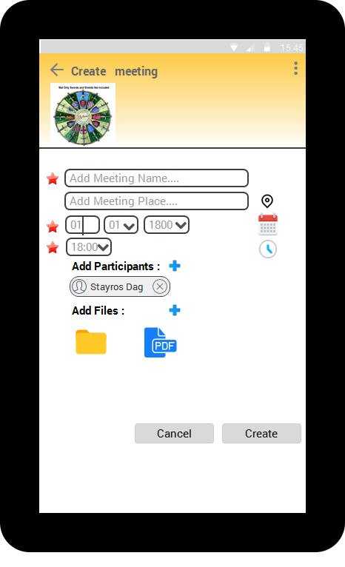The user can add users to send them invites and he can also add files to the meeting in order to be seen by all and be accessible at the meeting’s time

**Function 4(Calendar)**

Swiping left takes you to the calendar.

* He can see the planned meetings and if clicked their description
* He can see the meetings awaiting for his approval(attend/not attend/remote)
* 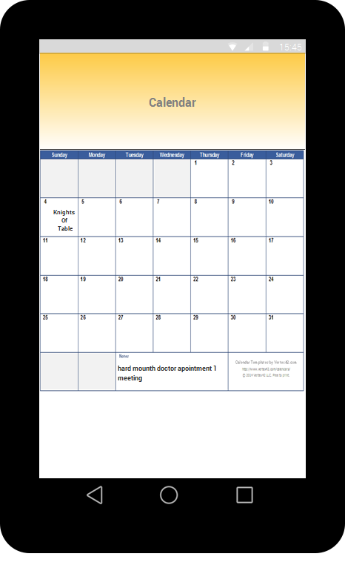He can create custom notes on the calendar

**Function 5(Profile)**

Clicking the three vertical dot on the upper left corner the user is presented with his profile screen

* He can select a user and send him a message
* He can see his recent notifications, clicking a meeting invite notification takes the user to the meeting description

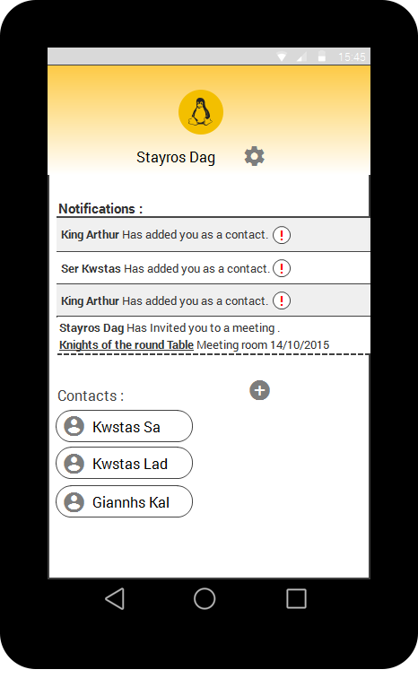

**Function 6(Meeting)**

When a meeting is about to start,at the meeting list, the meeting interface is changed and by clicking on the meeting takes the user to the meeting screen.

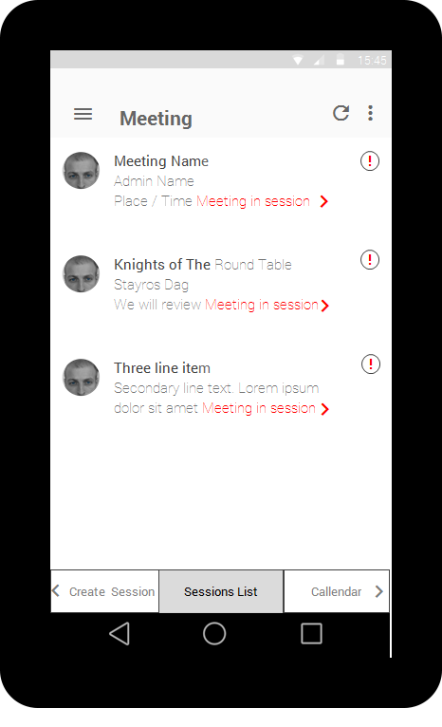

* On the center the user sees the meeting screen along with the corresponding buttons(sound,video,mic)
* At the bottom of the screen there is a chat box where the participants can write in case there is no mic or other limitations presented to the user

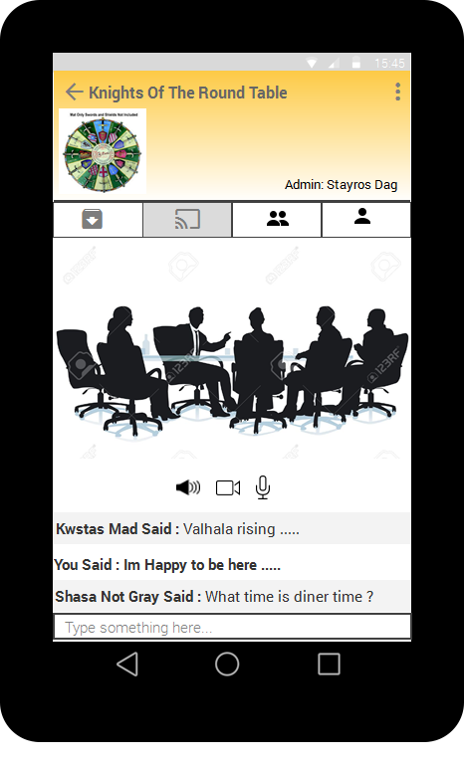

* Above the presentation screen the user has four options(one being the meeting screen, second from left)
  + 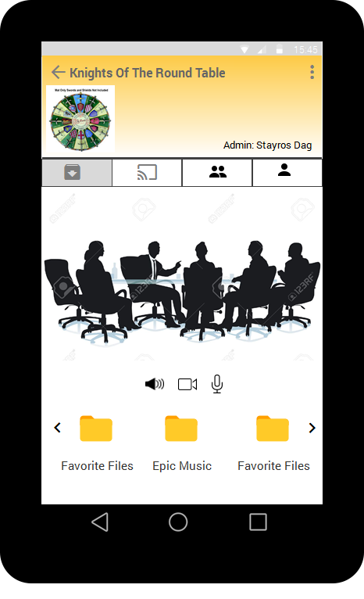The first one opens up the file list which overlaps the comment section
  + The third one opens up the participants of the meeting overlapping the comment section. The user can scroll right to see every user in the meeting room. The left-most user is the one currently speaking



* + The fourth tab opens up the profile where you can see how your video is showing you

**Desktop**

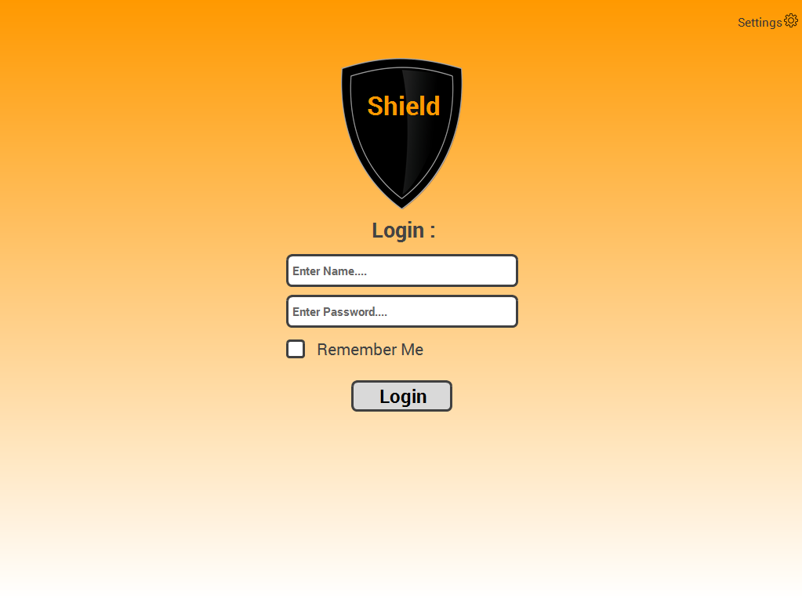

**Function 1(Notifications and Contacts)**

After logging in the user sees his home screen.

* He can see all the recent notifications that address him(exclamation mark)
* He can select a notification of a meeting (expands down) to see it’s description and participants. If he hasn't responded to a meeting he can use the buttons presented to him (Attend,Decline). Clicking attend gives him the option to specify the way he will (Remote,physically)
* He can also click one of his contacts and send him a message/file
* 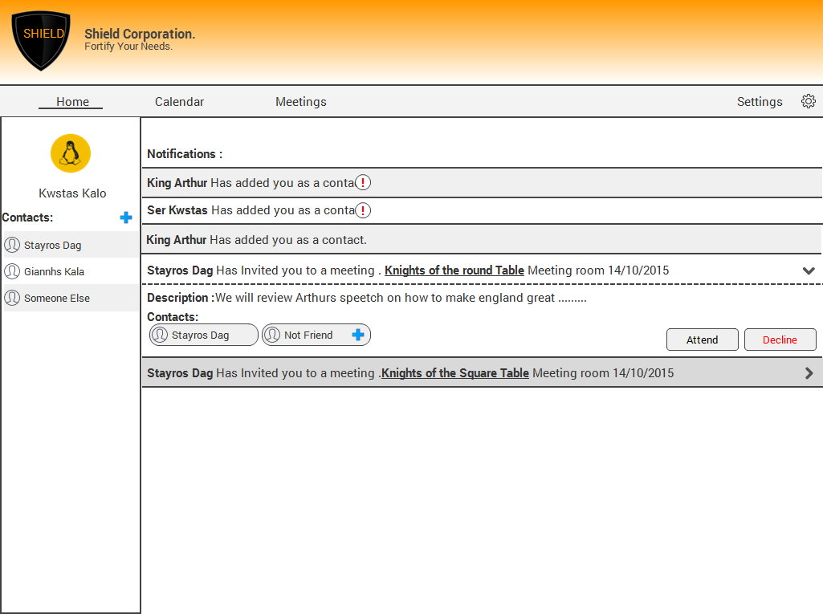He can click his name to be redirected to his profile page

**Function 2(Calendar)**

By clicking on the calendar menu, a calendar is presented to him

* He can see all the meetings of the current month.
* Clicking a meeting that he hasn’t responded yet,presents him with the options to attend or to decline along with the description of the meeting
* Clicking an already answered invite of a meeting, the user will see the description of the meeting,the files attached to it and the colleagues that have responded positively
* He can also create a note on a day he wishes to
* At the bottom of the calendar the user can see a sum of the events of the current month

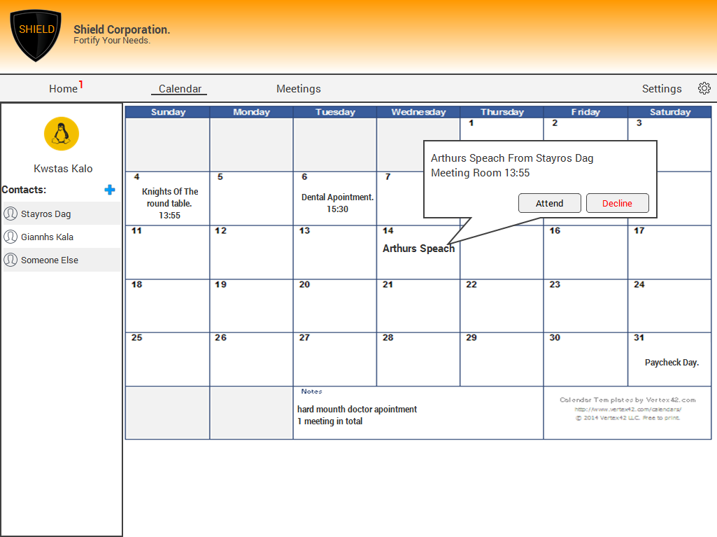

**Function 3(Meetings list)**

Clicking the meeting’s menu the user can see the current meetings

* He can sort the meetings by their Name/Date/Status.
* He can see the the creator of every meeting

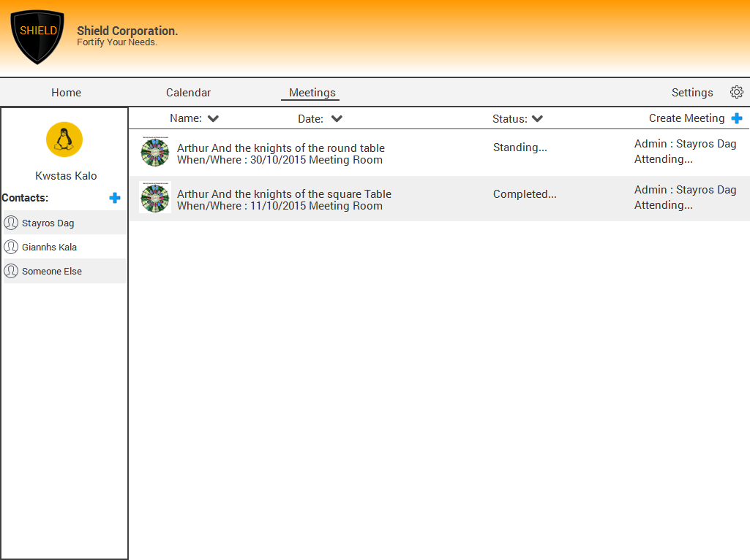

**Function 4(Meeting Description)**

Clicking on a meetings takes the user to the meeting’s description

* He is presented with the meeting description
* He can see the place, date and time the meeting will take place
* He can see the files attached to the meeting and the users participating
* He can respond to the invite by “Attend”, “Remote Attendance” and by “Not Attending”

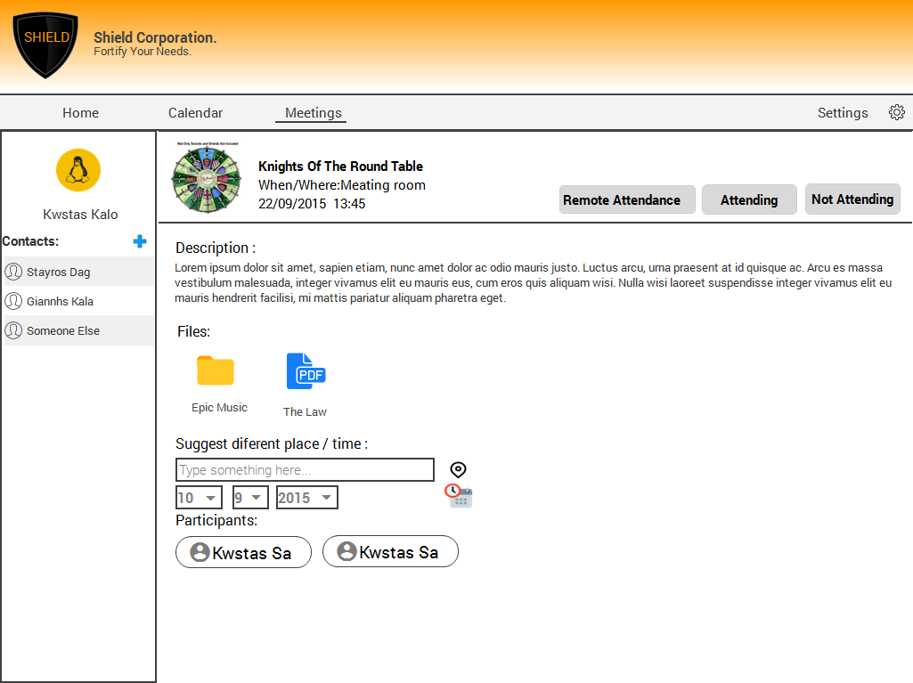

**Function 5(Create meeting)**

By clicking create meeting(upper right corner) he is given the options of the meeting he wish to create

* He can specify an image for the meeting
* He can specify the name of the meeting
* He can set place of the meeting if he wishes to,by default is the meeting room
* He can set the date and time at which the meeting will take place
* He can add colleagues to the meeting and attach any files he want

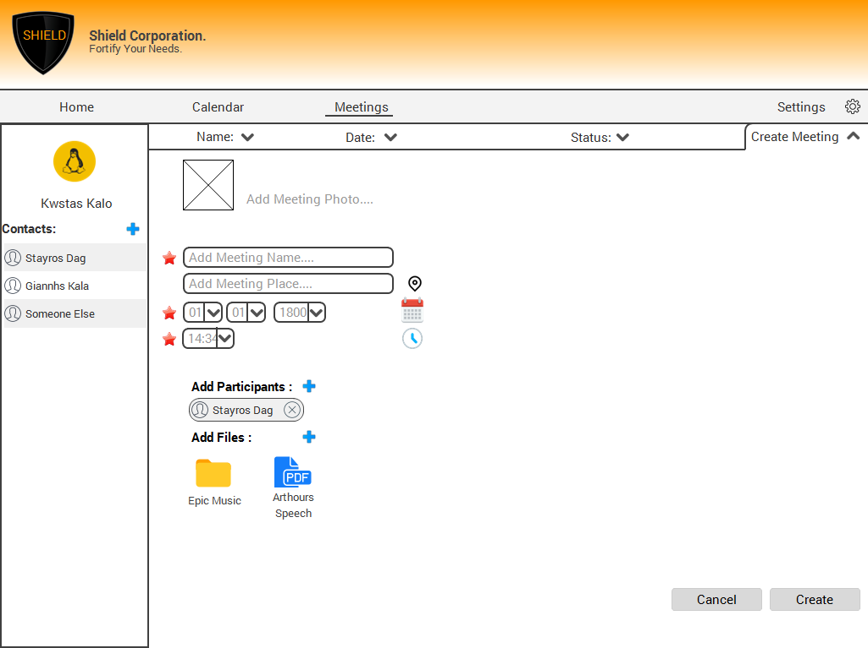

**Function 6(Meeting)**

When a meeting is about to start clicking the meeting takes him to the meeting description with a noticeable difference. On the upper right side he can choose to enter the meeting.

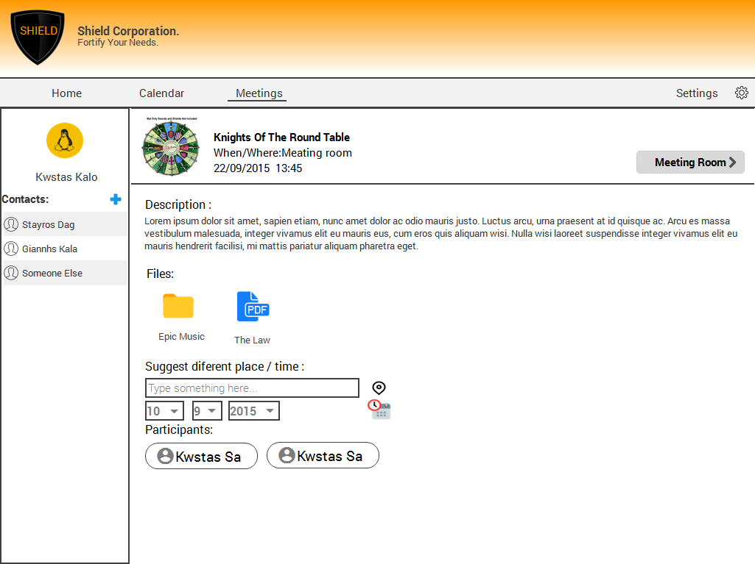

* In the middle section there is the presentation screen.
* At the right side the user can see all the participants, with the current one speaking being at the first place.
* 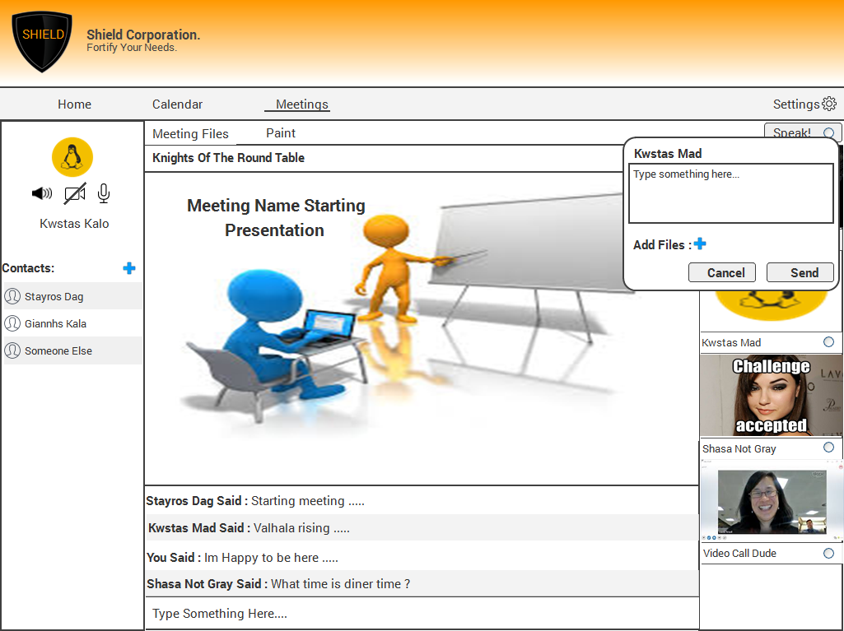Clicking on a user, brings up a box to send him a message or a file
* At the bottom of the screen there is a chat box
* At the upper right corner there is a “speak” button in order to ask for “control”. Clicking the button lights up the “led”.
* 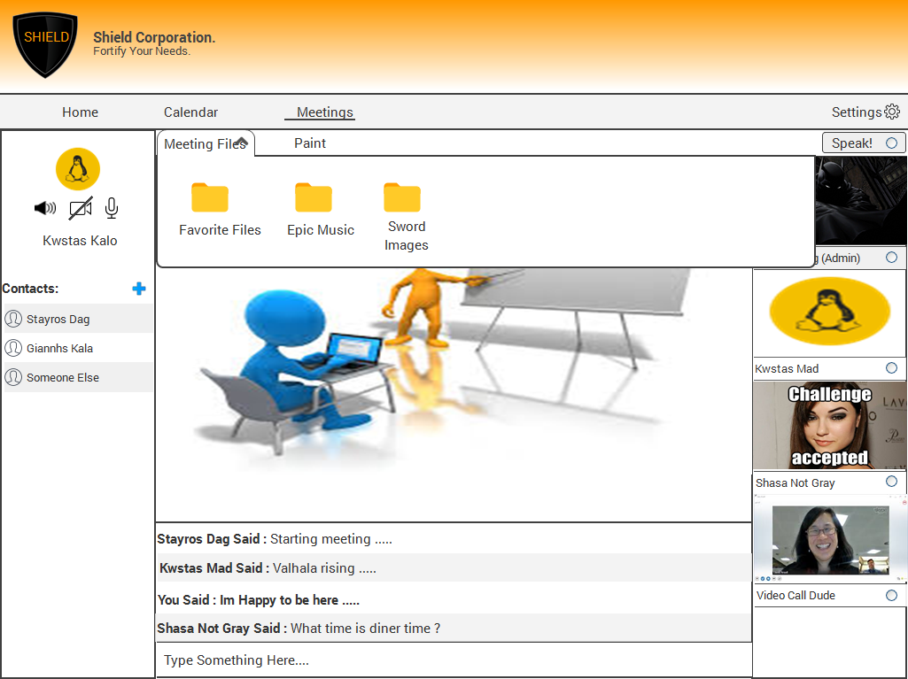Clicking on the “Meeting files” button, the file list drops a down
* Clicking the draw button(if he has control) the user can paint on the current(a copy of it) document

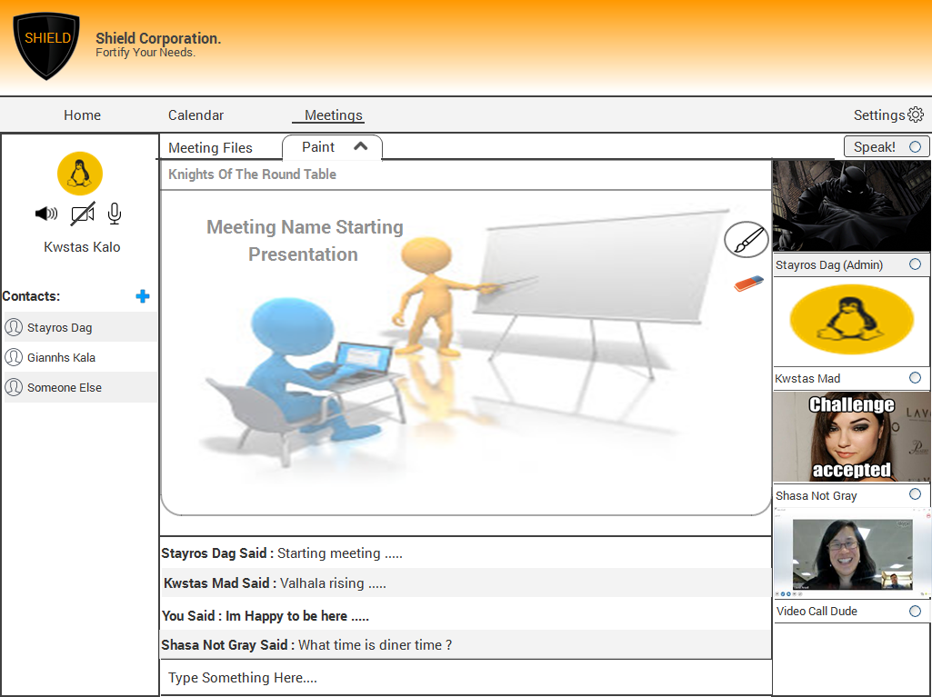

* At the upper left corner the user can see himself(his camera) and under that his configuration(sound,video,mic).