**Assignment No.1**

1. What does the abbreviation HTML stand for?
2. HyperText Markup Language
3. HighText Markup Language
4. HyperText Markdown Language
5. None of the above.

**Ans:-1) HyperText Markup Language**

1. What are the types of lists available in HTML?
2. Ordered, Unordered Lists.
3. Bulleted, Numbered Lists.
4. Named, Unnamed Lists.
5. None of the above.

**Ans:-1) Ordered,Unordered Lists.**

1. We enclose HTML tags within?
2. { }
3. <>
4. !!
5. None of the above.

**Ans:-2) <>**

1. How to display preformatted text in HTML?
2. <p>
3. <hr>
4. <pre>
5. All of the above

**Ans:- 3) <pre>**

1. Which of the following tags doesn’t require a closing tag?
2. <hr>
3. <img>
4. <input>
5. All of the above.

**Ans:- 4) All of the above**

1. The CSS inside HTML elements used alongside style attribute is called?
2. Inline Css
3. Internal Css
4. External Css
5. None of the Above

**Ans:- 2) Internal CSS**

1. Which of the following is true about HTML tags?
2. Are case Sensitive
3. Are not case Sensitive
4. Are in uppercase
5. Are in lowercase

**Ans:- 2) Are not case Sensitive**

1. What is the difference between <strong>, <b> tags and <em>, <i> tags?

**Ans:-** In HTML, the <strong> and <b> tags are used to emphasize the text, but they serve different purposes:-

i) The <strong> tag defines that the text is important while <b> tag does not convey any importance.

ii) The <strong> tag provides semantic meaning for screen readers whereas <b> tag does not.

iii) The <strong> tag can contribute to SEO by signaling importance to search engines, while <b> tag does not have this effect.

**Difference between <em> and <i> tags:-**

i) <i> tag in HTML is used to display text in italics. It is generally used for stylistic purposes without adding any semantic emphasis to the content.

ii) <em> tag in HTML is used to emphasize text. It conveys semantic meaning.

iii) The <em> element represents the stress emphasis of its content.

### What are different types of lists in HTML? Make your own Backet list using different types.

Ans:- <li> tag defines list of items in HTML.

**Different Types of lists:-**

**i) Ordered list:-** <ol> tag is used to display elements in ordered form, either numerical or alphabetical. There are five type attribute in <ol>tag.

e.g:- Type=1,Type=A,Type=a, Type=I and Type=i.

-> **’start’** attribute is used to set the starting number:-<ol start=5>

-> **‘reversed’** attribute reverses the order of the list.

**ii) Unordered list:-** An unordered list is used to create an unordered list. It is also known as bulleted list. There are four types of style in unordered lists:

=>type=”disc”, type=”circle”, type=”square” and type=”none”.

**iii) Description List:-** Description list is a list in which each term contains its description. This tag contains <dt> and <dd> tag.

* <dt></dt> is used to define the term or name.
* <dd></dd> is used to define the describe of the term.

**iv) Nested list**:- A nested list in HTML is a list that contains other lists within its list items. This creates a hierarchical structure.

**=> Nested Ordered list**

**=> Nested Unordered list**

**E.g:-**

<!DOCTYPE html>

<html lang="en">

<head>

<meta charset="UTF-8">

<meta name="viewport" content="width=device-width, initial-scale=1.0">

<title>Document</title>

</head>

<body>

<h1>A list of thins you need to learn to become a web developer:</h1>

<ol>

<li>Html</li>

<li>css</li>

<li>javascript</li>

<ul>

<li>VueJS</li>

<li>ReactJS</li>

<li>Angular JS</li>

</ul> </ol> <dl>

<dt>Angular JS:</dt>

<dd>AngularJS is a discontinued free and open-source JavaScript-based web framework for developing single-page

applications. </dd>

</dl>

</body>

</html>

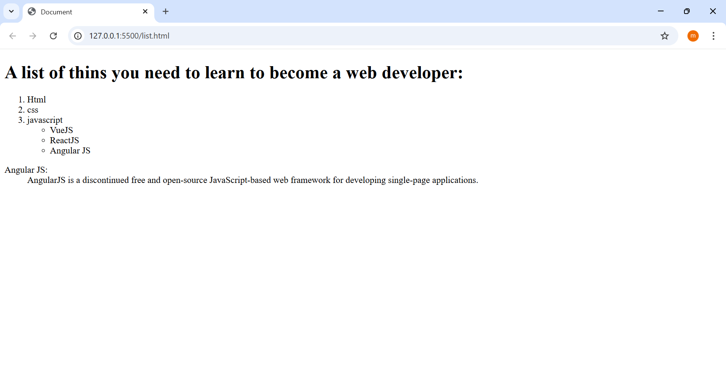

### What is the difference between the ‘id’ attribute and the ‘class’ attribute of HTML elements?

Ans:-The **id** attribute in HTML acts as a unique identifier for an element. It ensures that each element having an **id** is distinct from all others on the page. It’s like giving a specific name to an element, so you can refer to it uniquely. For instance, you might assign an **id** to a particular section of your webpage that you want to link to directly.

The **class** attribute in HTML serves to identify multiple elements as belonging to a particular group or having a shared style.

* **ID**: It is paramount to remember that an **id** should be unique within a page. This means you should not assign the same **id** value to multiple elements on a single page.
* **Class**: There’s flexibility with the **class** attribute. You can use the same class value for multiple elements on a page, making it an ideal choice for styling groups of elements with shared characteristics.