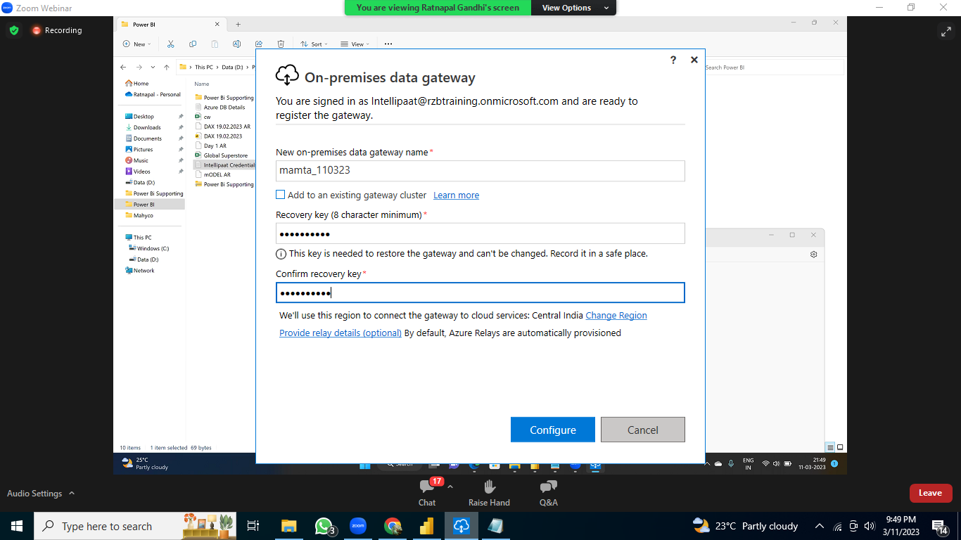

9535082058

Windows username

desktop-aqb1fat\jayesh Khatri\mamta

password/laptop password

mamta@intel

recovery-intel