**Diode**

We can call diode a small electronic device in which current flows in only one direction. Diode is a Semi-conductor device that act as a one way switch for current.

**How does a diode look like?**

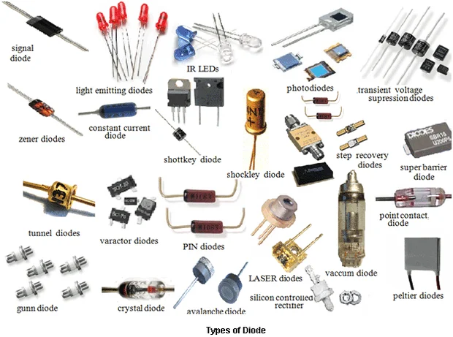

Above you can see an overview of how diodes look like. They come in different sizes, shapes, colours, material. There are various kinds of diodes & you must have seen a few of them at some point of your life.

Here is a basic Diagram of a diode for better understanding

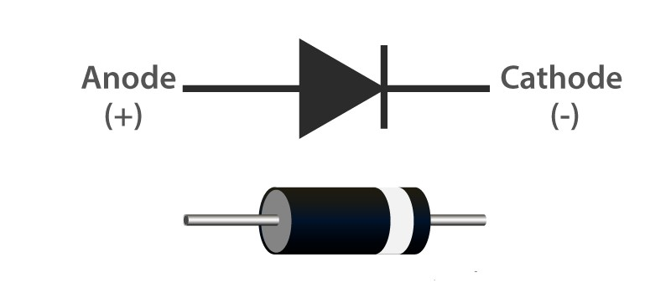

As you can see the positive terminal is the anode while the negative terminal is cathode.

We use diode to control the direction of current in a circuit.

Conditions for electric current flow in a diode:

* Forward Bias : In this condition the diode allows the electric current to flow through it and acts as a conductor.
* Reverse Bias : In this condition the diode doesn’t allow the electric current to flow through it and acts as an insulator.

Diodes explained:

Diode is a semi-conductor device. Because semiconductors can act as both a conductor and an insulator. Diodes are used to protect circuits by limiting the voltage and to also transform AC into DC.

Pure Silicon has almost no free electrons, so what engineers do is dope the silicon with a small amount of another material to change the properties and it is called p-type and n-type doping.

We combine these two materials and form a basic diode. The two materials join to form a P-N JUNCTION. At this junction we get a region which is known as the depletion region. In this region some of the excess electrons from the n-type side will move over to occupy the holes in the p-type side.

DIODES ARE GENERALLY MADE FROM TWO MATERIALS:

SILICON & GERMANIUM

Si 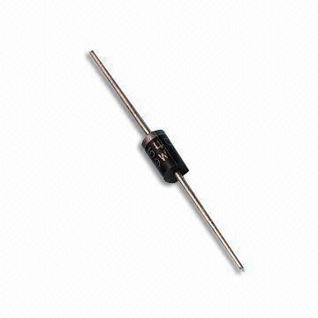 Ge