Practica 6 Enrutamiento Pasivo
Marco Gallego Moreno

El direccionamiento de esta red con salida a internet (Cloud0) está vacío, por lo que te va a tocar hacer una serie de pasos previos. Complétalos todos, rellena las tablas de enrutamiento de los cuatro routers y muéstrame el proceso.

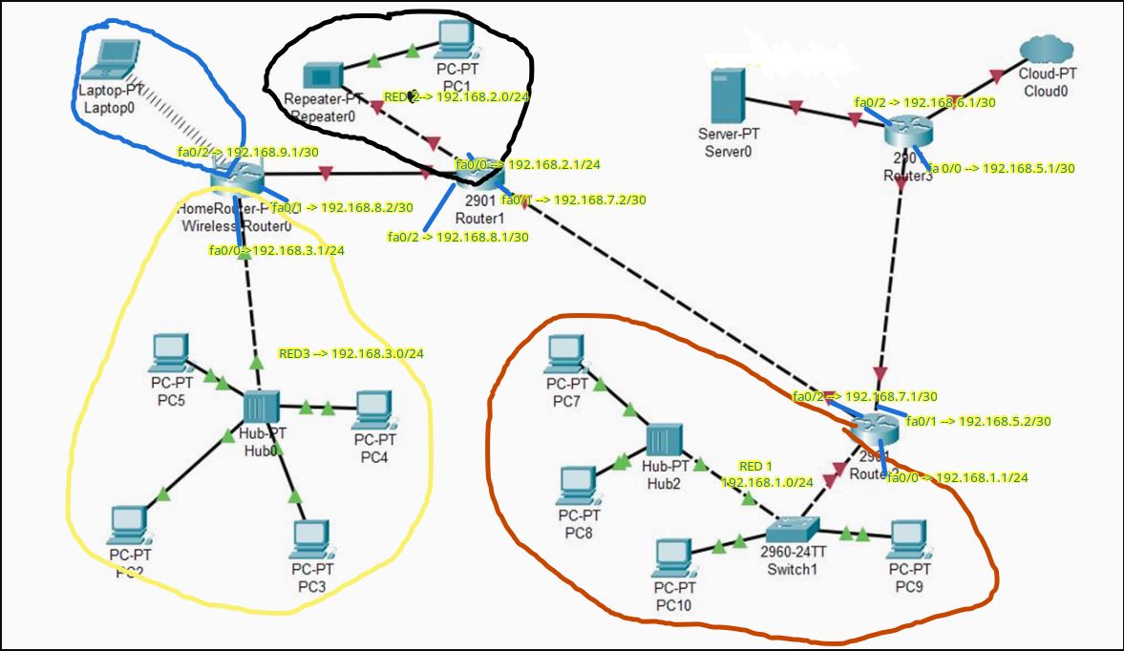

REDES

NOMBRE DE RED | IP RED | MASCARA RED
RED1 | 192.168.1.0/24 | 255.255.255.0
RED2 | 192.168.2.0/24 | 255.255.255.0
RED3 | 192.168.3.0/24 | 255.255.255.0
ROUTER 3 ---- SERVER0 | 192.168.6.0/30 | 255.255.255.252
ROUTER3 ---- ROUTER2 | 192.168.5.0/30 | 255.255.255.252
ROUTER2 ---- ROUTER1 | 192.168.7.0/30 | 255.255.255.252
ROUTER1 ---- ROUTER0 | 192.168.8.0/30 | 255.255.255.252
ROUTER0 ---- LAPTOP0 | 192.168.9.0/30 | 255.255.255.252
CLOUD0 → 200.20.0.0/30

ROUTER3

RED | MASCARA | INTERFAZ | PROX SALTO | METR
RED1→192.168.1.0/24 | 255.255.255.0 | Fa0/0(192.168.5.1) | 192.168.7.1/30 | 1
RED2→192.168.2.0/24 | 255.255.255.0 | Fa0/0(192.168.5.1) | 192.168.7.1/30 | 1
RED3→192.168.3.0/24 | 255.255.255.0 | Fa0/0(192.168.5.1) | 192.168.7.1/30 | 1
RO0-LAP→ 192.168.9.0/30 | 255.255.255.252 | Fa0/0(192.168.5.1) | 192.168.7.1/30 | 1
RO3-S0→ 192.168.6.0/30 | 255.255.255.252 | Fa0/2(192.168.6.1) | - | 0
RO3-RO2→ 192.168.5.0/30 | 255.255.255.252 | Fa0/0(192.168.5.1) | - | 0
RO2-RO1→ 192.168.7.0/30 | 255.255.255.252 | Fa0/0(192.168.5.1) | 192.168.7.1/30 | 1
RO1-RO0→ 192.168.8.0/30 | 255.255.255.252 | Fa0/0(192.168.5.1) | 192.168.7.1/30 | 1
CLOUD → 200.20.0.0/30 | 255.255.255.252 | fa0/1 | - | 0

ROUTER2

RED | MASCARA | INTERFAZ | PROX SALTO | METR
RED1→192.168.1.0/24 | 255.255.255.0 | Fa0/0(192.168.5.1) | - | 0
RED2→192.168.2.0/24 | 255.255.255.0 | Fa0/2(192.168.7.1) | 192.168.7.2/30 | 1
RED3→192.168.3.0/24 | 255.255.255.0 | Fa0/2(192.168.7.1) | 192.168.7.2/30 | 1
RO0-LAP→ 192.168.9.0/30 | 255.255.255.252 | Fa0/2(192.168.7.1) | 192.168.7.7/30 | 1
RO3-S0→ 192.168.6.0/30 | 255.255.255.252 | Fa0/1(192.168.5.2) | 192.168.5.1/30 | 1
RO3-RO2→ 192.168.5.0/30 | 255.255.255.252 | Fa0/1(192.168.5.2) | - | 0
RO2-RO1→ 192.168.7.0/30 | 255.255.255.252 | Fa0/2(192.168.7.1) | - | 0
RO1-RO0→ 192.168.8.0/30 | 255.255.255.252 | Fa0/2(192.168.7.1) | 192.168.7.2/30 | 1
CLOUD → 200.20.0.0/30 | 255.255.255.252 | Fa0/1(192.168.5.2) | 192.168.5.1/30 | 1

ROUTER1

RED | MASCARA | INTERFAZ | PROX SALTO | METR
RED1→192.168.1.0/24 | 255.255.255.0 | Fa0/1 | 192.168.7.1/30 | 1
RED2→192.168.2.0/24 | 255.255.255.0 | Fa0/0 | - | 0
RED3→192.168.3.0/24 | 255.255.255.0 | Fa0/2 | 192.168.8.2/30 | 1
RO0-LAP→ 192.168.9.0/30 | 255.255.255.252 | Fa0/2 | 192.168.8.2/30 | 1
RO3-S0→ 192.168.6.0/30 | 255.255.255.252 | Fa0/1 | 192.168.7.2/30 | 1
RO3-RO2→ 192.168.5.0/30 | 255.255.255.252 | Fa0/1 | 192.168.7.2/30 | 1
RO2-RO1→ 192.168.7.0/30 | 255.255.255.252 | Fa0/1 | - | 0
RO1-RO0→ 192.168.8.0/30 | 255.255.255.252 | Fa0/2 | - | 0
CLOUD → 200.20.0.0/30 | 255.255.255.252 | Fa0/1 | 192.168.7.2/30 | 1

ROUTER0

RED | MASCARA | INTERFAZ | PROX SALTO | METR
RED1→192.168.1.0/24 | 255.255.255.0 | Fa0/1 | 192.168.8.1/30 | 1
RED2→192.168.2.0/24 | 255.255.255.0 | Fa0/1 | 192.168.8.1/30 | 1
RED3→192.168.3.0/24 | 255.255.255.0 | Fa0/0 | - | 0
RO0-LAP→ 192.168.9.0/30 | 255.255.255.252 | Fa0/2 | - | 0
RO3-S0→ 192.168.6.0/30 | 255.255.255.252 | Fa0/1 | 192.168.8.1/30 | 1
RO3-RO2→ 192.168.5.0/30 | 255.255.255.252 | Fa0/1 | 192.168.8.1/30 | 1
RO2-RO1→ 192.168.7.0/30 | 255.255.255.252 | Fa0/1 | 192.168.8.1/30 | 1
RO1-RO0→ 192.168.8.0/30 | 255.255.255.252 | Fa0/1 | 192.168.8.1/30 | 1
CLOUD → 200.20.0.0/30 | 255.255.255.252 | Fa0/1 | 192.168.8.1/30 | 1

