

**Customer Requirements Specifications (CRS)**

***Accounting Management Module***

# **Document Information**

|  |  |
| --- | --- |
| Document Name | CRS of Procurement Management for Samuda Chemicals Ltd. |
| Document Author | Kamrun Nahar |
| Document Version | 1.0 |
| Release Date |  |

|  |  |
| --- | --- |
| Review by | Md. Mahfuzur Rahman |
| Review Date | TBA |
| Approved By | Matiar Rahman |
| Approval Date | TBA |

Signed on behalf of Signed on behalf of

Samuda Chemicals Ltd. Genweb2 Limited

Name: Name:

Designation: Designation:

Date: Date:

**______________________________ ______________________________**

Signature Signature

# **Document History**

|  |  |  |  |  |  |
| --- | --- | --- | --- | --- | --- |
| A=Added, M=Modified, D=Delete | | | | | |
| **Version No** | **Date** | **Section No** | **A/M/D** | **Description of Change** | **Author** |
| 1.0 | 29-Jan-2017 |  | A | Initial | Kamrun Nahar |
|  |  |  |  |  |  |
|  |  |  |  |  |  |

Contents

**A.** **Document Information** 2

**B.** **Document History** 3

**1.0** **Introduction** 5

**1.1 Purpose of CRS** 5

**2.0** **Accounting Module Overview** 5

**3.0** **Why Organization Requires Accounting Management** 6

**4.0 Features of Accounting Management** 6

**5.0** **Features Description** 7

**5.1** **General Ledger** 7

**5.2** **Accounts Receivable (AR)** 8

**5.3** **Accounts Payable (AP)** 11

**5.4** **Chart of Accounts** 13

**5.5** **Trial Balance** 14

**5.6** **Balance sheet** 15

**5.7** **Fixed Asset and Depreciation** 15

**5.8** **Petty Cash** 16

**5.9** **Profit and Cost Center** 17

**5.10** **Cost Distribution** 18

**5.11** **Comparative Statement** 18

**5.12** **Account Reconciliation** 19

**5.13** **Profit and Loss Statement** 20

**5.14** **Partner Ledger** 20

**5.15** **Opening and Closing a Financial Year** 21

**a)** **Open a New financial Year** 21

**b)** **Closing a Financial Year** 22

**6** **4. To be Determined** 23

# **Introduction**

# **1.1 Purpose of CRS**

The purposes of this CRS (Customer Requirement Specification) are to clearly identify the customer requirements and provide a detailed document. The customer will review the document and approve/make changes as required. It will also help the review team to validate whether the customer requirements have been fulfilled or not.

# **Accounting Module Overview**

Accounting software is an application software that records and processes accounting transactions within functional modules such as accounts payable, accounts receivable, general ledger, payroll and trial balance. It functions as an accounting information system.

Financial accounting module of an ERP package provides company wide control and integration of financial information. This module provides the ability to centrally track financial accounting data within a framework of multiple companies, languages and currencies. Accounting module will be integrated with modules named customer managment, human resourse, sales, procurement and inventory for effective and profitable accounting system for the

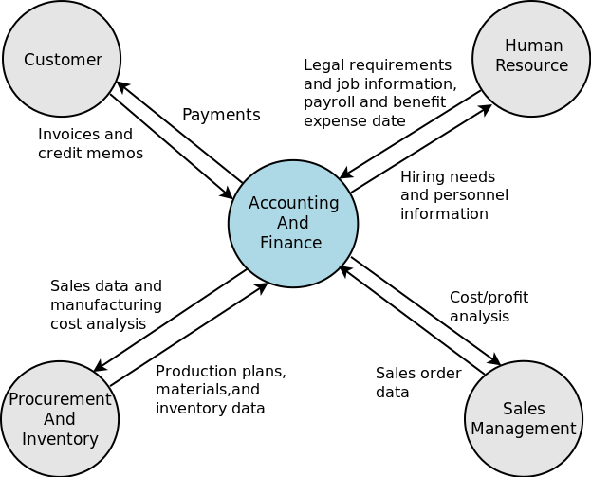

**Fig:** Accounting module integration with other module

# **Why Organization Requires Accounting Management**

* Automatic updating of customer accounts in the sales ledger
* Recording of suppliers’ invoices
* Automatic updating of suppliers' accounts in the purchases ledger Recording of bank receipts
* Making payments to suppliers and for expenses
* Automatic updating of the general ledger
* Automatic adjustment of stock records
* Can provide instant reports for management
* Automatic calculation of payroll and associated entries
* Automatic updating of customer accounts in the sales ledger
* Simplification of the month end accounting
* Security driven account trees ensure proper set of users only access their appropriate accounts

# **4.0 Features of Accounting Management**

1. General Ledger
2. Account Receivable
3. Account Payable
4. Chart of Accounts
5. Trial Balance
6. Balance Sheet
7. Fixed Asset and Depreciation
8. Petty Cash
9. Cost and Profit Centre
10. Cost distribution
11. Comparative statement
12. Account Reconciliation
13. Profit and Loss Statement
14. Partner Ledger
15. Opening and Closing a Financial Year

# **Features Description**

## **General Ledger**

A general ledger contains all the accounts for recording transactions relating to a company's assets, liabilities, owners' equity, revenue, and expenses. In modern accounting software or ERP, the general ledger works as a central repository for accounting data transferred from all sub ledgers or modules like accounts payable, accounts receivable, cash management, fixed assets, purchasing etc. The three main journals of the General Ledger:

**Accounts Receivable:** The daily record of the company’s sales and receipts and the invoices that clients had not yet paid.

**Accounts Payable:** The daily record of the company’s purchases and invoices the company still had to pay.

**Payroll:** The record of each employee’s compensation, the checks written to pay the employees and the related payroll taxes.

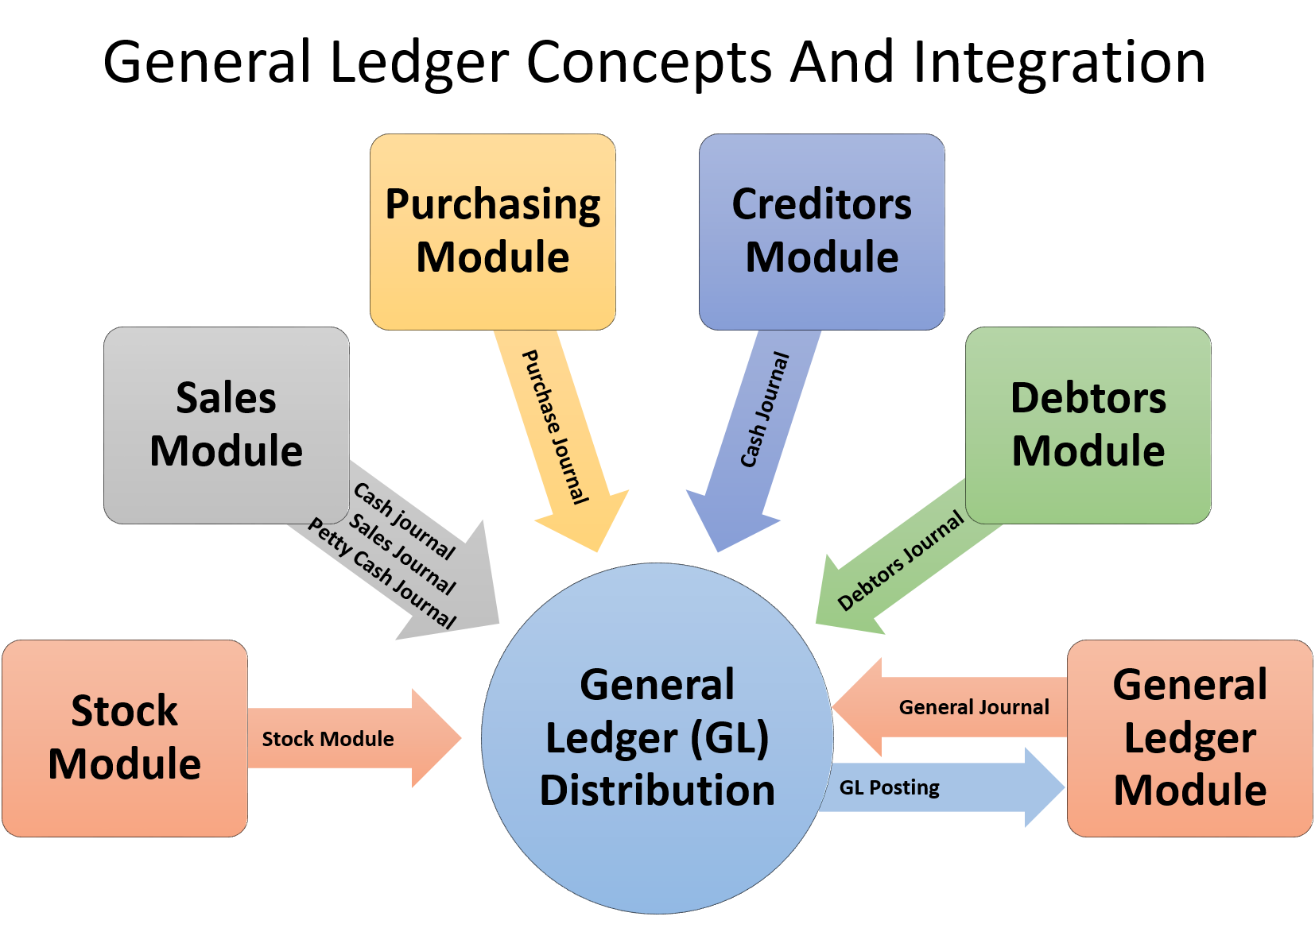

**Fig:** General Ledger Distribution

## **Accounts Receivable (AR)**

The account receivable is the process by which businesses receive payments from customers for goods or services sold. The process has several steps for payment that are completed by the customer once they are ready to pay. It's a simple turn of events that creates an accounts receivable. In order to have an accounts receivable, user needs two things: a sale and a purchase. A company sells an item or a service to a buyer and extends credit to that buyer so that the total cost of the sale can be paid later and on terms that are agreed upon by the seller and the buyer. When the buyer agrees to the terms set forth by the seller, then a purchase has been made. Now, if that extension of credit is not given, and payment is rendered at the time of sale, then no accounts receivable was created.

Once the accounts receivable is created, it has to be recorded in the accounting records. Since the AR account is considered an asset account, it is recorded in the ledger and reported on the balance sheet of a company. An asset is something that a company owns. The ledger is the place where all the increases and decreases in balance sheet accounts are recorded. The balance sheet is the financial statement that reports all the accounts of a company and their balances.

Every single transaction that occurs in a company has at least one account that is credited and one account that is debited. To record a sale that resulted in an accounts receivable, you would need to make a debit entry to the accounts receivable account for the sale amount and a credit entry to the revenue account for the same amount. Revenue is the amount of money that is received or will be received from a sale. By debiting the AR account and crediting the revenue account, the balances in both accounts increase. When payment is received on the account, the cash account is debited for the payment amount, and the AR account is credited. This decreases the amount in the AR account and increases the cash account balance. Each time a payment is made on a customer account, it will decrease the AR balance, just as each time a new credit sale is made, it will increase the balance in the AR account. There might be cases when customer may not pay on time that should be handled by system.

To understand the AR process please check the following Image.

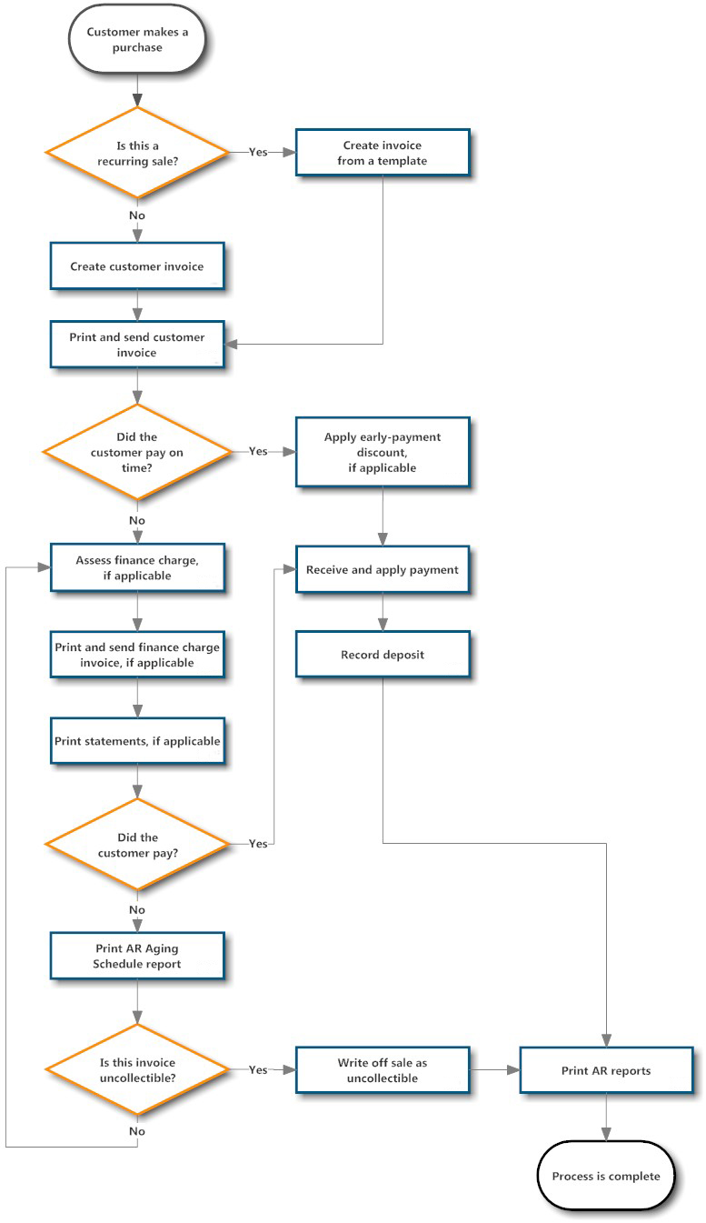

**Fig:** Accounts Receivable Process

## **Accounts Payable (AP)**

Accounts payable is money owed by a business to its suppliers shown as a liability on a company's balance sheet.

An accounts payable is recorded in the Account Payable sub-ledger at the time an invoice is vouchered for payment. It means that an invoice is approved for payment and has been recorded in the General Ledger or AP sub ledger as an outstanding, or open, liability because it has not been paid. Common examples of Expense Payables are advertising, travel, entertainment, office supplies and utilities. AP is a form of credit that suppliers offer to their customers by allowing them to pay for a product or service after it has already been received.

* All vendor invoices should be sent directly to Accounts Payable from the vendor, with the Purchase Order (PO) referenced by the vendor.
* Purchase Orders (POs) should initiate the procure-to-pay process and should have sufficient open encumbrance balance to cover any outstanding invoices
* **AP Recurring Payment Request Form:** These are payments for rents, training stipends, or Fellowships where 3+ payments are needed on a recurring schedule.
* **Payment Terms**: Suppliers offer various payment terms for an invoice. Payment terms may include the offer of a cash discount for paying an invoice within a defined number of days. For example, 2%, Net 30 terms mean that the payer will deduct 2% from the invoice if payment is made within 30 days. If the payment is made on Day 31 then the full amount is paid. There will have discount for early payments. Accounts Payable (AP) is responsible for processing all invoice and non-payroll payments.

To understand the AR process please check the following Image.

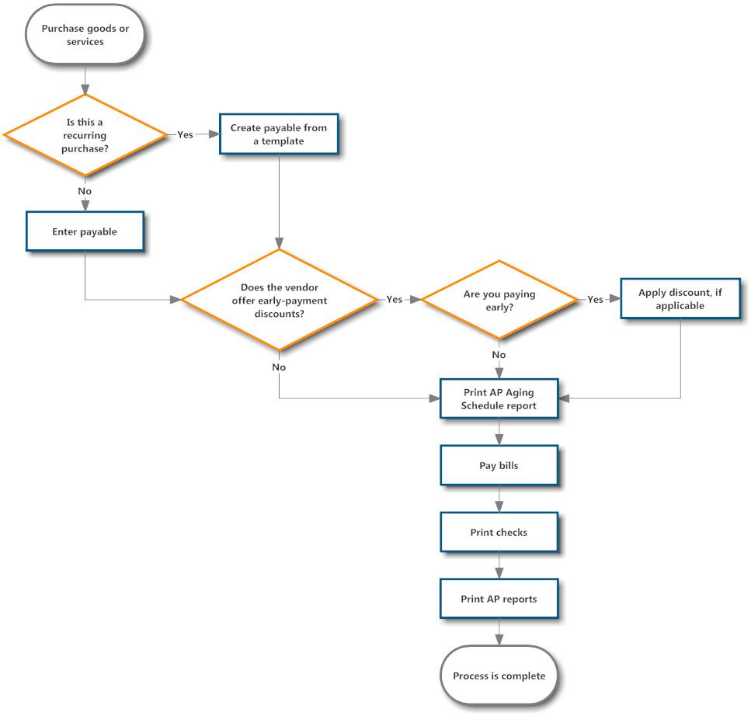

**Fig:** Accounts Payable (AP)

## **Chart of Accounts**

A chart of accounts is a list of all accounts used by a company in its accounting system. It makes the bookkeeper's work easier. The accounts included in the chart of accounts must be used consistently to prevent clerical or technical errors in the accounting system.

The chart of accounts vary from company to company. The contents depend upon the needs and preferences of the company using it.

A sample chart of account is given below to have an idea how may it looks like:

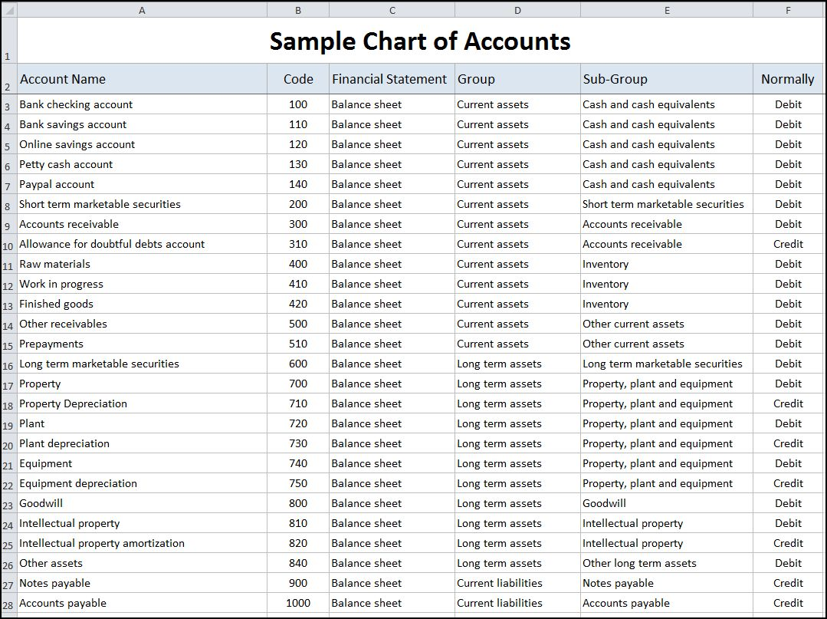

**Fig:** Sample of Chart of Accounts

There might have other features for chart of accounts.

1. **Defining Account Types**

* **Account Type:** the name of the account type.
* **Code:** the code of the account type.
* **PL/BS Category:** this category determines where in a report the account will be printed (i.e. Balance Sheet and Profit and Loss). There are five types you can use: No type at all (/), Balance Sheet (Assets Accounts = active), Balance Sheet (Liabilities Accounts = passive), Profit & Loss (Income) and Profit & Loss (Expense).
* **Deferral Method:** This indicates how and whether the account will be transferred at financial year closing.

1. **Defining Accounts**

* ***Account Code and Name*:** the code length is not limited to a specific number of digits. Use code 0 to indicate the root account and the account name.
* ***Parent*:** determines which account is the parent of this one, to create the tree structure of the chart of accounts.
* ***Account Type*:** it is important to select the corresponding account type, as explained above. This will have an impact at year closing and also when printing reports.
* ***Allow Reconciliation*:** determines if user can reconcile the entries in this account. Activate this field for receivable and payable accounts and any other account that need to be reconciled other than by bank statements.
* ***Default Taxes*:** this is the default tax applied to purchases or sales account. It enables the system to propose tax entries automatically when entering data in a journal manually.

The tree structure of the accounts can be altered as often and as much as user’s wish without recalculating any of the individual entries. So user can easily restructure his/her account during the year to reflect the reality of the company better.

## **Trial Balance**

In the accounting system the trial balance is one of the last steps that will take place, occurring just before you prepare the balance sheet and the income statement. The trial balance is not meant for outside use and is intended only to be seen and used internally by the managers and owners of a business. The trial balance is prepared after all of the current period’s transactions have been journalized and posted to the general ledger.

A trial balance sample is given below for better understanding.

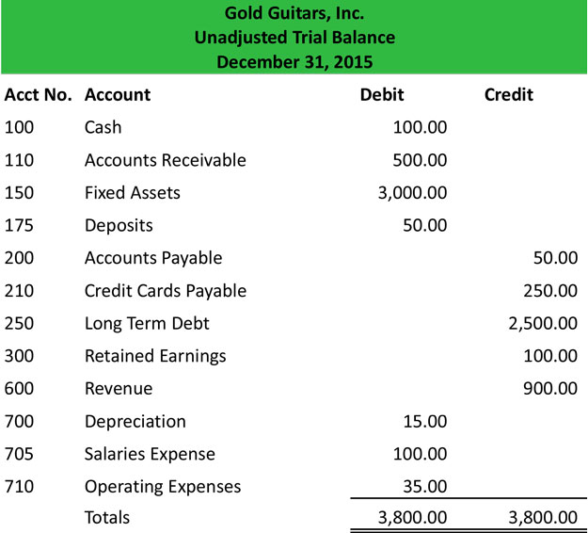

**Fig:** Sample of Trial Balance

The purpose of the trial balance is to test the equality between total debits and total credits after the posting process.

## **Balance sheet**

A Balance Sheet is a financial statement that summarizes the assets, liabilities and shareholders' equity of a company at a specific point in time. These three balance sheet segments give investors an idea as to what the company owns and owes, as well as the amount invested by the shareholders.

The balance sheet must follow the following formula:

**Assets = Liabilities + Shareholders' Equity**.

A balance sheet is often described as a snapshot of a company's financial condition.

## **Fixed Asset and Depreciation**

Fixed Assets are business purchases which will be used by the business for a few years. Examples are machinery, vans and computers. Fixed Assets are classified as Assets in the Balance Sheet, not Expenses in the Profit and Loss Account.

Fixed Assets fall into two categories:

* Tangible Fixed Assets (e.g. Cars, Machinery, Computers, Buildings, Desks)
* Intangible Fixed Assets (e.g. Goodwill, Intellectual Property)

Depreciation is the gradual transfer of the original cost of a Fixed Asset from the Balance Sheet to the Profit and Loss Account. The transfer is usually done by a Journal.

The "Assets" module allows to keep track of users’ fixed assets like machinery, land and building. The module allows you to generate monthly depreciation entries automatically, get depreciation board, sell or dispose assets and perform reports on your company assets.

As an example, you may buy a car for $36,000 (gross value) and you plan to amortize it over 36 months (3 years). Every months (periodicity), this feature will create a depreciation entry automatically reducing your assets value by $1,000 and passing $1,000 as an expense. After 3 years, this assets accounts for $0 (salvage value) in your balance sheet.

The different types of assets are grouped into "Assets Types" that describe how to deprecate an asset. Here are two examples of assets types:

**Building:** 10 years, yearly linear depreciation

**Car:** 5 years, monthly linear depreciation

This feature will allow to have following feature as well.

1. **Defining asset type:** Asset type are used to configure all information about an assets: asset and deprecation accounts, amortization method, etc. That way, advisers can configure asset types and users can further record assets without having to provide any complex accounting information. They just need to provide an asset type on the supplier bill. Assets can be created manually also.
2. **Creating assets automatically from a supplier bill:** Here assets can be automatically created from supplier bills. All you need to do is to set an asset category on the bill line. When the user will validate the bill, an asset will be automatically created using the information of the supplier bill.
3. **Deprecation of an asset:** This system will allow creating depreciation journal entries automatically at the right date for every confirmed asset. (Not the draft ones). User can control in the depreciation board from the system.
4. **Modifying an existing asset:** User can modify the depreciation and change the number of depreciation. Thus system will have recomputed a new depreciation board.
5. **Sale or disposal of an asset:** User can sell or dispose an asset and need to deprecate completely this asset for the sale or disposal purpose.

## **Petty Cash**

Petty cash is a small amount of cash that is kept on the company premises to pay for minor cash needs. Examples of these payments are office supplies, cards, flowers, and so forth. Petty cash is stored in a petty cash drawer or box near where it is most needed. There may be several petty cash locations in a larger business, probably one per building or even one per department. A separate accounting system is used to track petty cash transactions.

* Policies should be established regarding appropriate expenditure from the fund
* Receipts (petty cash voucher)set forth the amount and nature the expenditure

1. Should be placed in the petty cash box when disbursements are made
2. At any time, the receipts plus remaining cash should equal the original amount placed in the fund.

**Replenishment of Petty Cash:**

* Another check for cash is prepared to ring the fund back up to the original level
* Receipts are removed and formally recorded as expense.

So the petty cash account was not impacted.

**Increasing the Base Fund:**

* The base size of petty cash fund may need to be increased as the company grows
* Journal entry to increase the fund is identical to the first entry illustrated.
* Debit petty cash, credit cash
* Otherwise the only entry to the petty cash account occurs when the fund is established

## **Profit and Cost Center**

**Profit Center:** Profit center is a department of an entity/organization which recognizes profit only. Its objective is ascertaining the exact profit and maximizing it. It is performed by deducting actual cost from budgeted cost. Examples of a profit center can be a Sales department of any company.   
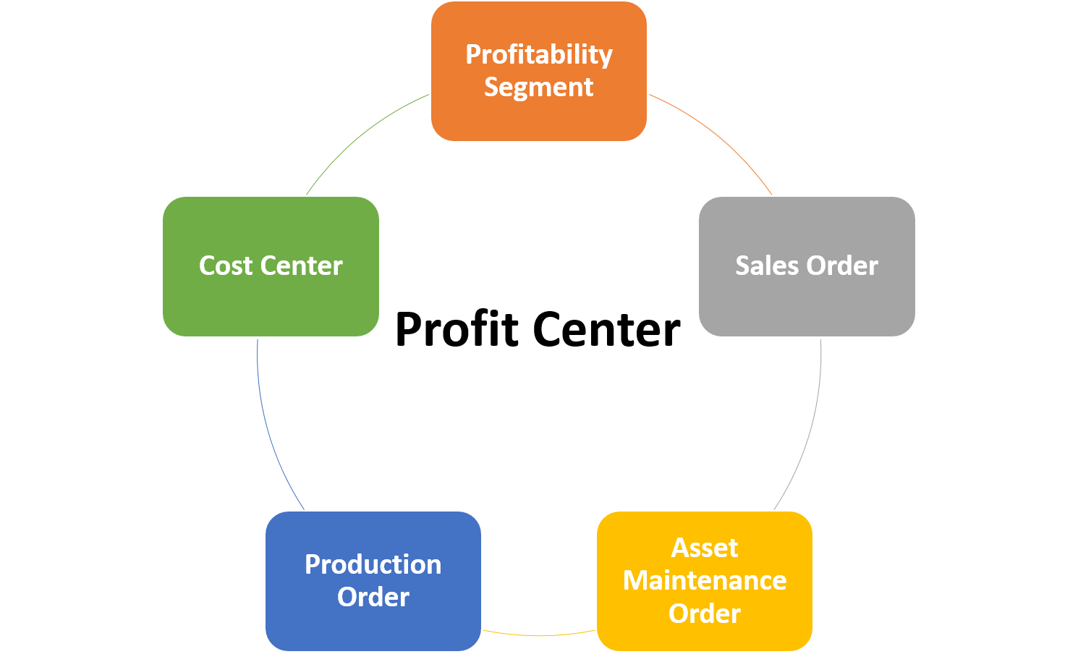

**Fig:** Profit Center

**Cost Center:**   
Cost center is a department of a company to which direct and indirect costs are charged. Its objective is cost control and cost reduction. It is performed by deducting actual cost from standard cost. Examples of a Cost Center is a Production, Administration, Research and Development, and Service Department of the organization which is responsible for the costs of that particular department.

## **Cost Distribution**

Distribution cost involves those expenses related to the transport of goods. Distribution costs may include the following:

* The movement of goods to supplier and customers
* Transport fees and tolls
* Warehousing costs
* Costs to maintain a fleet of transport vehicles

The distribution cost for a business can be substantial when the units shipped have a high cubic volume, goods are perishable or when customers are located in distant areas.Despite the differences, however, there are common functions that every distributor needs to have.

**Fulfillment:** Fulfillment is the heart of distribution operations. In fulfillment, the two major functions of distribution—picking and packing—come together. Companies don’t tend to overlook fulfillment when searching for enterprise resource planning (ERP) solutions

**Purchasing Optimization**: Distributors don’t win points when the customer’s order contains back-ordered items. ERP systems need to be able to manage inventory levels to avoid stock-out situations. Every distributor struggles with this. Managing inventory merges with purchasing at this point to ensure proper stocking levels and timing of incoming product.

**RFID, Barcode, and Inventory Tracking**: Knowing how much product is in the warehouse is good; knowing where the product is in the warehouse is vital. The distribution ERP system needs to tell receiving where to put away the incoming items, and it needs to tell the pickers where to get the product from the shelving.

**Transportation Management and Shipping**: After the order is packed, it has to get to the customer. ERP vendors need to manage the last mile of delivery just as much as inventory in the warehouse.

**Open Interface to Other Applications**: Most ERP salespeople talk about the completeness of their application. They sell one solution from one vendor to manage all distributors’ operations. Most distributors know better from experience.

A distribution ERP needs to be flexible to exchange data with other applications

## **Comparative Statement**

A comparative statement is a document that compares a particular financial statement with prior period statements or with the same financial report generated by another company. Analyst and business managers use the income statement, balance sheet and cash flow statement for comparative purposes. The process reveals trends in the financials and compares one company's performance with another business. The following are the most commonly used forms of such analysis.

1. Comparative Balance Sheet
2. Comparative Income Statement
3. Comparative Cash Flow Statement

An example of comparative statement is given below:

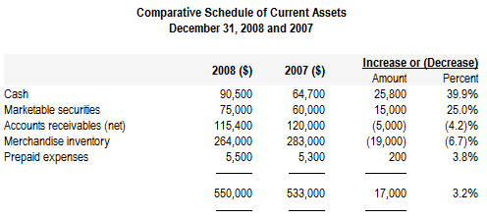

**Fig:** Example of Comparative Statement

## 

## **Account Reconciliation**

The reconciliation operation consists of matching entries in different accounts to indicate that they are related. Generally reconciliation is used for:

* Matching invoice entries to payments, so that invoices are marked as paid and customers do not get payment reminder letters for those entries (reconciliation in a customer account).
* Matching deposits and cheque withdrawals with their respective payments.
* Matching invoices and credit notes to cancel them out.

A reconciliation must be carried out on a list of accounting entries by an accountant, so that the sum of credits equals the sum of the debits for the matched entries. Account reconciliation is an underappreciated yet critical control to help, ensure an organization's financial integrity. Weaknesses and inefficiencies in the reconciliation process often lead to mistakes on the balance sheet and overall inaccuracies in the financial close.

Following this best practices list will send you on your way to error-free account reconciliations and a more efficient financial close:

**Account reconciliations should be complete and maintain the following points:**

* Ensure all appropriate accounts are being reconciled, including new accounts.
* Ensure that there is an overall reconciliation policy and that it is adhered to companywide.
* Ensure that each reconciliation includes a title, description of the account, and procedures and/or instructions on how to complete the reconciliation (applicable contacts, reports to run or obtain, etc.).
* Documentation supporting the account balance should be included with the reconciliation.

## **Profit and Loss Statement**

The Profit & Loss statement is a financial statement which gives a summary of the revenues, costs and expenses during a specific period of time. Such a report provides information that shows the ability of a company to generate profit by increasing revenue and reducing costs. The Profit & Loss statement is also known as an **"Income Statement**".

The result shown in this report, is a net profit or loss of a business.

In general, the Profit and Loss report will be used to determine profit ratios, to examine sales prices and costs, and to set marketing budgets, for instance.

## **Partner Ledger**

A partner record is a relatively simple document, often kept by partnerships, which details the ownership of the business. They are typically a chart-like registry, simply listing each partner and indicating what percentage ownership that partner has in the company, how much capital that partner contributed, etc. The ledger also keeps track of any changes in ownership, indicating when partners leave the partnership and what happens to their interest, or when partners join the partnership and how the ownership interests are reassessed.

An example of comparative statement is given below:

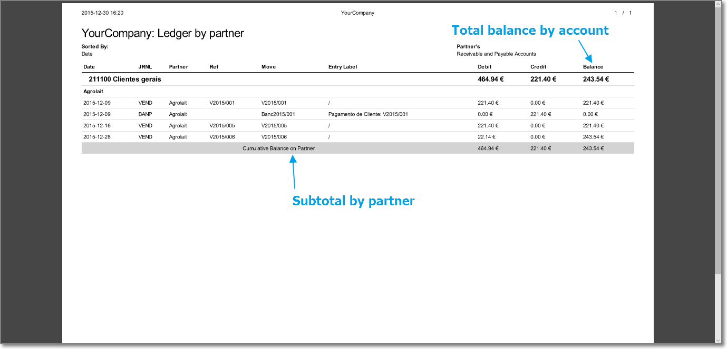

**Fig:** Partner Ledger Example

## **Opening and Closing a Financial Year**

At the end of a financial year, user will have to transfer the closing balance of that year as an opening balance to the new financial year. This feature allows user to automatically post that entry. User can transfer the new opening balance numerous times, because it is impossible to close a year at once. Correction entries will have to be made, due to which balances will change.

### **Open a New financial Year**

* User will have to create new financial year by defining period.
* Check the Account Types: Before generating the opening entries, user needs to check the defined account types, more specifically the **Deferral Method**. The deferral method determines whether and how account entries will be transferred to the new financial year.
* User needs to check the Link between accounts and accounts Type. Check whether each account is linked to the correct account type to avoid generating an incorrect opening entry.
* User needs to create a Purchase and/or Sales Journal for Outstanding Entries.
* User needs to enter the Opening Balance (Miscellaneous Entry). For each account that needs to be reopened, enter account data (debit or credit) in the journal.

These are the important steps to define a new financial year for accounting system.

### **Closing a Financial Year**

When the year is closed, user can no longer create or modify any transactions in that year. Closing a year is not mandatory and user can easily do that sometimes in the following year, when all the accounts are finally sent to the statutory authorities and no further modifications are permitted.

# **4. To be Determined**

1. ISO 9001 related reports are not implemented within this phase. We will cover in next phase.

Signed on behalf of Signed on behalf of

Samuda Chemicals Ltd. Genweb2 Limited

Name: Name:

Designation: Designation:

Date: Date:

**______________________________ ______________________________**

Signature Signature