Commercial Module

## Process:

1. Purchase Requisition Process
2. Techno Commercial Process
3. LC Process
4. Goods Delivery Process
5. Goods Receive Process

## Purchase Requisition Process:

### Process Diagram:

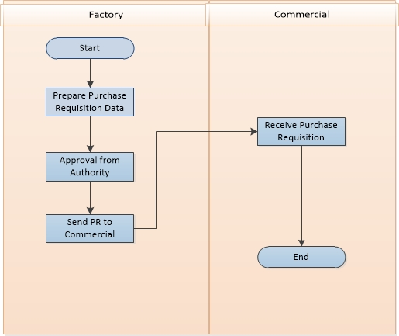

Figure 01: Purchase Requisition Process

### Process Flow:

* 1. Store in-charge prepares a requisition depending on product’s amount and future production plan. Store in-charge calculates all the quantity of required products.
  2. After prepare draft PR, store in-charge send PR to plan-in-charge.
  3. If plan-in-charge feels ok with the PR then plan-in-charge approve the PR and send to GM for further approval. Otherwise store-in-charge back the PR to store-in-charge for correction of products and quantity.
  4. If all goods, then GM approve the PR and send PR to COO/MD for next and final approval.
     1. Sometimes COO or MD both approval needed.
     2. Otherwise anyone is enough for PR.
  5. Final approved PR ready to for quotation preparation.

## Techno-Commercial Process:

### Process Diagram:

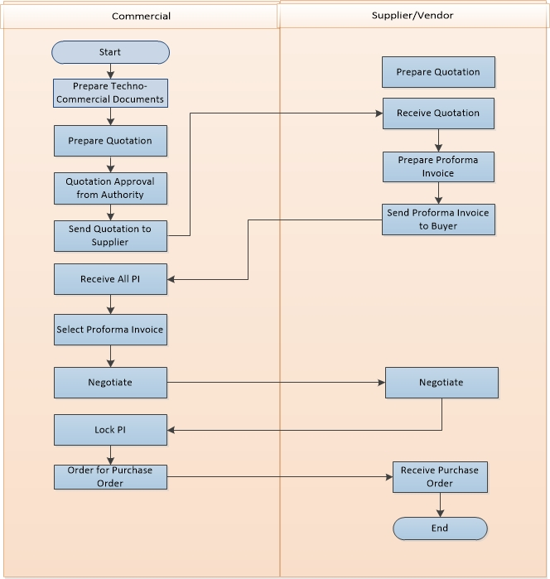

Figure 02: Techno-Commercial Process

### Process Flow:

* 1. Commercial department prepare a techno-commercial documents which includes all technical and commercial specification.
  2. Technical and commercial documents approved from authorized user
     1. Technical
     2. Commercial
  3. After prepare techno-commercial document, Commercial department prepare Quotation for sourcing the product.
  4. Every Quotation has two section names ‘Technical Specification’ and ‘Commercial Specification’. Both specifications have different hierarchy authority. Hierarchy authority are-
     1. Technical Authority: -
     2. Commercial Authority: AO(Approval Authority) -> GM(General Manager) -> COO/MD.
  5. After taking all approval, commercial send the quotation to selected supplier/vendor all over the world.
     1. Buyer may select depends on good quality, quantity or price etc.
  6. After response of all vendor/supplier, commercial department receive multiple Proforma Invoice (PI).
  7. Commercial department select one on multiple Proforma Invoice depending on price, quantity and other factors. Negotiation starts with the selected supplier.
     1. Negotiation includes price, quantity, delivery time etc.
  8. After negotiation, commercial department may select one or multiple vendor for particular order.
     1. Select one supplier for regular case
     2. Select multiple suppliers if one supplier is unable to supply the goods.
  9. After final negotiation, commercial department place and order to supplier/vendor.
  10. All negotiation must be discussed through email.

## Letter of Credit (LC) Process:

### Process Diagram:

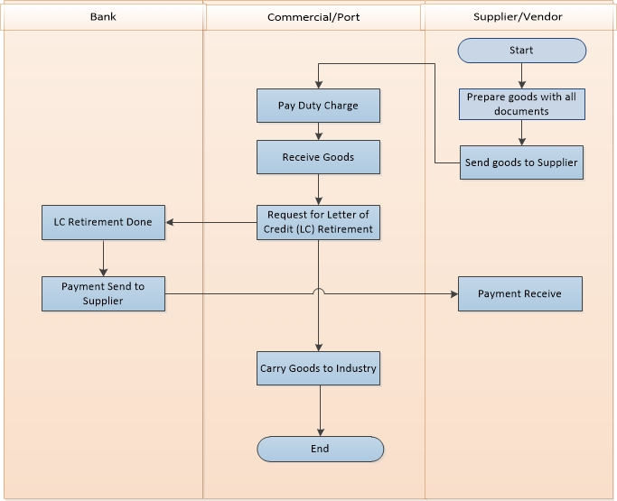

Figure 03: Letter of Credit (LC) Process

### Process Flow:

* 1. Commercial department request for opening Insurance against the Purchase Order.
  2. Insurance company open insurance.
  3. Commercial department request for opening LC to selected bank providing all necessary information.
  4. Bank opens an LC satisfying all terms and condition.
  5. Bank sends a copy of LC to customer and supplier.
  6. LC processes wait for goods delivery.

## Goods Delivery Process:

### Process Diagram:

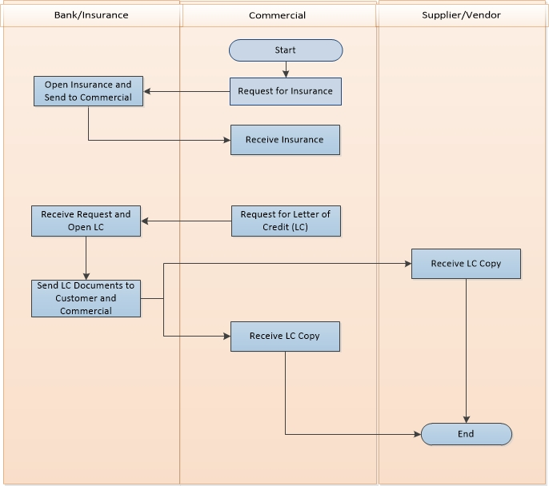

Figure 04: Goods Delivery Process

### Process Flow:

* 1. Supplier prepares the goods and ready to shipping the goods including all documents. Documents includes-
     1. Shipping Documents
     2. Customer Invoice
     3. Port Clearance
  2. Supplier sends goods to customer according to mentioned route.
  3. Commercial receives goods buy paying all for documents and charge to port.
  4. After completed all formality, commercial receive goods and place an LC retirement request to LC Bank.
  5. Commercial sends the goods to mentioned delivery address.

## Goods Receive Process:

### Process Flow:

* 1. Industry receives all goods by preparing a Material Receiving Report(MRR).
  2. In MRR, customer includes all product description with quantity and vat if any.
  3. MRR approval hierarchy-
     1. **Quantity Receive by –> Sig & Designation**
     2. **Received by -> Store Personnel**
     3. **Approved by -> Plant-in-charge**
  4. Process done.