

**Customer Requirements Specifications (CRS)**

***Commercial Management***

***For***

***Samuda Chemicals Ltd.***

# **Document Information**

|  |  |
| --- | --- |
| Document Name | Commercial Management for Samuda Chemicals Ltd. (CRS) |
| Document Author | Kamrun Nahar |
| Document Version | 1.0 |
| Release Date |  |

|  |  |
| --- | --- |
| Review by | Md. Mahfuzur Rahman |
| Review Date | TBA |
| Approved By | Matiar Rahman |
| Approval Date | TBA |

Signed on behalf of Signed on behalf of

Samuda Chemicals Ltd. Genweb2 Limited

Name: Name:

Designation: Designation:

Date: Date:

**______________________________ ______________________________**

Signature Signature

# **Document History**

|  |  |  |  |  |  |
| --- | --- | --- | --- | --- | --- |
| A=Added, M=Modified, D=Delete | | | | | |
| **Version No** | **Date** | **Section No** | **A/M/D** | **Description of Change** | **Author** |
| 1.0 | 28-Jan-2017 |  | A | Initial | Kamrun Nahar |
|  |  |  |  |  |  |
|  |  |  |  |  |  |

Contents

**A.** **Document Information** 2

**B.** **Document History** 3

**1.0** **Introduction** 5

**1.1 Purpose of CRS** 5

**2.0** **Commercial Module Overview** 5

**3.0 Commercial Module and its Process** 7

3.1 Techno-Commercial Process: 8

3.1.1 Process Flow Description 9

3.2 Letter of Credit (LC) Process 10

3.2.1 Process Flow Description 11

3.3 Goods Delivery Process: 12

3.3.1 Process Flow Description 12

3.4 Goods Receive Process 13

3.4.1 Process Flow Description 13

**4. To be Determined** 14

# **Introduction**

# **1.1 Purpose of CRS**

The purposes of this CRS (Customer Requirement Specification) are to clearly identify the customer requirements and provide a detailed document. The customer will review the document and approve/make changes as required. It will also help the review team to validate whether the customer requirements have been fulfilled or not.

# **Commercial Module Overview**

Globalization has encouraged many establishments to shift business focus beyond geographic boundaries as a way to increase their top line reviews. Subsequently, the imports/exports have boomed. However, importers/exporters are facing a problem with customers spread across different geographical locations, making it tough for them to comply with different export/import rules and regulations. Without a proper import /export management system, exporters/importers are unable to screen potential customers/supplier to see if they are listed on the restricted party list, figure out license requirements, comply with export rules and statutory regulations and generate the required import/export documentation.

Our versatile and robust Commercial management system will make it easy for the business to handle even the smallest import/export-related task. Our module is designed to automate import/export compliance and transactional functions; using it authorized user can deal with required international supplier/customer, ensure smooth delivery/receive process, generate necessary documents and file. In addition, this system also allows to maintain audit trails and promote management reporting. It is efficient and helps the business to make import/export process more efficient, while reducing the chances of risks.

Domestic sales procedure and international sales procedure is different thing in any organization. Commercial module works for resolving the issues where Buyers and Sellers are from different countries and they need to be assured about the product and payment. Commercial (Export & Import) module handles all the internationally accepted procedures to make sure successful international sales and purchase. Now a days some procedures like LC (Letter of Credit) became popular for domestic sales also, Commercial module will be managing all this scenario to make the import/export profitable one.

**Importance of Commercial Module**

It is user-friendly and has an easy interface. It is one of the easiest module which will serve business needs of commercial parts. User can customize different elements of the application. Using our export management system, you will be able to reduce the time and effort it takes to be current with regulations and lists, manage all export documentation effortlessly and ensures information are up-to-date. Using this module, it will reduce stress of losing the ability to export, as it will allow you to comply with all statutory regulations comfortably.

The solution is proposed to efficiently maintain and track the operational records starting from purchasing to final delivery. It is highly functional to which customers’ expectations and vendor delivery requirements get conveniently met simultaneously. Almost all the importers and exporters are facing problem in managing goods transaction related options for the elimination of these issues, so this is module gives a solution that best suited with import and export business needs.

# **3.0 Commercial Module and its Process**

The Following are the processes of commercial module:

1. Techno Commercial Process
2. LC Process
3. Goods Delivery Process
4. Goods Receive Process

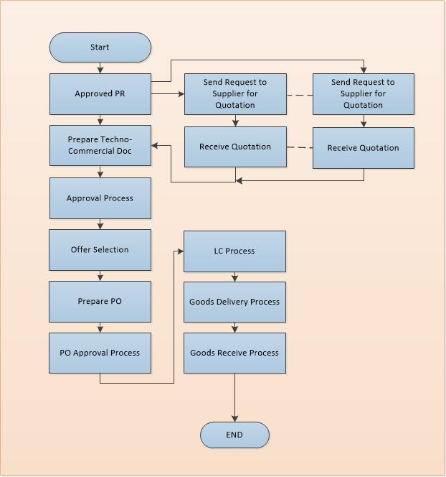

**Fig:** Commercial Process

## Techno-Commercial Process:

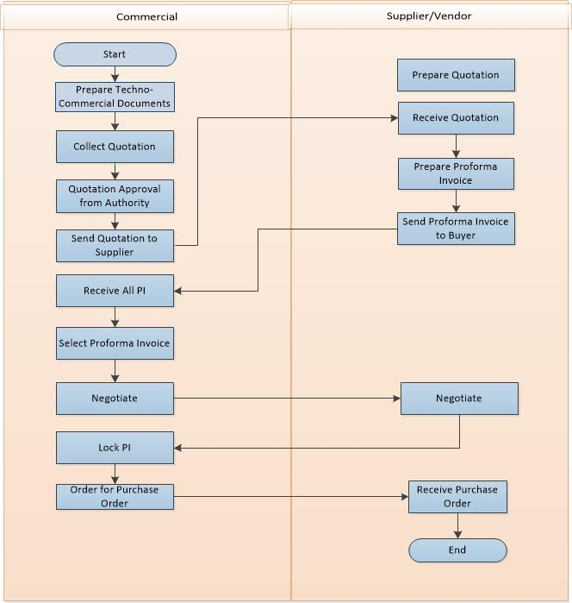

**Fig:** Techno-Commercial Process

### 3.1.1 Process Flow Description

* 1. Commercial department prepares a techno-commercial documents which includes all technical and commercial specification.
  2. Technical and commercial documents approved from authorized user
     1. Technical
     2. Commercial
  3. After preparing techno-commercial document, Commercial department prepares Quotation for sourcing the product.
  4. Every Quotation has two section named **‘Technical Specification’** and **‘Commercial Specification’**. Both specifications have different hierarchy authority. Hierarchy authorities given below:
     1. Technical Authority
     2. Commercial Authority hierarchy

AO (Approval Authority) GM (General Manager) Chief Operation Officer (COO) /MD.

* 1. After taking all the approval, commercial department sends the quotation to selected supplier/vendor all over the world.
     1. Buyer may be selected depends on good quality, quantity or price etc.
  2. After response from all vendor/supplier, commercial department receives multiple proforma Invoice (PI) from multiple suppliers.
  3. Commercial department selects one of multiple Proforma Invoices depending on price, quantity and other factors. After the selection of supplier, negotiation starts with the selected supplier. Negotiation may include price, quantity, delivery time etc.
  4. After negotiation, commercial department may select one or multiple vendors for particular order. The supplier selection can be two types.
     1. Select one supplier for regular purchase
     2. Select multiple suppliers if one supplier is unable to supply the goods for their customer.
  5. After final negotiation with supplier, commercial department places an order to supplier/vendor.
  6. All negotiation must be discussed through email and will be used as supporting documents for delivering/receiving goods.

## Letter of Credit (LC) Process

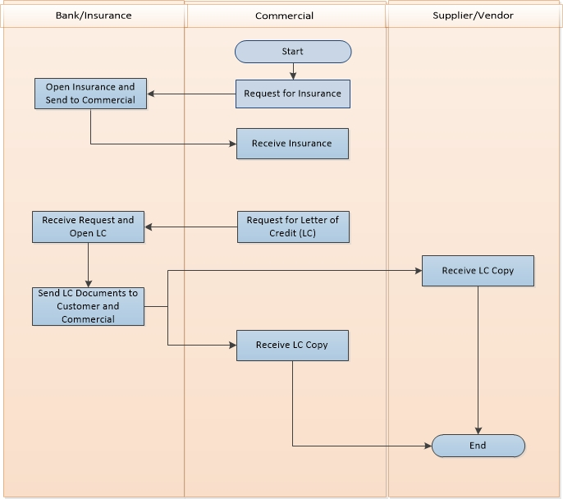

**Fig:** Letter of Credit (LC) Process

### Process Flow Description

1. Buyer and seller agree to conduct business. The seller wants a letter of credit to guarantee payment.
2. Buyer applies to his bank for a letter of credit in favor of the seller.
3. Buyer's bank approves the credit risk of the buyer, issues and forwards the credit to its correspondent bank (advising or confirming). The correspondent bank is usually located in the same geographical location as the seller (beneficiary).
4. Advising bank will authenticate the credit and forward the original credit to the seller (beneficiary).
5. Seller (beneficiary) ships the goods, then verifies and develops the documentary requirements to support the letter of credit. Documentary requirements may vary greatly depending on the perceived risk involved in dealing with a particular company.
6. Seller presents the required documents to the advising or confirming bank to be processed for payment.
7. Advising or confirming bank examines the documents for compliance with the terms and conditions of the letter of credit.
8. If the documents are correct, the advising or confirming bank will claim the funds by:   
   - Debiting the account of the issuing bank.  
   - Waiting until the issuing bank remits, after receiving the documents.  
   - Reimburse on another bank as required in the credit.
9. Advising or confirming bank will forward the documents to the issuing bank.
10. Issuing bank will examine the documents for compliance. If they are in order, the issuing bank will debit the buyer's account.
11. Issuing bank then forwards the documents to the buyer. .

## Goods Delivery Process:

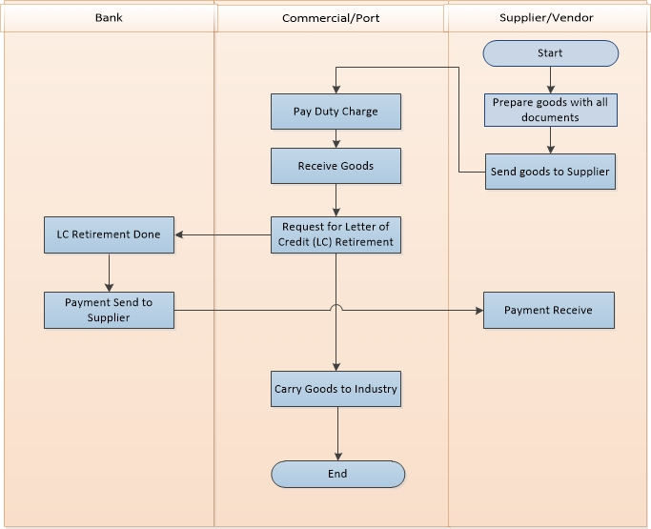

**Fig:** Goods Delivery Process

### 3.3.1 Process Flow Description

* 1. Supplier prepares the goods and make it ready for shipping the goods including all documents. Documents required for delivering goods are given below-
     1. **Shipping Documents:** Air waybill, bill of lading, or truck bill of lading, commercial invoice, certificate of origin, insurance certificate, packing list, or other documents required to clear customs and take delivery of the goods.
     2. **Customer Invoice:** A document, required by some foreign countries' customs officials to verify the value, quantity, and nature of the shipment, describing the shipment of goods and showing information such as the consignor, consignee and value of the shipment.
     3. **Port Clearance:** After receiving the documents of title of the goods, the importer’s only concern is to take delivery of the goods, when the ship arrives at the port and to bring them to his own place of business. The importer has to comply with many formalities for taking delivery of goods. Unless the following mentioned formalities are complied with, the goods lie in the custody of the Custom House.
  2. Supplier sends goods to customer according to mentioned route which was written in documents.
  3. Commercial receives goods by paying all for documents and charges to port.
  4. After completed all formality, commercial receives goods and place an LC retirement request to LC Bank.
  5. Commercial sends the goods in mentioned delivery address.

## Goods Receive Process

### 3.4.1 Process Flow Description

* 1. Industry receives all goods by preparing a Material Receiving Revenue (MRR).
  2. In MRR, customer includes all product description with quantity and vat if any.
  3. There is MRR approval hierarchy which is given below-

1. Quantity Receive by –> Sign & Designation
2. Received by -> Store Personnel
3. Approved by -> Plant-in-charge

# **4. To be Determined**

1. ISO 9001 related reports are not implemented within this phase. We will cover in next phase.

Signed on behalf of Signed on behalf of

Samuda Chemicals Ltd. Genweb2 Limited

Name: Name:

Designation: Designation:

Date: Date:

**______________________________ ______________________________**

Signature Signature