

**Customer Requirement Specifications (CRS)**

***Human Resource (HR) Module***

***For***

***ERP Solution for Samuda Chemicals Ltd.***

1. Document Information

|  |  |
| --- | --- |
| Document Name | HR Module of Samuda Chemicals Ltd. (CRS) |
| Document Author | Kamrun Nahar |
| Document Version | 1.0 |
| Release Date |  |

|  |  |
| --- | --- |
| Review by | Md. Mahfuzur Rahman |
| Review Date | Jan 25, 2017 |
| Approved By | Matiar Rahman |
| Approval Date | Jan 26, 2017 |

1. Document History

|  |  |  |  |  |  |
| --- | --- | --- | --- | --- | --- |
| A=Added, M=Modified, D=Delete | | | | | |
| **Version No** | **Date** | **Section No** | **A/M/D** | **Description of Change** | **Author** |
| 1.0 | 25-Jan-2017 |  | A | Initial | Kamrun Nahar |
|  |  |  |  |  |  |
|  |  |  |  |  |  |

**Contents**

A. Document Information 2

B. Document History 3

**1.0** **Introduction** 6

**1.1 Purpose of CRS** 6

**2.0** **HR Module Overview** 6

**3. Sub Module and Its feature Description** 8

**3.1 Employee Personal Information** 8

**3.2 Define Organization Calendar** 8

**3.2.1 Module Overview** 8

**3.2.2 To be System** 8

**3.3 Leave management** 9

**3.3.1 Module Overview** 9

**3.3.2 Leave Type Declaration** 10

**3.3.3 Declare Leave Year:** 10

**3.3.4 Leave Allocation Process** 10

**3.3.5 Leave Approval Process** 10

**3.3.6 Leave Carry Forward** 11

**3.3.7 Leave Encashment Process** 12

**3.3.8 Short Leave Process** 13

**3.4** **Attendance Management** 14

**3.4.1 Module Overview** 14

**3.4.2 To be system** 14

**3.5 Shift / Roster Management** 15

**3.5.1 Module Overview** 15

**3.5.2 To be System** 15

**3.6 Payroll Management** 17

**3.6.1 Module Overview** 17

**3.6.2 To Be System:** 18

**3.7 Employee Advance Salary Process** 20

**3.7.1 Module Overview** 20

**3.7.2 To Be System** 20

**3.8 Recruitment and Departure Process Management** 22

**3.8.1 Module Overview** 22

**3.8.2 To Be system** 22

**3.9 Employee Loan Management** 24

**3.9.1 Module overview** 24

**3.9.2 To Be System** 24

**3.10 Employee Benefits Management** 25

**3.10.1 Module overview** 25

**3.10.2 To Be system** 25

**4. To be Determined** 26

# **Introduction**

# **1.1 Purpose of CRS**

The purposes of this CRS (Customer Requirement Specification) are to clearly identify the customer requirements and provide a detailed document. The customer will review the document and approve/make changes as required. It will also help the review team to validate whether the customer requirements have been fulfilled or not.

# **HR Module Overview**

We often hear the term Human Resource Management, Employee Relations and Personnel Management used in the popular press as well as by Industry experts. Whenever we hear these terms, we conjure images of efficient managers busily going about their work in glitzy offices. The first definition of HRM is that it is the process of managing people in organizations in a structured and thorough manner. This covers the fields of staffing (hiring people), retention of people, pay and perks setting and management, performance management, change management and taking care of exits from the company to round off the activities. This is the traditional definition of HRM which leads some experts to define it as a modern version of the Personnel Management function that was used earlier.

The second definition of HRM encompasses the management of people in organizations from a macro perspective i.e. managing people in the form of a collective relationship between management and employees. This approach focuses on the objectives and outcomes of the HRM function. What this means is that the HR function in contemporary organizations is concerned with the notions of people enabling, people development and a focus on making the “employment relationship” fulfilling for both the management and employees.

There is a need to align organizational goals with that of the HR strategy to ensure that there is alignment of the people policies with that of the management objectives. This means that the HR department can no longer be viewed as an appendage of the firm but instead is a vital organ in ensuring organizational success.

The aims of module are to provide the organization with a sense of direction and a feeling of purpose. The days when the HR manager was concerned with administrative duties is over and the current HRM practices in many industries are taken as seriously as say, the marketing and production functions.

**Importance of HRMS**

The practice of HRM must be viewed through the prism of overall strategic goals for the organization instead of a standalone tint that takes a unit based or a micro approach. The idea here is to adopt a holistic perspective towards HRM that ensures that there are no piecemeal strategies and the HRM policy enmeshes itself fully with those of the organizational goals. For instance, if the training needs of the employees are simply met with perfunctory trainings on omnibus topics, the firm stands to lose not only from the time that the employees spend in training but also a loss of direction. Hence, the organization that takes its HRM policies seriously will ensure that training is based on focused and topical methods.

In conclusion, the practice of HRM needs to be integrated with the overall strategy to ensure effective use of people and provide better returns to the organizations in terms of ROI (Return on Investment) for every BDT or dollar spent on them. Unless the HRM practice is designed in this way, the firms stand to lose from not utilizing people fully and this does not bode well for the success of the organization

New information technologies and their services have significantly improved the cost-efficiency and lowered the execution risks of human resource management systems. This specific module will help **Samuda Chemicals Ltd.** to manage its HR Department’s serious and cumbersome workloads in most efficient way. The HR department performs heavy duty activities that are virtually common to all or any organizations. To change the HR workflows convenient and easy this modules will perform all the HR activities which are designed for a specific organization. All of these sub modules have their distinctive functions and have efficiencies to perform their respective jobs.

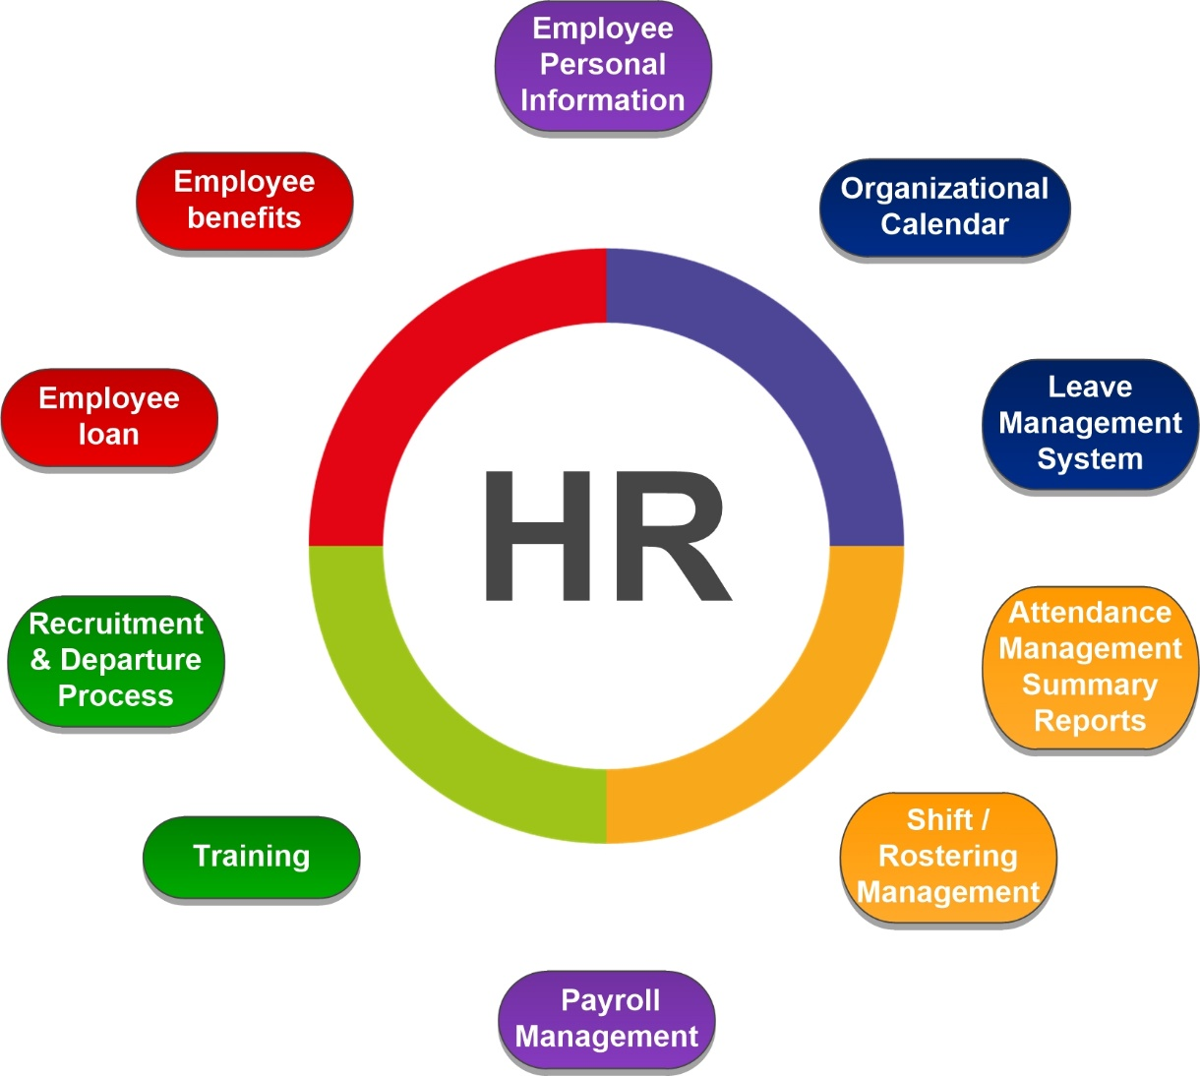

**Fig:** HR module and its Sub-modules

The following are the Sub modules of HR module is given below:

1. Employee Personal Information
2. Organization Calendar
3. Leave Management
4. Attendance Management
5. Shift / Roster Management
6. Payroll Management
7. Training
8. Recruitment & Departure Process
9. Employee Loan
10. Employee Benefits

# **3. Sub Module and Its feature Description**

## **3.1 Employee Personal Information**

This module will maintains all relevant employee related information‚ including different types of personal information‚ detailed qualifications and work experience‚ job related information etc. A picture of the employee can be added as well. All documents related to the employee can be scanned and attached to contribute to legally compliant record keeping. Information captured in this module is utilized by all other modules thus eliminating data redundancy. This will be only accessible by individual and Authorized HR user.

## **3.2 Define Organization Calendar**

### **3.2.1 Module Overview**

This will prepare an organization calendar every year by mentioning public holidays and week holidays. This calendar is prepared by authorized HR Personnel.

**Note:** It is not recommended to make any changes to the organization calendar within that year.

### **3.2.2 To be System**

This following days will be incorporated with system.

**Public holidays:**

Public holidays can be defined and be combined into organization calendars. Public holidays describe the statutory holidays for a particular country.

**Types of Public holidays:**

* Fixed date (Victory Day, Independence Day)
* Fixed day of week from a specific date
* Specific number of days before or after Eid-ul-Fitr and Eid-ul-Adha
* Moveable holiday (with individual specification of dates during each specified year).

For holidays with fixed date and moveable holidays it is possible to specify simple rules guaranteeing the holiday if it falls on certain days of the week (Thu, Fri, Sun, Sat/Sun).

**Week Holidays**

It will be configurable item depends on the employee category. E.g. for HR employee week holiday is Tuesday.

## **3.3 Leave management**

### **3.3.1 Module Overview**

Leave management module is responsible to track all the employees’ leave related activities. It will help to declare leave types along with leave encashment and carry forward feature. This module will also have dynamic leave approval system for the applied leave by the employee. Features of this sub module is given below:

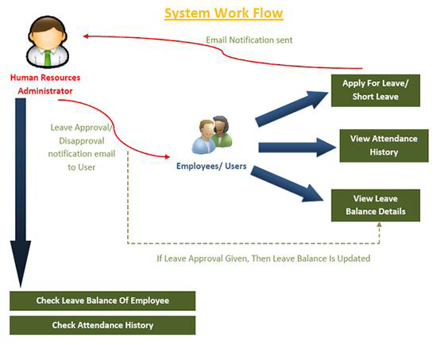

**Fig:** Leave Management Workflow

### **3.3.2 Leave Type Declaration**

Employees across all industries are entitled to a certain number of leaves per year aside from the holidays and days off. The number and type of leave depends on the industry, employer. Three types of leaves are generally found named earned leave, sick leave and casual leave which an employee can avail without loss of pay.

* + **Casual leave** is provided to take care of urgent and unseen matters like child has fallen down in school and you get call from school. For example: At Samuda employees can avail 13 days of casual leave yearly. It is configurable by Authorized HR Manager.
  + **Sick leave** is provided in case of when employee gets sick. For example: At Samuda employees can avail 7 days of sick leave. It is configurable by Authorized HR Manager.
  + **Earned Leave** is provided for planned long leaves for the purpose of travel/ vacation etc. For example: At Samuda, employees can avail 17 days of earned leave which is calculated yearly. At system's setting/configuration it will be declared the type of earned leave i.e. quarterly/yearly etc.

We need to allocate the leave based on type; casual leave and sick leave within the system. We don’t need to allocate earned leave separately and it will be system generated.

### **3.3.3 Declare Leave Year:**

An employer must usually tell their staff the dates of their statutory leave year as soon as they start working, e.g. it might run from 1st January to 31st December. Workers must take their statutory leave during this time. For example: Samuda leave year starts from January to December.

### **3.3.4 Leave Allocation Process**

Every Leave will be manually allocated except earn leave. Earn leave will be allocated end of year and employee will avail that next year and it will be system generated. Example: An employee can avail 7 days sick leave in a year. So it indicates sick leave allocation for that employee is 7 days which will be entertained throughout the year. Leave allocation can be done employee wise/department wise or for all employee.

### **3.3.5 Leave Approval Process**

Leave process can have multi-layer approval process. For example, after applying the leave application goes to line manager. Then after approval of line manager it will go to the head of the dept. for the final approval. The application can be rejected on both line manager and head of the department stage. At Samuda leave approval process will have two steps i.e. approval of line manager and department head.

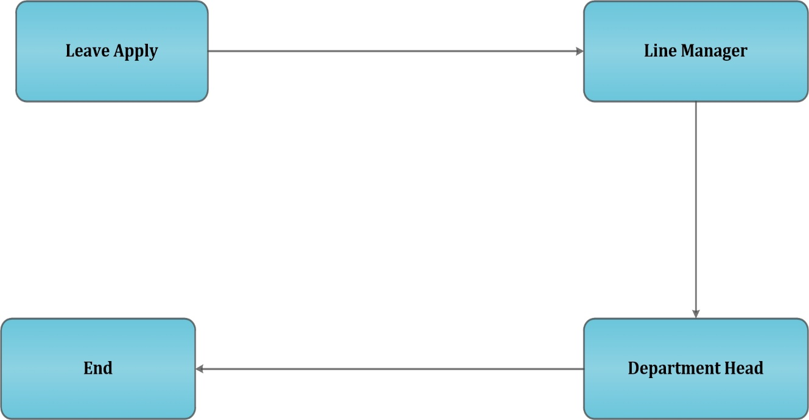

**Fig:** Leave Approval Process

### **3.3.6 Leave Carry Forward**

Earned Leave will be carry forward to next year if it meets the required criteria and added on users corresponding leave type. Process of earned leave carry forward is very simple:

First we need to check if user is eligible to carry forward his leave or not. For example, available leave has to be minimum of 5 days to be forwarded and user will be eligible. Then we check if user wants to carry forward his leave or not along with the carry forward leave type checking of yearly/quarterly etc. After user decides to carry forward his leave then we will have to generate eligible user list for leave carry forward. Also the multi-layer approval should be there to process it.



**Fig:** Leave Carry Forward and Encashment Process

### **3.3.7 Leave Encashment Process**

In case an employee does not avail earned leaves which were allowed to him, he may also encash these leaves and earns salary for the number of days which were allowed to be taken as leave but were not availed as leave. The policy of leave encashment depends on the employer for whom you are working and different employers have different policies for leave encashment.

First we need to check if user is eligible to carry forward his leave or not. For example, available leave has to be minimum of 5 days to be forwarded and user will be eligible. Then we check if user wants to carry forward his leave or not along with the carry forward leave type checking of yearly/quarterly etc. After user decides to carry forward his leave then we will have to generate eligible user list for leave carry forward. Also the multi-layer approval should be there to process it. To get the whole process please see the previous image.

### **3.3.8 Short Leave Process**

Short leave is for up to e.g. 3 working days per year for employees to attend matters of a personal and pressing nature that arise with little or no notice and require immediate attention and which cannot be conducted outside of normal business hours. In this leave employee will take few hours leave to manage his/her emergency issue. In this module employee needs to apply this for leave and the approval process is given below: Department/Line manager will approve this.

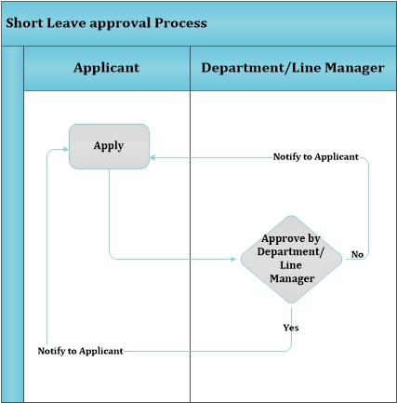

**Fig:** Short Leave Approval Process

## **Attendance Management**

### **3.4.1 Module Overview**

Every organization has a certain percent of employees whose punctuality and work hours per day are questionable. Using Attendance Management system, many organizations have been able to make their employees self-aware of their timings leading to a positive impact. Attendance Management System allows seamless attendance tracking of every employee in the organization.

Attendance management module is responsible to store, process and analyze all the employees’ attendance data. It will help to monitor employees late or absence summary also. It will also help in employees’ pay slip generation.

**3.4.2 To be system**Samuda intends to develop automated attendance system in order to track employees’ attendance and regularity. Some of the features are as following:

* Integration with any biometric attendance device.
* Attendance time (e.g. 9 A.M) should be pre-defined.
* There will be a grace time (e.g. 9.15 A.M) which will be pre-defined as well.
* Entry after e.g. 9.15 A.M should be counted as late.
* Late entry in case of some official task or urgent matter should be handles in this module. In this case he/she will have to apply for that special entry and approval process will be there. It will have impact on payroll module and shift management module.
* It will viewed by individual and authorized user only. Employee can’t see others attendance record.
* Absence summary will be generated from the attendance management module
* Easy report generation (e.g. daily attendance report, overtime report, late in/ early out report, employee swipe report)
* This attendance module will be integrated with leave management module also.
* In this module there will be record that if anyone will be delay for 3 times in a payroll month, as a punishment one day basic salary will be deducted. It will have to be integrated with payroll module.
* When applicant will apply, the approver will be department manager/line manager. If the application approved by department/line manager, notification will be sent to applicant and authorized HR user. If the approver rejects the application, the process ends there.

**Fig:** Manual Attendance Approval Process

## 

## **3.5 Shift / Roster Management**

### **3.5.1 Module Overview**

**Shift work** is an employment practice designed to make use of or provide service across, all 24 hours of the clock each day of the week (often abbreviated as *24/7*). The practice typically sees the day divided into shifts, set periods of time during which different groups of workers perform their duties. The term "shift work" includes both long-term night shifts and work schedules in which employees change or rotate shifts. This module will manage all the shifting process throughout the organization.

### **3.5.2 To be System**

Samuda intends to develop automated shift/ Roster management system in order to track employees’ shifting duty in a most efficient manner. Some of the features are as following:

* Configure the number of shifts (e.g. general shift, morning shift, night shift etc.)
* Configure shift hours
* Shifting can be employee/ group wise.
* Roster will be generated monthly. It can be generated at any time but it will always count the period from (1st to end of month). It can be configured dynamically.
* This will have integration with attendance management. E.g. if any worker log in 10 p. m. on 9th January, 2017 and he log out at 7 a.m. on 10th January, 2017 in that case his attendance will be count on log in date .
* Configure OT hours
* Shift change is allowed in this sub module. The following is the process how shift change will occur in Samuda chemicals.

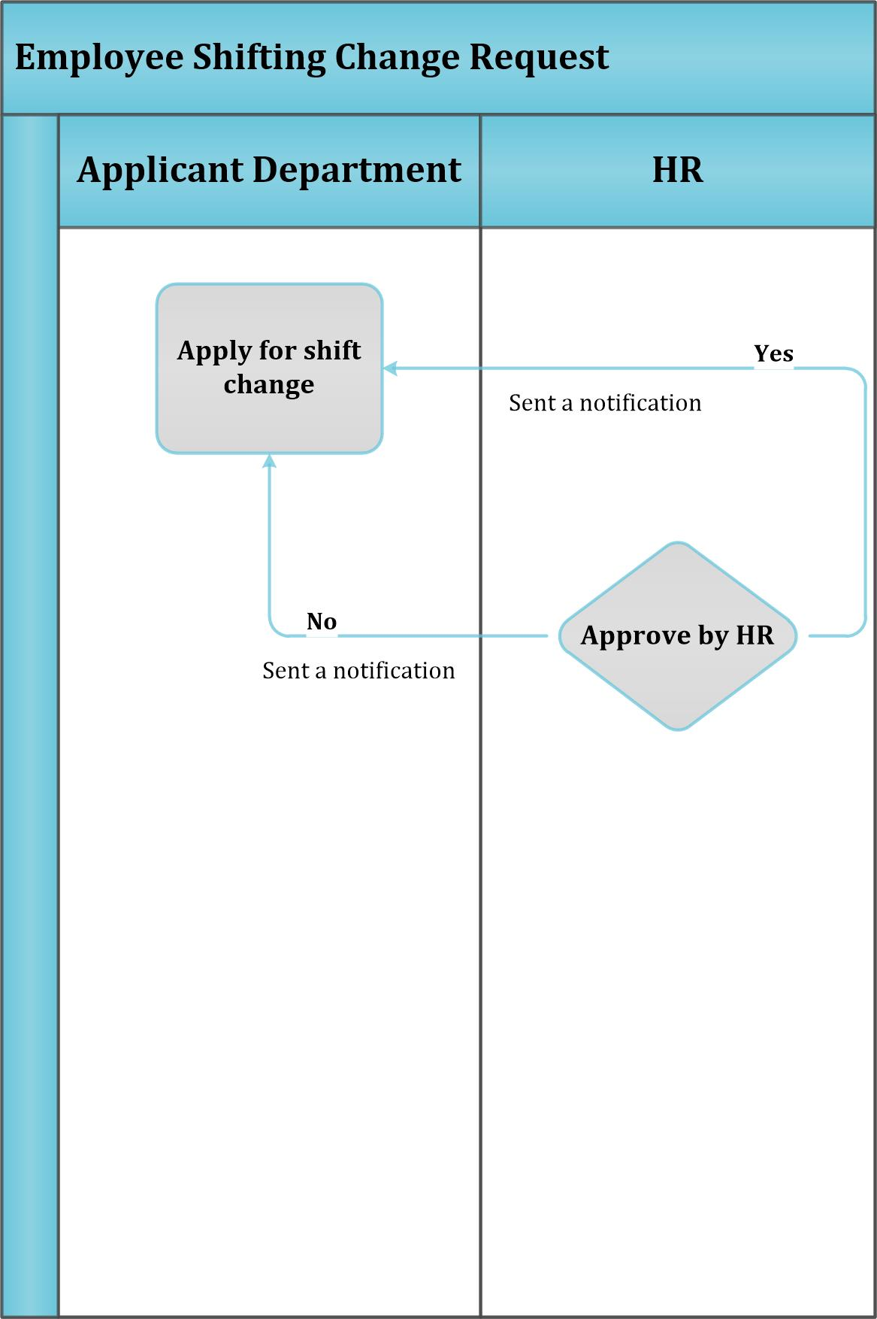

**Fig:** Shift Change Request Process

## **3.6 Payroll Management**

### **3.6.1 Module Overview**

Payroll system is the core part of HR System. Payroll is a process by which the employee of organization receives their salaries. For this system deals with the functions that involves balancing and integration of payroll data. It also includes depositing & reporting of payroll system information. Payroll system also takes care of wages generation, deductions and employee record keeping processes.

It is integrated Sub Modules are below:

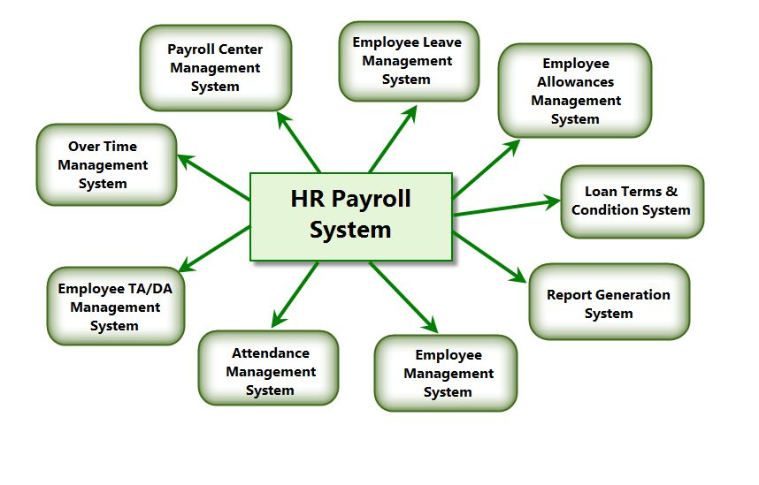

**Fig:** HR Payroll Management

The proposed payroll sub module includes a generic payroll engine that handles everything required to compute HR salary slips, the taxes to pay, etc. We can manage company's payroll by using this sub module. Proposed payroll can differ from one pay period to another due to overtime and other variables. Each month’s 26 date to next month 25 date becomes payroll period in this organization, which are dynamically configurable.

### **3.6.2 To Be System:**

* Salary rule: are used to compute data like allowances, deductions, net, taxes, contribution registers, etc. We can define salary rules by using the expression.
* Salary structure: Define a set of rules usually applied to a category of employees. Salary calculation after considering all the allowances, deductions and incentives (if any) etc.
* Contribution registers: A register containing to whom the company or the employee have to pay taxes.
* Employee and contract: It includes everything required to compute the salary slip of an employee.
* Salary processing on the basis of leaves taken or number of working days.
* Generating Reports.
* Integrated with Contracts and Holidays.
* Pay slip will be generated by HR executive and approval will be done by HR Manager.

**Salary Rule Categories**

Salary Rule Categories are your Basic, Allowance, Deduction, Gross, Net, Company Contribution, etc. by using which we can categorize your Salary Rule. We can define Salary Rule Categories in proposed system.

**Also can configure the following information:**

* Name: A name for the Salary Rule Category.
* Code: A code for the Salary Rule Category. It must be unique.
* Parent: It is used to create hierarchy for reporting purpose.

After entering the Salary Rule Category information will have to be saved in system.

**Salary Rules**

Salary Rules are the various types of Allowances, Deductions, etc. We can define Salary.

**House Rent Allowance defined as Salary Rule**

In the proposed system, there are list of Available Variables which will be used to specify field's value on Salary Rules. We can configure the following information:

* Name: A name for the Salary Rule.
* Code: A code for the salary rule. It must be unique.
* Category: Select a category for a rule.
* Sequence: Provide the sequence (integer).
* Active: If False, it will allow you to hide the salary rule without removing it.
* Appears on pay slip: If False, it won't appear on the pay slip but will be considered in the calculation.
* Condition based on: Consider a rule on the basis of some condition.
* Contribution Register: Eventual third party involved in the salary payment of the employees’ used in report.
* Amount Type: The computation type for the rule amount. There are three types available to compute the amount. I.e. Fixed Amount, Percentage, Python Code.
* Child Rules: It is used to assign child rules.
* Description: Description regarding the rule.
* Etc.

**Salary Structure**

We can configure the following information:

* Name: A name for a salary structure.
* Reference: A code for a salary structure. It must be unique.
* Parent: Select a structure whose rules you want to inherit.
* Salary Rules: Add the salary rules which you want to provide under your structure.

After entering the salary structure information will store.

**Contracts**

We need to define a contract for an employee which will be used during the pay slip generation.

Installation of payroll module adds the following fields on contract:

* Salary Structure: Salary structure for pay slip.
* Scheduled Pay: When a salary/wages are scheduled to be paid. E.g. monthly, weekly, quarterly etc.

**Employee Pay slip**

On the selection of an employee the Reference, Contract, Structure, Description, Worked Days and Input data (if we have a rule that has an input data) fields will be automatically filled. Allowances and Deductions will be shown in positive and negative values respectively. It will be computed on employee on change. It calculates the number of working days and hours on the basis of Working Schedule provided on contract. It also calculates the leaves. It is used when you want to provide some incentives, commissions, etc. Input Data comes from the rules having Inputs.

**Contribution Registers**

After creating a register you can assign it on Salary rule. When pay slip is created, pay slip lines generated through salary rules having a contribution register will be linked with that register. To see the pay slip lines related to a contribution register go to that particular register and print the Pay slip Lines report.

**Salary Process**

This salary Process will be done automatically with the help of some other modules (Attendance, leave, account etc.) along with required information. Attendance module will provide information about employees’ late attendance summary which might be deducted due to policy. Leave module will be giving information about is employee availing leave more than allocation or not. Employees’ loan, incentive etc. information will be collected from account module. Department will provide information about employee (if there is any feedback). After generating the pay slip it will be confirmed by authorized user and later on this will help account department to disburse employees’ system generated salary.

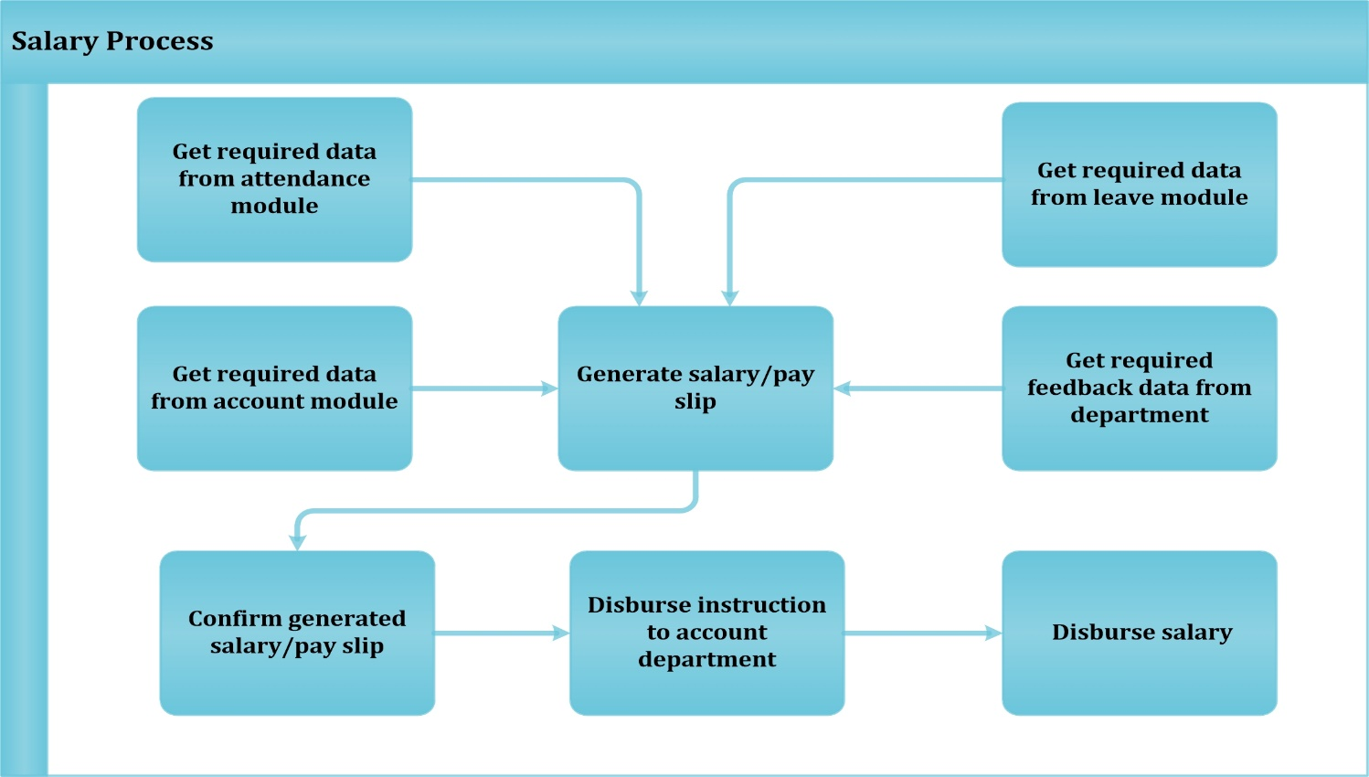

**Fig:** Salary Process

## **3.7 Employee Advance Salary Process**

### **3.7.1 Module Overview**

 If an employee is facing financial hardship they may have the opportunity to request a salary advance. To request a salary advance an employee will complete a Salary Advance Request and Payroll Deduction Form. Once the authorized user receives the form from applicant, he/she has the ability to approve or deny the request according to the requirements. If the request is approved, the next step is to calculate the amount the employee will be advanced. Normal taxes will be deducted from this payment.

### **3.7.2 To Be System**

A Request for Salary Advance shall only be approved for an eligible employee for an unforeseeable emergency which would cause severe financial hardship. An employee may request an advance only for the unpaid time earned to date.

* By submitting the Request for Salary Advance, the employee authorizes the Department of Human resources to deduct the amount of the advance in full from the employee’s next regularly processed pay check.
* A Request for Salary Advance must have the approval of the employee’s direct supervisor and Personnel Officer prior to submittal to the Payroll Manager of the Department of Human Resources (DHR) for final review.
* If a Request for Salary Advance is approved by the Payroll Manager, it will then be forwarded to the Account’s Office to process the payment.
* Salary advances will be in the different pay slip; they cannot be direct deposited because they are not generated during a regular payroll run.
* The purpose of the Request for Salary Advance form is to ensure that a salary advance is properly requested and reviewed as well as to ensure the advance is repaid in full on the payday following approval of the request.

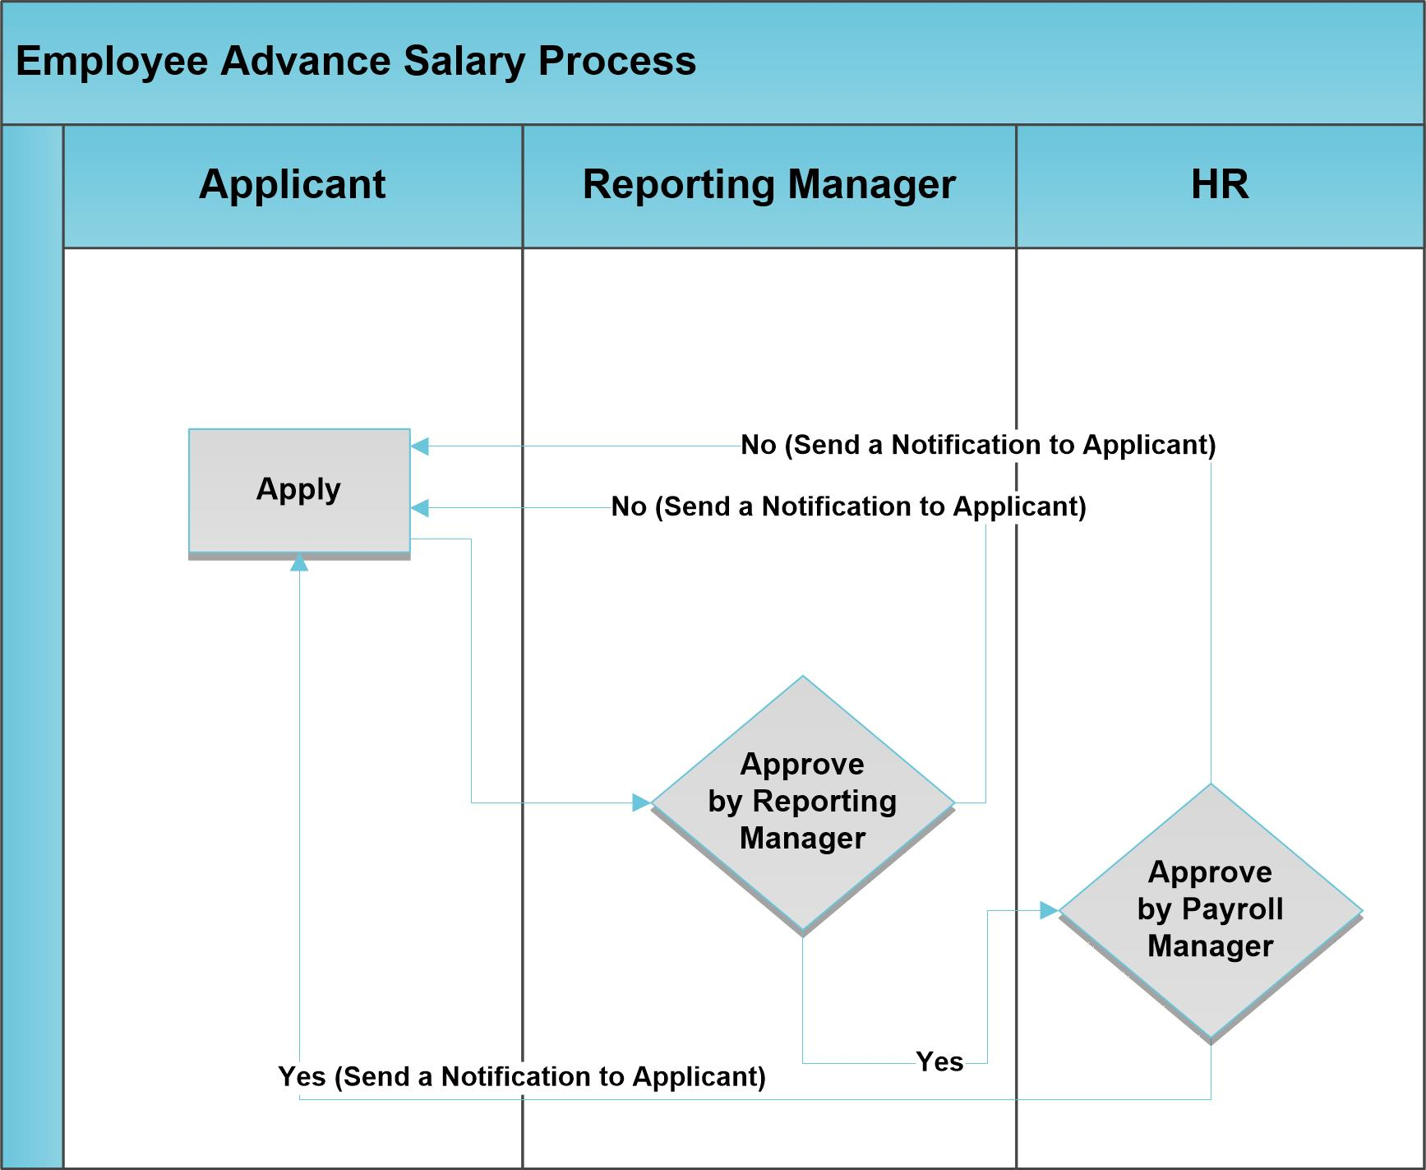

**Fig:** Employee Advance Salary Process

## **3.8 Recruitment and Departure Process Management**

### **3.8.1 Module Overview**

In order to increase efficiency in hiring and retention and to ensure consistency and compliance in the recruitment and selection process, it is recommended to have this to module to attract a talented and diverse applicant pool.

This exit process module allow organization to handle employee exit process or when employee leaving organization.

### **3.8.2 To Be system**

Using this module anyone can efficiently manage the process of hiring new people for the organization. It is a well-managed recruitment process from initial contact to hiring the applicant. The following features of the recruitment process is given below:

* Create applicants automatically based on incoming mail and keep track of attachments such as resumes and cover letters
* Define stages to track the progress in the recruitment process
* Define next action and next action dates
* E-mail communication with the applicant
* Fill questionnaires for each applicant (for instance preliminary questionnaires

1. **Create applicants automatically based on incoming mail and keep track of attachments such as resumes and cover letters**

It also configure email server in this module to create new applicants based on incoming mails. For example, if you have an e-mail ID jobs@yourcompany.com, you can configure it such that all emails received at this ID automatically generate new job applicants.

**Configuring an e-mail server**

After configuring the server, whenever you receive a new e-mail at the configured e-mail address, a new applicant record is created having the same subject name as the e-mail subject. The applicants e-mail details are stored also for future correspondence. You can add more details to this job application. In the figure Job applicants automatically created from e-mails, the Initial Qualification applicants have been created automatically from received e-mails.

**Job applicants automatically created from e-mails**

Because the server is confirmed to add attachments, if an incoming applicant e-mail contains attachments, it will be linked to the corresponding applicant record.

1. **Define stages to track the progress in the recruitment process**

In fact a string of stages (e.g. different stage name which will fit to organization) through which a recruitment progresses in order to bear a favorable outcome. You can define the stages which a recruitment process would undergo which is totally configurable.

1. **Define next action and next action dates**

The **Next Action Date** and **Next Action** fields let you define an action you would like to initiate on a given date. It serves as a reminder to the recruitment officer regarding what step he must take next and on which date.

1. **E-mail communication with the applicant**

It will provide the features which will send email to applicant and schedule meeting with applicants.

1. **Fill questionnaires for each applicant (for instance preliminary questionnaires)**

This will be using questionnaires as a tool to interview a job applicant. A survey form will be configured for set of questions and answers prepared for the selected applicants.

The features of HR departure Process will be the following list:

* Configure Checklists For Exit Process
* Employee Exit Request
* Employee Exit Checklists
* Print Employee Exit PDF Report.

1. **Configure Checklists for Exit Process**

This configuration allow organization to setup all checklist which must be pass before employee Exit Company. This is kind of initial setup and will be used during exit process.

1. **Employee Exit Request**

This will allow employee to request for exit in organization. Employee will apply for exit request and then confirm request and then it will be passed to workflow of approvals. Draft Confirmed request will be approved by Department head/line manager (according to configuration). It will be approved by HR and then by General Manager. This module have integrated calendar meetings and survey on exit process form. This will allow HR department to arrange meetings with various departments and also ask employee to fill exit survey.

1. **Employee Exit Checklists**

This is checklist request sent to respected department for verification and approval. Once department manager approve exit request all checklists configured in the system will make individual checklist request to respected departments for approval. This module has also added constraint as well, if all checklists are not approved and HR try to approve exit request then it will showing warning to HR to make sure all respected departments’ approval are needed.

1. **Print Employee Exit Report**

This will allow to print the employee exit request when it is approved by General Manager.

## **3.9 Employee Loan Management**

### **3.9.1 Module overview**

HR Loan Management allows any organization to effectively and effortlessly configure any policy for availing the loan, the frequency, the amount of the loan and the recovery. The system takes care of loans made to the employee and is fully integrated to the finance.

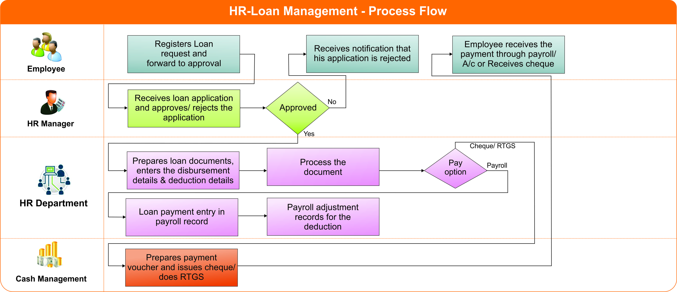

**Fig:** Loan Management Process

### **3.9.2 To Be System**

The following will be the features in HR loan Management Module:

* Loan Request and double layer Approval for the specific loan
* Approver may approve/reject the loan
* Loan Disbursement by Accountant
* Loan Report
* Loan Proofs Setup
* Loan Types Configuration
* Loan Policy Configuration
* Loan repayment process will start when there is disbursement of the specific loan
* Repayment of Loan will be integrated with Payroll System
* Disbursement using Cash/Bank or Payroll

**Note:** There might be some cases after approval of loan, employee may not take the loan as he didn’t get expected loan amount. This will also be handled by this sub module. Employee loan can be re-scheduled also.

## **3.10 Employee Benefits Management**

### **3.10.1 Module overview**

Employee benefits are optional, non-wage compensation provided to employees in addition to their normal wages or salaries. These types of benefits may include provident fund, gratuity fund etc. This sub module will manage all this benefits in an efficient manner.

### **3.10.2 To Be system**

The following will be two benefit which will be entertained by employee of Samuda.

1. **Provident Fund (PF)**

In PF a small portion of the employees’ salary is deducted and deposited with the organization and at the time of retirement it is paid as a lump sum to help the employee leading his life peacefully in spite of retirement and loss of monthly income. It can be employee/company contribution. Company contribution depends on employment period and HR policy. The Policy for Provident Fund (PF) is given below:

* If the employment period is (0-2) years, company will not provide anything.
* If the employment period is (2-3) years, company will contribute 50 %( of the deducted amount).
* If the employment period is more than 3 years, company will contribute 100 %( of the deducted amount).

1. **Gratuity Fund (GF)**

Gratuity is a scheme to motivate people to serve for longer durations with the sameemployer. Anybody who has served an organization for more than 5 years is eligible for Gratuity. A portion of Employee’s last drawn salary would be multiplied with the number of years of service and paid out to the employee when employee leaves an organization. After specific years of service. It will be contribution from Company. The Policy for Gratuity Fund (GF) is given below:

* If the employment period is (0-5) years, company will not provide anything.
* If the employment period is (5-10) years, company will provide him one basic salary (last drawn).
* If the employment period is more than 10 years, company will provide him the amount in following formula. Amount=no. of employment year*1.5 (e.g. if the employee is working for 12 years, the amount will be=12.*1.5=18 (Last drawn basic will be provided to him).

## **4. To be Determined**

1. Currently we are not considering Training Sub Module within this phase. We will cover this sub module in next phase.
2. ISO 9001 related reports are not implemented within this phase. We will cover in next phase.

Signed on behalf of Signed on behalf of

Samuda Chemicals Ltd. Genweb2 Limited

Name: Name:

Designation: Designation:

Date: Date:

**______________________________ ______________________________**

Signature Signature