|  |
| --- |
| genweb2 ltd. |
| Recruitment User Manual |
| REFERENCE: GW/ERP/USER MANUAL |
|  |
| **Genweb2 Ltd.** |
| **09-May-17** |

|  |
| --- |
| logo.png  **Genweb2 Limited**  TK Bhaban (11th Floor),  13 KaziNazrul Islam Avenue,  Kawran Bazar, Dhaka 1215, Bangladesh  web: [http://www.genweb2.com](http://www.genweb2.com/) |

Contents

Contents 2

1. Recruitment Management 3

1.1 Create Departments 3

1.2 Create Degrees 4

1.3 Create Stages 5

1.4 Create Surveys/ Interview Form 5

1.5 Creating Pages 6

1.6 Create Questions 7

1.7 Creating Labels 8

1.8 Create Job Positions 9

1.9 Create Applications 10

# 1. Recruitment Management

In order to increase efficiency in hiring and retention and to ensure consistency and compliance in the recruitment and selection process, it is recommended to have this to module to attract a talented and diverse applicant pool.

Recruitment module allows organization to handle employee exit process or when employee leaving organization.

Using this module anyone can efficiently manage the process of hiring new people for the organization. It is a well-managed recruitment process from initial contact to hiring the applicant. The features of the recruitment process is given below:

* Create applicants automatically based on incoming mail and keep track of attachments such as resumes and cover letters
* Define stages to track the progress in the recruitment process
* Define next action and action dates
* E-mail communication with the applicant
* Fill questionnaires for each applicant (for instance preliminary questionnaires)

## 1.1 Create Departments

First we need to create departments. Using departments we can track the department of an employee of the company.

Using the menu **Recruitment ‣ Departments** and click **Create.**

We need to configure the following:-

**Department Name**: A name for the department.

**Parent Department:** Make a relation with Parent department.

**Manager:** Select a manager.

After entering the department information click **Save**.

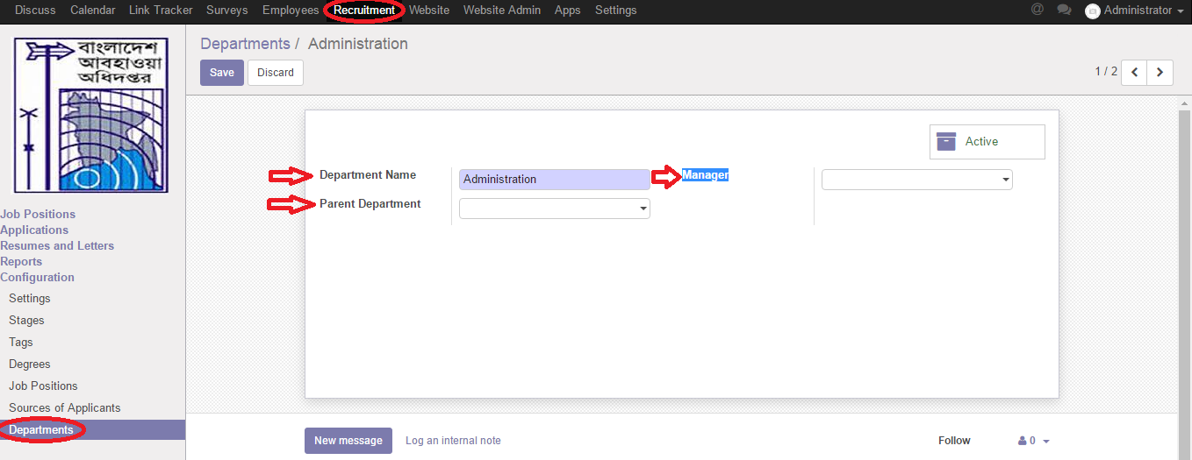

Figure: Create Departments

## 1.2 Create Degrees

We need to create academic degrees of various levels.  
We can create degrees by using the menu **Recruitment ‣ Degrees** and click **Create.**

You can configure the following information:-

**Degree:** A name for degree.

**Sequence:** A code for a degree. It must be unique.

After entering the degree information click **Save**.

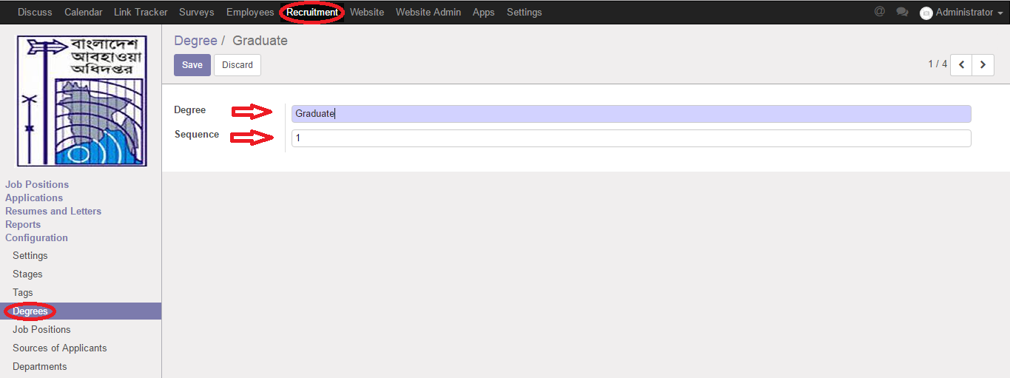

Figure: Create Degrees

## 1.3 Create Stages

The Recruitment Process application organizes the recruiting process in stages. The goal, of course, is to find new employee leads and then convert them into company employees.

Using the menu **Recruitment ‣ Stages** and click **Create.**

We can configure the following information:-

**Stage name:** A name for a stage.

**Sequence:** A code for a degree. It must be unique.

**Job Specific:** Select a job designation.

**Use template:** Select an applicant update like applicant interest or refuse.

After entering the Stage information click **Save**.

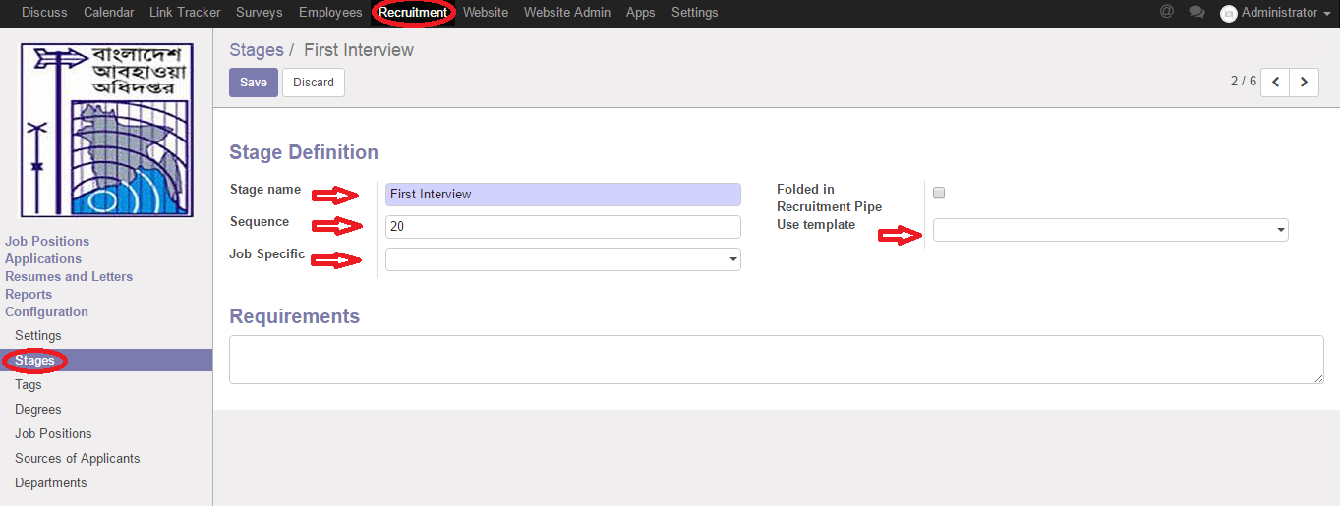

Figure: Create Stages

## 1.4 Create Surveys/ Interview Form

Survey form is also integrated to help the responsible prepare the list of questions for the interview, and take note answers from candidates. By clicking on button Start Interview. We can define a survey, pages, questions, question types using the Survey app located at menu Surveys.

Using the menu **Surveys** and click **Create**.

We can configure the following information:-

**Title:** A name for title.

**Add an item:** Add a pages.

After entering the all information click **Save**.

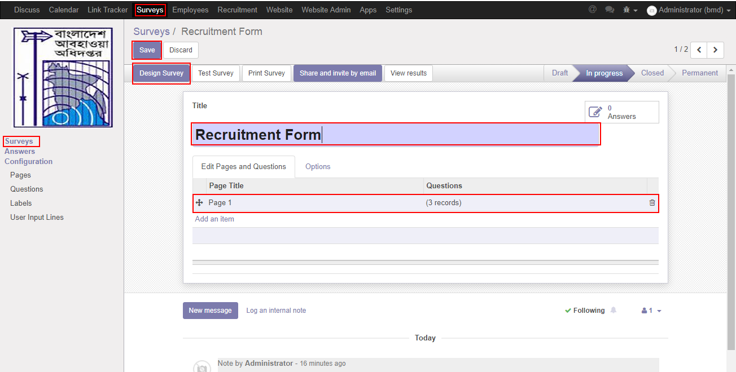

Figure: Create Surveys

## 1.5 Creating Pages

We need to create pages for interview. You can create questions by using the menu

**Surveys ‣ Surveys ‣ Page Title** and click **Add an item.**

We can configure the following information:-

**Page Title:** A name for title.

**Add an item:** Add a questions.

After entering the all information click **Save**.

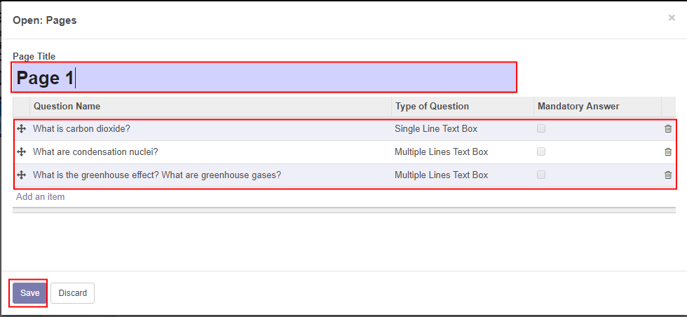

Figure: Creating Pages

## 1.6 Create Questions

We need to create questions for interview.   
We can create questions by using the menu **Surveys ‣ Surveys ‣ Pages ‣ Question Name** and click **Add an item.**

We can configure the following information:-

**Question name:** A name for a question.

**Type of Question:** Select a type.

After entering the all information click **Save**.

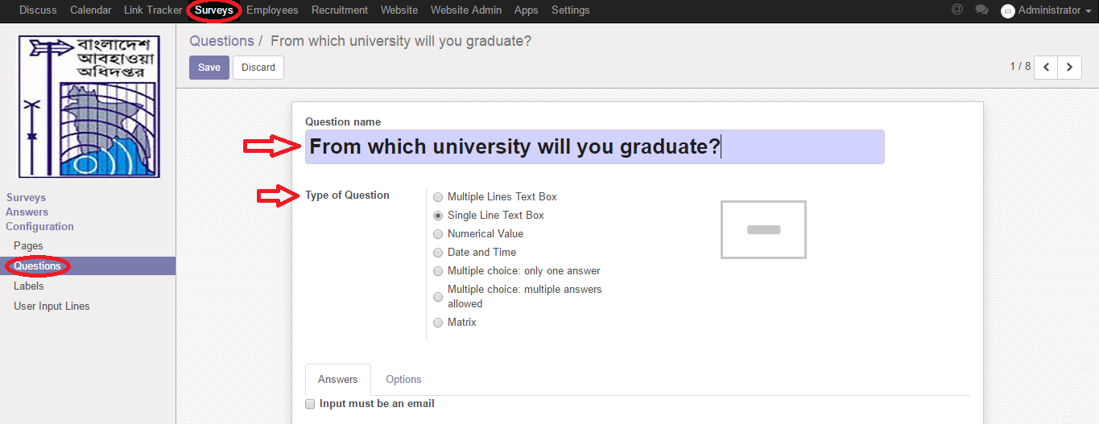

Figure: Creating Questions

## 1.7 Creating Labels

We need to create labels to filter question categories.   
We can create labels by using the menu **Surveys ‣ Labels** and click **Create.**

We can configure the following information:-

**Label of sequence:** A code for a label. It must be unique.

**Suggested value:** Define a value.

**Question:** Chose a question

**Question 2:** Chose a second question

**Score for this choice:** Define a score for this choice questions.

After entering the label information click **Save**.

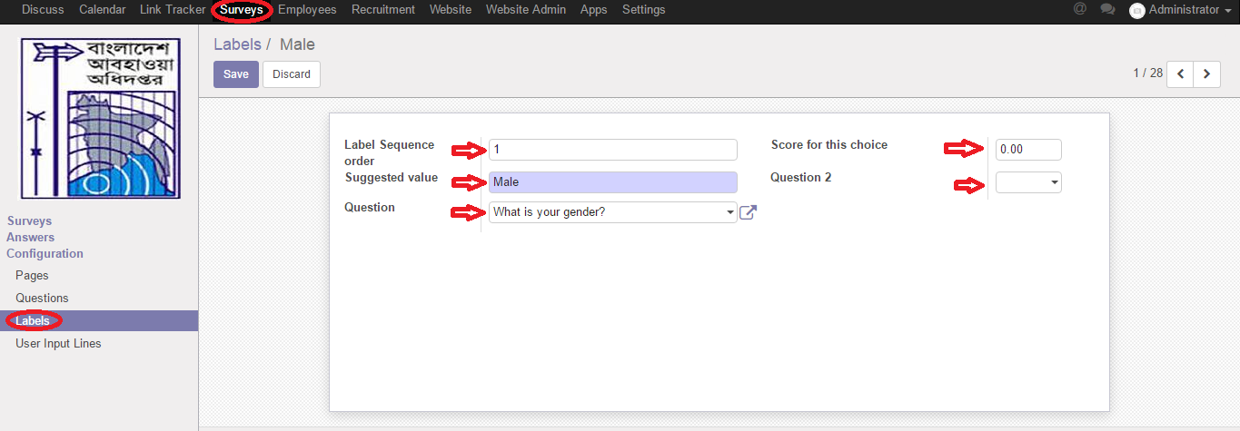

Figure: Creating Labels

## 1.8 Create Job Positions

The information about the Job Positions can be maintained by Using the menu**Recruitment ‣ Job Positions** and click **Create**.

We can configure the following information:-

**Job Title:** A name for job title

**Department:** Select department

**Expected New Employees:** Define expected number of employee

**Interview Form:** Select form

**Requirements**: Add requirements for this job position  
 **Job Description:** Describe job

**Website Description:** Add some web description for this job position

After entering the job title information click **Save.**

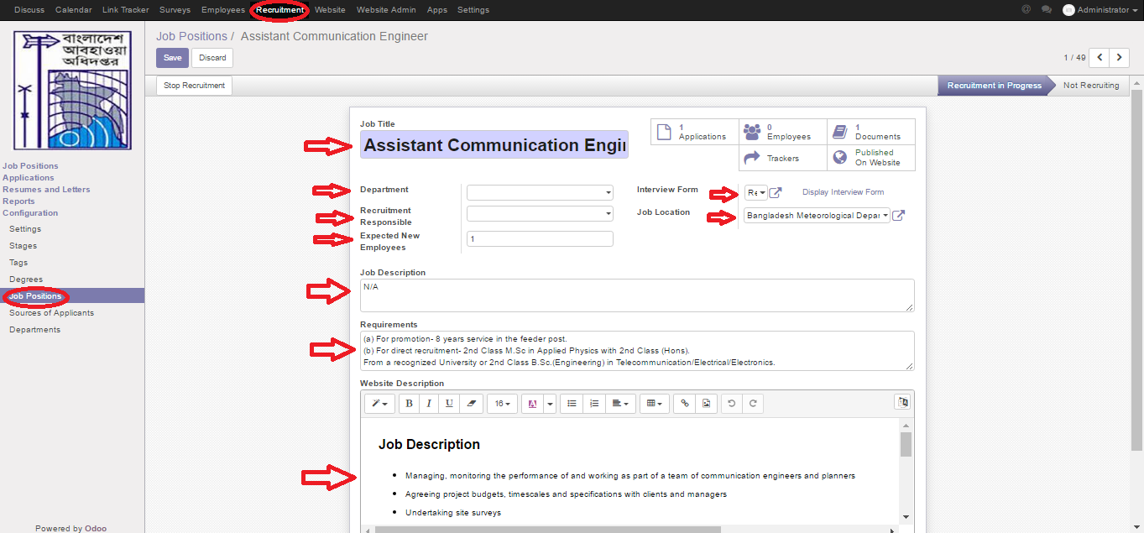

Figure: Creating Job Positions

## 1.9 Create Applications

On the application form view, we can see candidate’s related information: contact info, responsible, attached CV (button Documents) and an internal chatter for followers to discuss about it and candidate can apply for job by Job Application Form.

An applicant can apply by using the menu **Website ‣ Jobs ‣ Assistant Communication Engineer** and click **Apply Now.**

We need to configure the following:-

**Your Name**: Enter a name.

**Your Email:** Enter an email.

**Your Phone Number:** Enter a phone number.

**Short Introduction:** Enter a short introduction about yourself.

**Resume:** Attach a file.

After entering the Application from information click **Submit**.

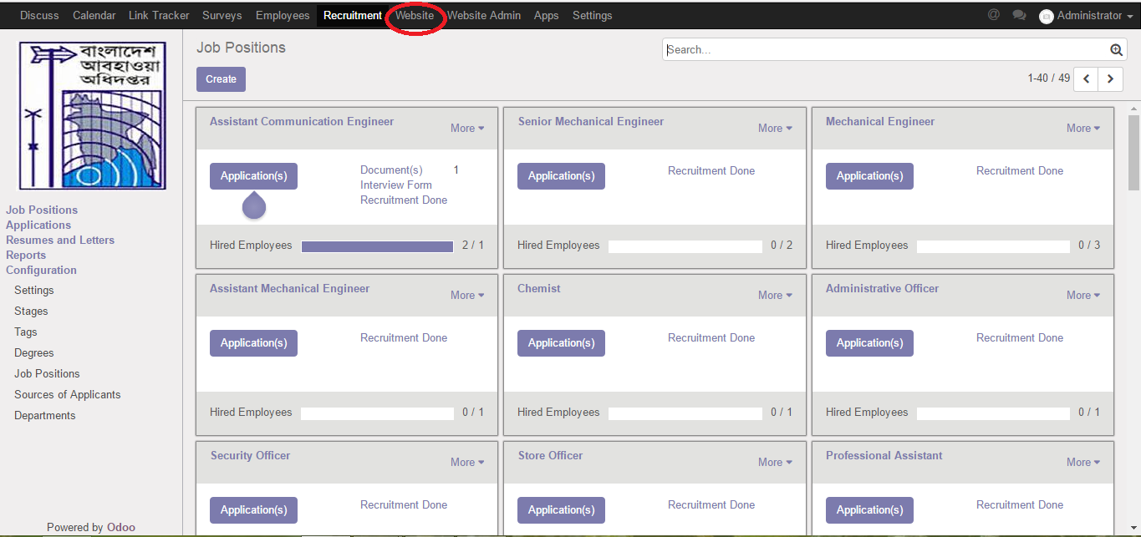

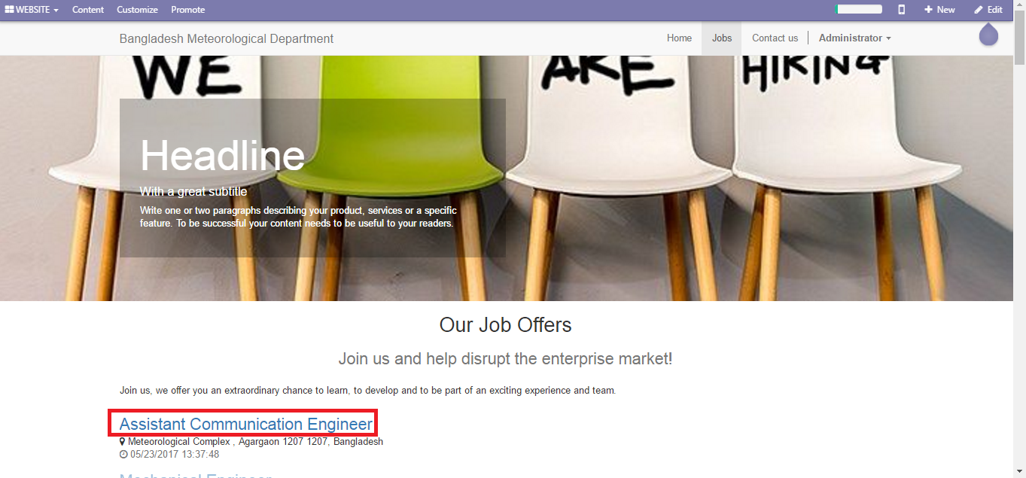

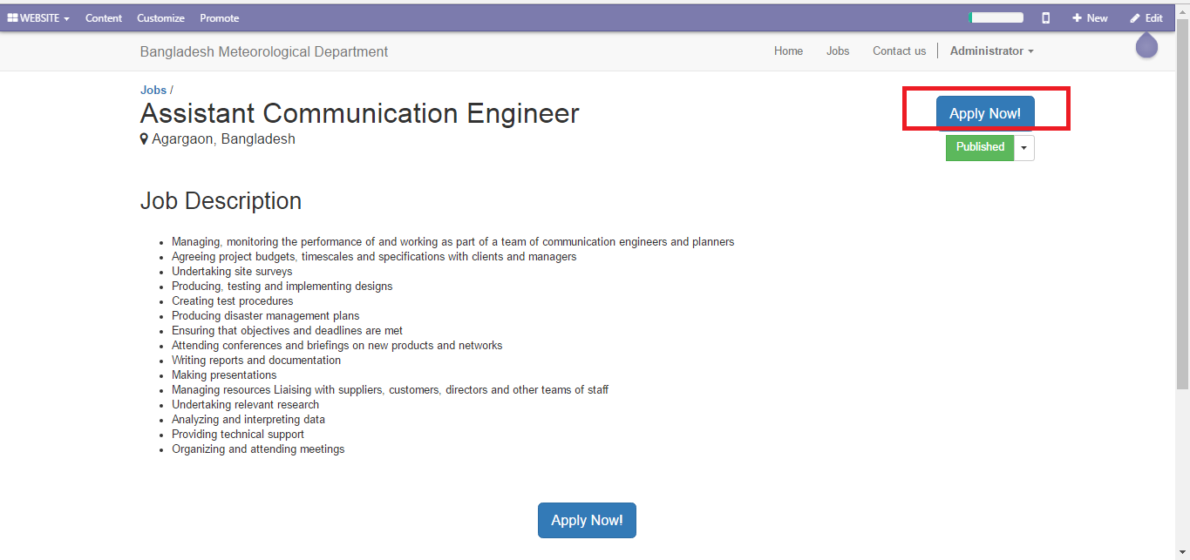

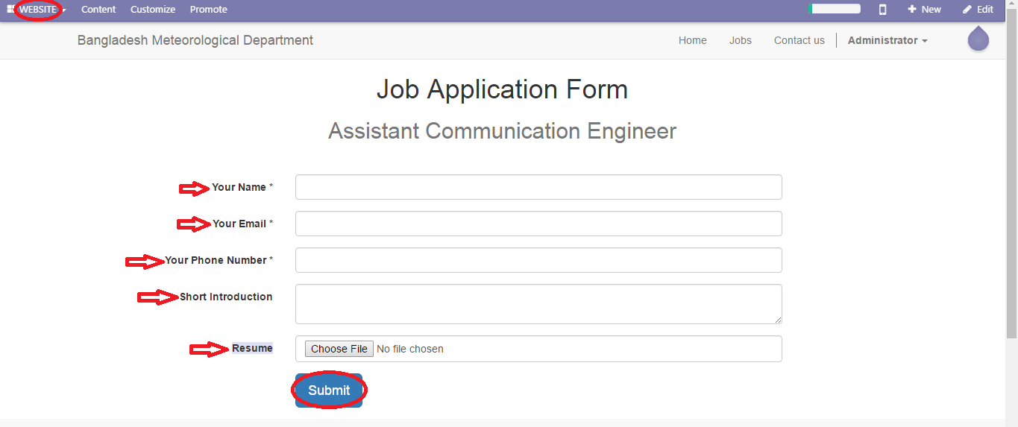

Figure: Create Job Application

**1.10 Received Applications**

After submit application form by candidate we can receive by using the menu **Recruitment ‣ Applications.**

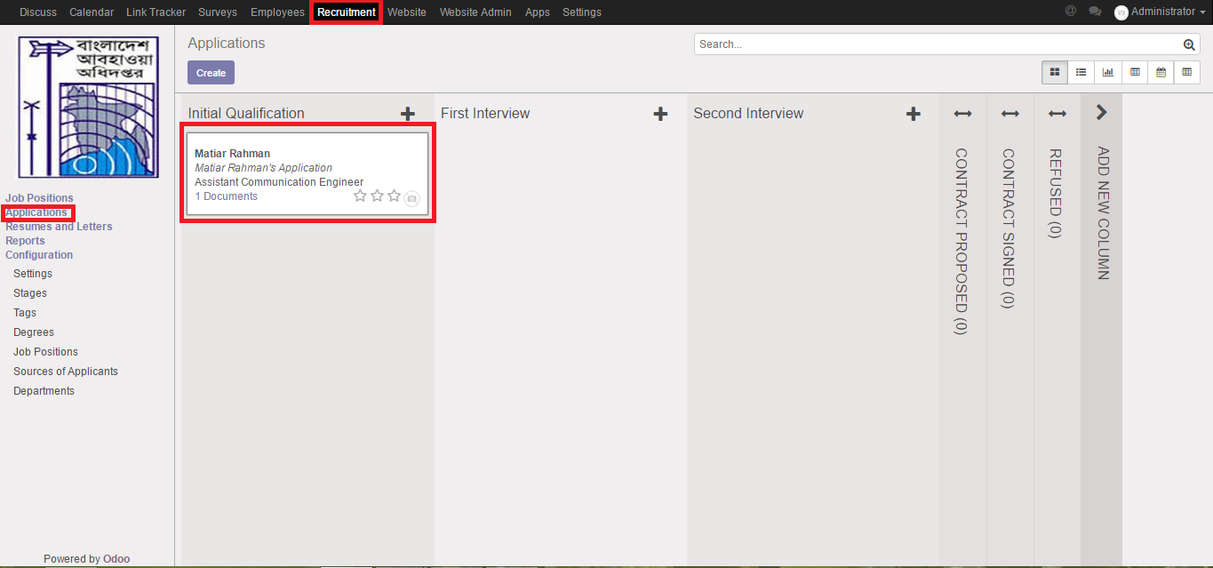

Then Click the Application and Set meeting by using the menu **Recruitment ‣ Applications ‣ click received application ‣ Meetings.**

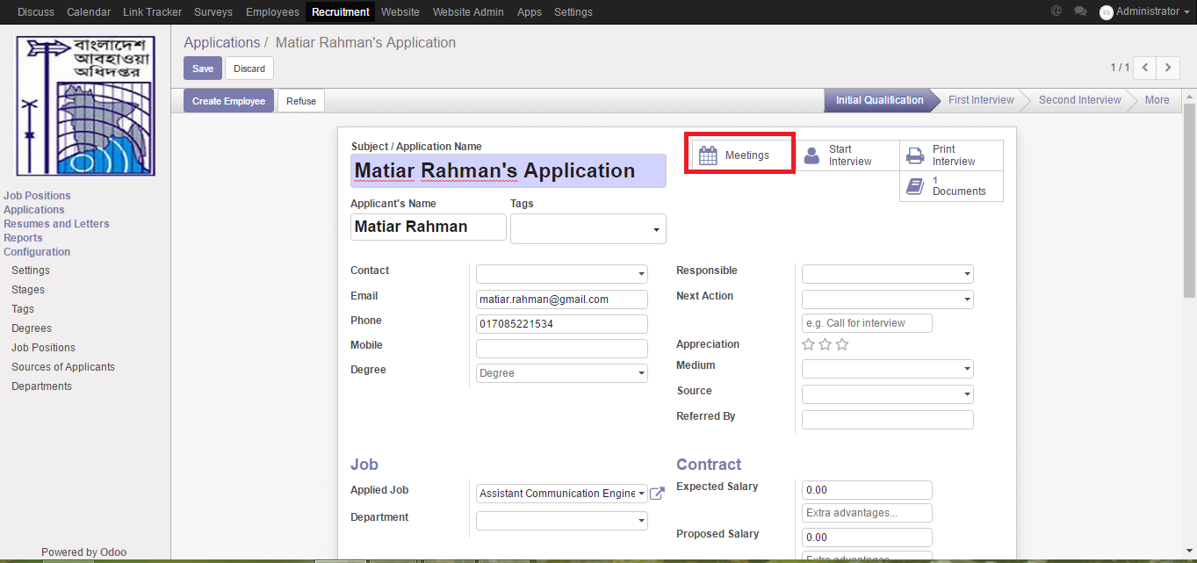

**‣ Select a date**

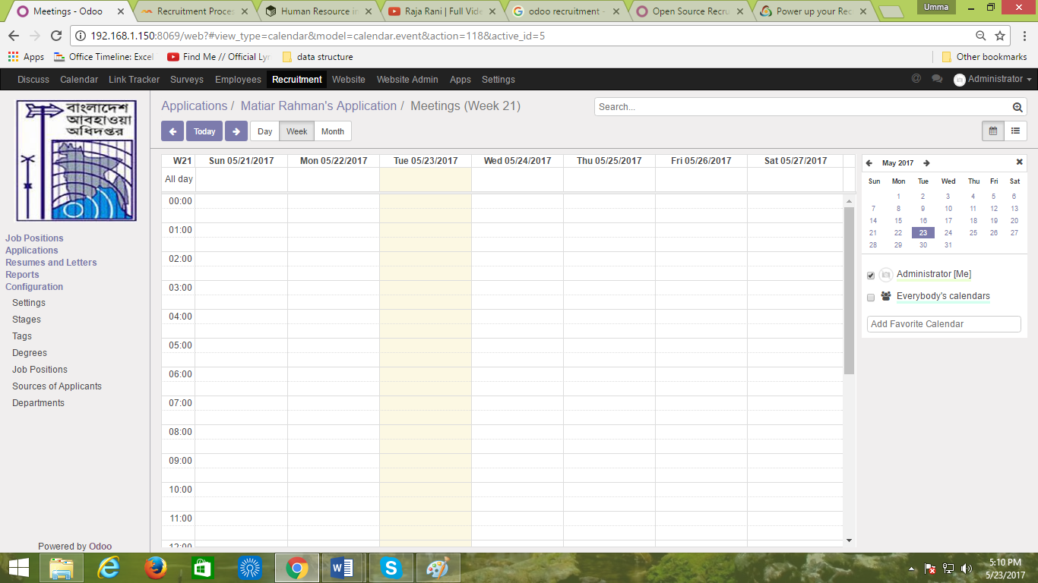

**‣ Create Summary for meeting**

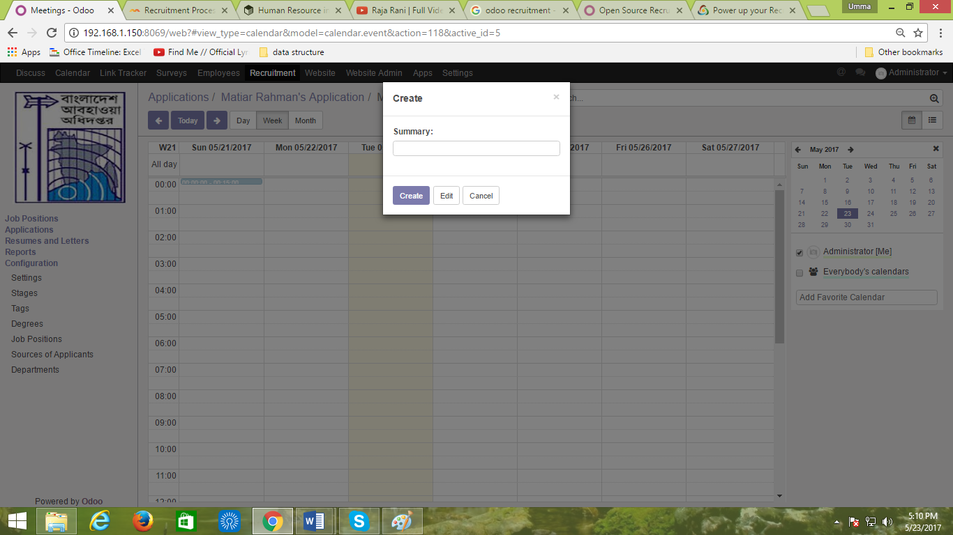

**‣ Start Interview**

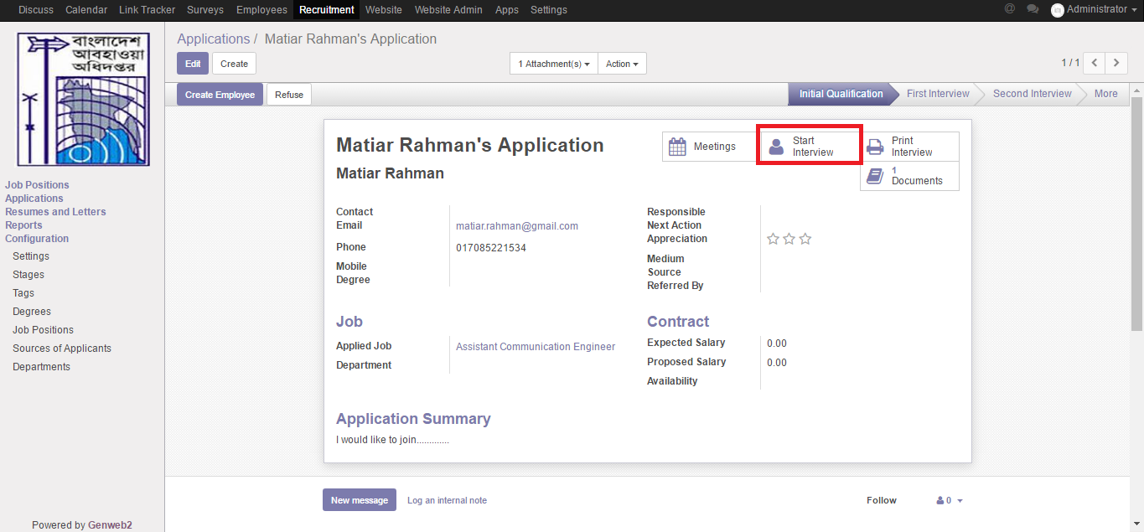

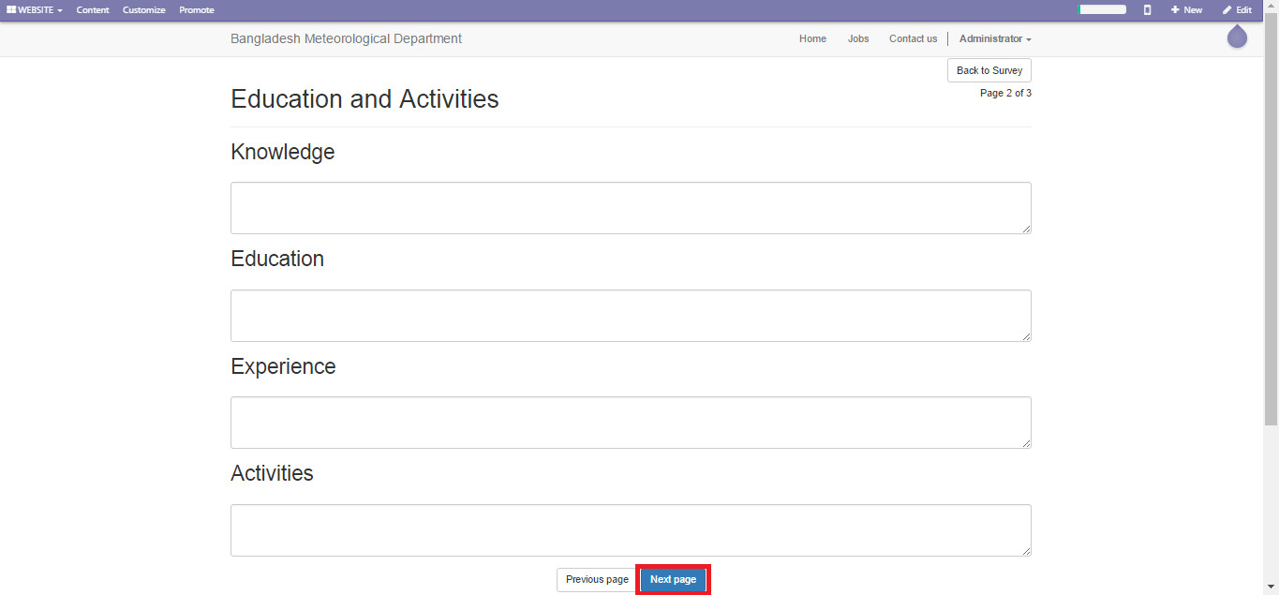

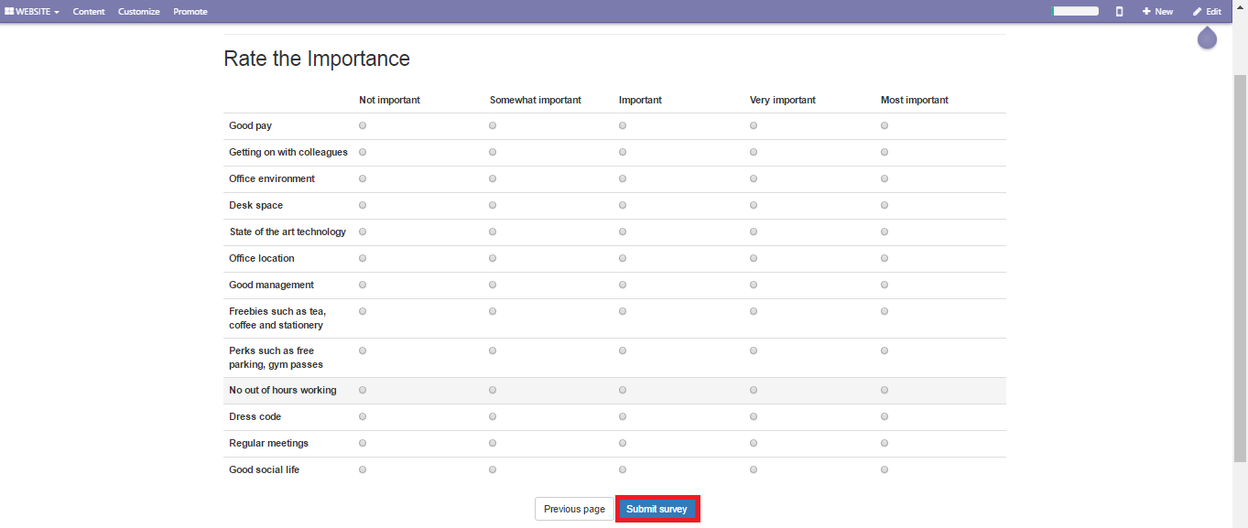

Recruitment (hiring) is a core function of human resource management. Recruitment refers to the overall process of attracting, selecting and appointing suitable candidates for jobs (either permanent or temporary) within an organization. Recruitment can also refer to processes involved in choosing individuals for unpaid positions, such as voluntary roles or unpaid trainee roles. Managers, human resource generalists and recruitment specialists may be tasked with carrying out recruitment, but in some cases public-sector employment agencies, commercial recruitment agencies, or specialist search consultancies are used to undertake parts of the process. Internet-based technologies to support all aspects of recruitment have become widespread.