

**Customer Requirements Specifications (CRS)**

***Procurement Management***

# **Document Information**

|  |  |
| --- | --- |
| Document Name | CRS of Procurement Management for Samuda Chemicals Ltd. |
| Document Author | Kamrun Nahar |
| Document Version | 1.0 |
| Release Date |  |

|  |  |
| --- | --- |
| Review by | Md. Mahfuzur Rahman |
| Review Date | TBA |
| Approved By | Matiar Rahman |
| Approval Date | TBA |

Signed on behalf of Signed on behalf of

Samuda Chemicals Ltd. Genweb2 Limited

Name: Name:

Designation: Designation:

Date: Date:

**______________________________ ______________________________**

Signature Signature

# **Document History**

|  |  |  |  |  |  |
| --- | --- | --- | --- | --- | --- |
| A=Added, M=Modified, D=Delete | | | | | |
| **Version No** | **Date** | **Section No** | **A/M/D** | **Description of Change** | **Author** |
| 1.0 | 29-Jan-2017 |  | A | Initial | Kamrun Nahar |
|  |  |  |  |  |  |
|  |  |  |  |  |  |

Contents

**A.** **Document Information** 2

**B.** **Document History** 3

**1.0** **Introduction** 5

**1.1 Purpose of CRS** 5

**2.0** **Purchase Module Overview** 5

**3.0 Procurement Process Flow:** 7

**3.0.1 Indent to Issue (need to change the heading)** 7

**3.0.2 Purchase Requisition** 9

**3.0.3 Receive Quotation details** 10

**3.0.3 Purchase Order** 11

**4.0 Making the Process Work Efficiently** 12

**5.0 Conclusion** 12

**4. To be Determined** 13

# **Introduction**

# **1.1 Purpose of CRS**

The purposes of this CRS (Customer Requirement Specification) are to clearly identify the customer requirements and provide a detailed document. The customer will review the document and approve/make changes as required. It will also help the review team to validate whether the customer requirements have been fulfilled or not.

# **Purchase Module Overview**

Procurement is the act of acquiring, buying goods, services or works from an external source. It is favorable that the goods, services or works are appropriate and that they are procured at the best possible cost to meet the needs of the acquirer in terms of quality and quantity, time, and location.

Now-a-days different organizations employ various management techniques to carry out the efficient functioning of their departments. Procurement management is one such form of management, where goods and services are acquired from a different organization or firm.

All organizations deal with this form of management at some point in the life of their businesses. It is in the way the procurement is carried out and the planning of the process that will ensure the things run smoothly.

Procurement management is known to help an organization to save much of the money spent when purchasing goods and services from external Supplier. It also has several other advantages.

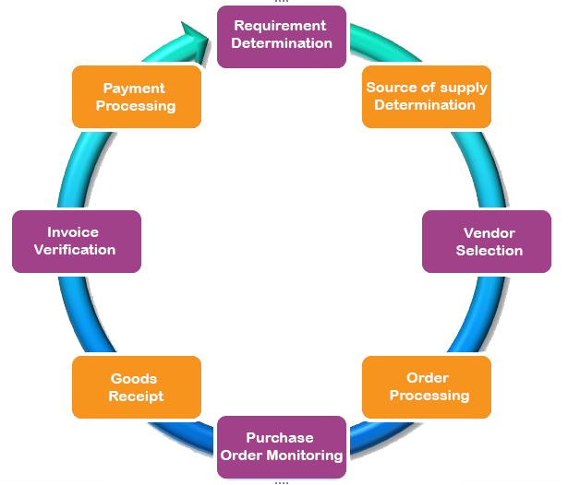**Fig:** Procurement Process

**Importance of Procure Management**

By using this Procurement Management Process, Samuda can ensure that the items provided meet its organizational need. It also helps the company to manage the supplier relationship, ensuring that any issues are resolved quickly. By implementing a Procurement Process, it can ensure the organization to get the maximum value from your supplier relationship.

**This procurement process will also help the organization to:**

* Identify the goods and services to procure
* Complete Purchase Orders and issue to suppliers
* Agree on delivery timeframes and methods
* Receive goods and services from suppliers
* Review and accept the items procured
* Approve supplier payments

**This Procurement Management Process will enable you to:**

* Identify supplier contract milestones
* Review supplier performance against contract
* Identify and resolve supplier performance issues
* Communicate the status to management

**Functional features of Procurement modules are given below**

* Employee/Department/ user will raises indent and looks for required approval.
* If the authority approves and stocks are not available procurement will start.
* Store user will raises purchase requisition
* Approval authority check purchase requisition if they do not approve then purchase requisition will be cancel
* When approval authority approve purchase requisition then procurement department sends request to supplier(s) for quotation
* If vendor quotation not less than 3 it will go to for evaluation
* Min quotation is configurable
* Once vendor is selected procurement user starts to create purchase order (PO).
* This purchase order now may go through one or two approval layer based upon value or quantity or product.
* Once all the approval processes are complete then the purchase order (PO) is given to the vendor.
* Purchase order sent to supplier

# **3.0 Procurement Process Flow:**

* Raise purchase requisition
* Receive quotation from supplier
* Issue Purchase order

## **3.0.1 Indent to Issue (need to change the heading)**

1. User will raise an indent.
2. The indent will go to his/her department. Head for approval.
3. Once it is approved then it will go to factory head for second approval. This process may not be required for some certain indent.
4. After approval from both department. Head and factory head (if required), the stock user will receive the indent.
5. The stock user will then issue the items mentioned in the indent upon availability. If the items are not available then procurement process will start.

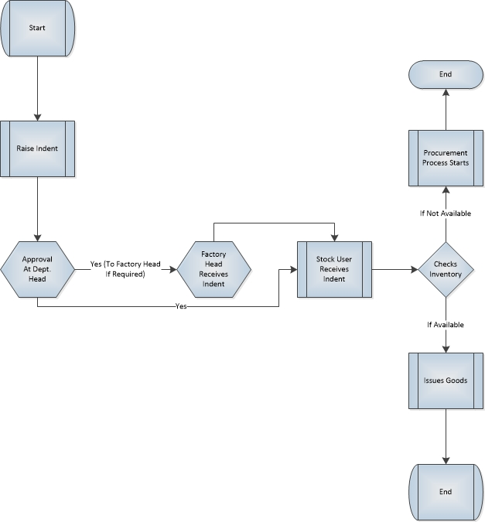

**Fig:** Indent to Issue

## **3.0.2 Purchase Requisition**

1. Store user will create the purchase requisition and then he/she will forward it store head for further approval.
2. The store head will approve the purchase requisition and forward it to procurement department for further processing. A message is sent to factory head about this approval. If the store head cancel the purchase, the process will end there.
3. Approval process will follow the approval hierarchy (CFO/CEO/COO).
4. Hierarchy will be configurable according to business.
5. The procurement department will approve the purchase requisition based on previous internal approval.



**Fig:** Purchase Requisition

## **3.0.3 Receive Quotation details**

1. Procurement Executive receives Quotation which was sent by supplier with details specification of materials/products.
2. Procurement Executive request to Procurement Manager for Request to Select Quotation depending on received purchased requisition.
3. Procurement Manager receives the Request and takes necessary decision
   1. **If select the quotation :** If Procurement Manager selects the quotation, then sent a selection confirmation message for taking necessary steps
   2. **If rejected:** If Procurement Manager rejects the quotation, then process will stop.
4. After getting Selection confirmation from Procurement Manager, Procurement Executive creates Purchase Order (PO).

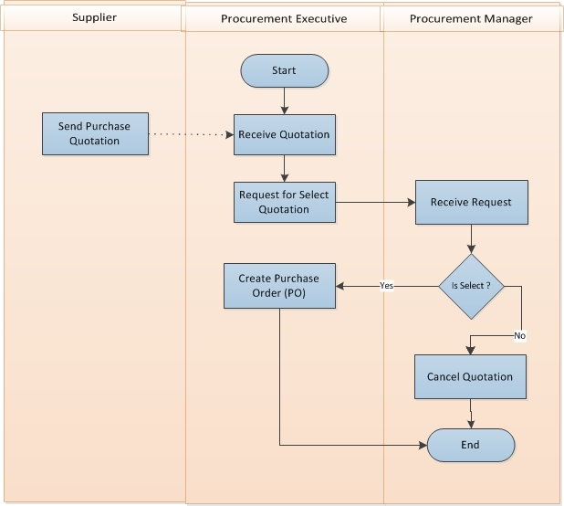

**Fig:** Quotation Selection Process

## **3.0.3 Purchase Order**

1. Procurement department floats request for Proposal (RFP).
2. After floating of request for Proposal (RFP) Procurement department receives quotation from different vendors.
3. Procurement department evaluates all the quotations and select certain vendor’s quotation to proceed further with.
4. If vendor quotation not less than 3 it will go to for evaluation
5. Min quotation is configurable
6. Once vendor is selected procurement user starts to create purchase order (PO).
7. This purchase order now may go through one or two approval layer based upon value or quantity or product.
8. Once all the approval processes are complete then the PO is given to the vendor.



**Fig:** Purchase Order

# **4.0 Making the Process Work Efficiently**

In order to ensure that everything goes well through to the end, organization would have to keep track of the progress of the procurement. This would mean that authorized user should keep checking on the suppliers in order to ensure that they are abiding by the terms of the contract and will be able to supply you with the goods and services by the deadline.

Should there be any discrepancies or any issues, you should always let the supplier know by means of the method of communication decided on at the time of making the contract.

The organization must always be willing and open to change. This is in respect of all changes required in order to ensure the efficiency of the process. These changes could be in the form of technological advancements and even changes to the workforce, among other changes.

In terms of technology, any new equipment and machinery required to handle these goods may need to be purchased.

Similarly, with regard to the workforce, you would need to employ workers, who are highly skilled and trained when it comes to dealing directly with suppliers.

It is always best for an organization to have different teams within who are specialized in different fields. This would make procurement management even easier. Each team could then deal with the relevant areas of buying and will also have the expertise required. For example, those who have experience buying machinery may not have the same skill when it comes to getting particular services from another organization.

# **5.0 Conclusion**

It should be kept in mind, however, that this procurement management system must run efficiently and smoothly for all benefits to be reaped. The key to this would therefore be an efficient system as well as the right supplier and resources. For the purpose of procurement management, there should be a team of highly trained individuals, if procurement management plays a key role. As an example, a Factory should have a dedicated procurement team and should employ strong procurement management techniques and tools.

# **4. To be Determined**

1. ISO 9001 related reports are not implemented within this phase. We will cover in next phase.

Signed on behalf of Signed on behalf of

Samuda Chemicals Ltd. Genweb2 Limited

Name: Name:

Designation: Designation:

Date: Date:

**______________________________ ______________________________**

Signature Signature