

**Customer Requirements Specifications (CRS)**

***Procurement Management***

# **Document Information**

|  |  |
| --- | --- |
| Document Name | CRS of Procurement Management for Samuda Chemicals Ltd. |
| Document Author | Kamrun Nahar |
| Document Version | 1.0 |
| Release Date | 19th March, 2017 |

|  |  |
| --- | --- |
| Review by | Md. Mahfuzur Rahman |
| Review Date | 19th March,2017 |
| Approved By | Matiar Rahman |
| Approval Date | 16th March, 2017 |

Signed on behalf of Signed on behalf of

Samuda Chemicals Ltd. Genweb2 Limited

Name: Name:

Designation: Designation:

Date: Date:

**______________________________ ______________________________**

Signature Signature

# **Document History**

|  |  |  |  |  |  |
| --- | --- | --- | --- | --- | --- |
| A=Added, M=Modified, D=Delete | | | | | |
| **Version No** | **Date** | **Section No** | **A/M/D** | **Description of Change** | **Author** |
| 1.0 | 15-March-2017 |  | A | Initial | Kamrun Nahar |
|  |  |  |  |  |  |
|  |  |  |  |  |  |

Contents

**A.** **Document Information** 2

**B.** **Document History** 3

**1.0** **Introduction** 5

**1.1 Purpose of CRS** 5

**2.0** **Purchase Module Overview** 5

**3.0 Procurement Process Flow:** 8

**3.0.1 Purchase Requisition** 8

**3.0.2 Receive Quotation details** 9

**3.0.3 Purchase Order** 10

**4.0 Conclusion** 12

**5.0 To be Determined** 13

# **Introduction**

# **1.1 Purpose of CRS**

The purposes of this CRS (Customer Requirement Specification) are to clearly identify the customer requirements and provide a detailed document. The customer will review the document and approve/make changes as required. It will also help the review team to validate whether the customer requirements have been fulfilled or not.

# **Purchase Module Overview**

Procurement is the act of acquiring, buying goods, services or works from an external source. It is favorable that the goods, services or works are appropriate and that they are procured at the best possible cost to meet the needs of the acquirer in terms of quality and quantity, time, and location.

Now-a-days different organizations employ various management techniques to carry out the efficient functioning of their departments. Procurement management is one such form of management, where goods and services are acquired from a different organization or firm.

All organizations deal with this form of management at some point in the life of their businesses. It is in the way the procurement is carried out and the planning of the process that will ensure the things run smoothly.

Procurement management is known to help an organization to save much of the money spent when purchasing goods and services from external Supplier. It also has several other advantages.

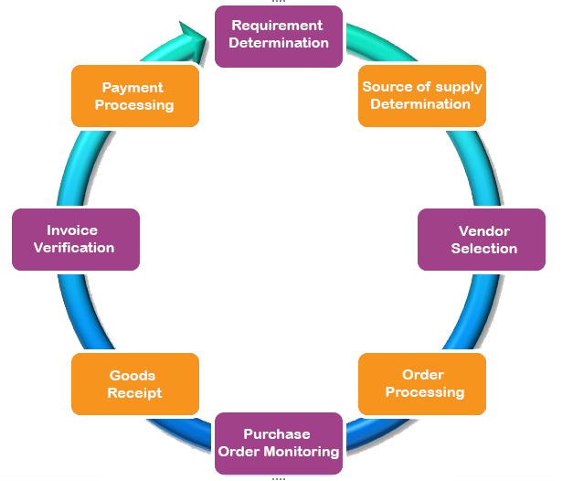

**Fig:** Procurement Process

**Importance of Procure Management**

By using this Procurement Management Process, Samuda can ensure that the items provided meet its organizational need. It also helps the company to manage the supplier relationship, ensuring that any issues are resolved quickly. By implementing a Procurement Process, it can ensure the organization to get the maximum value from your supplier relationship.

**This procurement process will also help the organization to:**

* Identify the goods and services to procure
* Complete Purchase Orders and issue to suppliers
* Agree on delivery timeframes and methods
* Review and accept the items procured

**This Procurement Management Process will enable you to have following Process**

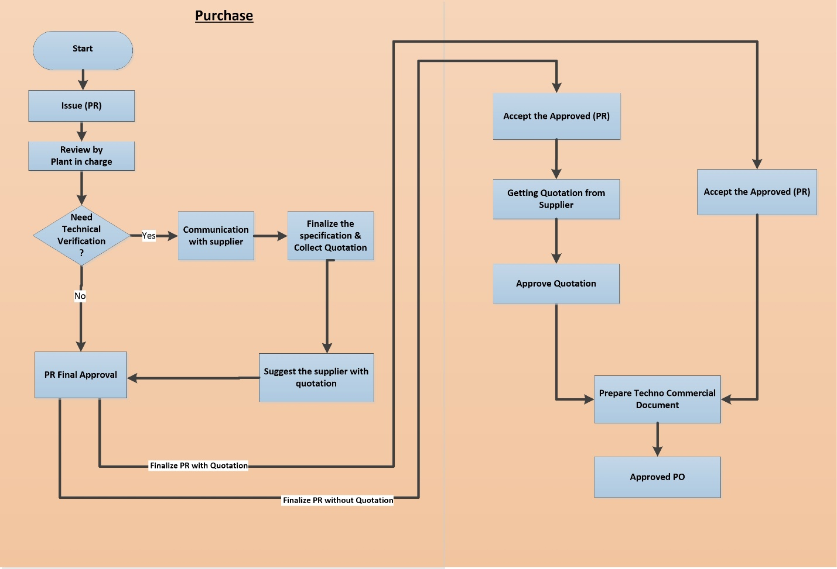

**Fig:** Procurement Overall Process

**Overall Process Description:**

Employee/Department/ user will raises indent and looks for required approval. If the authority approves and stocks are available procurement will start. Store keeper will raises purchase requisition. Plant in charge will be reviewing the PR. After the review, it may need technical verification. If it needs technical verification, authorized person will communicate with supplier. In the meantime, specification gets finalized and quotation is collected from supplier. At this moment Authorized Person will suggest supplier and Management Personal will approve PR. The PR which don’t need technical verification will have regular PR approval process. The PR which has no quotation yet (if needed) will get quotation from supplier. The quotation needs to be approved. After the approval of Purchase Requisition (PR) which have quotation for both raw material and machinery items, techno-Commercial document will be prepared at that time. When the procurement department sends request to supplier(s) for quotation. If vendor quotation not less than 3 it will go to for evaluation. Min quotation is configurable .Once vendor is selected procurement user starts to create purchase order (PO).This purchase order now may go through one or two approval layer based upon value or quantity or product. Once all the approval processes are complete then the purchase order (PO) is given to the vendor. Purchase order will be sent to supplier.

There might have other cases for procurement of goods/services.

1. **Cash Purchase of Goods**

Samuda can make a cash purchase using either cash or cheque. The payment to the supplier is immediate, there is no credit given by the supplier for the goods. This case usually arises when product price is unknown. When Samuda will have cash purchase, it will have Purchase Requisition (PR) only and there will be no Purchase Order (PO).

1. **Factory Purchase Goods**

There might be cases when factory will buy its goods. In this scenario there will be have PR for buying goods. Purchase Order (PO) will be approved for that specific PR but there will be no work order.

# **3.0 Procurement Process Flow:**

* Raise purchase requisition
* Receive quotation from supplier
* Issue Purchase order

## **3.0.1 Purchase Requisition**

1. Store keeper will create the purchase requisition and then he/she will forward it store head for further approval.
2. The store head will approve the purchase requisition and forward it to procurement department for further processing. A message is sent to factory head about this approval. If the store head cancel the purchase, the process will end there.
3. Approval process will follow the approval hierarchy (CFO/CEO/COO).
4. Hierarchy will be configurable according to business.
5. The procurement department will approve the purchase requisition based on previous internal approval.



**Fig:** Purchase Requisition

## **3.0.2 Receive Quotation details**

1. Procurement Executive receives Quotation which was sent by supplier with details specification of materials/products.
2. Procurement Executive request to Procurement Manager for Request to Select Quotation depending on received purchased requisition.
3. Procurement Manager receives the Request and takes necessary decision
   1. **If select the quotation :** If Procurement Manager selects the quotation, then sent a selection confirmation message for taking necessary steps
   2. **If rejected:** If Procurement Manager rejects the quotation, then process will stop.
4. After getting Selection confirmation from Procurement Manager, Procurement Executive creates Purchase Order (PO).

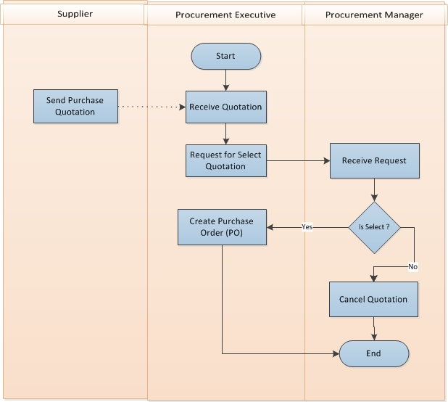

**Fig:** Quotation Selection Process

## **3.0.3 Purchase Order**

1. Procurement department floats request for Proposal (RFP).
2. After floating of request for Proposal (RFP) Procurement department receives quotation from different vendors.
3. Procurement department evaluates all the quotations and select certain vendor’s quotation to proceed further with.
4. If vendor quotation not less than 3 it will go to for evaluation
5. Min quotation is configurable
6. Once vendor is selected procurement user starts to create purchase order (PO).
7. This purchase order now may go through one or two approval layer based upon value or quantity or product.
8. Once all the approval processes are complete then the PO is given to the vendor.



**Fig:** Purchase Order

# **4.0 Conclusion**

It should be kept in mind, however, that this procurement management system must run efficiently and smoothly for all benefits to be reaped. The key to this would therefore be an efficient system as well as the right supplier and resources. For the purpose of procurement management, there should be a team of highly trained individuals, if procurement management plays a key role. As an example, a Factory should have a dedicated procurement team and should employ strong procurement management techniques and tools.

# **5.0 To be Determined**

1. ISO 9001 related reports are not implemented within this phase. We will cover in next phase.

Signed on behalf of Signed on behalf of

Samuda Chemicals Ltd. Genweb2 Limited

Name: Name:

Designation: Designation:

Date: Date:

**______________________________ ______________________________**

Signature Signature