

**Customer Requirements Specifications (CRS)**

***Production Module***

# **Document Information**

|  |  |
| --- | --- |
| Document Name | CRS of Procurement Management for Samuda Chemicals Ltd. |
| Document Author | Kamrun Nahar |
| Document Version | 1.0 |
| Release Date | 27th March, 2017 |

|  |  |
| --- | --- |
| Review by | Md. Mahfuzur Rahman |
| Review Date | 23rd March, 2017 |
| Approved By | Matiar Rahman |
| Approval Date | 27th March, 2017 |

Signed on behalf of Signed on behalf of

Samuda Chemicals Ltd. Genweb2 Limited

Name: Name:

Designation: Designation:

Date: Date:

**______________________________ ______________________________**

Signature Signature

# **Document History**

|  |  |  |  |  |  |
| --- | --- | --- | --- | --- | --- |
| A=Added, M=Modified, D=Delete | | | | | |
| **Version No** | **Date** | **Section No** | **A/M/D** | **Description of Change** | **Author** |
| 1.0 | 22-March-2017 |  | A | Initial | Kamrun Nahar |
|  |  |  |  |  |  |
|  |  |  |  |  |  |

Contents

**A.** **Document Information** 2

**B.** **Document History** 3

**1.0** **Introduction** 5

**1.1 Purpose of CRS** 5

**2.0** **Production Module Overview** 5

**3.0** **Features of Production Module** 6

**4.0 Feature Description of Production Module** 6

**4.1 Consumption** 6

**4.2** **Finished Goods** 7

**4.3 Bill of Material** 7

**4.4 Manufacturing Order** 7

**4.5 Work In Progress (WIP) Products** 7

**4.6 By-Product** 8

**5.0 Appendix** 8

**6.0 To be Determined** 12

# **Introduction**

# **1.1 Purpose of CRS**

The purposes of this CRS (Customer Requirement Specification) are to clearly identify the customer requirements and provide a detailed document. The customer will review the document and approve/make changes as required. It will also help the review team to validate whether the customer requirements have been fulfilled or not.

# **Production Module Overview**

The Production record in any manufacturing ERP system performs the changing of stock quantities decrementing raw materials and incrementing assemblies or finished goods and any associated accounting. This module will allow entering into the production how many of a particular raw materials user want to produce and system will split serial numbered items down to separate lines for each product.

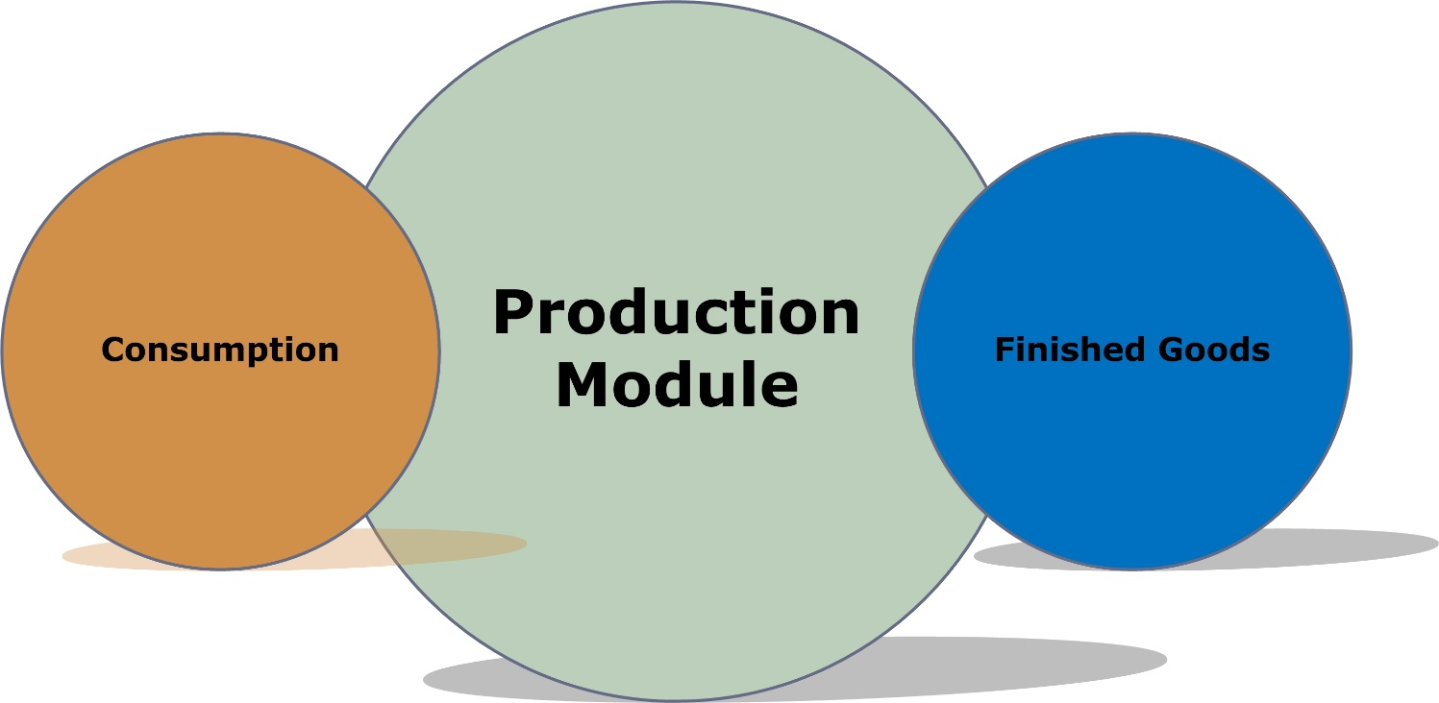

**Fig:** Production Module

**Why Samuda Needs Production Module**

* It minimizes the inventory, cuts down lead the time required for production, cuts down the production cycle duration and help to minimize the lead time required for automation and subcontracting.
* Production/manufacturing processes are completed using only essential materials. This prevents manufacturing waste.
* It reduces errors during subsequent production stages which minimizes the duration of the production cycle.
* Automation is a built-in feature for almost all process-based manufacturing software. Integration of every manufacturing process reduces human error.

# **Features of Production Module**

The following features will be covered by production module:

1. Consumption
2. Finished Goods
3. Bill Of Material
4. Manufacturing Order
5. WIP Products
6. Bi-Products

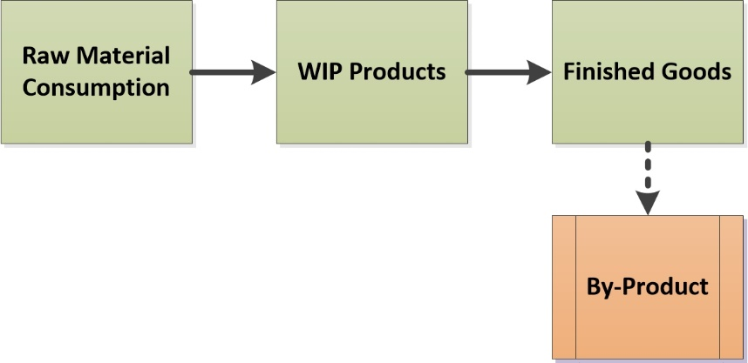

**Fig:** Production Process

# **4.0 Feature Description of Production Module**

## **4.1 Consumption**

The process in which the substance of a thing is completely destroyed, used up, or incorporated or transformed into something else. Consumption of goods is the amount of raw material used in a particular time period. E.g. A Company will produce 2000 Personal Computer (PC). To assemble the Personal Computer (PC) it needs keyboard, mouse etc. So this system will allow to take input of 200 consumption of keyboard, mouse etc. for producing a new product. This system will help user to prepare some analytical report for better business.

## **Finished Goods**

The products in a manufacturer's inventory that are completed and are awaiting to be sold. This account as containing the cost of the products in the finished goods warehouse. A manufacturer must disclose in its financial statements the amount of finished goods, work-in-process, and raw materials input as well. This is the last stage for the processing of goods

The module will help users by tracking number of finished goods at manufacturers’ end which are not yet sold or distributed to the end-user. This system will help user to prepare some analytical report for finished goods. There will have reports for finished goods.

## **4.3 Bill of Material**

A bill of materials (BOM) is a comprehensive list of parts, items, assemblies and sub-assemblies required to get a product ready to sell. The bill of materials can be understood as the recipe and shopping list for creating a final product. A bill of materials explains what to buy, how to buy and where to buy, and includes instructions for how to assemble the product. All manufacturers building products, regardless of their industry, get started by creating a bill of materials (BOM).

A bill of materials may include not only the unit quantity required to construct a finished product, but also an estimate of scrap that will occur during the production process.

This document must be extremely accurate. If this is not the case, an organization may order incorrectly from suppliers and pull the wrong items from stock for a production run, which can result major delays in the production process.

## **4.4 Manufacturing Order**

It is an order required to manufacture items and it is classified into internal order (to be manufactured by the company itself). The manufacturing order is prepared as manufacturing instructions. Manufacturing orders are generated in many ways to cater for different production methods and processes. Fundamentally they are used to plan, execute and record production activities.

## **4.5 Work In Progress (WIP) Products**

Work in progress (WIP), also called work in process, is inventory that has been also used in the manufacturing process and is no longer included in raw materials inventory but is not yet a completed product. On a balance sheet, work in progress is considered to be an asset because money has been spent towards a completed product. Because the product has not been completed.

Work in progress refers to the materials and partially completed products which are in various stages of the production process. WIP does not include raw materials or finished products at the beginning and end of the production cycle, respectively.

During the production of goods, there may be a considerable amount of investment in work in process over a long period of time, which is why it’s important to account for.

## **4.6 By-Product**

A by-product is a secondary product derived from a manufacturing process or chemical reaction. It is not the primary product or service being produced. In the context of production, a by-product is the 'output from a joint production process that is minor in quantity and/or net realizable value (NRV) when compared to the main products.

# **5.0 Appendix**

Some Forms of Samuda maintains for its production system.

1. Raw Material Report

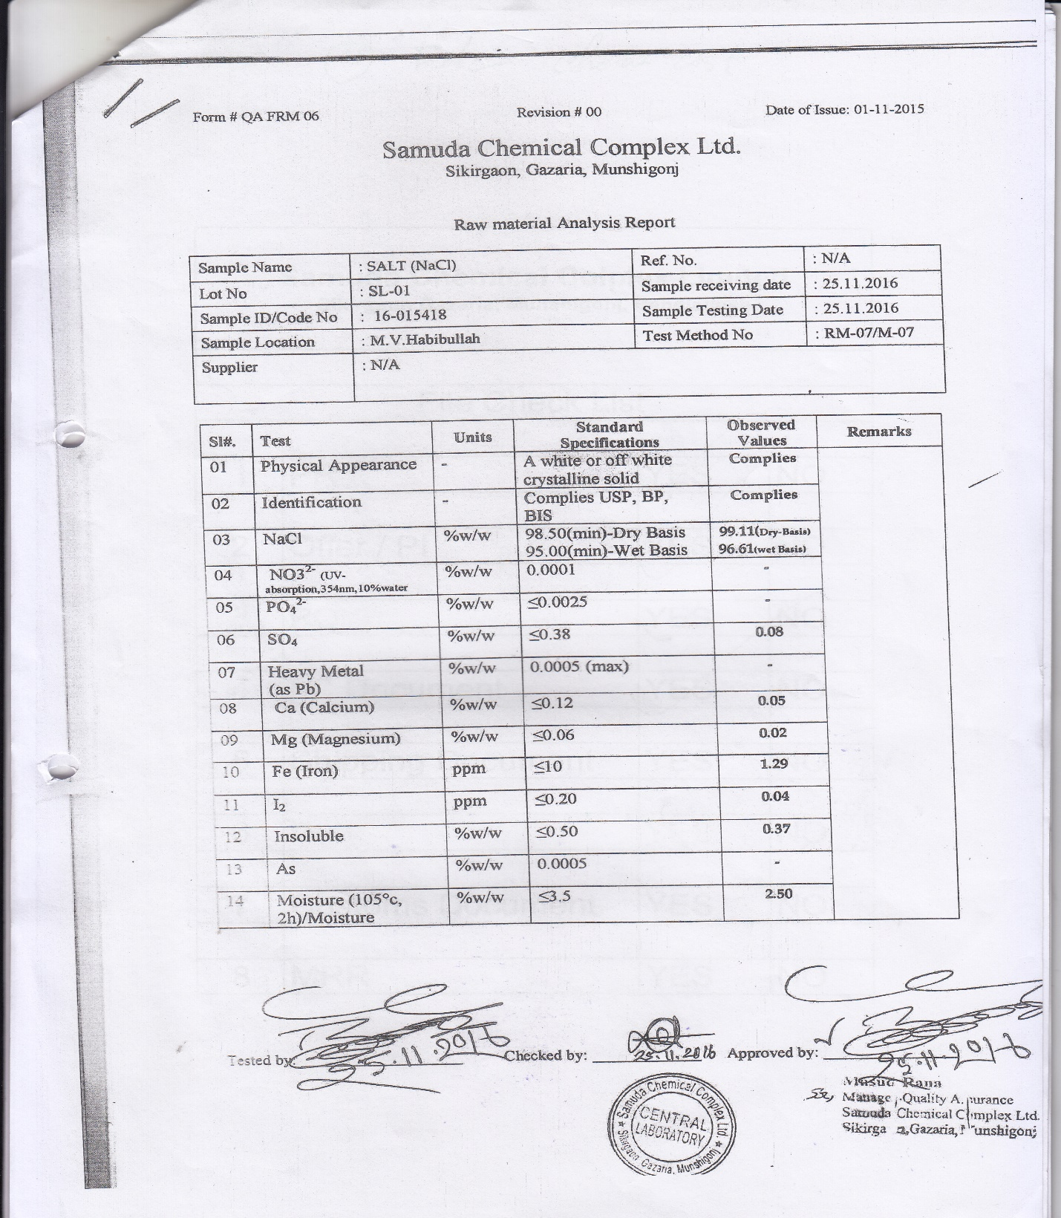

2. QC Report

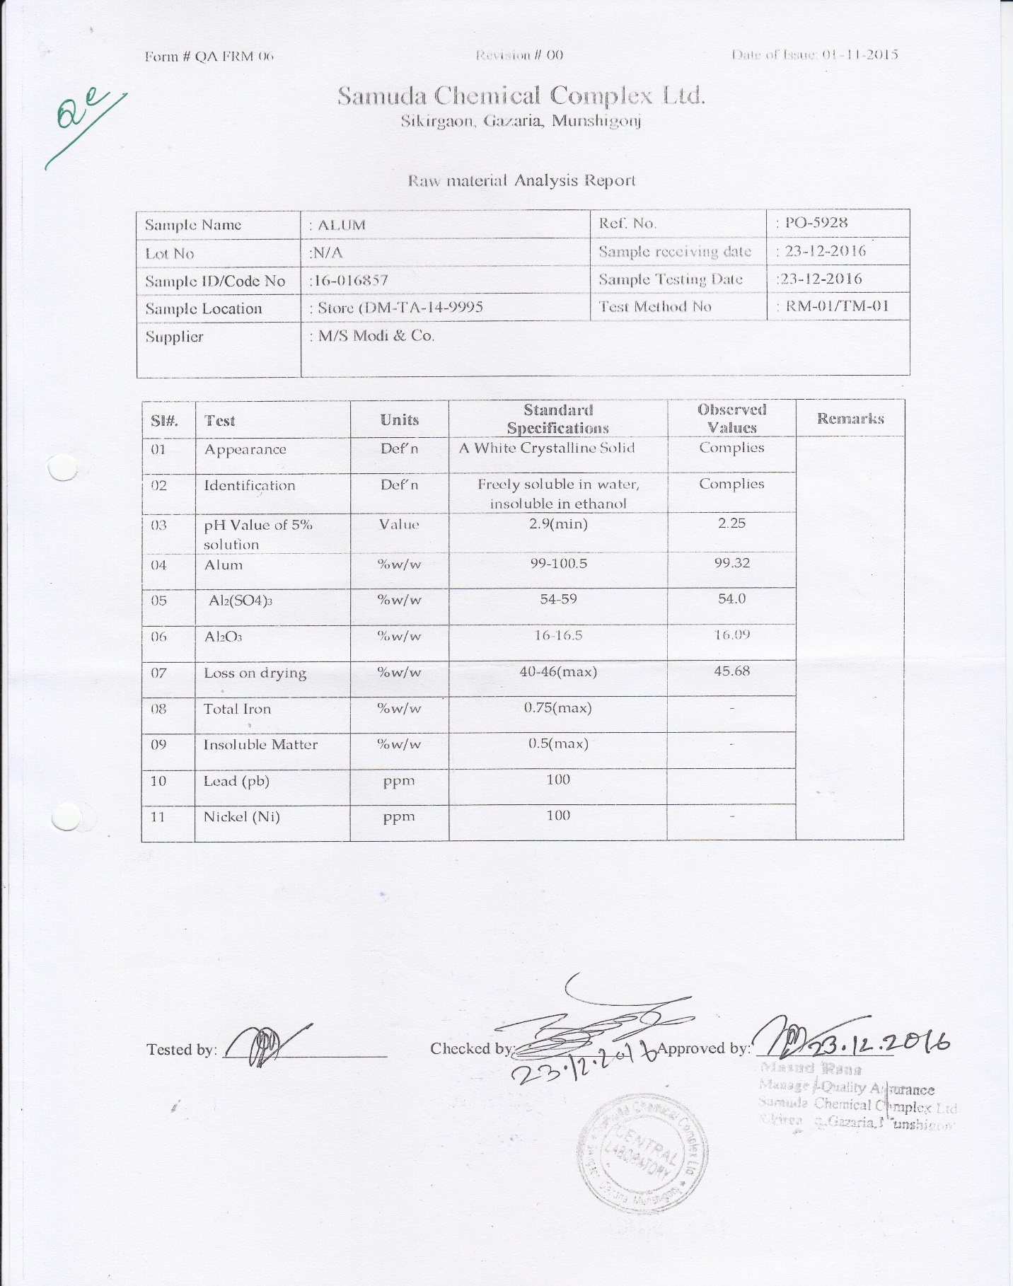

3. Monthly Lab Consumption

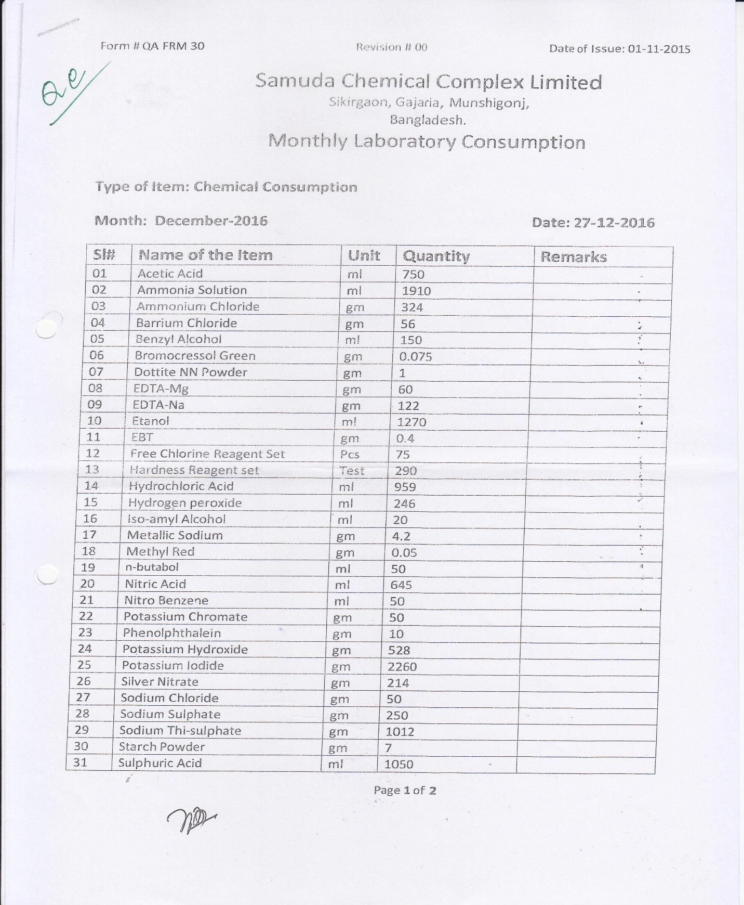

# **6.0 To be Determined**

1. ISO 9001 related reports are not implemented within this phase. We will cover in next phase.

Signed on behalf of Signed on behalf of

Samuda Chemicals Ltd. Genweb2 Limited

Name: Name:

Designation: Designation:

Date: Date:

**______________________________ ______________________________**

Signature Signature