

**Customer Requirements Specifications (CRS)**

***Sales Management***

# **Document Information**

|  |  |
| --- | --- |
| Document Name | CRS of Sales Management for Samuda Chemicals Ltd. |
| Document Author | Md. Golam Rabbi |
| Document Version | 1.1 |
| Release Date | 20th July, 2017 |

|  |  |
| --- | --- |
| Review by | Md. Matiar Rahman |
| Review Date | 25th July, 2017 |
| Approved By |  |
| Approval Date |  |

Signed on behalf of Signed on behalf of

Samuda Chemicals Ltd. Genweb2 Limited

Name: Name:

Designation: Designation:

Date: Date:

**______________________________ ______________________________**

Signature Signature

# **Document History**

|  |  |  |  |  |  |
| --- | --- | --- | --- | --- | --- |
| A=Added, M=Modified, D=Delete | | | | | |
| **Version No** | **Date** | **Section No** | **A/M/D** | **Description of Change** | **Author** |
| 1.0 | 15-March-2017 |  | A | Initial | Kamrun Nahar |
| 1.1 | 25-July-2017 |  | A | Approval process updated for Credit Limit, Sales Price, Sale Order and Customer Commission | Md. Golam Rabbi |
|  |  |  |  |  |  |

**Contents**

**A.** **Document Information** 2

**B.** **Document History** 3

**Contents** 4

**1.0** **Introduction** 5

**1.1 Purpose of CRS** 5

**2.0** **Sales Module Overview** 5

**3.0** **Features of Sales Modules** 6

**3.1 Order to Cash Process** 7

**3.2 Master Data Management** 8

**3.2.1 Product** 8

**3**.**2.2 Customer** 9

**3.2.3 Sales Team** 9

**3.3 Create the Sales Order** 9

**3.3.1 Sales Price** 12

**3.3.2 Customer Commission** 13

**3.4 Receive feedback from the Customer** 14

**3.5 Gives stock status report to Accounting Department** 14

**3.6 Gives quotation list to Customer and Accounting Department** 14

**3.7 Gives customer list to Accounting Department** 14

**3.8 Gives sales reports to Customer and Accounting Department** 14

**3.9 Gives contract to Customer and Accounting Department** 14

**3.10 Gives returned product report the Customer and Accounting Department** 14

**3.11 Gets a delivery receipt from Warehouse Keeper** 14

**3.12 Sales Target and Achievement** 14

**3.13 Cash Back** 15

**3.14 Reports** 15

**3.15 Customer Credit Limit** 15

**3.16 Payment Policy** 16

**3.17 The main external agents** 16

**4. Appendix** 17

**5. To be Determined** 18

# **Introduction**

# **1.1 Purpose of CRS**

The purposes of this CRS (Customer Requirement Specification) are to clearly identify the customer requirements and provide a detailed document. The customer will review the document and approve/make changes as required. It will also help the review team to validate whether the customer requirements have been fulfilled or not.

# **Sales Module Overview**

In the context of growing market competition, organizations are focusing more on closer partnership across supply chain. Increasing efficiency in sales process facilitates an organization to maintain its competitive edge. Best practice processes, embedded in an ERP package, are an enabler in this direction.

The important components of sales modules:

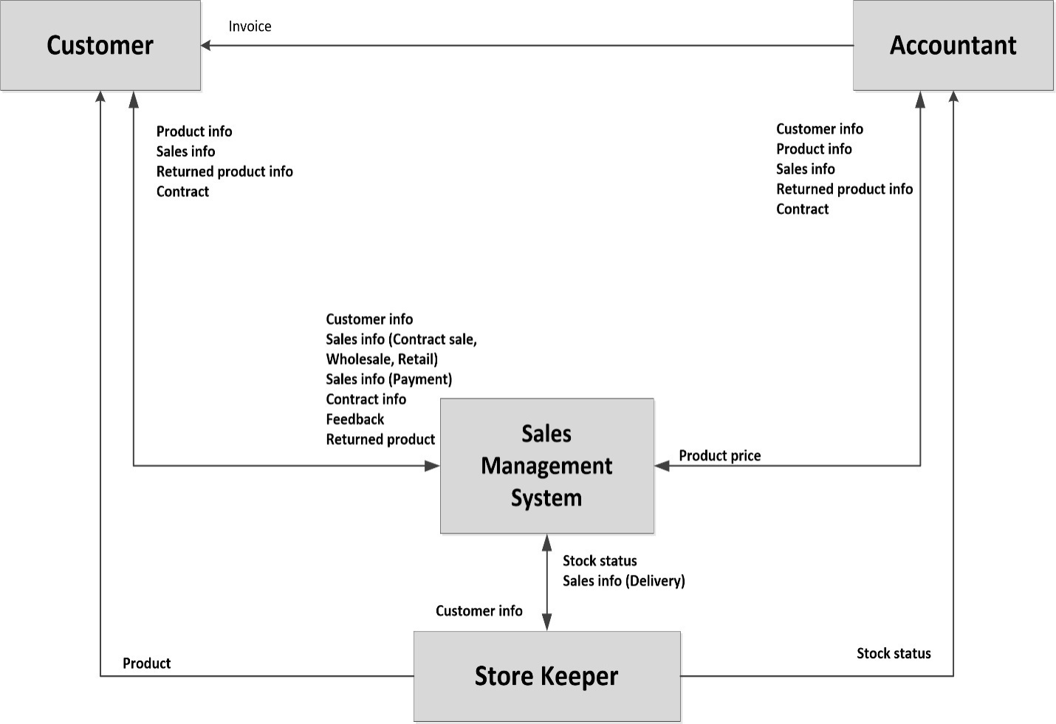

**Fig:** Sales Management System

**Integration with other modules:** Sales module is a highly integrated execution module. It draws most of its input from the following modules:

* Inventory module for verifying available and projected stock.
* Production module for production schedules and lead time of delivery.
* Purchasing module for generation of direct delivery purchase order.
* Accounts receivable module where sales invoices are recorded.

**Why Organization needs Sales Module**

* Increase sales volume by improving sales channels.
* Improve communication with current customers based on trade history.
* Evaluate at any time sales agents by integrating data.
* Detailed organization of the sales process on sales areas, divisions.
* Information about all Customers is collected and maintained using Sales Management System.
* Information about all delivery products with sell price is collected. Based on this information, the Director can see which product is more popular, which product has good profit, and which product should import continuously. Besides, the Director also can check the buy of the Customers to decide the gift in every festival.
* Information about the returned products and feedback is collected for checking the product quality of the manufacturers.
* Information about delivery and payment are needed for accounting system. Based on this information, the Accountant can inspect or audit the company’s financial record. On the other hand, the director can check how big the debt of the Customer is or how often the Customer receives the delivery or makes payment.
* Information about the contract is needed for the Director to let the Salesman to follow the delivery and the payment of the Customer.
* By getting Sales management module, management will get better control sales flow/process like no-one can generate a sales order with lower price or with extra commission.

# **Features of Sales Modules**

This module will help Samuda to manages its sales process very efficiently and give full feature list to customize according to business needs. Following are the feature description of Sales Module.

## **3.1 Order to Cash Process**

Sales module of ERP consists of all master data, system configuration and transactions to complete the process of Order to Cash. The main functions of Sales module are:-

* First Sales Order is being created by the sales executive. After that credit limit, product sales price and product commission will be checked.
* If the credit limit is okay, it needs multiple approval process. In all the approval process the sales quotation may be accepted/ revised/ cancelled. First level approval will be done by head of sales.
* When the first level approval is done, it requires for second level approval which is done by Management. Order will be saved at same time.
* When the sales order is approved by all the approval layers then it is converted to sales order. Besides that once customer confirms the purchase order the sales quotation is converted to sales order.
* When the sales order is created, this message will be forwarded inventory, productions, accounts and other relevant departments.
* Once goods are delivered, sales invoices (prepared by accounts section) are submitted to the customer for payment
* Finally the account gets updated upon received payment from customer.

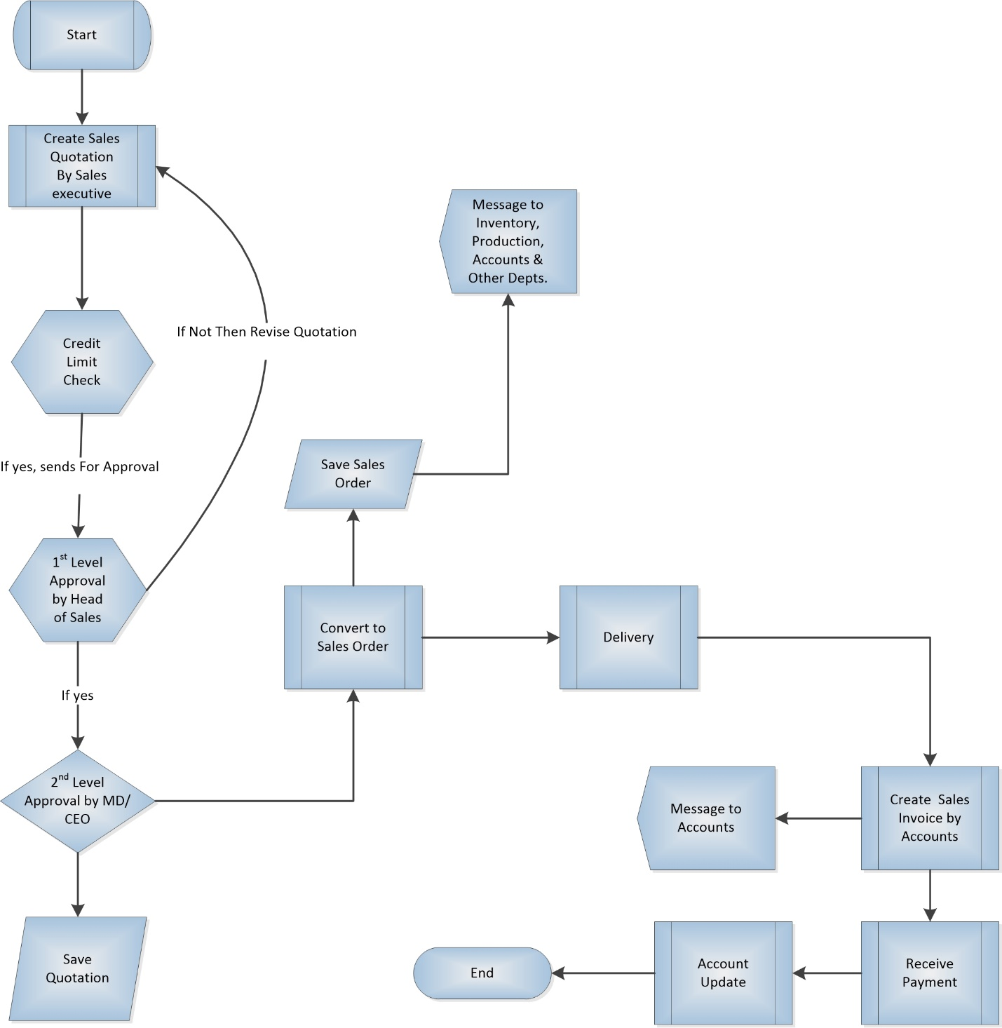

**Fig**: Order to Cash Process

## **3.2 Master Data Management**

### **3.2.1 Product**

Samuda has two types of product. Every feature of sales will have to handle both these category of products.

1. Basic Product
2. Auxiliary/Performance Product

We will have to set up all the products in the system. Product will have product name, product type, unit of measures etc.

### **3**.**2.2 Customer**

There will be only two types of customer for the sales module.

1. Local Customer
2. Foreign Customer

### **3.2.3 Sales Team**

The division of a business that's responsible for selling products or services. Evaluating the company’s current sales force is an important step in the process of deciding whether and how to grow the sales team. The sales organogram is given below:

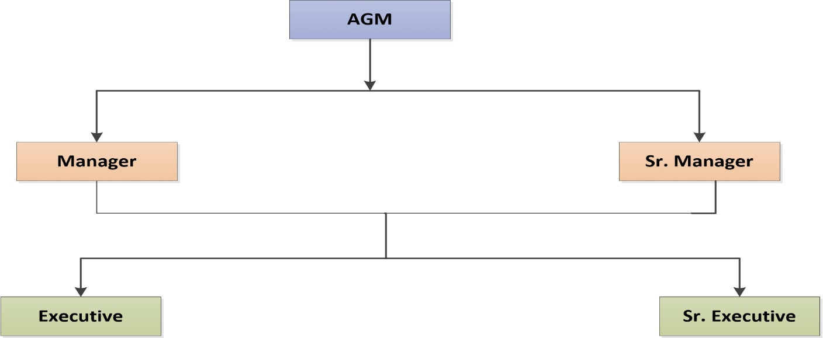

**Fig:** Sales Team

Every sales executive will be tagged with their own customer. One sales executive will be able to see other executive’s customer.

## **3.3 Create the Sales Order**

Once the product is set up, you can create a quotation or a sale order with the related product. Once the quotation is confirmed and transformed into a sale order, the task will be created.

A Sale Order have 9 stages.

* Draft Quotation
* Quotation Sent
* Cancelled
* Waiting Schedule
* Sales Order
* Sale to Invoice
* Invoice Exception
* Done

At first system user needs to create a draft quotation in sales module. After that a customer will be selected. Inside order lines tab user will have to click on “add an item” button. A product needs to be selected along with unit price and quantity. In other information tab user will have view option for several fields like shipping policy and create Invoice. It can be customized also.

Then they have to save the form. Now the draft quotation is created.

After creating a quotation it can be sent to the customer via Email. A pdf format of quotation will attached in that email. This is not required. Then authorized user can confirm it as a sale order.

User should remember, after confirming a sale order one can’t change the important values of the order like (Customer, Product, Quantity, Etc.)

Now user will have three options depends on the created invoice.

**On Demand** – User can create invoice or view delivery Order of the Sales Order

**On Delivery Order** – User can view the Delivery Order and deliver the required product if it is available. Only after completing the delivery process one can create invoice.

**Before Delivery** – In this option, first one will have to pay the invoice. After that user can deliver the product.

“Paid” and “Delivered” terms, inside the Other Information tab shows the status of invoice and delivery order. After completing these steps the sale Order workflow will be completed. One can cancel the sales order inside any step mentioned above.

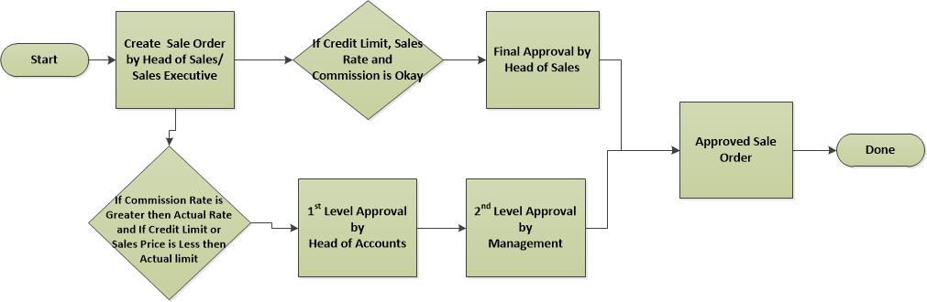

**Fig:** Sales Order Approval Process

Sale Order will be created by Sales Executive/Head of Sales. Before going on the second level approval, it will check if Credit Limit and Sale Price/Rate is Okay as approved, then Head of Sales will finally approve it. At this scenario there is no need of a second level approval.

Another scenario is, after creating Sale Order by Sales Executive/Head of Sales; if commission rate is greater than actual rate, credit limit and Sales Price is less than actual rate, then it will go on a second level approval from Head of Accounts and for Final Approval from Management.

**Important points are:**

* Sale Order will be created by Sales team/ Head of Sales.
* Once Sale Order is waiting for the approval from Head of Sales or Head of Accounts or from Management; they won't be able to edit the form. Only they will approve or reject the request.
* After each approval, a notification will be sent to Head of Sales, Head of A/C and Management.

### **3.3.1 Sales Price**

Every finished goods has it's Sales Price. Sales Price can be changed, process is described below:

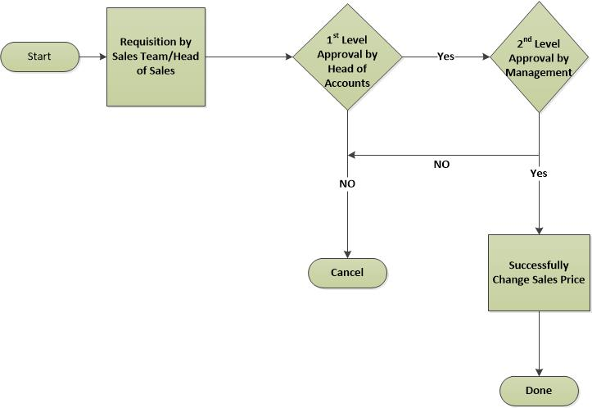

**Fig:** Sale Price Change Approval Process

Sale Price can be changed but need to go through to a proper approval process. Sale price change request will be initiated by Sales department for example Sales Executive. It will then wait for the first level approval from Head of Accounts. After the first level approval it will then wait for the second/final level of approval from Management. The request can be rejected from both the approval layers.

**Some important points:**

* Once it is waiting for the approval from Head of Accounts or Management, they won't be able to edit the form. Only they will approve or reject the request.
* Sales Price change history will be shown as for record.
* After each approval, a notification will be sent to Head of Sales, Head of A/C and Management.

### **3.3.2 Customer Commission**

There will be customer commission product wise which will have to go through a proper approval process. It will have two layers of approval process which is described as below:

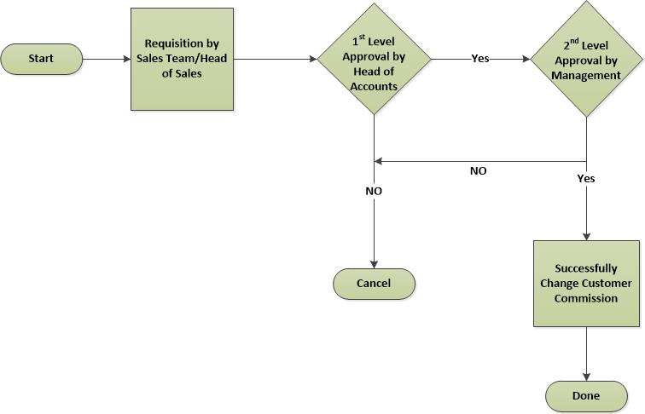

**Fig:** Customer Commission approval process

Customer Commission request will be initiated by Sales department for example Sales Executive/Head of Sales. It will then wait for the first level approval from Head of Accounts. After the first level approval it will then wait for the second/final level of approval from Management. The request can be rejected from both the approval layers.

**Some important points:**

* Once it is waiting for the approval from Head of Accounts or Management, they won't be able to edit the form. Only they will approve or reject the request.
* Commission change history will be shown as for record.
* After each approval, a notification will be sent to Head of Sales, Head of A/C and Management.

## **3.4 Receive feedback from the Customer**

The Customer may contact the Salesman by phone or directly. The feedback of the Customer will be stored in the system and it will be viewable by authorized user only.

## **3.5 Gives stock status report to Accounting Department**

The Accountant needs a stock status report for checking whether the input and output are matched between the Sales Department, Warehouse, and his/her account record.

## **3.6 Gives quotation list to Customer and Accounting Department**

Every time the new products have been imported to the company, the Salesmen will promote products information as a quotation list of product to the Customer at the company or to Customer’s place. In order to follow the price easily, the Accountant in Accounting Department also needs a quotation list from the Sales Department.

## **3.7 Gives customer list to Accounting Department**

After the customer information has been recorded in system, it will be given to the Accounting Department.

## **3.8 Gives sales reports to Customer and Accounting Department**

The Salesmen have to send the daily sales reports, which show the daily delivery and payment of the Customers, to the Accounting Department. Sometimes the Customers also require having these sales reports in the certain period to check by him or herself whether they are correct or not.

## **3.9 Gives contract to Customer and Accounting Department**

After the contract has been made, three copies will be made: first for Customer, second for Accounting Department and third for Sales Department itself.

## **3.10 Gives returned product report the Customer and Accounting Department**

The returned product reflects the quality of the product and influent to the long-term business relationship. On the other hands, the value of the returned product is considered as payment and the debt of the customer will be reduced. The Account needs the returned product report to follow the payment in the account. The customer sometimes requires the returned product report as well.

## **3.11 Gets a delivery receipt from Warehouse Keeper**

The Customer will sign on the delivery receipt after receiving the products. The Salesman will get the signed delivery receipt from Warehouse Keepers after the product has been delivered.

The delivery receipt is made in three copies: first for Customer, second for Salesman, third for Warehouse Keeper him-/herself.

## **3.12 Sales Target and Achievement**

A specified amount of sales that a management sets for achieving or exceeding within a specified timeframe. Sales targets are apportioned among different sales units such as salespersons, franchisees, distributors, agents, etc. There will have volume wise target on the whole sales team. The sales target will be product wise (basic/ auxiliary). Every sales executive will have time based target. The target can be yearly/monthly depending on the decision.

If the sales targets are achieved, then it is considered as achievement. This achievement can be measured yearly/ half-yearly/ quarterly. There will be a report on target vs. achievement. This can be individual or group wise.

## **3.13 Cash Back**

This feature gives customers the option of withdrawing cash from their debit account when they make a purchase at seller’s place of business. Seller provides this special discount when customer purchase desired amount/ price of product. Cashback is only available on debit Purchases.

So, in a way this is not exactly rewarding for customer who are buying their products- actually it is inflating the price of the service or goods that customer bought and pay a part of that increased cost back to the buyer to lure them to use their goods more.

## **3.14 Reports**

* A report of product list with stock status.
* A report of product list with price list.
* A report of customer list sorted by selection criteria.
* A report of delivery list in detail information in a certain period for one customer.
* A report of payment list in detail information in a certain period for one customer.
* A report on target vs. achievement.

## **3.15 Customer Credit Limit**

Every customer will have a credit limit. The credit limit can be increased or decreased. If limit crosses, there should be option to reset the limit. Requisition of increase or decrease will be generated by Head of Sales. After the approval from Head of Accounts with a comment, it will wait for the approval from higher authority. If higher authority approves then limit will increase automatically.

Credit Limit Decrease Process will be same as Credit Limit Increase process i.e. two level approval. Person who will increase the limit, will have the right to decrease as well.

**Some Important points are:**

* Once it is waiting for the approval from Head of Accounts or Management, they won't be able to edit the form. Only they will approve or reject the request.
* Credit Limit change history will be shown.
* After each approval, notification email will be sent to to Head of Sales, Head of A/C and Management.
* If Credit Limit reaches at 80%, then notification mail will be sent to Head of Sales, Head of A/C and Management.

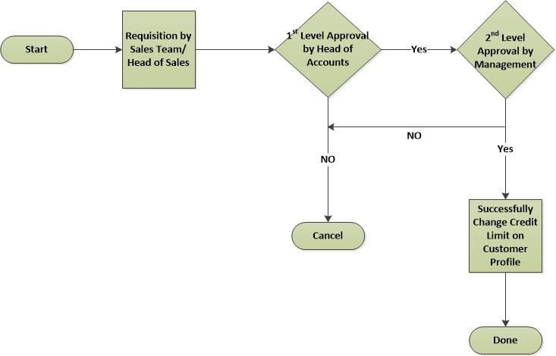

**Fig:** Credit Limit Increase/Decrease Approval Process

## **3.16 Payment Policy**

The following are the options for payment policy.

* LC
* TT
* Credit Sale
* Advanced Payment

Some points regarding Payment Policy:

* LC/Cash. If cash there will be option to select currency like Taka or Doller.
* LC will not be treated as Credit Limit .

## **3.17 The main external agents**

Accounting Department is a place where keeps, inspects, and audits financial record of the company.

Accounting Department is the external agent of the sales management process and internal agent of the company.

Customer may be a person, a workshop or a store that buys products at the company.

An inventory is a place where storages the company’s products. Each inventory has its own stock. There is one store Keeper in each inventory. It can vary also depend on the organization structure.

The inventory is external agent of the sales management process and internal agent of the company.

A supplier is a manufacturer or an exporter who supplies products to the company.

The supplier is an external agent of the company.

# **4. Appendix**

Forms of Samuda maintain for its Sales Management.

1.Sales Order

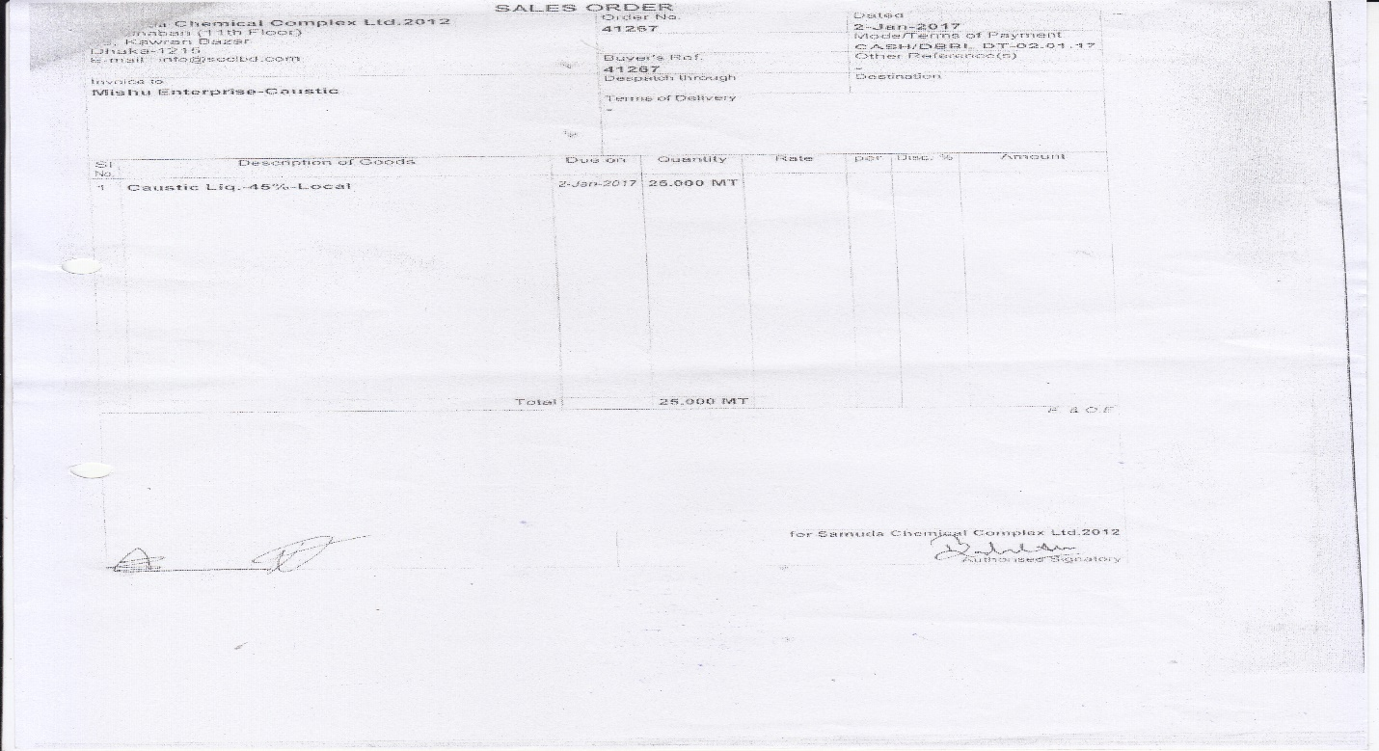

# **5. To be Determined**

1. ISO 9001 related reports are not implemented within this phase. We will cover in next phase.

Signed on behalf of Signed on behalf of

Samuda Chemicals Ltd. Genweb2 Limited

Name: Name:

Designation: Designation:

Date: Date:

**______________________________ ______________________________**

Signature Signature