

**Customer Requirements Specification (CRS)**

***Order to Cash Management***

# **Document Information**

|  |  |
| --- | --- |
| Document Name | CRS of Order to Cash Management |
| Document Author | Md. Golam Rabbi |
| Document Version | 1.2 |
| Release Date | 13thAugust, 2017 |

|  |  |
| --- | --- |
| Review by | Md. Matiar Rahman |
| Review Date | August 14, 2017 |
| Approved By |  |
| Approval Date |  |

Signed on behalf of Signed on behalf of

Samuda Chemicals Ltd. Genweb2 Limited

Name: Name:

Designation: Designation:

Date: Date:

**______________________________ ______________________________**

Signature Signature

# **Document History**

|  |  |  |  |  |  |
| --- | --- | --- | --- | --- | --- |
| A=Added, M=Modified, D=Delete | | | | | |
| **Version No** | **Date** | **Section No** | **A/M/D** | **Description of Change** | **Author** |
| 1.0 | 15-March-2017 |  | A | Initial | Kamrun Nahar |
| 1.1 | 25-July-2017 |  | A | Approval process updated for Credit Limit, Sales Price, Sale Order and Customer Commission | Md. Golam Rabbi |
| 1.2 | 13-August-2017 |  | A | Flow updated and Mock up images added | Md. Golam Rabbi |
| 0.4.6.1 | 3-dec-2017 |  | A | Some business modified Order to Cash | Rashedul Alam |
| 0.4.6.2 | 10-Apr-2018 |  | A | Delivery order(DO) business Added | Rashedul Alam |
| 0.4.6.3 | 30-Apr-2018 |  | A | Business Logic updated for Credit Sales | Md. Golam Rabbi |

**Contents**

**A.** **Document Information** 2

**B.** **Document History** 3

**Contents** 4

**1.0** **Introduction** 6

**1.1 Purpose of CRS** 6

**2.0** **Order to Cash Module Overview** 6

**3.0** **Features** 6

**3.1 Master Data Management** 7

**3.1.1 Product** 7

**3.1.2 Daily Production Information** 7

3**.1.3 Customer** 7

**3.2 Sales Team** 8

**3.3 Customer Commission** 10

**3.4 Customer Credit Limit** 11

**3.5 Sales Price** 13

**3.6 Order to Cash Process** 14

**3. 6.1 Sales Order (CASH)** 14

**3.6.2 Sales Order (Credit)** 14

**3.6.3 Sales Order (LC)** 15

**3.6.4 Uniqueness of a Sale Order Number:** 15

**3.6.5 Delivery order (DO)** 16

**3.7 Delivery Order Approval Process** 18

**3.8 Payment Information Data Capturing** 18

**3.12 Sales Target and Achievement** 18

**3.13 Reports** 19

**3.14 Payment Policy** 19

**3.15 The main external agents** 19

**4. Appendix** 20

**1. Customer Profile Information:** 20

**1a) Contacts and address:** 20

**1b) Customer Commission** 21

**1c) Customer Credit Limit** 22

**1d) Accounting:** 23

**1e) Sales & Purchase** 24

**2. Product Master data** 25

**2a) Product General Information** 25

**2b) Product Invoicing** 25

**2c) Product Saleswith Currency Type** 26

**2d) Product Sales Price Change** 26

**2e) Product Sales Price Change History** 28

**3. Daily Production Information** 28

**4. Customer Commission:** 28

**4a) By Product** 28

**4b) By Customer** 29

**5. Customer Credit Limit:** 30

**6. Sales Order** 31

**6a) In USD** 31

**6b) In BDT** 32

**7. Delivery Order** 33

**7a) Products** 33

**7b) Payment in Cash** 34

**7c) Payment in Cheque** 35

**7d) Payment in TT** 36

**7e) Payment in LC** 37

**8. Delivery Goods** 38

# **Introduction**

## **1.1 Purpose of CRS**

The purposes of this CRS (Customer Requirement Specification) is to clearly identify the customer requirements and provide a detailed document. The customer will review the document and approve/make changes as required. It will also help the review team to validate whether the customer requirements have been fulfilled or not.

# **Order to Cash Module Overview**

In the context of growing market competition, organizations are focusing more on closer partnership across supply chain. Increasing efficiency in sales process facilitates an organization to maintain its competitive edge. Best practice processes, embedded in an ERP package, are an enabler in this direction.

The important components of Order to Cash modules:

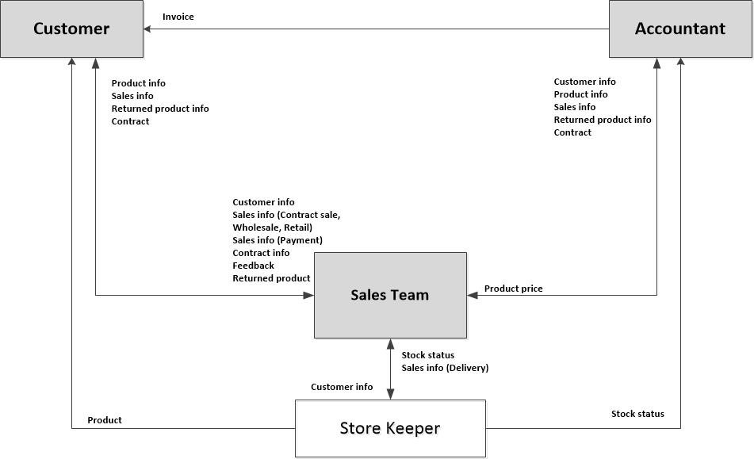

**Fig:**Order to Cash Management System

# **Features**

This module will help Samuda to manage its order to cash process very efficiently and give full feature list to customize according to business needs. Following are the feature description of Order to Cash Module.

## **3.1 Master Data Management**

### **3.1.1 Product**

Samuda has two types of product. Every feature of sales will have to handle both these category of products.

1. Basic Product

2. Auxiliary/Performance Product

We will have to set up all the products in the system. Product will have product name, product type, unit of measures etc.

**Important notes:**

* Finished products will be created by Accounts department.
* Finish products Sales can be sold selected product will come only in sales module.
* Sales product sales executive view only.
* Sales Product Manager New rule impose.
* Sales Product Manager should create & write permission.
* Product type, Company & Unit of Measurement--Product Manager can edit only.
* Admin (Administrator) user should have only Delete permission.
* Procurement&Location ---sales user will not see
* Inventory tab should invisible for Sales user
* Purchase button should invisible for Sales user.
* Invoicing no need

### **3.1.2 Daily Production Information**

System will capture Daily Production Information and store it. Following fields will be on that form:

* Date of production,
* Warehouse information,
* Product,
* UoM

### 3**.1.3 Customer**

There will be only two types of customer for the sales module.

1. Local Customer

2. Foreign Customer

**Important notes:**

* ~~Customers will be created by Accounts department~~.
* Customer will be created/Edit by Customer Manager only
* Customer Manager Group require.
* Customer delete Admin(Administrator) only
* Notification group require
* Customer Create/Edit send email notification to Notification group

#### 3.1.3.1 Customer Profile

Customer profile is the place where customer’s information stored. Some key information which are captured at customer profile is given below:

* Customer's Address
* Trade License No.
* VAT Registration No.
* Customer Credit Limit history
* Master data of Customer Commission Rate history
* Customer can see his Sales, Invoice etc history.
* Company contacts and Address.
* Customer's Receivable and payable.

## **3.2 Sales Team**

The division of a business that's responsible for selling products or services. Evaluating the company’s current sales force is an important step in the process of deciding whether and how to grow the sales team. The sales organogram is given below:

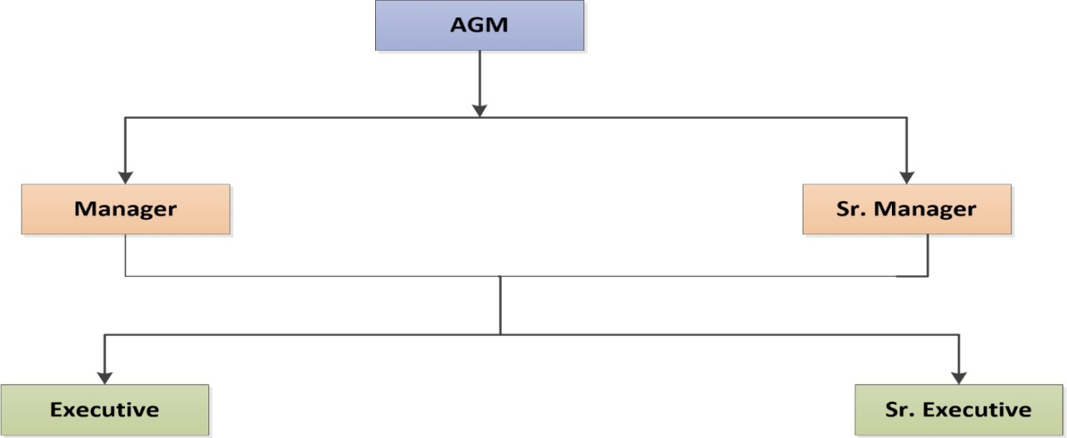

**Fig:** Sales Team

Every sales executive will be tagged with their own customer. One sales executive will be able to see other executive’s customer.

## **3.3 Customer Commission**

There will be product wise customer commission which will have to go through a proper approval process. It will have two layers of approval process which is described as below:

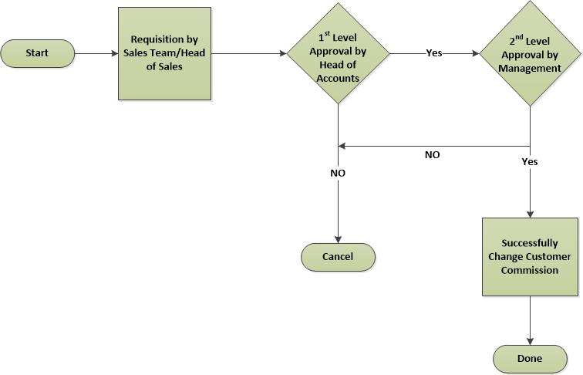

**Fig: Customer Commission Approval Process**

Customer commission request will be initiated by Sales department for example Sales Executive/Head of Sales. It will then wait for the first level approval from Head of Accounts. After the first level approval it will then wait for the second/final level of approval from Management. The request can be rejected from both the approval layers.

**Some important points:**

* Once it is waiting for the approval from Head of Accounts or Management, they won't be able to edit the form. Only they will approve or reject the request.
* Commission change history will be shown as for record.
* After each approval, a notification will be sent to Head of Sales, Head of A/C and Management.
* Print option require
* Sequence needed auto number will be set

## **3.4 Customer Credit Limit**

Every customer will have a credit limit. The credit limit can be increased or decreased. If limit crosses, there should be option to reset the limit. Requisition of increase or decrease will be generated by Head of Sales. After the approval from Head of Accounts with a comment, it will wait for the approval from higher authority. If higher authority approves then limit will increase automatically.

Credit Limit Decrease Process will be same as Credit Limit Increase process i.e. two level approval. Person who will increase the limit, will have the right to decrease as well.

**Some Important points are:**

* Once it is waiting for the approval from Head of Accounts or Management, they won't be able to edit the form. Only they will approve or reject the request.
* Credit Limit change history will be shown.
* After each approval, notification email will be sent to to Head of Sales, Head of A/C and Management.
* If Credit Limit reaches at 80%, then notification mail will be sent to Head of Sales, Head of A/C and Management.
* Print option require
* Sequence needed auto number will be set
* Credit limit & Days non mandatory

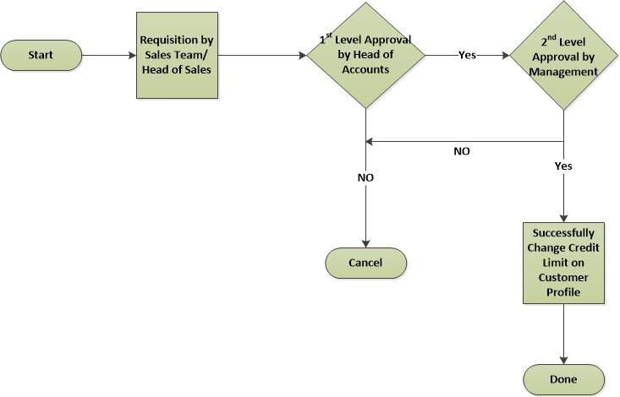

**Fig: Credit Limit Increase/Decrease Approval Process**

## **3.5 Sales Price**

Every finished goods has a Sales Price. Sales Price can be changed, process is described below:

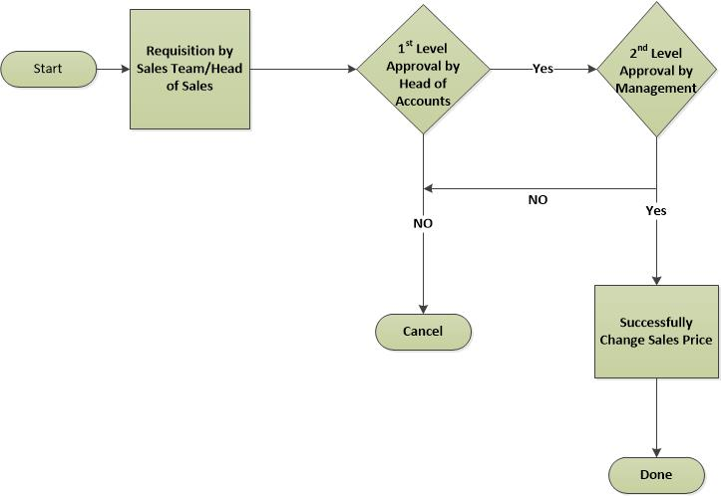

**Fig: Sale Price Change Approval Process**

Sale Price can be changed but need to go through to a proper approval process. Sale price change request will be initiated by Sales department for example Sales Executive. It will then wait for the first level approval from Head of Accounts. After the first level approval it will then wait for the second/final level of approval from Management. The request can be rejected from both the approval layers.

**Some important points:**

* Once it is waiting for the approval from Head of Accounts or Management, they won't be able to edit the form. Only they will approve or reject the request.
* Sales Price change history will be shown as for record.
* After each approval, a notification will be sent to Head of Sales, Head of A/C and Management.

## **3.6 Order to Cash Process**

The process start from getting an order request from a customer to sales executive. Based on the business nature, Samuda practices three types of Sales Order; it is described shortly below with process image and description:

1. Cash

2. Credit Sales

3. LC

### **3. 6.1 Sales Order (CASH)**

Here are some key points for cash based sales order:

* Sales Order (SO) is created by Sales Executive/Head of Sales.
* After creation of SO, system will check if Customer Commission, Product Sales Price Rate are okay or not. If positive then there is no need of second approval for this case and Head of Sales can give final approval of Sales Order.
* If any of the Customer Commission and Product Sales Price Rate is not okay then Head of Sales will confirm the request and Management team will give final approval.
* After Sales Order is finally approved then before preparing Delivery Authorization (DA), system checks that if the **CASH** or payment is being received or not. Ifpayment is not received then DA will not approve.
* After receiving payment through deposit to bank or bank cheque, DA will be prepared by account executive and get approval of DA; after that Goods will be delivered.
* Invoice will be created after Goods delivery.
* Once Sales Order is waiting for the approval from Head of Sales or from Management; they won't be able to edit the SO. Only they will approve or reject the request.
* After each approval, a notification will be sent to Head of Sales, Head of Accounts and Management.

### **3.6.2 Sales Order (Credit)**

Here are some key points for **Credit Sales**:

* Sales Order (SO) is created by Sales Executive/Head of Sales.
* After creation of SO, system will check the summation of Sales Order amount, Customer's Receivable amount, total undelivered DO qty amount for that customer, total unposted Invoiced amount for that customer with Customer's Credit Limit. If positive then there is no need of Second Approval for this case and Head of Sales can give final approval of Sales Order.
* If any of the Customer Credit Limit, Customer Commission and Product Sales Price Rate is not okay and summation of Customer's Receivable amount, total undelivered DO qty amount for that customer, total unposted Invoiced amount for that customer is less than the total Credit Limit of that Customer; in this scenario Head of Sales will confirm the request and Management team will give final approval.
* After final approval of Sales Order, Delivery Authorization (DA) will be prepared. After approval of DA finished Goods will be delivered.
* Invoice will be created after delivery of Goods.
* Once Sales Order is waiting for the approval from Head of Sales or from Management; they won't be able to edit the form. Only they will approve or reject the request.
* After each approval, a notification will be sent to Head of Sales and Management.

### **3.6.3 Sales Order (LC)**

Sales Order can be created from LC and PI also. Some key points are given below:

**PI SO:**

* At first Sales team will create PI.
* From that PI, Sales Order will be created by Sales Executive.
* At this stage flow is same as CASH Sales.

**PI LC SO:**

* Sometimes LC is created from PI and then from that PI, Sales order is generated. After that flow is same as above.

**Some points to be noted:**

* Delivery Order (DO) is not issued without LC or PI. DO can be generated from PI and there is a limit based on company and product for example 100MT.
* Invoice will be created after delivery of Goods.

### **3.6.4 Uniqueness of a Sale Order Number:**

A Sale Order Number will be unique based on Operating units. By default Sale Order number starts with **SO**; uniqueness will be ensured by introducing following properties to Sale Order:

* + - 1. Company Prefix
      2. Operating Unit Prefix
      3. Fiscal Year
      4. Sale Order Sequence Number

Example:

Company Prefix: SCCL (Samuda Chemical Complex Ltd)

Operating Unit Prefix: DF (Dhaka Factory)

Fiscal year: 2017

Sale Order Seq. Number: 00001

Complete example: **SO/SCCL/DF/2017/00001**

**Note:**

SaleOrder number will automatically be reset at the end of fiscal year.

### **3.6.5 Delivery order (DO)**

A delivery order before state of stock picking and after state of delivery authorization. Accounts executive or Accounts head will generate & confirm the delivery order. Delivery order will not go for Stock picking until DO confirmation.

**Note:**SO=>DA=>DO=>Stock picking then order Qty will move to stock or Customer location

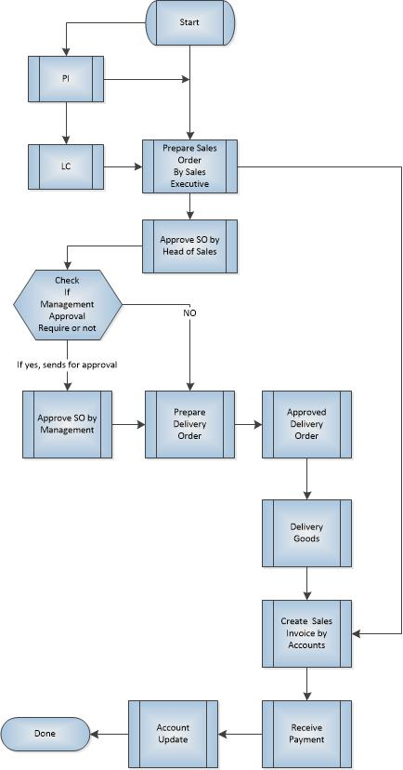

**Fig**: **Order to Cash Process**

## **3.7 Delivery Order Approval Process**

After successful approval of a Sales Order, a Delivery Order will prepared by accounts executive. As based on the DO the goods will be delivered from warehouse / store / factory, so accounts executive does some checking on sales order and payment. If the sales order type is CASH, he will check the payment status, if the payment is not received the DO will not be prepared. If the sales order type is LC, if the LC is not received he’ll not approve the DO. Generally DO will be prepared after approval of sales order but for some exceptional cases, DO can be prepared without reference of Sales Order and will be linked to Sales Order after the approval of SO. The below diagram is the process of DO approval:

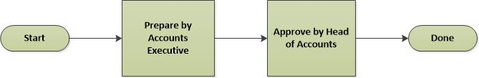

**Fig:** Delivery Order / Authorization Approval Process

**Important Points:**

* DO will be prepared by Accounts Executives and approved by Head of Accounts.
* DO form will have Sales Order reference or Payment History, Product information in editable mode, and Warehouse information i.e. from which factory goods will be delivered, Transport details i.e. vehicle no, driver no etc.
* The DO creation and approval process will remain within the accounts departments.
* After approval of DO finished Goods will be delivered.

## **3.8 Payment Information Data Capturing**

There will be a payment data information capturing UI for check payments. Form will have following information:

* Sales Order reference
* Cheque No
* Account No
* Amount etc.

**Key points:**

* Payment history will be checked upon Delivery Order preparation against specific Sales Order reference and if no information is found then DO will not proceed.

## **3.12 Sales Target and Achievement**

A specified amount of sales that a management sets for achieving or exceeding within a specified timeframe. Sales targets are apportioned among different sales units such as salespersons, franchisees, distributors, agents, etc. There will have volume wise target on the whole sales team. The sales target will be product wise (basic/ auxiliary). Every sales executive will have time based target. The target can be yearly/monthly depending on the decision.

If the sales targets are achieved, then it is considered as achievement. This achievement can be measured yearly/ half-yearly/ quarterly. There will be a report on target vs. achievement. This can be individual or group wise.

## **3.13 Reports**

* A report of product list with stock status.
* A report of product list with price list.
* A report of customer list sorted by selection criteria.
* A report of delivery list in detail information in a certain period for one customer.
* A report of payment list in detail information in a certain period for one customer.
* A report on target vs. achievement.

## **3.14 Payment Policy**

The following are the options for payment policy.

* LC
* TT
* Credit Sale
* Advanced Payment
* Some points regarding Payment Policy:
* LC/Cash. If cash there will be option to select currency like Taka or Dollar.
* LC will not be treated as Credit Limit.

## **3.15 The main external agents**

Accounting Department is a place where keeps, inspects, and audits financial record of the company.

Accounting Department is the external agent of the sales management process and internal agent of the company.

Customer may be a person, a workshop or a store that buys products at the company.

An inventory is a place where storages the company’s products. Each inventory has its own stock. There is one store Keeper in each inventory. It can vary also depend on the organization structure.

The inventory is external agent of the sales management process and internal agent of the company.

A supplier is a manufacturer or an exporter who supplies products to the company.

The supplier is an external agent of the company.

# **4. Appendix**

## **1. Customer Profile Information:**

### **1a) Contacts and address:**

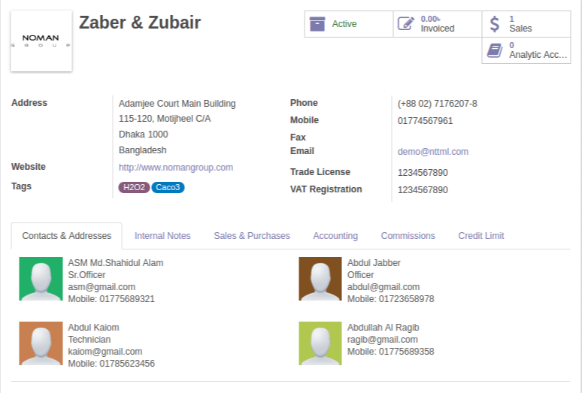

### **1b) Customer Commission**

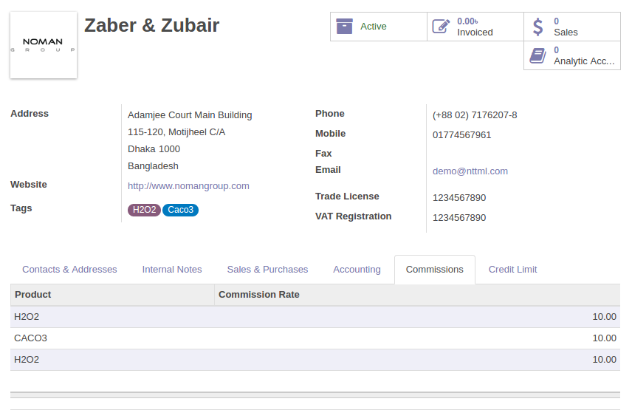

### **1c) Customer Credit Limit**

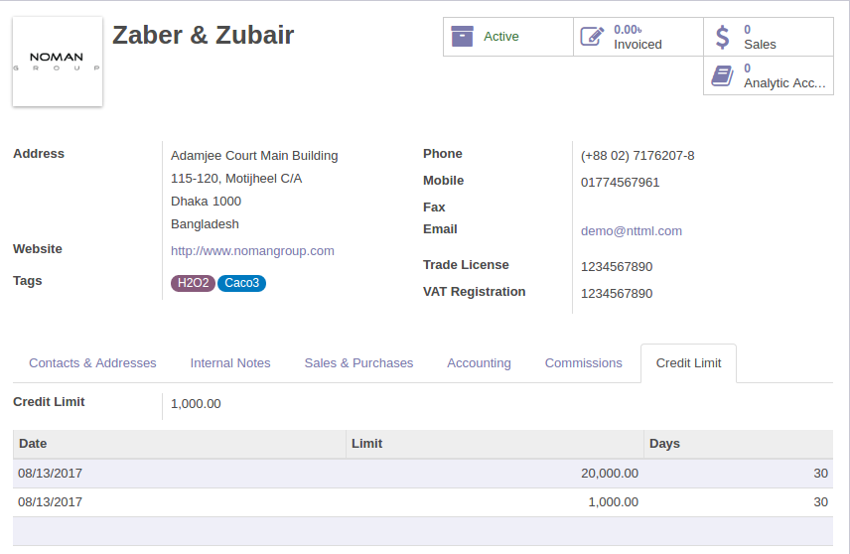

### **1d) Accounting:**

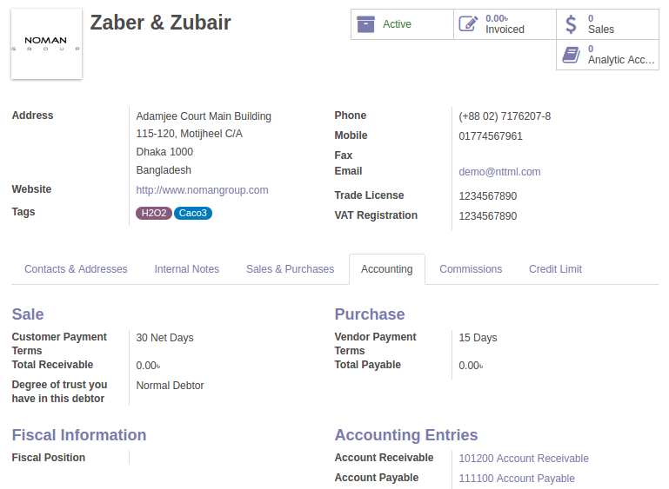

### **1e) Sales & Purchase**

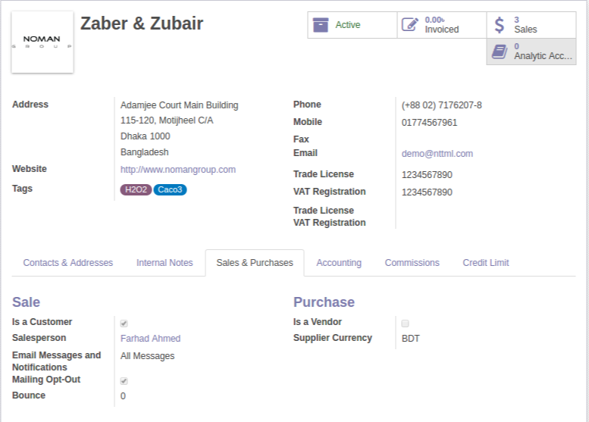

## **2. Product Master data**

### **2a) Product General Information**

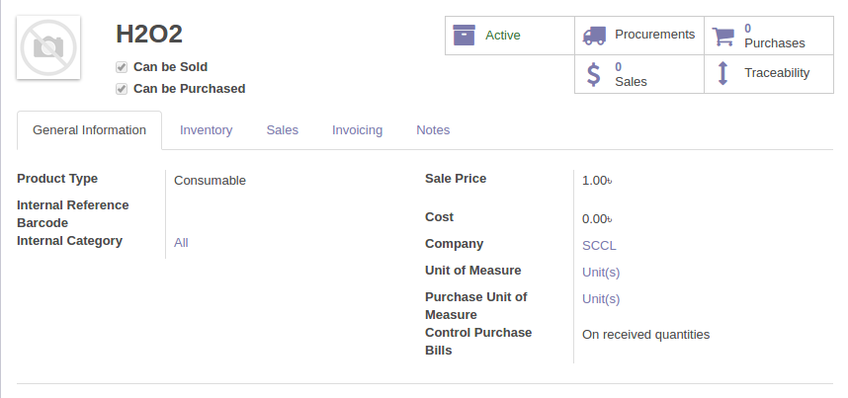

### **2b) Product Invoicing**

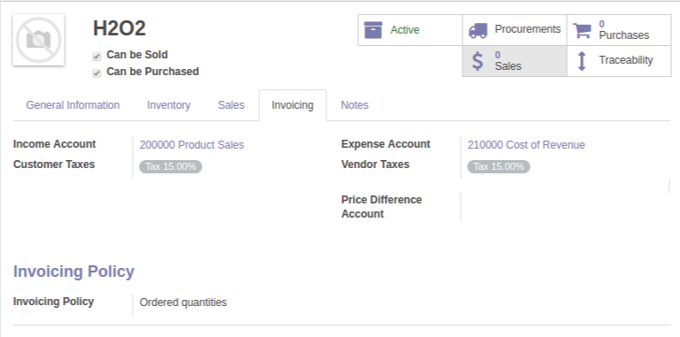

### **2c) Product Saleswith Currency Type**

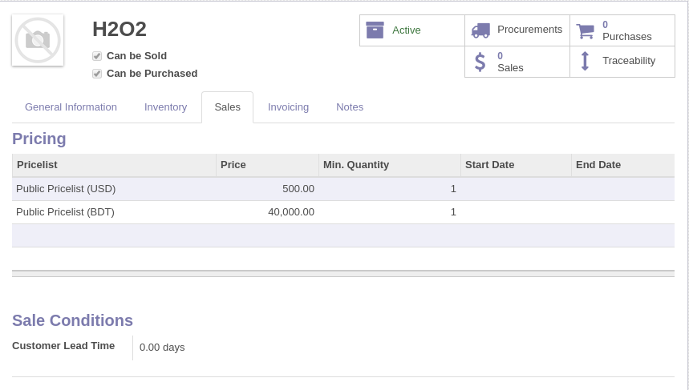

### **2d) Product Sales Price Change**

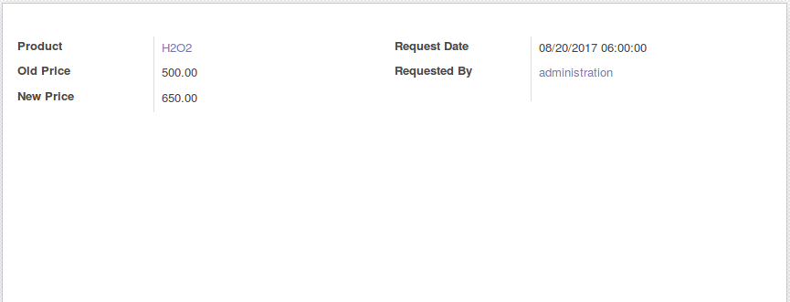

**Important notes:**

1. Change product price form name should be change

2. Edit icon should be omit from entry form.

3. Print report require

### **2e) Product Sales Price Change History**

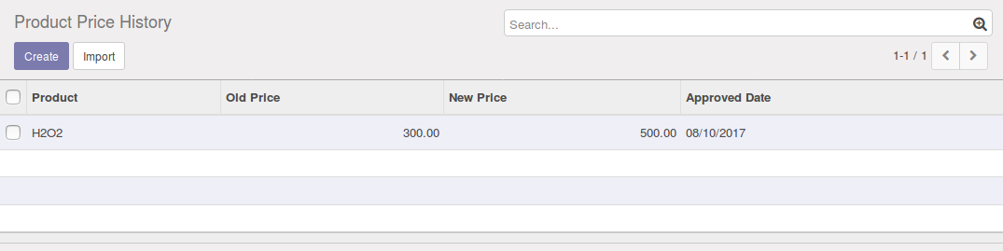

**Important notes:**

1. Product variant group by descending order

2. Group by should not be some.

**3. Daily Production Information**

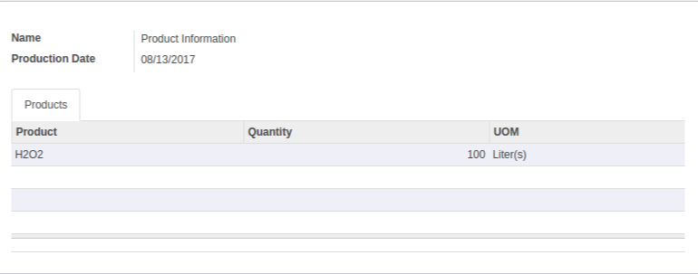

## **4. Customer Commission:**

### **4a) By Product**

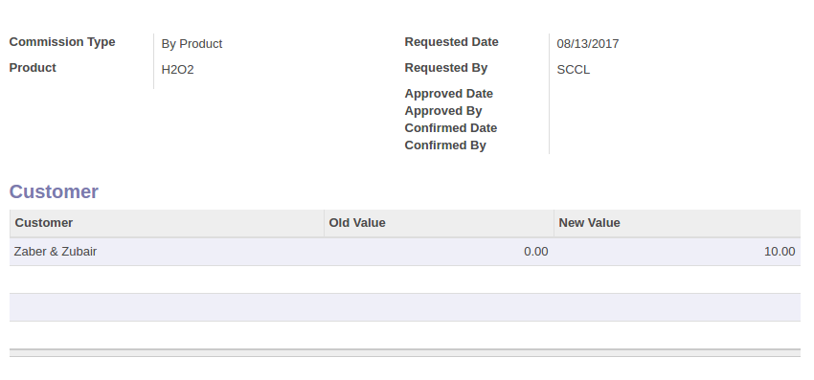

### **4b) By Customer**

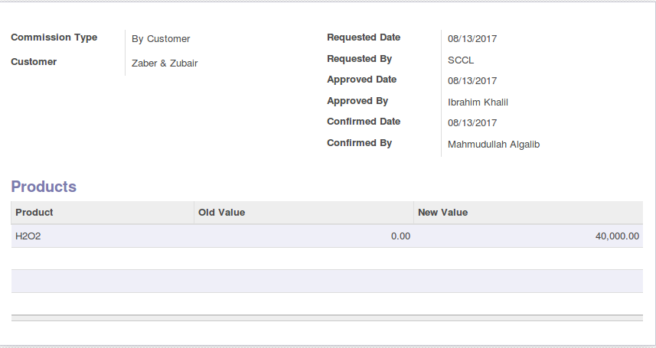

## **5. Customer Credit Limit:**

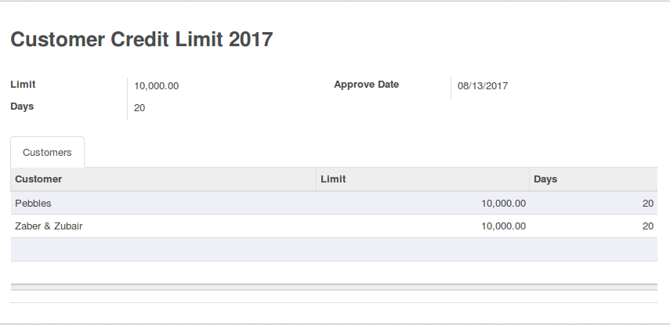

**Important notes:**

1. If exceed credit limit during Sales order then Second level approval require.

2. If (Receivable amount +sales order amount) is greater than credit limit then will go second level approval.

## **6. Sales Order**

**Important Notes:**

* Should implement **DF-Cash-BDT,DF-Credit-BDT,DF-LC-BDT etc** in Sales order type
* If **DF-cash-BDT**/**DF-Credit-BDT** etc select then sales order type &currency type should select auto.
* Section & Analytic tag should omit from grid
* Print view will Impose
* Commission price negative balance-- test require.
* Sales order complete then Need to create Delivery authorization
* Operating unit will be added.
* Delivery address & Sales order type will remain & others all info will omit.
* Type LC then two field will visible Pi & LC
* Sales order type when LC then Unit price & Commission will be added.
* Others tag will omit.

### **6a) In USD**

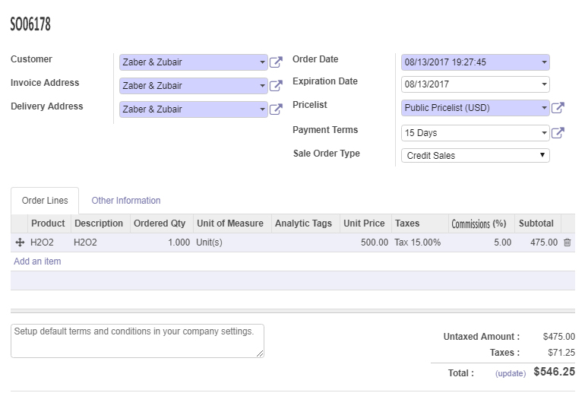

### **6b) In BDT**

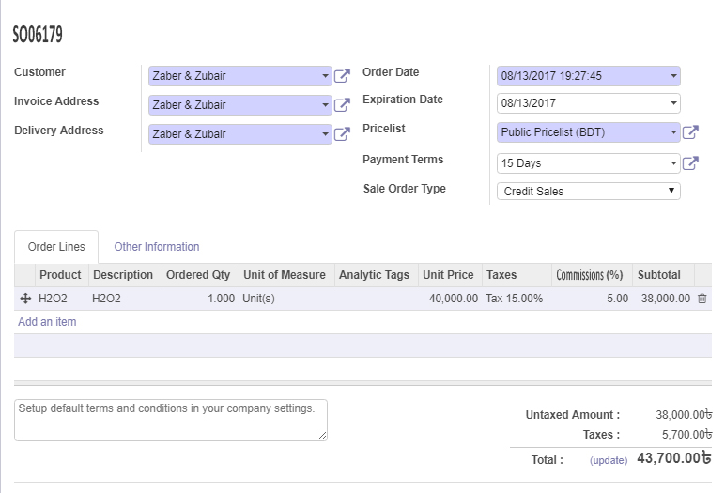

## **7. Delivery Order**

### **7a) Products**

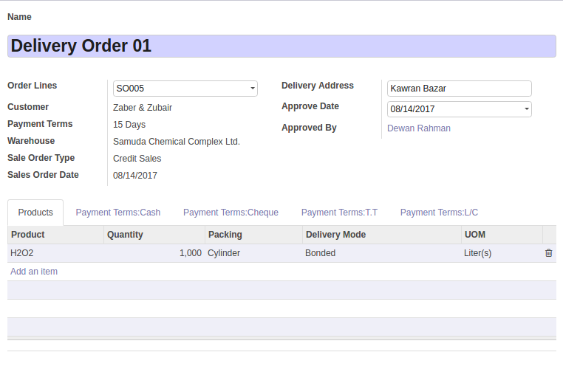

**Important notes:**

* Sales order type when Cash then deposit information will be added.
* Pending delivery order state (Pending DA) will be added.
* Sales order should not load in sales order combo which is already Payment.
* All info will load in grid after payment received.
* Payment info will come auto after select sales order number.
* Payment synchronization button need to Impose.
* Sales order type should read-only
* Sales order info No edit/Change then Not going second level approval
* Sales order type LC then Proforma invoice(Pi) will open
* LC should be ±10.
* If PI & LC exist then no need second level approval
* If PI exist but no LC then second level approval require
* If LC exit but no Pi then second level approval require
* PI exist but No LC then 100MT business will open.
* Partial delivery will open up to 100MT i.e 20MT,30MT,50MT then no more capable to order then 20MT payment then 20MT will open then again capable to order 20MT.
* PI exist but No LC then Tag LC will visible.
* Tag LC implement & Some Qty will open then again Capable to order and no need second level approval, if exceed 100MT then again Second level approval require.
* Company ID require
* Operating unit require
* Keep the log info in existing form.
* Delivery Authorization entry form
* Delivery Authorization order will create when Sales order approved.
* Store will get a notification when Delivery Authorization will be approved
* Delivery Authorization Transport information require
* Delivery Authorization cannot be more
* Schedule date require
* Stock cannot be minus for Testing purpose
* Finish goods produce UI require
* Color conversion—Need 45%..Then Mixed 60% product and 20% water then 60% product will be decreased&New 45% product will be created.

### **7b) Payment in Cash**

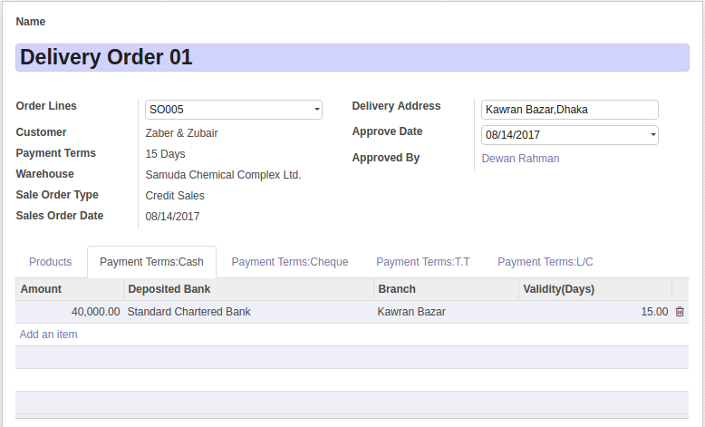

### **7c) Payment in Cheque**

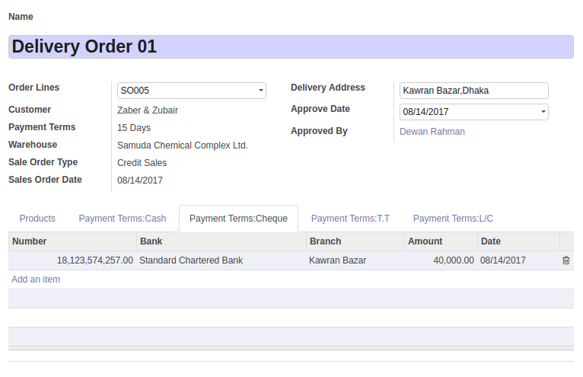

**7d) Payment in TT**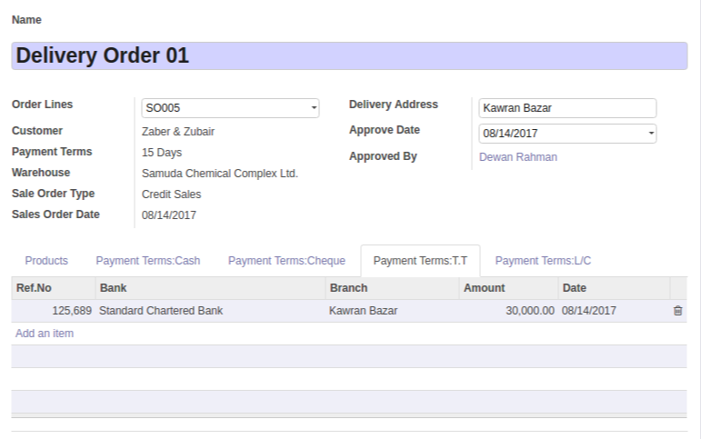

### **7e) Payment in LC**

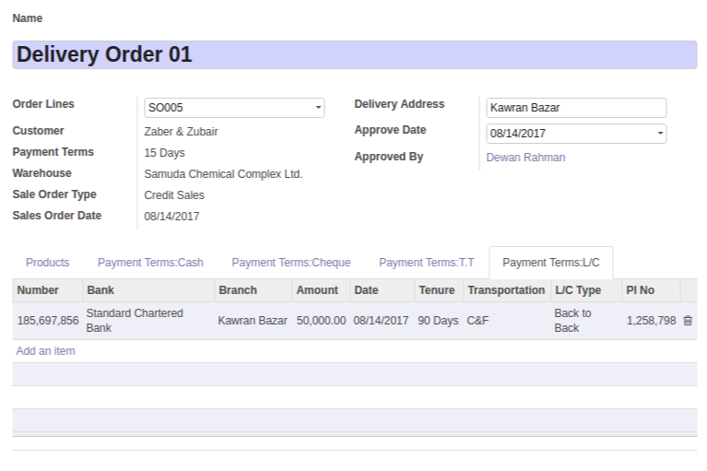

## **8. Delivery Goods**

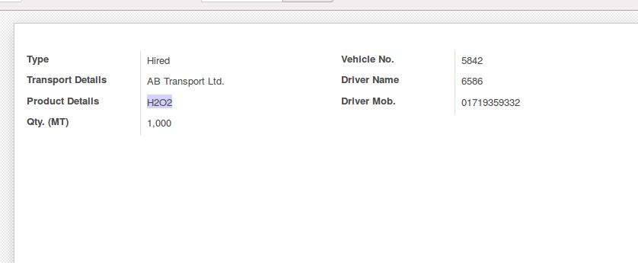

Signed on behalf of Signed on behalf of

Samuda Chemicals Ltd. Genweb2 Limited

Name: Name:

Designation: Designation:

Date: Date:

**______________________________ __________________________**

Signature Signature