**Customer Requirement Specifications (CRS)**

***Sales Module***

***OF***

***ERP Solution for Samuda Chemicals Ltd.***



**Genweb2 Limited**

TK Bhaban (11th Floor),

13 Kazi Nazrul Islam Avenue,

Kawran Bazar, Dhaka 1215, Bangladesh

Web: [http://www.genweb2.com](http://www.genweb2.com/)

1. Document Information

|  |  |
| --- | --- |
| Document Name | Sales Module of Samuda Chemicals Ltd. (CRS) |
| Document Author |  |
| Document Version | 1.0 |
| Release Date |  |

|  |  |
| --- | --- |
| Review by |  |
| Review Date |  |
| Approved By |  |
| Approval Date |  |

1. Document History

|  |  |  |  |  |  |
| --- | --- | --- | --- | --- | --- |
| A=Added, M=Modified, D=Delete | | | | | |
| **Version No** | **Date** | **Section No** | **A/M/D** | **Description of Change** | **Author** |
| 1.0 | 18-Jan-2017 |  |  |  |  |
|  |  |  |  |  |  |
|  |  |  |  |  |  |

Contents

A. Document Information 2

B. Document History 3

**1.0** **Introduction** 5

**1.1 Purpose of CRS** 5

**2.0** **Sales Module Overview** 5

**3.0** **Features of Sales Modules** 7

**3.1 Order to Cash Process** 7

**3.2 Sub-System of Sales Management** 9

**a)** **Create and set up a product** 9

**b)** **Create the Sales Order** 10

# **Introduction**

# **1.1 Purpose of CRS**

The purposes of this CRS (Customer Requirement Specification) are to clearly identify the customer requirements and provide a detailed document. The customer will review the document and approve/make changes as required. It will also help the review team to validate whether the customer requirements have been fulfilled or not.

# **Sales Module Overview**

In the context of growing market competition, organizations are focusing more on closer partnership across supply chain. Increasing efficiency in sales process facilitates an organization to maintain its competitive edge. Best practice processes, embedded in an ERP package, are an enabler in this direction.

The important components of sales modules:

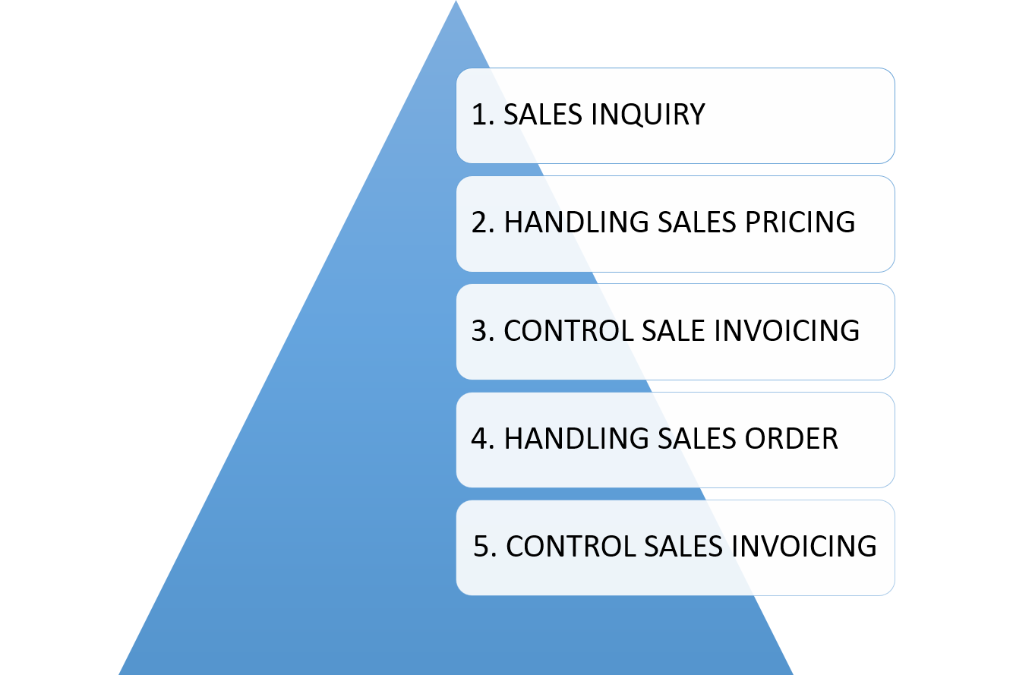

**Fig:** Important Components of Sales Module

**Integration with other modules:** Sales module is a highly integrated execution module. It draws most of its input from the following modules:

* Inventory module for verifying available and projected stock.
* Production module for production schedules and lead time of delivery.
* Purchasing module for generation of direct delivery purchase order.
* Warehousing module for issuing order and shipment.
* Accounts receivable module where sales invoices are recorded.
* Distribution requirement planning under planning module for just in time delivery and supplying to channels partners.

**Why Organization needs Sales Module**

* Expand sales channels through integration with E-commerce module
* Increase sales volume by improving sales channels
* Improve communication with current customers based on trade history
* Evaluate at any time sales agents by integrating data.
* Detailed organization of the sales process on sales areas, divisions
* Fast registration of entire flow of specific documents

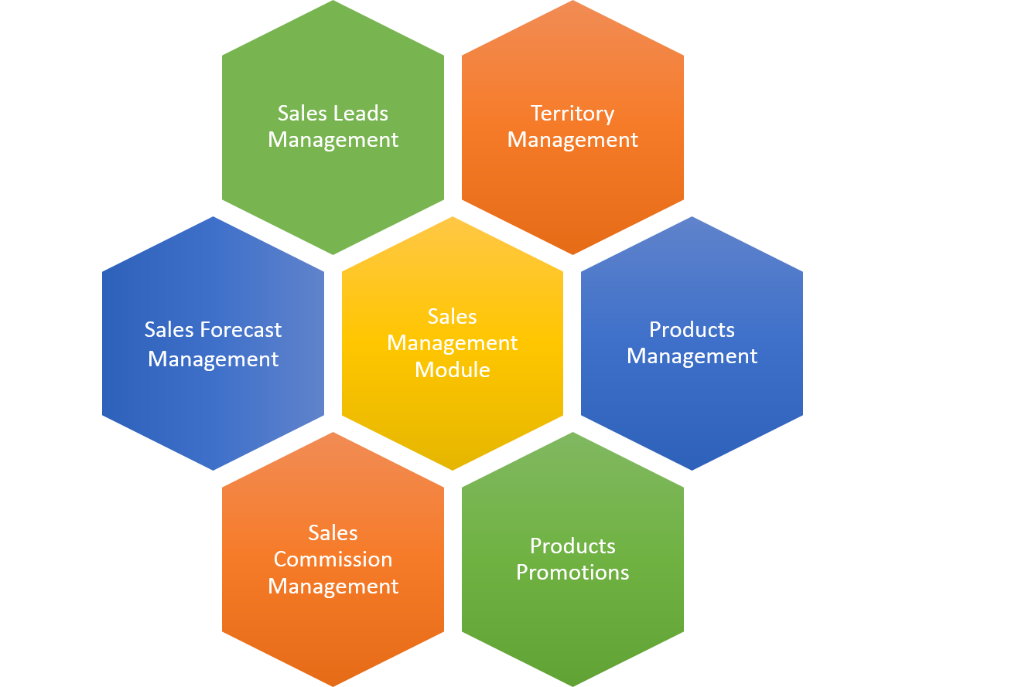

**Fig:** Sales Management Module

# **Features of Sales Modules**

This module will help Samuda to manages its sales process very efficiently and give full feature list to customize according to business needs. Following are the feature description of Sales Module:

## **3.1 The main external agents**

Accounting Department is a place where keeps, inspects, and audits financial record of the company.

Accounting Department is the external agent of the sales management process and internal agent of the company.

Customer may be a person, a workshop or a store that buys products at the company.

A warehouse is a place where storages the company’s products. Each ware house has its own stock. There is one Warehouse Keeper in each warehouse.

The warehouse is external agent of the sales management process and internal agent of the company.

A supplier is a manufacturer or an exporter who supplies products to the company.

The supplier is an external agent of the company.

## **3.2 Order to Cash Process**

Sales module of ERP consists of all master data, system configuration and transactions to complete the process of Order to Cash. The main functions of Sales module are:-

* First Sales quotation is being created
* After sales quotation is created it needs multiple approval process. In all the approval process the sales quotation may be accepted/ revised/ cancelled.
* If the sales quotation is approved by all the approval layers then it is converted to sales order. Besides that once customer confirms the purchase order the sales quotation is converted to sales order.
* When the sales order is created, this message will be forwarded inventory, productions, accounts and other relevant departments.
* Credit limit is being checked for that sales order before delivering the goods.
* Once goods are delivered, sales invoices are submitted to the customer for payment
* Finally the account gets updated upon receive payment.

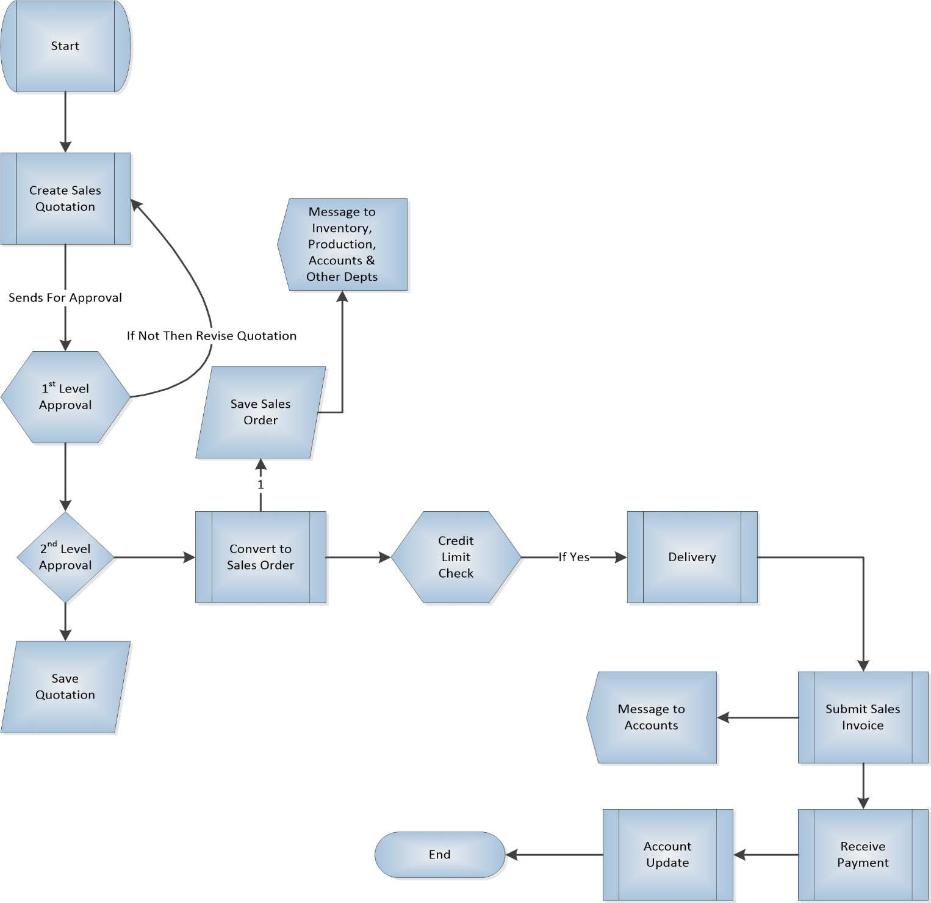

**Fig**: Order to Cash Process flow

## **3.3 Sub-System of Sales Management**

Sales module will contain following subsystem:-

**1. Master Data Management: -** This module is to keep information about all entities so that they can be made available to the decision-makers and also for the automatic generation of reports, contracts, invoices, etc. In Sales module product are sold/sent to business partners. The following are the master data of Sales Module:

1. **Product**- Finished goods will be sold in this module. There will be no variants declared for the finished products. Product will have two type:
   1. Main Item
   2. Auxiliary Item
2. **Territory/Zones-** Sales territory management is more important than many may realize. It can boost sales team’s morale, increase sales, provide a larger customer base and inspire team cohesion. Territory management is a customer group or geographic area over which either an individual salesperson or a sales team has responsibility. These territories are usually defined based on geography, sales potential or a combination of these factors. The ultimate aim of this division of areas is to maximize sales and profits and to allocate resources efficiently.
3. **Sales Team:** The division of a business that's responsible for selling products or services. Evaluating the current **sales** force is an important step in the process of deciding whether and how to grow the **sales team**. The Sales team will consist of following members:

**Head of Sales**

**Sales Manager**

**Sales Executive**

1. **Customer :**

A party/individual that receives or consumes products (goods or services) and has the ability to choose between different products and suppliers is called customer. One of the key master data in sales module.

**2. Sales Order Management: -** This application allows company to manage sales operations efficiently and quickly and also provide comprehensive solutions to the management for quotes, prices, contracts, orders, customer discount, price list etc.

## 

## **Create and set up a product**

First we need to configure our service on the product form itself in order to generate a task every time it will be sold. From the **Sales** module, use the menu **Sales ‣ Products** and create a new product with the following setup:

* **Name**: Technical Support
* **Product Type**: Service
* **Unit of Measure**: Hours (go to **Configuration ‣ Settings** and, under **Unit of measures**, check the **Some products may be sold/purchased in different unit of measures (advanced)** radio button)
* **Invoicing policy**: You can set up your invoice policy either on ordered quantity or on delivered quantity. You can easily follow the amount of hours that were delivered and/or invoiced to your client.
* **Track Service**: Create a task and track hours, as your product is a service invoice able by hours you have to set the units of measures of the product to hours as well.

## **Create the Sales Order**

Once the product is set up, you can create a quotation or a sale order with the related product. Once the quotation is confirmed and transformed into a sale order, the task will be created.

A sale order have 9 stages.

* Draft Quotation
* Quotation Sent
* Cancelled
* Waiting Schedule
* Sales Order
* Sale to Invoice
* Invoice Exception
* Done

At first we create a *quotation.*

Sales-> Quotation->Create

Select a customer

Inside Order Lines tab click on “*add an item” button.*

Select a Product. After that the systems fills the *Unit Price*and other related fields.

Now you can specify the quantity

In *Other Information* tab we will have several fields like *Shipping Policy* and *Create Invoice.*It can be customized also.

Then save the form. Now th Quotation is Created

After creating a Quotation it can be send to the customer via Email. A pdf format of Quotation will attached in that email. This is not required.

Then we can confirm it as a sale order.

Remember after confirming a sale order one can’t change the important values of the order like (Customer, Product, Quantity, Etc.)

Now we will have three options depends on your *Create Invoice*filed value.

**On Demand –**we can *Create Invoice* or view *Delivery Order* of the Sales Order

**On Delivery Order** – We can view the *Delivery Order*and deliver your product if it is available. Only after completing the Delivery process one can create invoice.

**Before Delivery –**In this option, first one will have to pay the invoice. After that we can deliver the product

*Paid* and *Delivered*Fields, inside the O*ther Information* tab shows the status of invoice and delivery order. After completing these steps your Sale Order workflow will be completed. We can cancel the Sales Order inside any step mentioned above.

**Price List:**

This Feature allows you to use customer specific price list Sale. This helps in a great way in managing business by offering customer specific benefits as per their configured price list. Customer specific pricelist in sales module gives the following feature:

* Assign Price list while creating Customer from the module
* Enables businesses to offer Customer specific Price benefit
* Ease of doing business
* Smooth end to end pricelist flow