

**Customer Requirements Specifications (CRS)**

***Sales Management***

# **Document Information**

|  |  |
| --- | --- |
| Document Name | CRS of Sales Management for Samuda Chemicals Ltd. |
| Document Author | Kamrun Nahar |
| Document Version | 1.0 |
| Release Date | 19th March, 2017 |

|  |  |
| --- | --- |
| Review by | Md. Mahfuzur Rahman |
| Review Date | 16th March,2017 |
| Approved By | Matiar Rahman |
| Approval Date | 19th March, 2017 |

Signed on behalf of Signed on behalf of

Samuda Chemicals Ltd. Genweb2 Limited

Name: Name:

Designation: Designation:

Date: Date:

**______________________________ ______________________________**

Signature Signature

# **Document History**

|  |  |  |  |  |  |
| --- | --- | --- | --- | --- | --- |
| A=Added, M=Modified, D=Delete | | | | | |
| **Version No** | **Date** | **Section No** | **A/M/D** | **Description of Change** | **Author** |
| 1.0 | 15-March-2017 |  | A | Initial | Kamrun Nahar |
|  |  |  |  |  |  |
|  |  |  |  |  |  |

Contents

**A.** **Document Information** 2

**B.** **Document History** 3

**1.0** **Introduction** 5

**1.1 Purpose of CRS** 5

**2.0** **Sales Module Overview** 5

**3.0** **Features of Sales Modules** 7

**3.1 Order to Cash Process** 7

**3.2 Master Data Management** 9

**3.2.1 Product** 9

**3**.**2.2 Customer** 9

**3.2.3 Sales Team** 9

**3.3 Create the Sales Order** 9

**3.3.1 Sales Price** 11

**3.4 Receive feedback from the Customer** 11

**3.5 Gives stock status report to Accounting Department** 11

**3.6 Gives quotation list to Customer and Accounting Department** 11

**3.7 Gives customer list to Accounting Department** 11

**3.8 Gives sales reports to Customer and Accounting Department** 11

**3.9 Gives contract to Customer and Accounting Department** 12

**3.10 Gives returned product report the Customer and Accounting Department** 12

**3.11 Gets a delivery receipt from Warehouse Keeper** 12

**3.12 Sales Target and Achievement** 12

**3.13 Sales Discount** 12

**3.14 Reports** 12

**3.15 Local Sales** 12

**3.16 Payment Policy** 13

**3.17 The main external agents** 14

**4. Appendix** 15

**5. To be Determined** 16

# **Introduction**

# **1.1 Purpose of CRS**

The purposes of this CRS (Customer Requirement Specification) are to clearly identify the customer requirements and provide a detailed document. The customer will review the document and approve/make changes as required. It will also help the review team to validate whether the customer requirements have been fulfilled or not.

# **Sales Module Overview**

In the context of growing market competition, organizations are focusing more on closer partnership across supply chain. Increasing efficiency in sales process facilitates an organization to maintain its competitive edge. Best practice processes, embedded in an ERP package, are an enabler in this direction.

The important components of sales modules:

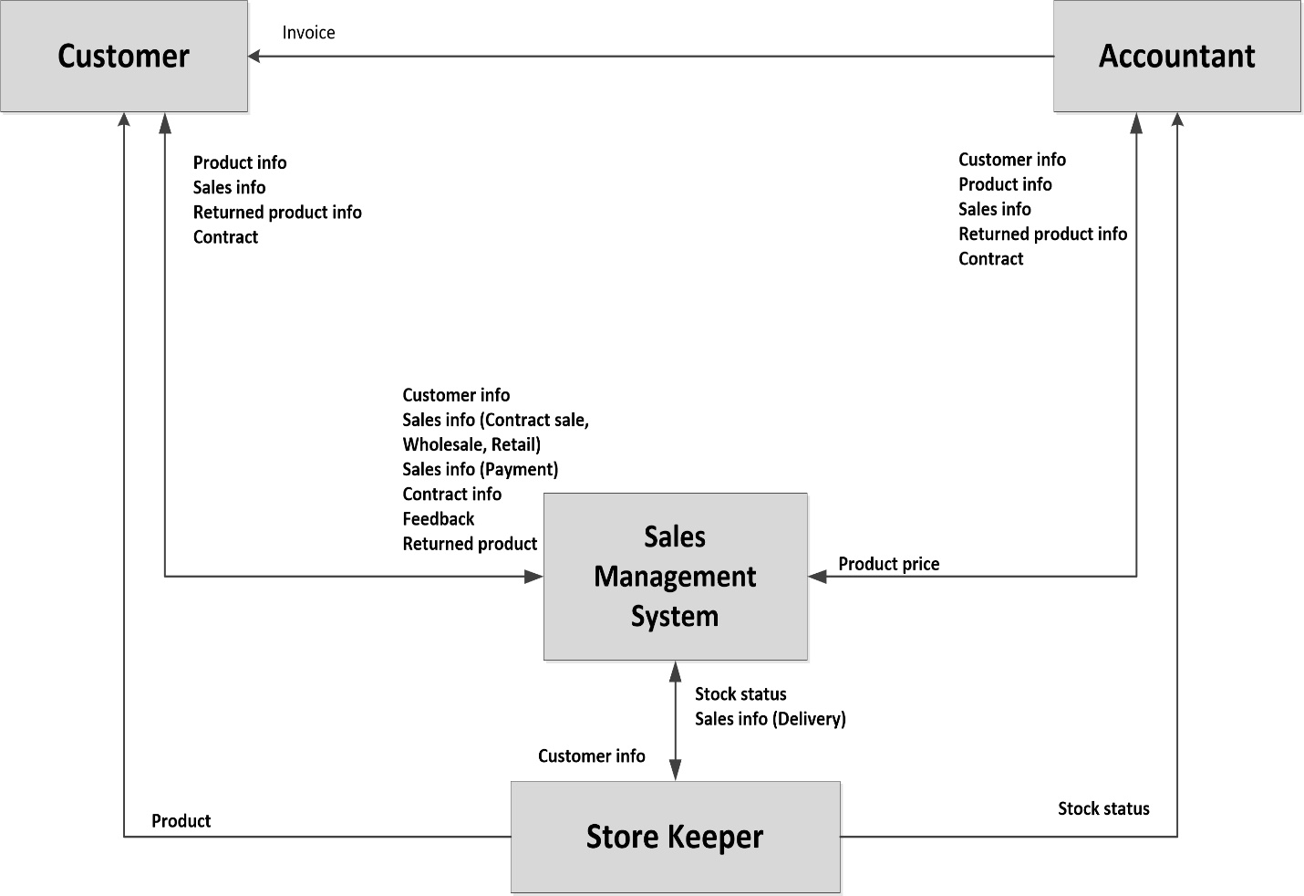

**Fig:** Sales Management System

**Integration with other modules:** Sales module is a highly integrated execution module. It draws most of its input from the following modules:

* Inventory module for verifying available and projected stock.
* Production module for production schedules and lead time of delivery.
* Purchasing module for generation of direct delivery purchase order.
* Accounts receivable module where sales invoices are recorded.

**Why Organization needs Sales Module**

* Expand sales channels through integration with E-commerce module.
* Increase sales volume by improving sales channels.
* Improve communication with current customers based on trade history.
* Evaluate at any time sales agents by integrating data.
* Detailed organization of the sales process on sales areas, divisions.
* Fast registration of entire flow of specific documents.
* Information about all Customers is collected and maintained using Sales Management System. Based on this information, the Director can easily contact with the Customer directly.
* Information about all delivery products with sell price is collected. Based on this information, the Director can see which product is more popular, which product has good profit, and which product should import continuously. Besides, the Director also can check the buy of the Customers to decide the gift in every festival.
* Information about the returned products and feedback is collected for checking the product quality of the manufacturers.
* Information about delivery and payment are needed for accounting system. Based on this information, the Accountant can inspect or audit the company’s financial record. On the other hand, the director can check how big the debt of the Customer is or how often the Customer receives the delivery or makes payment.
* Information about the contract is needed for the Director to let the Salesman to follow the delivery and the payment of the Customer.

# **Features of Sales Modules**

This module will help Samuda to manages its sales process very efficiently and give full feature list to customize according to business needs. Following are the feature description of Sales Module.

## **3.1 Order to Cash Process**

Sales module of ERP consists of all master data, system configuration and transactions to complete the process of Order to Cash. The main functions of Sales module are:-

* First sales quotation is being created by the sales executive.
* After that credit limit will be checked.
* If the credit limit is ok, it needs multiple approval process. In all the approval process the sales quotation may be accepted/ revised/ cancelled. First level approval will be done by head of sales.
* When the first level approval is done, it requires for second level approval which is done by MD/ CEO. Quotation will be saved at same time.
* When the sales quotation is approved by all the approval layers then it is converted to sales order. Besides that once customer confirms the purchase order the sales quotation is converted to sales order.
* When the sales order is created, this message will be forwarded inventory, productions, accounts and other relevant departments.
* Once goods are delivered, sales invoices (prepared by accounts section) are submitted to the customer for payment
* Finally the account gets updated upon received payment from customer.

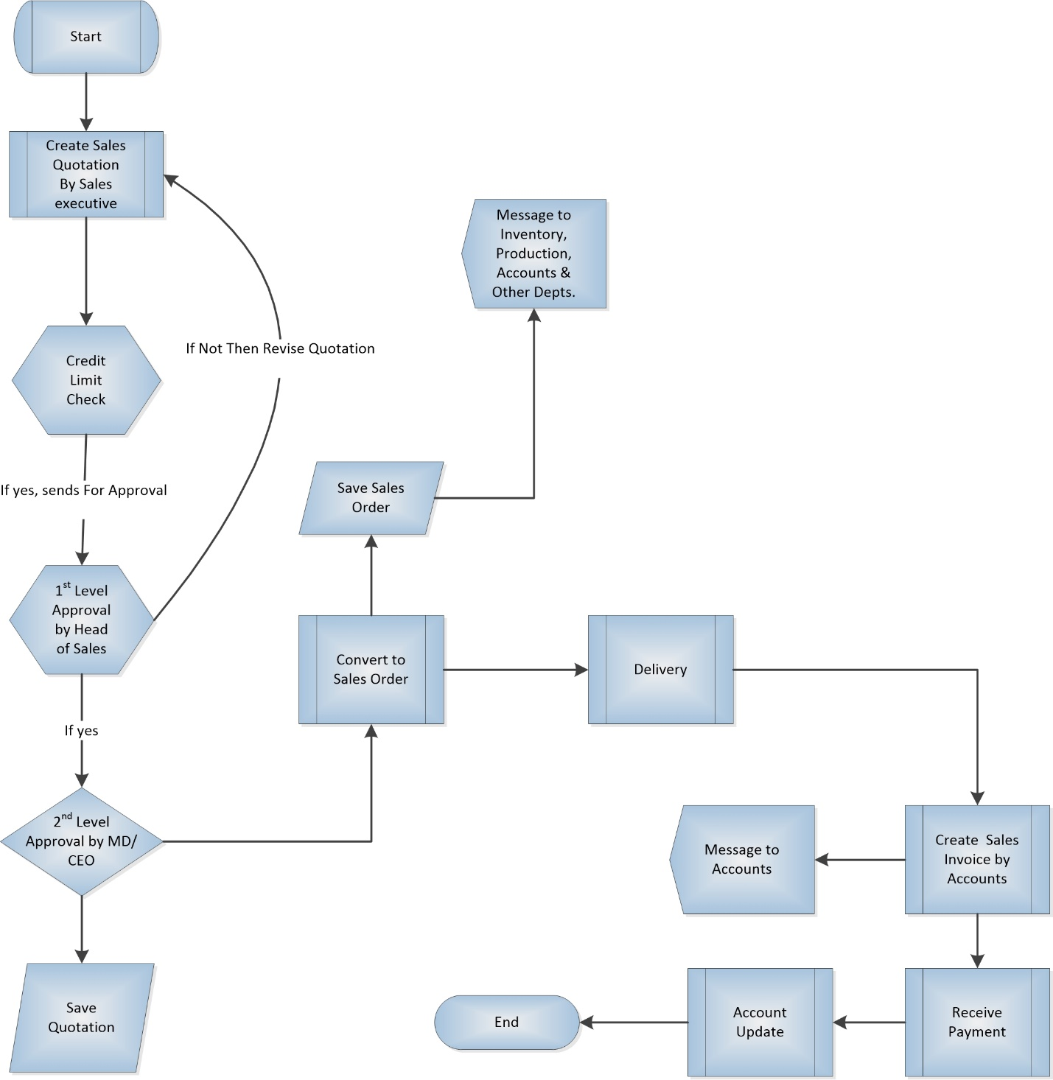

**Fig**: Order to Cash Process

## **3.2 Master Data Management**

### **3.2.1 Product**

Samuda has two types of product. Every feature of sales will have to handle both these category of products.

1. Basic Product
2. Auxiliary/Performance Product

We will have to set up all the products in the system. Product will have product name, product type, unit of measures etc.

### **3**.**2.2 Customer**

There will be only two types of customer for the sales module.

1. Local Customer
2. Foreign Customer

### **3.2.3 Sales Team**

The division of a business that's responsible for selling products or services. Evaluating the company’s current sales force is an important step in the process of deciding whether and how to grow the sales team. The sales organogram is given below:

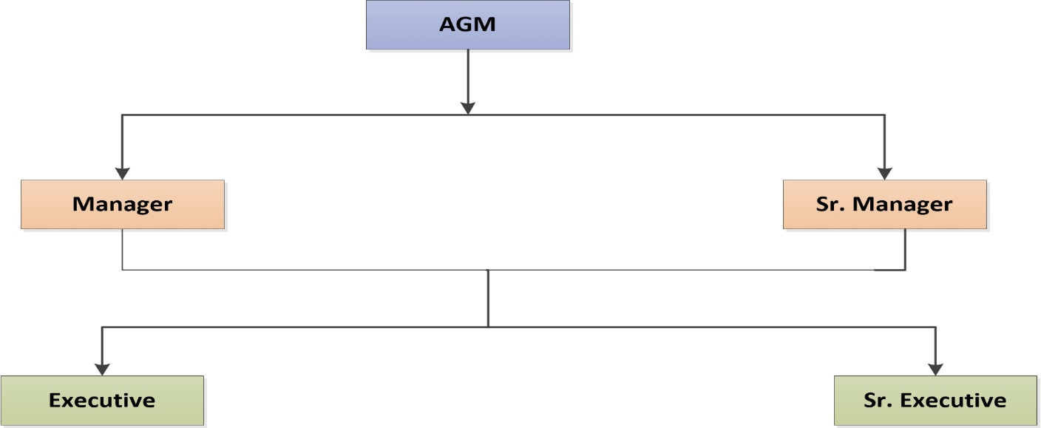

**Fig:** Sales Team

Every sales executive will be tagged with their own customer. One sales executive will be able to see other executive’s customer.

## **3.3 Create the Sales Order**

Once the product is set up, you can create a quotation or a sale order with the related product. Once the quotation is confirmed and transformed into a sale order, the task will be created.

A sale order have 9 stages.

* Draft Quotation
* Quotation Sent
* Cancelled
* Waiting Schedule
* Sales Order
* Sale to Invoice
* Invoice Exception
* Done

At first system user needs to create a draft quotation in sales module. After that a customer will be selected. Inside order lines tab user will have to click on “add an item” button. A product needs to be selected along with unit price and quantity. In other information tab user will have view option for several fields like shipping policy and create Invoice. It can be customized also.

Then they have to save the form. Now the draft quotation is created.

After creating a quotation it can be sent to the customer via Email. A pdf format of quotation will attached in that email. This is not required. Then authorized user can confirm it as a sale order.

User should remember, after confirming a sale order one can’t change the important values of the order like (Customer, Product, Quantity, Etc.)

Now user will have three options depends on the created invoice.

**On Demand** – User can create invoice or view delivery Order of the Sales Order

**On Delivery Order** – User can view the Delivery Order and deliver the required product if it is available. Only after completing the delivery process one can create invoice.

**Before Delivery** – In this option, first one will have to pay the invoice. After that user can deliver the product.

“Paid” and “Delivered” terms, inside the Other Information tab shows the status of invoice and delivery order. After completing these steps the sale Order workflow will be completed. One can cancel the sales order inside any step mentioned above.

Sales order needs two layers approval.

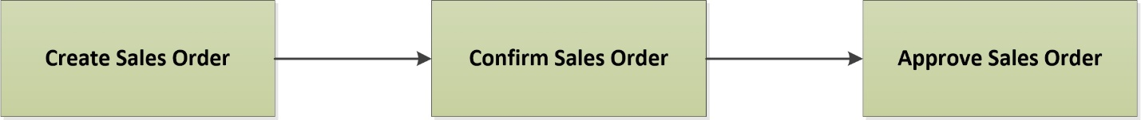

**Fig:** Sales Order Approval

Sales executive will create the sales order. Senior executive will confirm the sales order. There will be no approval option unless they confirm the order. After the confirmation of the order head of sales will approve this.

### **3.3.1 Sales Price**

This Feature allows you to use customer specific price list Sale. This helps in a great way in managing business by offering customer specific benefits as per their configured price list. Customer specific pricelist in sales module gives the following feature:

* Assign Price list while creating Customer from the module
* Enables businesses to offer Customer specific Price benefit
* Ease of doing business
* Smooth end to end pricelist flow

The selection of sales price for a products will have approval. No one will be able to sale below that fixed price.

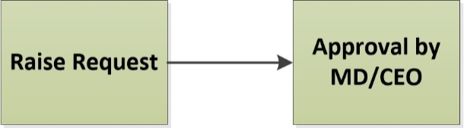

**Fig:** Approval Process

It will have effective date according to product category (basic/auxiliary).

## **3.4 Receive feedback from the Customer**

The Customer may contact the Salesman by phone or directly. The feedback of the Customer will be stored in the system and it will be viewable by authorized user only.

## **3.5 Gives stock status report to Accounting Department**

The Accountant needs a stock status report for checking whether the input and output are matched between the Sales Department, Warehouse, and his/her account record.

## **3.6 Gives quotation list to Customer and Accounting Department**

Every time the new products have been imported to the company, the Salesmen will promote products information as a quotation list of product to the Customer at the company or to Customer’s place. In order to follow the price easily, the Accountant in Accounting Department also needs a quotation list from the Sales Department.

## **3.7 Gives customer list to Accounting Department**

After the customer information has been recorded in system, it will be given to the Accounting Department.

## **3.8 Gives sales reports to Customer and Accounting Department**

The Salesmen have to send the daily sales reports, which show the daily delivery and payment of the Customers, to the Accounting Department. Sometimes the Customers also require having these sales reports in the certain period to check by him or herself whether they are correct or not.

## **3.9 Gives contract to Customer and Accounting Department**

After the contract has been made, three copies will be made: first for Customer, second for Accounting Department and third for Sales Department itself.

## **3.10 Gives returned product report the Customer and Accounting Department**

The returned product reflects the quality of the product and influent to the long-term business relationship. On the other hands, the value of the returned product is considered as payment and the debt of the customer will be reduced. The Account needs the returned product report to follow the payment in the account. The customer sometimes requires the returned product report as well.

## **3.11 Gets a delivery receipt from Warehouse Keeper**

The Customer will sign on the delivery receipt after receiving the products. The Salesman will get the signed delivery receipt from Warehouse Keepers after the product has been delivered.

The delivery receipt is made in three copies: first for Customer, second for Salesman, third for Warehouse Keeper him-/herself.

## **3.12 Sales Target and Achievement**

A specified amount of sales that a management sets for achieving or exceeding within a specified timeframe. Sales targets are apportioned among different sales units such as salespersons, franchisees, distributors, agents, etc. There will have volume wise target on the whole sales team. The sales target will be product wise (basic/ auxiliary). Every sales executive will have time based target. The target can be yearly/monthly depending on the decision.

If the sales targets are achieved, then it is considered as achievement. This achievement can be measured yearly/ half-yearly/ quarterly. There will be a report on target vs. achievement. This can be individual or group wise.

## **3.13 Sales Discount**

 A sales discount is a reduction in the price of a product or service that is offered by the seller, in exchange for early payment by the buyer. This discount may be fixed or percentage. Debit note **(TBD)**

## **3.14 Reports**

* A report of product list with stock status.
* A report of product list with price list.
* A report of customer list sorted by selection criteria.
* A report of delivery list in detail information in a certain period for one customer.
* A report of payment list in detail information in a certain period for one customer.
* A report on target vs. achievement.

## **3.15 Local Sales**

Every customer will have a credit limit. The credit limit can be increased or decreased. Both process has policy for increase/ decrease and have approval process as well.

**Credit Limit Increase Approval:**

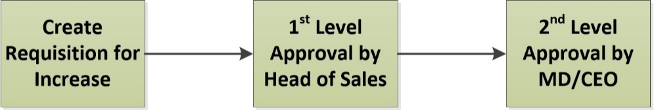

**Fig:** Credit Limit Increase Approval

For the credit limit increase it need 2 layers of approval. Sales executive will make the request for increase. First level approval will be done by head of sales. Second level approval will be done by MD/CEO. After the process credit limit will be increased.

**Credit Limit Decrease Approval:** For the credit limit decrease it needs only one level approval.

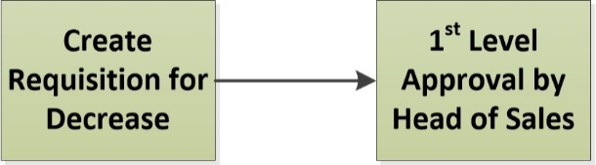

**Fig:** Credit Limit Decrease Approval

For the credit limit decrease it needs only one approval. Sales executive will make the request for decrease. First level approval will be done by head of sales. After the process credit limit will be decreased.

**Grace Amount of Credit Limit:**

If anyone wants to purchase more than credit limit, it will have option for grace amount. Usually grace amount is approved by head of sales. Sales executivecan’t process this amount. If anyone wants to purchase more than grace amount, no one will be able to approve the grace amount. To handle that particular situation, credit limit needs to be increased.

## **3.16 Payment Policy**

The following are the options for payment policy.

* LC
* TT
* Credit Sale
* Advanced Payment

## **3.17 The main external agents**

Accounting Department is a place where keeps, inspects, and audits financial record of the company.

Accounting Department is the external agent of the sales management process and internal agent of the company.

Customer may be a person, a workshop or a store that buys products at the company.

An inventory is a place where storages the company’s products. Each inventory has its own stock. There is one store Keeper in each inventory. It can vary also depend on the organization structure.

The inventory is external agent of the sales management process and internal agent of the company.

A supplier is a manufacturer or an exporter who supplies products to the company.

The supplier is an external agent of the company.

# **4. Appendix**

Forms of Samuda maintain for its Sales Management.

1. Sales Order

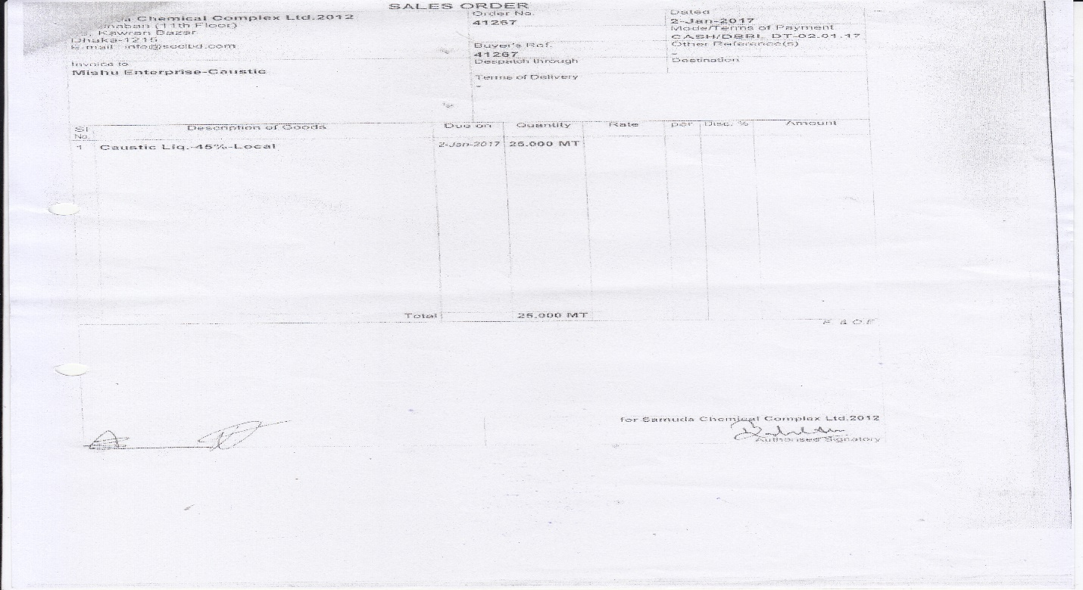

# **5. To be Determined**

1. ISO 9001 related reports are not implemented within this phase. We will cover in next phase.

Signed on behalf of Signed on behalf of

Samuda Chemicals Ltd. Genweb2 Limited

Name: Name:

Designation: Designation:

Date: Date:

**______________________________ ______________________________**

Signature Signature