|  |
| --- |
| genweb2 ltd. |
| Pebbles User Manual |
| REFERENCE: GW/ERP/USER MANUAL |
|  |
| **Genweb2 Ltd.** |
| **01-Dec-16** |

|  |
| --- |
| logo.png  **Genweb2 Limited**  TK Bhaban (11th Floor),  13 KaziNazrul Islam Avenue,  Kawran Bazar, Dhaka 1215, Bangladesh  web: [http://www.genweb2.com](http://www.genweb2.com/) |

Contents

1. Sales Management 3

1.1 Unit of Measurement Categories 3

1.2 Creating Product Categories 3

1.3 Creating Attributes 4

1.4 Creating Attribute Values 4

1.5 Creating Products 5

2. Warehouse 5

2.1 Configurations 5

2.2 Inventory Adjustment Matrix 6

2.3 Creating Locations 7

3 Point of Sale 8

3.1 Creating Point of Sale 8

3.2 Your Session 8

4 Distribution of Stocks 9

4.1 Stock Distribution (Warehouse) 9

5. Suppliers 9

5.1 Create Suppliers 9

6 Customer 10

6.1 Create Customers 10

7 Purchase 11

7.1 Request for Quotation 11

7.2 Purchase Order 11

# 1. Sales Management

## 1.1 Unit of Measurement Categories

First We need to create unit of measurement categories to measure the units.

Navigation Menu:  **Sales >>Configuration >> Unit of Measurement Categories**

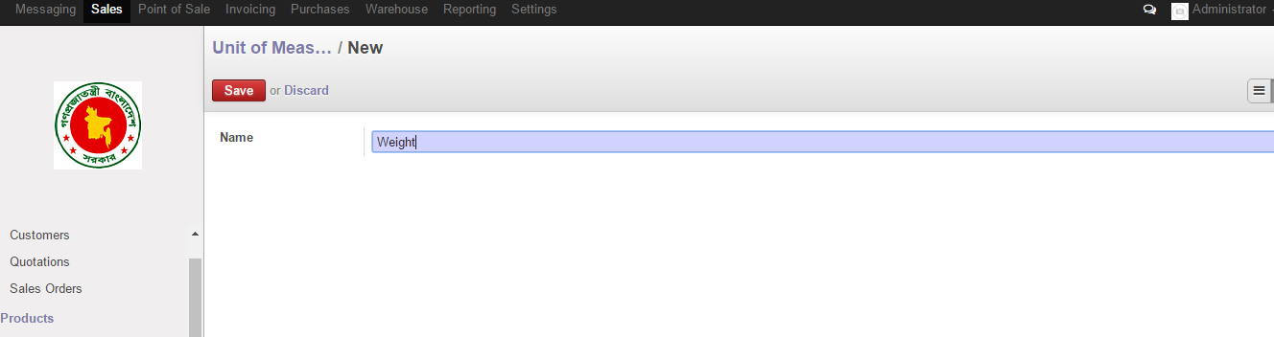

Figure: Create Unit of Measurement Categories

## 1.2 Creating Product Categories

We need to create Product Categories which is under Product Categories & Attribute menu.

Navigation Menu: **Sales >> Product Categories & Attribute >> Product Categories**

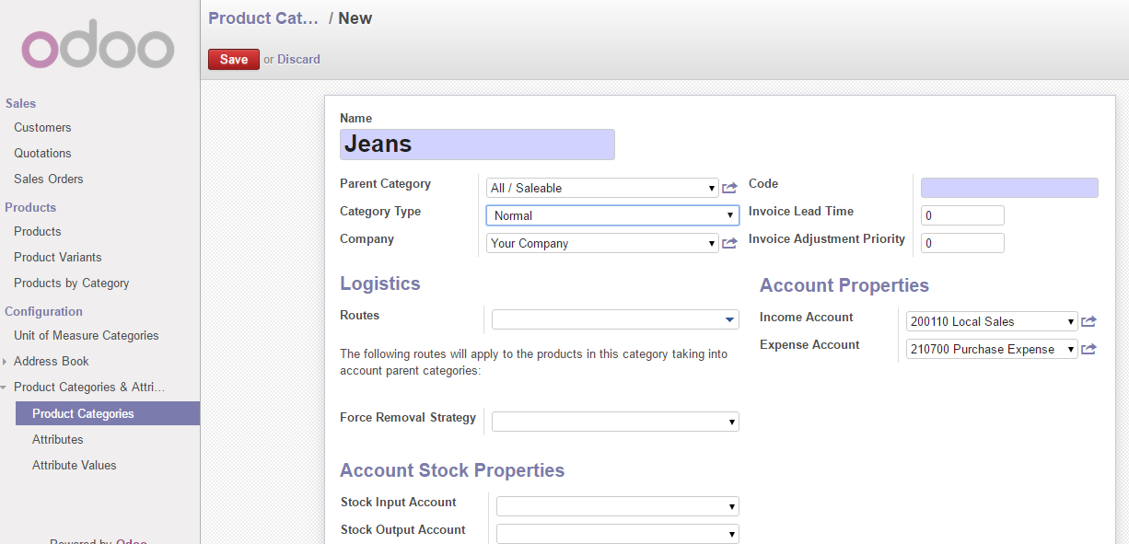

Figure: Create Product Categories

## 1.3 Creating Attributes

Then we need to create Product Attributes like color or size etc.

Navigation Menu: **Sales >> Product Categories & Attribute >> Attributes**

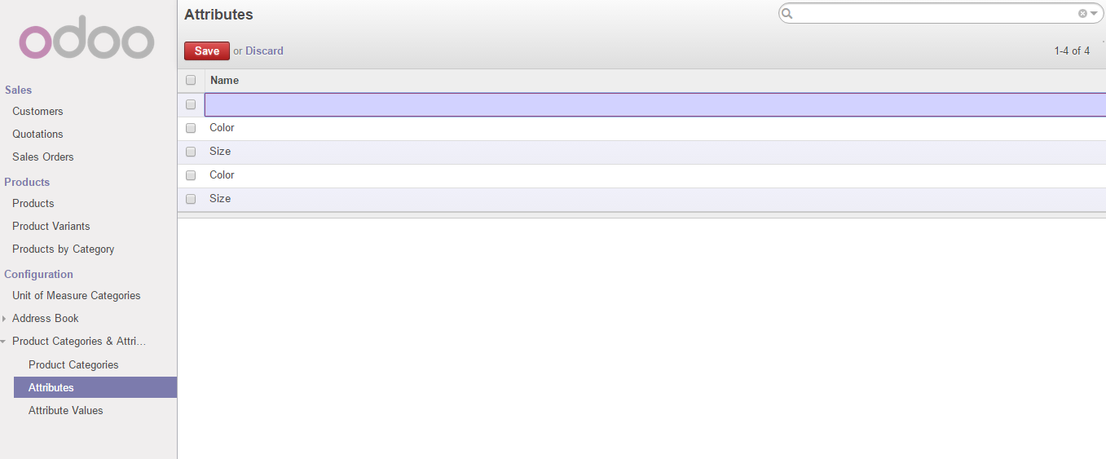

Figure: Create Product Attribute

## 1.4 Creating Attribute Values

First we need to create attribute values from Product Categories & Attribute left menu. We can choose variants which suits our products i.e. color or size etc.

Navigation Menu: **Sales >> Product Categories & Attribute >> Attribute Values**

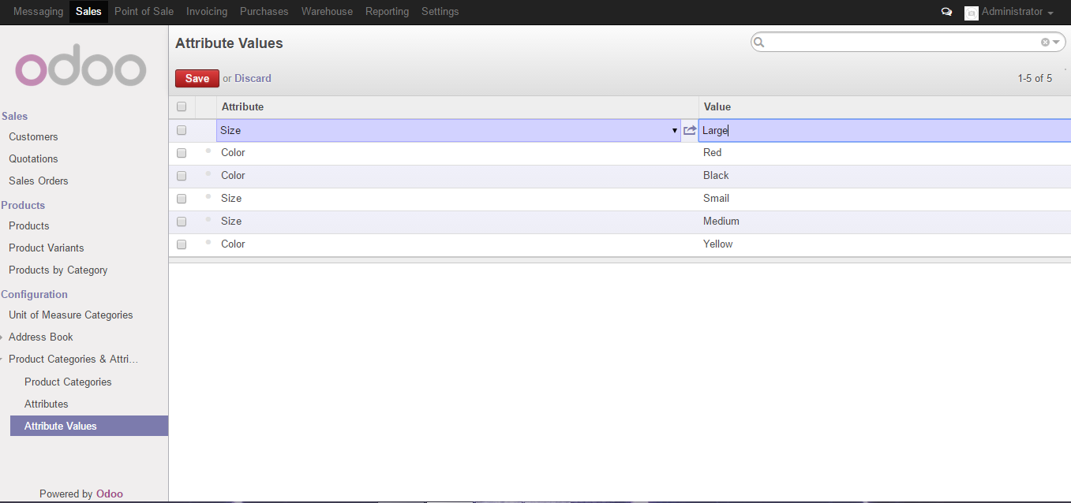

Figure: Attribute Value creation

## 1.5 Creating Products

Now we can create our own products from **Products** left menu under Products.

Navigation Menu: **Sales >> Products >> Products**

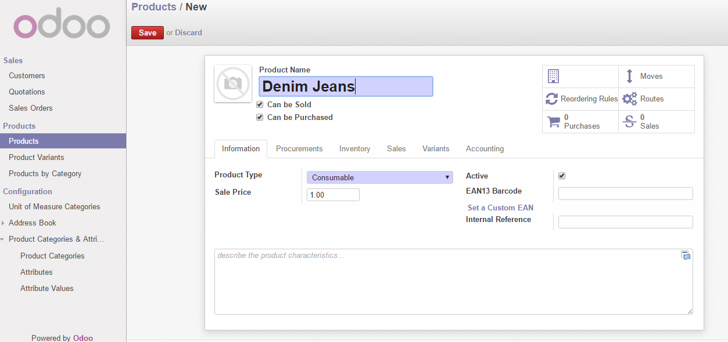

Figure: Creating Products

# 2. Warehouse

## 2.1 Configurations

We need to create warehouse first to move forward with the warehouse system.

Navigation Menu: **Warehouse >> Configurations >> Warehouse**

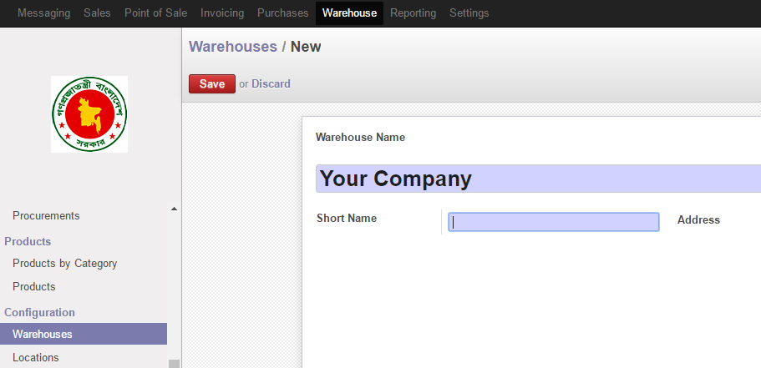

Figure: Create Warehouse

## 2.2 Inventory Adjustment Matrix

First and foremost task when using Warehouse is we need to adjust our inventory with the products we already have in stock. We do it using *Inventory Adjustment Management* menu under Inventory Control. Where we can create an inventory with the available products. After clicking on Save button we need to click on *Start Inventory* button; which means it is locked and you can't edit it anymore. After that to actually start inventory you will have to click on *Validate Inventory* button.

Navigation Menu: **Warehouse >> Inventory Control >> Inventory Adjustment Matrix**

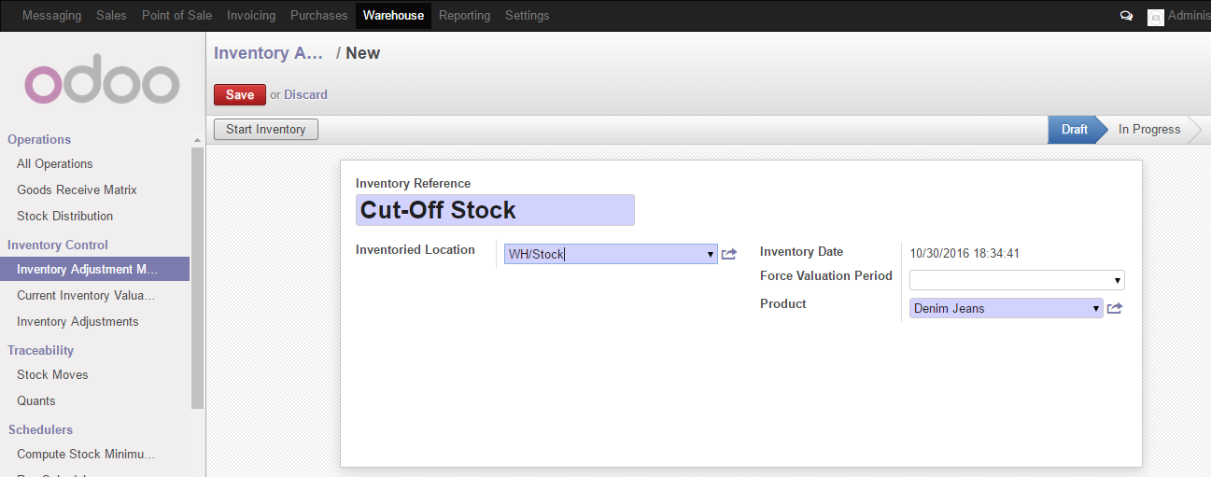

Figure: Create Inventory Adjustment

## 2.3 Creating Locations

Now at this stage, we need to create locations where the business outlets will remain. When creating locations you need to give a parent location address.

Navigation Menu: **Warehouse >> Configuration >> Locations**

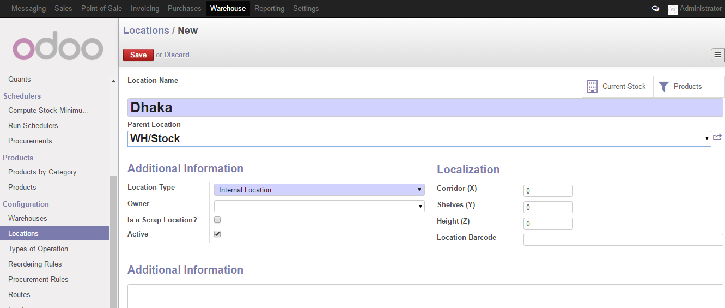

Figure: Create Locations

# 3 Point of Sale

## 3.1 Creating Point of Sale

After creating the locations we need to define the Point of Sale (POS) which will be business outlets.

**Point of Sale >> Configuration >> Point of Sale**

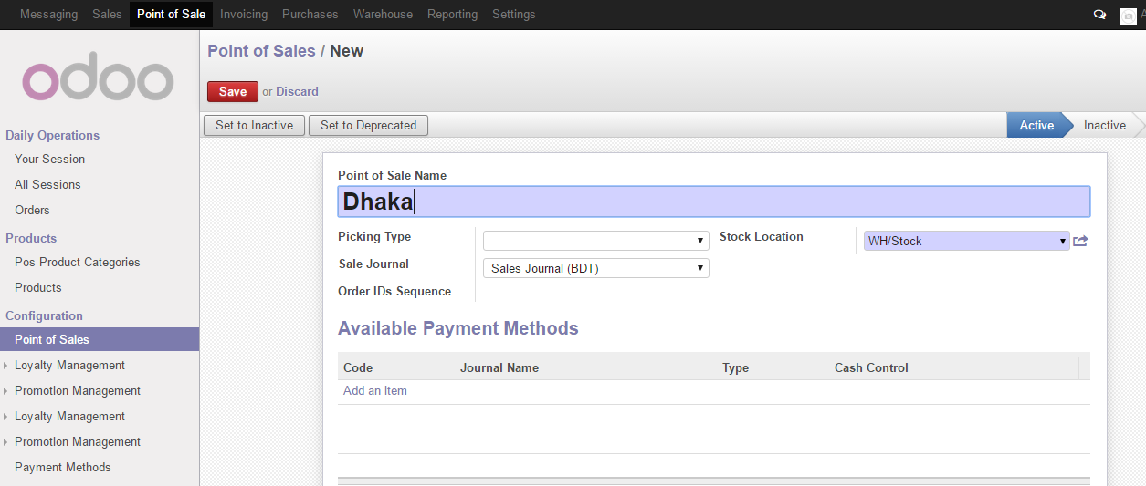

Figure 7: Create Point of Sale

## 3.2 Your Session

Navigation menu: **Point of Sale >> Daily Operations >> Your Session**

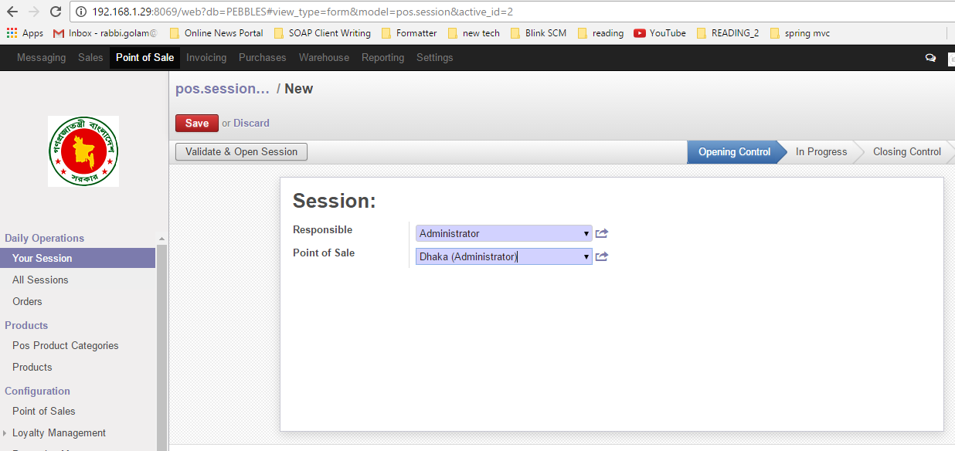

Figure: Create Session

# 4 Distribution of Stocks

## 4.1 Stock Distribution (Warehouse)

Now we have created our shop outlets on various locations; we can distribute our products among the POS. *Stock Distribution* is under *Warehouse* main menu. After saving we need to click on Transfer menu to actually transfer the products to its corresponding outlets.

Navigation Menu: **Warehouse >> Operations >> Stock Distribution**

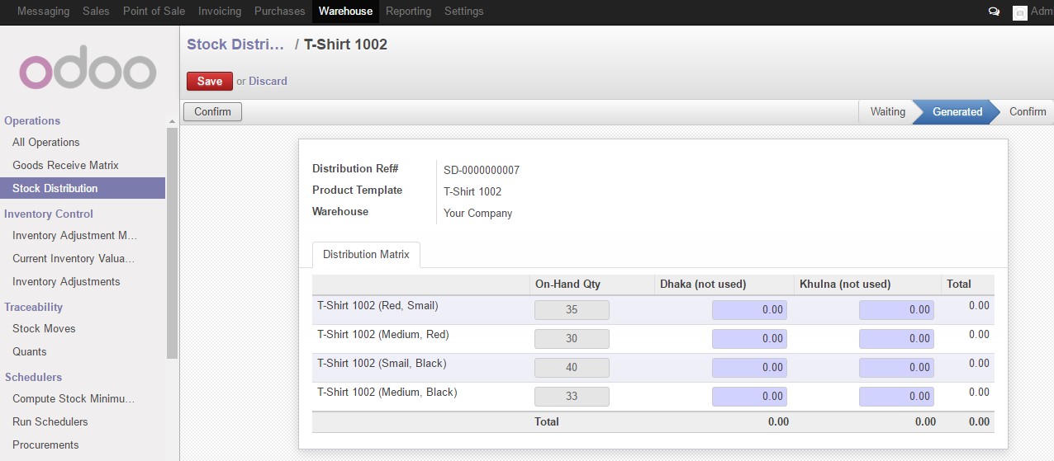

Figure: Stock Distribution

# 5. Suppliers

## 5.1 Create Suppliers

We need to create suppliers using this navigation menu:

Navigation Menu: **Purchases >> Purchase >> Supplier**

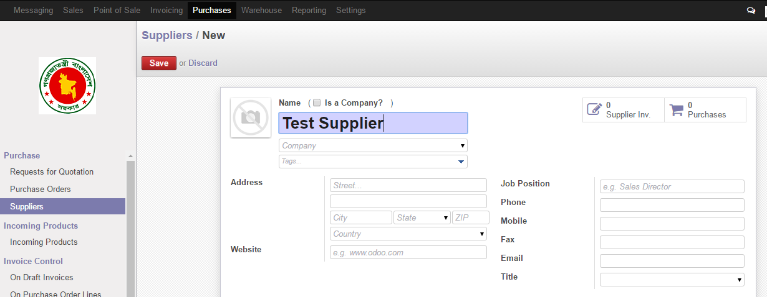

Figure: Create suppliers

# 6 Customer

## 6.1 Create Customers

We need to create customers from below navigation menu:

Navigation Menu: **Sales >> Sales >> Customers**

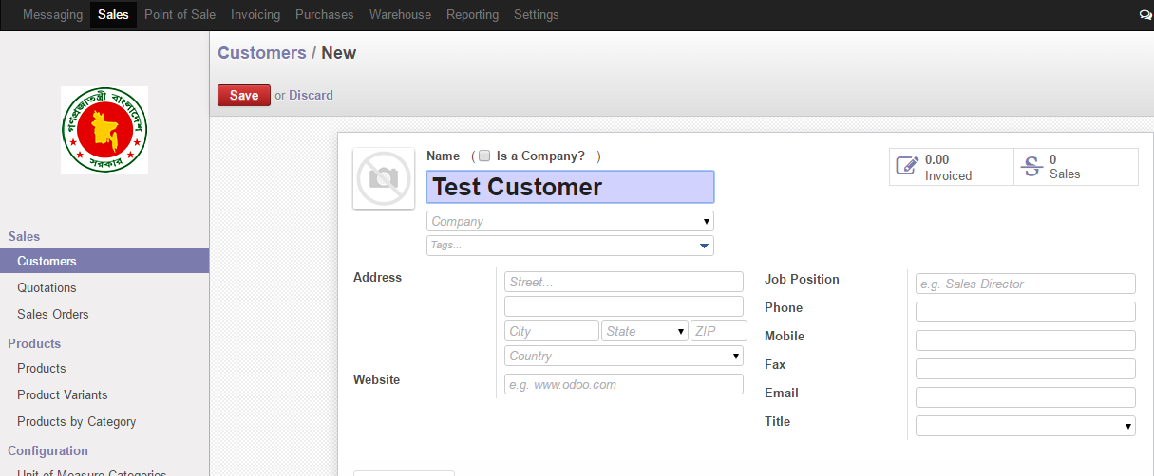

Figure: Create Customer

# 7 Purchase

## 7.1 Request for Quotation

We need to create quotation request by following below menu

Navigation Menu: **Purchases >> Purchase >> Request for Quotation**

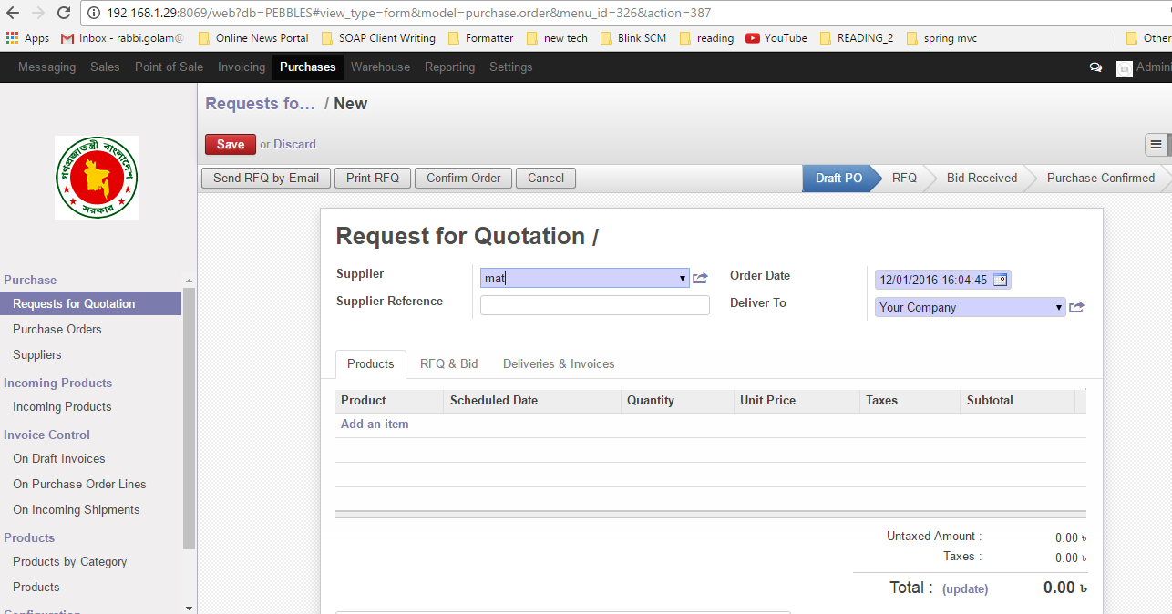

Figure: Create request of quotation

## 7.2 Purchase Order

We need to create purchase order following below navigation link

Navigation Menu: **Purchases >> Purchase >> Purchase Order**

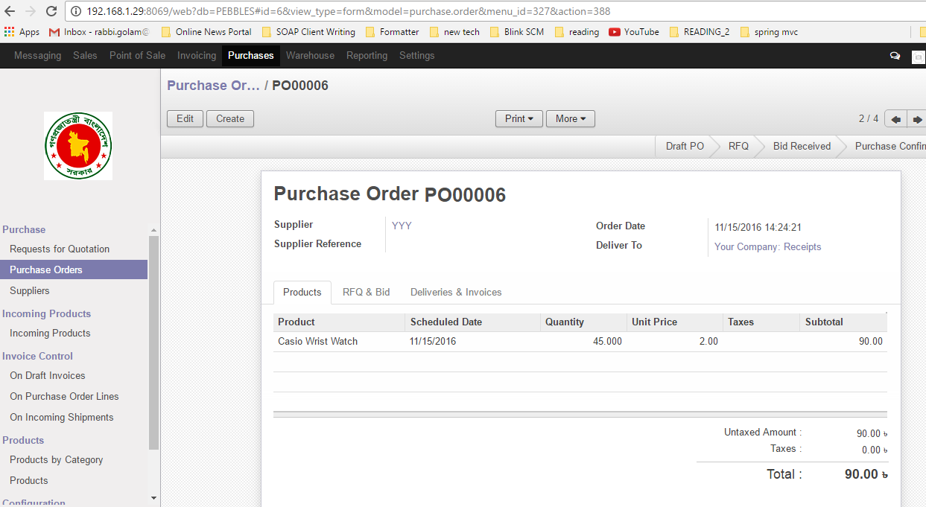

Figure: Create Request for Quotation