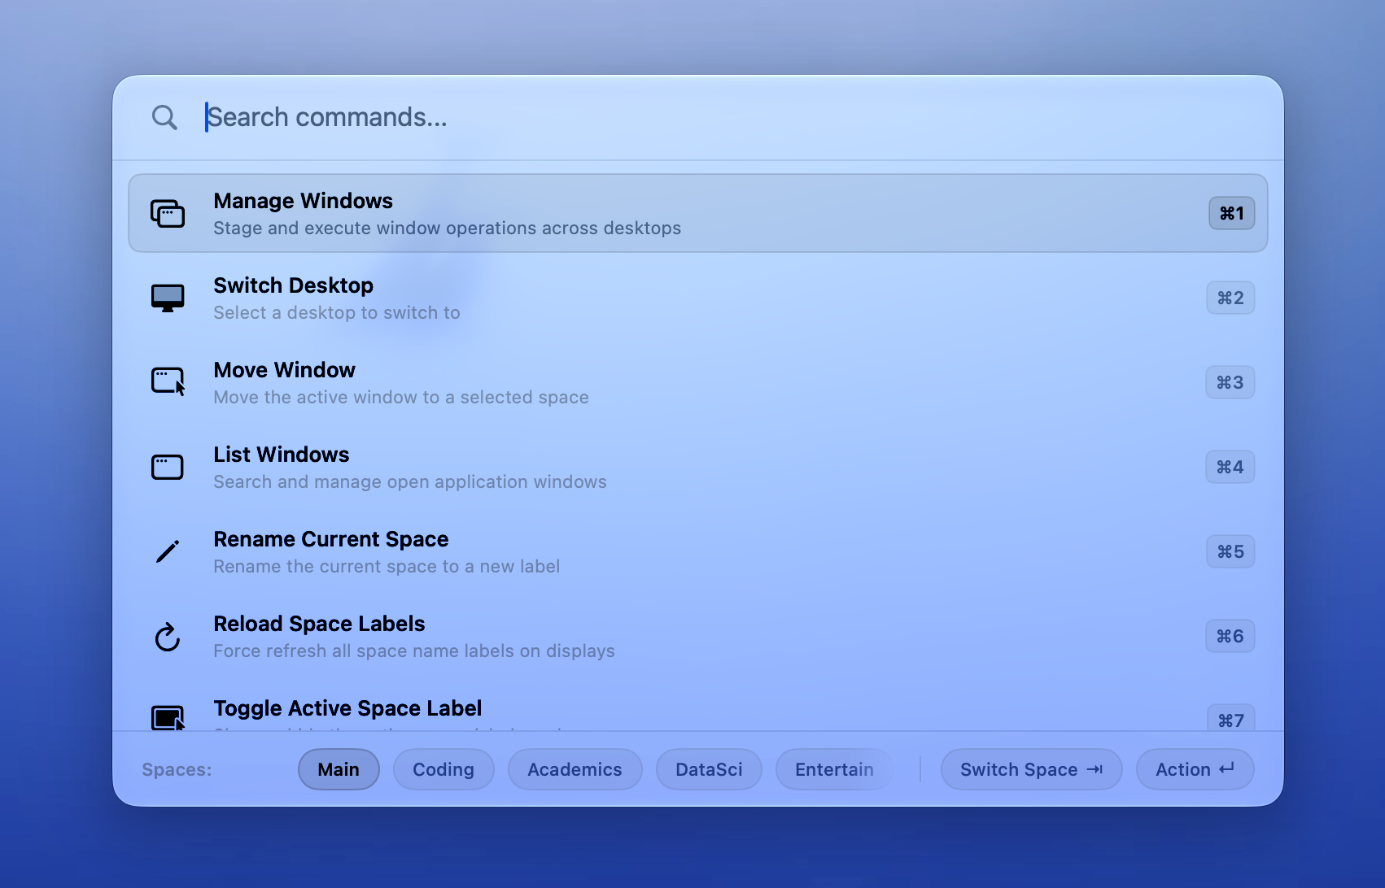
DesktopRenamer launcher showing the shared workspace vocabulary

MacOS Workspace Utilities
Product design report for DesktopRenamer OptClicker and SpaceSwitcher
Scope  Feature inventory and interaction model | Prepared by  Codex | Reviewed  September 2026

Contents
Executive summary 3
Key findings 4
DesktopRenamer 6
OptClicker 10
SpaceSwitcher 14
Cross app system map 18
Linear planning context 20
Appendix 24
Reading note
Implemented behavior is described from source and resource review. Linear items are listed separately as planning context and are not treated as shipped behavior.

Executive summary
DesktopRenamer, OptClicker, and SpaceSwitcher are three accessory macOS utilities that share a workspace model. DesktopRenamer gives Spaces names, labels, navigation, window movement, and a structured API. OptClicker turns the Option key into a configurable right-click control and changes its state automatically from app, website, or space context. SpaceSwitcher consumes the same SpaceAPI to apply per-space window and Dock workflows.
The product family is built around low-friction, always-available surfaces: menu bar status items, keyboard shortcuts, small HUDs, settings windows, and background observers. The main design complexity is not a single screen; it is the relationship between current space, display, window state, app focus, permissions, and automation status.

At a glance
• DesktopRenamer is the source of truth for named spaces and current-space events. It also provides the richest direct manipulation surface through its launcher and labels.
• OptClicker is a focused input utility. Its core loop is Option press, synthetic right-click, Option release, with Auto Toggle determining when the loop is active.
• SpaceSwitcher is a rule engine. It maps current spaces and window conditions to ordered app actions, and maps spaces to Dock sets.
• All three apps use SwiftUI settings with sidebar navigation and search, launch-at-login controls, Sparkle update controls, permissions views, and About surfaces.
• Accessibility and input-event permissions are part of the product experience because window movement, synthetic clicks, shortcuts, and rule enforcement depend on them.

Product snapshot
App | Primary role | Main user surfaces | Integration position
DesktopRenamer | Name, label, navigate, and manage Spaces | Menu bar, launcher, labels, Settings, widget, API | Publishes space identity and events
OptClicker | Make Option behave as right click | Menu bar, Settings, shortcut recorder, Auto Toggle | Consumes DesktopRenamer SpaceAPI optionally
SpaceSwitcher | Apply app and Dock workflows by Space | Menu bar, Rules editor, Docks editor, Settings | Consumes DesktopRenamer SpaceAPI

Key findings

Workspace orientation
The common object is a named macOS Space, not an app window. A Space can belong to a display, be full screen, have a persistent identifier, carry a user-facing name, and be the target of navigation or automation. DesktopRenamer exposes this object directly; the other two apps use it as a condition or trigger.

Interaction surfaces
Surface | DesktopRenamer | OptClicker | SpaceSwitcher
Menu bar | Space list, rename, lock, restore, labels, launcher, settings | Toggle, Auto Toggle, status reason, frontmost process | Automation toggles, manual Dock set switching, settings
Settings | Seven tabs plus search and diagnostics | Five tabs plus search | Five tabs plus search
Keyboard | Switch, move, lock, restore, launcher, label commands | Toggle click mode and Auto Toggle | Captured app and system shortcuts inside rules
Visual feedback | Preview labels, active labels, launcher HUD | Menu bar icon and Auto Toggle indicator | Menu bar state and settings status
Background work | Space monitoring, recovery, widget updates, API server | Input monitors, frontmost app, browser URL, SpaceAPI | Space changes, window enforcement, Dock replacement

Patterns in the evidence
• Configuration is persistent and layered. A global switch enables a subsystem, then app, space, display, or window-specific settings refine it.
• The apps expose recovery state instead of assuming a perfect system: SpaceAPI can be available, disabled, or unavailable; labels and Dock application retry after system changes; permissions are visible and actionable.
• Full-screen Spaces and multiple displays are first-class constraints. Many operations explicitly exclude, reposition, or group full-screen and per-display Spaces.
• Automation is deliberately reversible in several places: DesktopRenamer tracks windows moved by a lock; SpaceSwitcher tracks visibility changes it made; OptClicker can restore the last manual state when an Auto Toggle rule no longer matches.
Design reading
The product family is best understood as a small workspace operating layer: DesktopRenamer establishes identity, OptClicker changes input semantics, and SpaceSwitcher applies context-aware visibility and Dock state.

Shared constraints
Constraint | How it appears in the codebase
macOS permissions | Accessibility, input-event posting, Screen Recording for trackpad window moves, browser automation, and SpaceAPI access are surfaced in settings.
System APIs | Private or low-level APIs are used for Spaces, window membership, Dock persistence, CGEvents, and DistributedNotificationCenter compatibility.
Lifecycle churn | Sleep and wake, display changes, rebooted labels, late callbacks, retries, and stale SpaceAPI revisions are explicitly handled.
Update identity | Current and legacy bundle identifiers coexist with migration bridges and Sparkle update controls.

DesktopRenamer
DesktopRenamer is the workspace identity and control center. It runs as a menu bar accessory app, watches the macOS Space topology, lets the user name and arrange Spaces, draws labels on displays, provides a Raycast-like launcher, and exposes the current state to companion apps through SpaceAPI.
Current build | Marketing version 1.14.0, build 38; current bundle dev.mqiu.DesktopRenamer
Platform | macOS 13 app target; widget target macOS 14
Primary dependency | Accessibility; Screen Recording for trackpad window-moving behavior; optional SpaceAPI consumers
State owner | Named Spaces, per-display grouping, labels, window restoration queues, API snapshots, widget data

Primary surfaces
Surface | Behavior
Status bar menu | Shows the current display's Spaces with the current Space checked; supports switch, Option alternate move-window-to, rename, lock, restore, label toggles, launcher, Settings, and Quit.
Preview labels | Display-level labels for Space names and numbers during Mission Control or switching. The label manager supports scale, padding, docking, transparency, blur, Liquid Glass disable, and hide-while-switching options.
Active labels | Persistent current-Space labels that can remain on the desktop, float or dock, and be toggled independently from preview labels.
Settings | General, Spaces, Labels, Switch, Launcher, Permissions, and About tabs. Sidebar search indexes settings and jumps directly to a control.
Diagnostics | Live event log, save-to-file report, GitHub issue handoff, onboarding review, and factory reset. The app includes a diagnostic window and sleep-wake recovery logging.

Space management
The Spaces screen groups Spaces by display. Ordinary Spaces can be renamed inline, dragged to reorder, and locked or unlocked; full-screen Spaces are shown but have different operation rules. The current Space is marked with its number. A setting can keep full-screen Spaces next to the source desktop, including automatic drag/rearrangement behavior.
The Space model stores a persistent identifier, custom name, number, display ID, full-screen flag, owning app metadata, global shortcut number, and reboot-stable persistent ID. The manager reconciles this model against the system, retries when the topology is changing, and keeps a persistent-name cache so labels survive reboot.

Labels and visual feedback
Preview and active labels are independent windows managed by SpaceLabelManager. Each label family has visibility, keep-visible, scale, window/padding scale, and Liquid Glass controls. Labels can be positioned relative to a display, docked at the right edge, or floated. The manager responds to wake, display changes, Space changes, and the user's reload-labels command.
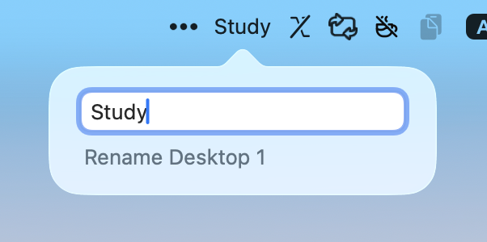
DesktopRenamer rename HUD showing the inline Space naming interaction

Launcher
The launcher is a frosted HUD with search, keyboard and pointer selection, pinyin and diacritic matching, bottom-bar action hints, and temporary Command-number overlays. It can return the user to the original Space after an action; command ranking can be usage-based or manually reordered.
Command | Function
Switch Desktop | Select a Space to switch to.
Move Window | Move the active window captured when the launcher opened to a selected Space.
List Windows | Search open windows grouped by Space and focus one, switching to its Space first.
Manage Windows | Stage and execute move, restore-to, close, minimize, hide, full-screen, quit, or restore actions across windows and Spaces.
Rename Current Space | Rename the current Space from the launcher.
Reload Space Labels | Force label windows to refresh.
Toggle Active Space Label | Show or hide the active label.
Toggle Preview Space Label | Show or hide preview labels.
Toggle Active Space Label Visibility | Pin the active label to the desktop or hide it on apps.

List Windows opens a Command-K submenu with Move Window to Current Desktop, Move to, Close, Minimize, Hide, Enter or Exit Full Screen, Quit, and Restore. Manage Windows uses a staging model so a user can review a set of window operations before execution. The launcher also supports Cmd Shift Up and Cmd Shift Down to rearrange Spaces while the Switch Desktop command is active.

Switch controls
The Switch tab records shortcuts for previous and next Space, numbered Space selection, moving the active window previous or next, numbered window moves, moving to the previous or next display, locking the current Space, restoring windows moved by a lock, and opening the launcher. Numeric shortcuts are supported for 1 through 9; shortcut recording includes re-listen, reset, and Accessibility conflict guidance.
Trackpad Switch Gesture Override handles three- or four-finger horizontal gestures. The display can follow the cursor or active window. Holding Option changes the gesture from switching Space to moving the active window, which also requires Screen Recording. Gesture duration, threshold, grabbing offsets, and per-app offset exceptions are configurable, with a demo-video path in Settings.

Lock and restoration
Locking a Space tracks windows moved away from it and exposes a restoration queue. The menu provides restore actions and an Option alternate for cleaning restoration queues. The code distinguishes windows moved by the lock from unrelated user changes, while full-screen windows have special handling: they can be unfullscreened and moved where supported, but operations can no-op when the selected Space is the current full-screen Space.

SpaceAPI
SpaceAPI is a JSON-RPC 2.0 contract with version 1.0.0, structured snapshots, validation, error codes, a one-megabyte maximum payload, and a distributed state-change channel. SpaceAPI is enabled from Settings Advanced and is intended for companion apps and extensions.
API group | Methods and data
Identity and snapshot | getAPIInfo, getAPIVersion, getSpaceSnapshot, getCurrentSpaceName, getCurrentSpaceID, getAllSpaces.
Space control | switchToSpace, renameCurrentSpace, renameSpace, rearrangeSpace, reloadSpaceLabels.
Window control | moveWindowNext, moveWindowPrevious, moveWindowToSpace, getWindows, focusWindow, executeWindowAction, moveSpecificWindow.
App controls | toggleMenubar, toggleLauncher, toggleLabels, toggleActiveLabel, togglePreviewLabel, toggleDesktopVisibility.
Events | stateChanged events with activeSpaceChanged or spaceListChanged reasons, revision, timestamp, display and full-screen metadata.

The app keeps a legacy DistributedNotificationCenter channel for compatibility, while structured snapshots and revisions are the primary integration path. Companion clients are expected to handle disabled and unavailable states and to reconcile after a revision gap.

Widget and lifecycle
The WidgetKit extension reads current Space name, number, full-screen state, and the available Space list through the app group and legacy notification channel. Small, medium, and large layouts are supported. Selecting a Space uses desktoprenamer://switch?uuid= with a numeric fallback. Timeline entries refresh on state changes and fall back to a five-minute cadence when disconnected.
On first launch, DesktopRenamer registers a login item and presents onboarding for the product, features, launcher, lock, and permissions. It owns URL routes for Settings and Space switching, menu commands for demo videos and diagnostics, and a legacy bundle-ID migration bridge alongside the current bundle ID.

OptClicker
OptClicker is a small input utility that makes the Option key behave like a right mouse button. It is designed for applications and games where holding Option should produce a right-click press and release, including touchpad use where a user may hold left and right click together.
Current build | Marketing version 1.5.1, build 9; current bundle dev.mqiu.OptClicker
Platform | macOS 13 or later
Primary dependency | Accessibility for reading and frontmost-app context; input-event posting for synthetic clicks
Optional dependency | DesktopRenamer SpaceAPI and browser automation for space and website rules

Core interaction
When OptClicker is enabled, InputManager observes Option flagsChanged events. A press posts a synthetic right mouse down at the current cursor position; release posts the matching right mouse up. Enabling and disabling the feature starts or stops the event monitor. The menu bar icon changes between enabled and disabled states and shows an A indicator when Auto Toggle is active.

Settings and status
Tab or surface | Behavior
General | Enable Option to right click, launch at login, choose launch behavior as enabled, disabled, or last state, show status reason, show frontmost process, and control Sparkle checks and migration.
Auto Toggle | Enable context rules, choose app and space sources, choose And or Or matching, edit target lists, and decide whether a non-match disables OptClicker or restores the last manual state.
Permissions | Check Accessibility, input-event posting, DesktopRenamer SpaceAPI, and browser automation; open, launch, install, authorize, or remove access where applicable.
Shortcuts | Record or reset Toggle OptClicker and Toggle Auto Toggle shortcuts. The current default app toggle is Control R; Auto Toggle is unassigned by default.
Status menu | Expose the click-mode toggle, Auto Toggle toggle, current status reason, current frontmost process, Settings, and Quit.

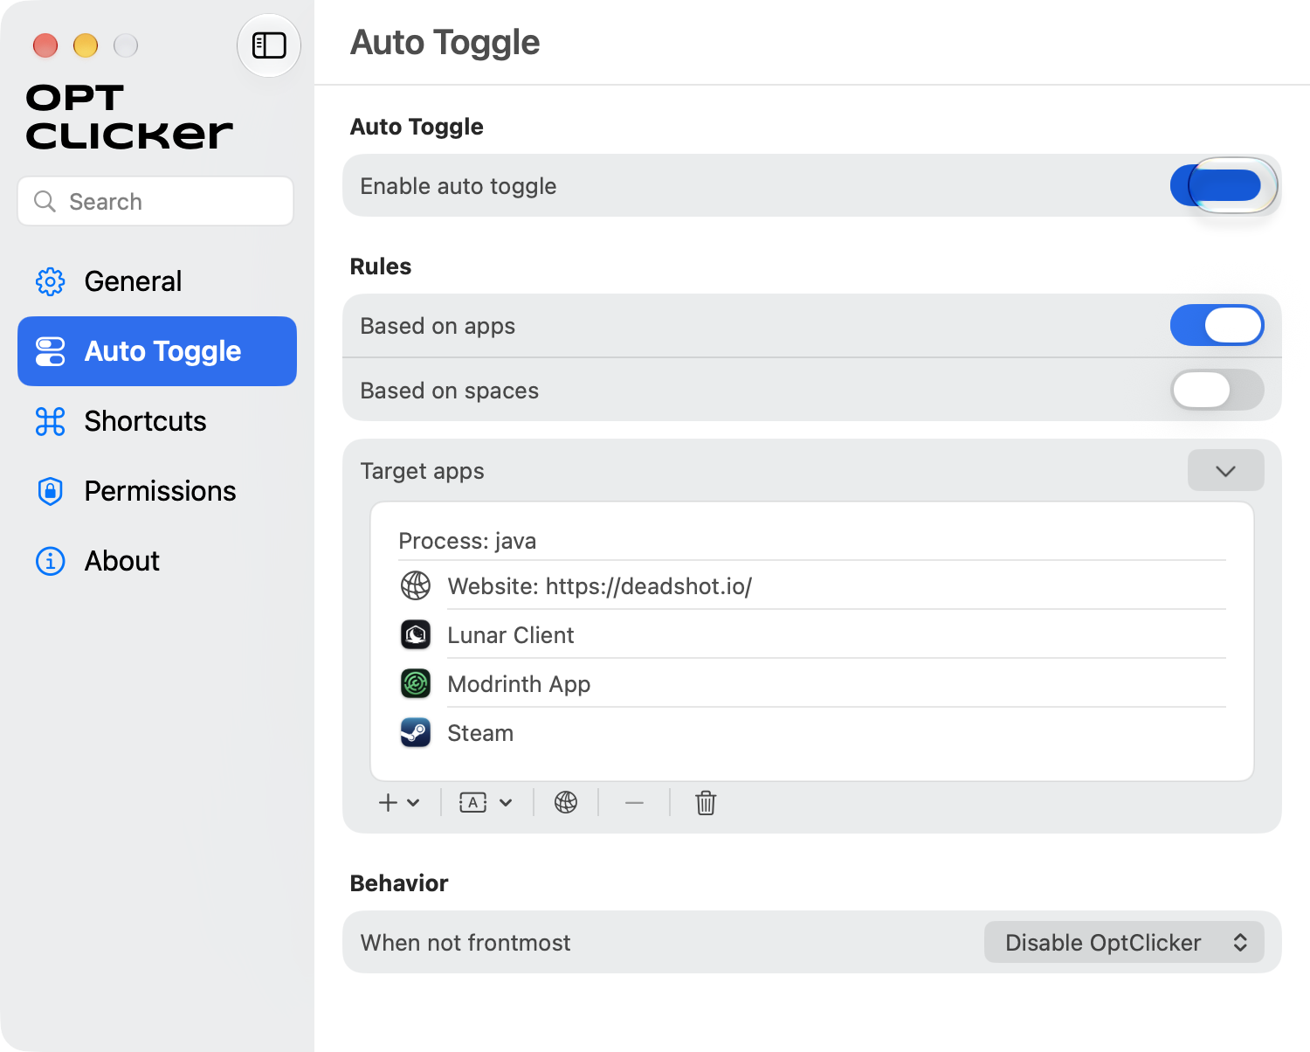
OptClicker Auto Toggle showing mixed process, website, and application rules

Auto Toggle rule model
Auto Toggle can match on frontmost apps, website URLs, and DesktopRenamer Spaces. App rules can be bundle identifiers, exact process names, partial process names, selected Steam games, Chrome apps, CrossOver apps, Safari apps, or Minecraft Java. Website matching reads the active URL from supported, authorized browsers; Firefox-based browsers are called out as unsupported in the UI helper text.
Space rules include regular Space identifiers from DesktopRenamer and a Fullscreen sentinel. An empty Space list means all Spaces. The match condition combines enabled app and space sources with And or Or. The engine also tracks the frontmost process and exposes a human-readable reason for the current enabled state in the menu bar.
Rule dimension | Options
App identity | Bundle ID; exact process proc:; partial process proc~; website web: substring; curated pickers for Steam, Chrome, CrossOver, Safari, and Minecraft Java.
Space identity | Named Space from DesktopRenamer or Fullscreen; no selected Spaces means all Spaces.
Combination | And or Or between app-based and Space-based matching.
Non-match | Disable OptClicker, or follow the last manual setting.
Refresh | Frontmost-app changes are observed; authorized browser website rules refresh on a one-second timer.

SpaceAPI connection
OptClicker has a SpaceManager client for DesktopRenamer structured JSON-RPC and legacy DistributedNotificationCenter notifications. It discovers current and available Spaces, display names, and API availability. The client uses a short retry schedule, checks JSON-RPC and contract versions, prefers structured snapshots, and falls back to the legacy channel when necessary.

Permissions and lifecycle
The Permissions screen separates why each permission is needed: Accessibility for Option and window context, input-event posting for the synthetic right click, SpaceAPI for space rules, and browser automation for website rules. Settings also includes launch behavior, automatic checks, manual Check Now, About links, acknowledgements, and the identity-migration bridge.
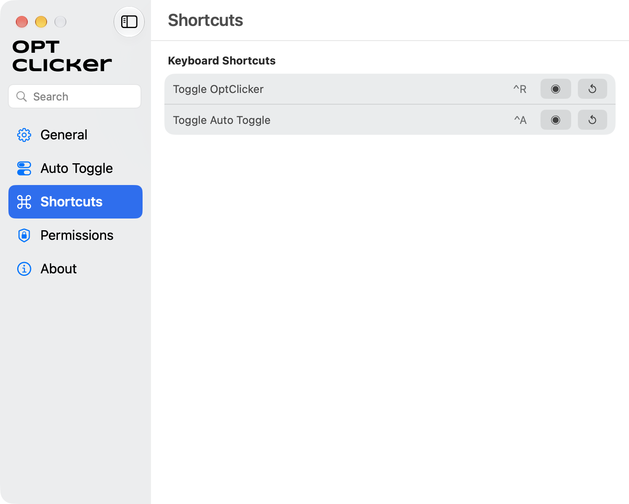
OptClicker shortcut recording surface

SpaceSwitcher
SpaceSwitcher is a beta workspace automation app that uses the current Space as a trigger for two related systems: application-window rules and Dock-set switching. It is designed for apps assigned to all Spaces, where the user wants visibility, focus, or shortcut behavior to vary by workspace.
Project state | README describes an early beta and non-production-ready app; project settings show marketing version 1.0.0, build 5
Platform | macOS 13 target
Primary dependency | DesktopRenamer SpaceAPI for current and available Spaces
System permissions | Accessibility for window enumeration and visibility; input events for simulated app and system shortcuts

General and connection
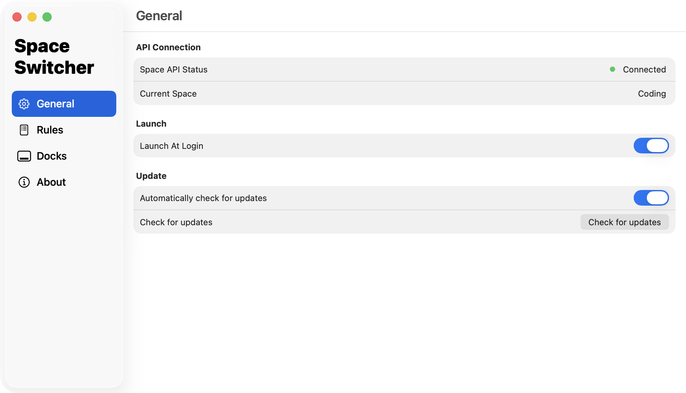
SpaceSwitcher General tab showing SpaceAPI connection and current Space
The General tab reports SpaceAPI status and the current Space, controls launch at login, and exposes Sparkle update checks. The status menu mirrors the connection state and provides toggles for Rule Automation and Dock Automation.

Rule automation
Rules are persisted in UserDefaults and applied when the current Space changes. A rule targets one app, all apps, or a selected running/application bundle. It contains ordered workflow groups, each assigned to explicit target Spaces and optionally the Source Space, plus ordered fallback actions for every other Space. Rules can be enabled or disabled independently.
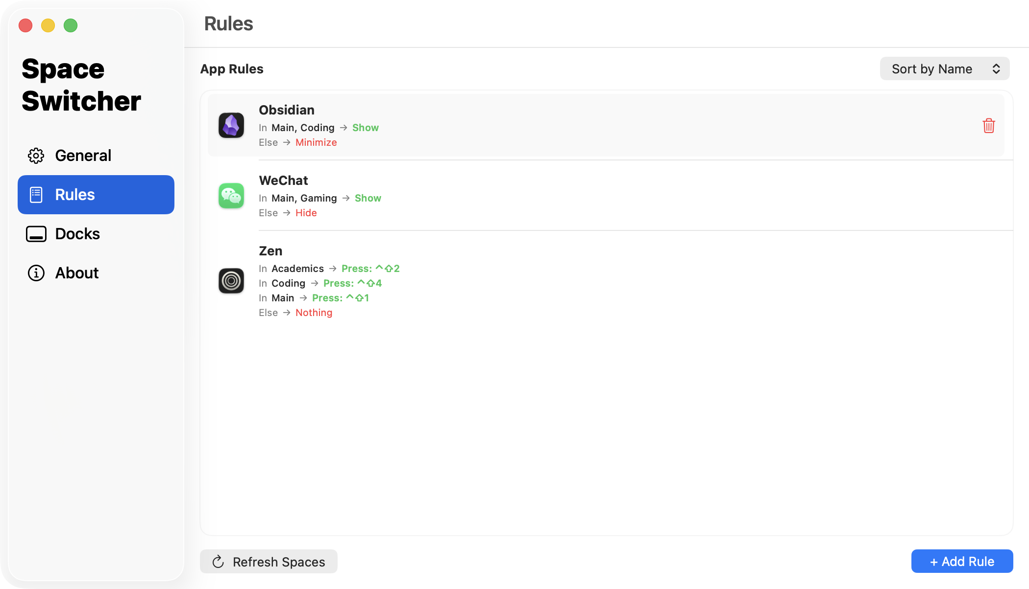
SpaceSwitcher Rules tab showing per-app workflows and fallback behavior
Rule concept | Behavior
Target | A selected app, All Apps, or an app chosen from Applications; rules can be sorted and deleted.
Group target | One or more explicit Spaces plus Source Space, which means the Space the window came from.
Window conditions | Window minimized, frontmost, hidden, or full screen. Legacy application-active and application-hidden conditions migrate to the newer names.
Fallback | Else actions execute outside the matching groups; the editor shows a separate fallback path.
Reversibility | The service records visibility and minimized changes made by SpaceSwitcher so Restore reverses managed changes without overwriting unrelated user actions.

Window actions
Action family | Available behavior
Visibility | Show, Restore, Hide, Minimize, Bring to Front.
Condition blocks | If window minimized, frontmost, hidden, or full screen; End If closes the block. Condition blocks cannot nest and must contain actions.
App shortcut | Send a captured key code and modifiers to the target app, optionally wait for the app to become frontmost, restore the window, and optionally restore the previous app.
System shortcut | Send a global key code and modifiers through CGEvent.
Editor behavior | Drag to reorder actions; capture modifiers and key; validate on save; disable invalid restore combinations when wait-frontmost is not selected.

WindowSpaceService combines Accessibility window enumeration with WindowServer space membership to evaluate minimized, hidden, full-screen, and frontmost state. Enforcement is debounced and stale work is cancelled when the current Space changes again.

Dock automation
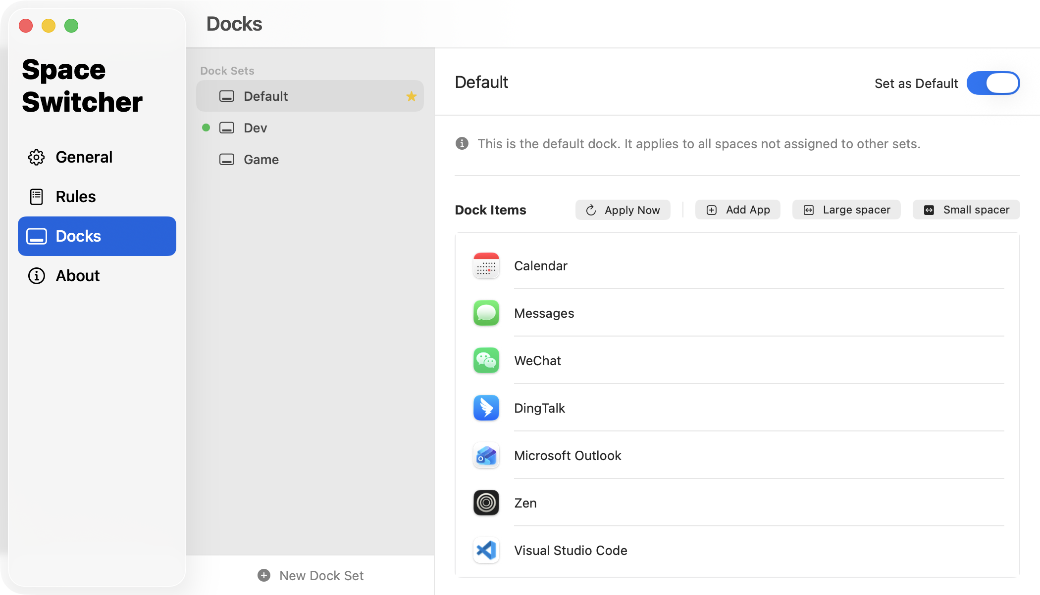
SpaceSwitcher Docks tab showing named Dock sets and Dock items
A Dock set is a named, ordered collection of Dock tiles. Tiles preserve the app bundle identifier, file URL, raw Dock plist data, and spacer information. Users can create and delete sets, set a default, create a set from the current Dock, replace a set with the current Dock, add applications, add large or small spacers, reorder tiles, and remove tiles.
Dock sets can be assigned to individual Spaces in a display-grouped grid. Unassigned Spaces use the default set. The status menu detects the active set, allows manual switching when automation is off, and shows connected or disconnected SpaceAPI state.
System side effect
Applying a Dock set is a two-phase system operation: persistent-apps data and cfprefsd are rewritten, cfprefsd and Dock are restarted with a debounce, the plist and preferences are rewritten again, and the result is verified twice with up to three retries. Apply Now runs the full synchronous path.

Connection and permissions
SpaceSwitcher uses structured JSON-RPC 2.0 with contract version checks and retains the legacy notification path. It stores the last revision, requests a fresh snapshot after a revision gap, retries with increasing delays, and exposes available, disabled, or unavailable API states. The Permissions tab links Accessibility, input-event, and DesktopRenamer installation or launch actions.

Cross app system map
The three codebases form a directed integration graph. DesktopRenamer owns Space identity and publishes state; OptClicker and SpaceSwitcher subscribe only when their features require it. The companion apps are designed to remain understandable when DesktopRenamer is missing, disabled, or temporarily unavailable.

Integration boundaries
Source or channel | Provider | Consumers | Role
SpaceAPI JSON-RPC | DesktopRenamer | OptClicker, SpaceSwitcher, extensions | Snapshot, current Space, available Spaces, actions, contract and revision metadata
Legacy distributed notifications | DesktopRenamer | All companion clients | Compatibility channel for current Space and state changes
App group and widget data | DesktopRenamer | DesktopRenamer Widget | Current name, number, full-screen state, Space list, switch deep links
Accessibility and CGEvent | macOS | All three apps | Window operations, synthetic click input, captured and simulated shortcuts
Sparkle and migration metadata | Each app | Each app's updater and bridge | Update checks, downloads, current and legacy bundle identity migration

Shared state vocabulary
Term | Meaning in the apps
Space | A macOS virtual desktop with a persistent identity, display membership, name, number, and optional full-screen state.
Display | A physical or logical screen that owns a group of Spaces and label positioning.
Source Space | The Space where a rule began or where a moved window originated; used by DesktopRenamer and SpaceSwitcher.
Active label | The label describing the current Space during normal desktop use.
Preview label | The label used during Mission Control or Space transitions to preview Space identity.
Rule | A persisted conditional mapping from app, Space, and window state to ordered actions.
Dock set | A persisted named ordered list of Dock tiles assigned to one or more Spaces.
Auto Toggle | OptClicker subsystem that turns click-mode on or off from context rules.
SpaceAPI | Structured JSON-RPC contract, event stream, and compatibility notification path between workspace apps.

Representative journeys
Journey | Sequence visible to the user | Primary owner
Name and navigate | Open menu or launcher → choose Space → see label and widget update → optionally move the active window or return after a batch action. | DesktopRenamer
Contextual right click | Enable Auto Toggle → choose app, website, or Space rules → switch context → menu reason and icon state update → Option press emits the synthetic right click. | OptClicker
Workspace workflow | Connect SpaceAPI → create app rule or Dock set → assign target Spaces → Space changes → window actions and Dock set enforcement run with status feedback. | SpaceSwitcher

Boundary condition
A companion app can be installed and open while DesktopRenamer is unavailable. In that state, connection status, retry behavior, and permission affordances are part of the functional surface rather than incidental error handling.

Linear planning context
Linear was reviewed for the three app projects on September 19 2026. The lists below preserve the issue identifier, current status, and a condensed title. Done items describe work already reflected in the codebase or recent history; In Progress, In Review, Todo, and Backlog items are planning context and should not be read as implemented features.

DesktopRenamer issues
Issue | Status | Planned or shipped behavior
MQIU-207 | In Progress | Cmd + , in launcher to open settings
MQIU-218 | In Review | When center on the space bar, show Search at left
MQIU-216 | In Review | Freezing of the launcher when executing commands
MQIU-128 | Backlog | Lock returns after culprit window closed
MQIU-212 | Todo | HUD toasts for native launcher
MQIU-33 | Backlog | Right click at the dock icon to switch space
MQIU-85 | In Review | Labels clustering together and overlapping windows
MQIU-217 | Todo | More detailed auto return settings
MQIU-208 | Todo | Lock in launcher
MQIU-213 | In Review | Right click on a launcher row to show the CmdK submenu
MQIU-214 | In Review | Remove cursor hover selection when unneeded
MQIU-210 | In Review | Label can be pushed away by window title
MQIU-211 | In Review | Selected item persistence
MQIU-195 | Todo | Multi thread window action executions
MQIU-177 | Done | Move space to another display
MQIU-179 | Backlog | SpaceAPI permission controls
MQIU-206 | Backlog | Export settings
MQIU-204 | Backlog | Temporary spaces
MQIU-205 | Backlog | Close space backend
MQIU-203 | Backlog | Group spaces across display
MQIU-201 | Backlog | About DesktopRenamer and Check for updates button in menu
MQIU-198 | Done | Make migrator a separate repo
MQIU-188 | Done | Labels mismatched after reboot
MQIU-187 | Done | Settings opening caused anomalous space switches
MQIU-183 | Done | Standardize API input and output
MQIU-184 | Done | Document new SpaceAPI
MQIU-186 | Done | Manage Windows actions respect return to desktop setting
MQIU-156 | Done | App crashes upon waking from sleep
MQIU-181 | Done | Launcher reopened with filtering words retained bad filter
MQIU-176 | Done | Startup led to other spaces
MQIU-175 | Done | Do not hide active labels during space changes
MQIU-166 | Done | Type word directly filters spaces when focus on space row
MQIU-167 | Done | VisualEffectView white in light theme
MQIU-165 | Done | Allow moving full screen window
MQIU-169 | Done | Allow dragging row to rearrange spaces
MQIU-172 | Done | Raycast extension SpaceAPI to speed up
MQIU-160 | Done | Empty launcher input space selection keyboard behavior
MQIU-157 | Done | Close Raycast immediately on window management execution
MQIU-153 | Done | Quit app removes all its windows from list
MQIU-151 | Done | Launcher fails to show in full screen
MQIU-140 | Done | Get version info for extensions
MQIU-87 | Done | List Windows focus now switches to window’s space first
MQIU-199 | Backlog | Option to show all desktops in menu
MQIU-197 | Backlog | Optional stats for API calls
MQIU-196 | Backlog | Integrate all Raycast settings in DesktopRenamer
MQIU-190 | Backlog | Give menu hotkey to reload labels
MQIU-189 | Backlog | Update default settings
MQIU-185 | Backlog | Return to window’s desktop when failed to move it
MQIU-180 | Backlog | Move cursor at menubar when entering Mission Control
MQIU-178 | Done | Better onboarding
MQIU-171 | Done | Provide API version
MQIU-164 | Done | Auto-drag full-screen space next to source desktop
MQIU-170 | Done | Cmd Shift Up Down rearrange spaces in Switch Desktop
MQIU-168 | Done | Rearrange spaces
MQIU-163 | Backlog | Assign each native launcher command a hotkey
MQIU-127 | Backlog | Improve custom launcher UI closer to Raycast
MQIU-158 | Backlog | Automatically restore windows upon unlock
MQIU-152 | Backlog | Allow multiple actions on a window at same time
MQIU-32 | Backlog | Wheel window around cursor to switch spaces quickly
MQIU-65 | Backlog | Add support for Shortcuts app
MQIU-80 | Backlog | Version update splash screen
MQIU-88 | Backlog | Hold number while Option swipe to move window to nth space
MQIU-34 | Backlog | Menu customization options
MQIU-76 | Backlog | Swipe at edge to show exact target space menu
MQIU-30 | Backlog | Assign each space a hotkey

OptClicker issues
Issue | Status | Planned or shipped behavior
MQIU-202 | Backlog | Quick add current process to auto toggle rule
MQIU-150 | In Review | App asks which app to launch upon an app launch
MQIU-90 | Backlog | Left and right Option and Control settings
MQIU-146 | Backlog | Option click at menu bar icon to directly toggle OptClicker
MQIU-192 | Backlog | Notification for OptClicker auto toggle enabled

SpaceSwitcher issues
Issue | Status | Planned or shipped behavior
MQIU-215 | In Progress | Conditions such as if window is minimized
MQIU-209 | Backlog | Presets such as hide minimized windows when not in source desktop
MQIU-147 | Backlog | Hide minimized windows when not at source desktop
MQIU-108 | Backlog | Block dock switching on fullscreen
MQIU-109 | Backlog | Only monitor main monitor space switch
MQIU-103 | Backlog | A marketplace for workflows

Issue detail notes
The following items carried meaningful context beyond their titles during review:
• MQIU-156 records the sleep and wake recovery design: pause monitoring during sleep, cancel retries and layout checks, ignore late callbacks, make monitoring restart idempotent, wait three seconds after wake, then restart. The issue is Done, while real sleep and wake verification remains a manual concern.
• MQIU-85 describes labels clustering, disappearing Spaces, and labels covering windows on macOS 26.5 with DesktopRenamer 1.13.0. It is In Review.
• MQIU-216 describes launcher unresponsiveness while actions execute and calls for a loading state or blocking further actions while busy. It is In Review.
• MQIU-196 is the proposed centralization of Raycast settings and blocks MQIU-217, which would add more detailed auto-return conditions. Both remain Backlog or Todo respectively.
• MQIU-202 for OptClicker would add the current process directly to an Auto Toggle rule; MQIU-146 would make Option-click on the menu bar icon a direct toggle; MQIU-192 would add an Auto Toggle notification or HUD. All three remain Backlog.
• MQIU-215 for SpaceSwitcher is In Progress and covers more window conditions, including minimized state. MQIU-209 and MQIU-147 cover presets and minimized-window visibility behavior.

Appendix

Source coverage
The report was assembled from the three repositories' READMEs, Swift source, project settings, resource screenshots, tests, and the corresponding Linear projects and issues. The code inventory prioritized app entry points, models, service managers, settings views, status bar managers, API contracts, widget code, and system-integration services.
Repository | Key source areas reviewed | Design-relevant evidence
DesktopRenamer | DesktopRenamerApp.swift; Models; Views; Services/Space; Services/Switch; Services/API; Services/System; Widget target; Resources/Demo | Space model, labels, launcher, window operations, API contract, widget, permissions, recovery, screenshots
OptClicker | InputManager.swift; HotkeyManager; StatusBarManager; SettingsSubViews; Services/Space; update and migration services; Resources/Demo | Synthetic input loop, Auto Toggle grammar, status reasons, permissions, SpaceAPI and browser integration
SpaceSwitcher | RuleModels.swift; RuleManager.swift; WindowSpaceService; DockModels.swift; DockManager.swift; SettingsSubViews; Services/Space; Resources/Demo | Conditional window actions, reversible enforcement, Dock sets, system modification path, SpaceAPI states

Repository paths
• DesktopRenamer: /Users/michaelqiu/Projects/03_App_macOS/DesktopRenamer
• OptClicker: /Users/michaelqiu/Projects/03_App_macOS/OptClicker
• SpaceSwitcher: /Users/michaelqiu/Projects/03_App_macOS/SpaceSwitcher

Version and source notes
• The report uses project settings and current source as the authority for current bundle IDs, build numbers, target versions, and behavior. README text and demo filenames are retained as context when they describe user intent or a named release.
• OptClicker README text references an older v1.4.0 framing while current project settings and demo resources show v1.5.1; the report identifies the current project setting and does not merge the two labels.
• SpaceSwitcher README describes the product as beta and non-production-ready while project settings show marketing version 1.0.0 build 5; both facts are recorded because they describe different aspects of product state.
• SpaceSwitcher had a pre-existing localization resource modification at review time; it was preserved and not used as a basis for feature claims.

Reference note
Report boundary
This document is an inventory and comprehension aid. It records implemented surfaces, integration behavior, system constraints, and Linear planning context. It intentionally does not propose new features or design directions.

End of report

