Title of the claim — fill this in
As-If Science Jam · Poster · Team — fill this in

Data
One sentence: which dataset did you take, and why this one? and hallo

Provenance
Where do the bytes come from, and how would anyone tell they are the same bytes?
- Source: the URI you fetched the file from
- Content address: sha256:… — it is in the post you shopped it from
- Licence: and whether it permits what you intend to do
- As of: when you fetched it. For a query rather than a file: the bounds that are in the URI (period, threshold, field list)
This is the first part the opposition recomputes. One line here saves an argument there.

Format
What is one row, and what do the columns mean?
- A row is: a tree? a grant? a station on one day? If a row is something other than what you think, then every sum over it is something other than what you think.
- Rows and columns: how many
- Time axis: which column is the clock — and if there are several, which one you took
- Missing values: what they look like. -1 is not a rainfall, 0 is not a planting year
- What you changed before you started: separator, encoding, decimal comma

Exploratory analysis
What did you look at before you had an opinion?

Overview
What do the data look like as a whole?
The figure shows the shape: distribution, development over time, orders of magnitude. No thesis yet — only what anyone would see who looked.
In the text: what is the order of magnitude, and what is the range everything happens in?
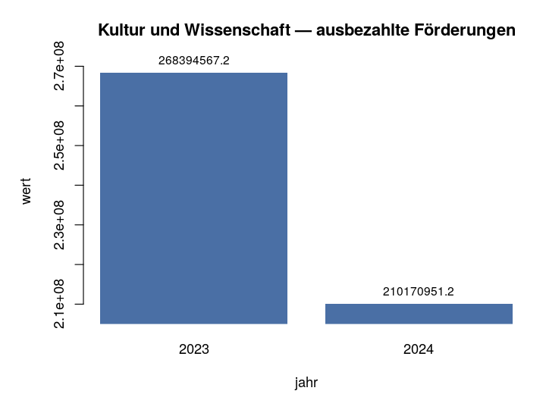

Anomalies
What stands out, and what did you do about it?
Outliers, gaps, groups with very few observations, values sitting at a boundary. For each anomaly one line with the decision: kept, removed, handled separately — and why.
This is where an exclusion decision belongs. Written here, it is a reasoned choice; written nowhere, the opposition finds it anyway.


Model
What did you compute your claim with?

What was computed
The computation itself, in one sentence and one formula.
- Formula: what against what
- Method: and why this one
- On what: the whole dataset or a part of it — and if a part, which
The figure shows the result of the computation, not the raw data.
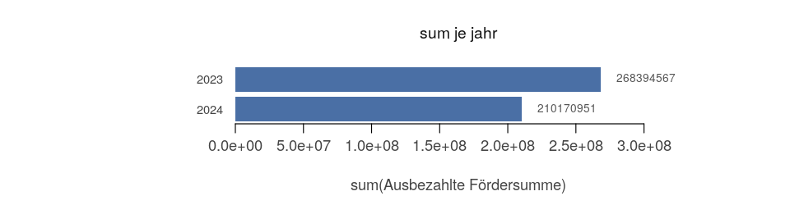

Robustness
What happens to your claim if someone turns one of the knobs?
Take the one parameter your claim hangs on — the exclusion threshold, the class boundary, the period — and let it run across a range. The figure shows the curve.
Two honest answers are possible, and both count:
- It holds: the claim survives the whole range. Then say so, with numbers.
- It flips: past some value it turns around. Then say past which one — and why you picked the value you picked anyway.
Leaving this section out is also an answer, and the opposition will name it.


Result
Your claim, in one sentence.
Then: which three steps carry it — the dataset, the one decision in the EDA, the computation. Anyone who wants to dispute the sentence should know where to start.
And the thing this jam is about: every number in it comes from the data, and every step can be recomputed. Whether the conclusion is right is a different question — and that is the interesting one.

