**Employees Data Analysis**

The primary objective of the employee data analysis is to gain actionable insights into the workforce composition and dynamics within the organization. By analyzing various attributes such as employee demographics, departmental distributions, and salary structures, the analysis aims to identify trends and patterns that can inform strategic decision-making.

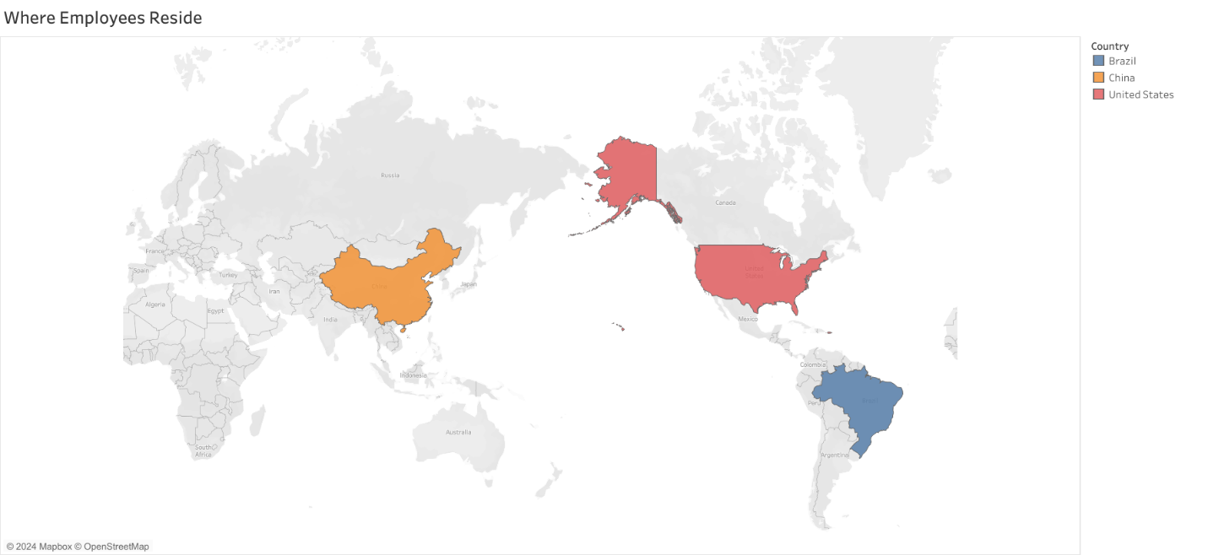

According to the world map, employees reside in United States, Brazil, and China

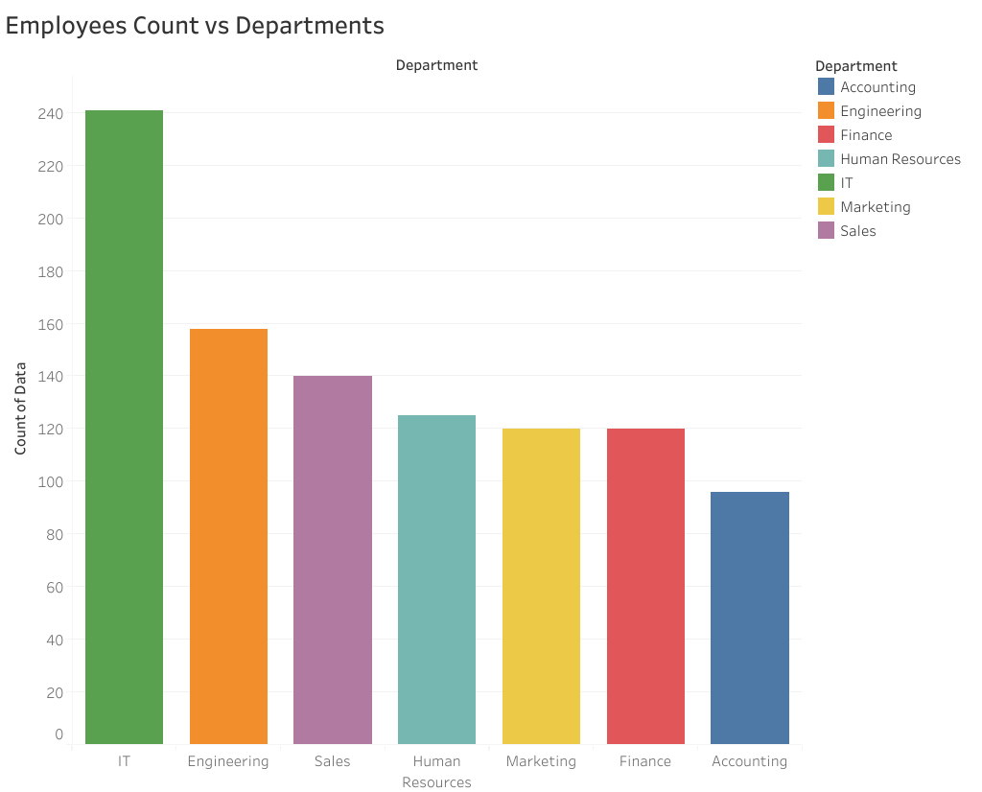

We have most people in IT department, following by engineers and sales representatives.

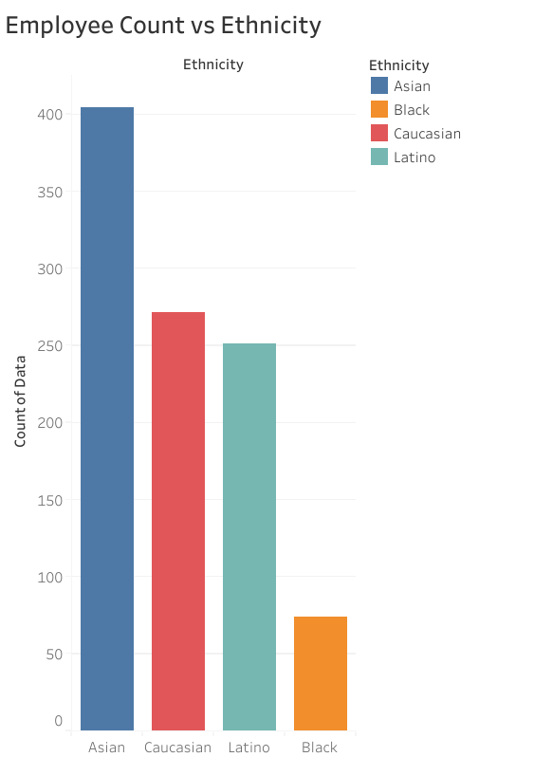

The company has a diverse range of ethnicities, with Asians being the majority.

How old are the employees?

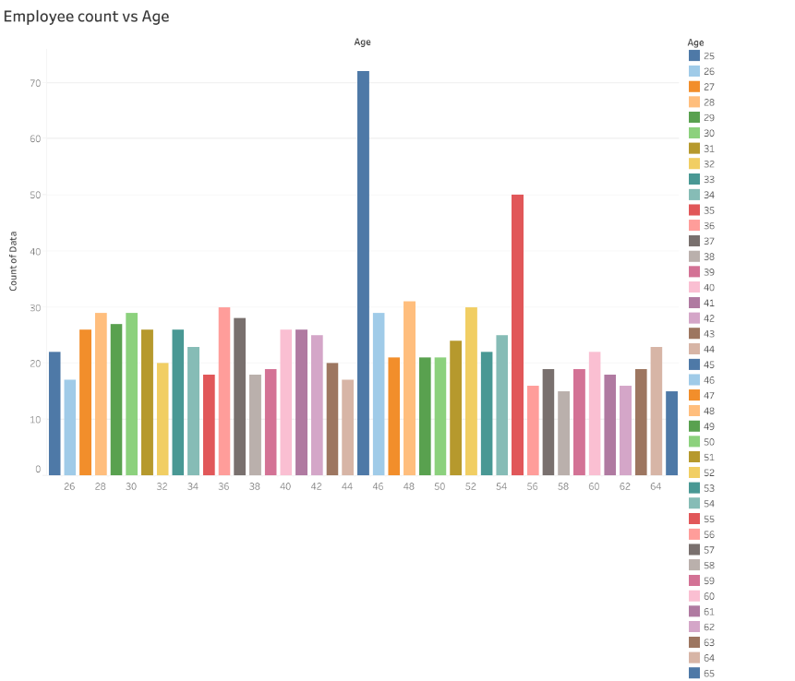

There are many employees who are 45 and 55 years old, while employees of other ages are distributed more evenly.

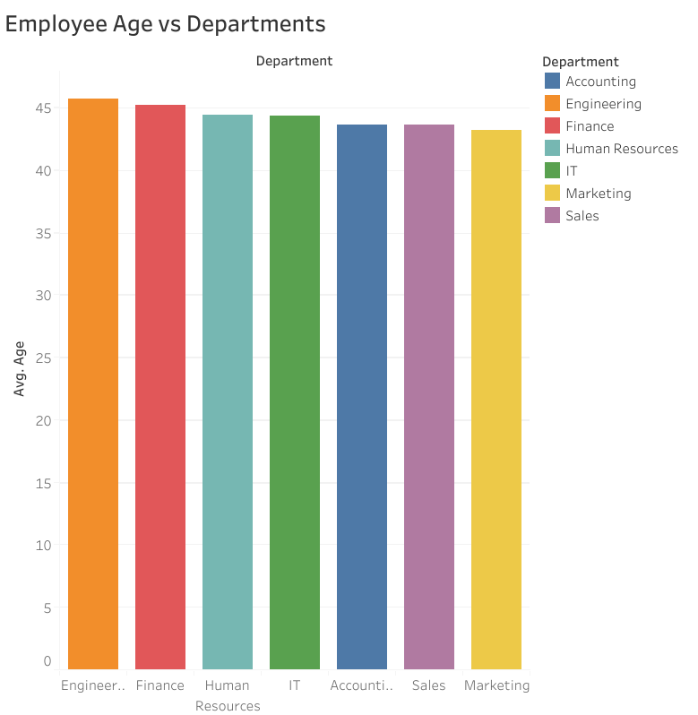

However, the average age for each department was almost the same.

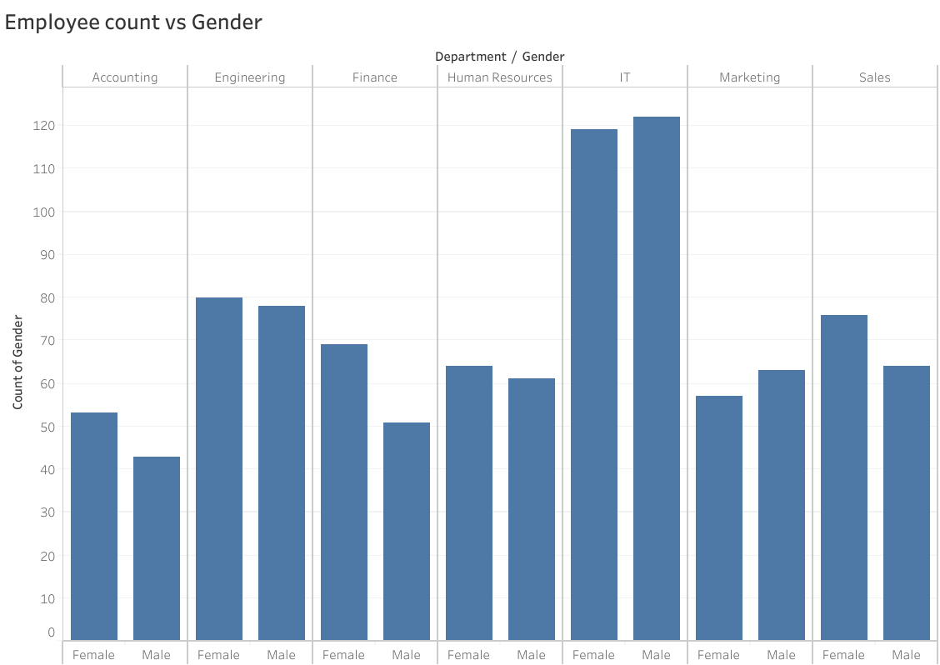Genders are also distributed across each department.

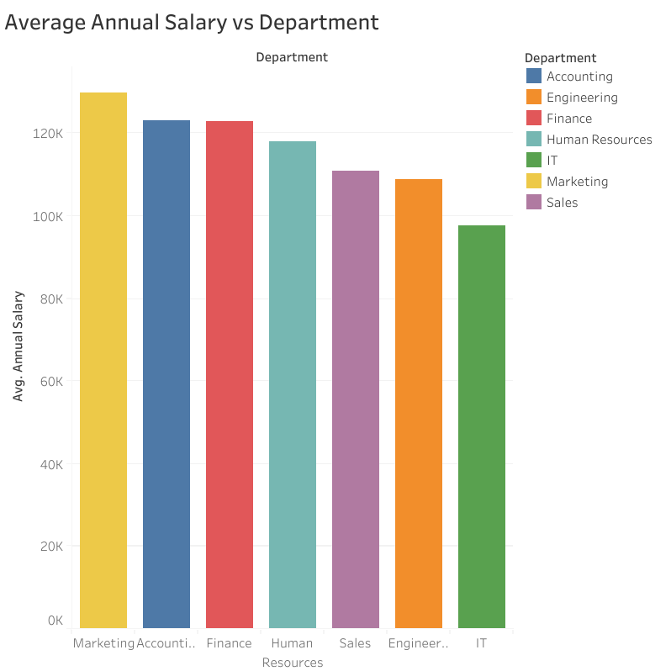

The average salary across departments ranges from $90,000 to $130,000.