Shiva A

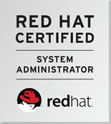 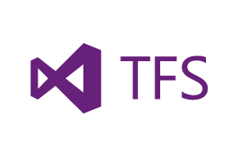 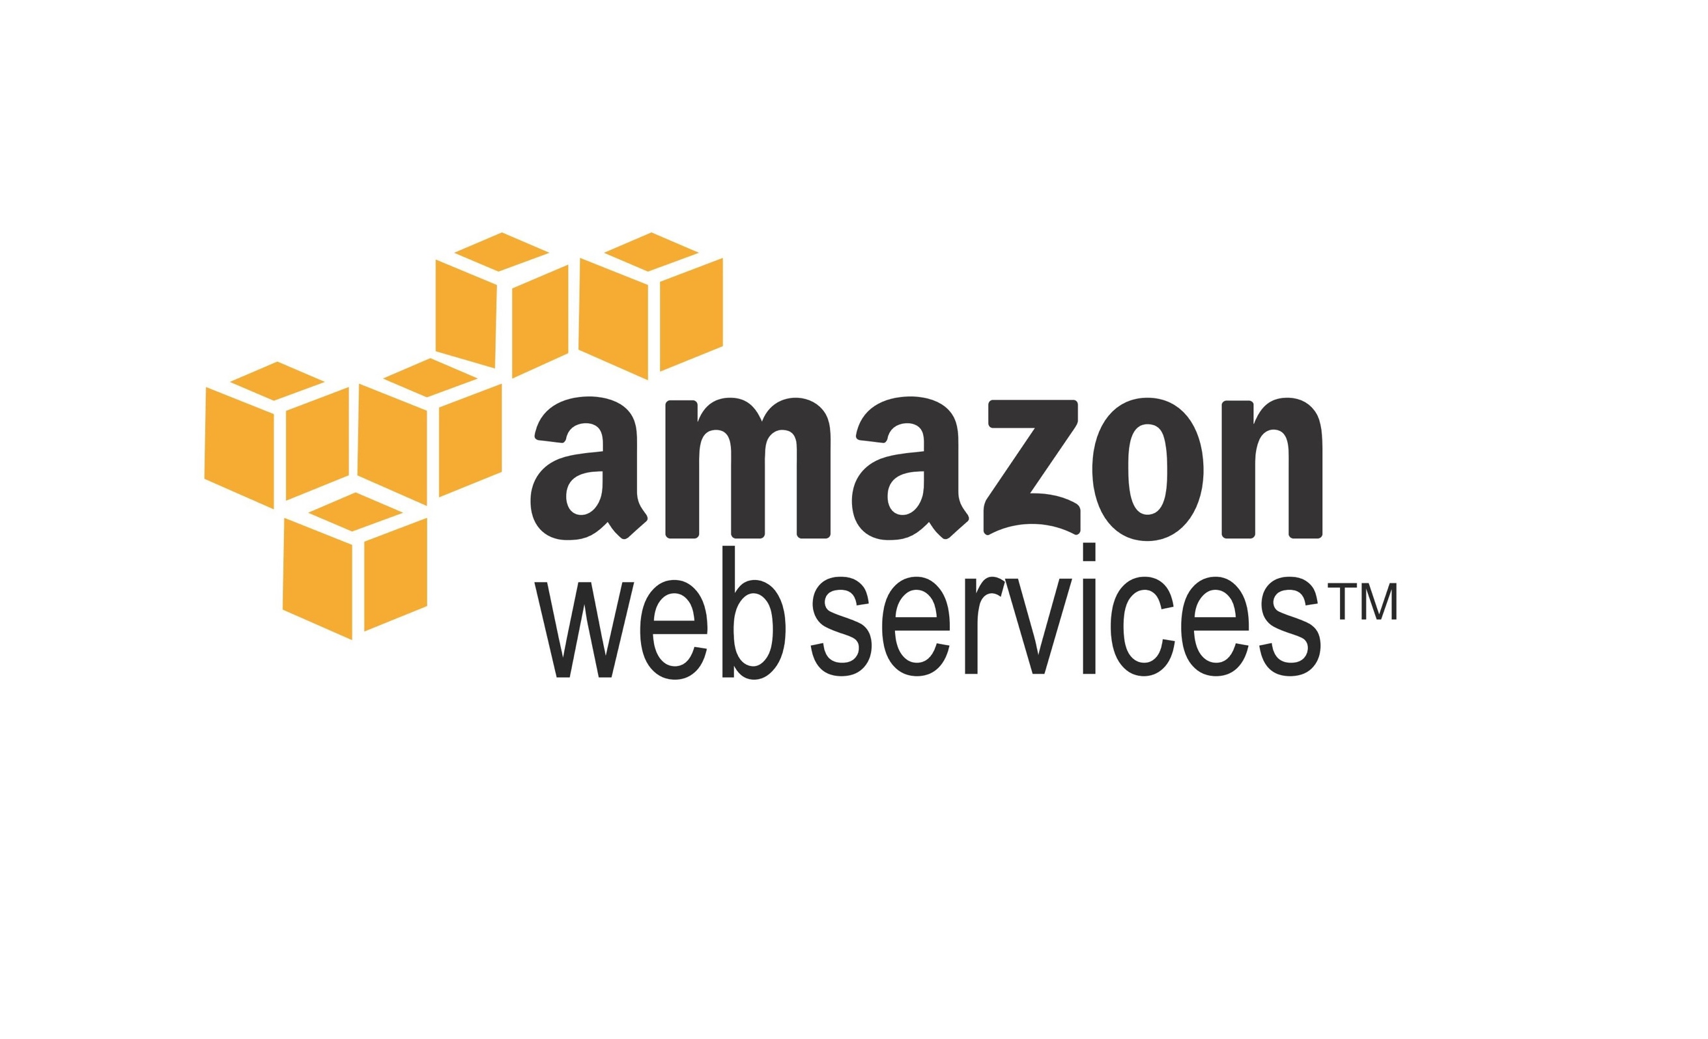 

Build and Release Engineer

**Contact: (512) 515-3002**

**Mail ID:** [aj@microinfoinc.com](mailto:aj@microinfoinc.com)

Overview

Software Developer, Systems Engineer and Build and Release Engineer experienced in CI/ CD, Release and DevOps frameworks. Expertise in application configuration, code development, packaging, building, automating, managing and releasing code from one environment to another, and configuring and building application middleware stacks in server stacks and cloud. Excellent communicative, interpersonal, intuitive, analytic and leadership skills with ability to work efficiently in both independent and team environments.

Summary of Experience

* In-depth understanding DevOps environment, principles and best practices of SDLC, Software Configuration Management (SCM) and Release Management in SaaS, PaaS, Agile, SCRUM, Waterfall methodologies.
* Experience in administering version control systems like TFS, GIT and SVN. Enterprise level maintenance of Jenkins, Nexus and Artifactory repositories and SonarQube, HP Fortify and ALM.
* Implemented strategic and scalable on demand next generation Release management process.
* Extensively worked on building Jenkins, TFS 2013/2015 for continuous integration (CI) and for End to End automation for all build automations using Chef, Docker, AWS, Open stack, puppet.
* Designed, built and deployed a multitude applications utilizing almost all the AWS (Including EC2, S3, Elastic Beanstalk, Elastic Load Balancing (Classic/Application), Auto Scaling, RDS, VPC, Route53, Cloud Watch and IAM), focusing on high-availability, fault tolerance, and auto-scaling with Cloud watch monitoring
* Experienced in planning and development of designs for Migrating to AWS cloud and LAMBDA which runs the code with response of events.
* Experienced in Building E2E testing platform with selenium grid testing using cucumber, appium, jasmine, gatling.
* Experienced with Server less/PaaS (API Gateway, Lambda, Dynamo, S3). Building micro services using API gateway.
* Production Support and JAVA JEE and AngularJS Web application development in Behavior driven Development (BDD).
* Experience in Configuring, Deploying application artifacts on application stack on middleware tools Jboss, Apache Tomcat web server, IIS Server, Oracle web logic, and IBM WebSphere.
* Experience in building RHEL application stack in AWS (EC2, S3), open shift, EMC data and Windows stack on Azure. Orchestration using Docker, puppet. Automation deployments using Ansible and CHEF.
* Experience in working testing platform Selenium Grid using cucumber, protractor in E2E testing.
* Experience in Monitoring Linux (RHEL) and Windows (2003/2008/2012) servers extensively using monitoring tools.
* Experience in writing shell, python, PowerShell scripts for automation and alleviating manual work.
* Strong SQL, PL/SQL, Data experience using Oracle 11g/12c /ODI, Hadoop, HDFS, SAS, R.

Technical Skills

|  |  |
| --- | --- |
| Programming & Scripting | .Net, Java, Shell Script, Power Shell Script, R, Ruby, SAS, JavaScript, AngularJS |
| Database System | SQL Server 2005/2008, Oracle 9i/10g/11g/12c, MS Access, HDFS |
| Project Management | MS Project, Atlassian Tools, TFS, Service Now, Agile, SCRUM, Waterfall, Kanban |
| Bug tracker & Testing | JIRA, Bugzilla, Junit, Web pack, Selenium, npm, NuGet, NodeJS, Restful API |
| SCM /CI/Build Tools | Subversion, GIT, TFS 2013/2015, SVN, Jenkins, Ant, Maven, MS Build, Grunt, Gulp, BitBucket |
| Automation Tool | CHEF, Ansible, Udeploy, octopus, puppet |
| Platforms | Windows 2003/2008/2012 servers, Linux RHEL 5/6/7 |
| Application Middleware | Jboss EAP 6.4, EAP7, Apache2, Tomcat, Oracle Web logic, IIS Server, IBM -IIB9, BPM, ODM, MQ |
| IDE | Eclipse, MS Visual Studio, IntelliJ IDEA/Webstrom |
| Virtual, Cloud, Vault | OpenStack, AWS, F5 - Big IP, CyberArk-EPV, Vagrant, EMC Hybrid Cloud, SAS |

Certifications

Chef Fundamentals ITIL Red Hat Certified System Administrator 7

LINUX Foundation Six Sigma Green Belt

Professional Experience

**EzShipp Fairfax, VA**

**Devops Consultant March 2017 - Present**

* Designed and deployed a multi-tier Web application on IOS and Android application utilizing main services of the AWS stack in a high-availability, fault tolerance and scalable environment.
* Built high oriented scalable release management across company within policy and regulations and Audit capable.
* Built high availability environment for Application servers on EC2 by using ELB and Auto-scaling and Lambda.
* Worked with the architects on SDLC process as the owner of post-development environments Coordinated the resources with project managers for the release and carried deployments and builds on various environments using continuous integration tools.
* Implemented next generation advanced strategic release process automating using TFS, Git, Jira and AWS.
* Implemented and built Created and designed high visible and fault tolerant Jenkins pipelines (CI & CD) Process stack using AWS, GITHUB/GIT, Jenkins, and Chef.
* Developed automation scripting groovy scripts to deploy and manage Java applications across ec2 instances.
* Defined branching, labeling, and merge strategies for all applications in GIT and TFS 2015.
* Utilized Configuration Management Tool Chef & created Chef Cookbooks using recipes to automate system operations
* Implemented new hybrid technologies across development modules in a behavior driven development (BDD) and End to End testing (E2E) using npm, selenium, Gatling and jasmine.

**Environment:** MAVEN, Grunt, Gulp, NPM, Jenkins, Java/JEE, Ruby, TFS, GIT, RHEL6/7, Centos7, Oracle11g/12c, Golden gate, JIRA, SonarQube, Chef, nexus, jboss, apache, AWS – EC2, s3, Lambda, ELB, Route53, cloudtrail, cloudwatch

**Raymond James Financial Tampa, FL**

**Build and Release Engineer (DevOps) May 2015 – February 2017**

Responsibilities**:**

* Build and Release Engineer for continuous delivery team involves in supporting different development teams, Platform teams and multiple simultaneous software releases, DevOps integration, CI / CD support. Involved in improvement of continuous Delivery, CI, Software Release Management strategies for various applications.
* Trained team members on new technologies like Git, AngularJS, Grunt, Jenkins, Maven, Nexus, and SonarQube.
* Participated in release meetings with Technology stakeholders, worked closely with CMO to identify and mitigate potential risks associated with the releases and code.
* Continuous Delivery Engineer for Enterprise applications and High Visible Applications.
* Imported and managed multiple PCG, corporate, wealth management applications into TFS and GIT.
* Provided required training and support for In-house Built Automation Tool, TFS, Git, Jenkins, Nexus, SonarQube, JBOSS EAP 6.4, ODI users to effectively use the tools.
* Maintained Enterprise Nexus code repository and SonarQube Code Quality management. Regularly monitoring the quality gate of Enterprise application using SonarQube ,security scans with HP fortify and build agents on Amazons.
* Successfully managed multiple Jenkins build pipelines from DEV through Production of JAVA and JavaScript(Angular), Oracle application. Created and maintained Jenkins jobs and automation testing jobs using selenium on RHEL 6.
* Maintained Selenium grid with virtual systems enterprise level and supported CI/CD test environment with cucumber and jasmine reports with more than 150 offshore and onsite Automation testers.
* Created Selenium test jobs for AngularJS and Java application projects in enterprise level.
* Closely worked with platform engineers on creating Jboss server groups and Data Sources (mssql, Oracle) for standalone and domain controller. Created CHEF Jenkins jobs for integration with VMware VRA, VRO for web and font end applications on RHEL6.
* Managed Visual Studio Team Services and TFS 2013 and 2015 server on Enterprise level more than 600 projects in TFS.
* Validated, build JAVA code and deployed JEE applications to Red hat JBOSS EAP 6.4, Tomcat, IIB9, and WebLogic Coherence in an agile continuous integration environment and automated process.
* Developed Groovy, shell scripts and PowerShell scripts for automation of the build and release process Deployments on Linux and windows stacks.
* Implementation of client side validations using jQuery, Angular JS and server-side validation using ASP.NET MVC Validation at Controller level
* Experienced in TFS Administration activities, Merging, Branching, User permissions and TFS Build and Deploy enterprise level.
* Involved in editing the existing MS Build, MAVEN, Ant files in case of errors or changes in the Windows, JAVA Enterprise applications project requirements migration of Jenkins agents from RHEL 6 to RHEL 7.
* Automated and created SQL files for deploying db. objects in Oracle Database and ODI using Red Gate Compare Tool.
* Initiated in designing a Data driven analytical tool for CD/ERM for reporting analysis of CD projects and Release management using Angular2 and Java.

**Environment:** MAVEN, MS Build, Grunt, Gulp, NPM, Jenkins, Java/JEE, .net, IIB9, IBM-MQ, Shell Scripts, XML, Ruby, TFS, GIT, RHEL6/7, Centos7, Windows2008/2012, Oracle11g/12c, Golden gate, JIRA, SonarQube, Chef, nexus, jboss, apache, ODM, BPM, ODI, HP Fortify, Red gate, solr, Oracle Coherence, octopus, puppet, open stack, open shift, puppet

**TIAA -CREF Charlotte, NC**

**DevOps Engineer Oct 2013 – May 2015**

Responsibilities**:**

* DevOps Engineer Worked on designing and deploying a multi-tier application utilizing almost all the main services of the AWS stack (like EC2, S3, RDS, VPC, IAM, ELB, Cloud watch, Route 53, Lambda and Cloud Formation) focused on high - availability, fault tolerance environment.
* Created Cloud Formation Template for main services like EC2, VPC and S3 for reusing the current environment.
* Created network architecture on AWS VPC, subnets, Internet Gateway, Route Table and NAT Setup puppet.
* Worked with IAM to manage the users and groups using IAM by assigning individual policies and roles to each users and group as per requirements.
* Designed high availability environment for Application servers and database on EC2 by using ELB and Auto-scaling.
* Used Cloud Watch for monitoring AWS cloud resources and the applications that deployed on AWS by creating new alarm, enable notification service Orchestration using Puppet and Docker images.
* Decent knowledge on Dynamo DB and Amazon EMR.
* Administered Puppet Enterprise to provision multi-platform virtual machine configurations across multiple-platform environment Servers dedicated for building, deploying as well as for development, test and production systems.
* Built a load-balanced, version-controlled, Hiera/r10k-enabled Puppet environment.
* Created a custom Puppet module skeleton to use same structure across all Puppet modules.
* Implemented Continuous Integration and Continuous Delivery Process stack using AWS, GITHUB/GIT, Jenkins, and Chef.
* Worked on migrated Team foundation server 2013 to 2015.
* Managed and built build definitions in TFS 2015 for visual studio projects using Team foundation team services.
* Migrated Asp.net Webforms applications into Asp.net MVC web sites on azure cloud.
* Responsible for designing Rich user Interface Applications using JavaScript, JQuery, CSS, HTML, AJAX and AngularJS.
* Worked on Deploying and troubleshooting .net apps on IIS servers on legacy platform
* Used Jenkins to automate the build process and integrated with puppet other tools.
* Performed built Elastic search, Log stash for centralized logging metrics into S3bucket using Lambda function.
* Configuration tool Installed and configured such as chef server / workstation and nodes via CLI tools to AWS nodes.
* Manage amazon redshift clusters such as launching the cluster and specifying the node type as well.
* Provide highly durable and available data by using S3 data store, versioning, lifecycle policies, and create AMIs for mission critical production servers for backup.
* Defined branching, labeling, and merge strategies for all applications in GIT and TFS 2015.

**Environment:** JavaScript, CSS, HTML, AngularJS, Apache server, Tomcat, EC2, VPC, S3, IAM, ELB, Auto Scaling, Cloud Watch, JSON, Python script, Shell script, Jenkins, Maven, Ant, GIT, GitHub, Puppet, Nagios and Linux servers, puppet, oracle 12c

**Excel M Pvt Ltd Hyderabad INDIA**

**Software Developer June 2012- Sep 2013**

Responsibilities:

* Design and Developing of workflow procedures. Interacted with client to gather the requirements and implementation.
* Responsible for handling the Billing application and related Change requests.
* Worked closely with front end and backend developers and involved in code changes in JAVA EE and Angular Scripts to parse data. Managed code repository of all team applications in Git repository and legacy in SVN.
* Implemented PL/SQL queries, triggers and Stored Procedures as per the design and development related requirements of the project in JAVA JEE json data and maven as build tool and built on Hudson/Jenkins project.
* Extensively worked in Oracle SQL, PL/SQL, SQL*Plus, SQL* Loader, Created DDL scripts, Created database objects like Tables, Views Indexes, Synonyms and Sequences.
* Migrated media to s3 and used Cloud Front to distribute content with low latency and at high data transfer rates.
* Work with application development teams to ensure their applications are designed properly for interacting with AWS.
* Maintained all code in TFS 2010 and git repositories.
* Developed user controls and used validation controls available in .NET environment.
* Extensively used the advanced features of PL/SQL like Records, Tables, Object types and Dynamic SQL.
* Used PL/SQL and SQL*Loader to create ETL packages for flat file loading and error capturing into log tables.
* Tuning of the SQL queries, which takes long time to process the request using Explain Plan, Hints to reduce the response time. Worked with platform engineers on troubleshooting server issues and application connectivity.
* Involved in all phases of database development, from needs assessment to QA/QC, design, and support.
* Generated log files for Procedures using UTL File. Deployed app on AWS stack using Jenkins.
* Worked on integrating .net MVC services running on windows 2008 IIS server platform.
* Extensively used spring framework modules like core, IOC, AOP modules throughout the application.
* Involved with OLTP relational databases system analysis, design, implementation and management.

**Environment**: RHEL 5/6, Windows Server 2008 R2/2012, Oracle 11g R1/R2, Java, TOAD, OEM, Data Pump, Diagnostic and Tuning Advisors, WebLogic Server 11g, tomcat, Oracle ODI, Java 5&6, AWS, EC2, S3, MAVEN, ansible

**NI-MSME Hyderabad INDIA**

**Systems Engineer January 2012-May 2012**

Responsibilities:

* Used ELB and Auto scaling for load balancing and scaling EC2 instances up/down based on Network Traffic. Migrated the website domain to Route 53. Create, maintain, and grow cloud infrastructure to ensure maximum productivity for customers. Used ELB and Auto scaling for load balancing and scaling EC2 instances up/down based on Network Traffic.
* Provided guidance on AWS operations and deployment, and best practices throughout the lifecycle of a project.
* Installed the application on AWS EC2 instances and configured the storage on S3 buckets.
* Performed S3 buckets creation, policies and on the IAM role based polices and customizing the JSON template.
* Used PL/SQL and SQL*Loader to create ETL packages for flat file loading and error capturing into log tables. Extensively used the advanced features of PL/SQL like Records, Tables, Object types and Dynamic SQL.
* Involved in configuring middleware tools like WAS, Apache HTTP as coordinating with other teams on daily basis. Doing firmware and Microcode upgrades. Managing NFS, DNS, DHCP, NIS, AutoFS, tomcat servers.
* Integrated Build Process through Jenkins to various SCM tools like GitHub, SVN. Written shell scripts for automating logs backup and archiving. Troubleshooted IIS server issues and configuration issued for integration of services.
* Manage VMware Infrastructure clusters on Test/Development environments.
* Experience working with VMware tools like vCenter and vSphere to manage VM's running on ESX cluster nodes and experience working vMotion.

**Environment:** Java1.5, J2EE, Struts 1.2, HTML, My SQL, JSP, EJB, JUnit, WebSphere 5.x, XML, UML, CVS, Visio, WSAD 5.x, Windows, Ant, MAVEN, tomcat, AWS, ec2, oracle 11g, dynamo, RHEL 6, Oracle 11g

**BEC Hyderabad INDIA**

**Linux Engineer August2009-December2011**

Responsibilities:

* Installation, Maintenance, Administration and troubleshooting of Linux, windows servers
* Performed automated installations of Operating System using kick start for Linux
* Installing and configuring services such as Apache, DNS, SMTP, HTTPD, NTP, DHCP and supporting them on Linux production servers.
* Hands on experienced with SOAP, REST. Performing RPM and YUM package installations, patch and other server management
* Troubleshooting Linux network, security related issues, capturing packets using tools such as IP tables.
* Extensively worked on LVM and extended the logical volumes.
* Maintained all the Red hat servers entitled with the latest subscriptions
* Perform error analysis and recovery, documentation and procedures required for reference
* Log all scheduled/unscheduled system activities and problems
* Monitored the systems CPU, memory, IDE/SCSI disks, disk controllers, RAID, and network parameters using the tools NAGIOS monitoring system.
* Managed git repository.
* Worked on high availability servers - load balancing and clustering
* Worked with Network Attached Storage devices and RAID technology Worked with NetBackup.
* Manage VMware Infrastructure clusters on Test/Development environments.
* Built windows 2008 stack and configured IIS server.
* Involved in trouble shooting IIS issues and windows 2003 and 2008 server problems.
* Experience working with VMware tools like vCenter and vSphere to manage VM's running on ESX cluster nodes and experience working vMotion.
* Provide responsive off-hours support in a 24 / 7 environment and ensure maximum availability of all servers and applications.

**Environment:** Java, HTML, My SQL, XML, UML, CVS, Visio, WSAD 5.x, Windows, RHEL5/6, Centos, Windows, tomcat