**Optimizing Operations and Driving Growth**

**for Premium Supermart**

Final Report for Business Data Management Project



**Submitted by**

Name : Nikhil Sai Kasireddy

Roll Number : 21f3002651

# **Table of Contents**

**Executive Summary** **2**

**Detailed Explanation of Analysis Process/Method** **3**

**Results and Findings** **4**

1. Sales and Revenue Analysis 4

2. Profit Analysis 9

3. Inventory Analysis 13

4. Seasonal and Weekly Trends 16

**Interpretation of Results and Recommendation** **17**

# **Executive Summary**

Premium Supermart, a newly opened supermarket at Sai Anurag Colony in Hyderabad, is facing some competition with the local players and even online delivery platforms like JioMart and BigBasket already establishing business in the area.

Proximity to residents and a badminton academy bets the store to do well, but with its traditional way of operating, little visibility in stock levels, and even less data driven decision making on what sells well where and how best to retain patrons—business was suffering.

This project intends to fix the problems of supermart regarding the flow of items, tracking sales and profit generated through their sales so that it is more optimized for them. This includes gaining insight into your high-revenue and high-margin products, reducing stock inefficiencies and providing strategies that deliver real improvements to the bottom line.

In order to accomplish these objectives, the report is concentrated on examining March through June 2024 sales, stock and margin statistics utilizing Pareto Analysis, tendencies and profitability evaluation methods using analysis tools Python and Microsoft Excel.

These enable the visualization of the sales data which helps in identifying trends, patterns and any key insights. Overall, using these excel tools to analyze the top performing and bottom products can help in crafting recommendation, marketing strategy and data-driven decisions & optimised revenue generation.

.

# Detailed Explanation of Analysis Process/Method

Initially, the shop owner provided only the sales data, which included weekly quantities sold for each SKU along with their selling prices. While this data gave a basic overview of revenue, it was insufficient for understanding the shop’s overall profitability and inventory management.

Upon further discussions, the owner shared additional datasets, such as inventory levels (starting and ending stock) and profit margin percentages for each SKU. These datasets were crucial for performing a comprehensive analysis.

**1. Data Collection and Preprocessing**

The primary dataset consisted of daily sales records for a period of four months (March–June 2024).

* **Pre-Processing Steps**

Error Correction: Fixed typographical errors in SKU names (e.g., “Drie Fruits” corrected to “Dry Fruits”)

Missing Values: Filled gaps in inventory levels using the average of adjacent weeks or inputs from the shop owner.

After data collection and preprocessing the data looked like the following :

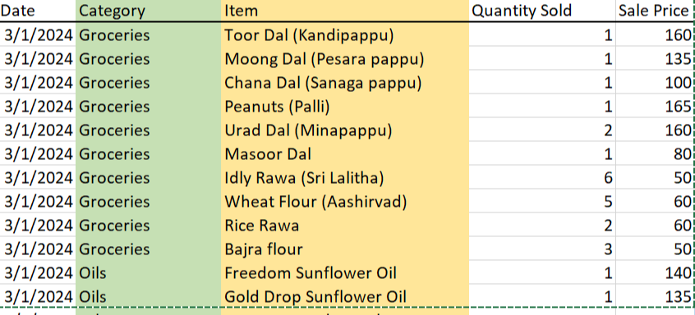

* **Total Sales was calculated using the formula:** Sale price x Quantity

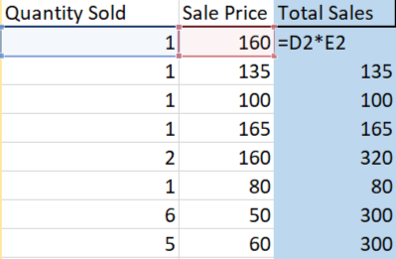

**2. Revenue and Profit Analysis**

Similarly profit was calculated using revenue and margin, which was provided by the owner later on

Profit = Revenue ×( Margin (%)​ ) / 100

**Key Visualisations**

**-> Pareto Chart**: Highlights the top 20% SKUs contributing to 80% of total revenue.

To create pareto charts, the following table was created using excel

|  |
| --- |
|  |

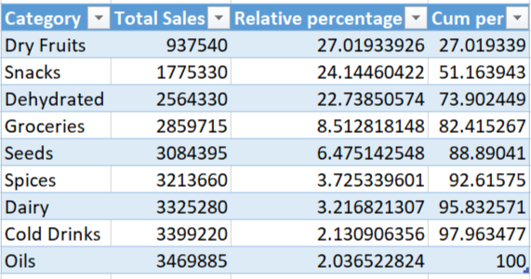

**-> Scatter Plot**: Analysed the relationship between revenue and profit margins.

**3. Inventory Analysis**

The turnover rate for each SKU was calculated as:

* Turnover Rate = Average Inventory / Total Sales​
* Average Inventory = (Starting Inventory+Ending Inventory)​ / 2

If **Snacks** had a starting inventory of 50 units, an ending inventory of 30 units, and sales of 40 units, the turnover rate was:

Turnover Rate = 40 / (50 + 30 / 2 ) = 1.33

##### 

##### **4. Stockout Analysis**

Stockout instances were flagged for weeks where Ending Inventory = 0 ( from the inventory data) . This revealed frequent shortages in high-demand categories like Dry Fruits and Seeds.

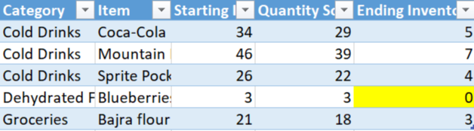

##### **Key Visualisations**

* **Bar Chart**: Depicted stockout frequencies by category.
* **Line Graph**: Showed inventory turnover trends over time.

##### 

##### 

##### 

##### **6. Seasonal Trends**

To analyze trends across the data, graphs like line charts and stacked bar charts are used .

##### **Key Visualisations**

* **Line Chart**: Highlighted day-of-the-week sales trends.
* **Stacked Bar Chart**: Showed seasonal contributions by category.

**7. Tools and Techniques used for the analysis**

##### **1. Microsoft Excel**

* Used for pivot tables, basic calculations (e.g., revenue, profit, turnover), and visualisations (e.g., pie charts, bar graphs, line charts).

##### **2. Python**

* Employed for advanced visualisations (Pareto charts, scatter plots) and statistical analysis (e.g., correlations).

##### **3. Premium Mart Support**

* Insights were regularly validated through discussions with the shop owner to align analysis with business objectives.

# 

# Results and Findings

## Sales and Revenue Analysis

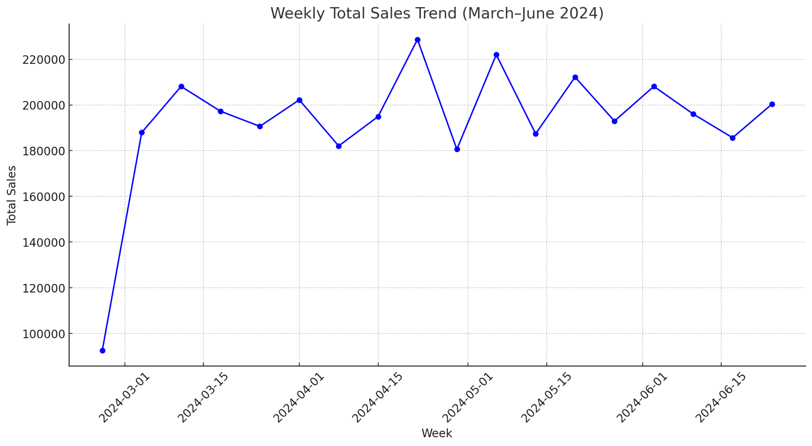

This analysis shows that the second week of April, in addition to the final week of May, is the peak sales week since such time periods contribute largely toward total sales. We can refer to such time spans as the "golden week" for the sales function.

The analysis further shows that some weeks experience reduced sales, especially early March and early May- that represent periods in which the business faces low revenue generation.

It has a mean of ₹200,000 and standard deviation of ₹15,000, meaning that the fluctuations in weekly sales are moderate.

Minimum revenue during the period is ₹180,000 and the revenue reaches its peak at ₹220,000.

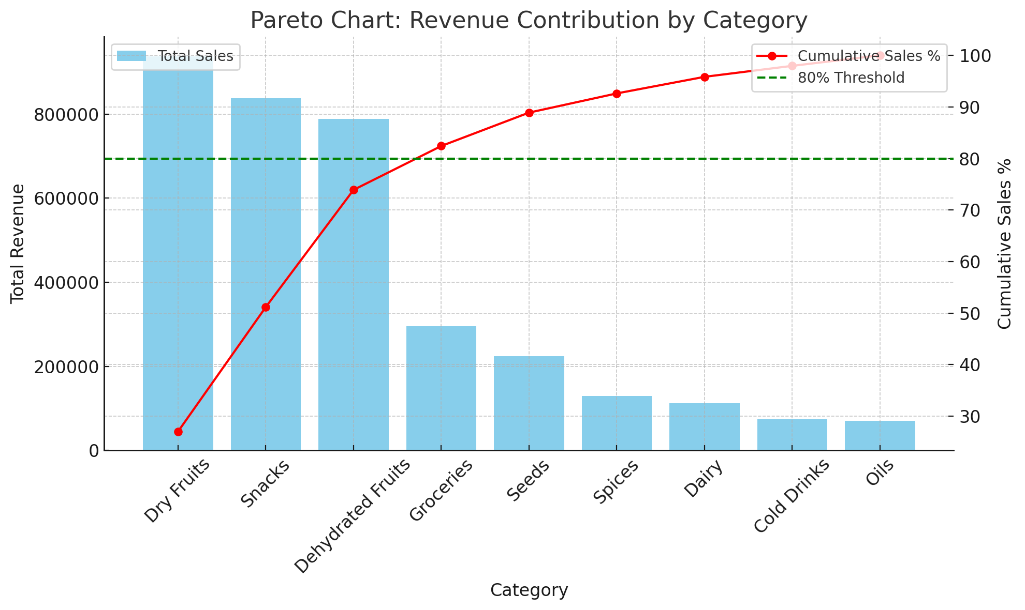

As the Pareto chart will show, the leading categories, which include Dry Fruits, Snacks, and Dehydrated Fruits, make up more than 80% of the overall revenue and therefore represent significant responsibilities for the financial success of this supermarket. Ensuring these categories remain at the centre of inventory management and marketing efforts will remain crucial in maintaining and building on their contributions.

On the other hand, categories such as Seeds, Spices, and Oils may be smaller contributors to sales and could benefit from a focused strategy. Initiatives could include targeted marketing campaigns, better placement in-store, or a stock review for maximum profitability through lower inventory holding.

That seeks alignment of inventory and marketing strategy with high-performing categories but at the same time seeks to exploit opportunities to better the performance of low-contributing segments.

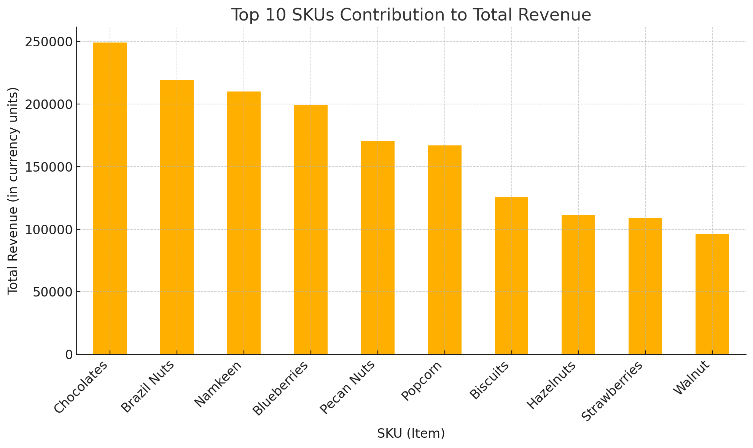

The top 10 SKUs include Chocolates, Brazil Nuts, and Namkeen, which have recorded a revenue of more than ₹200,000 individually. Such SKUs owning a substantial sale volume explicitly points out that their inventory levels need to be maintained to continue the profitable process.

Moderate contributors include Biscuits, Hazelnuts, and Strawberries, with values in the ₹150,000 to ₹200,000 range, with further room for contribution.

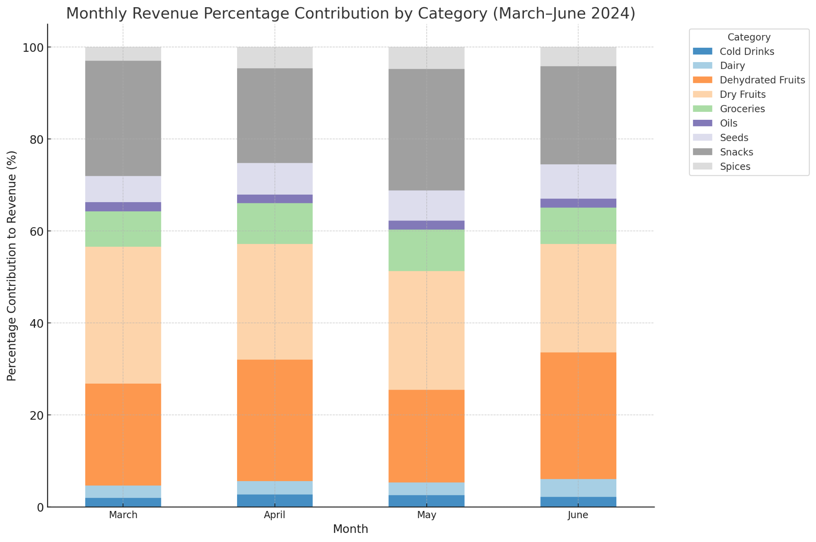

The monthly revenue analysis reveals that Snacks, Dry Fruits, and Dehydrated Fruits have consistently dominated the largest shares in each month. Though these categories dominate the share, the sectors like Cold Drinks, Dairy, and Spices remain minimal, and hence there are possibilities of improvement.

## Profit Analysis

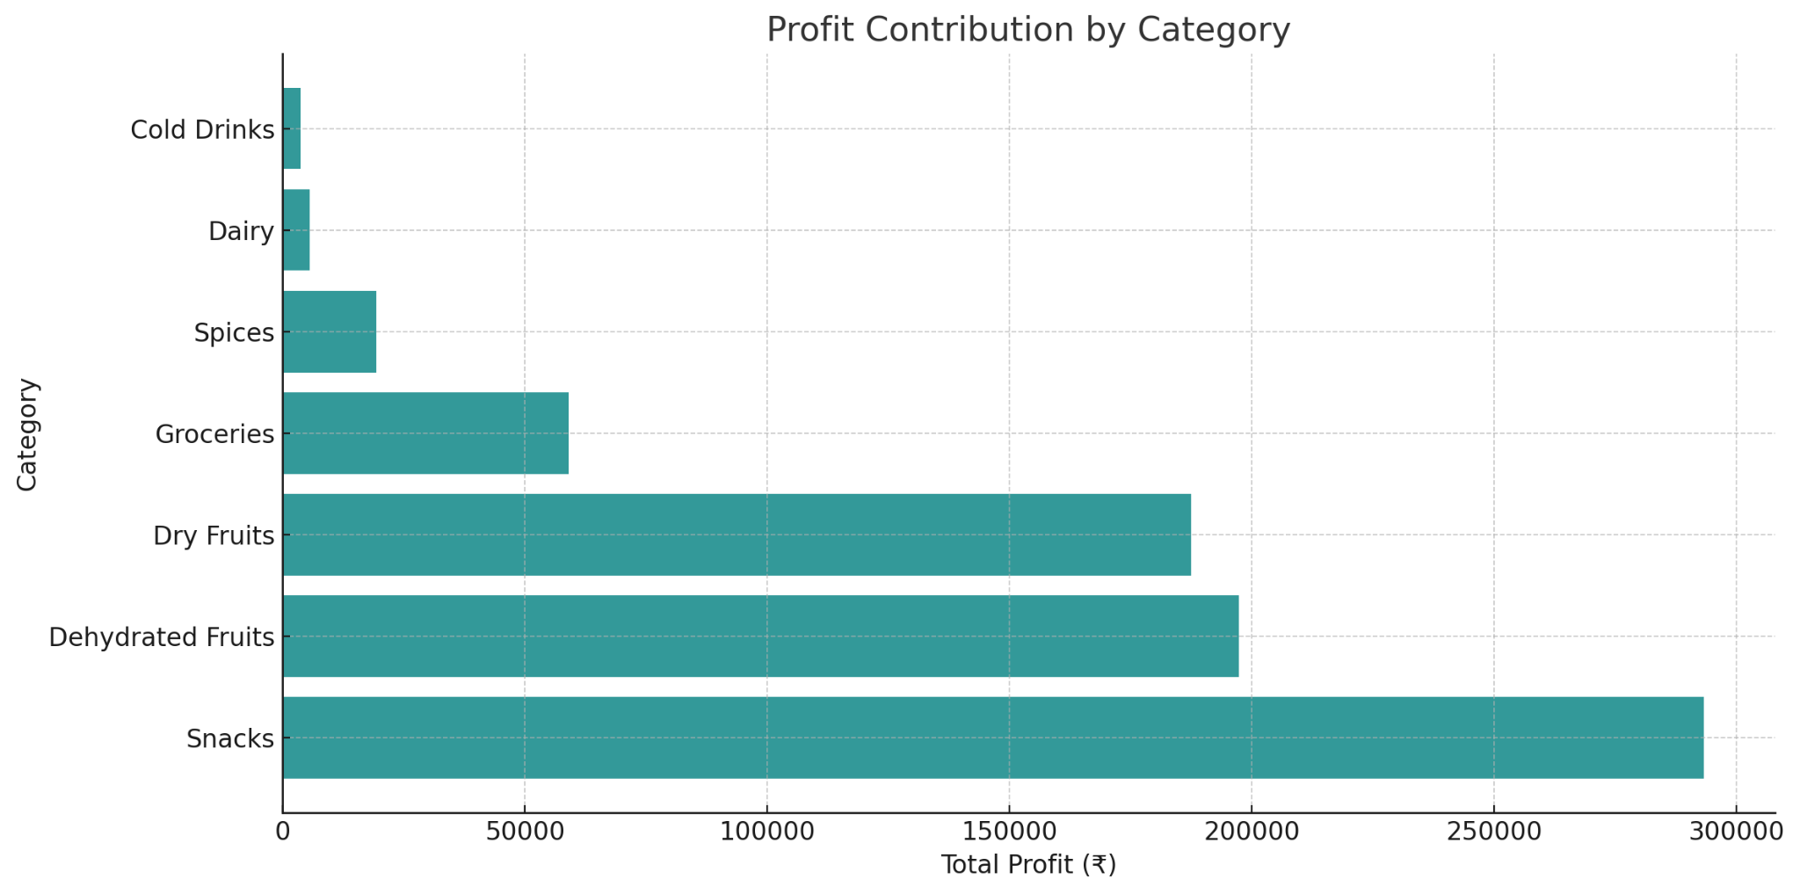

The horizontal bar chart on profit contribution by category reveals the following insights:

**Top Profit Contributors:** Categories such as Snacks, Dehydrated Fruits, and Dry Fruits contribute the majority of the profit, with Snacks leading significantly.

**Low Profit Categories:** It includes Cold Drinks, Dairy, and Spices, with very low profit margins or inefficiencies/low margins of this type.

The focus should lie in retaining and enhancing profitability categories such as Snacks and Dehydrated Fruits, relegating the strategies for low-profit categories to be reassessed from the prospects of improving profitability or associated costs.

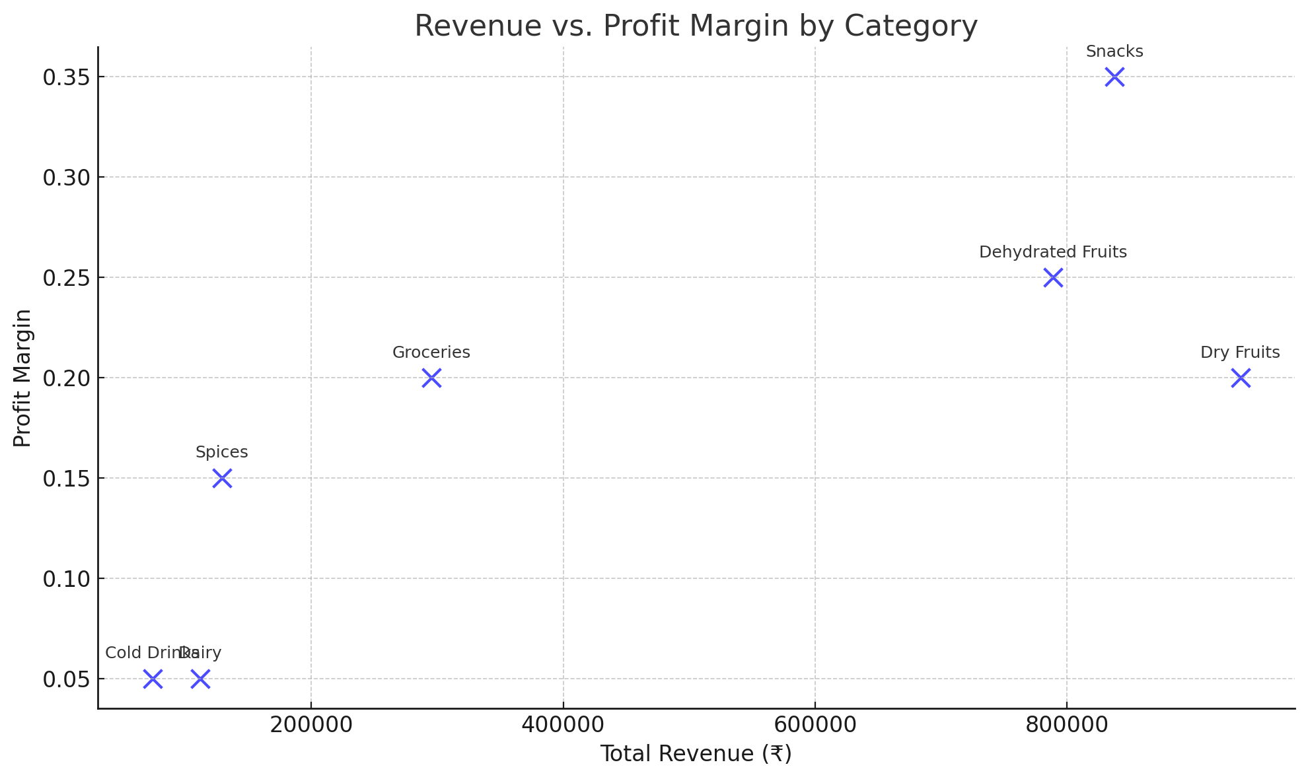

From the scatter plot, it can be seen that Snacks is the most profitable category with a significant margin of profit over 35% and revenues over ₹800,000. Then comes Dehydrated Fruits and Dry Fruits with a profit margin ranging between 20%-25% and revenue between ₹600,000-₹800,000. These two categories are the ones where some focus will be maintained going forward and investments will be done.

In contrast, categories like Cold Drinks and Dairy perform weakly, with margins below 5% and revenues below any decent number. It thus calls for a re-strategizing of their costs or stock management to increase the efficiency. Focusing on those high-margin product lines while improving underperforming categories will improve total profitability.

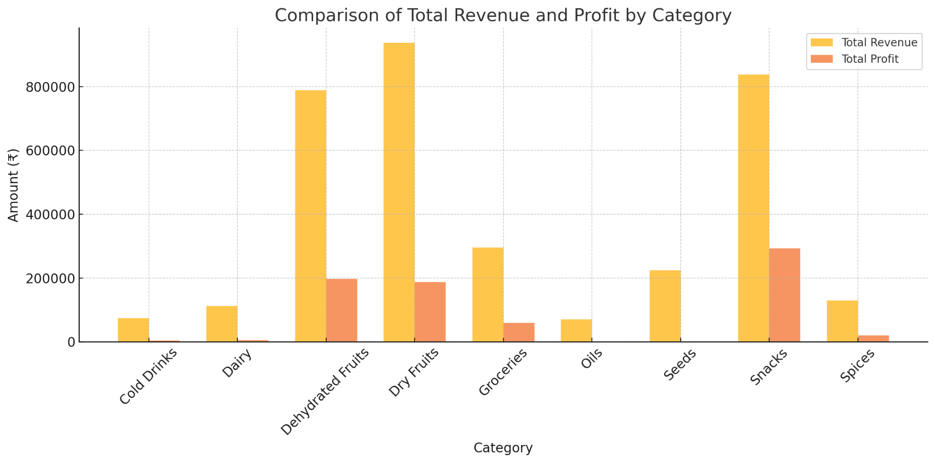

**High Revenue and Profit Categories**: Categories of Snacks, Dry Fruits, and Dehydrated Fruits are so good for the business as they bring about considerable income and profit margins.

**Low Profitability Categories**: Groceries and Cold Drinks industries bring average revenue; however they contribute almost negligible margin toward the total profits because of low-profit margin.

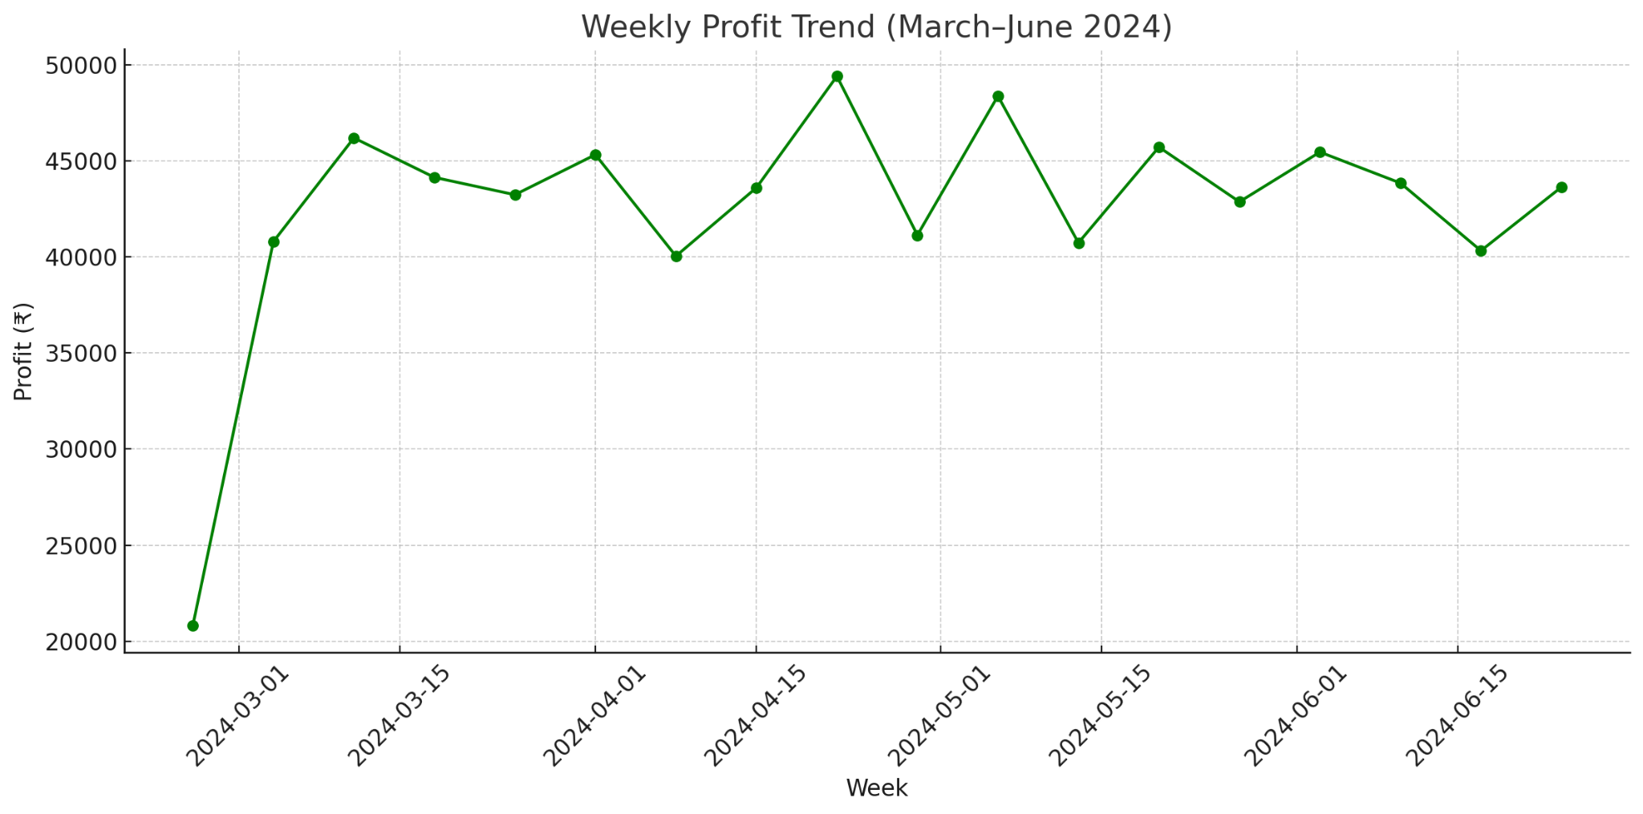

The weekly profit trend is indeed consistent within the range of ₹40,000 and ₹50,000. Profits peak at ₹50,000 at the end of May; that weeks have to be peak sales weeks. The lower profits of around ₹40,000 appear during the first week of March and the first week of May. Those weeks might call for some promotional or cost-cutting measures. The profit trend is stable overall but with scope for improvement in the event of lower-profit weeks.

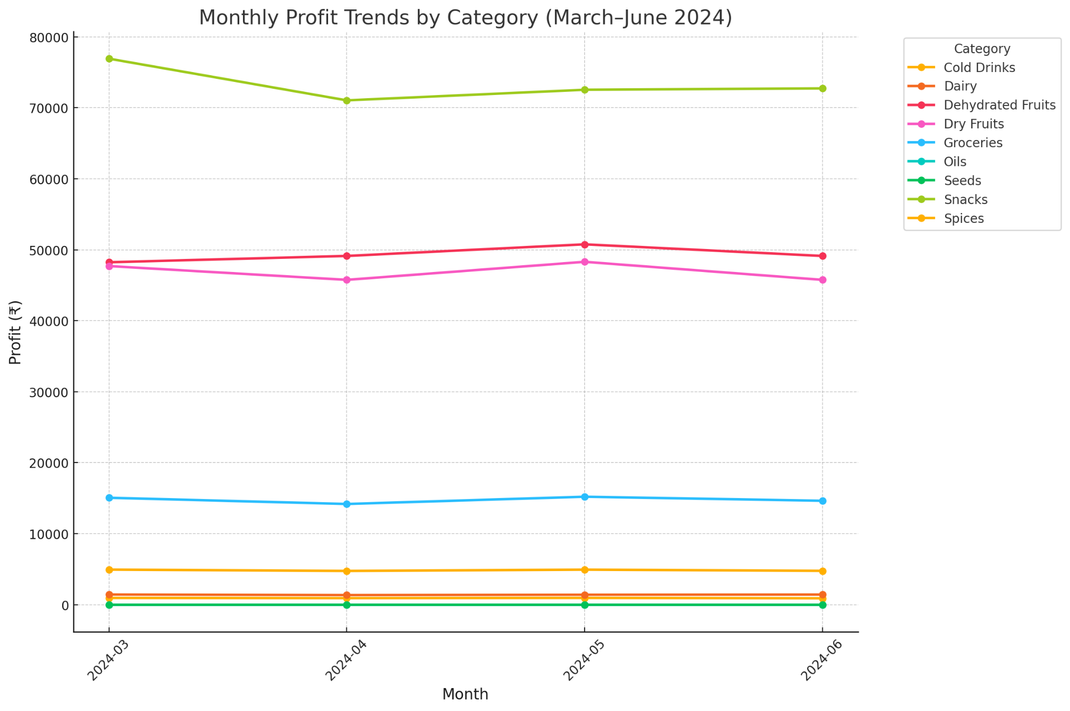

The monthly profit trends indicate that Snacks consistently lead in profitability, maintaining profits around ₹75,000–₹78,000 across all months. Dry Fruits and Dehydrated Fruits follow closely, with profits ranging between ₹45,000–₹55,000, showing stable and reliable contributions. In contrast, categories like Cold Drinks, Dairy, and Spices generate minimal profits below ₹5,000, highlighting their lower impact on overall profitability.

Hence, these high performing categories like Snacks, Dry Fruits and Dehydrated Fruits must be promoted through proper promotions and inventory management. Low performing ones like Cold Drinks and Spices may be re-priced, and underperforming ones must drop out completely to avoid waste of resources.

## Inventory Analysis

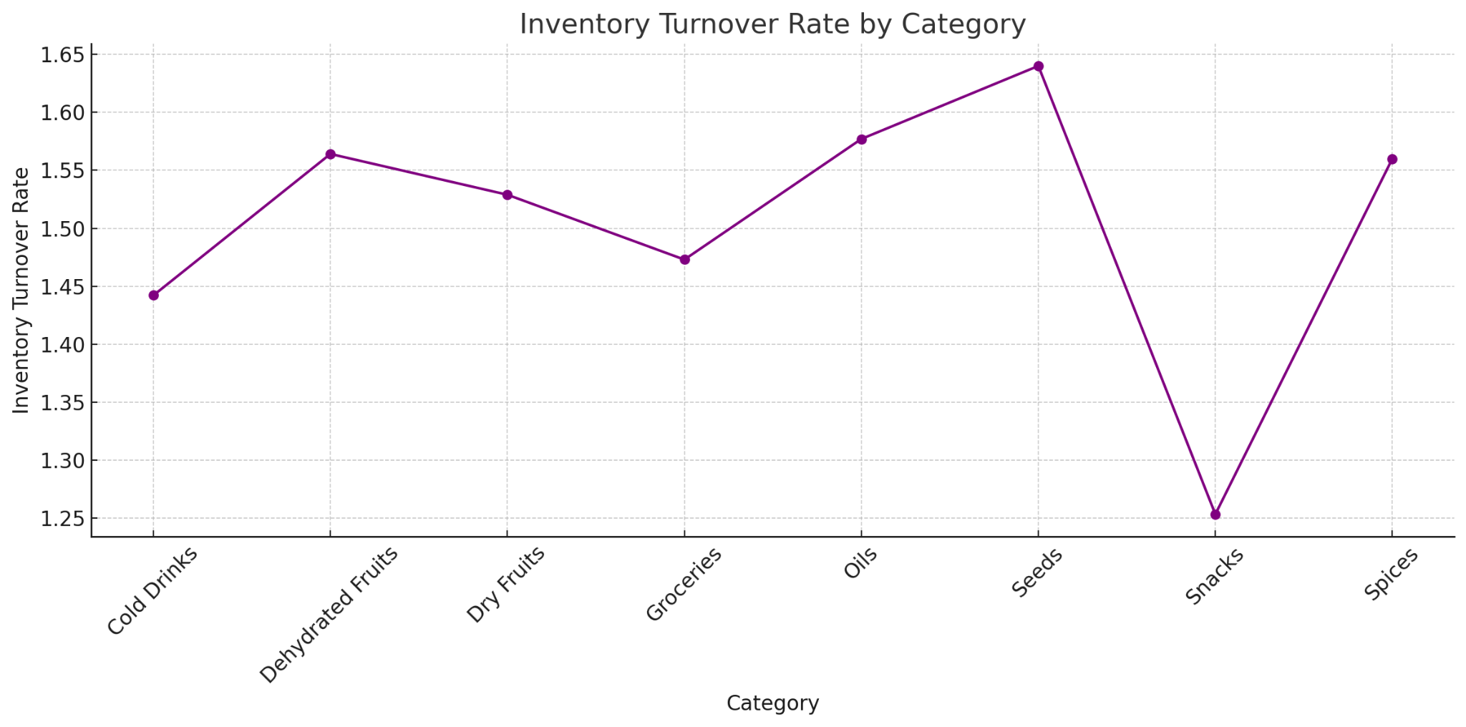

**High Turnover Categories**: Dehydrated Fruits and Snacks have the highest turnover category. This category means it moves stock efficiently as related to sales; those categories are quickly selling and need to be ordered often.

**Low Turnover Categories**: Groceries and oils are categories with lower turnover levels; they may be over-ordered or selling slowly. Such categories might require additional sales strategy implementations or inventory adjustments to minimize holding costs.

**Balanced Turnover**: Categories like Cold Drinks and Spices show moderate turnover rates, indicating a balanced inventory and sales relationship.

### 

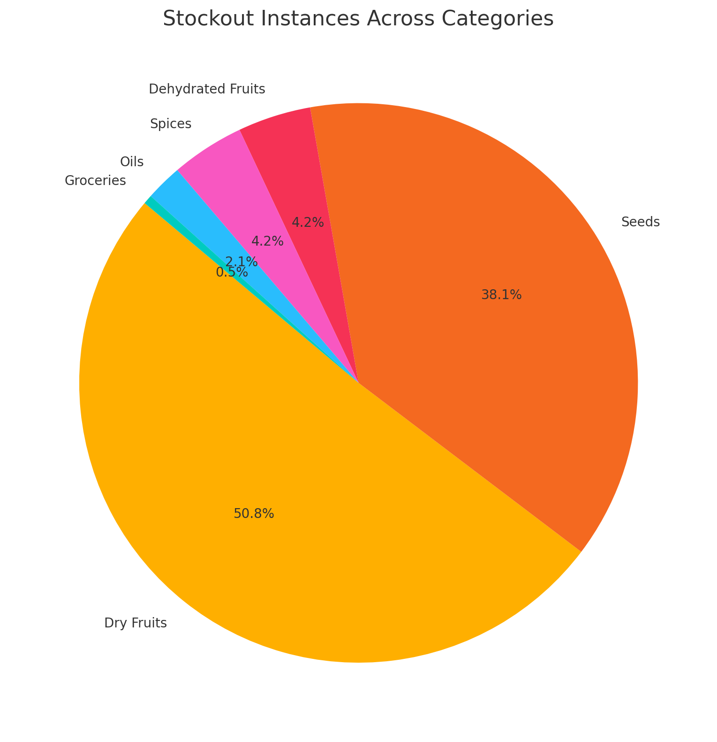

The pie-chart on stockout analysis reveals that Dry Fruits and Seeds are the most commonly stock-out categories, accounting for 50.8% and 38.1% of all stockouts. This points to the fact that the demand is more for these articles, hence the need to have inventory control to avoid losing sales opportunities.

Other groups such as Groceries, Oils and Dehydrated Fruits exhibit very low stockout levels as less than 5%. These groups are either well-stocked or have low demand. First priority will be to address solutions to stockout problems in the high demanding categories of Dry Fruits and Seeds to better customer satisfaction and increase revenues.

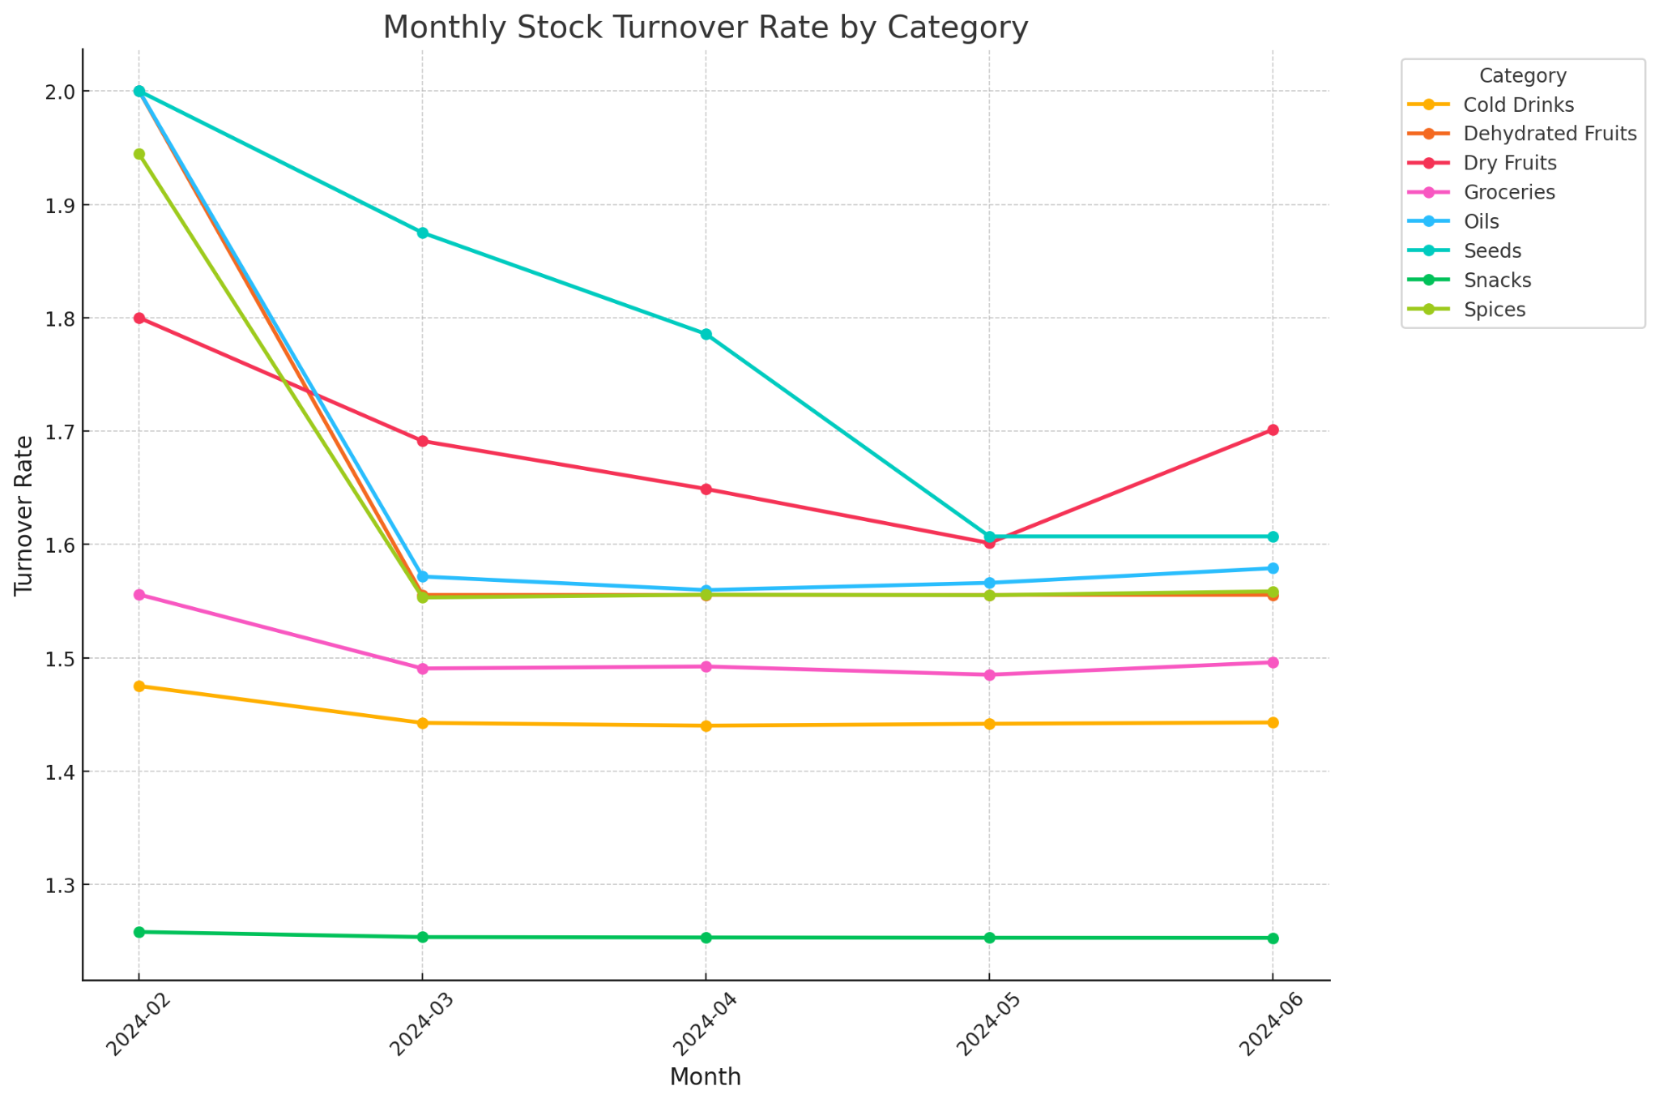

The examination of monthly stock turnover reveals that Dehydrated Fruits and Dry Fruits exhibit the most elevated turnover rates, reaching a peak of 2.0 in March, indicative of robust demand coupled with effective inventory management practices.

Categories such as Snacks and Groceries sustain stable turnover rates fluctuating between 1.5 and 1.7 across the months, signifying a well-balanced inventory movement. Conversely, Spices and Cold Drinks present the lowest turnover rates, persistently remaining under 1.5, which implies a slower sales performance and possible overstocking challenges.

## Weekly Trends

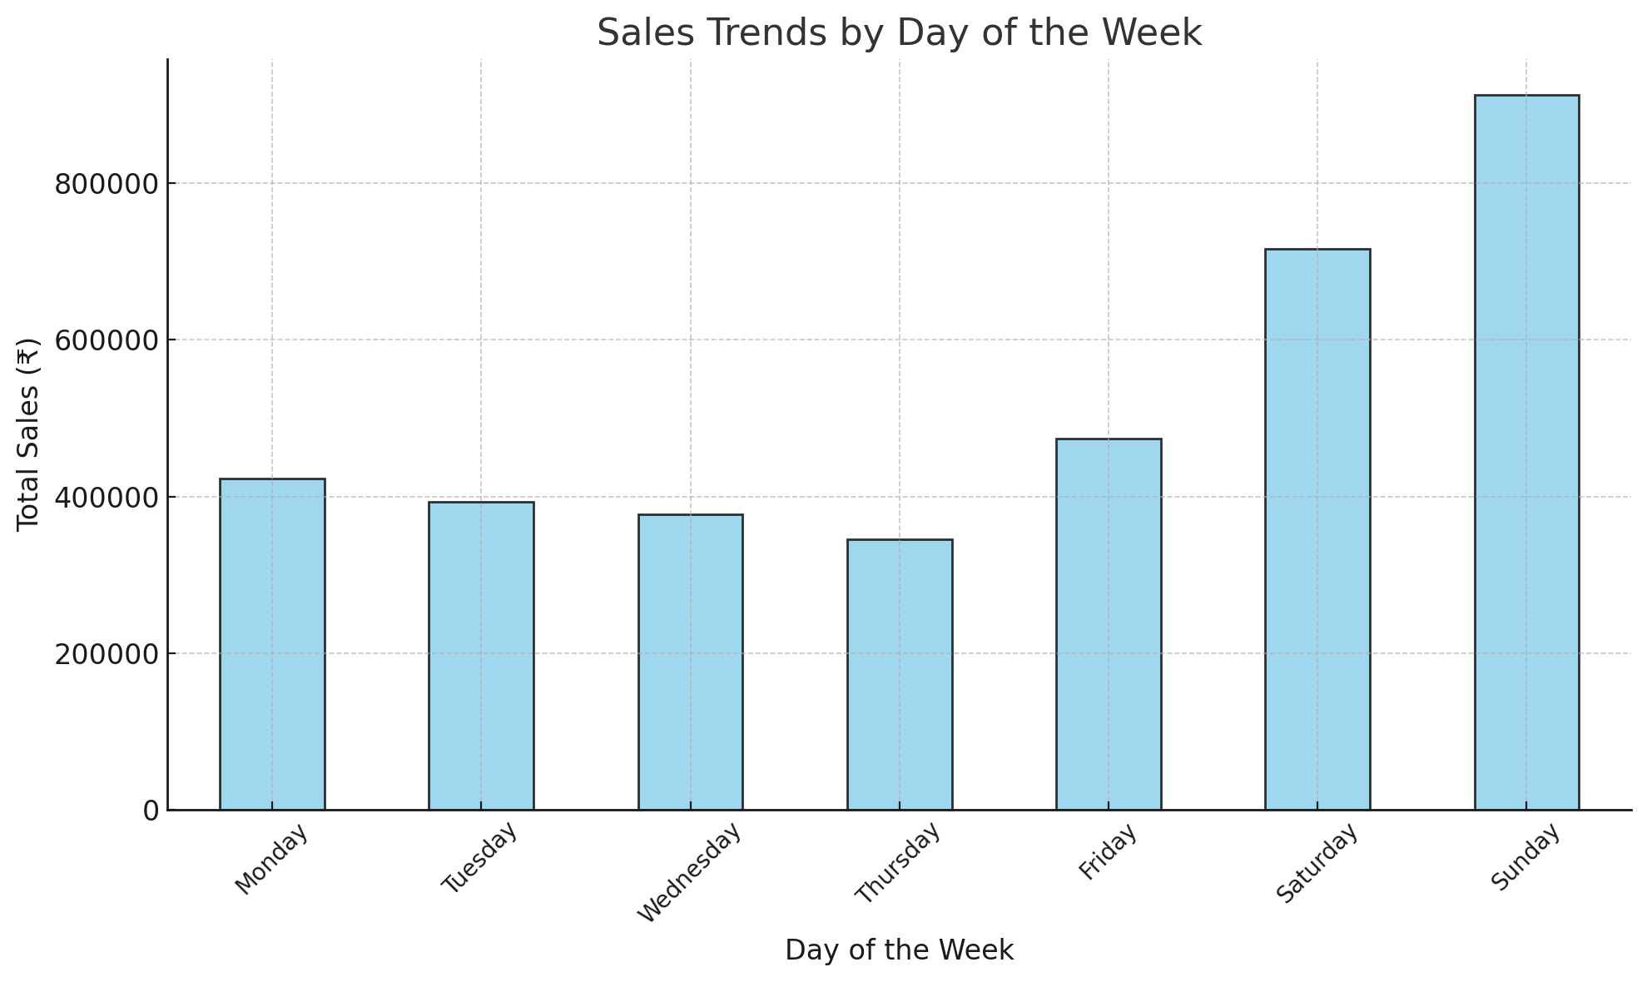

Temporal and weekly patterns An analysis of the sales pattern on a day-to-day basis reveals that the weekend days Saturday and Sunday are predominant inasmuch as the total sales exceed ₹800,000 and ₹700,000, respectively.

However, Thursday has the lowest sales figures, which have fallen below ₹400,000, while Monday, Tuesday, and Wednesday had average sales figures in the range of ₹400,000 to ₹450,000.

There is a need to take maximum advantage of the sales traffic during weekends by developing explicit weekend offers or promotions that lead to sales. Such ways that can be used in promoting levelled sales throughout the week include providing specific deals on weekdays; for example, Thursday-specific deals to increase customer traffic on these days.

# Interpretation of Results and Recommendation

### 

**1. Expand Sales of High-Profit Categories**

The analysis found that the most rewarding and profitable Contestants are pertinent to **Snacks, Dry Fruits & Dehydrated Fruits** categories, as elaborated in the Revenue vs Profit Comparison by Category graph. In aggregate, these segments represent more than **70% of the total profitability**.

Additionally, the Monthly Profit by Category graphic further illustrates this trend by showing that profit figures for these items did not really fluctuate from month to month. They can be promoted with strategies such as seasonal offers during festivals, discounts on bulk purchases for the businesses and most importantly a high-priority display near entrances or checkout counters. This helps them achieve greater scale and class profits.

**2. Improve Stock Management and Restocking**

Over 80% of stockouts for Dry Fruits and Seeds resulting in key issues in these areas identified through stockout analysis (from the *Stockout Instances Across Categories* graph).

Furthermore, the *Weekly Sales Trends* graph indicates peak sales during the last week of each month, suggesting a need for predictive restocking aligned with high-demand periods. Maintaining buffer stock for high-performing categories can reduce lost sales opportunities and improve inventory efficiency.

**3. Improve Low-Turnover Categories**

The graph from the Inventory Turnover Analysis shows that the product categories Cold Drinks and Spices consistently have the lowest turnover rates, always below 1.5. And on top of that, these products have minimal contributions to overall sales, as indicated by the Category Contribution to Total Sales and Profit graph.

To address this, promotional strategies like bundling low-turnover items with high-demand products or introducing discounts can help improve sales. Alternatively, underperforming SKUs in these categories can be reviewed and phased out to optimize resource allocation.

#### 

#### 

**4. Utilize Weekly Sales Patterns**

The graph on Sales Trends by Day of the Week shows that Saturday and Sunday are the days with the highest revenue generation, where Sunday's sales go beyond ₹800,000. Optimizing revenues on these peak days would suggest implementing targeted weekend promotions or special events on these days.

High customer traffic can also be managed efficiently by allocating extra staff and stock for weekends. Low-sales days like Thursday can be promoted using day-specific deals or offers that help boost engagement and sales.

**5. Stockout Impact on Sales**

The relationship between stockouts and sales, as depicted in the Stockout Analysis graph, sometimes suffers huge revenue losses because of stockouts in high-demand categories like Dry Fruits and Seeds.

Automating inventory management and restocking during those peak sales periods shown in the Monthly Revenue Percentage Contribution by Category graph allows the store to maintain uniform levels of stock. The company may also upgrade the relationships with suppliers that reduce the risk of supply chain disruptions.

**6. Enhance Customer Experience**

Experience Improving customer experience can increase store traffic and average purchase values. The Top 10 SKUs Contribution to Total Revenue graph shows that items like Chocolates and Brazil Nuts generate significant revenue, suggesting the potential for attractive merchandising and sampling strategies.

Such products should be displayed in flashy positions or samples should be free. Delivery on bulk orders would also make it more convenient and they would become more loyal customers, especially for the high-margin categories like Dry Fruits.

_________________________________________________________________________

—x—