**Excel Assignment - 12**

**Dataset:**

https://docs.google.com/spreadsheets/d/1IRSEnmgz8Ro276-

GslknRNk0zlrB5CZH1YrnT71kqFM/edit?usp=sharing

**Use the above dataset and answer the following questions.**

**1. What is the total amount of stationary bought from Madhya Pradesh?**

Formula: =SUMIFS(D2:D187,F2:F187,"Madhya Pradesh",C2:C187,"Stationary")

Total amount of stationary bought from Madhya Pradesh: **176971**

**2. What is the total count of stationary bought from Tamil Nādu?**

Formula: =COUNTIFS(F2:F187,"Tamilnadu",C2:C187,"Stationary")

Total count of stationary bought from Tamil Nādu: **13**

**3. What is the total amount spent on footwear?**

Formula: =SUMIFS(D2:D187,C2:C187,"Footwear")

Total amount spent on footwear: **194226**

**4. What is the total amount of money spent for stationary in July?**

Formula: =SUMIFS(D2:D187,E2:E187,">="&DATE(2016,7,1), E2:E187,"<="&EOMONTH(DATE(2016,7,31),0))

Total amount of money spent for stationary in July: **67565**

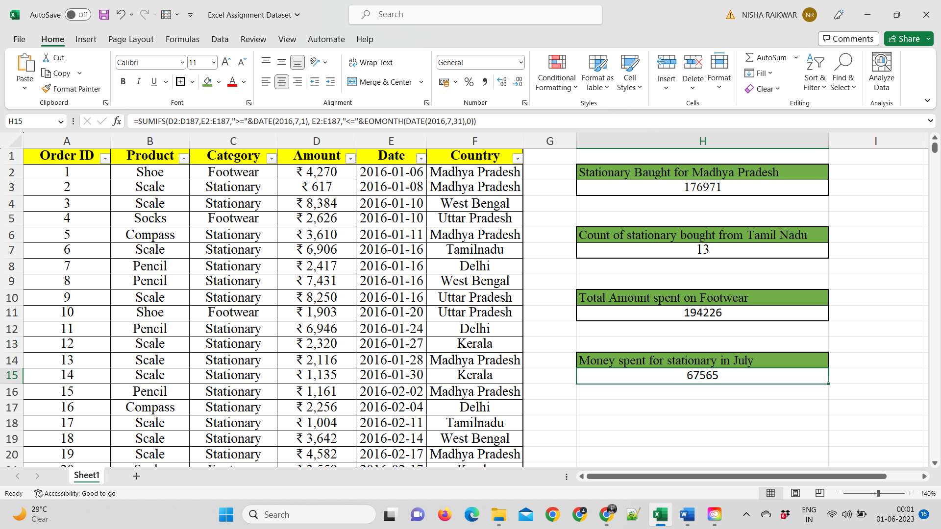

**5. What is the count of footwear that is coming from Delhi?**

Formula: =COUNTIFS(F2:F187,"Delhi",C2:C187,"Footwear")

The count of footwear that is coming from Delhi: **2**

