**Excel Assignment - 14**

**Dataset:**

https://docs.google.com/spreadsheets/d/1-Zo-

A4gnlLOQxpU8qgpkTJPJCS8cQBmNzKVirJ_Ow0w/edit?usp=sharing

**Use the above dataset and answer the following questions. Assume that a**

**gang is trying to loot Diamonds and Soft drinks being exported from India.**

**1. How much Diamonds were looted from Chennai Port Trust?**

Formula: =SUMIFS(D2:D59,C2:C59,"Chennai Port Trust")

Diamonds were looted from Chennai Port Trust: **7182**

**2. How many Ships were looted near Paradip Port Trust and Chennai Port**

**Trust?**

Ships looted near Paradip Port Trust: **3**

Formula: =COUNTIFS(C2:C59,"Paradip Port Trust",B2:B59,"Ship/to/Ship")

Ships looted near Chennai Port Trust: **3**

Formula: =COUNTIFS(C2:C59,"Chennai Port Trust",B2:B59,"Ship/to/Ship")

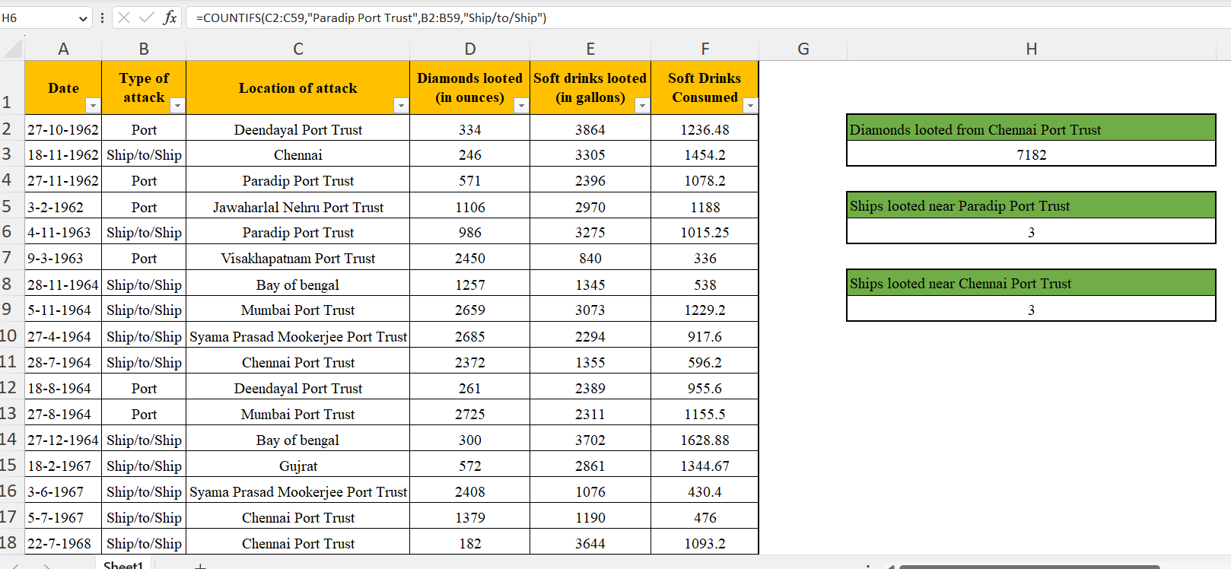

**3. What is the sum total of Diamonds looted from the V.O. Chidambarnar**

**port trust?**

Formula: =SUMIFS(D2:D59,C2:C59,"V.O. Chidambaranar Port Trust")

Sum total of Diamonds looted from V.O. Chidambarnar Port Trust: **9887**

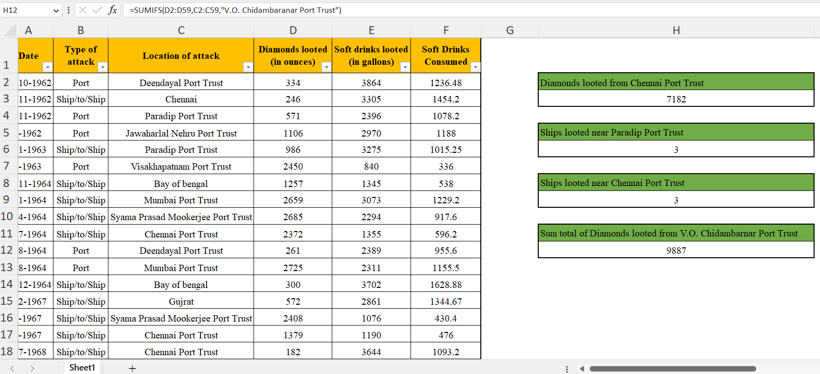

**4. What is the average amount of Diamonds and Soft drinks looted?**

Formula for Diamonds: =AVERAGE(D2:D59)

Average amount of Diamonds looted: **1254.862069**

Formula for Soft Drinks: =AVERAGE(E2:E59)

Average amount of Soft drinks looted: **2227.758621**

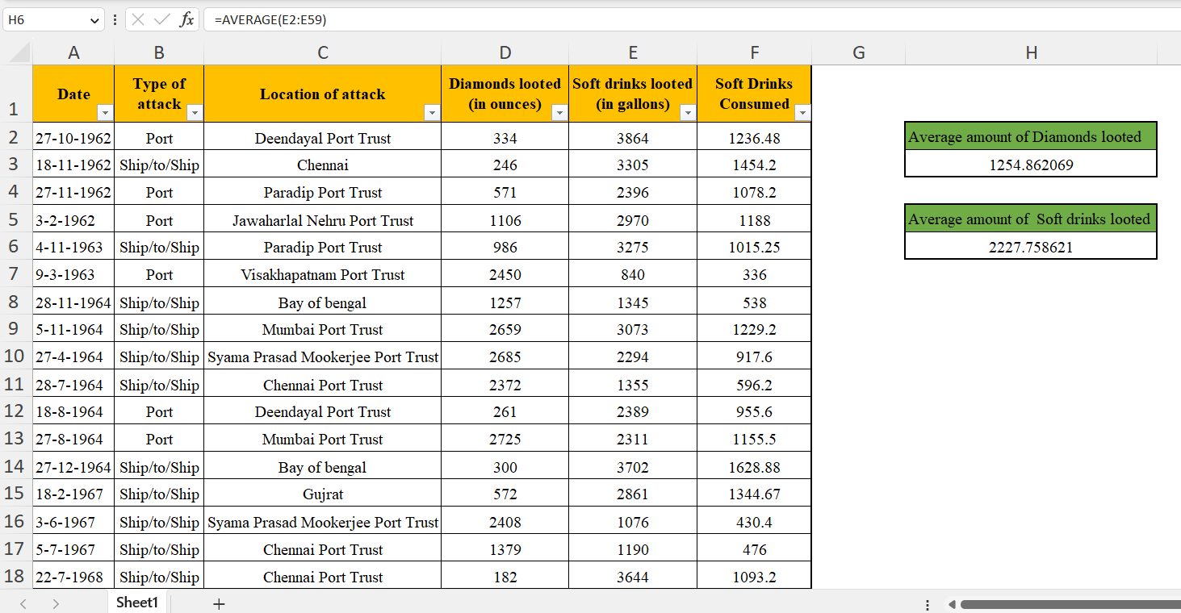

**5. What is the ratio of soft drinks drunk to soft drinks looted?**

Formula: =AVERAGE(F2:F59) / AVERAGE(E2:E59)

The ratio of soft drinks drunk to soft drinks looted: **0.39201664**

