**Excel Assignment - 16**

**1. What is a Macro? How is it useful in excel or in your daily work?**

A macro is a set of instructions or code that automates repetitive tasks in software applications, such as Excel. In Excel, macros are created using the Visual Basic for Applications (VBA) programming language. Here's some information on macros and their usefulness in Excel and daily work:

* Automation: Macros allow you to automate repetitive tasks in Excel. You can record a series of actions, such as formatting, data manipulation, or complex calculations, and then replay them with a single click. This saves time and reduces the potential for errors when performing repetitive tasks.
* Efficiency: Macros help streamline workflows and improve efficiency by automating tasks that would otherwise require manual effort. They can handle large datasets, perform complex calculations, and generate reports or charts automatically, allowing you to focus on more value-added activities.
* Customization: Macros provide the flexibility to customize Excel to meet specific needs. You can create personalized functions, automate data imports or exports, and develop interactive user interfaces. This allows you to tailor Excel to your unique requirements and enhance productivity.
* Data Analysis: Macros can be used to automate data analysis tasks in Excel. You can write VBA code to perform statistical analysis, create dynamic dashboards, generate charts or graphs, and analyze large datasets. Macros enable you to extract meaningful insights from data more efficiently.
* Error Handling: Macros allow you to incorporate error handling and validation checks in Excel. You can write code to validate input data, perform data cleansing, and handle exceptions. This helps ensure data accuracy and integrity while reducing the risk of errors.
* Repetitive Reporting: Macros are useful for automating repetitive reporting tasks. You can create macros to consolidate data from multiple sources, apply predefined formatting, and generate standardized reports with a single click. This saves time and ensures consistency in reporting.
* Personal Productivity: Macros can significantly enhance personal productivity by automating tasks that are performed regularly. Whether it's generating invoices, creating personalized documents, or sending emails, macros can simplify and speed up these activities, allowing you to focus on more strategic or creative work.

In summary, macros are powerful automation tools in Excel that allow you to streamline workflows, automate tasks, and customize Excel to your specific needs. By leveraging macros, you can increase efficiency, reduce errors, and save time in your daily work.

**2. What is VBA? Write its full form and briefly explain why VBA is used in**

**excel?**

VBA stands for Visual Basic for Applications. It is a programming language developed by Microsoft and integrated into their Office suite of applications, including Excel. VBA allows users to automate tasks, create custom functions, and build interactive applications within Excel.

Here's a brief explanation of why VBA is used in Excel:

* Automation: VBA allows you to automate repetitive tasks in Excel. You can write code to perform actions like data manipulation, formatting, and calculations automatically, saving time and effort.
* Customization: VBA provides the flexibility to customize Excel to meet specific needs. You can create custom functions, design user interfaces, and add new features or functionality that are not available in Excel by default.
* Integration: VBA enables integration between Excel and other applications. You can use VBA to interact with external data sources, connect to databases, retrieve data from the web, or automate interactions with other Office applications like Word or PowerPoint.
* Advanced Data Analysis: VBA allows for advanced data analysis in Excel. You can write code to perform complex calculations, statistical analysis, data mining, and modeling. VBA provides the flexibility to build customized data analysis solutions tailored to specific requirements.
* Reporting: VBA is used to automate reporting tasks in Excel. You can create macros to consolidate and summarize data, generate standardized reports, apply formatting, and distribute reports automatically.
* Error Handling: VBA enables error handling and validation checks in Excel. You can write code to validate input data, handle exceptions, and ensure data integrity and accuracy.
* Interactivity: VBA allows you to create interactive applications and user interfaces in Excel. You can build forms, buttons, drop-down menus, and other controls to enhance the user experience and facilitate data entry or analysis.

**3. How do you record a macro? Write detailed steps to create a macro to**

**automatically make the following table in bold and to create borders for**

**it in excel.**

hi 78

hello 69

ineuron 45

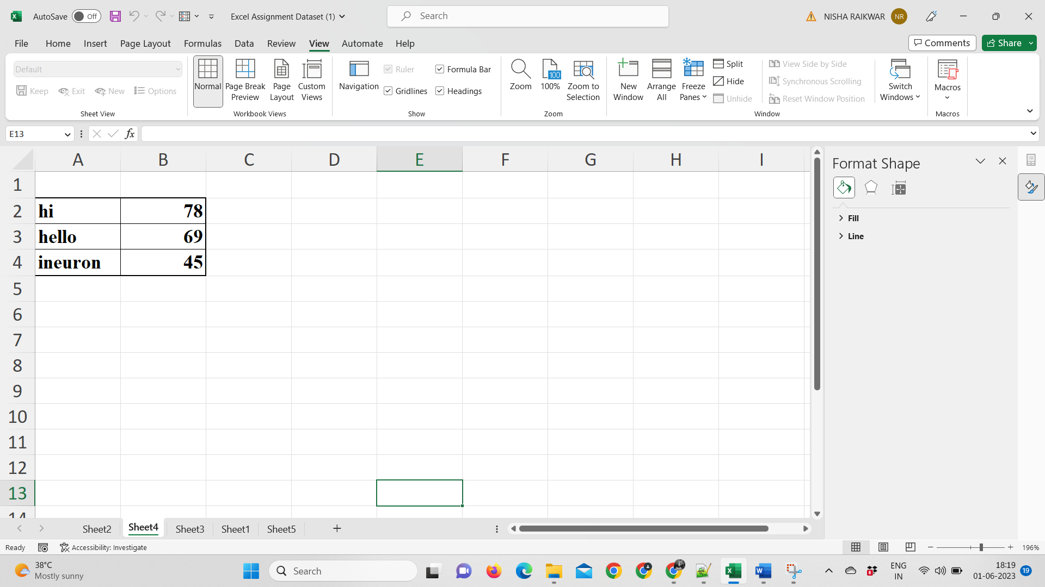

To record a macro in Excel and automate the process of making a table bold and adding borders, follow these detailed steps:

* Open Excel and navigate to the worksheet where you want to create the table.
* In the Excel toolbar, go to the "View" tab and click on the "Macros" dropdown button. Select "Record Macro" from the dropdown menu. The "Record Macro" dialog box will appear.
* In the "Macro name" field, enter a name for your macro. Choose a descriptive name that represents the action you're recording, such as "FormatTable." Avoid using spaces or special characters in the macro name.
* (Optional) In the "Shortcut key" field, you can assign a keyboard shortcut to run the macro quickly. This step is optional, and you can leave it blank if you prefer to run the macro using other methods.
* (Optional) In the "Description" field, you can enter a brief description of the macro. This is useful for documenting the purpose or functionality of the macro for future reference.
* Click on the "OK" button to start recording the macro. The macro recording will begin, and any actions you perform in Excel will be recorded.
* Select the table or range that you want to format. This can be done by clicking and dragging the mouse to select the cells.
* In the Excel toolbar, go to the "Home" tab. To make the selected table bold, click on the "Bold" button in the "Font" group.
* To add borders to the table, click on the "Borders" button in the "Font" group. Choose the desired border style from the dropdown menu, such as "All Borders" or "Outline."
* Once you have finished formatting the table, go back to the Excel toolbar and click on the "Stop Recording" button, represented by a square icon, in the "Macros" dropdown.
* The macro recording is now complete. You can run the macro by going to the "View" tab, clicking on the "Macros" dropdown, and selecting the macro name from the list. Alternatively, if you assigned a shortcut key in step 4, you can use that shortcut to run the macro.

**4. What do you mean when we say VBA Editor?**

When we refer to the VBA Editor, we are referring to the integrated development environment (IDE) within Microsoft Office applications, including Excel, that allows users to write, edit, and manage VBA code. The VBA Editor provides a dedicated workspace for writing and debugging VBA macros and applications.

Here are some key features and components of the VBA Editor:

* Code Window: The main area of the VBA Editor where you write and view VBA code. It provides syntax highlighting, code suggestions, and various tools to help with code development.
* Project Explorer: This window displays a hierarchical view of the workbook and its associated VBA projects. It allows you to navigate through different modules, forms, and other project components.
* Properties Window: The Properties window displays the properties and attributes of selected objects, such as worksheets, cells, or controls. You can modify these properties to customize the behavior or appearance of the objects.
* Immediate Window: The Immediate window is a useful tool for testing and debugging VBA code. It allows you to execute code statements and view the results interactively.
* Watch Window: The Watch window helps you monitor the value of variables or expressions during code execution. You can add variables to the Watch window to keep track of their values and easily identify any issues or changes
* Object Browser: The Object Browser provides a comprehensive view of the available objects, properties, methods, and events in the Excel object model. It helps you explore and understand the functionalities provided by various objects.
* Debugging Tools: The VBA Editor includes debugging tools such as breakpoints, step-through execution, and error handling capabilities. These tools help identify and resolve issues in VBA code by allowing you to pause the execution, examine variable values, and track the flow of the program.

**5. Briefly describe the interface of a VBA editor? What is properties**

**window? And what is watch window? How do you display these**

**windows?**

The interface of the VBA Editor consists of several windows and tools that facilitate the development and management of VBA code. Here's a brief description of the main components:

* Code Window: The Code window is the main area where you write and view VBA code. It provides syntax highlighting, line numbering, and code suggestions as you type. This is where you write your macros, functions, or event procedures.
* Project Explorer: The Project Explorer window displays a hierarchical view of the workbook and its associated VBA projects. It allows you to navigate through different modules, forms, class modules, and other project components. You can expand or collapse project nodes to access specific code modules or forms.
* Properties Window: The Properties window provides a list of properties and attributes for the currently selected object. It allows you to view and modify various properties to customize the behavior or appearance of objects. For example, you can change the font size of a textbox or set the number format of a cell.
* Immediate Window: The Immediate window is a tool for testing and debugging VBA code. It allows you to execute code statements interactively and view the results immediately. You can also use it to debug by displaying the values of variables or expressions during code execution.
* Watch Window: The Watch window is used to monitor the value of variables or expressions during code execution. You can add variables or expressions to the Watch window to track their values as the code runs. This helps you observe changes, debug issues, or verify the expected behavior of your code.

To display these windows in the VBA Editor:

* Code Window: The Code window is the default window that appears when you open a code module. You can navigate to a specific code module by selecting it in the Project Explorer window.
* Project Explorer: To display the Project Explorer window, press "Ctrl+R" or navigate to "View" in the VBA Editor's menu and click on "Project Explorer."
* Properties Window: To display the Properties window, press "F4" or navigate to "View" and click on "Properties Window." You can also right-click on an object in the VBA Editor and select "Properties" from the context menu.
* Immediate Window: To display the Immediate window, press "Ctrl+G" or navigate to "View" and click on "Immediate Window." You can also open it by clicking on the "Immediate" button in the toolbar.
* Watch Window: To display the Watch window, go to "View" and click on "Watch Window." Alternatively, you can add or view variables in the Watch window by selecting them in the code and right-clicking to access the context menu, then choose "Add Watch."

**6. What is an immediate Window and what is it used for?**

The Immediate Window is a feature within the VBA Editor in Excel and other Microsoft Office applications. It provides an interactive window where you can execute VBA code statements, view immediate results, and interact with the code during development and debugging. Here's a brief description of the Immediate Window and its uses:

* Code Execution: The Immediate Window allows you to execute VBA code statements line by line or in batches. You can type or paste code directly into the window and press Enter to execute it immediately. This provides a quick way to test code logic, evaluate expressions, or perform calculations without having to run an entire macro or procedure.
* Debugging: The Immediate Window is a valuable tool for debugging VBA code. During code execution, you can use the Immediate Window to check the value of variables or expressions at specific points in your code. By printing values or using the Debug.Print statement, you can verify if variables have the expected values, identify issues, or track the flow of the program.
* Variable Manipulation: The Immediate Window allows you to interact with variables in real-time. You can change the value of variables on-the-fly by assigning new values directly in the Immediate Window. This is particularly useful when debugging and testing different scenarios or conditions without modifying the code itself.
* Quick Calculations: The Immediate Window is helpful for performing quick calculations or evaluations. You can enter mathematical expressions or formulas directly into the window and immediately see the results. This can be useful for testing formulas, verifying calculations, or performing ad-hoc calculations without leaving the VBA Editor.
* Object Manipulation: The Immediate Window enables interaction with objects in VBA. You can access object properties or methods directly in the Immediate Window to view or modify their values during code execution. This can be helpful for inspecting or manipulating object properties, testing object behavior, or exploring the capabilities of specific objects.