Excel Questions- 18

**1. What are comments and what is the importance if commenting in any**

**Code?**

Comments in code are text-based annotations or explanations that are written within the source code of a computer program. These comments are not executed by the computer; instead, they are intended for human readers, including other programmers who may need to understand, modify, or maintain the code in the future. Comments serve several important purposes in programming:

**1. Documentation:** Comments provide documentation and explanations for the code. They help programmers and collaborators understand the purpose of specific code segments, the rationale behind certain decisions, and how the code works. Good comments can serve as a form of self-documentation, making it easier for others (and yourself) to grasp the code's functionality.

**2. Clarity:** Code can be complex and hard to understand, especially for those who didn't write it. Comments help clarify the code's logic and structure. They explain the intent behind variables, functions, and algorithms, making it easier to follow and debug.

**3. Debugging:** When you encounter a bug or need to modify existing code, comments can provide valuable context. They help you identify potential sources of issues or understand why a particular approach was chosen. This can save a significant amount of time when troubleshooting and debugging.

**4. Collaboration:** In collaborative software development, multiple programmers often work on the same codebase. Comments facilitate communication among team members by explaining the purpose and usage of various code components. This reduces misunderstandings and promotes efficient collaboration.

**5. Future Maintenance:** Code is not static; it evolves over time. Comments make it easier for future developers, including yourself, to maintain and extend the codebase. They act as a roadmap, guiding developers who may need to make changes or improvements down the line.

**6. Compliance and Standards:** Comments can help ensure that code adheres to coding standards and practices. They can explain why certain coding conventions or design patterns were chosen, ensuring consistency across the project.

**7. Education:** Comments can be educational for less experienced programmers. They can provide insights into coding techniques, algorithms, and best practices. Novice programmers can learn from well-commented code examples.

**2. What is Call Statement and when do you use this statement?**

* A "call statement" is a generic term used in programming to refer to a statement or instruction that invokes (calls) a function or subroutine. The specific syntax and usage of call statements can vary depending on the programming language you are working with. Here's a general explanation:
* Calling a Function or Subroutine: In most programming languages, you use a call statement to invoke a function or subroutine (also known as a method or procedure). This is done to execute a specific set of instructions encapsulated within that function or subroutine.
* Passing Arguments: When you call a function, you typically provide it with one or more arguments or parameters. These values are passed to the function, allowing it to perform operations with the given data. The function may also return a result, which can be used in the calling code.

**3. How do you compile a code in VBA? What are some of the problem that**

**you might face when you don’t compile a code?**

In VBA (Visual Basic for Applications), you don't typically compile code in the same way you do in some other programming languages. VBA is an interpreted language, which means that it's executed directly by the application in which it's used (e.g., Microsoft Excel, Word, Access, etc.), and there's no separate compilation step like in languages such as C++ or Java. However, there is a process called "compilation" in VBA, but it's not the same as in a compiled language.

In VBA, code is compiled on-the-fly by the VBA editor when you run or execute the code. During this process, the VBA editor checks the code for syntax errors and resolves variable references. If there are any issues, it will display error messages.

To execute or "compile" VBA code, you typically do the following:

1. **Open the VBA Editor:** In the application where you want to run VBA code (e.g., Microsoft Excel), press `Alt + F11` to open the VBA editor.
2. **Navigate to the Module:** In the VBA editor, navigate to the module where your VBA code is located. If you don't have an existing module, you can insert a new one.
3. **Run the Code:** You can run VBA code by placing the cursor within the code you want to execute and pressing `F5` or by selecting "Run" from the menu.

Now, regarding the problems you might face when you don't compile your VBA code or when you have errors in your code:

1. **Syntax Errors:** If your code has syntax errors (e.g., misspelled keywords, missing parentheses, or incorrect variable names), it won't run, and you'll receive error messages.
2. **Runtime Errors:** Even if your code is syntactically correct, it can still have logical errors that cause issues during runtime (e.g., dividing by zero or trying to access an undefined object). Properly debugging your code is essential to catch these errors.
3. **Performance Issues:** Unoptimized or inefficient code can lead to performance problems, such as slow execution or excessive memory usage.
4. **Unexpected Behavior:** Without proper testing and debugging, your code may produce unexpected results, causing data corruption or incorrect calculations.
5. **Maintenance Challenges:** Code that is not well-documented or organized can be difficult to understand and modify in the future, leading to maintenance challenges.

To avoid these problems, it's crucial to follow best practices in VBA development, including:

1. - Regularly test and debug your code.
2. - Use meaningful variable names and comment your code for clarity.
3. - Plan and design your VBA solutions before coding.
4. - Optimize your code for performance.
5. - Consider error handling to gracefully handle unexpected issues.
6. - Keep backups of your work and follow version control practices if collaborating with others on VBA projects.

**4. What are hot keys in VBA? How can you create your own hot keys?**

Hotkeys, also known as keyboard shortcuts or accelerator keys, are key combinations that allow you to quickly perform specific actions or commands in VBA (Visual Basic for Applications) or in the application where you are working (e.g., Microsoft Excel, Word, or Access). These shortcuts can greatly improve your efficiency when working with VBA or any other software.

In VBA, you can create your own custom hotkeys using a technique called "Custom Command Bars." Here's how you can do it:

* Open the VBA Editor: Press Alt + F11 to open the VBA editor.
* Create a New Module (if needed): If you don't already have a module where you want to add the hotkey code, you can create one. Right-click on your VBA project in the Project Explorer, choose "Insert," and then select "Module."
* Write the Code: Inside the module, write the code that you want to execute when the hotkey is pressed.
* Create a Custom Command Bar: Now, you'll create a custom command bar and add your macro to it.
* Run the Code: Close the VBA editor and return to your workbook or document. You can run the CreateCustomHotkey macro by going to the Excel Developer tab (if it's not visible, enable it in Excel options) and clicking "Macros." Select "CreateCustomHotkey" and click "Run."
* Use Your Custom Hotkey: After running the CreateCustomHotkey macro, you should see a floating toolbar with your custom hotkey. Now, you can use Ctrl + Shift + A to trigger the macro and display the message box.

Keep in mind that custom hotkeys created in this way are specific to the workbook or document where you created them. If you want to use the same hotkeys in other documents, you'll need to repeat the process.

Creating custom hotkeys can be a powerful way to streamline your VBA workflow, but be sure to choose key combinations that don't conflict with existing shortcuts in your application.

**5. Create a macro and shortcut key to find the square root of the following**

**numbers 665, 89, 72, 86, 48, 32, 569, 7521**

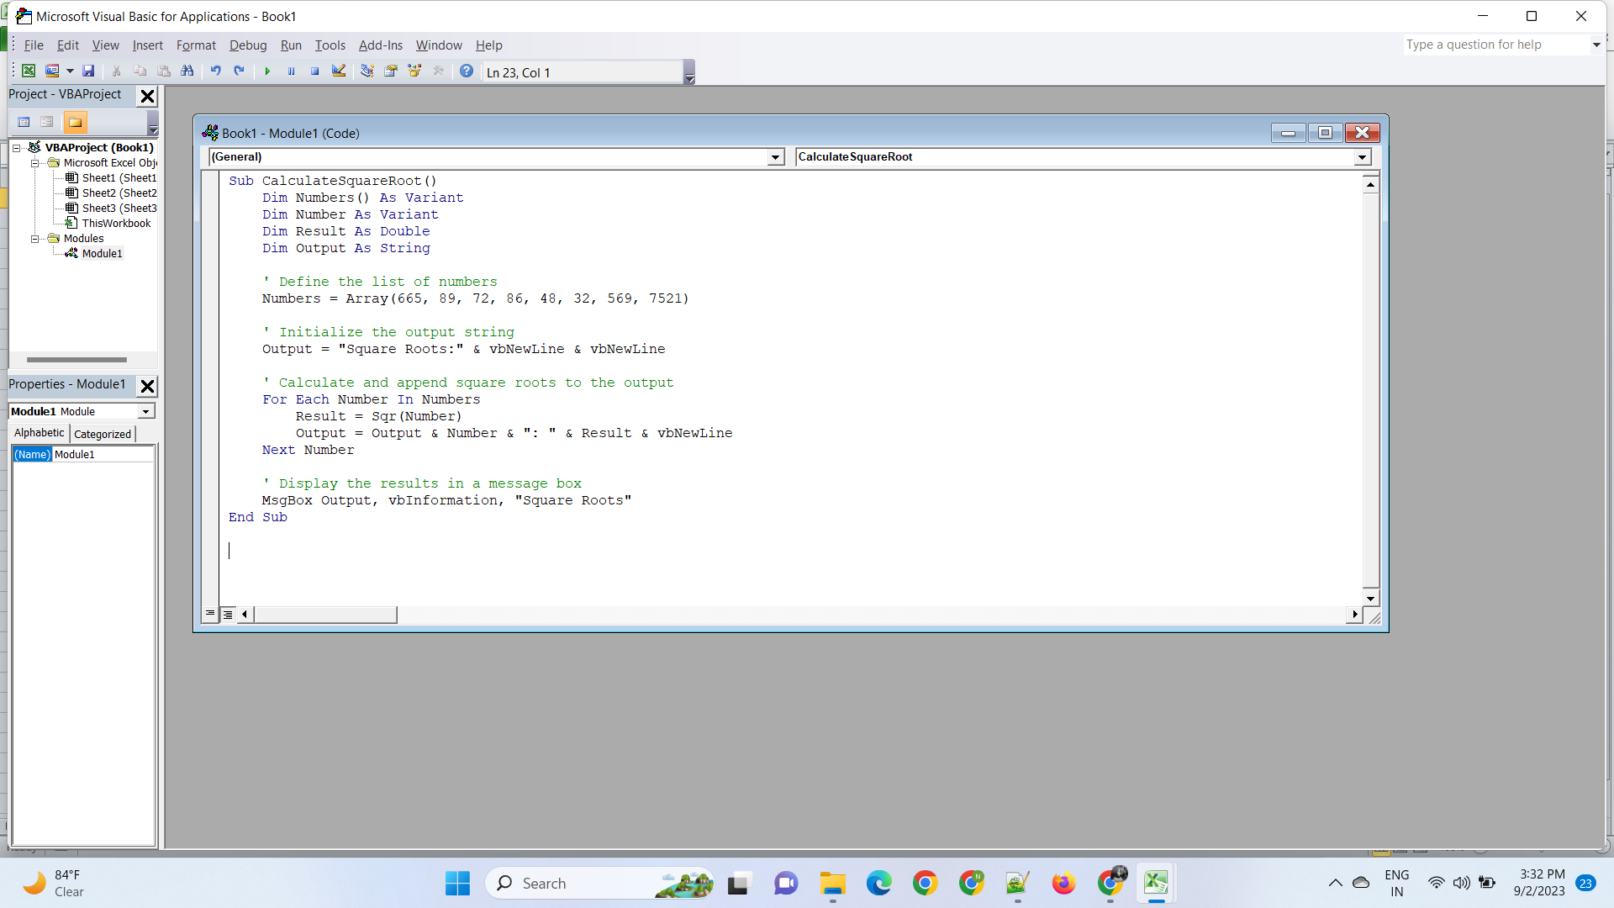

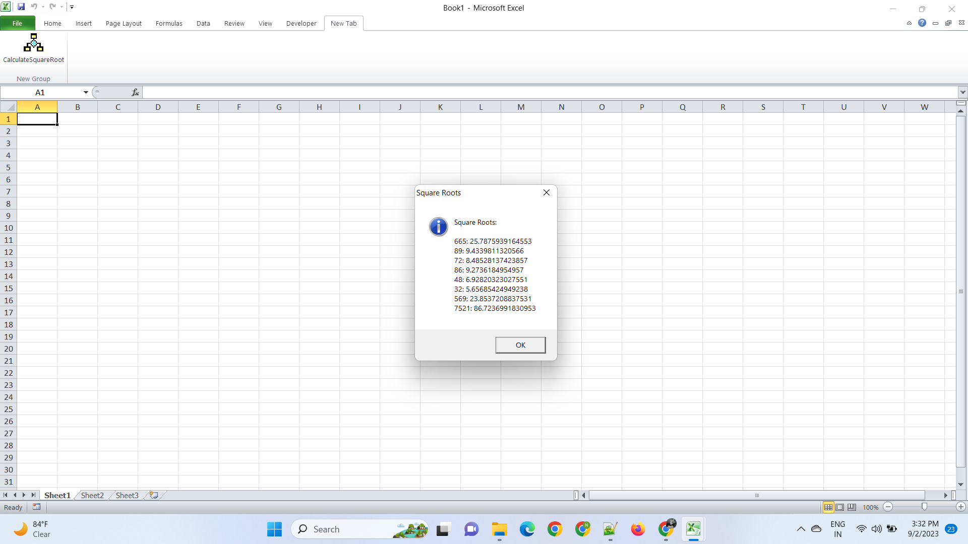

**6. What are the shortcut keys used to**

**a. Run the code**

**b. Step into the code**

**c. Step out of code**

**d. Reset the code**

In VBA (Visual Basic for Applications), you can use several shortcut keys to navigate and control the execution of your code while debugging or running macros. Here are the common shortcut keys for these actions:

1. **Run the Code:** To run or execute the code, you can use the following shortcut key:

- F5: Pressing F5 runs the code from the current position of the cursor or from the beginning of the currently selected subroutine.

1. **Step into the Code:** To step into the code and execute it line by line (useful for debugging and understanding code execution), you can use the following shortcut key:

- F8: Pressing F8 allows you to execute one line of code at a time, moving through the code step by step. If a line of code contains a subroutine call, F8 will take you into that subroutine.

1. **Step Out of Code:** To step out of the current subroutine and continue running the code until it reaches the next subroutine call or the end of the macro, you can use the following shortcut key:

- **Shift + F8**: While you're inside a subroutine, pressing Shift + F8 will execute the remaining code inside the current subroutine and return to the calling code.

1. **Reset the Code:** To stop the execution of your code and return to the VBA editor, you can use the following shortcut key:

- **Ctrl + Break (sometimes labeled as Pause or Pause/Break)**: Pressing Ctrl + Break interrupts the code execution and returns you to the VBA editor. This is often used when code is running in an infinite loop or taking longer to execute than expected.