**Excel Assignment - 20**

**1. Write a VBA code to select the cells from A5 to C10. Give it a name**

**“Data Analytics” and fill the cells with the following cells “This is Excel**

**VBA”**

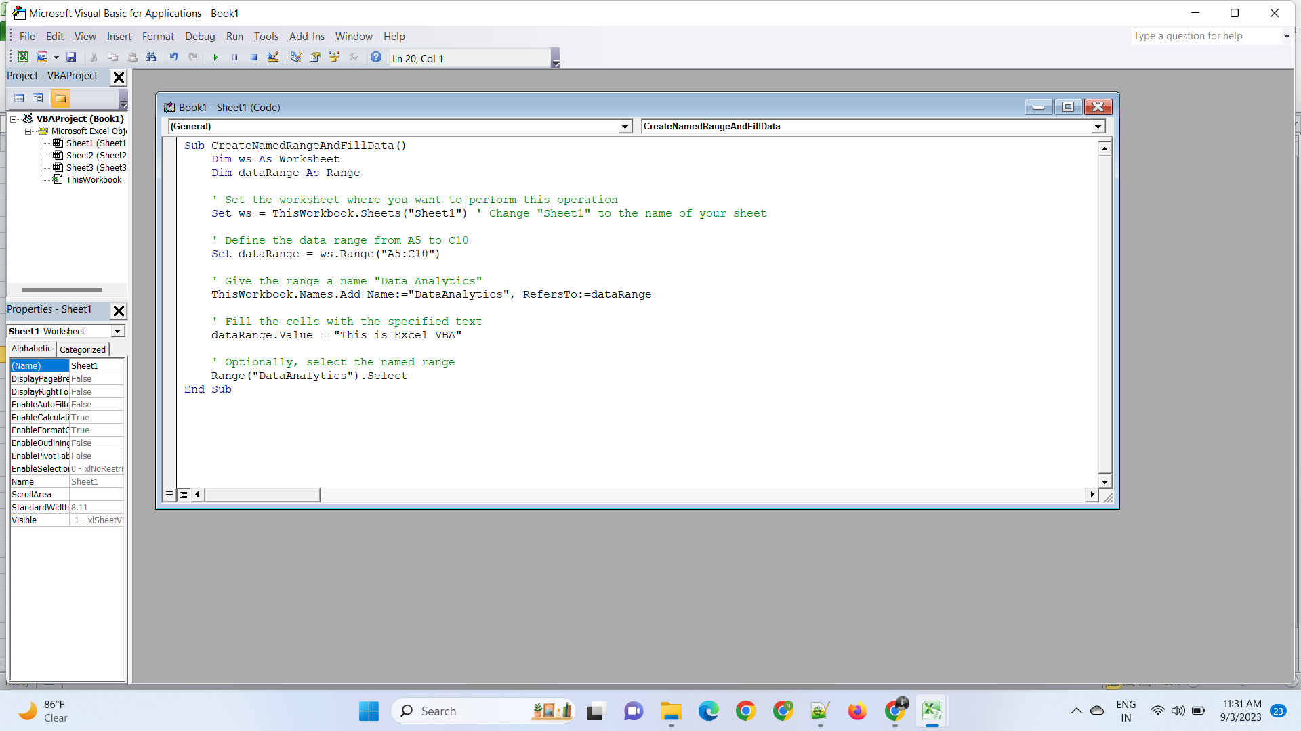

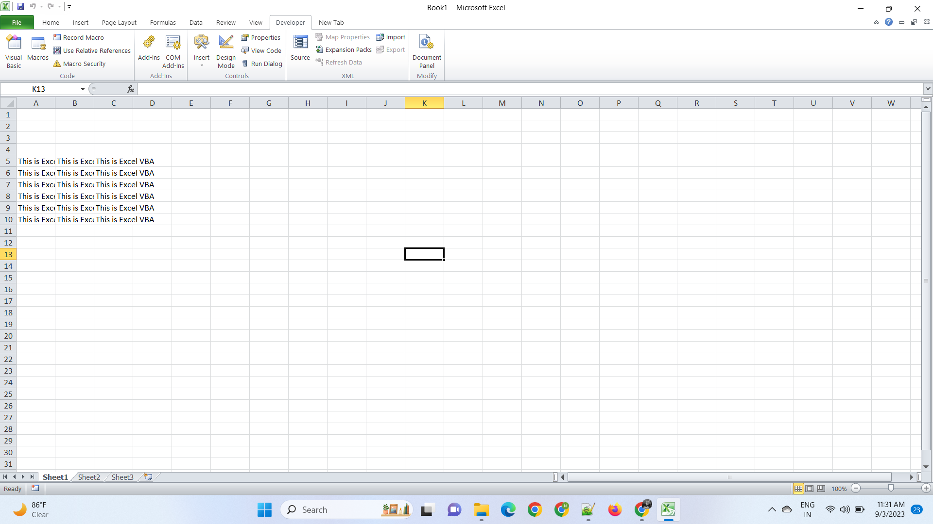

**2. Use the above data and write a VBA code using the following**

**statements to display in the next column if the number is odd or even**

**a. IF ELSE statement**

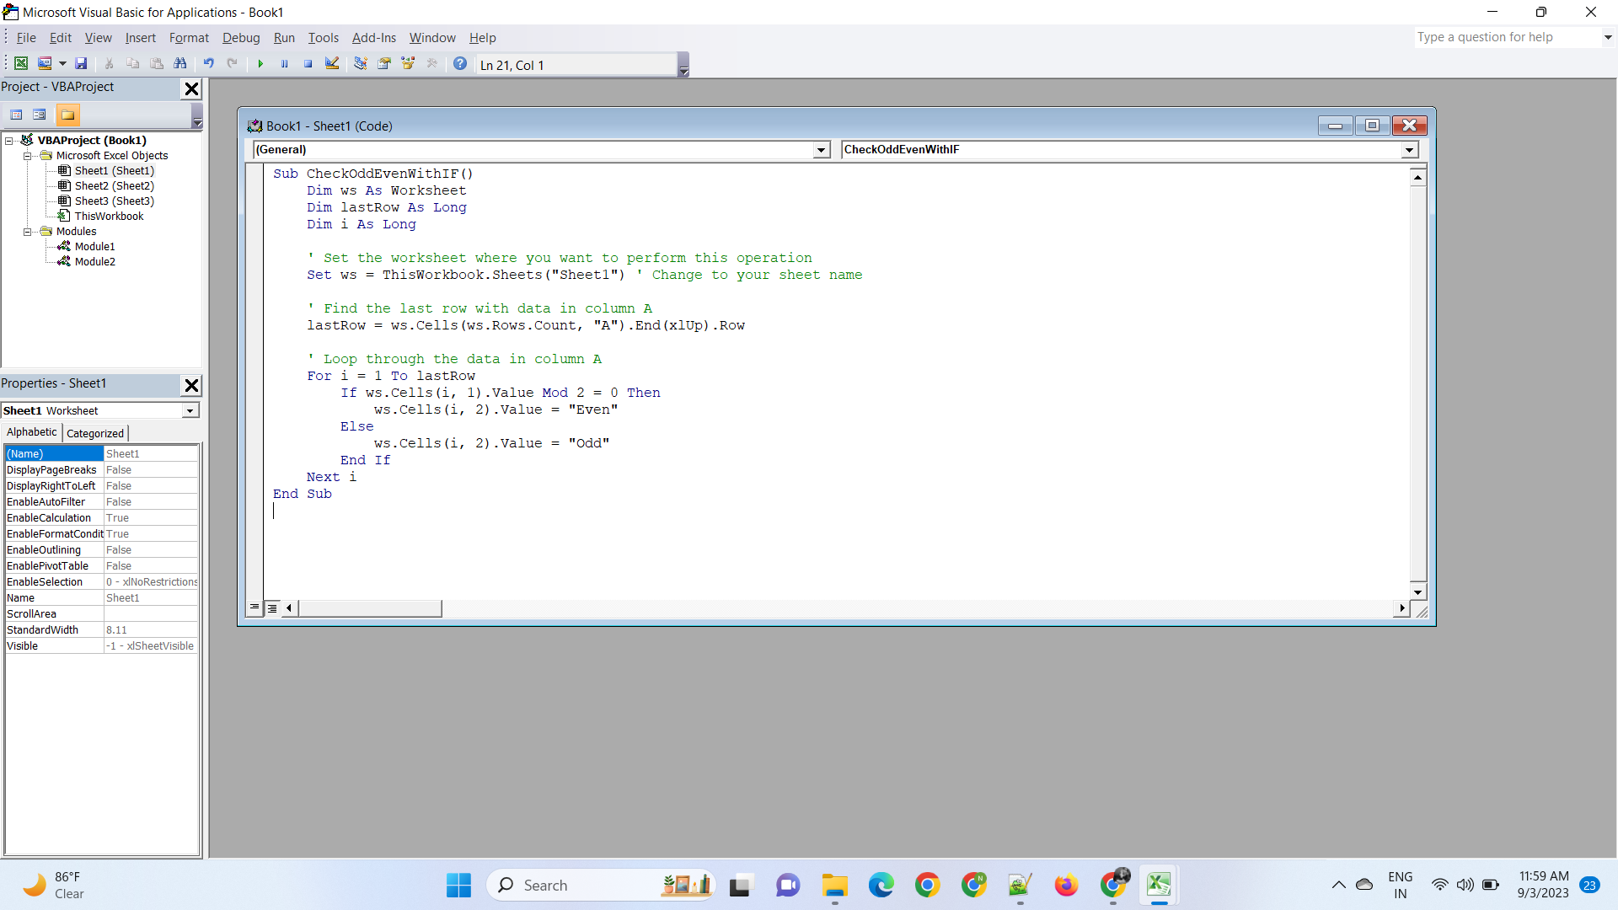

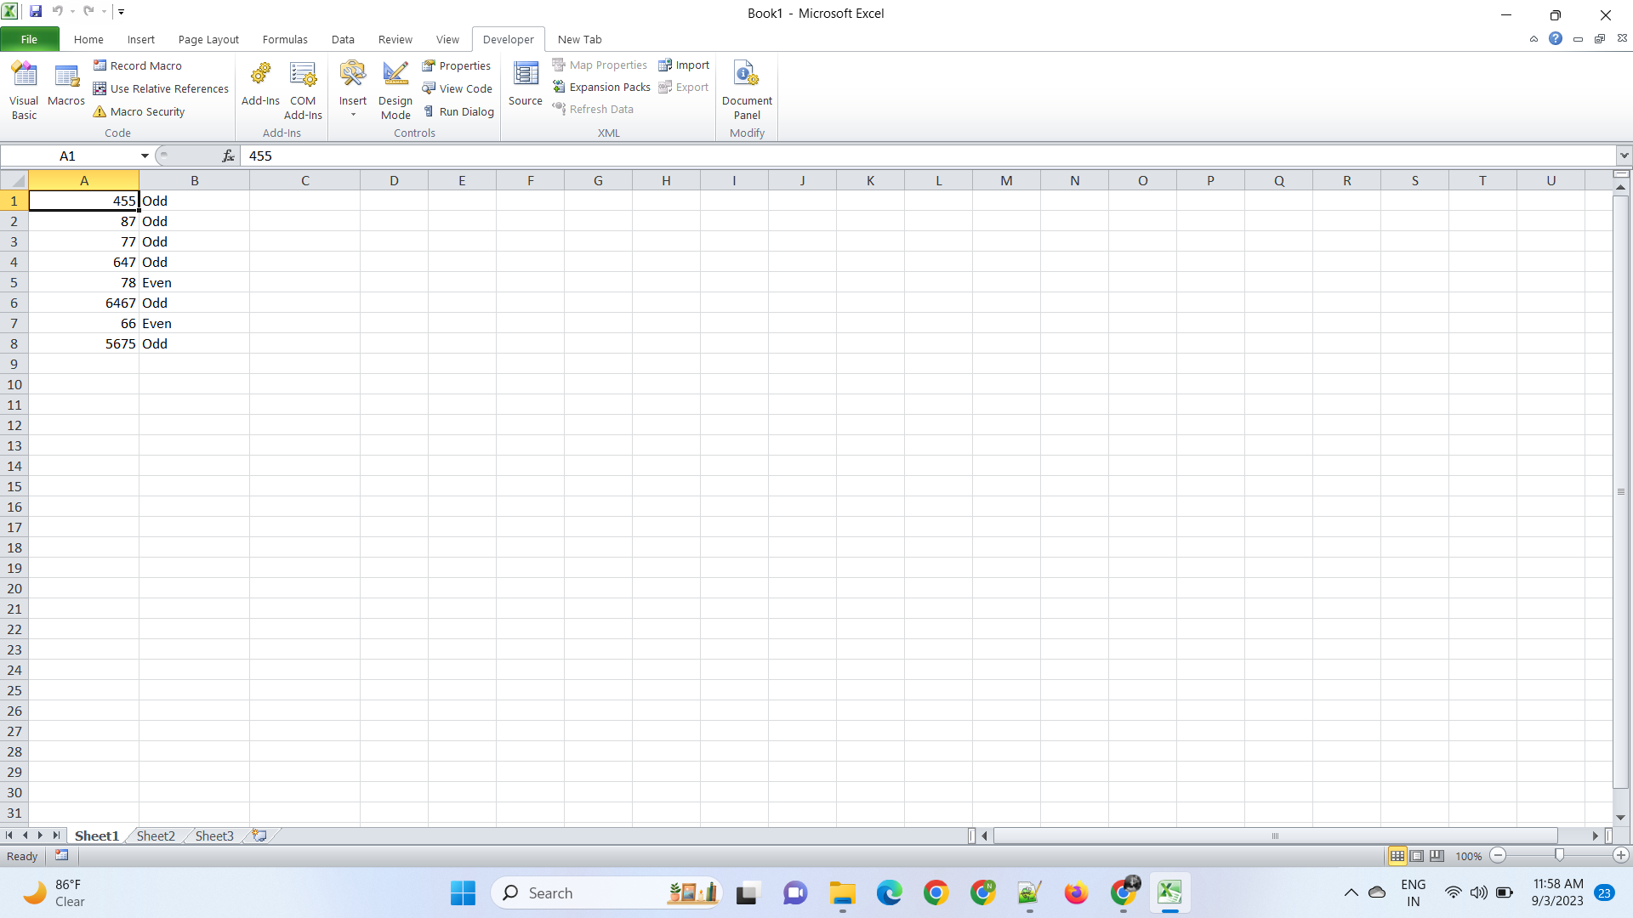

**b. Select Case statement**

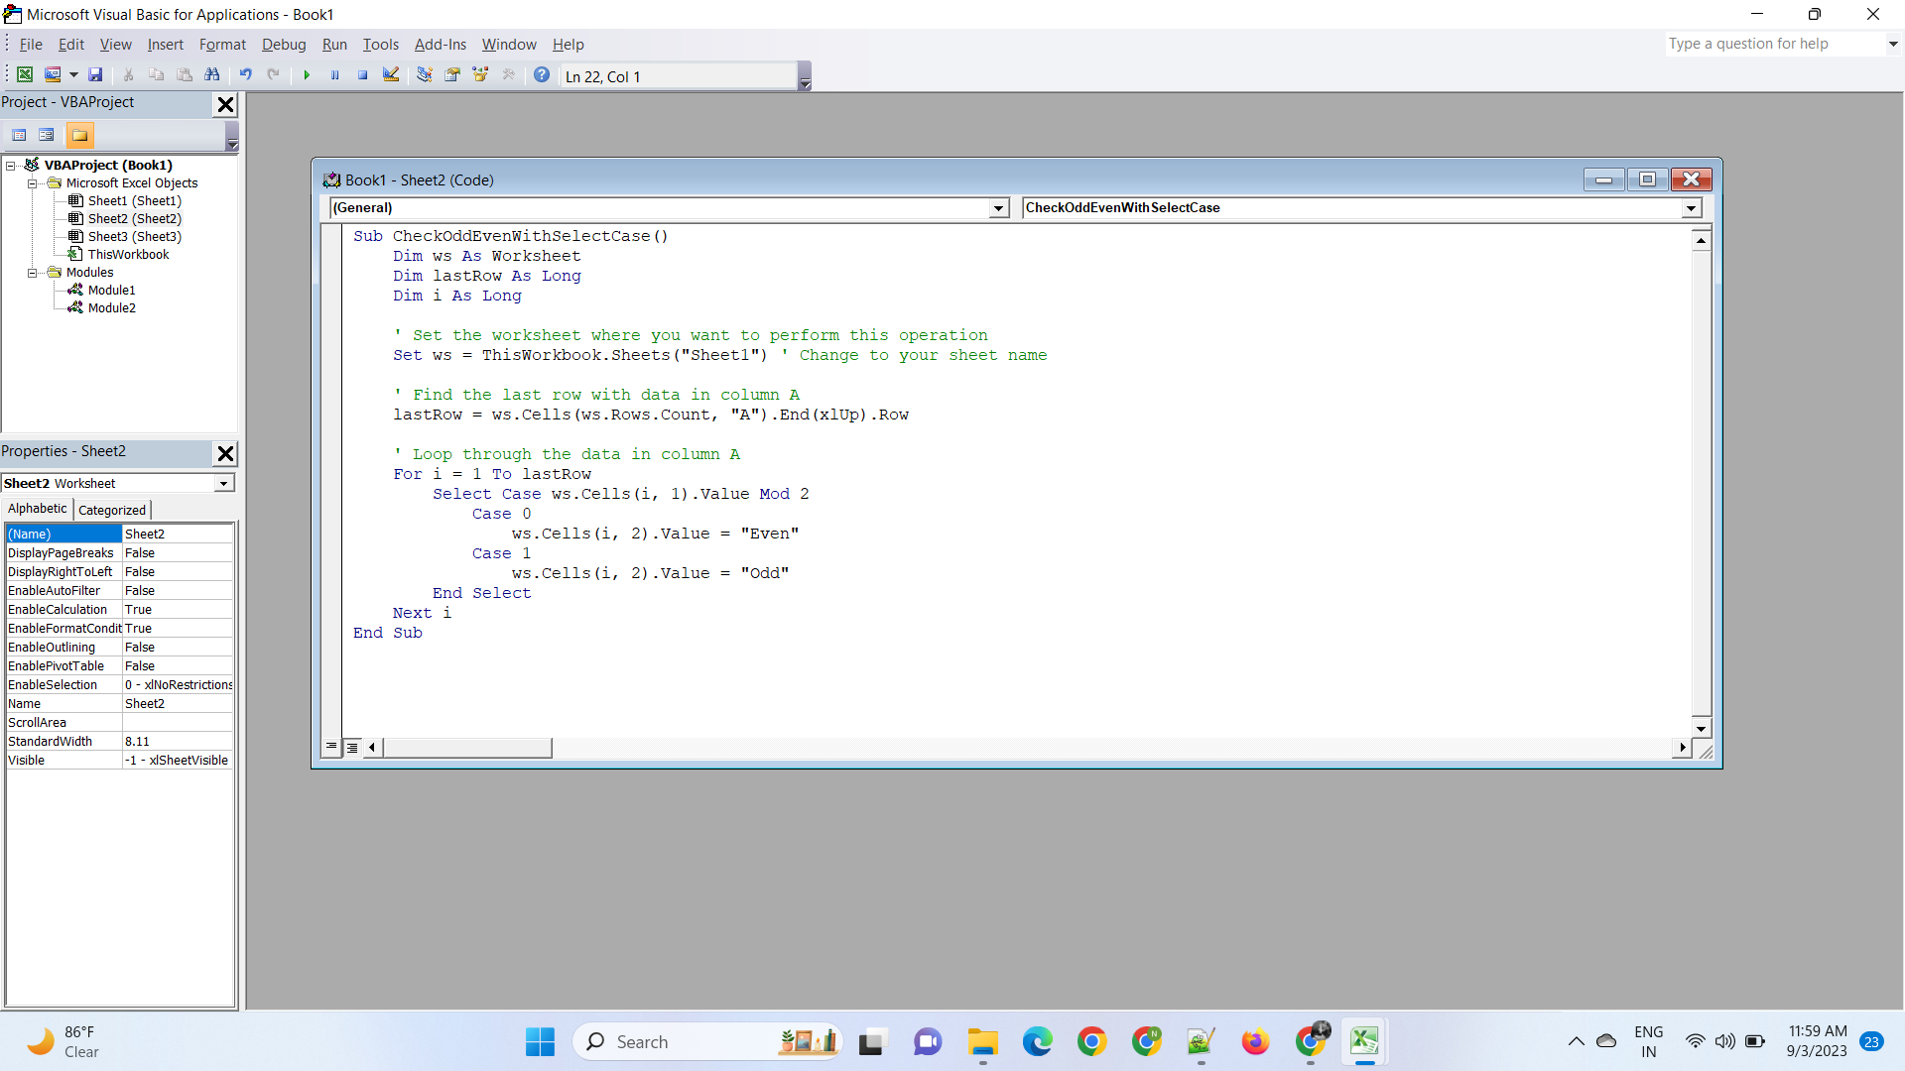



**c. For Next Statement**

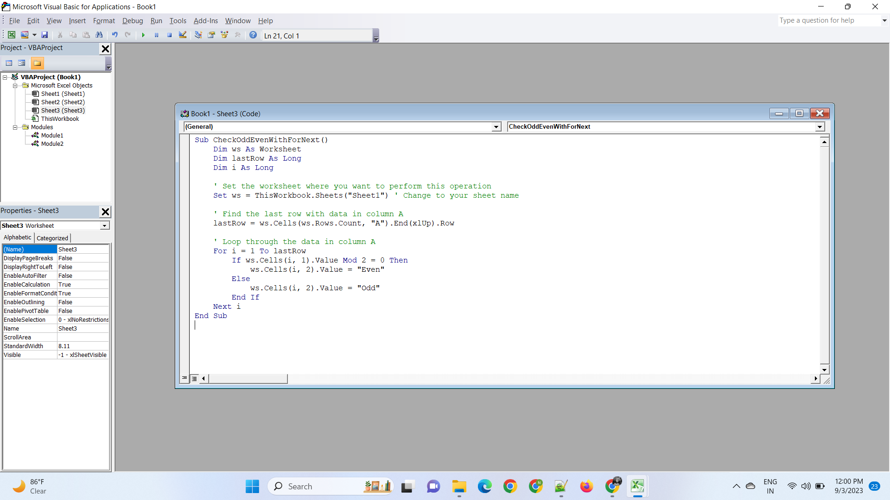



**3. What are the types of errors that you usually see in VBA?**

In VBA (Visual Basic for Applications), you can encounter various types of errors during the development and execution of your code. These errors are typically categorized into three main types:

1. **Syntax Errors:**

* Common Mistakes: These errors occur due to incorrect syntax in your VBA code. Examples include missing parentheses, improper use of keywords, and typographical errors.

Examples:

* Missing `End If` for an `If` statement.
* Mismatched parentheses in a function call.
* Misspelling a variable or function name.

2. **Runtime Errors:**

* Common Causes: Runtime errors occur during the execution of your VBA code and can result from various issues, such as invalid input, division by zero, or referencing objects that don't exist.

Examples:

* Division by zero (`Error 11` - Division by zero).
* Trying to access a non-existent worksheet or range (`Error 9` - Subscript out of range).
* Attempting to open a file that doesn't exist (`Error 53` - File not found).

3. **Logic Errors:**

* Common Causes: Logic errors are not caught by the VBA compiler or runtime checks. They occur when your code does not produce the expected results due to incorrect program logic or algorithms.

Examples:

* Incorrect formula in a spreadsheet cell that leads to incorrect calculations.
* Flawed conditional logic that produces incorrect branching in your code.
* Using the wrong variable or data type, resulting in unintended behavior.

**4. How do you handle Runtime errors in VBA?**

Certainly, here's a concise overview of handling runtime errors in VBA without examples:

1. **Using `On Error` Statements:**

* `On Error Resume Next`: Allows code to continue running after an error occurs, and you can check the `Err` object to handle errors.
* `On Error GoTo`: Directs VBA to jump to a specific label or line of code when an error occurs, enabling you to define error-handling routines.

2. **Using `Err` Object:**

* The `Err` object provides information about the error, such as the error number (`Err.Number`) and error description (`Err.Description`).

3. **Using `Resume` Statement:**

* `Resume Next`: Resumes execution after the line that caused the error.
* `Resume label`: Jumps to a specific label in your code for error handling.

4. **Using `Exit Sub` or `Exit Function`:**

* `Exit Sub` or `Exit Function` is used to gracefully exit the current subroutine or function when an error occurs.

5. **Logging and Reporting:**

* Logging errors to a file or reporting them to the user can help with debugging and troubleshooting.

**5. Write some good practices to be followed by VBA users for handling**

**Errors Number Odd or even**

**56**

**89**

**26**

**36**

**75**

**48**

**92**

**58**

**13**

**25**

Handling errors in VBA is crucial for creating robust and reliable code. Here are some good practices to follow when dealing with errors, including distinguishing odd and even numbers:

1. **Use Descriptive Variable Names:**

- Use meaningful variable names to enhance code readability. For example, `numberList` is more informative than just `n`.

2. **Comment Your Code:**

- Add comments to explain the purpose and logic of your code, especially when handling errors. Clear comments make it easier for others (and your future self) to understand your intentions.

3. **Modularize Your Code:**

- Break your code into smaller, reusable functions or subroutines. This not only improves readability but also makes error handling more manageable within each module.

4. **Handle Errors Proactively:**

- Anticipate possible errors and handle them before they occur, whenever possible. For example, you can check if a number is zero before performing division.

5. **Use Appropriate Error Handling Techniques:**

- Implement error-handling mechanisms like `On Error Resume Next`, `On Error GoTo`, or `Try...Catch` (for later versions of VBA) based on the specific requirements of your code.

6. **Validate User Input**:

- If your code relies on user input, validate it to ensure it meets your expectations. Handle cases where the input doesn't conform to your requirements gracefully.

7. **Provide User-Friendly Error Messages:**

- When an error occurs, display informative and user-friendly error messages. This helps users understand what went wrong and how to correct it.

8. **Log Errors:**

- If applicable, log errors to a file or database for later analysis. Logging can be invaluable for debugging and troubleshooting.

9. **Test Your Code Thoroughly:**

- Conduct extensive testing to identify and resolve errors. Test with various inputs, including edge cases, to ensure your code behaves as expected.

10. **Handle Unexpected Errors Gracefully:**

- Even if you can't anticipate all errors, ensure your code doesn't crash when unexpected errors occur. Implement general error-handling mechanisms to capture and report these errors.

11. **Document Error Handling Logic:**

- Clearly document your error-handling approach in your code comments. This helps other developers understand how errors are handled in your code.

12. **Plan for Future Updates:**

- Consider how your code may evolve over time. Ensure that your error-handling strategies can accommodate future changes and additions to the codebase.

13. **Seek Peer Review:**

- Have your code reviewed by peers to get different perspectives and identify potential error-handling improvements.

14. **Stay Informed:**

- Keep up to date with best practices for error handling in VBA and any changes or enhancements in the language. Stay informed about the latest tools and techniques for debugging and error tracking.

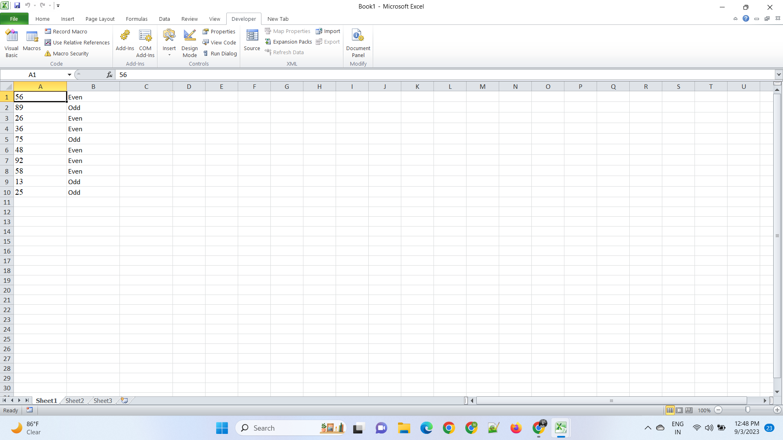

By following these best practices, you can write VBA code that not only effectively handles errors but also contributes to code maintainability and reliability.

**6. What is UDF? Why are UDF’s used? Create a UDF to multiply 2**

**numbers in VBA.**

UDF stands for User-Defined Function. In the context of VBA (Visual Basic for Applications) or Excel, a UDF is a custom function that you can create and use in your spreadsheet, just like built-in Excel functions (e.g., SUM, AVERAGE). UDFs are used to perform custom calculations or operations that are not readily achievable with Excel's built-in functions.

Here are some reasons why UDFs are used:

* Custom Calculations: UDFs allow you to perform calculations specific to your needs, which may not be possible or efficient using Excel's built-in functions.
* Automation: UDFs can automate repetitive tasks, making complex calculations more manageable.
* Data Transformation: UDFs can help transform data into the desired format or structure.
* Enhanced Functionality: You can extend Excel's functionality by creating custom functions that cater to your specific requirements.
* Improved Readability: UDFs can enhance the readability of your formulas by breaking down complex operations into smaller, more understandable parts.

