**Excel Assignment - 21**

**1. Write a VBA code to enter your name in A1 Cell using Input Box and once you enter the name display a message box that says the name has been entered.**

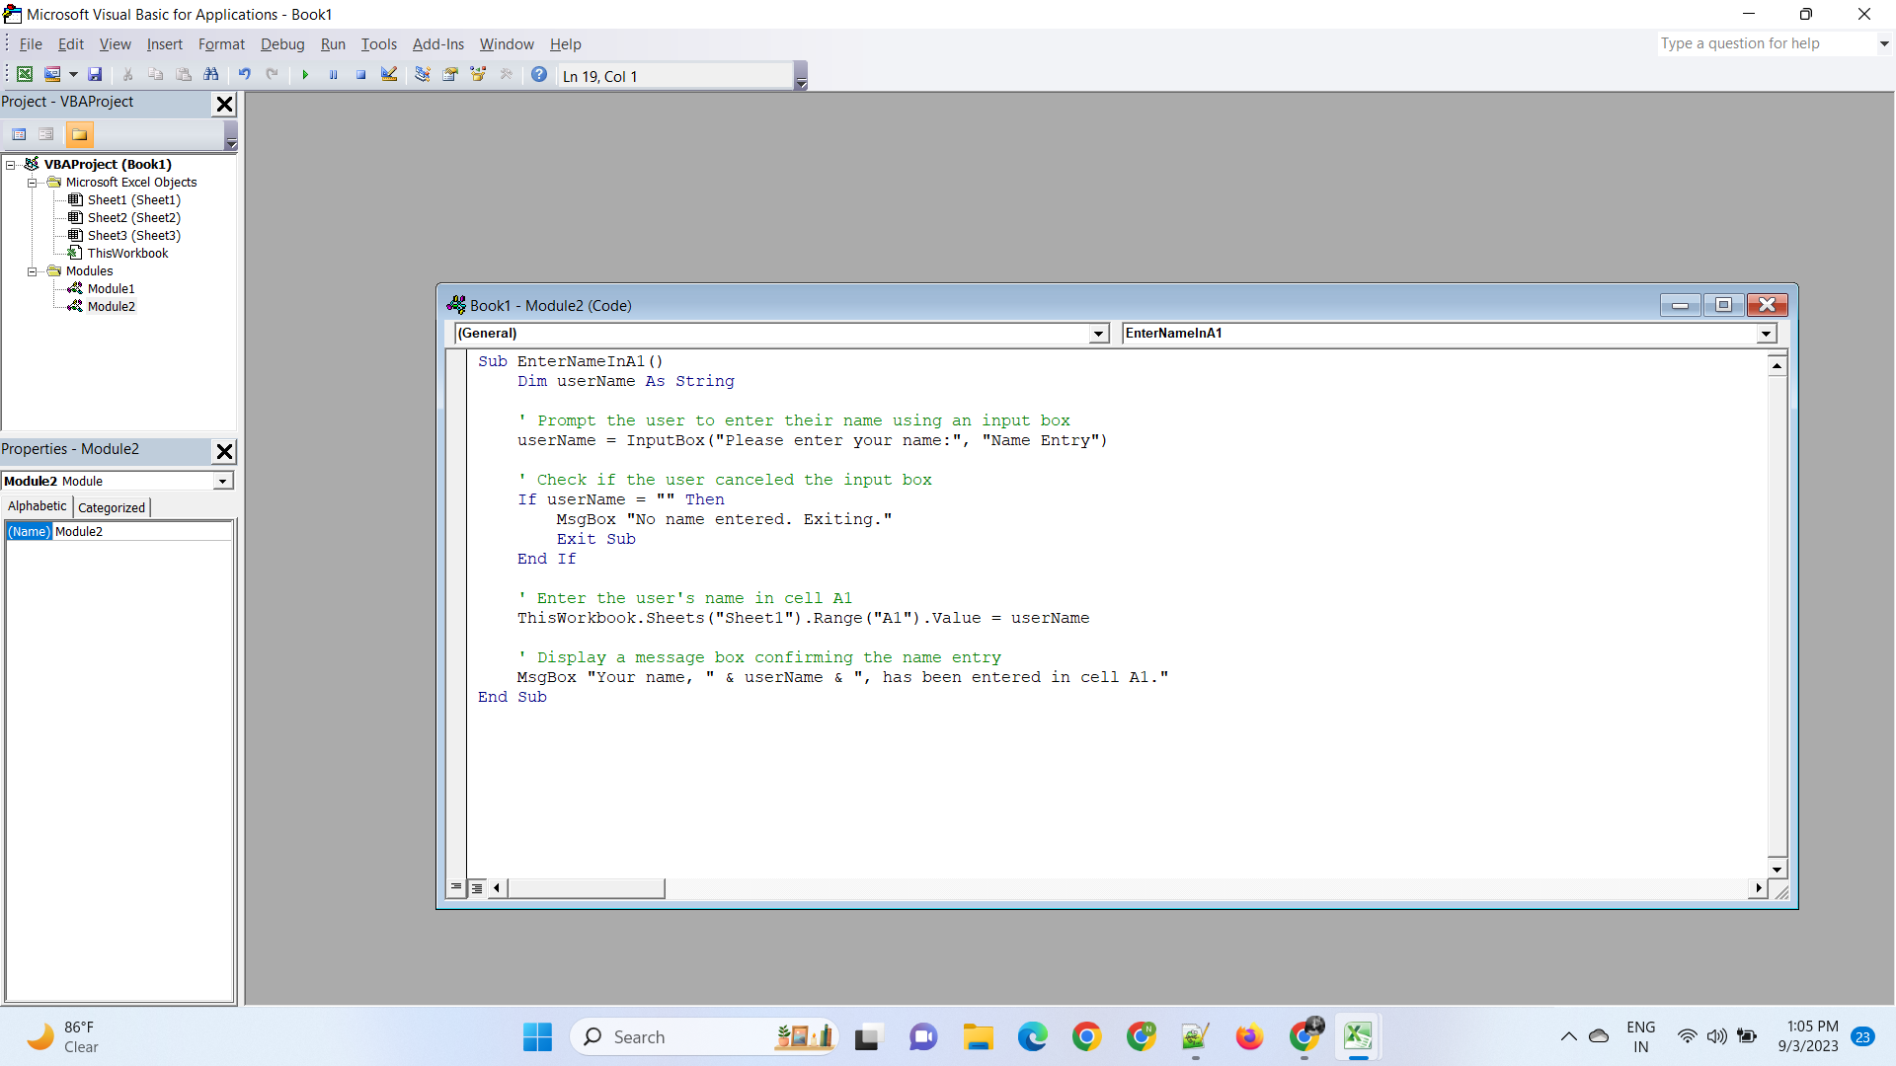

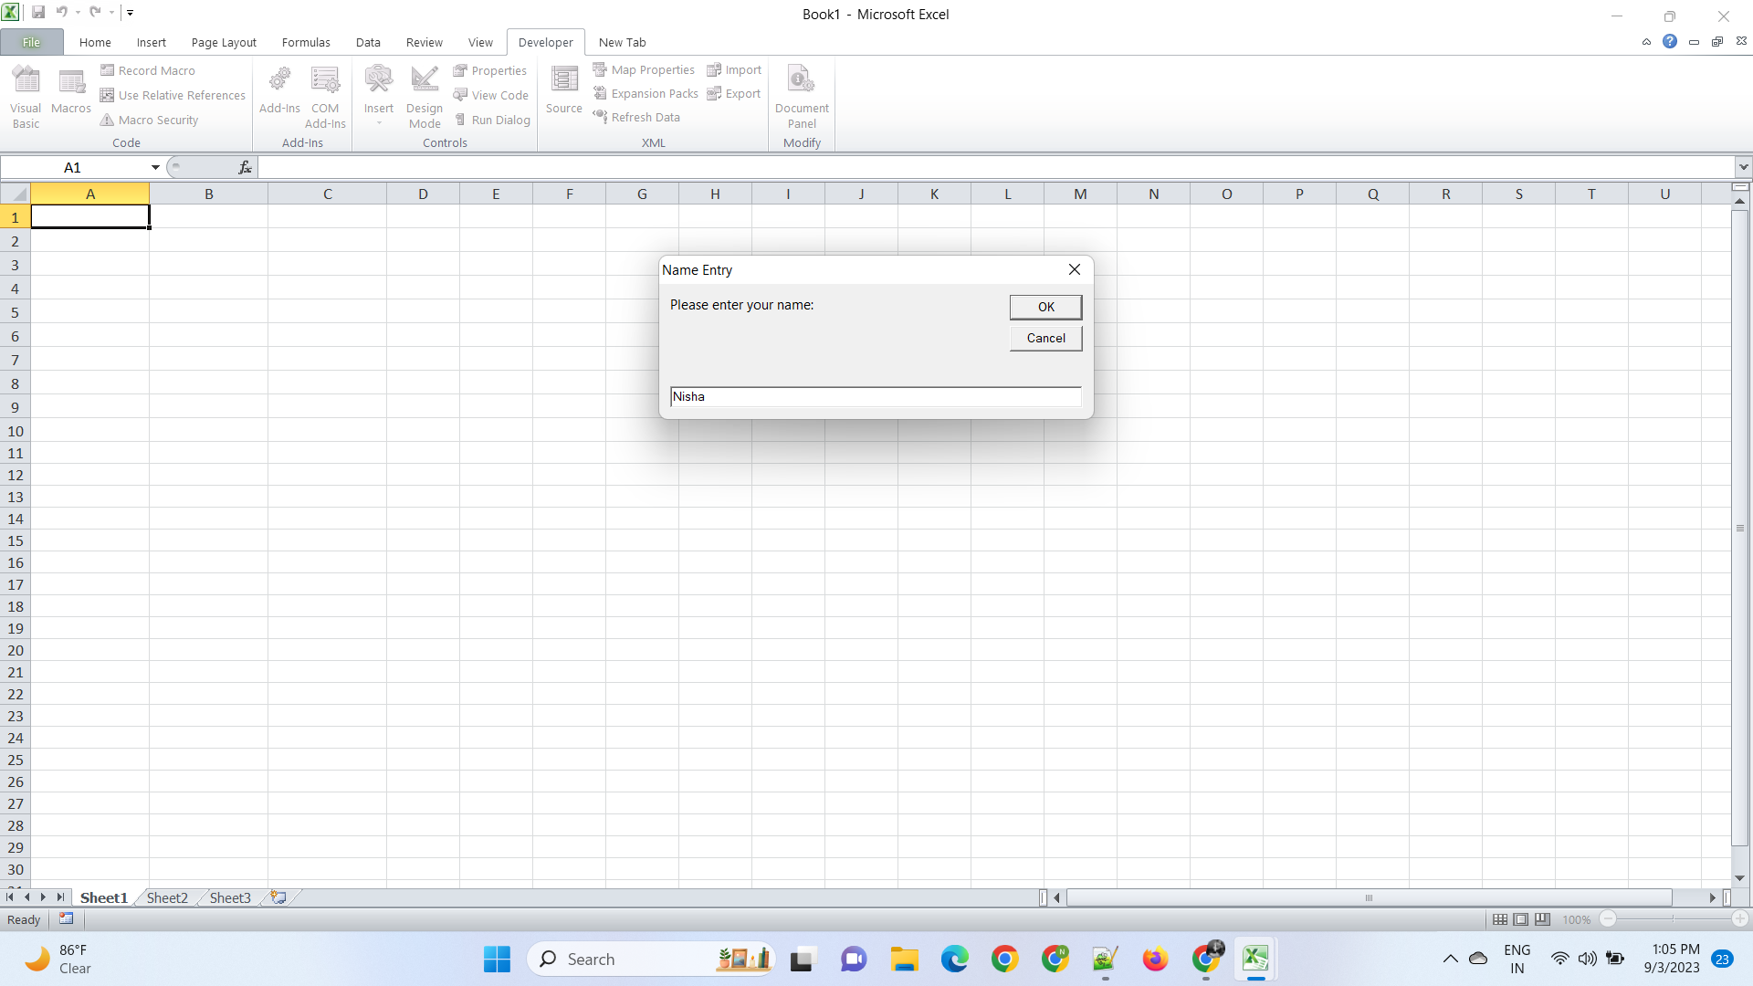

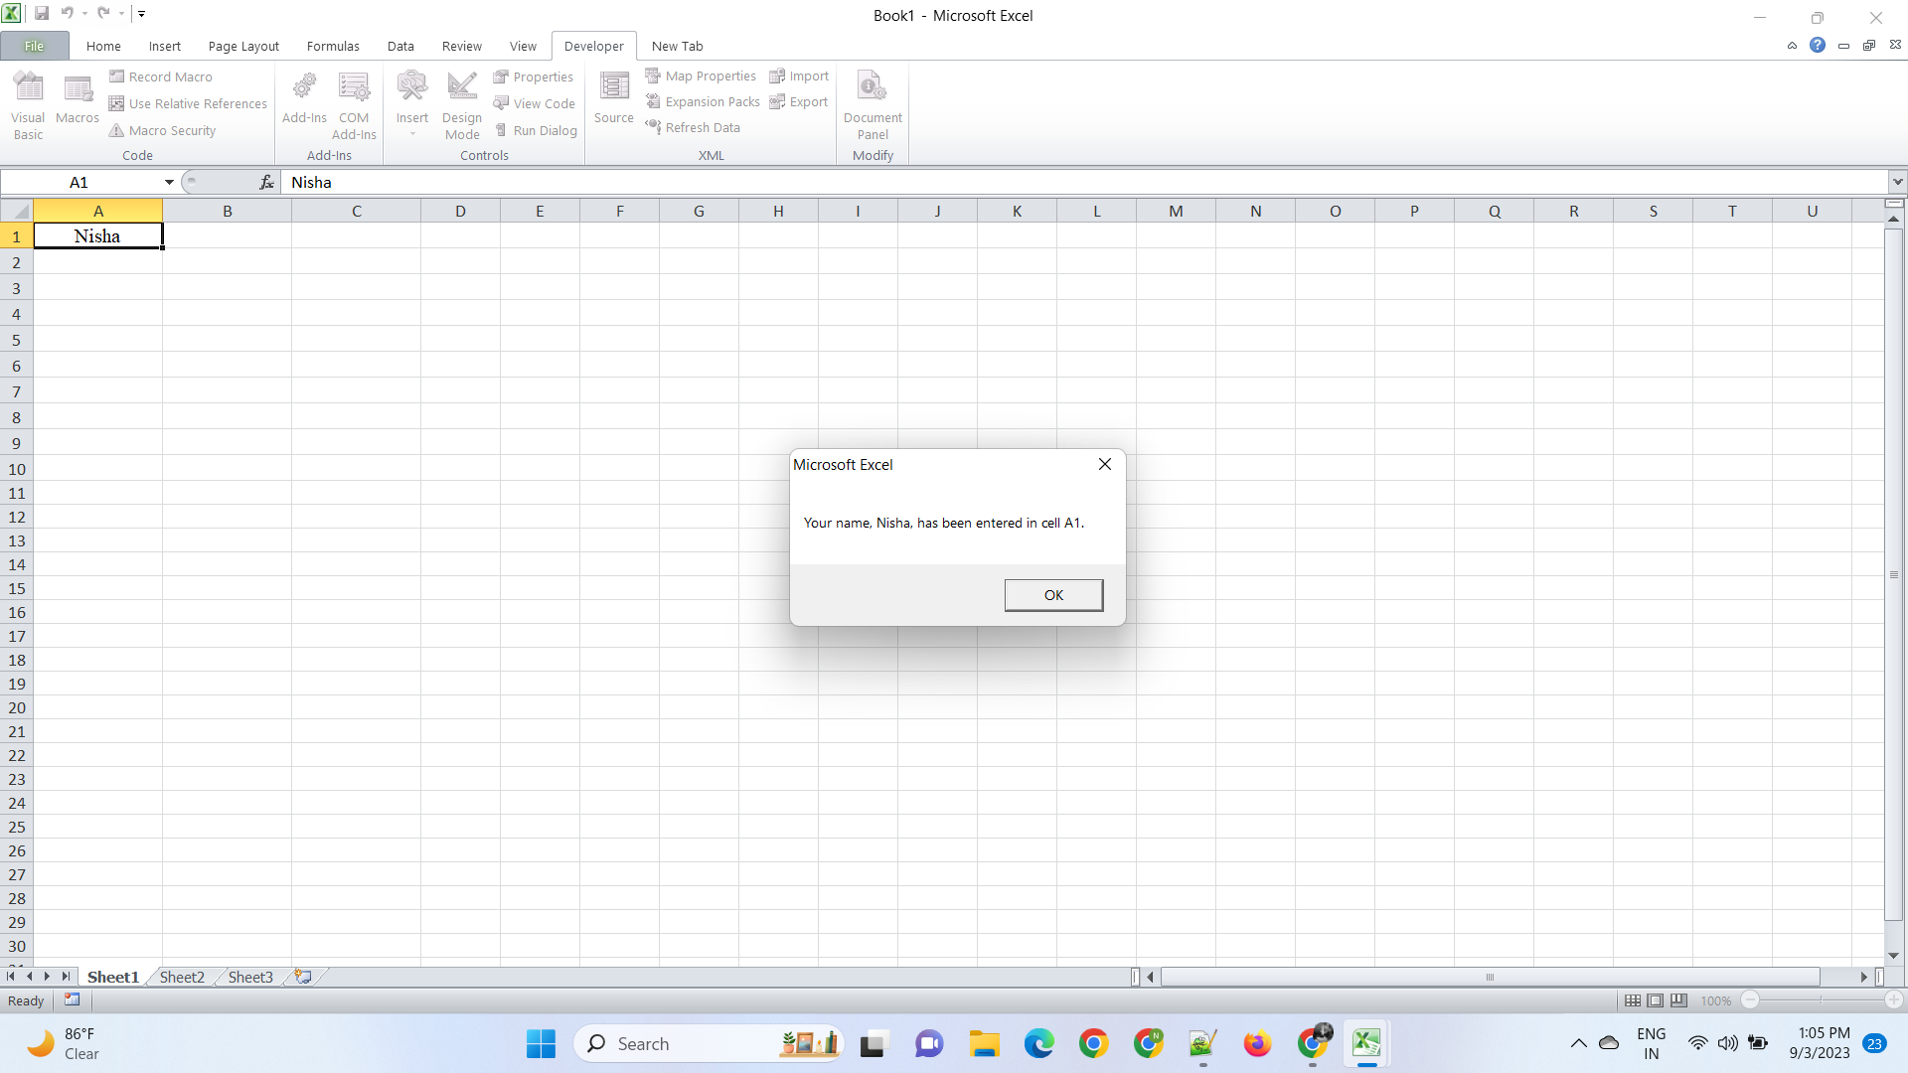

**2. What are Userforms? Why are they used? How to fill a list box using for loop.**

* UserForms in VBA are custom dialog boxes or forms that you can create to interact with users in Excel. They are used to enhance the user interface by providing a structured way to input, display, or manipulate data within Excel workbooks.

Common Use Cases and Reasons for Using UserForms:

1. Data Entry: UserForms are used to create custom data entry forms, improving data accuracy and user experience.

2. Data Display: They display information such as reports or details about selected items in a user-friendly format.

3. Settings and Configuration: UserForms enable users to configure settings or preferences for Excel workbooks or add-ins.

4. Data Selection: UserForms with list boxes or combo boxes allow users to efficiently select items from a list.

5. Custom Calculations: You can build custom calculators or tools using UserForms to simplify complex calculations.

Populating a List Box in a UserForm Using a For Loop. To populate a list box in a UserForm using a `For` loop, follow these steps:

1. Create a UserForm: Open the VBA editor, insert a new UserForm, and design it with a list box control.

2. Write Code: In the UserForm's code module, write VBA code to populate the list box with data using a `For` loop. This code typically goes in the `UserForm_Initialize` event, which runs when the UserForm is initialized.

3. Display the UserForm: Use VBA code to display the UserForm to the user when needed. You can call the `UserFormName.Show` method to do this.

These steps allow you to populate a list box in a UserForm with data using a `For` loop without the need for a specific example.

**3. What is an array? Write a VBA code to enter students and their marks from the below table.**

* An array is a data structure in programming that allows you to store a collection of values, such as numbers or strings, under a single variable name. Each value in an array is referred to as an element, and each element is accessed by its index or position within the array. Arrays are used to store and manage multiple related values, making it easier to work with large sets of data.
* In VBA (Visual Basic for Applications), you can use arrays to store and manipulate data efficiently.

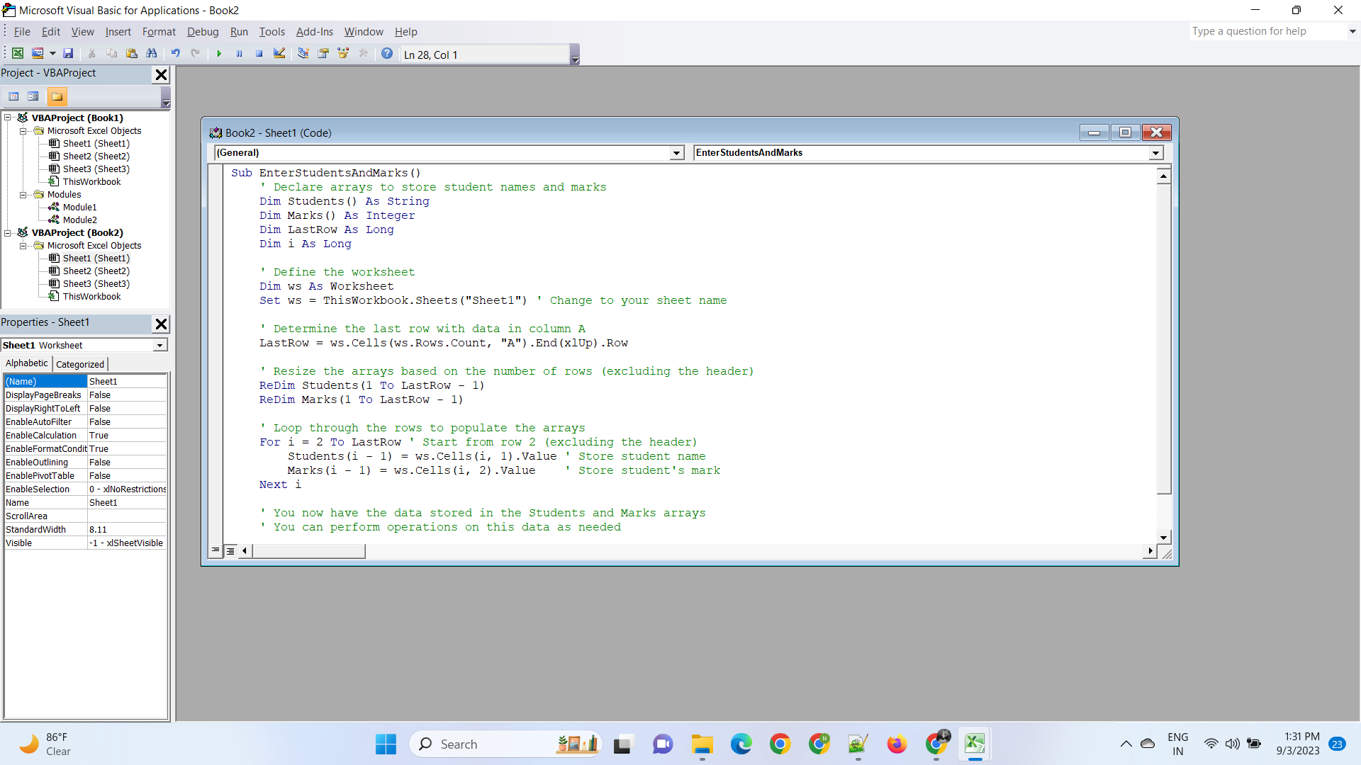

**4. Use the following data to create a pie chart using VBA code. Use Font - ‘Times new Roman’, Size -14, Bold, Title - Piechart’ and you are per to use colours as per your taste.**

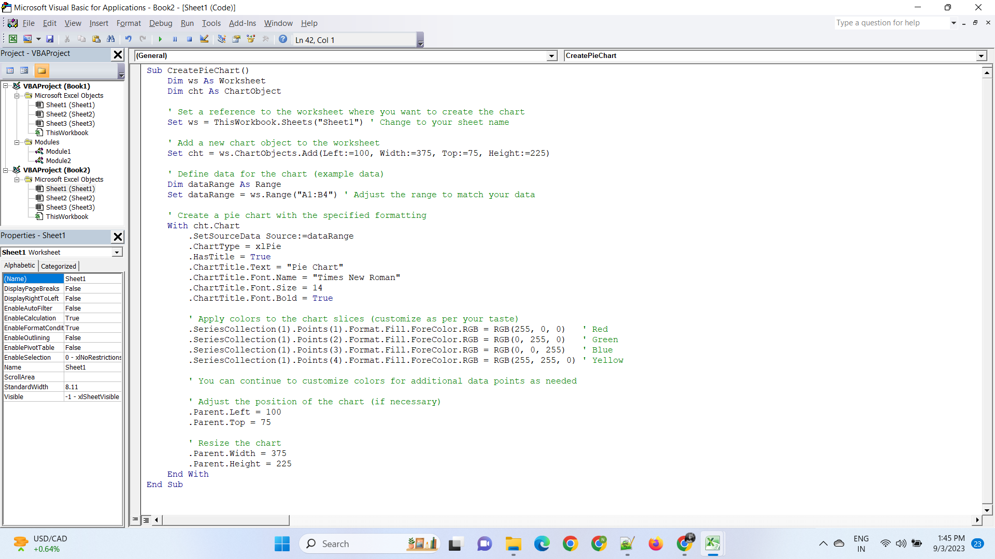

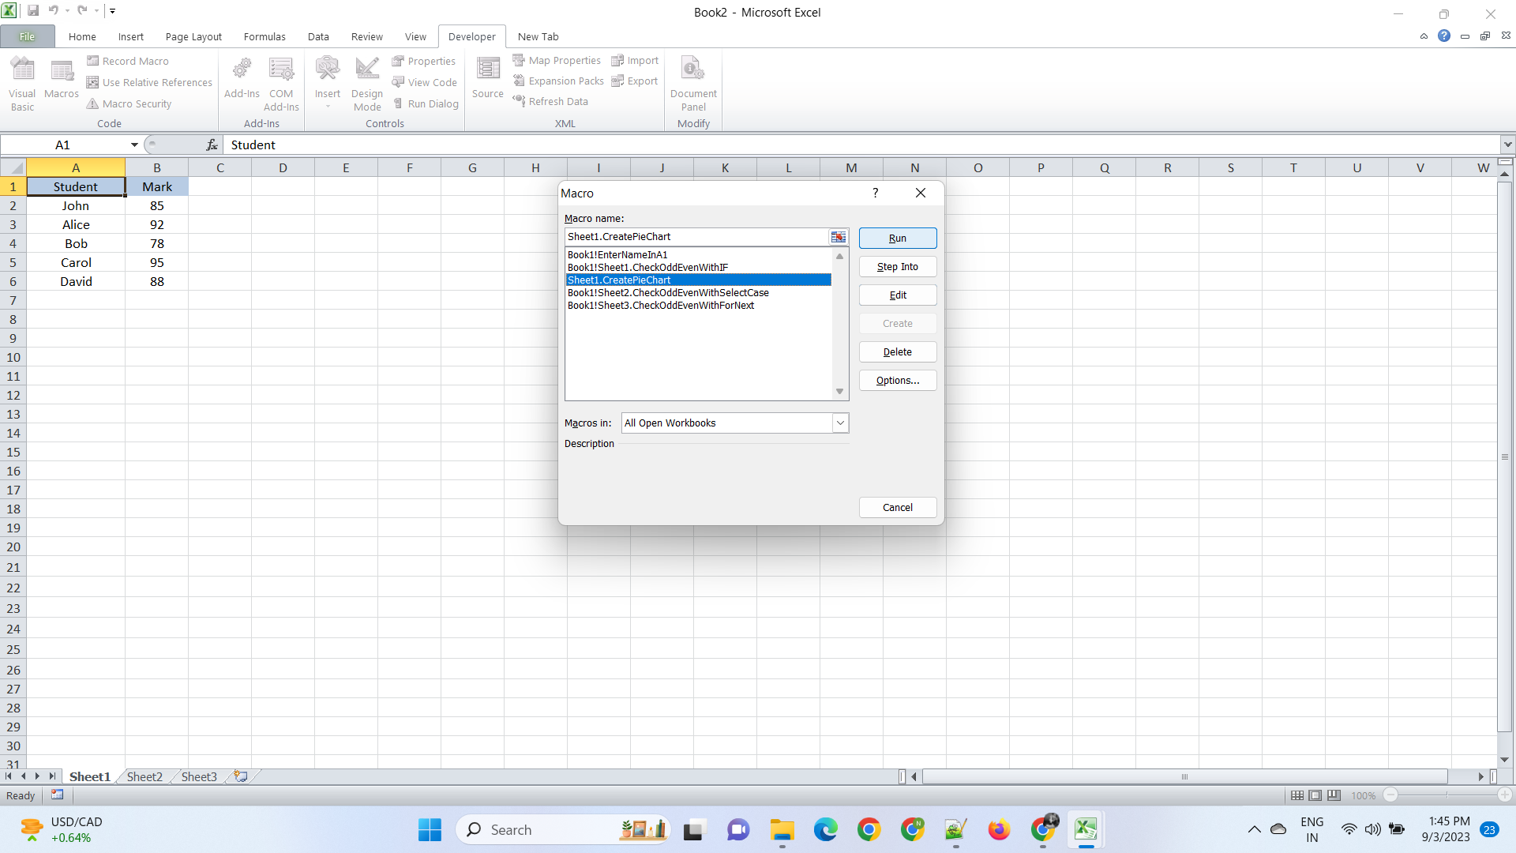

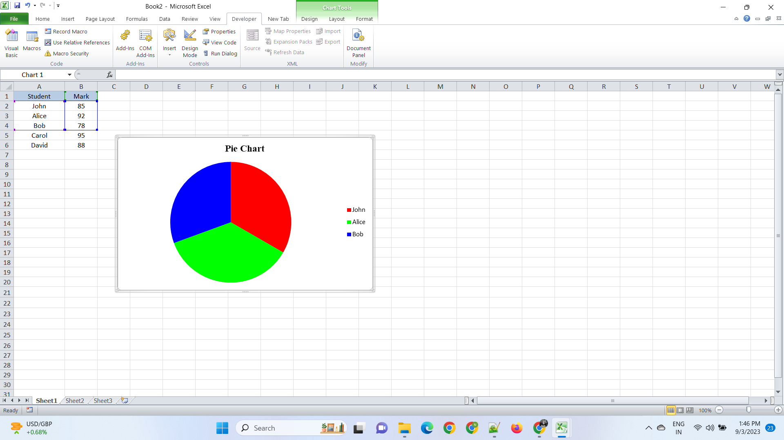

**5. Check the dataset in the link given below and create a pivot table using VBA showing the sales for the year from stationary category.**

**https://docs.google.com/spreadsheets/d/1IRSEnmgz8Ro276-**

**GslknRNk0zlrB5CZH1YrnT71kqFM/edit?usp=sharing**

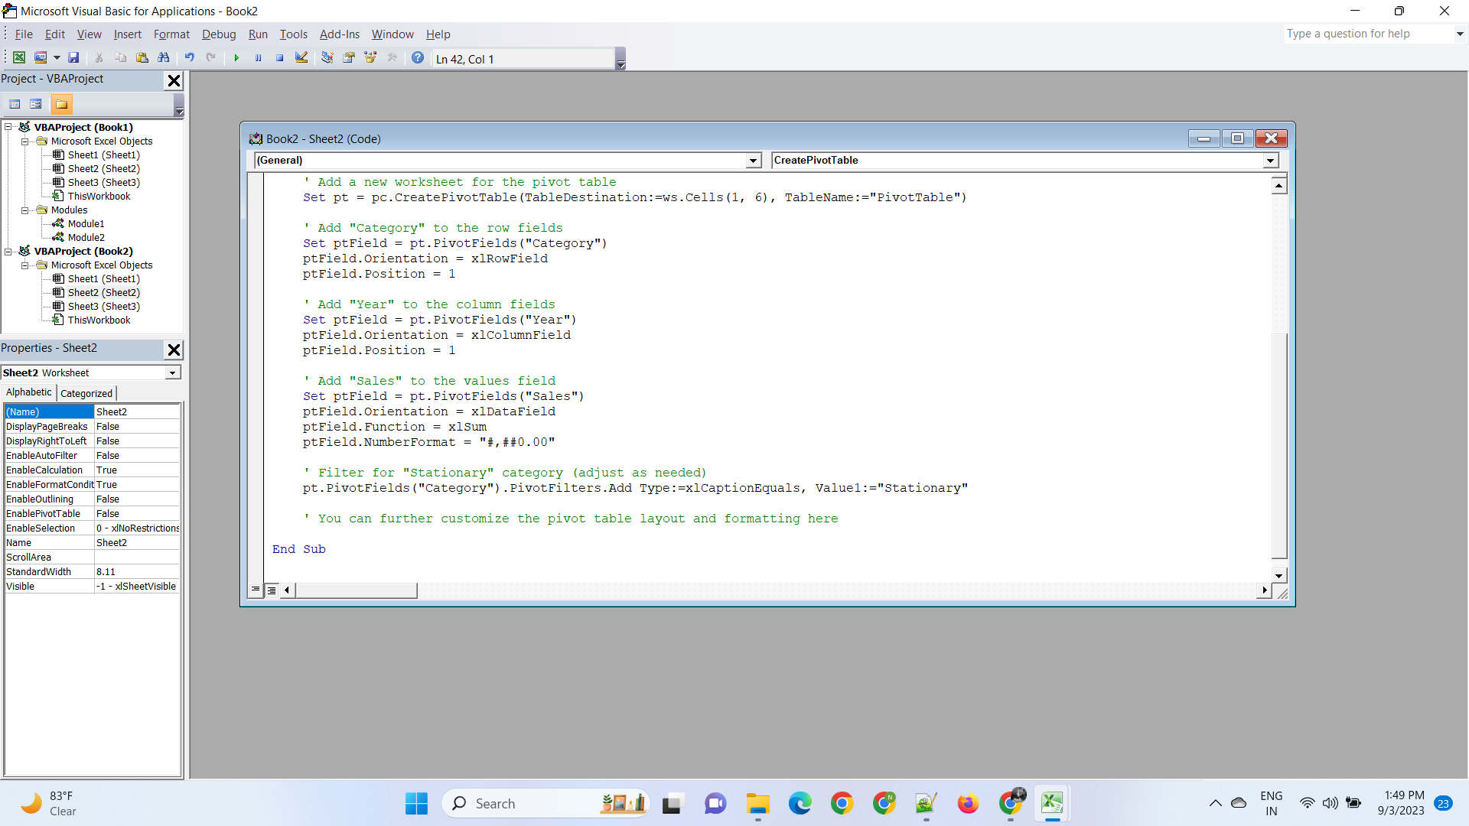

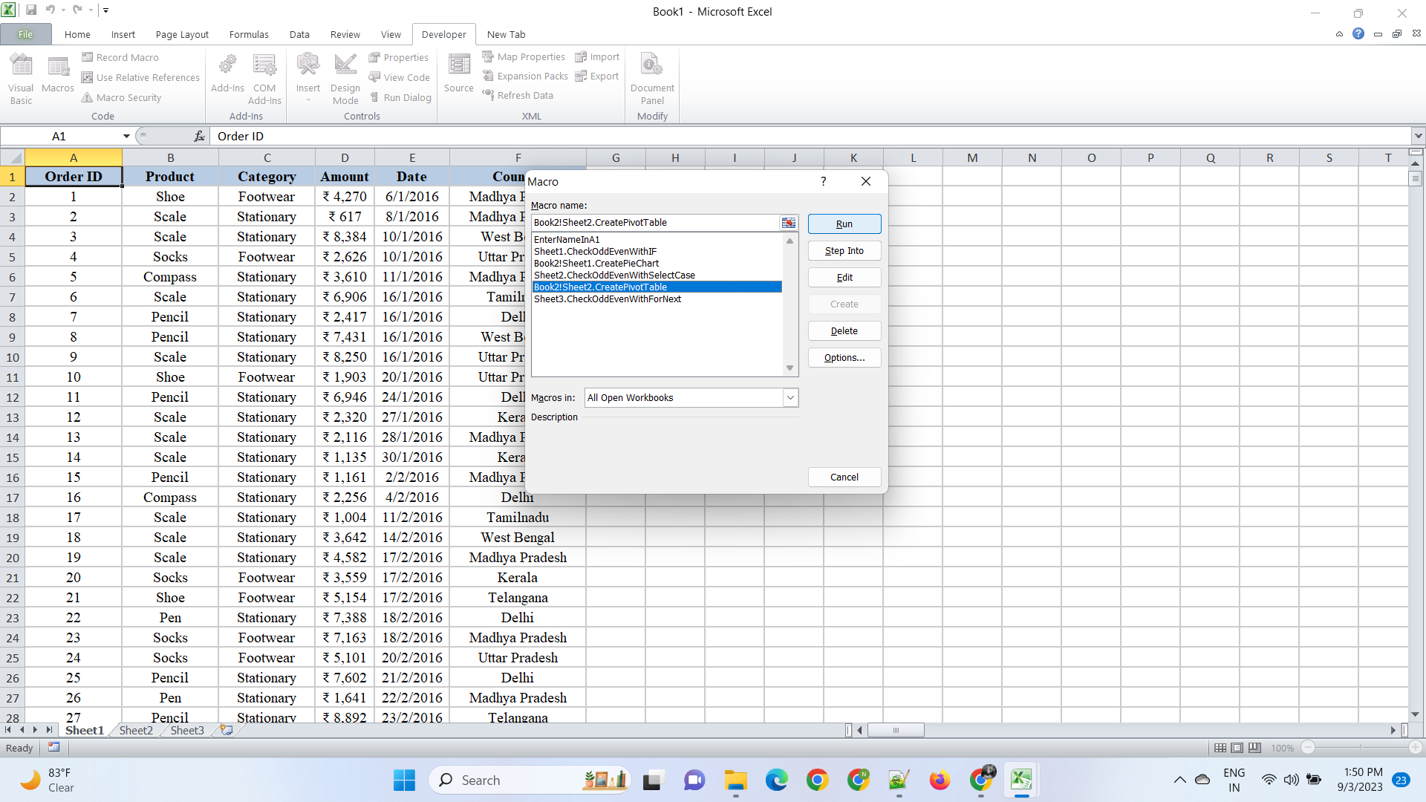

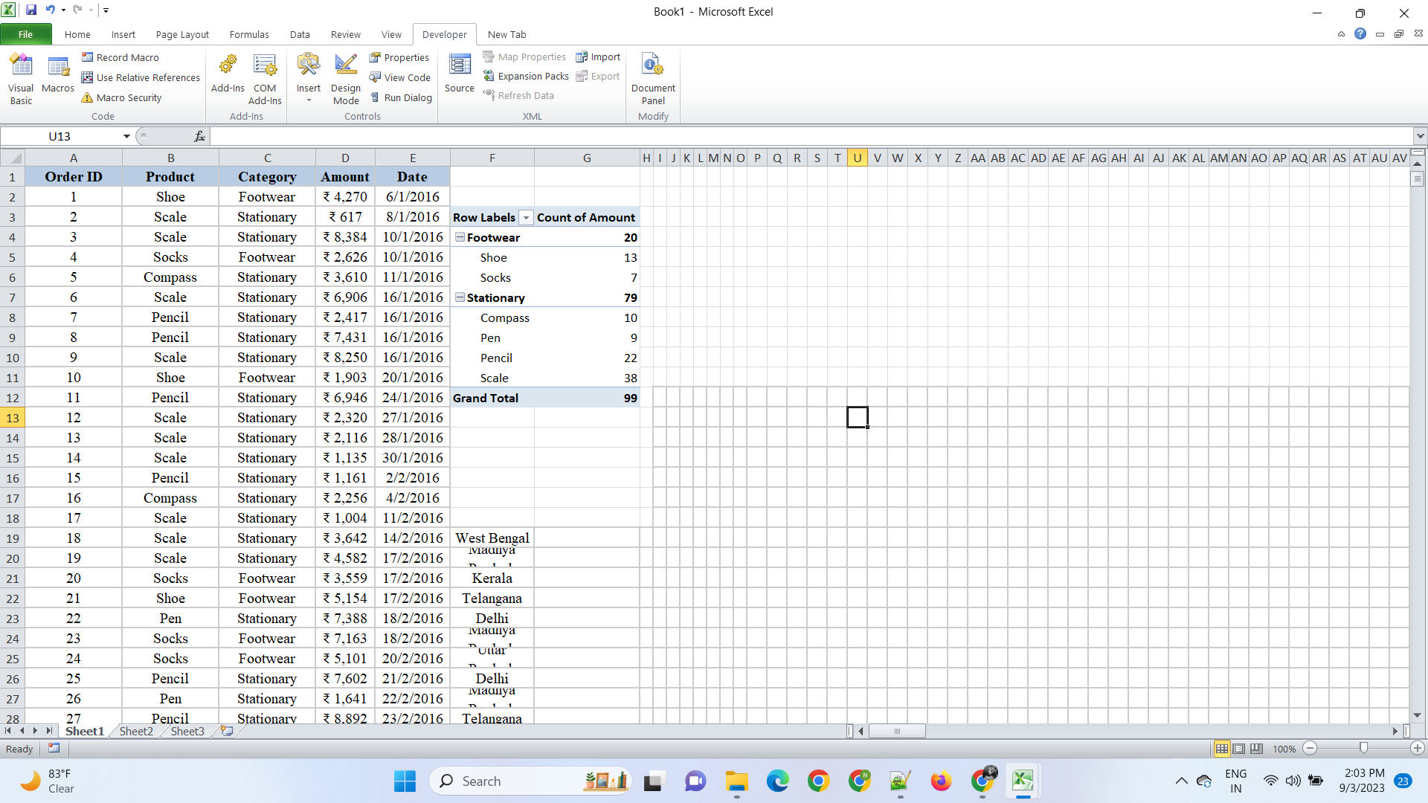

**6. Write step by step procedure to protect your workbook using a**

**Password.**

To protect your Excel workbook with a password, follow these step-by-step procedures:

**Step 1: Open Your Workbook**

Open the Excel workbook that you want to protect with a password.

**Step 2: Save a Backup (Optional)**

Before applying a password, it's a good practice to save a backup copy of your workbook. You can do this by clicking on "File" > "Save As" and choosing a different name or location for the backup copy.

**Step 3: Go to Workbook Protection**

1. Click on the "Review" tab in the Excel ribbon.

2. In the "Changes" group, you'll find an option called "Protect Workbook." Click on it.

**Step 4: Set a Password**

1. In the "Protect Structure and Windows" dialog box, check the "Structure" box to protect the structure of the workbook (e.g., sheets, charts, macros).

2. Optionally, you can check the "Windows" box if you want to protect the workbook's window size and position.

3. Click on the "OK" button.

**Step 5: Enter and Confirm Password**

1. A "Protect Structure" dialog box will appear, prompting you to enter a password. Enter a password of your choice.

2. Confirm the password by typing it again in the "Reenter password to proceed" box.

**Step 6: Save the Workbook**

After entering and confirming the password, click "OK."

**Step 7: Re-enter the Password (Optional**

If you chose to protect the workbook's window size and position, you'll need to enter the password again when you open the workbook to restore the window to its previous state.

**Step 8: Test the Protection**

Close the workbook and reopen it. You will be prompted to enter the password you set to access the workbook. Without the correct password, the workbook cannot be opened or modified.

**Step 9: Remember Your Password**

Make sure to remember the password you set, as there is no built-in way to recover it if you forget it. If you forget the password, you may lose access to your workbook.

**Step 10: Store Password Securely**

If you need to share the workbook with others or store it in a secure location, be sure to store the password securely, such as in a password manager or a physical location only you can access.

That's it! You have successfully protected your Excel workbook with a password. Make sure to keep your password safe and accessible only to those who should have access to the workbook.