Below is the Graph taken from “geeksforgeeks” that is to be solved for the shortest path using Greedy and Dynamic programming respectively:

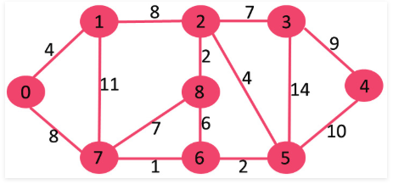

Following is the solution for shortest path by using Greedy:

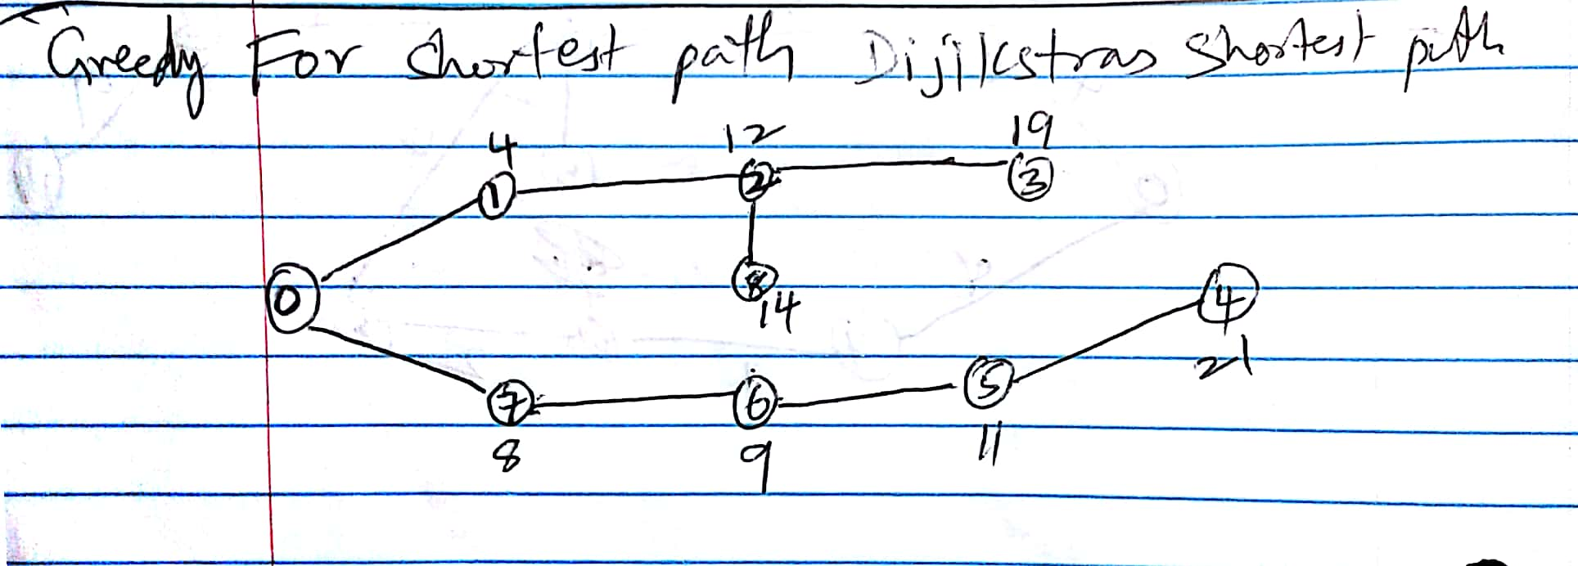

Following image is the solution for shortest path based on the Dynamic programming, the shortest path is highlighted in yellow resulting in 21 (8 + 1 + 2 + 10).

