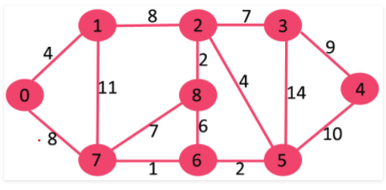

Graphs are taken from GeeksForGeeks website.

|  |  |
| --- | --- |
| Prims’s Algorithm of minimum spanning tree | Kruskal’s Algorithm of minimum spanning tree |

|  |  |
| --- | --- |
| Greedy Algorithm (Dijkstra’s shortest path algorithm) |  |