

Requirement Specification Document

**Pharma Database (Web)**

**Eli Research India Pvt. Ltd.,**

4th Floor, C Block, Cyber Gateway, Hyderabad – 500076, India.

Tel: +91 40 4080 8700

Document Revision History

|  |  |  |  |  |  |
| --- | --- | --- | --- | --- | --- |
| **Ver. #** | **Date** | **Author** | **Reviewer** | **Description of Changes** | **Comments** |
| 1.0 | 15-Apr-16 | Dev Team |  |  | Initial Draft |
| 1.1 | 21-Apr-16 | Dev Team | Neel Kamal | * Modified In scope and out scope * Updated field details for each screen * Modified search view grid view layout |  |
|  |  |  |  |  |  |
|  |  |  |  |  |  |

Contents

**1.** **Introduction** 3

**2.** **Overview** 3

**3.** **Business Process Understanding** 3

**4.** **Business Requirements** 3

**5.** **Users of the Application** 4

**6.** **Application Flow** 4

6.1. User Registration 4

6.2. Request Demo 4

6.3. Login 7

6.4. Search 11

6.5. My Profile 34

**7.** **Admin Panel** 39

**8.** **System Requirements** 43

**9.** **Data Migration Requirements** 44

**10.** **Backup & Data Recovery Requirements** 44

**11.** **Special User Requirements** 44

**12.** **Risk** 44

**13.** **Open Issues** 44

# **Introduction**

# **Overview**

* 1. Purpose
  2. Intended audience

# **Business Process Understanding**

* 1. System Functional Overview
     1. Technology Overview
     2. Data Model

# **Business Requirements**

* 1. Application Scope and Boundary

Application scope is limited to below features for this release

**In Scope: (Planned for first release)**

* User Registration
* Basic search
* Advance search
* Search results
  + Grid view
  + List view
* Module result view
  + Company view
  + Product view
  + Deals view
  + News view
* Module wise search
  + Company
  + Product
  + Deals
  + News
* Save queries
* Export result to Excel
* Reports (max 3 reports)

**Out of Scope: (Will be planned for next release)**

* Company financial info
* Company stock info
* Company stock price vs news
* Module result view
  + Patent view
  + Regulatory view
  + Milestones view
  + Product sales view
  + Royalty view
* Module wise search
  + Patents
  + Regulatory
  + Milestones
  + Product sales
* Chart view
* Alerts on saved queries

# **Users of the Application**

This application will be accessed by below mentioned users

* + - Admin
    - Subscription users(Full access)
    - Demo users(Full access)
    - Trial User(partial access)

# **Application Flow**

# User Registration

To access the application user has to first get registered in the application. In order to get registered user has to first request for demo of the application.

# Request Demo

When a user is interested in PharmaDatabase product. Before purchasing user would prefer to have a demo. On behalf of the organization, authorized person would request for demo.

**Steps for Requesting demo:**

1. Enter into PharmaDatabase.com
2. Click on "Request Demo" button
3. Redirects to "Request Demo" page
4. Fill the required fields and click submit button

**Validation:**

1. Is the provided email ID registered early?
2. If registered early and used our software for the trail period, inform the user and proceed to upgradation option.
3. Registered but not activated, prompt the user for re-sending activation link on his/her registered email. So, user could activate the demo.
4. If not an existing user, check for the link expiration date.
5. If the user is not an existing one/link not expired, send verification email to the user.

**Flow Diagram:**

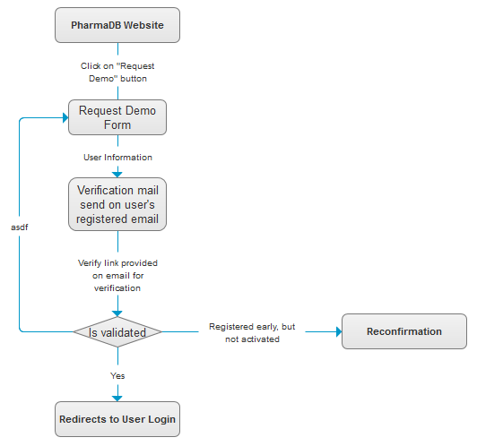

**Mock Screen:**

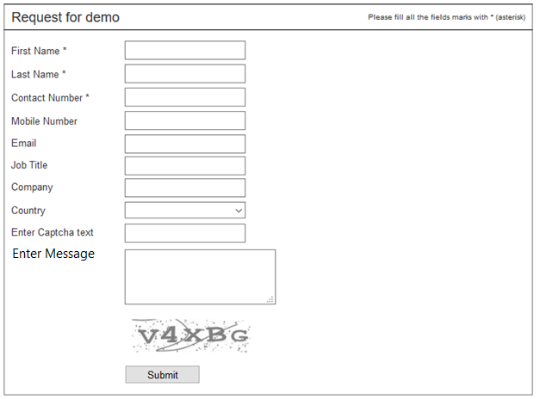

|  |  |  |  |
| --- | --- | --- | --- |
| Screen field details: | |  | *FT = Field Type *DT= Data Type |
| **Field** | **Type** | **Validation/Restrictions** | **Description** |
| First Name | FT: Textbox DT: NVarchar | Mandatory Min-Length: 3 Max-Length: 100 | First Name of the person requested for demo |
| Last Name | FT: Textbox DT: NVarchar | Mandatory Min-Length: 3 Max-Length: 100 | Last Name of the person requested for demo |
| Contact Number | FT: Textbox DT: NVarchar | Mandatory | Users contact number |
| Mobile Number | FT: Textbox DT: NVarchar | Optional | Users mobile number |
| Email | FT: Textbox DT: NVarchar | Mandatory Min-Length: 3 Max-Length: 100 Special Chars: @ _ . Type: Valid email | Official email ID for communication |
| Job Title | FT: Textbox DT: NVarchar | Mandatory Min-Length: 3 Max-Length: 100 | Job title of the person who requested for demo. |
| Company | FT: Textbox DT: NVarchar | Mandatory Min-Length: 3 Max-Length: 100 | Name of the company |
| Country | FT: Dropdown DT: Varchar | Mandatory | Select country where the company is located |
| Comments | FT: Textarea DT: Varchar | NA |  |
| Message | FT: Textarea DT: Varchar |  | Input field to enter message by the user. |
| Captcha | FT: Dropdown DT: Varchar | Mandatory |  |
| **Action Items** | | | |
| |  |  |  |  | | --- | --- | --- | --- | | **Control Name** | **Control Type** | **Event** | **Action** | | Submit | Button | Click | **Actions:**   * Send data to the server   **Client Side Validations:**   * Mandatory   **Server Side Validations:**   * Validate for unique email id | | | | |

# Login

In order to access Pharma Database application, user must be registered with an official (Company) email ID.

**Flow Diagram:**

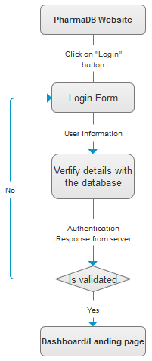

**Mock Screen:**

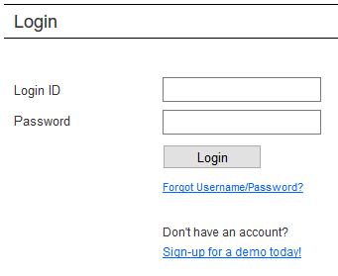

|  |  |  |  |
| --- | --- | --- | --- |
| Screen field details: | |  | *FT = Field Type *DT= Data Type |
| **Field** | **Type** | **Validation/Restrictions** | **Description** |
| Login Id | FT: Textbox DT: NVarchar | Mandatory Length: 10 | User login ID to access application |
| Password | FT: Textbox DT: NVarchar | Mandatory Length: 10 | User login password to access application |
| **Action Items** | | | |
| |  |  |  |  | | --- | --- | --- | --- | | **Control Name** | **Control Type** | **Event** | **Action** | | Login | Button | Click | **Actions:**   * Send   **Client Side Validations:**   * Mandatory   **Server Side Validations:**   * Check for valid credentials | | Reset | Button | Click | **Actions:**   * Clear the form values | | | | |

* + 1. **Forgot Password**

This option will be used to retrieve password when user forgets password

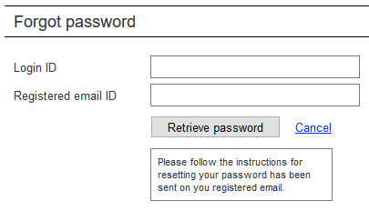

|  |  |  |  |
| --- | --- | --- | --- |
| Screen field details: | |  | *FT = Field Type *DT= Data Type |
| **Field** | **Type** | **Validation/Restrictions** | **Description** |
| Login ID | FT: Textbox DT: NVarchar | Mandatory | Input field to enter user login id |
| Registered Email ID | FT: Textbox DT: NVarchar | Mandatory | Input field to enter user registered email id |
|  |  |  |  |
| **Action Items** | | | |
| |  |  |  |  | | --- | --- | --- | --- | | **Control Name** | **Control Type** | **Event** | **Action** | | Retrieve Password | Button | Click | **Actions:**   * Send data to the server   **Client Side Validations:**   * Mandatory   **Server Side Validations:**   * Check if user id and email matches * If matched, send password reset request to user email id | | | | |

* + 1. **Change password:**

This screen allows user to change current password with new password.

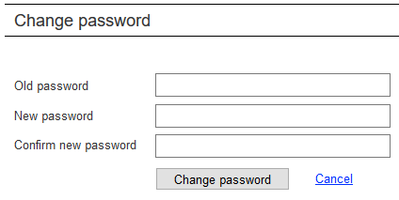

|  |  |  |  |
| --- | --- | --- | --- |
| Screen field details: | |  | *FT = Field Type *DT= Data Type |
| **Field** | **Type** | **Validation/Restrictions** | **Description** |
| Old Password | FT: Textbox DT: NVarchar | Mandatory | Input field to enter user old password |
| New Password | FT: Textbox DT: NVarchar | Mandatory | Input field to enter user new password |
| Confirm Password | FT: Textbox DT: NVarchar | Mandatory | Input field to confirm new password |
| **Action Items** | | | |
| |  |  |  |  | | --- | --- | --- | --- | | **Control Name** | **Control Type** | **Event** | **Action** | | Change Password | Button | Click | **Actions:**   * Send data to the server * Updated new password if validated   **Client Side Validations:**   * Mandatory * Old and new password should not be same   **Server Side Validations:**   * Check user id with old password | | | | |

# Search

After successful login user will be redirected to landing page where basic search option is available to the user along with other information related to pharma database modules.

User will have two types of searches like

* Basic search
* Advanced search
  + 1. **Basic search**

Basic search allows user to search on a specific field by entering a key word related to selected field. Basic search performs the searches on all the selected field value containing the key word entered by the user.

Below are the fields available for basic search:

* Company name
* Ticker symbol
* Product Name
* Active ingredient
* Therapy area

Steps for basic search:

* Select the field from list of the fields
* Enter keyword related to selected field
* Click on Search button to perform the search
* User will be redirected to search results page

Mock screen:

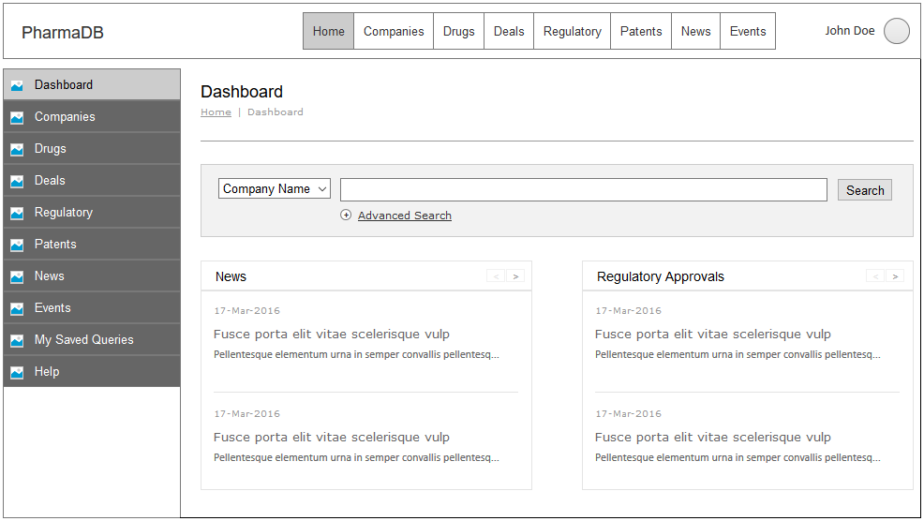

|  |  |  |  |
| --- | --- | --- | --- |
| Screen field details: | |  | *FT = Field Type *DT= Data Type |
| **Field** | **Type** | **Validation/Restrictions** | **Description** |
| Search fields | FT: Dropdown DT: NVarchar | Mandatory | List of fields for performing search |
| Search text | FT: Textbox DT: NVarchar | Mandatory | Input field to enter search text. This will be autocomplete field as per selected search field |
| **Action Items** | | | |
| |  |  |  |  | | --- | --- | --- | --- | | **Control Name** | **Control Type** | **Event** | **Action** | | Search | Button | Click | **Actions:**   * Search database as per selected search field and text   **Client Side Validations:**   * Mandatory   **Server Side Validations:** | | | | |

* + 1. **Advanced Search**

Advance search will have more fields to search and allows user to select more than one field to search along with the required condition operator like “And” or “Or” to perform the search.

Below are fields available for advanced search:

* Company name
* Company industry
* Ticker symbol
* Product Name
* Active ingredient
* Therapy area
* Mechanism of action
* Mode of Action
* Phase name
* ATC
* Chemical and Biological class

Steps for basic search:

* Select the field from list of the fields
* Enter keyword related to selected field
* Select the operator as “And” or “Or” (default is “And”)
* Click on “Add Row” button to select another field and enter the key word
* Click on Search button to perform the search
* User will be redirected to search results page

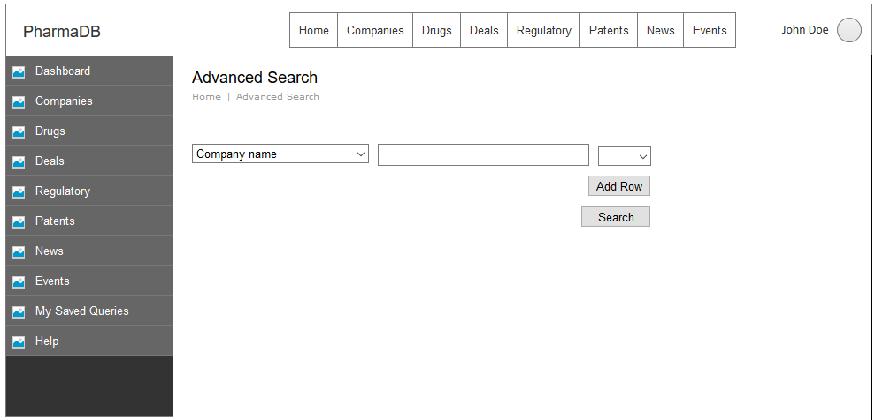

|  |  |  |  |
| --- | --- | --- | --- |
| Screen field details: | |  | *FT = Field Type *DT= Data Type |
| **Field** | **Type** | **Validation/Restrictions** | **Description** |
| Search field | FT: Dropdown DT: NVarchar | Mandatory | Displays list of fields to select and perform search |
| Search text | FT: Dropdown DT: NVarchar | Mandatory | Input field to enter search text. This will be autocomplete field as per selected search field |
| Condition operator | FT: Dropdown DT: NVarchar | Mandatory Default: And | Lists condition operators which are And & Or. Default will be And operator |
| **Action Items** | | | |
| |  |  |  |  | | --- | --- | --- | --- | | **Control Name** | **Control Type** | **Event** | **Action** | | Add Row | Button | Click | **Actions:**   * Add another row with search field and search text   **Client Side Validations:**   * Mandatory   **Server Side Validations:** | | Search | Button | Click | **Actions:**   * Search database as per selected search field and text   **Client Side Validations:**   * Mandatory   **Server Side Validations:** | | | | |

* + 1. **Search Results**

Once user performs search either from basic or advance search, user will be redirected to search results page which will be listed in grid view by default.

**Note:** This view is common for all the modules, where the columns would be populated dynamically according to the module.

**Grid View:**

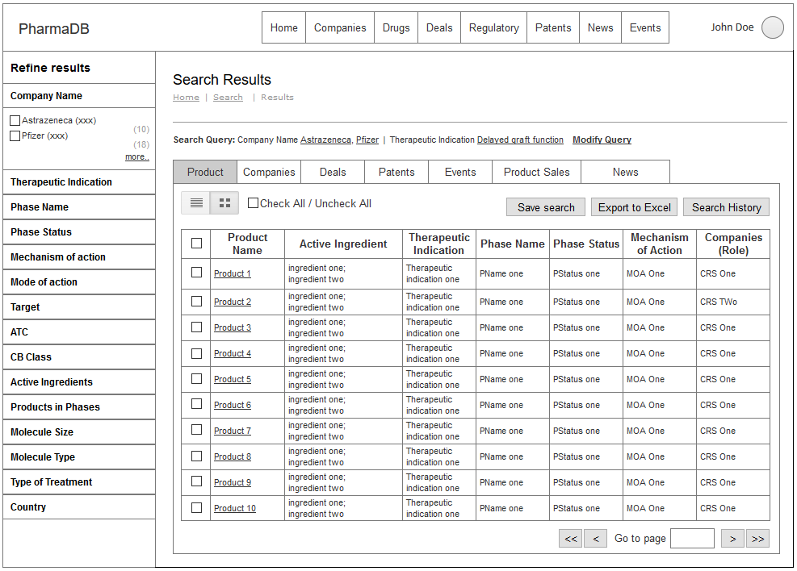

**List View:**

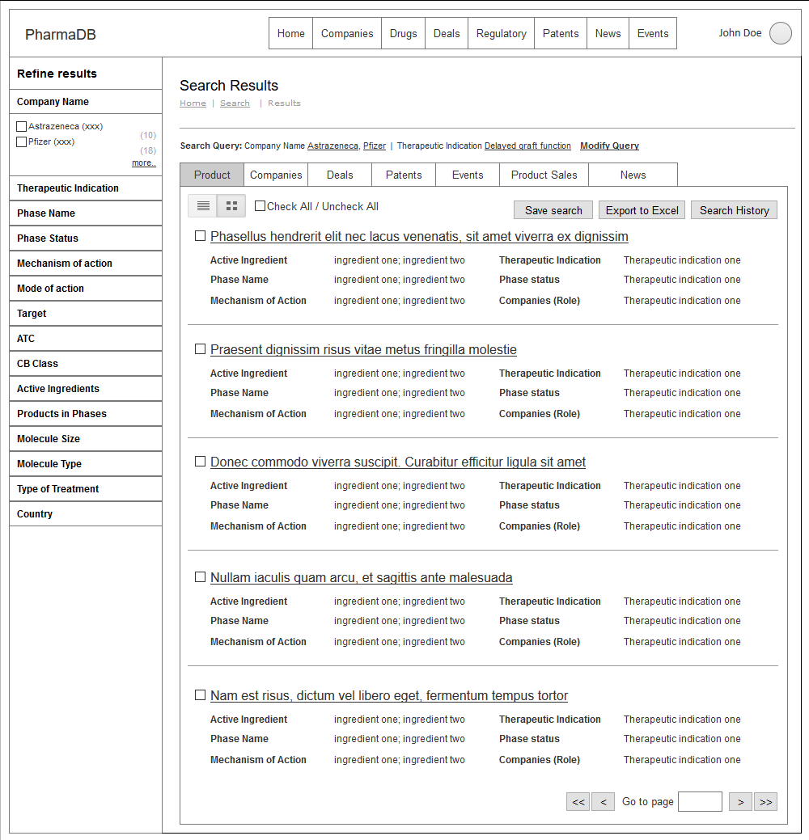

|  |  |  |  |
| --- | --- | --- | --- |
| Screen field details: | |  | *FT = Field Type *DT= Data Type |
| **Field** | **Type** | **Validation/Restrictions** | **Description** |
| **Product Results View:** | | | |
| Check/Uncheck All | FT: Textbox DT: NVarchar | NA | Selects all the items being displayed by checking it. |
| Select Product | FT: Checkbox DT: NVarchar | NA | Selects individual item by checking it. |
| Product Title | FT: Text DT: NVarchar | NA | Displays name of the product |
| Active Ingredient | FT: Text DT: NVarchar | NA | List of active ingredients |
| Therapeutic Indication | FT: Text DT: NVarchar | NA | Name of therapeutic indication |
| Phase Name | FT: Text DT: NVarchar | NA | Name of the phase |
| Phase Status | FT: Text DT: NVarchar | NA | Status of the trial phase |
| Mechanism of Action | FT: Text DT: NVarchar | NA | Displays the list of mechanism of actions. |
| Companies (Role) | FT: Text DT: NVarchar | NA | List of companies and their roles |
| **Tabs** | | | |
| Product | FT: Text DT: NVarchar | NA | Filter and Display search result by Product |
| Companies | FT: Text DT: NVarchar | NA | Filter and Display search result by Companies |
| Deals | FT: Text DT: NVarchar | NA | Filter and Display search result by Deals |
| Patents | FT: Text DT: NVarchar | NA | Filter and Display search result by Patents |
| Events | FT: Text DT: NVarchar | NA | Filter and Display search result by Events |
| Sales | FT: Text DT: NVarchar | NA | Filter and Display search result by Sales |
| News | FT: Text DT: NVarchar | NA | Filter and Display search result by News |
| **Action Items** | | | |
| |  |  |  |  | | --- | --- | --- | --- | | **Control Name** | **Control Type** | **Event** | **Action** | | Save Search | Button | Click | **Actions:**   * Send data to the server   **Client Side Validations:**   * Mandatory   **Server Side Validations:**   * Check | | Export to Excel | Button | Click | **Actions:**   * Exports selected data into excel file with extension .xlsx | | Search History | Button | Click | **Actions:**   * Displays the search performed | | List view/Grid view | Button | Click | **Actions:**   * Changes the view of search results into List/Grid views | | | | |

**Search refining fields:**

These fields will be using for refining primary search criteria.

|  |  |
| --- | --- |
| * Company Name * Therapeutic Indication * Phase Name * Phase Status * Mechanism of action * Mode of action * Target * ATC | * CB Class * Active Ingredients * Products in Phases * Molecule Size * Molecule Type * Type of Treatment * Country |

**Module Views:**

**Product View:**

Single view – Snapshot

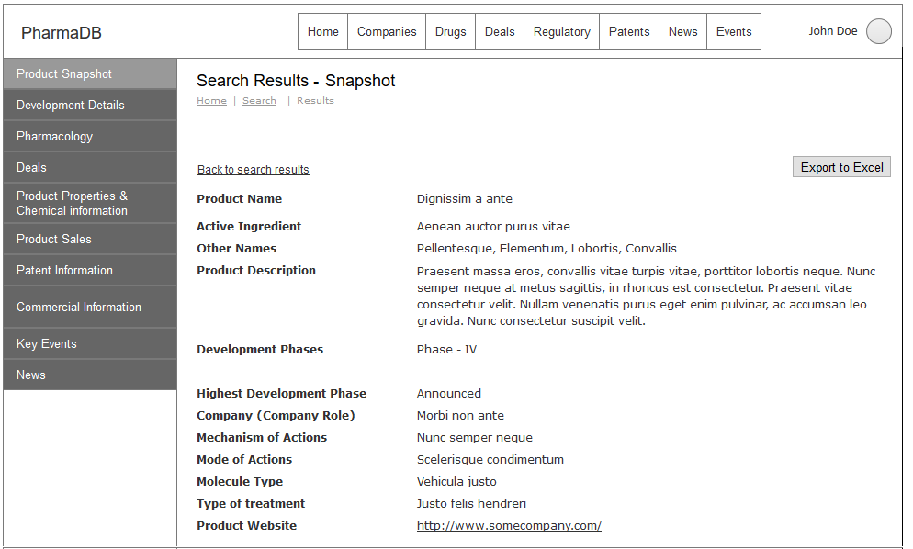

|  |  |  |  |
| --- | --- | --- | --- |
| Screen field details: | |  | *FT = Field Type *DT= Data Type |
| **Field** | **Type** | **Validation/Restrictions** | **Description** |
| Product Name | FT: Text DT: NVarchar |  | Name of the product |
| Active Ingredient | FT: Text DT: NVarchar |  | List of active ingredients |
| Other Names | FT: Text DT: NVarchar |  | Displays other names of the product if it has any. |
| Product Description | FT: Text DT: NVarchar |  | Detailed information about the product |
| Development Phases | FT: Text DT: NVarchar |  | List of phases under development |
| Highest Development Phase | FT: Text DT: NVarchar |  | Latest phase of the development |
| Company (Company Role) | FT: Text DT: NVarchar |  | List of companies and their roles |
| Mechanism of Actions | FT: Text DT: NVarchar |  | Displays the list of mechanism of actions. |
| Mode of Actions | FT: Text DT: NVarchar |  | Lists out mode of actions performed |
| Molecule Type | FT: Text DT: NVarchar |  | Displays type of the molecule |
| Type of Treatment | FT: Text DT: NVarchar |  | Displays the treatment type |
| Product Website | FT: URL DT: NVarchar |  | URL of the product website |
| **Action Items** | | | |
| |  |  |  |  | | --- | --- | --- | --- | | **Control Name** | **Control Type** | **Event** | **Action** | | Export to Excel | Button | Click | **Actions:**   * Send data to the server   **Client Side Validations:**   * Mandatory   **Server Side Validations:**   * Check | | | | |

Single view – Development Details

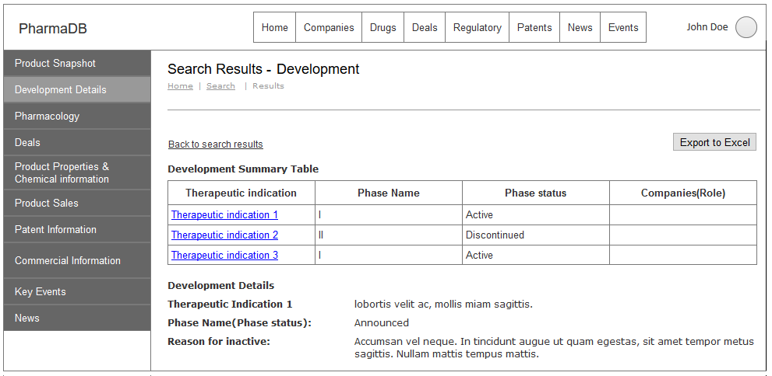

|  |  |  |  |
| --- | --- | --- | --- |
| Screen field details: | |  | *FT = Field Type *DT= Data Type |
| **Field** | **Type** | **Validation/Restrictions** | **Description** |
| **Development Summary Table:** | | | |
| Phase Name | FT: Text DT: NVarchar |  | Displays name of the development phase |
| Phase Status | FT: Text DT: NVarchar |  | Displays current status of the phase |
| Companies (Role) | FT: Text DT: NVarchar |  | List of companies and their roles |
| **Development Details:** | | | |
| Therapeutic Indication | FT: Text DT: NVarchar |  | Displays name of the therapeutic indication |
| Phase Name (Phase Status) | FT: Text DT: NVarchar |  | Displays current phase name of the development |
| Reason for Inactive | FT: Text DT: NVarchar |  | Describes reason why development is inactive |
| **Action Items** | | | |
| |  |  |  |  | | --- | --- | --- | --- | | **Control Name** | **Control Type** | **Event** | **Action** | | Export to Excel | Button | Click | **Actions:**   * Send data to the server   **Client Side Validations:**   * Mandatory   **Server Side Validations:**   * Check | | Therapeutic Indication | Anchor | Click | **Actions:**   * Send data to the server   **Client Side Validations:**   * Mandatory   **Server Side Validations:**  Check | | | | |

Product – Pharmacology

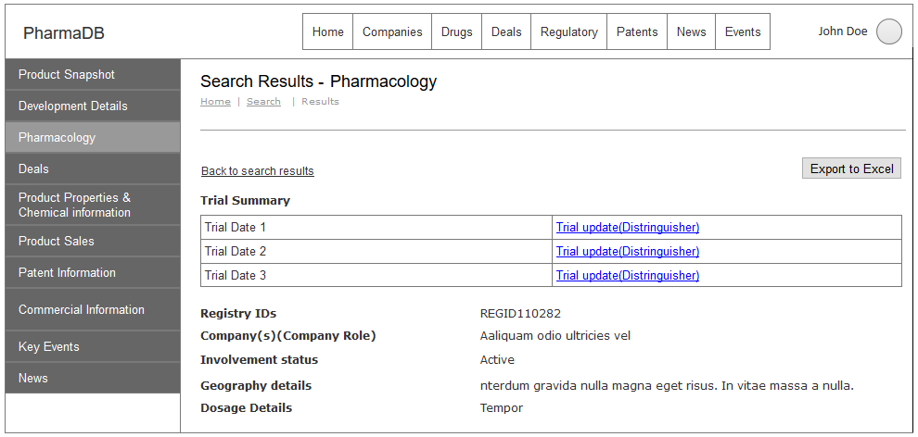

|  |  |  |  |
| --- | --- | --- | --- |
| Screen field details: | |  | *FT = Field Type *DT= Data Type |
| **Field** | **Type** | **Validation/Restrictions** | **Description** |
| **Trial Summary Table:** | | | |
| Trial Date | FT: Text DT: NVarchar | Date format only. | Date of the trial conducted |
| Registry IDs | FT: Text DT: NVarchar |  | IDs registered at this stage |
| Company(s) Role(s) | FT: Text DT: NVarchar |  | List of companies and their roles |
| Involvement Status | FT: Text DT: NVarchar |  | Displays status of the Involvement |
| Geography Details | FT: Text DT: NVarchar |  | Geographical details of the development which was performed |
| Dosage Details | FT: Text DT: NVarchar |  | Details of the dosages used for the product |
| **Action Items** | | | |
| |  |  |  |  | | --- | --- | --- | --- | | **Control Name** | **Control Type** | **Event** | **Action** | | Export to Excel | Button | Click | **Actions:**   * Send data to the server   **Client Side Validations:**   * Mandatory   **Server Side Validations:**   * Check | | Trial Update | Anchor | Click | **Actions:**   * Send data to the server   **Client Side Validations:**   * Mandatory   **Server Side Validations:**  Check | | | | |

Product – Deals

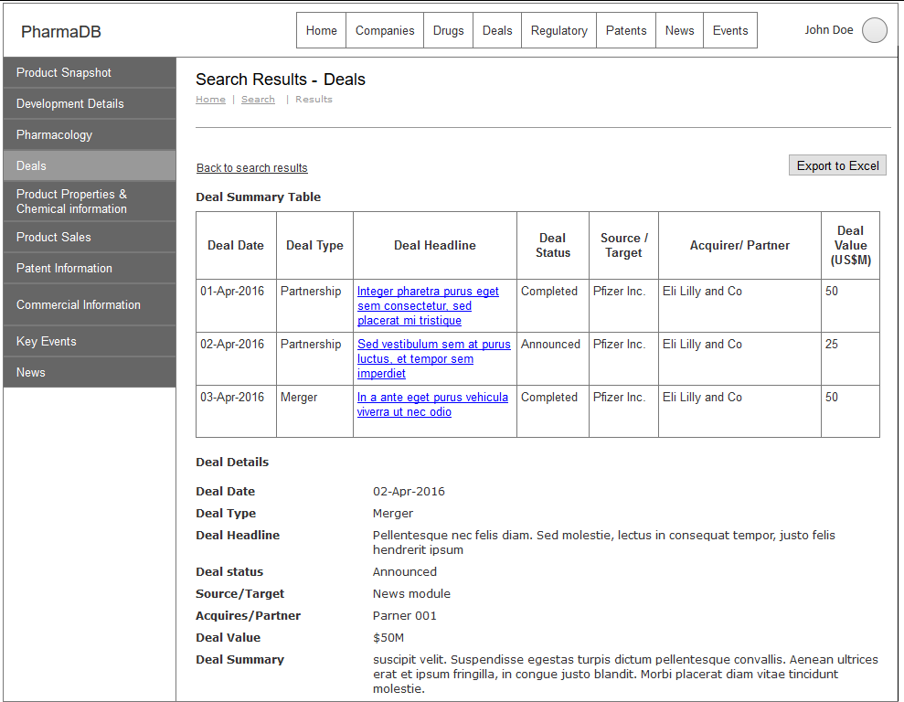

|  |  |  |  |
| --- | --- | --- | --- |
| Screen field details: | |  | *FT = Field Type *DT= Data Type |
| **Field** | **Type** | **Validation/Restrictions** | **Description** |
| **Deals Summary Table** | | | |
| Deal Date | FT: Text DT: NVarchar | Date format only. | Date of the deal confirmed/announced |
| Deal Type | FT: Text DT: NVarchar |  | Shows type of deal |
| Deal Status | FT: Text DT: NVarchar |  | Displays status of the deal |
| Source/Target | FT: Text DT: NVarchar |  | Displays info about source/target |
| Acquirer/Partner | FT: Text DT: NVarchar |  | Details about the Acquirer/Partner |
| Deal Value (US $M) | FT: Text DT: Numeric |  | Total value of the deal in USD $M |
| **Deal Details** | | | |
| Deal Date | FT: Text DT: NVarchar |  | Date of the deal confirmed/announced |
| Deal Type | FT: Text DT: NVarchar |  | Shows type of deal |
| Deal Headline | FT: Text DT: NVarchar |  | Headline of the deal |
| Deal status | FT: Text DT: NVarchar |  | Displays status of the deal |
| Source/Target | FT: Text DT: NVarchar |  | Displays info about source/target |
| Acquires/Partner | FT: Text DT: NVarchar |  | Details about the Acquirer/Partner |
| Deal Value | FT: Text DT: NVarchar |  | Total value of the deal in USD $M |
| Deal Summary | FT: Text DT: NVarchar |  | Detailed information about the deal |
| **Action Items** | | | |
| |  |  |  |  | | --- | --- | --- | --- | | **Control Name** | **Control Type** | **Event** | **Action** | | Export to Excel | Button | Click | **Actions:**   * Send data to the server   **Client Side Validations:**   * Mandatory   **Server Side Validations:**   * Check | | Deal Headline | Anchor | Click | **Actions:**   * Send data to the server   **Client Side Validations:**   * Mandatory   **Server Side Validations:**  Check | | | | |

Product – Product properties & Chemical information

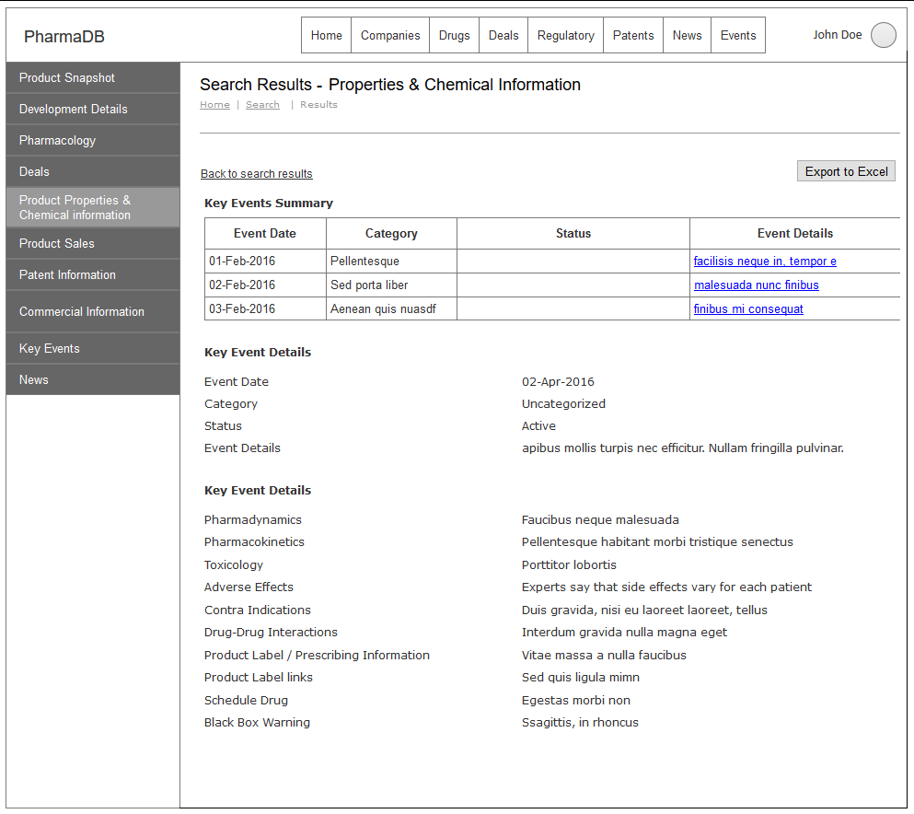

|  |  |  |  |
| --- | --- | --- | --- |
| Screen field details: | |  | *FT = Field Type *DT= Data Type |
| **Field** | **Type** | **Validation/Restrictions** | **Description** |
| **Key Events Summary** | | | |
| Event Date | FT: Text DT: NVarchar | Date format only. | Date of the event occurred |
| Category | FT: Text DT: NVarchar |  | Category of the event |
| Status | FT: Text DT: NVarchar |  | Displays status of the event |
| **Key Event Details:** | | | |
| Event Date | FT: Text DT: NVarchar |  | Date of the event occurred |
| Category | FT: Text DT: NVarchar |  | Category of the event |
| Status | FT: Text DT: NVarchar |  | Displays status of the event |
| Event Details | FT: Text DT: NVarchar |  | Full details about the event |
| Pharmadynamics | FT: Text DT: NVarchar |  | Displays Pharmadynamics details |
| Pharmacokinetics | FT: Text DT: NVarchar |  | Displays Pharmadynamics details |
| Toxicology | FT: Text DT: NVarchar |  | Displays Toxicology details |
| Adverse Effects | FT: Text DT: NVarchar |  | Adverse effects of the event |
| Contra Indications | FT: Text DT: NVarchar |  | Indicates event condition |
| Drug-Drug Interactions | FT: Text DT: NVarchar |  | Displays Drug-Drug Interactions details |
| Product Label / Prescribing Information | FT: Text DT: NVarchar |  | Full information about Product Label/Prescribing Information |
| Product Label links | FT: Text DT: NVarchar |  | Links of product labels |
| Schedule Drug | FT: Text DT: NVarchar |  | Details of Drug schedule |
| Black Box Warning | FT: Text DT: NVarchar |  | Details of the black box warning |
| **Action Items** | | | |
| |  |  |  |  | | --- | --- | --- | --- | | **Control Name** | **Control Type** | **Event** | **Action** | | Export to Excel | Button | Click | **Actions:**   * Send data to the server * Export to Excel file   **Client Side Validations:**   * Mandatory   **Server Side Validations:**   * Check | | Event Details | Anchor | Click | **Actions:**   * Send data to the server   **Client Side Validations:**   * Mandatory   **Server Side Validations:**  Check | | | | |

Product – Product Sales

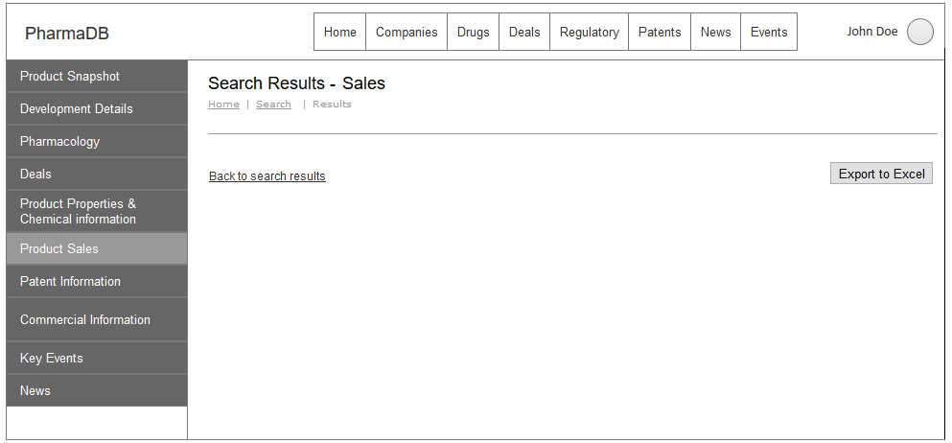

|  |  |  |  |
| --- | --- | --- | --- |
| Screen field details: | |  | *FT = Field Type *DT= Data Type |
| **Field** | **Type** | **Validation/Restrictions** | **Description** |
|  |  |  |  |
|  |  |  |  |
| **Action Items** | | | |
| |  |  |  |  | | --- | --- | --- | --- | | **Control Name** | **Control Type** | **Event** | **Action** | | Export to Excel | Button | Click | **Actions:**   * Send data to the server   **Client Side Validations:**   * Mandatory   **Server Side Validations:**   * Check | | | | |

Product – Patent Information

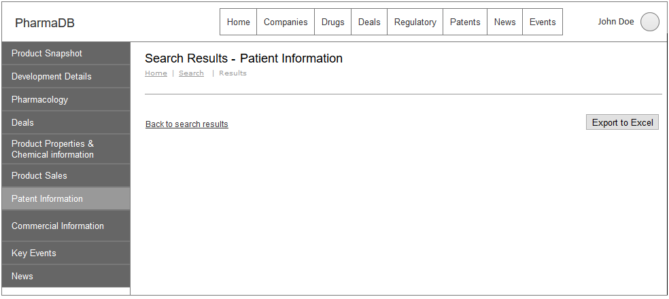

|  |  |  |  |
| --- | --- | --- | --- |
| Screen field details: | |  | *FT = Field Type *DT= Data Type |
| **Field** | **Type** | **Validation/Restrictions** | **Description** |
|  |  |  |  |
|  |  |  |  |
| **Action Items** | | | |
| |  |  |  |  | | --- | --- | --- | --- | | **Control Name** | **Control Type** | **Event** | **Action** | | Export to Excel | Button | Click | **Actions:**   * Send data to the server   **Client Side Validations:**   * Mandatory   **Server Side Validations:**   * Check | | | | |

Product – Commercial Information

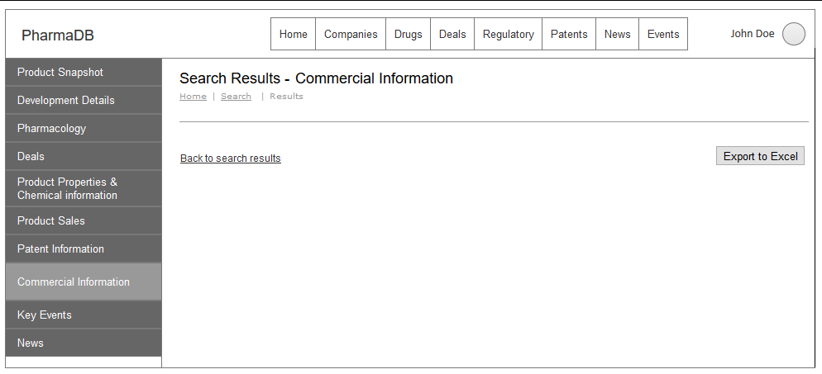

|  |  |  |  |
| --- | --- | --- | --- |
| Screen field details: | |  | *FT = Field Type *DT= Data Type |
| **Field** | **Type** | **Validation/Restrictions** | **Description** |
|  |  |  |  |
|  |  |  |  |
| **Action Items** | | | |
| |  |  |  |  | | --- | --- | --- | --- | | **Control Name** | **Control Type** | **Event** | **Action** | | Export to Excel | Button | Click | **Actions:**   * Send data to the server   **Client Side Validations:**   * Mandatory   **Server Side Validations:**   * Check | | | | |

Product – Key events

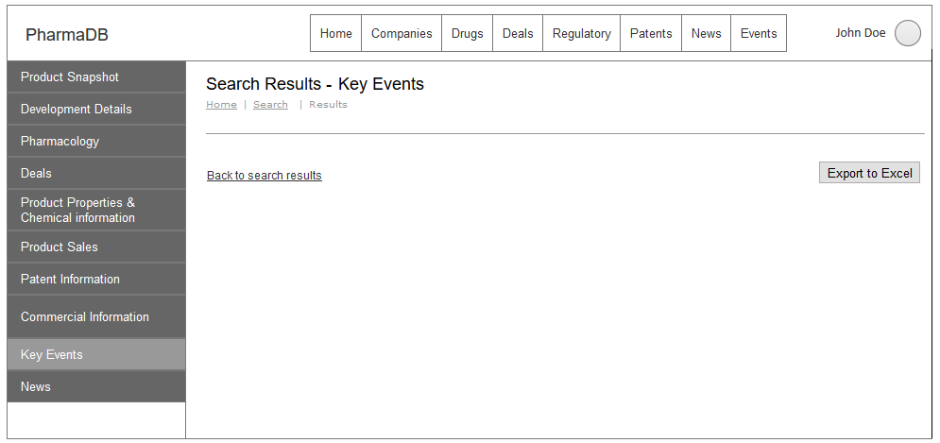

|  |  |  |  |
| --- | --- | --- | --- |
| Screen field details: | |  | *FT = Field Type *DT= Data Type |
| **Field** | **Type** | **Validation/Restrictions** | **Description** |
|  |  |  |  |
|  |  |  |  |
| **Action Items** | | | |
| |  |  |  |  | | --- | --- | --- | --- | | **Control Name** | **Control Type** | **Event** | **Action** | | Export to Excel | Button | Click | **Actions:**   * Send data to the server   **Client Side Validations:**   * Mandatory   **Server Side Validations:**   * Check | | | | |

Product – News

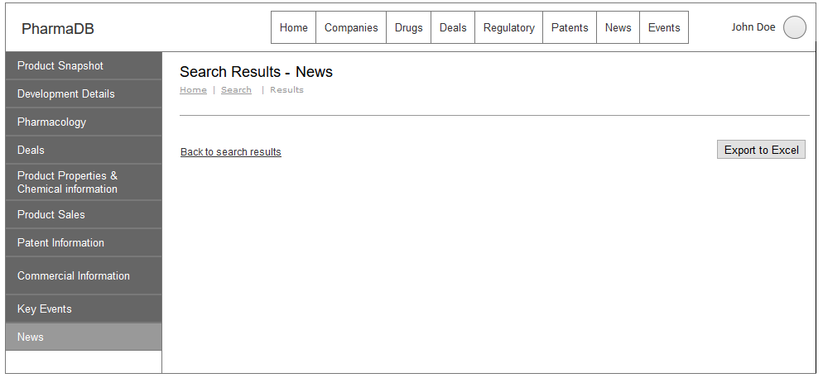

|  |  |  |  |
| --- | --- | --- | --- |
| Screen field details: | |  | *FT = Field Type *DT= Data Type |
| **Field** | **Type** | **Validation/Restrictions** | **Description** |
|  |  |  |  |
|  |  |  |  |
| **Action Items** | | | |
| |  |  |  |  | | --- | --- | --- | --- | | **Control Name** | **Control Type** | **Event** | **Action** | | Export to Excel | Button | Click | **Actions:**   * Send data to the server   **Client Side Validations:**   * Mandatory   **Server Side Validations:**   * Check | | | | |

* + 1. **Save search query**

This feature allows users to save the primary search criteria, saved queries can be viewed by the users using “My saved queries”.

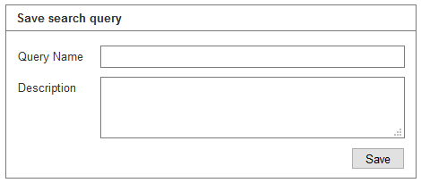

|  |  |  |  |
| --- | --- | --- | --- |
| Screen field details: | |  | *FT = Field Type *DT= Data Type |
| **Field** | **Type** | **Validation/Restrictions** | **Description** |
| Query Name | FT: Textbox DT: NVarchar | Mandatory Min length: 10 Max length: 100 | Displays Name of the query |
| Description | FT: Textbox DT: Textarea | Min length: 10 Max length: 1000 | Information about the saved search query entered by the user |
| **Action Items** | | | |
| |  |  |  |  | | --- | --- | --- | --- | | **Control Name** | **Control Type** | **Event** | **Action** | | Submit | Button | Click | **Actions:**   * Send data to the server   **Client Side Validations:**   * Mandatory   **Server Side Validations:**   * Check | | | | |

* + 1. **Export to Excel**

This feature allows user to export all the search results to excel document. Data will be exported into multiple sheets as per the fields selected by the user in export form.

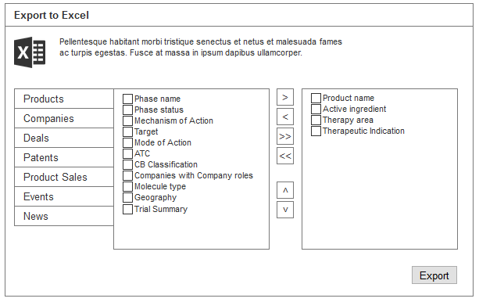

# My Profile

* + 1. **Change Password**

This feature allows users to change their current password to new password.

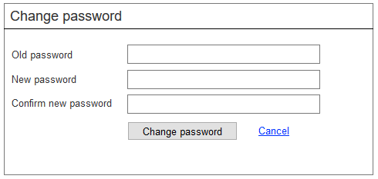

|  |  |  |  |
| --- | --- | --- | --- |
| Screen field details: | |  | *FT = Field Type *DT= Data Type |
| **Field** | **Type** | **Validation/Restrictions** | **Description** |
| Old password | FT: Textbox DT: NVarchar | Mandatory | Old/Existing password which is being used for log into the application. |
| New Password | FT: Textbox DT: NVarchar | Mandatory Not equal to: Old password | New password user wish to set |
| Confirm new password | FT: Textbox DT: NVarchar | Mandatory Equalto: New Password | Make sure both the new password and confirm new password are same |
| **Action Items** | | | |
| |  |  |  |  | | --- | --- | --- | --- | | **Control Name** | **Control Type** | **Event** | **Action** | | Change password | Button | Click | **Actions:**   * Send data to the server   **Client Side Validations:**   * Mandatory   **Server Side Validations:**   * Check | | Cancel | Anchor/Button | Click | **Actions:**   * Takes back the user to the previous form | | | | |

* + 1. **My Saved Queries**

This feature allows user to view all the queries saved by the user when he has performed the search and saved from search results page.

User will have option to Run the query, Modify and Delete the saved query as shown in the below screens.

My Saved Queries

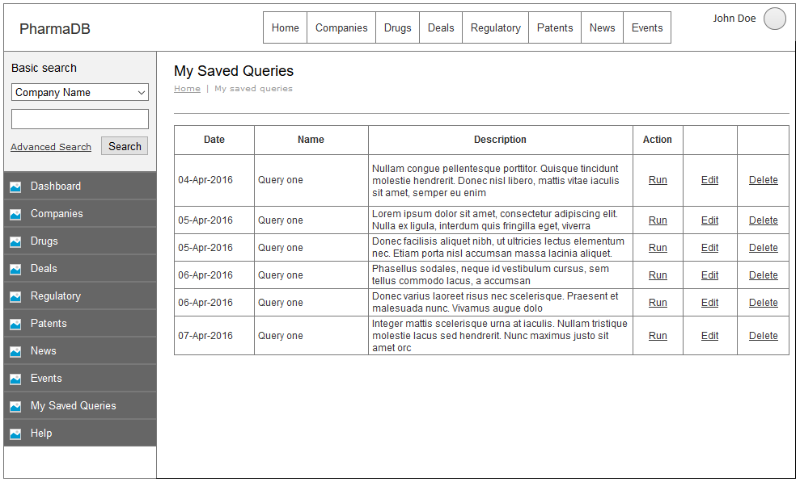

|  |  |  |  |
| --- | --- | --- | --- |
| Screen field details: | |  | *FT = Field Type *DT= Data Type |
| **Field** | **Type** | **Validation/Restrictions** | **Description** |
| Date | FT: Text DT: NVarchar | Only date format. | Date of the query saved |
| Name | FT: Text DT: NVarchar |  | Name of the query entered by the user |
| Description | FT: Text DT: NVarchar |  | Displays Description of the query entered by the user |
| **Action Items** | | | |
| |  |  |  |  | | --- | --- | --- | --- | | **Control Name** | **Control Type** | **Event** | **Action** | | Run | Anchor/Button | Click | **Actions:**   * Send data to the server   **Client Side Validations:**   * Mandatory   **Server Side Validations:**   * Check | | Edit | Anchor/Button | Click | **Actions:**   * Send data to the server   **Client Side Validations:**   * Mandatory   **Server Side Validations:**  Check | | Delete | Anchor/Button | Click | **Actions:**   * Send data to the server   **Client Side Validations:**   * Mandatory   **Server Side Validations:**  Check | | | | |

My Saved Queries – Edit

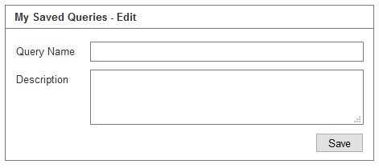

|  |  |  |  |
| --- | --- | --- | --- |
| Screen field details: | |  | *FT = Field Type *DT= Data Type |
| **Field** | **Type** | **Validation/Restrictions** | **Description** |
| Query Name | FT: Textbox DT: NVarchar | Mandatory | Name of the query |
| Description | FT: Textarea DT: NVarchar |  | Description of the query |
| **Action Items** | | | |
| |  |  |  |  | | --- | --- | --- | --- | | **Control Name** | **Control Type** | **Event** | **Action** | | Save | Button | Click | **Actions:**   * Send data to the server   **Client Side Validations:**   * Mandatory   **Server Side Validations:**   * Check | | | | |

My Saved Queries – Delete

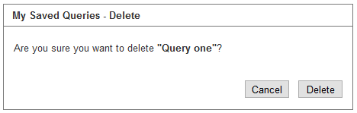

|  |  |  |  |
| --- | --- | --- | --- |
| Screen field details: | |  | *FT = Field Type *DT= Data Type |
| **Field** | **Type** | **Validation/Restrictions** | **Description** |
| Prompt/Alert/Popup | FT: Text DT: NVarchar |  | Prompt window to make sure to perform the desired action |
| **Action Items** | | | |
| |  |  |  |  | | --- | --- | --- | --- | | **Control Name** | **Control Type** | **Event** | **Action** | | Cancel | Button | Click | **Actions:**   * Takes back the user to the previous form | | Delete | Button | Click | **Actions:**   * Send request to the server and perform the preferred action   **Client Side Validations:**   * Mandatory   **Server Side Validations:**  Check | | | | |

* + 1. **Logout**

Logout allows user to log off from the application. Once user clicks on logout link all the user sessions will be closed and will be redirected to home page.

# **Admin Panel**

* + 1. **List of Users**

This feature lists out all the users who are registered.

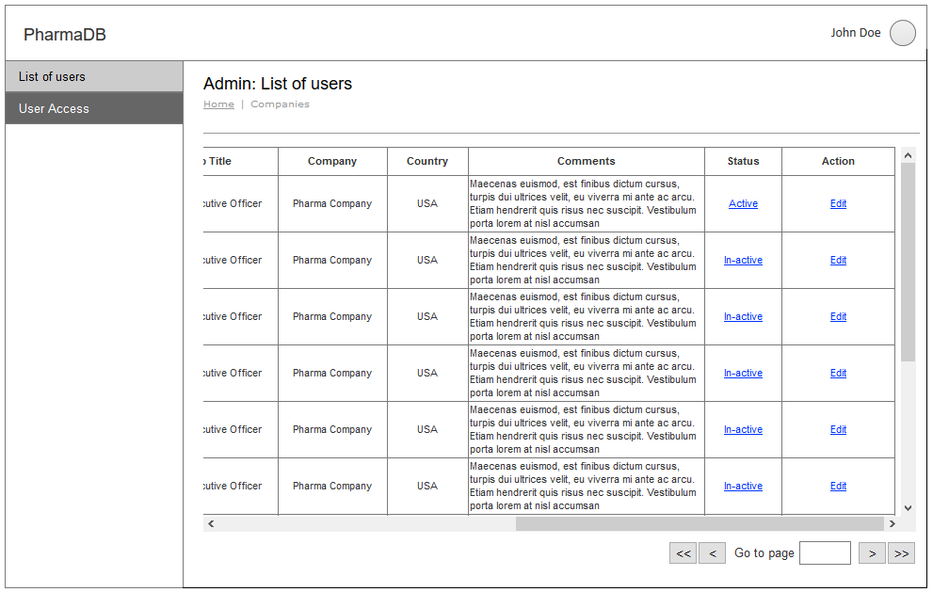

|  |  |  |  |
| --- | --- | --- | --- |
| Screen field details: | |  | *FT = Field Type *DT= Data Type |
| **Field** | **Type** | **Validation/Restrictions** | **Description** |
| First Name | FT: Label DT: NVarchar | N/A | Displays First Name of the registered user |
| Last Name | FT: Label DT: NVarchar | N/A | Displays Last Name of the registered user |
| Contact Number | FT: Label DT: NVarchar | N/A | Displays Contact Number of the registered user |
| Email | FT: Label DT: NVarchar | N/A | Displays Email of the registered user |
| Job Title | FT: Label DT: NVarchar | N/A | Displays Job Title of the registered user |
| Company | FT: Label DT: NVarchar | N/A | Displays name of the company where the registered user is working. |
| Country | FT: Label DT: NVarchar | N/A | Country name of the registered user. |
| Comments | FT: Label DT: NVarchar | N/A | Comments by the user entered at the time of Requesting Demo. |
| **Action Items** | | | |
| |  |  |  |  | | --- | --- | --- | --- | | **Control Name** | **Control Type** | **Event** | **Action** | | Activate/Deactivate | Anchor/Button | Click | **Actions:**   * Send data to the server   **Client Side Validations:**   * Mandatory   **Server Side Validations:**   * Check | | Edit | Anchor/Button | Click | **Actions:**   * Takes back the user to the previous form | | | | |

* + 1. **Activate/Deactivate user:**

This prompt helps admin to confirm changes.

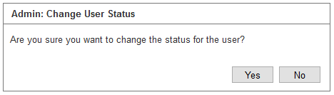

|  |  |  |  |
| --- | --- | --- | --- |
| Screen field details: | |  | *FT = Field Type *DT= Data Type |
| **Field** | **Type** | **Validation/Restrictions** | **Description** |
| Prompt message | FT: Label DT: NVarchar | N/A | Prompts user to make sure of performing the desired action. |
| **Action Items** | | | |
| |  |  |  |  | | --- | --- | --- | --- | | **Control Name** | **Control Type** | **Event** | **Action** | | Yes | Button | Click | **Actions:**   * Send data to the server   **Client Side Validations:**   * Mandatory   **Server Side Validations:**   * Update data on server |  | | No | Anchor/Button | Click | **Actions:**   * Takes back the user to the previous form | | | | |

* + 1. **Access/Modify user:**

This feature allows the admin to update/modify/change details or status of the particular user.

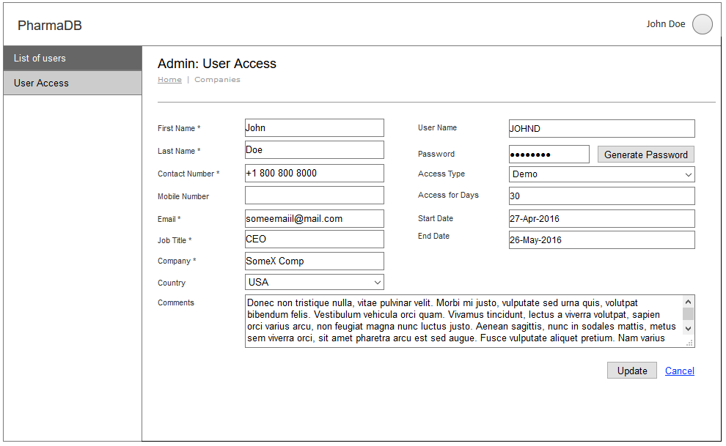

|  |  |  |  |
| --- | --- | --- | --- |
| Screen field details: | |  | *FT = Field Type *DT= Data Type |
| **Field** | **Type** | **Validation/Restrictions** | **Description** |
| First Name | FT: Textbox DT: NVarchar | Mandatory Min-Length: 3 Max-Length: 100 | First Name of the person requested for demo |
| Last Name | FT: Textbox DT: NVarchar | Mandatory Min-Length: 3 Max-Length: 100 | Last Name of the person requested for demo |
| Contact Number | FT: Textbox DT: NVarchar | Mandatory | Users contact number |
| Mobile Number | FT: Textbox DT: NVarchar | Optional | Users mobile number |
| Email | FT: Textbox DT: NVarchar | Mandatory Min-Length: 3 Max-Length: 100 Special Chars: @ _ . Type: Valid email | Official email ID for communication |
| Job Title | FT: Textbox DT: NVarchar | Mandatory Min-Length: 3 Max-Length: 100 | Job title of the person who requested for demo. |
| Company | FT: Textbox DT: NVarchar | Mandatory Min-Length: 3 Max-Length: 100 | Name of the company |
| Country | FT: Dropdown DT: Varchar | Mandatory | Select country where the company is located |
| Comments | FT: Textarea DT: Varchar | NA | Input field to enter message by the user. |
| User Name | FT: Textbox DT: NVarchar | Mandatory Min-Length: 3 Max-Length: 100 | User name generates dynamically according to the provided first name and last name |
| Password | FT: Textbox DT: NVarchar | Mandatory Min-Length: 3 Max-Length: 100 | Password can be set by clicking on generate password button |
| Access Type | FT: Dropdown DT: NVarchar | Mandatory | User has to select type of access can be assigned |
| Access Tenure | FT: Radio button | Mandatory | Value will be Days & Years |
| Access for Days | FT: Textbox for Days DT: Number  FT: Dropdown for Years DT: Number | Mandatory Days: Min Value =1 & Max Value = 365  Years: 1 to 5 | Duration of the access period in days |
| Start Date | FT: Textbox DT: NVarchar | Mandatory | Start date for accessing application |
| End Date | FT: Textbox DT: NVarchar | Mandatory | End date for accessing application |
| **Action Items** | | | |
| |  |  |  |  | | --- | --- | --- | --- | | **Control Name** | **Control Type** | **Event** | **Action** | | Generate Password | Button | Click | **Actions:**   * Generate new password   **Client Side Validations:**   * N/A   **Server Side Validations:**   * Validate password | | Update | Button | Click | **Actions:**   * Send data to the server   **Client Side Validations:**   * Mandatory   **Server Side Validations:**  Validate for data | | Cancel | Button/Anchor | Click | **Actions:**  Takes back the user to the previous form | | | | |

# **System Requirements**

* 1. **Application Architecture**

This application will be developed using MVC (Model View Controller) architectural pattern.

* 1. **Architecture Requirements**

Application will be developed using below technologies

* Application will be developed using Microsoft .Net Technologies
* Application uses .Net framework 4.2 with Entity framework
* Developed using C# programming language
* User interface will be developed using Bootstrap for responsive design
* User interface will be designed using CSS, JQuery, JQuery UI
* Database will be Microsoft SQL Server 2014
  1. **Pending decisions and Risks**
* Procuring online space for hosting application

# **Data Migration Requirements**

This application data will be in two different databases names as

**Authoring tool data:** Authoring tool data is an offline data which contains data migrated from excel format and data curated using authoring tool for some pharma database modules.

**Search data:** Search data is an online data which is located in public servers. Data in authoring tool is processed in two stages as Data curation and Quality check. After quality check is done all the data will be migrated from offline to online search database.

**Note: The data structure of Authoring tool data and Search data is completely different.**

Below are different steps for data migration

* Data curated in Excel format will be migrated to MS SQL server 2014 using SSIS packages
* Data from Authoring tool will be migrated to online search database

# **Backup & Data Recovery Requirements**

# **Special User Requirements**

* 1. Security
  2. Reliability
  3. Audit Trial
  4. User Training

# **Risk**

* 1. Document References

# **Open Issues**

* 1. Review and Sign Off
  2. Appendix