[GVK BIO](http://www.gvkbio.com/)

Requirement Specification Document

Version: 1.0

To

Bayer cropscience AG

**MixTox Tool**

**Phase-2**

GVK Biosciences Private Limited

Informatics Division

Plot No: 79, Nacharam,

IDA Mallapur, Hyderabad – 500076, India.

Tel: +91 40 6736 6200 / 6736 6300

Fax: +91 40 67366444

Document Revision History

|  |  |  |  |
| --- | --- | --- | --- |
| **Ver #** | **Date** | **Author** | **Comments** |
| 1.0 | 16th June 2015 | GVKBIO | Initial Draft |
|  |  |  |  |
|  |  |  |  |
|  |  |  |  |

**Table of Contents**

1 Introduction 4

1.1 Overview 4

1.2 Purpose 4

1.3 Intended audience 4

2 Business Process Understanding 4

2.1 System Functional Overview 4

2.1.1 High Level System Context 5

2.1.2 Technology Overview 5

2.1.3 System interfaces Overview 6

3 Business Requirements 6

3.1 Application Scope and Boundary 7

3.2 Users of the Application 7

4 Application Flow 7

5 System Requirements 12

5.1 Application Architecture 12

5.2 Architecture Requirements 12

5.2.1 Miscellaneous system requirements 12

5.2.2 Pending decisions and Risks 12

6 Data Migration Requirements 12

7 Backup & Data Recovery Requirements 12

8 Risk 12

9 Document reference 12

10 Review and Sign Off 12

REQUIREMENTS SPECIFICATIONS

# Introduction

## Overview

The main objective of this tool is to automate the process of environmental risk assessment of mixtures (parent or metabolites; Step 3 or Step 4), for a given combinations of chemicals/calculations. The tool has to calculate the overall mixture concentrations and perform the evaluation of the associated risk based on the appropriate methodology.

The calculated result data has to be exportedinto .csvtype files (following specification). Display of the resulting data in graphical representation has to be supported.

In order to facilitate the whole process and to allow for easy adaptation to currently ongoing changes in the regulatory environment, the development shall be divided in three steps:

1. Support for processing of concentrations of the individual mixture partners, evaluation of total concentrations and other tasks of “preparatory” nature; import and export of data sets for further processing
2. Support for evaluation of the relevant ETX criteria using the data generated under 1); the methodology(ies) to be specified
3. Support for simplified evaluation of effect of rate change on the overall outcome of the ETX evaluation (assuming linear relationship between applied rate and resulting concentration) using the procedures derived at 2)

## Purpose

*Purpose is to develop a MixTox tool to automate the environmental risk assessment process.*

## Intended audience

*This tool will be used by the users specified by Bayer Crop Science only.*

# Business Process Understanding

## System Functional Overview

The first development step concerns the following tasks:

* *Read .csv files generated ShrinkToxswaTool*
* *Generate the output in desired format*
* *Generate .csvfor external processing and XML files for internal processing (load/save functionality within the tool)*

### High Level System Context

***Application Work flow***



### Technology Overview

* Application will be developed using Microsoft .NET technology.
* Windows based application using VB programming language
* Target .NET framework version 4; application will be used in Windows 7 operating system
* BCS will provide a set of basic definition classes/enums to GVKBio in order to allow for consistent naming and constant definitions (water body names, crop names, …) and up-to-date version of the ShrinkToxswaOut tool.
* Code sharing and review will be done using BCS SharePoint; GVKBio already has access

### System interfaces Overview

* *Select a folder which has .cwa, .cs1 and .sum files*
* *Read value for Crop*
* *Generate excel file for each .cwa and .cs1 input file*
* *Export graphs of each excel file into one common word document*

# Business Requirements

1. Select the type of calculation to be processed (currently only FOCUS SW will be supported but the tool should be built so that it can support various assessment types
2. Enter compounds basic information (name, code, type – parent or metabolite)
3. Specify whether PECsw with or without suspended solids should be used for the assessments
4. Select the path for the directories containing the individual calculations
5. Tool reads the contents of these directories and analyses meta information from all outputs of ShrinkToxswaOut (named T-OUT in the following; the tool will be started by the user beforehand; user should have the possibility to trigger the execution of ShrinkToxswaOut from the tool as well)
6. Based on the meta information in T-OUTs, the tool attempts automatic assignment of corresponding data (i.e., identify which files belong to a given calculation scenario); in case this is not possible, the tool will provide means of manual assignment (e.g., via a list sorted by the user, …); in order to facilitate this task, it should be possible to view the contents of the given T-OUT (header)
7. For successfully assigned combinations, the tool shall
   1. Calculate sum of concentrations in all available compartments of all constituents (e.g., 0.6 + 0.5 + 0.9 = 2.0) for all datapoints
   2. Write the calculated sums into an equivalent of T-OUT file for possible further processing (e.g., graphics generation for the mixture)
   3. Calculatefractions of the individual constituents (e.g., 30 %, 25 %, 45 %) in individual compartments for all datapoints
   4. Write files with mixture specific information into an XML file allowing for load/save functionality within the tool (store individual concentrations & mixture properties)
   5. Write individual evaluations into an equivalent of T-OUT file for possible further processing (e.g., display/analysis of mixture and individual concentrations) – typical example would be time evolution (1st column) of mixture PECsw (2nd column) and of individual constituents (columns 3, …)

***Note:*** *Based on the discussions with LubosVrbka the points 1 to 6 (out of 14 points given in initial requirement document) have been considered in this document. The requirement specifications for further points will be added later based on further discussions.*

## Application Scope and Boundary

Application scope is limited to the list of requirements mentioned in the Section 3.

## Users of the Application

This tool will be used by the users specified by Bayer crop sciences

# Application Flow

As per the current scope, application flow is divided into two sections:

* Compound details
* Overview

Additional sections will be added in scope after discussion on remaining points given in initial requirements document are over.

**Compound Details:**

This form facilitates the user to add one or more compound details to generate the overview. While adding the compounds, tool will validate if “ShrinkToxswaOut” tool has been already used to process the selected data path. If ShrinkToxswaOuthasnotbeen yet executed, user will be warned and tool will not allow the user to add the compound details.

Selection of “calculation type” should be done outside of the compound details; location next to “load xml” – the selected calculation type will also determine the type of xml that can be saved/loaded.

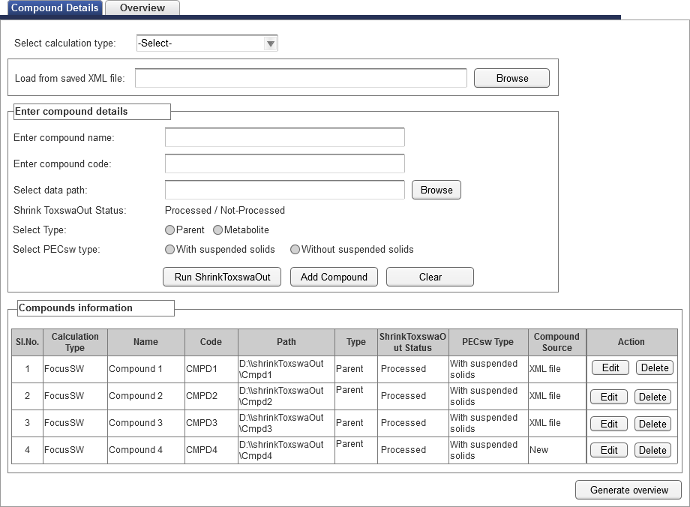

**Figure 4**

* Run ShrinkToxswaOut:This button is used to run ShrinkToxswaOuttool for the purpose of generating T-Out files, if not present in the selected data path.
* Add compound: When user clicks on this button, compound details will be added to the Compounds Information grid.
  + If user adds the data from “Enter compound details” section, then “Compound source” will be marked as “New”
  + If data loaded from XML by using ‘Load from saved XML file’ option, then compound source will be marked as “XML file”.
  + This compound source will be useful to differentiate the data source, which will be used in the “Generate overview” step.
* Clear: Clears the fields data in enter compound details section.
* Generate Overview: When user clicks on this button, an Overview data is processed and displayed in next tab.Edit Button: This button is used to edit the compound details.
  + When user clicks on edit button in compounds information grid
  + Tool should populates data in“Enter compound details”for the respective fields..
  + Add compound button will become as “Update Compound”.
  + Click on “Update compound” button to save the changes and update the compound information grid with modified data.
* Delete button: When user clicks on this button, a confirmation dialog box will be displayed with Yes/No buttons. If user opted for Yes then compound will be deleted otherwise compound will not be removed.

**Form validations:**

* PECsw Type field will be enabled, only if calculation type is ‘Focus SW’. Otherwise it will be disabled and also should not display in compounds information grid.
* When user clicks on Add Compound button,
  + Tool will validate for selected compound type (i.e. Parent or Metabolite) files (i.e. with .csv extension) present in the selected data folder path or not.
  + If not present then user will get alert as ‘T-Out files not present, please run ShrinkToxswaOut tool to generate’.

**Overview:**

After user has added the compound details and clicks on “Generate Overview”, tool will read the T-OUT files from the selected paths and based on the meta information (i.e. Scenario and waterbody) given in .csv files (output files of ShrinkToxswaOut), tool will try to assign the respective scenario combinations based on this metadata.

**For example:** we have two compounds. If compound-1is present in two .csv files and same way compound-2is present in three .csv files. The tool will read the Scenario and waterbody from these files and displays the overview grid as shown below:

|  |  |
| --- | --- |
| **Compound 1** | **Compound 2** |
| D1 Ditch | D1 Ditch |
| D1 Stream | D1 Stream |
|  | D2 Ditch |

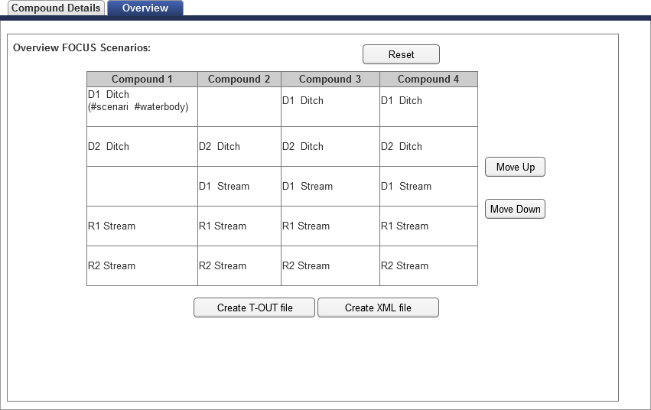

* **Reset:** Using Reset button, the data will be sorted to default sorting order
* **Move UP & Move Down:** These two buttons helps user to move the individual (selected) cell up & down and arrange the list as per the need.
* **Create T-OUT files:** When user clicks on this button,
  + Tool validates the data as mentioned below in “Form Validation” section.
  + If validation is successful, folder browser dialog will be displayed to select the location to save the generated files as mentioned below.
  + **Calculate Sums:** This step will calculate hourlysum of PECsw components and/or PECsed components, hourlyfractions of individual components for PECsw(for individual constituents, the respective value with or without suspended solids will be used) and/or hourlyfractions of individual components for PECsed.

Inaddition, maximum PECsw/PECsed values for individual components (together with dates) and their sum will be calculated and maximum mixture concentration should be recorded, together with date and time.

**Create Mixture T-OUT file:**This step will create an equivalent T-OUT file (.csv file) presenting the unique identifier for this particular calculation and mixture PECsw and PECsed values on hourly basis without information on individual constituents, as shown in file below.   


* + **Create New T-OUT file:**This step will create new T-OUT file (.csv file) presenting the unique identifier for this particular calculation, mixture and individual constituents PECsw or PECsed values on hourly basis, as shown in files below

Additional/optional two separate files presenting sum and individual fractions can also be generated for PECsw and PECsed.

Note:-

1. “Entry” column will be removed from generated T-Out files.
2. Naming convention for output files will be
   1. #Scenario#1stCharofWaterBody_#Mix/Conc/Frac_#sw/sed/sws.csv

* #Mix/Conc/Frac – Mixture/Concentration/Fraction
* _#sw/sed/sws – Surface water without suspended solids/Sedement/Surface water with suspended solids

Ex: D1d_Mix_sw.csv, D1s_Conc_sed.csv…etc

1. Unique identifier will be generated using Guid structure.
2. For each scenario tool will generate one mixture file, three concentration files and three fraction files.
3. Formula for calculating the fraction is (Compound PEC) / (Mixture PEC).



* **Create XML file:**Clicking on this button, data displayed in the overview screen will be saved in XML file, together with the info on the data assignment. The XML file generated by the tool can be reused by the user for the future reference. The extension of the file will be tool specific (.sw/.sed), so that this XML file can be used only by this tool. The software should also allow for saving also the individual datasets within a XML file (in this case, the “path” should indicate such situation).

The tool always processes both PECsw and PECsed data and prepares them for further steps (which might be limited to either PECsw or PECsed)

Form validations:

* Tool should ignore if any cell is bank in a scenario data.
* “Appin Date” must be matched for all compounds data in a scenario. If this validation fails for any scenario, application will display a confirmation dialog box with the failed scenarios. User will have option to stop(No) or continue(Yes). If user opts to continue then tool will not consider the failure scenarios, otherwise process will stop.
* Date and Time column should be matched for all compounds in a scenario. If no match found then error message should be displayed and terminates the process.

# System Requirements

Informatics will use the current infrastructure for Application development

## Application Architecture

NA

## Architecture Requirements

*Application will be a windows based application developed using Microsoft .Net framework 4.0, with VisualBasic programming language*

### Miscellaneous system requirements

* **Operating System**: Windows 7.0, MS Office 2010

### Pending decisions and Risks

NA

# Data Migration Requirements

NA

# Backup & Data Recovery Requirements

*NA*

# Risk

NA

# Document reference

* FOCUS pattern evaluation tool - Requirements_June 2014.doc
* GVK BIO response on Basic workflow requirements_30072014.doc

# Review and Sign Off