|  |
| --- |
| [GVK BIO](http://www.gvkbio.com/) |
| HR-DAT |
| HR – Daily Activity Tracker |
|  |
|  |
| **7/20/2015** |

Table of Contents

Introduction 4

1. Overview 4

2. Intended audience 4

3. Business Requirements 4

1.1. Application Scope and Boundary 5

.

Document Revision History

|  |  |  |  |  |  |
| --- | --- | --- | --- | --- | --- |
| **Ver#** | **Date** | **Author** | **Reviewer** | **Description of Changes** | **Comments** |
|  |  |  |  |  | Initial Draft |

**REQUIREMENTS SPECIFICATIONS**

# Introduction

## Overview

HR-DAT is a tool is designed to track individual activities that will be performed by human resources department on a daily basis. This tool allows the user to submit the activities on weekly basis and the same will be approved by the reporting managers.

## Intended audience

This tool will be mainly used by informatics human resource team

## Business Requirements

Build application to informatics HR team to track daily activities. This tool must have features like

* Create To-do list as per the projects
* Add tasks as per user assigned projects
* Assign tasks to team members
* Approve weekly tasks submitted by the team members.

## 3.1 Application Scope and Boundary

Scope of the application is to provide below modules

* Create To-do list as per the projects
* Add tasks as per user assigned projects
* Assign tasks to team members
* Approve weekly tasks submitted by the team members.

1. Users of the Application:

| **Role** | **Responsibilities** |
| --- | --- |
| Resources | * Create tasks * Submit the tasks on weekly basis |
| Reporting Manager | * Create tasks * Assign tasks * Submit the tasks on weekly basis |

1. Application Flow

Application flow is categorized into different modules as below

* **Create task**
* **Add task**
* **Assign task**
* **Submit task**
  1. Home
     1. Login Screen:

To login into this application must have

* Valid LDAP user id
* User has to be created in PRA tool
* Resource type must be “HR”
* User must be assigned project

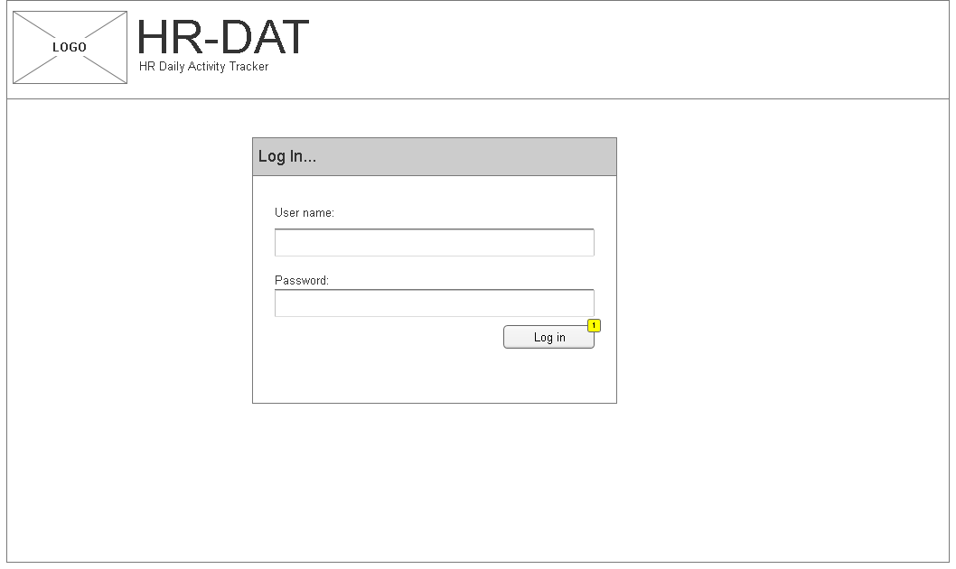

* + 1. Widget Table

|  |  |  |  |
| --- | --- | --- | --- |
| Screen field details: | | | *FT = Field Type *DT= Data Type |
| **Field** | **Type** | **Validation/Restrictions** | **Description** |
| User Name | Text box | Mandatory |  |
| Password | Textbox | Mandatory |  |
| **Action Items** | | | |
| |  |  |  |  | | --- | --- | --- | --- | | **Control Name** | **Control Type** | **Event** | **Action** | | Log In | Button | Click | * Validate for mandatory fields * Validate for valid user from GVK LDAP server | | | | |

* 1. Dashboard:

Upon success login user will be redirected to this page. This is a common page for all the users of this tool. In this page user has option to

* Add To-Do Item
* Add Task
* Add Task

The above features are explained in detailed in below section.

User dashboard basically contains two sections

1. **My To-do list:** This section contains
   1. Tasks which are created by the user through “Add to-do items”
   2. Tasks assigned by the reporting manager
   3. Tasks will be created or assigned as per the project under which user is allocated
   4. Each task will be created with a due date for completion
   5. To-do list lists only tasks which are in progress status
   6. On completing the to-do list, that task will be added to weekly dashboard as per the selected completing date along with the total hours spent.
2. **Weekly task dashboard:**

Weekly dashboard gives overview of the tasks that are performed by the user on a weekly basis. By default dashboard displays the tasks of the current week, user can navigate to previous weeks using the navigation available on top-right of the table.

User will have option to edit the tasks which are not submitted to the reporting manager.

User has to submit the tasks on weekly basis. Before submitting the task user has to make sure that total week tasks are updated in the dashboard.

Mock screen: User dashboard

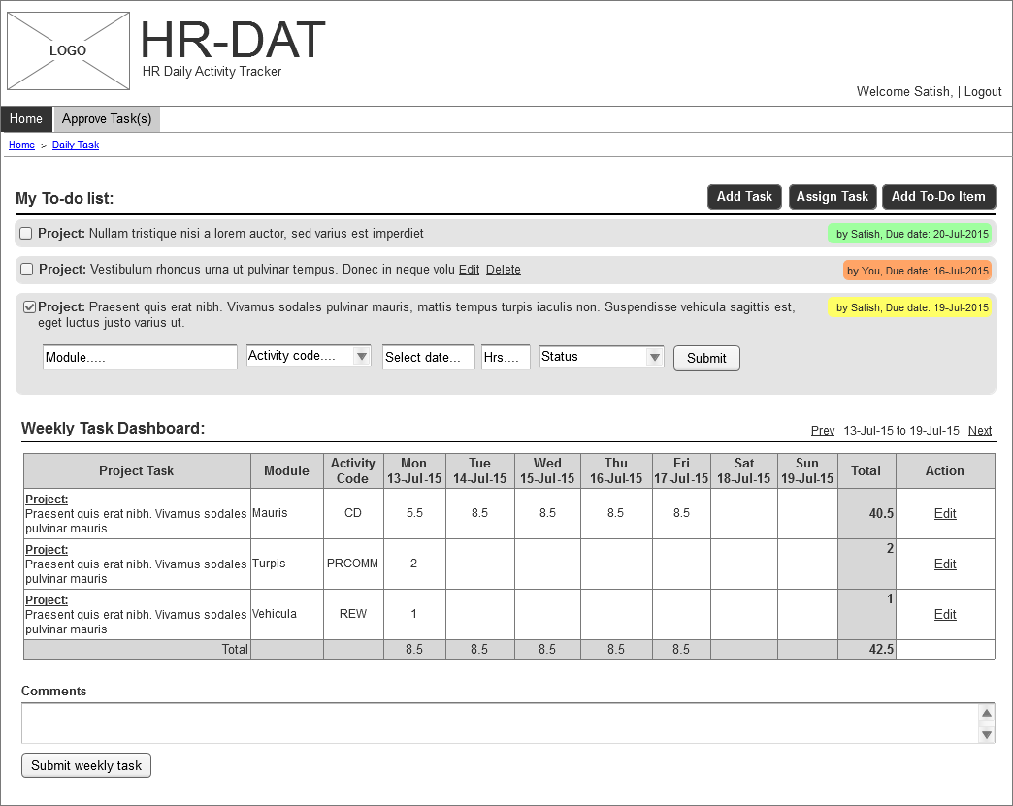

* + 1. Add To-Do Item:

This feature allows user to create the tasks which has to be performed by himself, for a given project.

**Steps to create To-do list:**

* Click on “Add To-do item” from menu
* In the popup, select Project
* Select Module, Activity code
* Select due date
* Enter task details
* Click “Add To-do Item” button

Upon clicking on “Add to-do item” button, task will be added to user to-do list in dashboard.

Once the tasks is completed, user has option to complete the task

**Steps to complete To-do task:**

* Click on check box present on left hand side of the task
* Task box will expand with options like Module, Activity code, date, hours and status
* Enter number of hours spent
* Select status as “In Progress/Complete”
* Click “Submit” button

Upon clicking on “Submit” button, the task will be updated as per the selected status as mentioned below

***In Progress:***  If status is In Progress, then the task along with the hours entered will be added to weekly task for selected date and the task will appear in the to-do list

***Completed:*** If status is completed, then the task along with the hours entered will added to weekly task and the task will be removed from to-do list.

Mock Screen: Add To-do items

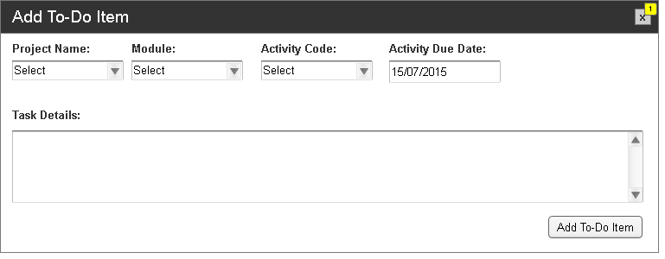

* + 1. Add Task:

This section allows the user to add the task which has been completed for the specific period of hours for a given project.

**Steps to create To-do list:**

* Click on “Add Task” from menu
* In the popup, select Project
* Select Module, Activity code
* Select due date
* Enter task details
* Enter number of hours
* Click “Add Task” button

Upon clicking Add Task button, task will be added to weekly dashboard as per the selected date.

Mock Screen: Add Task

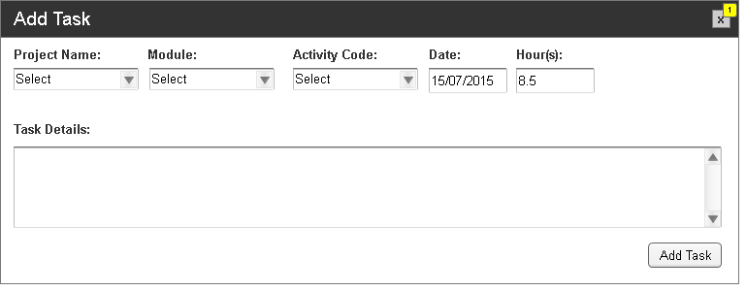

* + 1. Assign Task:

This module is accessible only for reporting managers. It helps reporting manager to assign tasks for his team members and keep track of the task as per the due date.

**Steps to Assign Task:**

* Click on “Assign Task” from menu
* In the popup, select Project
* Select “Assign To”: Lists the team members reporting to the manager.
* Select Module, Activity code
* Select due date
* Enter task details
* Click “Assign Task” button

Upon clicking Assign Task button, task will be added to user’s (Assign To) to-do list in the user dashboard.

Mock Screen: Assign Task

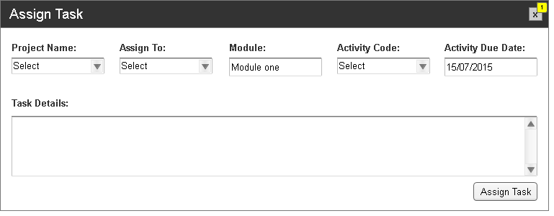

* 1. Approve Task:

This module lists out all the tasks submitted by the respective team members and the manager/supervisor would be in a position to approve/reject the submitted tasks**.**

**Steps to Approve Task:**

* Click on “Approve Task” from top menu
* Select “Assign To”: Lists the team members reporting to the manager.
* Select Task status as “Submitted”
* Select task week for approving the submitted tasks
* Click “Show Task” to display tasks for selected user and week
* Enter comments
* Click “Approve/Reject”

Mock Screen: Approve team tasks

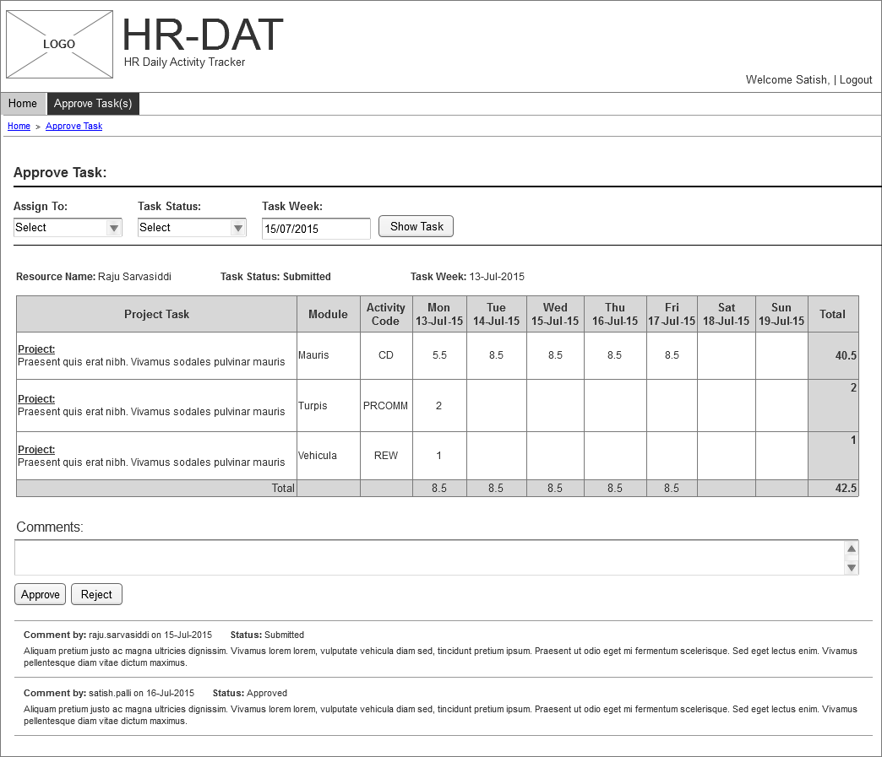

* 1. System Requirements

GVK will use the current infrastructure to host and maintain the Application and Database server

* 1. Application Architecture
  2. Backup & Data Recovery Requirements

*Data backup will be taken regularly on periodic intervals as mentioned below. There will be automation system to take the backups.*

* *Daily*
* *Weekly*
* *Monthly*
  1. Special User Requirements
     1. Security
* *User Authentication: User authentication will be done in application level thru LDAP server.*
* *Access will be restricted as per the role assigned to user when creating new user.*
  + 1. Reliability

No Reliability requirements are defined

* + 1. Audit Trial

No Audit Trial Requirements are defined.

* + 1. User Training
    2. User Manual & Help

User manual will be prepared as per the application flow.

* + 1. Risk

Below are few of the risks identified:

|  |  |  |  |  |  |
| --- | --- | --- | --- | --- | --- |
| Sl.no | Risk | Probability | Impact | Mitigation | Comments |
| 1 |  |  |  |  |  |

* + 1. Document References
    2. Open Issues
    3. Review and Sign Off