**New Jersey Institute of Technology**

**College of Computing Sciences**

**IS 684 Business Process Innovation – Spring 2018**

**ATD Modeling Homework**

**By**

**TEAM 1**

**Pushkar Gadgil, Rafael Correa De Ysasi, Sachin Mathew Jose, Kehinde Adewuyi**

**The scenario:**

1. The family of an elderly parent schedules an emergency appointment for the parent with a doctor. (Parent is hereafter referred to as patient).

2. During doctor’s office visit, the doctor requests Patient X-Rays from an Imaging Center.

3. The doctor discusses results of the X-Rays and the doctor’s diagnosis with the family.

4. After discussing with the family, the doctor immediately requests the patient be admitted to a hospital for three days of further testing.

5. After the patient has been admitted to the hospital, the doctor requests the family to select a nursing care facility, and the family agrees to do so.

6. At the end of the hospital stay (and after the family has selected the nursing care facility), the doctor requests that the patient be transferred to the nursing care facility (Actually doctor request the nursing care facility to admit the patient).

7. After an appropriate stay at the nursing care facility and when the patient has healed, the nursing care facility makes arrangements with the family for the patient to return home.

8. The hospital requests payment from Medicare for the hospital stay after patient is released to the nursing care facility.

9. The nursing care facility requests payment from Medicare after the patient goes home.

In reviewing and understanding the scenario above, concentrate on the coordinating acts between actors. Don’t worry about other aspects of the scenario (e.g. how the patient actually moves from place to place) or delays in time (e.g. length of stay in nursing hospital or nursing care facility).

However, there are some dependencies in the coordination flow.

The purpose of the assignment is to take a process and understand the coordination dependences.

**Assignment Parts:**

1. **Identify the actors in the scenario.**
   1. A0- Family
   2. A1 – Doctor
   3. A2 – Nursing Care Facility
   4. A3 - Hospital
   5. A4 – Medicare
   6. A5 – Imaging Center
2. **Identify the transactions in scenario that take place between the actors. This is at the top-level or the essential map of coordination between the actors in the scenario.**

T1 - Family schedules an emergency appointment with the doctor

T2 - Doctor makes an X-Ray request from the Imaging Center

T3 - Doctor requests patient to be admitted to hospital for 3 days.

T4 - The doctor requests the family to select a Nursing Care Facility

T5 - Doctor Requests stay at the Nursing Care Facility

T6 - Nursing Care Facility decides for the patient’s discharge.

T7 - Hospital Requests payments from Medicare

T8 - Nursing Care Facility requests payment from Medicare

1. **Draw a top-level ATD for the scenario.**

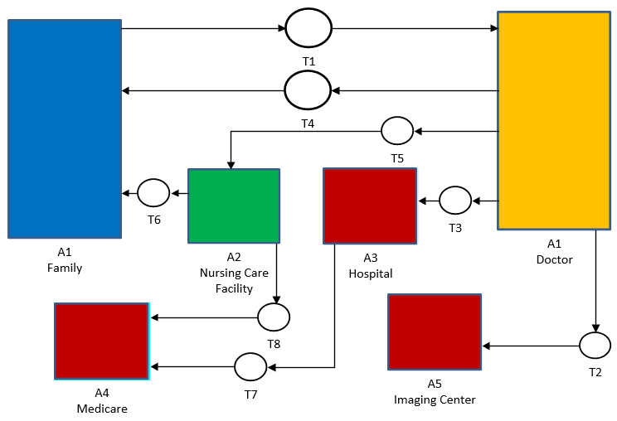

1. **Draw a Detail Level ATD for the scenario, taking care to note dependencies.**

