**Battle of Neighbourhood for Dublin Postal districts**

# **Introduction**

This report explains search for a catering businessperson for best location for his business with less competition.

# **Problem Description**

In recent years Migrations to Ireland are increased and most of the migrant are based at Dublin location. Due to increased housing prices in Dublin city area, people are preferring to locate little away from Dublin, but they find difficult to locate good restaurants or grocery store near their homes. In such scenario, restaurants like Asian, Chinese or Italian cuisine or even a grocery restaurant would be blessing for people and they won’t need to visit Dublin city centre always.

Idea of this project is - If a business person want to open a restaurant or a grocery shop in Dublin, help him/her analyse which area would be better depending on competition and population within Dublin.

# **Data**

Dublin has postal districts 1-24 or Greater Dublin with 4 major regions can be scrapped from below sites,

<https://en.wikipedia.org/wiki/List_of_Irish_counties_by_population>

<https://en.wikipedia.org/wiki/County_Dublin>

For the problem mentioned we would need data

* Location data for Dublin postal districts and greater Dublin
* Venues data around all Dublin postal districts and for Greater Dublin regions
* Also population data for 4 major regions of Dublin

With Four square API, nearby venues within 1km region for each of Dublin Postal Districts or greater Dublin region are found.

*Note: Population data is available only for major Dublin regions and not for postal Districts.*

# **Methodology**

This project will check the density of restaurants and grocery shops in all Dublin postal districts. Also separate check of density of restaurants in each of 4 major regions of Dublin.

Distance between Dublin postal districts varies, range around ~2km is considered to fetch venues for around in each district also venues within ~8km distance is considered for 4 major Dublin regions.

Plot bar charts for restaurants, Grocery shops in Dublin postal districts. Plot bar chart for % of Restaurants, Grocery shops and population for greater Dublin regions.

# **Results**

* **Restaurants and grocery store counts for all postal districts of Dublin**

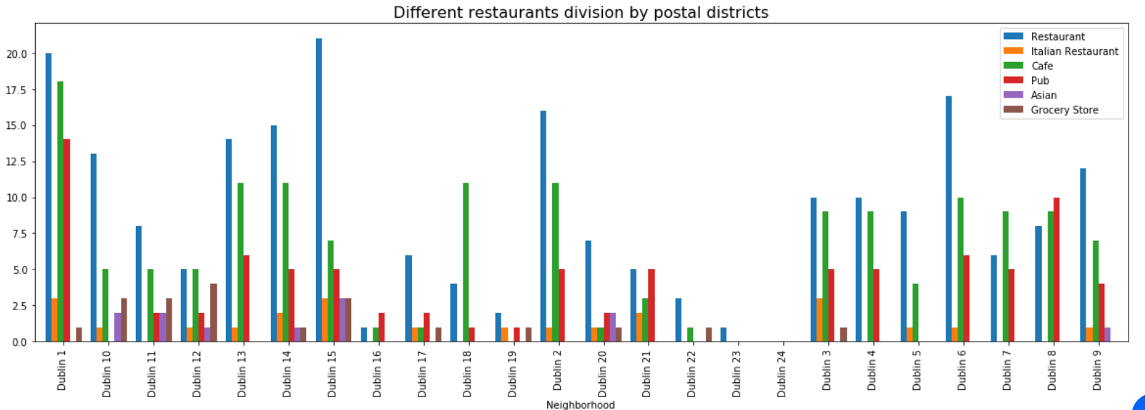

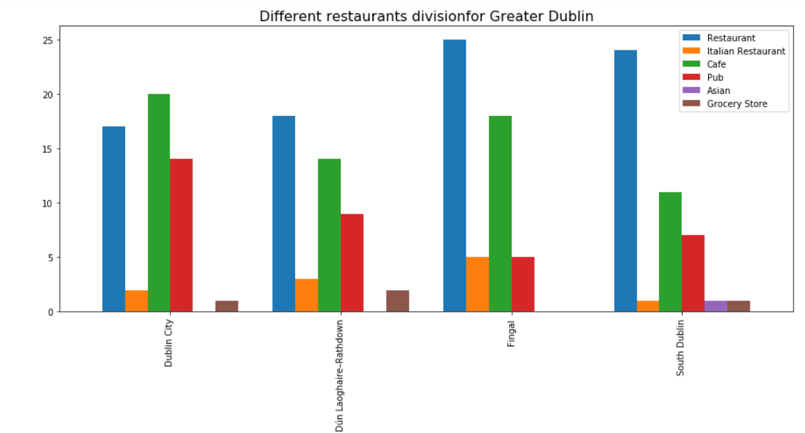

* **% of Restaurants and Grocery stores for postal districts**

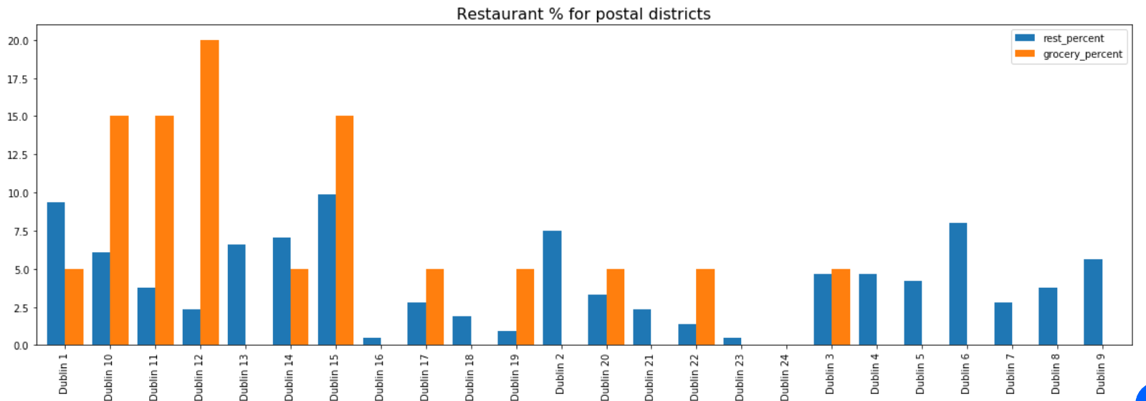

* **% of Population, Restaurants and Grocery stores for major regions of Dublin**

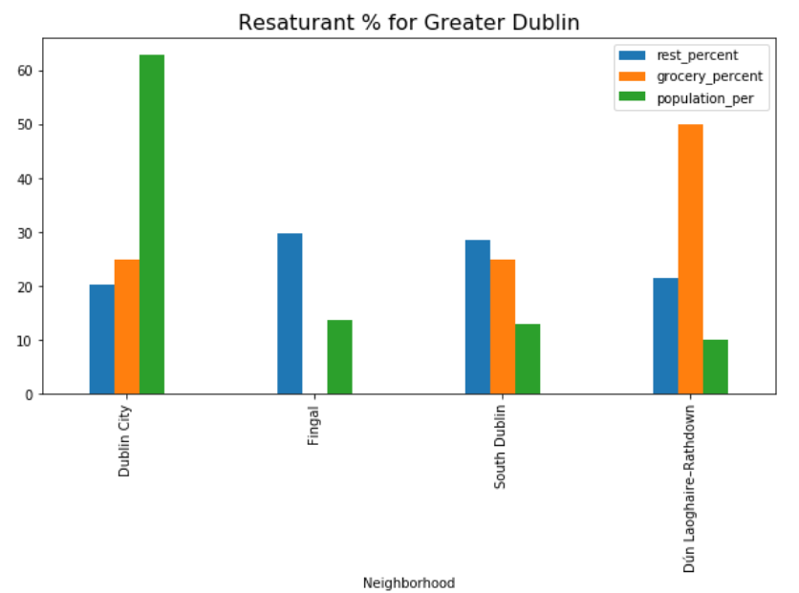

# **Analysis**

Overall Italian Restaurants are not in postal districts – Dublin 7,8,11,22,23

Asian Restaurants are not observed in Dublin 1, 4,6,7,8 and Fingal region which has plenty of restaurants and cafe otherwise.

Grocery stores are not located in Fingal area which has potential population.

# **Conclusion**

***Fingal*** would be potential region to open a ***Grocery store***

Assuming increasing population in **Dublin 4, Dublin 8 and Fingal region,** ***Asian restaurants*** would have good potential in these areas of Dublin