**Class**

**Syntax**

***Class is a keyword .To declare a new class in java***

***Access modifier class class name***

***{***

***body***

***}***

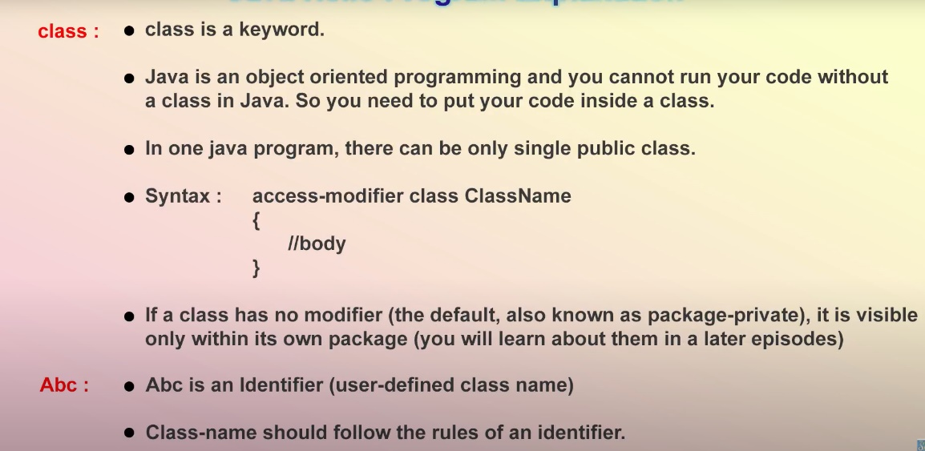

***Class ClassName2{body}***

***In one java program we can create multiple classes***

***When we use public class ClassNameA: only one public class we can use in one java program.***

***Eg Hello world program***

***Class Abc-----here Abc is an identifier***

***{***

***Public static void main(String[] args){***

***System.out.println(“Hello World”);***

***}***

***}***

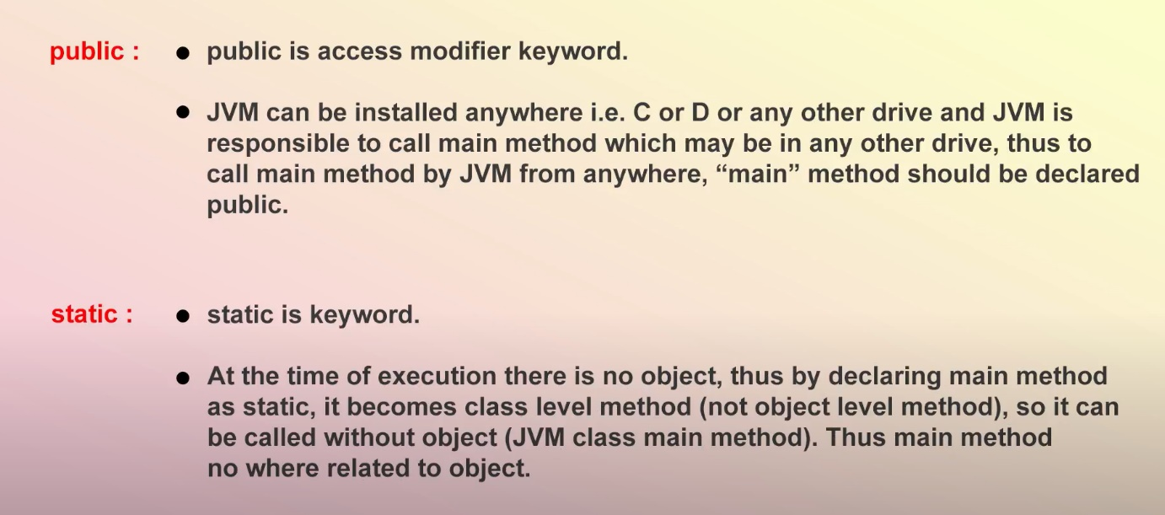

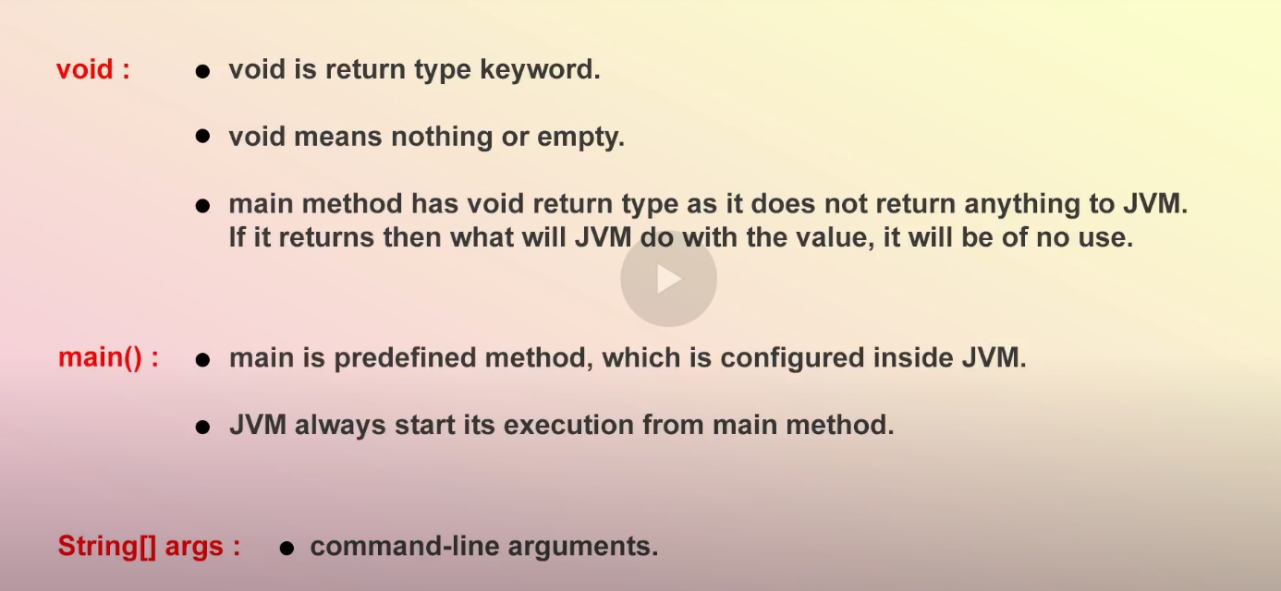

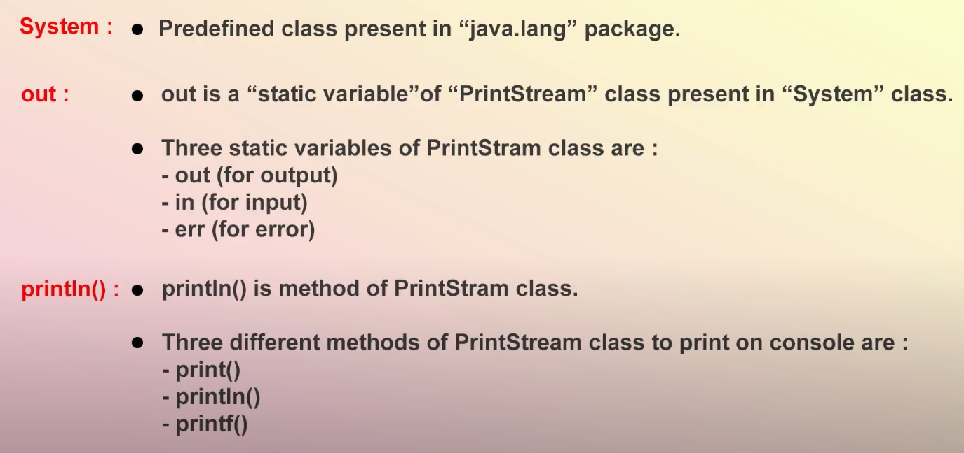

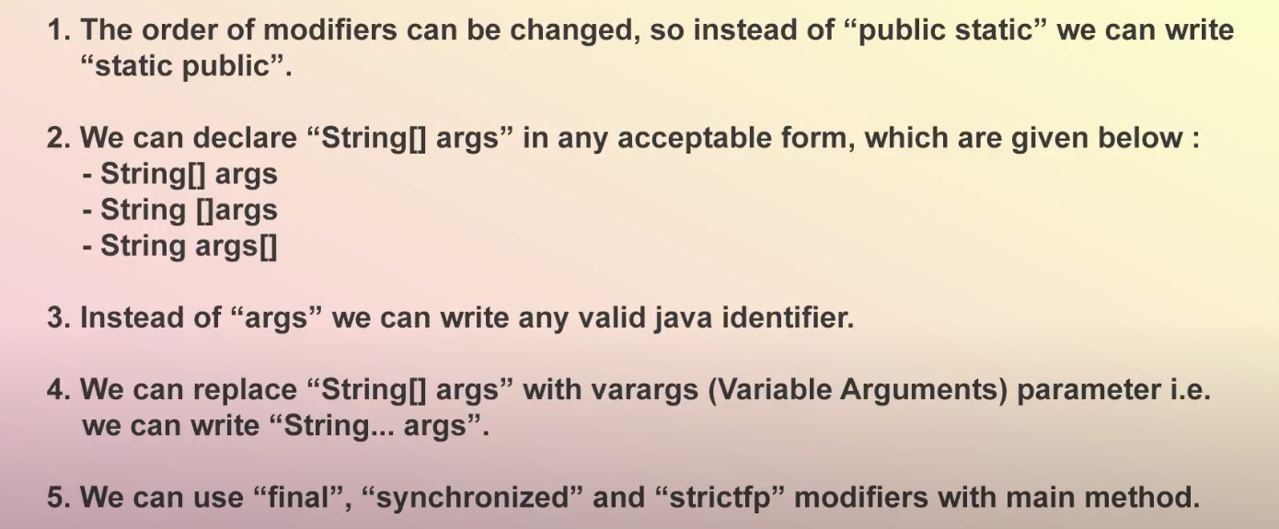

***Public: Access modifier keyword. Visibility***

### *Static: Jvm directly call main method without creating object.* *When java runtime starts, there is no object of the class present. That’s why the main method has to be static so that JVM can load the class into memory and call the main method. If the main method won’t be static, JVM would not be able to call it because there is no object of the class is present*

***Void: return type keyword. main method is returning nothing. Doesn’t return 0or null.***

***Main: it’s a predefined method.***

***String[] args:*** ***Java main method accepts a single argument of type String array. This is also called as java command line arguments***

***String: Class. Strings are immutable. bcz all the process in java is in the form of Strings***

***[]: array***

***Args: array name.***

***System: it’s a class inside java.lang package***

***Out: it’s a static variable inside PrintStream class in System class.(3 static variables…in,out and err for error)***

***Println: method in Printstream class.(3 methods are print(),println() and printf() :%d or %s in c program for printf )***

***Main method format changes which JVM can accepts***

