**this Keyword**

*this keyword is a reference variable that refers to the current object.*

*This refers to the current class instance variable.*

*If local variable name=instance variable name,we can use this to distinguish these 2.if we havent use this here ,it will return default value of that type.*

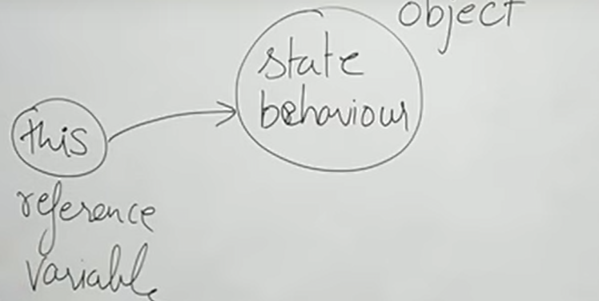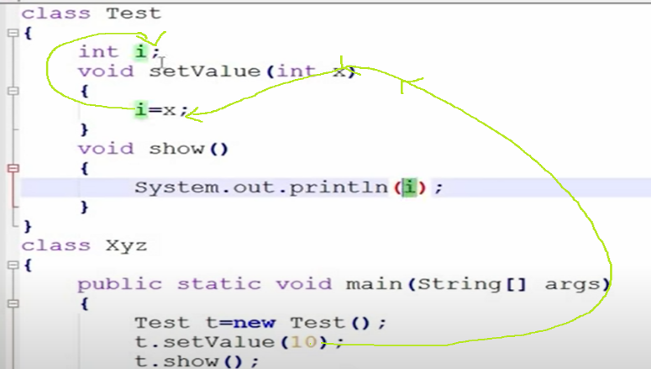

Here show method printed int default value even we have given 10…to over come this we are using this keyword to refer the current class instance variable.

Note: when you initialize a **variable**, that is an **instance variable**. e.g. 2. when you initialize an object, that is a **reference variable**.

*Parameter int i=refers to local variable*

*this.i refers to instance variable*

*this—refers to the current class’s instance variable which is int i(instance variable )*

*this: its for reference variable of current class object*

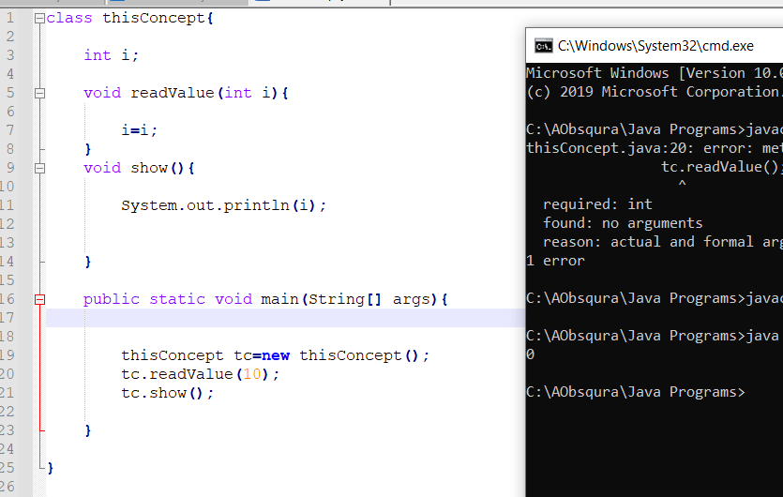

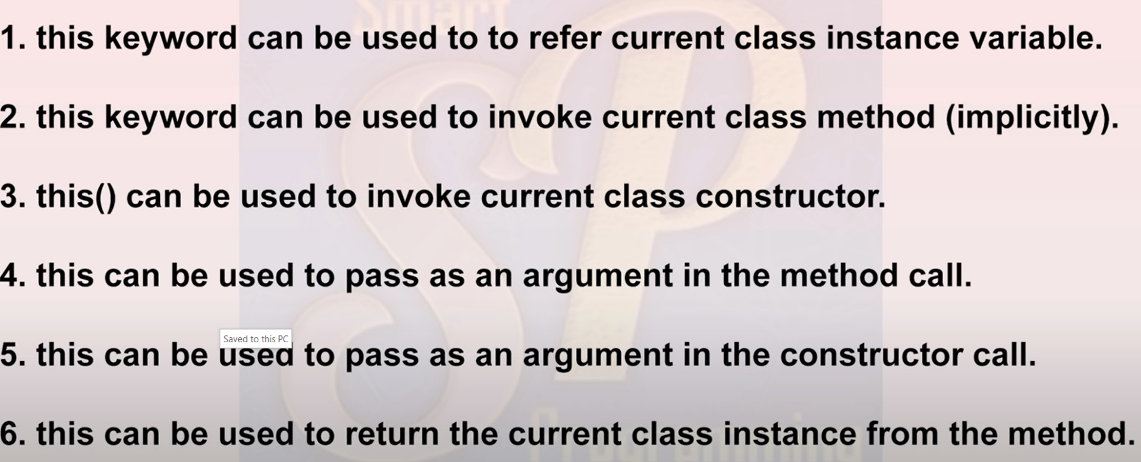

*2.When we invoke a method ,this keyword will be added by compiler by default.*

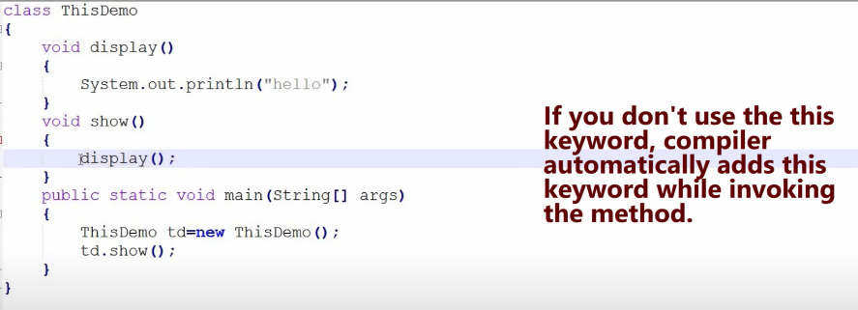

3. 2ways

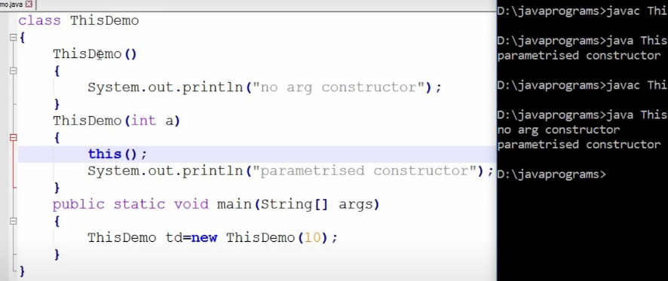

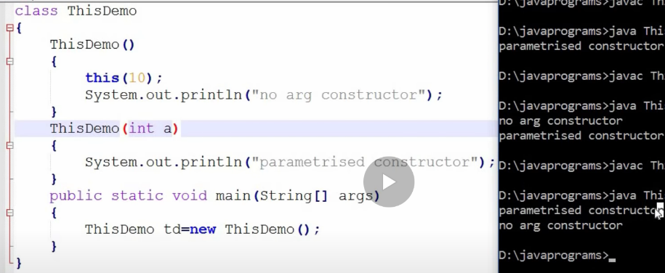

4. Passing **this** keyword as argument in method call.

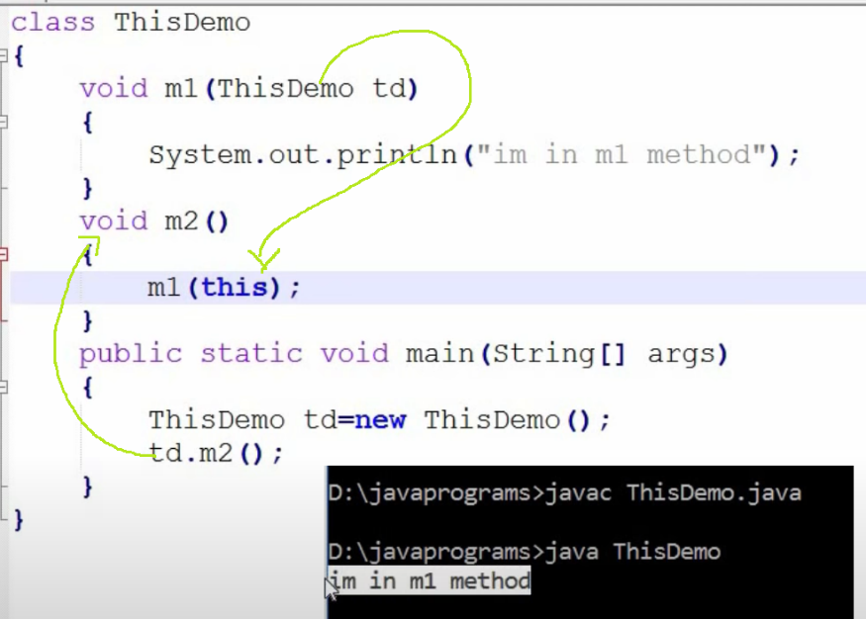

5. passing this keyword as an argument in constructor call

