Getting Started with the New Statistics in R

David Erceg-Hurn, Geoff Cumming, Robert Calin-Jageman

2017-03-09

# Overview

[R](https://www.r-project.org/) is a popular and powerful free program that can be used to conduct most of the statistical analyses outlined in *Introduction to the New Statistics* (Cumming & Calin-Jageman, 2017). Unlike programs such as SPSS where analyses are usually conducted by clicking on menus, in R analyses are typically performed by typing *commands*.

This document is a brief guide that will help you to get started using the 'new statistics' in R. The guide is split into three sections. The first part provides some tips about installing and learning the basics of R. If you've never used R before you should read this section - if you already know how to use R you can skip it. The second section provides a brief overview of a new R package, [itns](https://github.com/gitrman/itns), that contains the datasets used in *Introduction to the New Statistics*. You can use the datasets in the itns package to work through the examples covered in the book and the end-of-chapter exercises. The final section provides an overview of R packages and functions that can be used to conduct the analyses covered in *Introdudction to the New Statistics*.

You will notice that some words in this document are a blue colour. These are hyper links. If you click on the blue text, you will be redirected to websites that contain information about using R.

# Part One - Installing R and Learning the Basics

To install R, visit the [RStudio website and follow the installation instructions](https://www.rstudio.com/resources/training/online-learning/#R). That webpage also contains links to interactive tutorials for R beginners. The tutorials will help you learn how to perform basic tasks like importing and manipulating datasets. Other useful resources for learning R include:

* [R for Data Science](http://r4ds.had.co.nz/) - An online book by Garrett Grolemund and Hadley Wickham that will teach you how to import, tidy, and explore data.
* [Kelly Black's R Tutorial](http://www.cyclismo.org/tutorial/R/index.html) - An introductory tutorial focusing on the basics of R.
* [How to Learn R Blog](http://www.r-bloggers.com/how-to-learn-r-2) - A collection of resources that will help you learn R.
* [Quick-R](http://www.statmethods.net) - A website that contains example code for running basic analyses.
* [R Quick Reference Card](http://cran.r-project.org/doc/contrib/Short-refcard.pdf) - A list of key commands built into R.

Also remember that Google is your friend. If you have a question about how to do something in R, it is likely that someone else has already asked the same question and that there is an answer on the Internet. For example if you type 'R how to create a histogram' into Google, you will find many links to webpages showing you the R code that you need to plot a histogram.

In the remainder of the document, we assume that you have a basic understanding of how to use R.

# Part Two - The *itns* Package

[itns](https://github.com/gitrman/itns) is an R package that contains most of the datasets used in *Introduction to the New Statistics*. The datasets were converted from Microsoft Excel files (found on the book's website) into R data frames. The table on the next page lists the names of the data frames in the package, and the sections of the book where they are mentioned.

**itns Data Frames For Within-Chapter Exercises**

|  |  |  |
| --- | --- | --- |
| Name | Chapter | Topic |
| body_well | 11, 12 | Correlation, Regression |
| natsal | 16.11 | Robust Methods - Two Independent Groups |
| pen_laptop1 | 7.6-7.12 | Two Independent Groups |
| pen_laptop2 | 7.36-7.38 | Two Independent Groups |
| rattan | 14.10-14.12 | One-Way Independent Group Contrasts and Comparisons |
| thomason1 | 8, 11, 12 | Two Dependent Groups, Scatterplots, Regression |
| thomason2 | 8 | Two Dependent Groups |
| thomason3 | 8, 12.18 | Two Dependent Groups, Regression |

**itns Data Frames For End-Of-Chapter Exercises**

|  |  |  |
| --- | --- | --- |
| Name | Chapter | Topic |
| altruism_happiness | 12.3 | Regression |
| anchor_estimate | 7.3 | Two Independent Groups |
| anchor_estimate_ma | 9.1 | Meta-Analysis |
| campus_involvement | 11.7 | Correlation |
| clean_moral_johnson | 7.4 | Two Independent Groups |
| clean_moral_schall | 7.4 , 10.2 | Two Independent Groups |
| college_survey1 | 3.2, 3.3, 5.2, 5.3 | Descriptive Statistics & Plots, Single Sample Confidence Interval |
| college_survey2 | 5.4 | Single Sample Confidence Interval |
| dana | 16.3 | Robust Methods - Two Independent Groups |
| emotion_heartrate | 8.3 | Two Dependent Groups |
| exam_scores | 11.2 | Correlation |
| flag_priming_ma | 9.2 | Meta-Analysis |
| home_prices | 12.2 | Regression |
| home_prices_holdout | 12.2 | Regression |
| labels_flavor | 8.4 | Two Dependent Groups |
| math_gender_iat | 7.5 | Two Independent Groups |
| math_gender_iat_ma | 9.3 | Meta-Analysis |
| organic_moral | 14.7 | One-Way Independent Group Contrasts and Comparisons |
| power_performance_ma | 9.4 | Meta-Analysis |
| religious_belief | 3.4 | Descripitive Statistics & Plots |
| religion_sharing | 14.3 | One-Way Independent Group Contrasts and Comparisons |
| self_explain_time | 15.4 | Analysing factorial designs |
| sleep_beauty | 11.6 | Correlation |
| study_strategies | 14.1 | One-Way Independent Group Contrasts and Comparisons |
| stickgold | 6.5 | Single Sample Confidence Interval |
| videogame_aggression | 15.3 | Analysing factorial designs |

The itns package is not yet on [CRAN](https://cran.r-project.org), but you can download it from [github](https://github.com/gitrman/itns) using the devtools package:

# install.packages("devtools") # if you haven't already, install devtools from CRAN  
 library(devtools) # load devtools  
 install_github("gitrman/itns") # install itns

Once you have installed the package, you can use the library() function to load it, str() to examine metadata for each data frame, and functions such as head() and tail() to print the first or last few rows to your screen.

library(itns) # loads the package  
 str(pen_laptop1) # displays metadata

## 'data.frame': 65 obs. of 2 variables:  
## $ group : Factor w/ 2 levels "Laptop","Pen": 2 2 2 2 2 2 2 2 2 2 ...  
## $ transcription: num 12.1 6.5 8.1 7.6 12.2 10.8 1 2.9 14.4 8.4 ...

head(pen_laptop1) # prints the first few rows

## group transcription  
## 1 Pen 12.1  
## 2 Pen 6.5  
## 3 Pen 8.1  
## 4 Pen 7.6  
## 5 Pen 12.2  
## 6 Pen 10.8

tail(pen_laptop1) # prints the last few rows

## group transcription  
## 60 Laptop 10.3  
## 61 Laptop 9.0  
## 62 Laptop 12.8  
## 63 Laptop 12.0  
## 64 Laptop 34.7  
## 65 Laptop 4.1

To access further details about each dataset, type a question mark and the name of the dataset, for example:

?pen_laptop1

or access the PDF help file **LINK TO GO HERE** on the [itns github site](https://github.com/gitrman/itns).

The datasets in the itns package can be used to replicate analyses that appear in *Introduction to the New Statistics*, and to work through the book's end-of-chapter exercises using the packages and functions outlined in the next section of this guide.

# Part 3 - Helpful Packages and Functions

Most of the analyses described in *Introduction to the New Statistics* can be conducted using inbuilt R functions, or functions in packages that can be downloaded from CRAN or github. In this section we mention some useful functions and packages, and resources that will help you learn how to use them. This section is *not* intended to be a comprehensive tutorial on how to use each function; rather, our aim is to point you in the direction of resources already on the Internet.

## Basic Descriptive Statistics

Functions to compute basic descriptive statistics are built into R. These include mean(), median(), minimum() and maximum() functions; var() for variance, sd() for the standard deviation, IQR() for interquartile range, range(), quantile() for percentiles, and summary(), which for numeric variables returns the minimum, 25th percentile, median, mean, 75th percentile, and maximum. Some examples of these functions in action are given below. See [John Quirk's tutorial](https://rtutorialseries.blogspot.com.au/2009/11/r-tutorial-series-summary-and.html) on using basic descriptive statistics for more information.

# Compute basic descrpitive statistics for transcription score in pen_laptop1 data frame  
 # Mean  
 mean(pen_laptop1$transcription)

## [1] 11.53385

# Median  
 median(pen_laptop1$transcription)

## [1] 10.7

# Standard Deviation  
 sd(pen_laptop1$transcription)

## [1] 6.690695

# 0 to 100th percentile in steps of 10%   
 quantile(pen_laptop1$transcription, probs = seq(from = 0, to = 1, by = .1))

## 0% 10% 20% 30% 40% 50% 60% 70% 80% 90% 100%   
## 1.00 3.38 6.24 8.50 9.16 10.70 12.04 13.20 17.06 18.92 34.70

# Example of summary function output   
 summary(pen_laptop1$transcription)

## Min. 1st Qu. Median Mean 3rd Qu. Max.   
## 1.00 8.00 10.70 11.53 15.20 34.70

### Summary Statistics By Group

You will sometimes want to compute descriptive statistics separately for multiple groups. There are many ways to do this. One option is to use the group_by() and summarise() functions in the dplyr package, for example:

# Compute mean and standard deviation separately for the laptop and pen groups  
 library(dplyr)

##   
## Attaching package: 'dplyr'

## The following objects are masked from 'package:stats':  
##   
## filter, lag

## The following objects are masked from 'package:base':  
##   
## intersect, setdiff, setequal, union

pen_laptop1 %>%  
 group_by(group) %>%  
 summarise(  
 mean = mean(transcription),  
 sd = sd(transcription)  
 )

## # A tibble: 2 × 3  
## group mean sd  
## <fctr> <dbl> <dbl>  
## 1 Laptop 14.519355 7.285576  
## 2 Pen 8.811765 4.749339

For more information see the section on *Grouped Operations* in the [dplyr tutorial](https://cran.rstudio.com/web/packages/dplyr/vignettes/introduction.html).

Other options for computing descriptive statistics separately for different groups include the inbuilt R function [aggregate()](http://www.inside-r.org/r-doc/stats/aggregate) or the [doBy package](https://cran.r-project.org/web/packages/doBy/vignettes/doBy.pdf).

## Data Visualisation (Plotting)

R has three systems that can be used for data visualisation - [Base graphics](http://rpubs.com/SusanEJohnston/7953), [lattice](https://rstudio-pubs-static.s3.amazonaws.com/12556_4e02f5564dc24b57b7a8f6d95d2a5cf7.html), and [ggplot2](http://ggplot2.org). The STHDA website has [guides to creating graphics](http://www.sthda.com/english/wiki/data-visualization) using all three systems.

Base graphics, lattice, and ggplot2 all have functions for creating histograms and dotplots, covered in Chapter 3 of *Introduction to the New Statistics*. Here are some examples of simple histograms produced by the three packages:

# Base Graphics Histogram  
 hist(pen_laptop1$transcription)

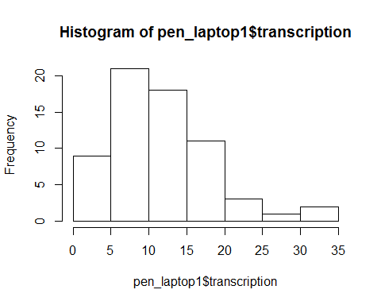

# lattice Histogram  
 library(lattice)  
 histogram(~transcription, data = pen_laptop1)

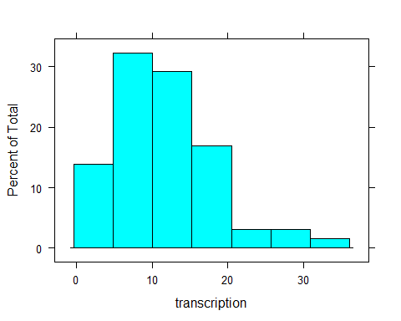

# ggplot2 Histogram   
 library(ggplot2)  
 ggplot(pen_laptop1, aes(transcription) ) + geom_histogram(bins = 7, colour="black", fill="white")

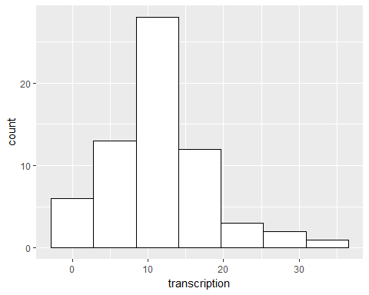

If you are new to R and want to learn one graphics package, we recommend learning how to use ggplot2 as it is the most powerful and flexible system. Resources that will help you learn how to use ggplot2 include:

* [Winston Chang's R Graphics Cookbook](http://www.cookbook-r.com/Graphs).
* [STHDA's ggplot2 essentials](http://www.sthda.com/english/wiki/ggplot2-essentials).
* Hadley Wickham's [ggplot2 book](https://www.amazon.com/ggplot2-Elegant-Graphics-Data-Analysis/dp/331924275X/ref=dp_ob_title_bk).
* [DataCamp's ggplot2 courses](https://www.datacamp.com/courses/data-visualization-with-ggplot2-1).
* [Harvard Introduction to ggplot2](http://tutorials.iq.harvard.edu/R/Rgraphics/Rgraphics.html).
* [R4Stats ggplot2 tutorial](http://r4stats.com/examples/graphics-ggplot2).
* [ggplot2 online documentation](http://docs.ggplot2.org/current/index.html).
* [R-Studio's Data Visualisation cheatsheet](https://www.rstudio.com/resources/cheatsheets).
* An [online workshop](http://moc.environmentalinformatics-marburg.de/gitbooks/publicationQualityGraphics/_book/index.html) about creating publication quality graphics using the ggplot2 and lattice graphics packages by Tim Appelhans.

If you are interested in learning the lattice package, a good place to start is the [STHDA Lattice Guide](http://www.sthda.com/english/wiki/lattice-graphs). R-Studio also have a handy [Guide to R Graphics using lattice](https://rstudio-pubs-static.s3.amazonaws.com/12556_4e02f5564dc24b57b7a8f6d95d2a5cf7.html). There is also a [book about the Lattice package](https://www.springer.com/gp/book/9780387759685).

### ggplot2 Histogram and Dotplot Tutorials

* [R Bloggers - How to make a histogram with ggplot2](http://www.r-bloggers.com/how-to-make-a-histogram-with-ggplot2).
* [STHDA Histogram Tutorial](http://www.sthda.com/english/wiki/ggplot2-histogram-plot-quick-start-guide-r-software-and-data-visualization).
* [STHDA guide to making dotplots](http://www.sthda.com/english/wiki/ggplot2-dot-plot-easy-function-for-making-a-dot-plot#dot-plot-with-multiple-groups).
* [ggplot2 documentation](http://docs.ggplot2.org/current/geom_dotplot.html) for the geom_dotplot() geom.

## Cat's Eye Pictures and Difference Plots

The [multicon](https://cran.r-project.org/web/packages/multicon/index.html) package, available on CRAN, contains the functions egraph(), catseye() and diffPlot(). These can be used to quickly produce plots of error bars, cat's eye pictures, and difference plots.

#install.packages("multicon") # if needed , install muliticon package  
library(multicon) # load the package

## Loading required package: psych

##   
## Attaching package: 'psych'

## The following objects are masked from 'package:ggplot2':  
##   
## %+%, alpha

## Loading required package: abind

## Loading required package: foreach

# Plot group means and 95% confidence intervals  
egraph(DV = pen_laptop1$transcription, grp = pen_laptop1$group,   
 xlab = "Group", ylab = "Transcription score")

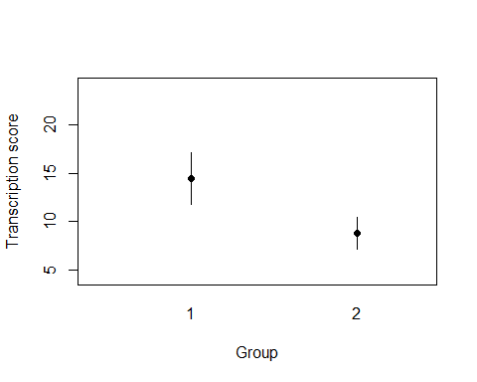

# Create a Cat's Eye Plot  
catseye(DV = pen_laptop1$transcription, grp = pen_laptop1$group,   
 xlab = "Group", ylab = "Transcription score")

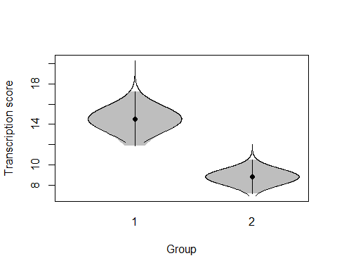

# Create a Difference Plot  
diffPlot(transcription ~ group, data = pen_laptop1,   
 xlab = "Group", ylab = "Transcription score")

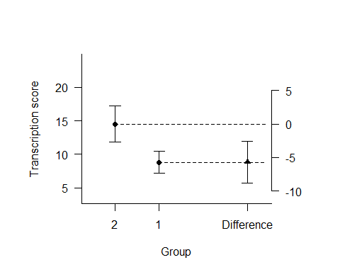

## Z-Scores

[John Quick's tutorial](http://www.r-bloggers.com/r-tutorial-series-centering-variables-and-generating-z-scores-with-the-scale-function) shows how to use R's inbuilt scale() function to compute Z-scores. See also [Seam Dolinar's tutorial](http://stats.seandolinar.com/calculating-z-scores-with-r/) on calculating Z scores and finding tail probabilities.

## P-values and Confidence Intervals for a Single Sample

Kelly Black has written tutorials showing how to [compute p values using z- or t-distributions](http://www.cyclismo.org/tutorial/R/pValues.html), and how to [calculate confidence intervals for means using normal or t-distributions](http://www.cyclismo.org/tutorial/R/confidence.html).

## t.test() function

The t.test() function is built into R. It produces confidence intervals and p-values for single samples, two independent groups, and paired samples.

# Single Sample  
t.test(pen_laptop1$transcription)

##   
## One Sample t-test  
##   
## data: pen_laptop1$transcription  
## t = 13.898, df = 64, p-value < 2.2e-16  
## alternative hypothesis: true mean is not equal to 0  
## 95 percent confidence interval:  
## 9.875973 13.191719  
## sample estimates:  
## mean of x   
## 11.53385

# Two Independent Groups - by default the Welch T-Test (equal variances not assumed) is calculated  
t.test(transcription ~ group, data = pen_laptop1)

##   
## Welch Two Sample t-test  
##   
## data: transcription by group  
## t = 3.7031, df = 50.816, p-value = 0.0005254  
## alternative hypothesis: true difference in means is not equal to 0  
## 95 percent confidence interval:  
## 2.612991 8.802189  
## sample estimates:  
## mean in group Laptop mean in group Pen   
## 14.519355 8.811765

# Two Independent Groups - assuming variances are equal  
t.test(transcription ~ group, data = pen_laptop1, var.equal = TRUE)

##   
## Two Sample t-test  
##   
## data: transcription by group  
## t = 3.7738, df = 63, p-value = 0.0003579  
## alternative hypothesis: true difference in means is not equal to 0  
## 95 percent confidence interval:  
## 2.685265 8.729915  
## sample estimates:  
## mean in group Laptop mean in group Pen   
## 14.519355 8.811765

# Paired Samples  
t.test(thomason1$pre, thomason1$post, paired = TRUE)

##   
## Paired t-test  
##   
## data: thomason1$pre and thomason1$post  
## t = -3.8555, df = 11, p-value = 0.002674  
## alternative hypothesis: true difference in means is not equal to 0  
## 95 percent confidence interval:  
## -2.618115 -0.715218  
## sample estimates:  
## mean of the differences   
## -1.666667

## MBESS package

Ken Kelley's [MBESS (Methods for the Behavioural and Social Sciences)](https://www3.nd.edu/~kkelley/site/MBESS.html) package contains numerous functions which can be used to compute confidence intervals for many effect sizes, including standardized mean differences, mean contrasts in one-way and factorial designs, unstandardized and standardised regression coefficients, R-squared, etc. MBESS also includes functions for power analysis and sample size planning for precision. The [MBESS website](https://www3.nd.edu/~kkelley/site/MBESS.html) contains links to two journal articles about the package, and help files.

## effsize package

The MBESS package contains the functions smd() and ci.smd(), which can be used to compute the standardized mean difference for the two independent groups design, and a confidence interval. However, using MBESS for this task is somewhat cumbersome as the point estimate and confidence interval have to be calculated in separate steps. The sample size for each group must also be calculated.

# Use dplyr package to extract transcription scores for   
# the laptop and pen groups in the pen_laptop1 dataset  
 # library(dplyr) # load dplyr if it has not already been loaded  
 laptop <- pen_laptop1 %>% filter(group == "Laptop")  
 pen <- pen_laptop1 %>% filter(group == "Pen")  
# Install MBESS if it is not already installed  
 # install.packages("MBESS")  
# Load MBESS library  
 library(MBESS)  
# Use the smd() function to compute d-biased (Cohen's d)  
 es <- smd(laptop$transcription, pen$transcription)  
# Sample sizes  
 n1 <- nrow(pen)  
 n2 <- nrow(laptop)  
# Use ci.smd() to compute a 95% confidence interval for the biased estimate  
 ci.smd(smd = es, n.1 = n1, n.2 = n2)

## $Lower.Conf.Limit.smd  
## [1] 0.4204238  
##   
## $smd  
## [1] 0.9371681  
##   
## $Upper.Conf.Limit.smd  
## [1] 1.447208

A faster way to compute the standardized mean difference and confidence interval is to use the cohen.d() function in the [effsize](https://github.com/mtorchiano/effsize) package, which can be downloaded from CRAN.

# Install effsize package if it is not already installed  
 #install.packages("effsize")  
 # Load library  
 library(effsize)  
 # Compute d-biased  
 cohen.d(transcription ~ group, data = pen_laptop1, noncentral = TRUE)

##   
## Cohen's d  
##   
## d estimate: 0.9371681 (large)  
## 95 percent confidence interval:  
## inf sup   
## 0.4204238 1.4472083

# Compute d-unbiased  
 cohen.d(transcription ~ group, data = pen_laptop1, noncentral = TRUE, hedges.correction = TRUE)

##   
## Hedges's g  
##   
## g estimate: 0.9259669 (large)  
## 95 percent confidence interval:  
## inf sup   
## 0.4204238 1.4472083

## Cohen's d for Repeated Measures Designs

The itns package contains a function called cohensd_rm() that you can use to compute Cohen's d and a confidence interval for repeated measures (paired samples).

# Compute Cohen's d and a 95% CI  
 cohensd_rm(x = thomason1$post, y = thomason1$pre)

## est ll ul   
## 0.5354272 0.1776376 0.8787996

In the function output, *est* is the estimated effect size (d-value), *ll* is the lower limit of the confidence interval, and *ul* is the upper limit of the interval.

By default, the function computes a 95% confidence interval. To use a different confidence level, use the argument `ci'. For example, to compute a 99% confidence interval you would use the following code:

# Compute Cohen's d and a 99% CI  
 cohensd_rm(x = thomason1$post, y = thomason1$pre, ci = 99)

## est ll ul   
## 0.53542722 0.07229343 0.99344782

It is also possible to correct the estimate of d for small sample bias, using the *unbiased* argument.

# Compute unbiased Cohen's d and a 95% CI  
 cohensd_rm(x = thomason1$post, y = thomason1$pre, unbiased = TRUE)

## est ll ul   
## 0.4979258 0.1776376 0.8787996

The cohensd_rm() function uses the average of the pre and post-treatment scores as the standardizer. This is the standardizer recommended in *Introduction to the New Statistics*. An alternative (which we do not recommend) is to use the standard deviation of the change scores as the standardizer. Should you wish to do this, you can use the cohen.d() function in the effsize package.

cohen.d(thomason1$pre, thomason1$post, noncentral = TRUE, paired = TRUE)

##   
## Cohen's d  
##   
## d estimate: -1.112986 (large)  
## 95 percent confidence interval:  
## inf sup   
## 0.3856722 1.9079727

## Meta-Analysis

There are numerous R packages that can be used to conduct meta-analyses for a wide variety of effect sizes such as means, mean differences, standardized mean differences, proportions, odds ratios, etc. See the [CRAN Meta-Analysis Task View](https://cran.r-project.org/web/views/MetaAnalysis.html) for a comprehensive list of them.

A popular and well documented package for conducting meta-analyses in R is [metafor](http://www.metafor-project.org). See the detailed [metafor website](http://www.metafor-project.org) for more information.

The [compute.es](https://cran.r-project.org/web/packages/compute.es) package can be used to compute and convert between various effect sizes as part of performing a meta-analysis.

[metagear](http://lajeunesse.myweb.usf.edu/publications.html) is a relatively new package that has meta-analytic capabilities, as well as functions that help users conduct systematic reviews and generate [PRISMA (Preferred Reporting Items for Systematic Reviews and Meta-Analyses)](http://www.prisma-statement.org/) flow charts. [This vignette](http://lajeunesse.myweb.usf.edu/metagear/metagear_basic_vignette.html) provides an overview of the metagear package.

Other useful sources of information about conducting meta-analyses in R include:

* [A.C Del Re's Practical Tutorial](http://www.tqmp.org/RegularArticles/vol11-1/p037/p037.pdf) on conducting Meta-Analysis in R using the metafor and MAd packages
* Stephanie Kovalchik's [Tutorial on Meta-Analysis in R](http://www.edii.uclm.es/~useR-2013/Tutorials/kovalchik/kovalchik_meta_tutorial.pdf) from the 2013 useR! Conference
* Schwarzer, Carpenter, and Rucker's [Meta-Analysis with R](https://link.springer.com/book/10.1007/978-3-319-21416-0) book
* [R-Studio's tutorial](https://rstudio-pubs-static.s3.amazonaws.com/10913_5858762ec84b458d89b0f4a4e6dd5e81.html) on running meta-analyses in R using the metafor package
* Simon Knight's Guide to Meta-Analysis in R - [part 1](http://www.transplantevidence.com/blog/2014/07/meta-analysis-in-r-part-1-installing-the-software/) and [part 2](http://www.transplantevidence.com/blog/2014/08/meta-analysis-in-r-part-2-binary-data).
* Stephanie Hick's [Easy Introduction to Meta-Analysis in R](https://statisticalrecipes.blogspot.com.au/2014/01/easy-introduction-to-meta-analyses-in-r.html) using the meta package

## Correlation and Regression

### Scatterplots

The [Cookbook for R website](http://www.cookbook-r.com/Graphs/Scatterplots_(ggplot2)/) illustrates how to create scatterplots using the ggplot2 package.

library(ggplot2)  
 ggplot(sleep_beauty, aes(x = nightly_sleep_hours, y = rated_attractiveness)) +  
 geom_point() +   
 geom_smooth(method = lm) # Add linear regression line

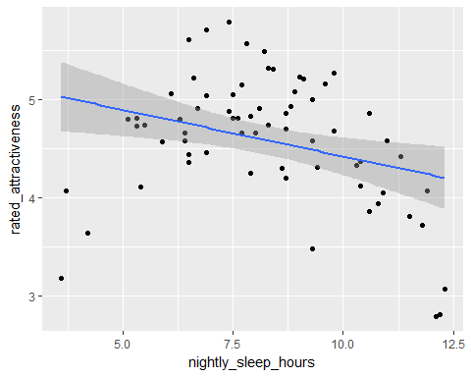

Instead of a linear regression line, it is possible to add a non-linear regression (also known as a 'smoother') line to the plot. For the sleep_beauty data set, the non-linear regression line appears to fit the data better than the linear regression line.

ggplot(sleep_beauty, aes(x = nightly_sleep_hours, y = rated_attractiveness)) +  
 geom_point() + # Use hollow circles  
 geom_smooth() # Add nonlinear regression line

## `geom_smooth()` using method = 'loess'

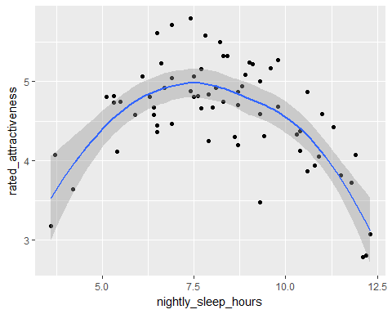

### Correlation

The inbuilt R function cor.test() computes correlation coefficients and confidence intervals.

cor.test(sleep_beauty$nightly_sleep_hours, sleep_beauty$rated_attractiveness)

##   
## Pearson's product-moment correlation  
##   
## data: sleep_beauty$nightly_sleep_hours and sleep_beauty$rated_attractiveness  
## t = -2.7175, df = 68, p-value = 0.008337  
## alternative hypothesis: true correlation is not equal to 0  
## 95 percent confidence interval:  
## -0.51041935 -0.08420143  
## sample estimates:  
## cor   
## -0.312983

### Regression

The inbuilt R function lm() fits ordinary least-squares regression models. confint() returns confidence intervals for the regression coefficients, and anova() the ANOVA F-test.

fit <- lm(rated_attractiveness ~ nightly_sleep_hours, data = sleep_beauty)  
 summary(fit)

##   
## Call:  
## lm(formula = rated_attractiveness ~ nightly_sleep_hours, data = sleep_beauty)  
##   
## Residuals:  
## Min 1Q Median 3Q Max   
## -1.85879 -0.27999 0.03998 0.38011 1.12675   
##   
## Coefficients:  
## Estimate Std. Error t value Pr(>|t|)   
## (Intercept) 5.37388 0.29805 18.030 < 2e-16 ***  
## nightly_sleep_hours -0.09502 0.03497 -2.717 0.00834 **   
## ---  
## Signif. codes: 0 '***' 0.001 '**' 0.01 '*' 0.05 '.' 0.1 ' ' 1  
##   
## Residual standard error: 0.6121 on 68 degrees of freedom  
## Multiple R-squared: 0.09796, Adjusted R-squared: 0.08469   
## F-statistic: 7.385 on 1 and 68 DF, p-value: 0.008337

anova(fit)

## Analysis of Variance Table  
##   
## Response: rated_attractiveness  
## Df Sum Sq Mean Sq F value Pr(>F)   
## nightly_sleep_hours 1 2.7666 2.76661 7.3845 0.008337 **  
## Residuals 68 25.4761 0.37465   
## ---  
## Signif. codes: 0 '***' 0.001 '**' 0.01 '*' 0.05 '.' 0.1 ' ' 1

confint(fit)

## 2.5 % 97.5 %  
## (Intercept) 4.7791288 5.96862811  
## nightly_sleep_hours -0.1647994 -0.02524601

The [Learn by Marketing](http://www.learnbymarketing.com/tutorials/linear-regression-in-r/) and [Harvard Regression Models in R](http://tutorials.iq.harvard.edu/R/Rstatistics/Rstatistics.html) websites contain further information about how to conduct basic regression analyses in R. DataCamp also have [paid online courses](https://www.datacamp.com/courses/intro-to-statistics-with-r-correlation-and-linear-regression) about correlation and regression analyses in R.

In addition to the lm() function built into R, there are numerous other functions and packages dedicated to fitting regression models. Probably the most famous is the [car](https://cran.r-project.org/web/packages/car/index.html) (Companion to Applied Regression) package, which is described in John Fox and Sanford Weisberg's book [An R Companion to Applied Regression](https://uk.sagepub.com/en-gb/eur/an-r-companion-to-applied-regression/book233899).

## Categorical Data - Frequencies, Proportions, Risk Ratios and Risk Differences

The [PropCIs](https://cran.r-project.org/web/packages/PropCIs/PropCIs.pdf) and [pairwiseCI](https://cran.r-project.org/web/packages/pairwiseCI/index.html) packages contains numerous functions for computing confidence intervals for single, paired and independent proportions. See also the BinomCI(), BinomDiffCI() and BinomRatioCI() functions in the [DescTools](https://cran.r-project.org/web/packages/DescTools) package and the [R manual to accompany Agresti's Categorical Data Analysis](http://www.stat.ufl.edu/~aa/cda/Thompson_manual.pdf) by Laura Thompson.

There are many R packages that include a function for computing the Chi-Square test - such as the chisq_test() function in the [coin](https://cran.r-project.org/web/packages/coin/) package.

There is also a package called [vcd](https://cran.r-project.org/web/packages/vcd/) for visualising categorical data.

## Extended Designs - One-Way and Factorial Designs

See the [Quick R website](http://www.statmethods.net/stats/anova.html) for some basic examples of how to fit one-way and factorial models in R using the inbuilt aov() function. There is a more detailed discussion with examples [here](https://egret.psychol.cam.ac.uk/statistics/R/anova.html).

If you are analysing data from these designs you may also find the [ez](https://github.com/mike-lawrence/ez) package useful, as it is designed to provide a simplified interface for analysis of variance models.

There are several R packages that can be used for comparisons and contrasts, such as [contrast](https://github.com/mike-lawrence/ez), [multicon](https://cran.r-project.org/web/packages/multcomp/) and [lsmeans](https://cran.r-project.org/web/packages/lsmeans/index.html).

## Robust Methods

The [WRS2](https://cran.r-project.org/web/packages/WRS2/index.html) package contains a collection of robust methods, including methods for computing effect sizes and confidence intervals for independent groups and repeated-measures designs. For example, the yuen() function can be used to compare two independent groups using trimmed means. The function returns the difference in trimmed means, a confidence interval, and p-value. By default, 20% trimming is used.

# Install package if not yet installed  
 # install.packages("WRS2")  
 library(WRS2)  
 yuen(transcription ~ group, data = pen_laptop1)

## Call:  
## yuen(formula = transcription ~ group, data = pen_laptop1)  
##   
## Test statistic: 3.5543 (df = 32.41), p-value = 0.00119  
##   
## Trimmed mean difference: 5.07632   
## 95 percent confidence interval:  
## 2.1686 7.9841

The [WRS2 vignette](https://cran.r-project.org/web/packages/WRS2/vignettes/WRS2.pdf) describes how to use the package.

Many additional robust statistics functions can be downloaded from [Rand Wilcox's website](https://dornsife.usc.edu/labs/rwilcox/software). The functions are described in [Professor Wilcox's books](https://dornsife.usc.edu/labs/rwilcox/books).

# Summary

In this guide we have provided a brief overview of how to install R, the itns data package, and a variety of R packages and functions that will help get you started using the 'new statistics' in R. In addition to the packages covered in this guide, there are many others that are useful for data analysis - at the time of writing there were over [10,000 available on CRAN](https://cran.r-project.org/web/packages). A good way to keep up to date with new packages and developments in the R community is to subscribe to [R bloggers](https://www.r-bloggers.com). We wish you luck in your adventures using R - may your confidence intervals be short!

# Reference

Cumming, G., & Calin-Jageman, R. (2017). *Introduction to the New Statistics*. New York; Routledge.